EXPERIMENT 4
DATA MODELLING AND FORM DESIGN

AIM

To design and implement an Internship Management System in Zoho Creator using appropriate data fields, validations, form sections, and a report for managing student internship information.

THEORY
Data modelling and form design are essential components of low-code application development. In platforms such as Zoho Creator, data modelling involves designing forms that act as the primary interface for capturing, validating, and storing information.
Key concepts involved in data modelling and form design include:
- Field Types: Basic field types such as text, number, date, dropdown, radio button, and multi-select fields allow developers to capture structured internship data.
- Mandatory Fields: Essential fields such as student name, email, contact number, and internship type can be marked mandatory.
- Validation Rules: Field-level validations such as email format, phone number pattern, and numeric ranges help maintain accurate student and internship information.
- Form Sections: Related fields can be grouped into sections such as student details, contact details, internship preferences, and internship schedule.
- Reports: Reports display submitted internship information in tabular format, allowing coordinators to view, filter, sort, and manage records.
- Workflow Integration: Forms can be linked with workflows to trigger notifications, approvals, or application status updates automatically after submission.
By combining structured data models with well-designed forms, Zoho Creator can be used to develop a reliable internship management application that reduces manual record keeping and improves the management of student internship information.

OBJECTIVE

To create a structured digital Internship Management System that captures student details, contact information, college details, internship preferences, skills, internship duration, schedule, application status, and declaration details.

PROCEDURE
1. Open the Internship Management System application in Zoho Creator and open the Internship_Registration_Form.
2. Design the form using the required basic field types and configure the necessary mandatory fields.
3. Configure the student, contact, college, internship preference, scheduling, and declaration fields.
4. Configure the Internship_Registration_Report to display submitted internship information.
5. Add sample student internship records and verify that the submitted information appears correctly in the report.
6. Configure the application status to help track internship application

FIGURE 4.1 — FORM BUILDER / DESIGN VIEW
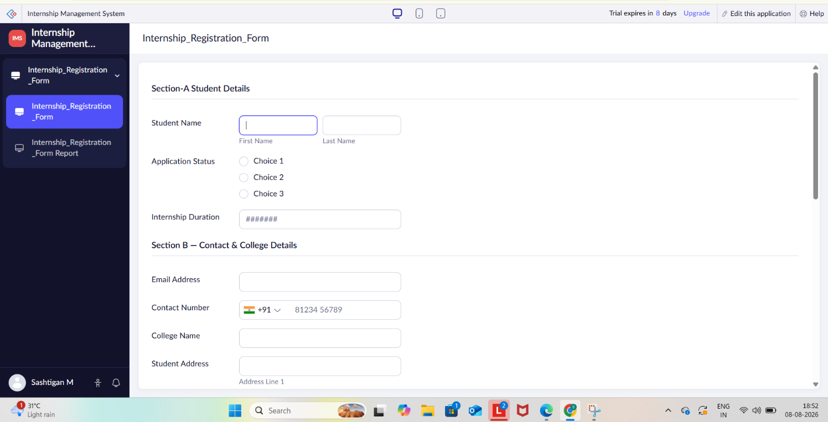

FIGURE 4.2 — LIVE PREVIEW OF CLAIM REQUEST FORM
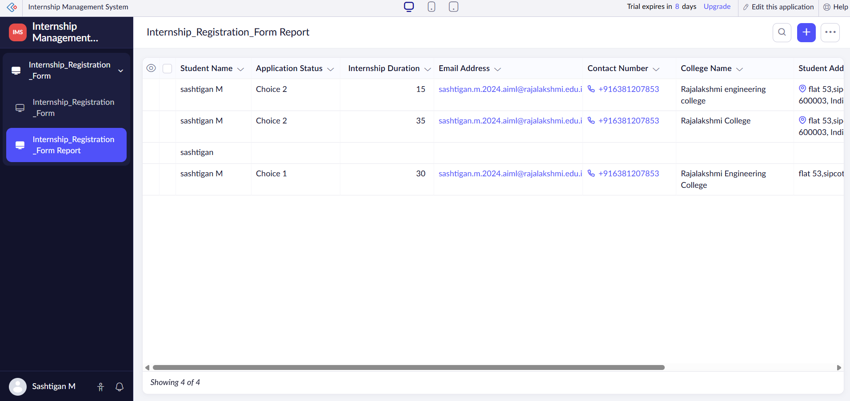

FIGURE 4.3 — INTERNSHIP REQUEST SUBMISSION CONFIRMATION EMAIL
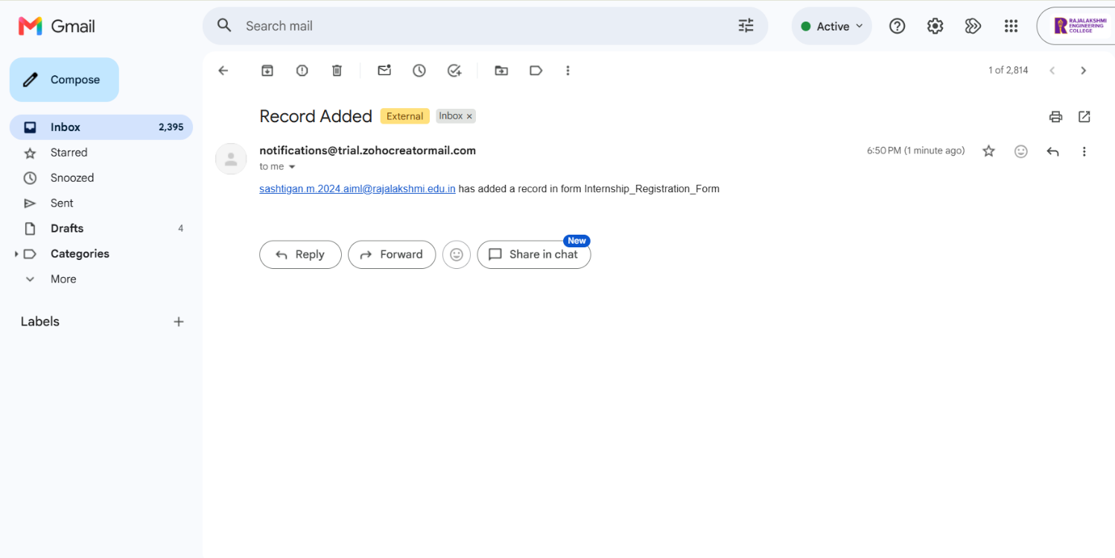

RESULT
The Internship Management System was successfully designed in Zoho Creator using appropriate data fields, sections, validations, and a report. The Internship_Registration_Report was populated with sample internship records, demonstrating a structured and reliable method for collecting, managing, and viewing student internship information.

