PROGRAMMING USING C

Done By:

Name:Sashtigan.M

Register No: 241501190

Department/Section: AIML “C”

Year: IST

Batch: 2024 - 2025

Week : 01-01

Q1) Problem Statement:

This is a simple challenge to help you practice printing to stdout. We're starting out by printing the most famous computing phrase of all time! In the editor below, use either printf or cout to print the string Hello, World! to stdout.

Input Format

You do not need to read any input in this challenge.

Output Format

Print Hello, World! to stdout. Sample Output 1

Hello, World!

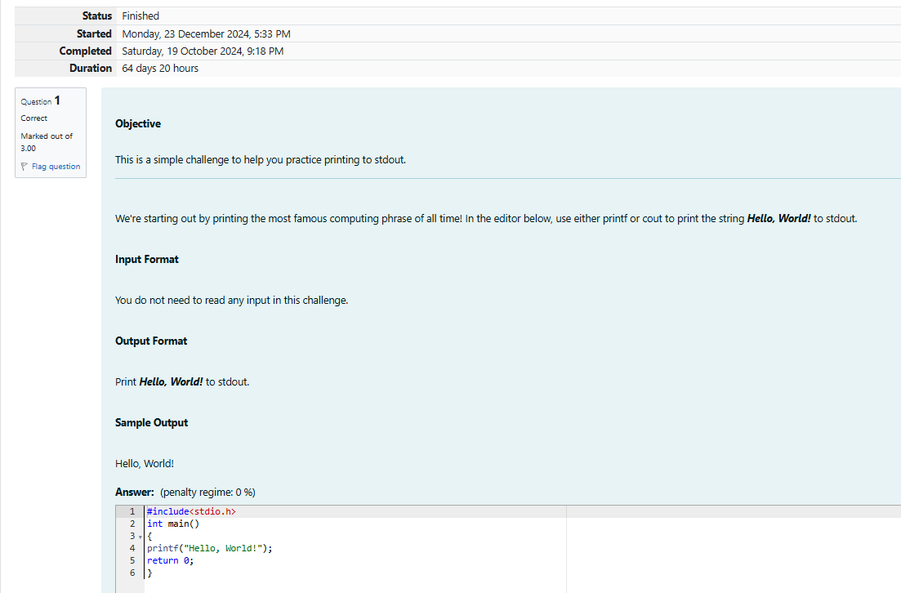

OUTPUT:

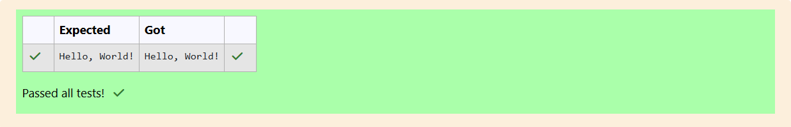

Q2) This challenge will help you to learn how to take a character, a string and a sentence as input in

C. To take a single character ch as input, you can use scanf("%c", &ch); and printf("%c", ch) writes a character specified by the argument char to stdout:

char ch;

scanf("%c", &ch);

printf("%c", ch);

Sample Input 1

C

program

Programming using C

Sample Output 1

C

program

Programming using C

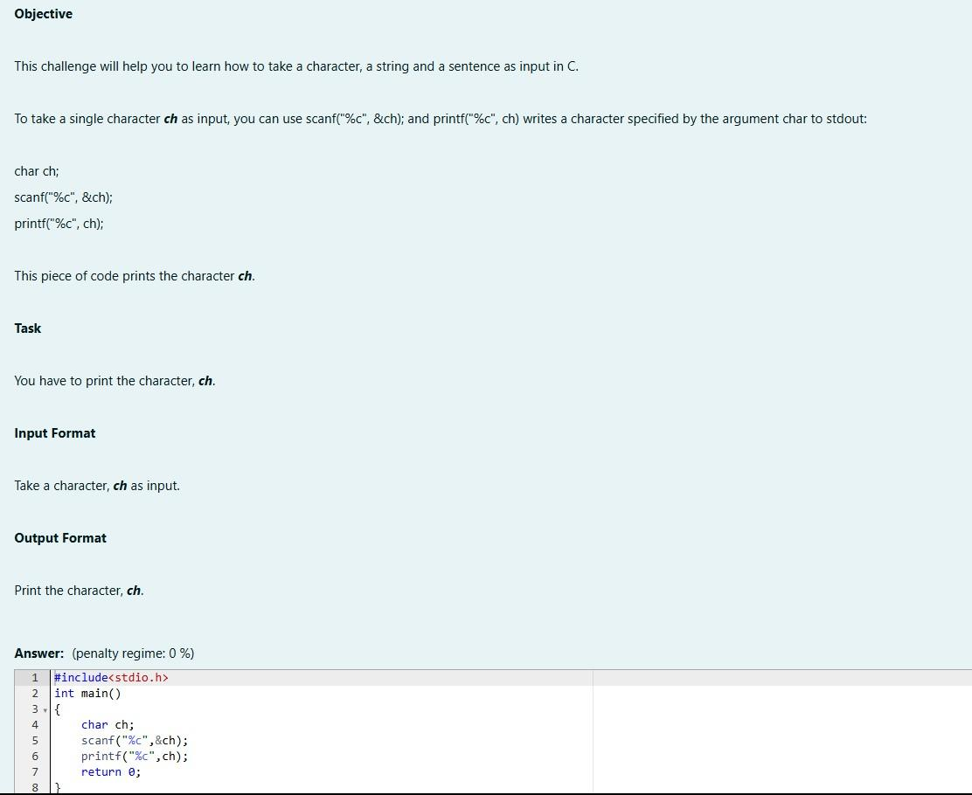

OUTPUT:

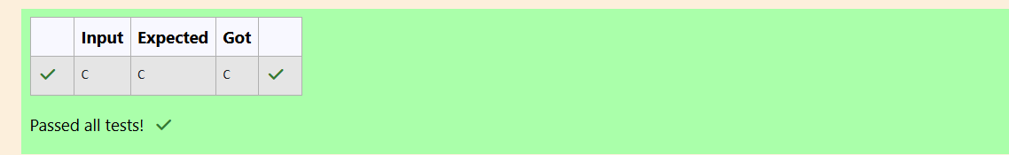

Q3) Problem Statement:

The fundamental data types in c are int, float and char. Today, we're discussing int and float data types.

The printf() function prints the given statement to the console. The syntax is printf("format string", argument_list);. In the function, if we are using an integer, character, string or float as argument, then in the format string we have to write %d (integer), %c (character), %s (string), %f (float) respectively.

The scanf() function reads the input data from the console. The syntax is scanf("format string", argument_list);. For ex: The scanf("%d", &number) statement reads integer number from the

console and stores the given value in variable number.To input two integers separated by a space on a single line, the command is scanf("%d %d", &n, &m), where n and m are the two integers.

Task

Your task is to take two numbers of int data type, two numbers of float data type as input and output their sum:

Declare 4 variables: two of type int and two of type float.

Read 2 lines of input from stdin (according to the sequence given in the 'Input Format' section below) and initialize your 4 variables.

Use the + and - operator to perform the following operations:

Print the sum and difference of two int variable on a new line.

Print the sum and difference of two float variable rounded to one decimal place on a new line.

Input Format

The first line contains two integers.

The second line contains two floating point numbers. Constraints: 1 ≤ integer variables ≤ 10^4

1 ≤ float variables ≤ 10^4

Output Format

Print the sum and difference of both integers separated by a space on the first line, and the sum and difference of both float (scaled to 1 decimal place) separated by a space on the second line.

Sample Input

10 4

4.0 2.0

Sample Output

14 6

6.0 2.0

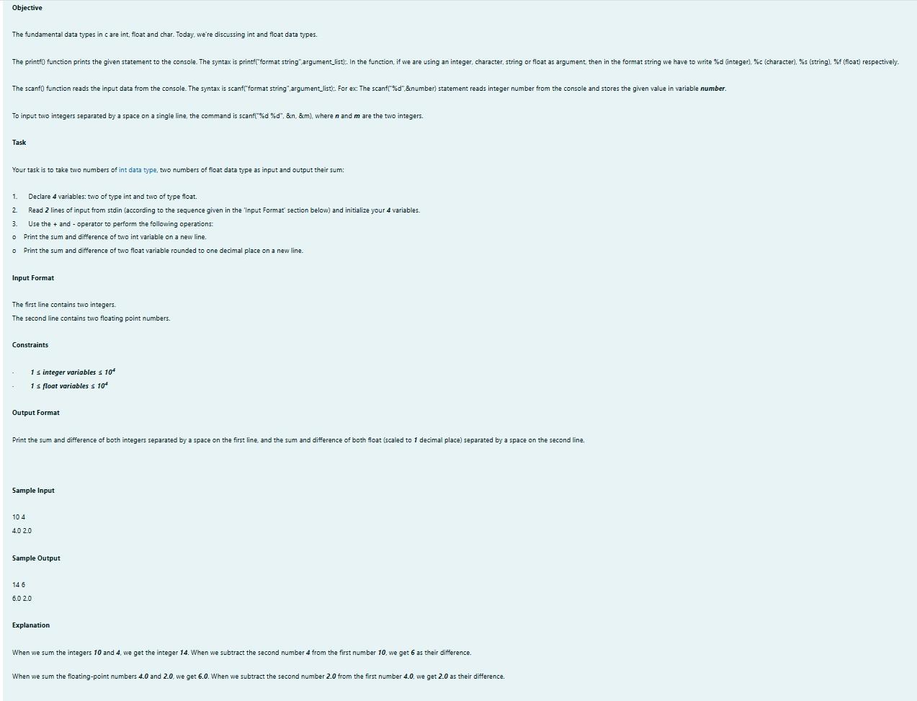

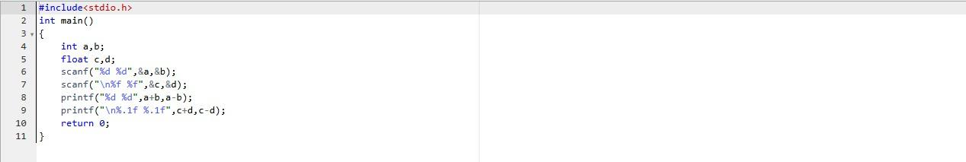

OUTPUT:

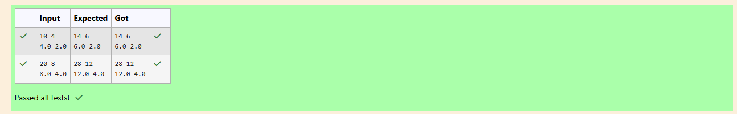

Week:01-02

Q1) Problem Statement

Write a program to input a name (as a single character) and marks of three tests as m1, m2, and m3 of a student considering all the three marks have been given in integer format.

Now, you need to calculate the average of the given marks and print it along with the name as mentioned in the output format section.

All the test marks are in integers and hence calculate the average in integer as well. That is, you need to print the integer part of the average only and neglect the decimal part.

Input Format:

Line 1: Name (Single character)

Line 2: Marks scored in the 3 tests separated by single space.

Output Format:

First line of output prints the name of the student. Second line of the output prints the average mark.

Constraints

Marks for each student lie in the range 0 to 100 (both inclusive)

Sample Input 1:

A

3 4 6

Sample Output 1:

A 4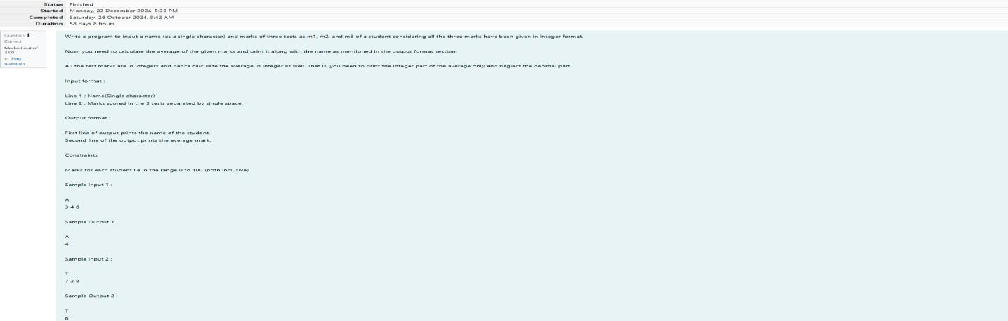

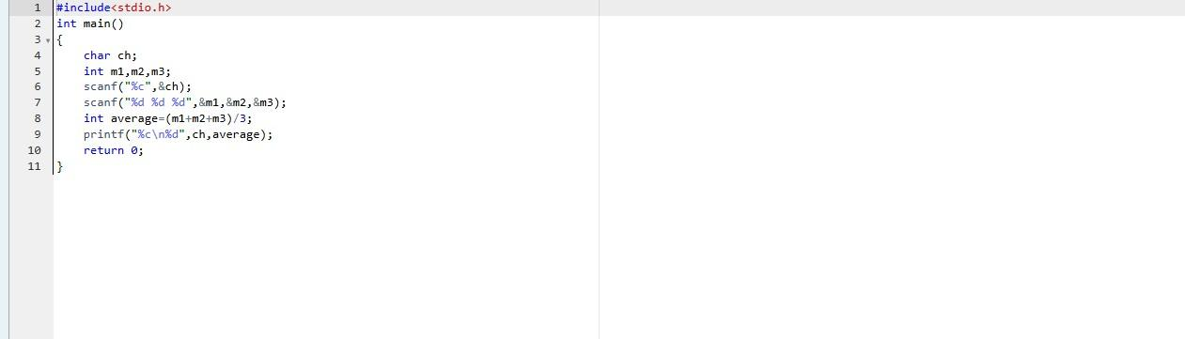

OUTPUT:

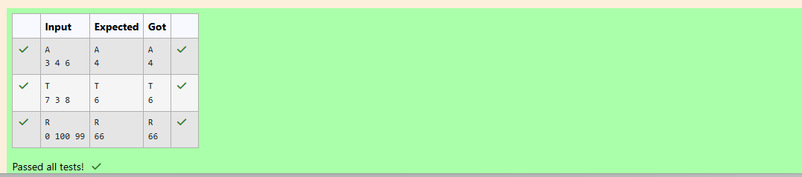

Q2) Problem Statement:

Some C data types, their format specifiers, and their most common bit widths are as follows: Int ("%d"): 32 Bit integer

Long ("%ld"): 64 bit integer Char ("%c"): Character type Float ("%f"): 32 bit real value

Double ("%lf"): 64 bit real value

Reading

To read a data type, use the following syntax:

scanf("format_specifier", &val)

For example, to read a character followed by a double: C

char ch; double d;

scanf("%c %lf", &ch, &d);

For the moment, we can ignore the spacing between format specifiers. Printing

To print a data type, use the following syntax:

printf("format_specifier", val)

For example, to print a character followed by a double:

C

char ch = 'd';

double d = 234.432; printf("%c %lf", ch, d);

Note: You can also use cin and cout instead of scanf and printf; however, if you are taking a million numbers as input and printing a million lines, it is faster to use scanf and printf.

Input Format

Input consists of the following space-separated values: int, long, char, float, and double, respectively.

Output Format

Print each element on a new line in the same order it was received as input. Note that the floating- point value should be correct up to 3 decimal places and the double to 9 decimal places.

Sample Input

3

12345678912345

a

334.23

14049.30493

Sample Output

3

12345678912345

a

334.230

14049.304930000

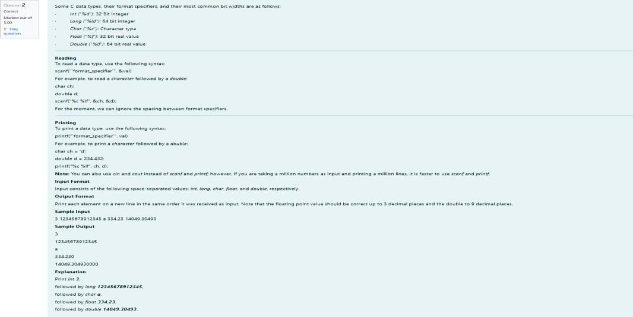

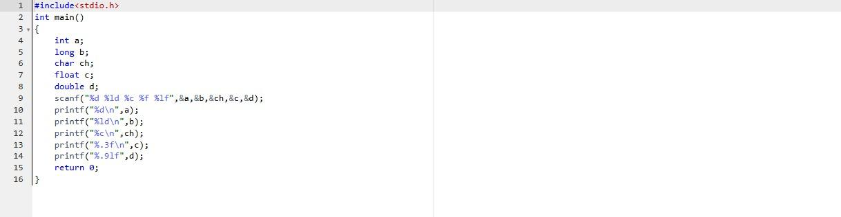

OUTPUT:

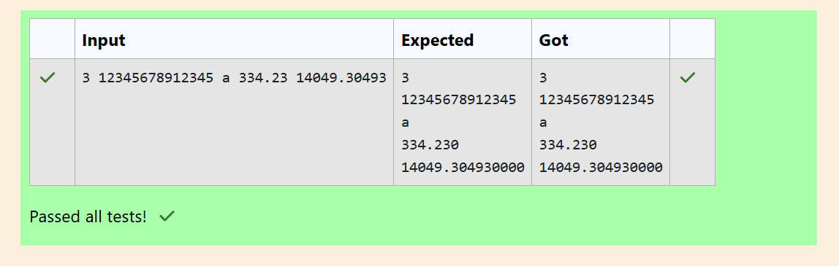

Q3) Problem Statement:

Write a program to print the ASCII value and the two adjacent characters of the given character. Input Format: Reads the character

Output Format: First line prints the ascii value, second line prints the previous character and next character of the input character

Sample Input 1:

E

Sample Output 1:

69

DF

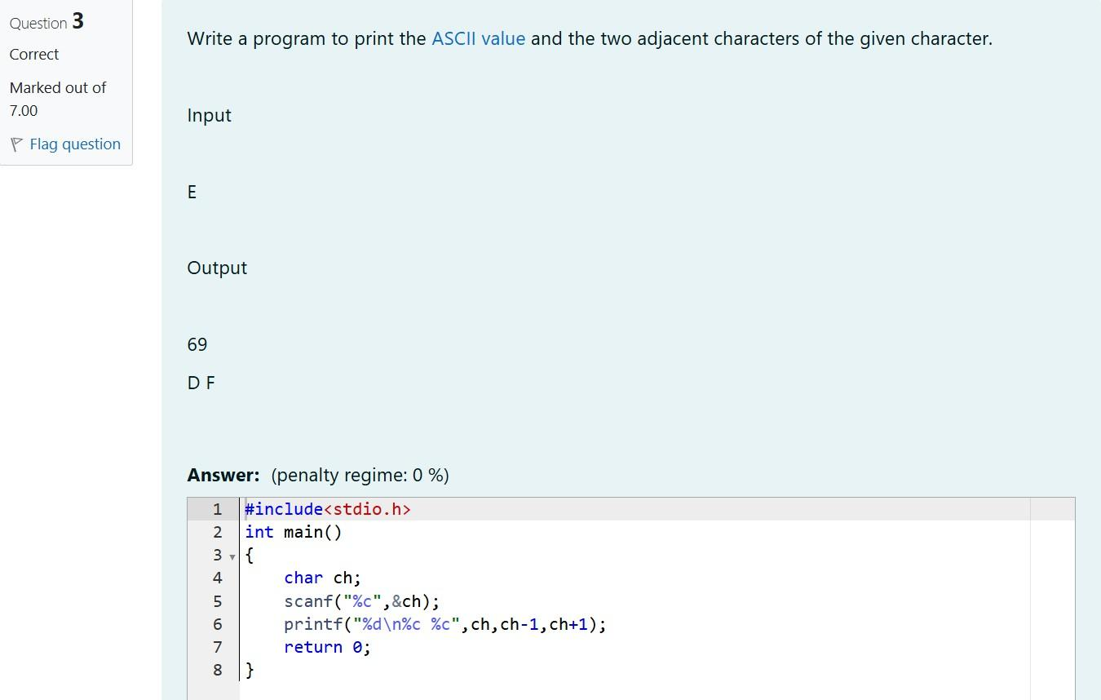

OUTPUT:

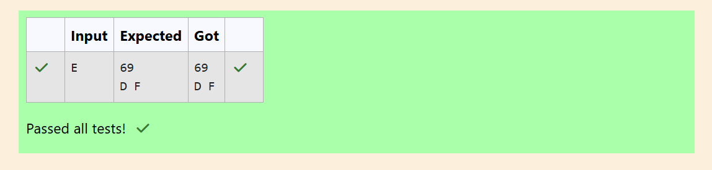

**Week 2**

**Week-02-01-Practice Session-Coding**

**Q1)** Many people think about their height in feet and inches, even in some countries that primarily use the metric system. Write a program that reads a number of feet from the user, followed by a number of inch- es. Once these values are read, your program should compute and display the equivalent number of cen- timeters.

Hint:

One foot is 12 inches.

One inch is 2.54 centimeters. Input Format

First line,read the number of feet. Second line, read the number of inches. Output Format

In one line print the height in centimeters.

Note: All of the values should be displayed using two decimal places. Sample Input 1

5 6

Sample Output 1

167.64

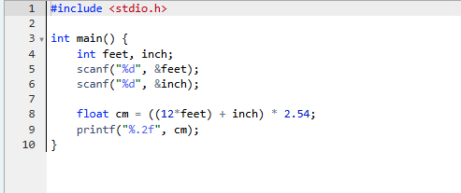

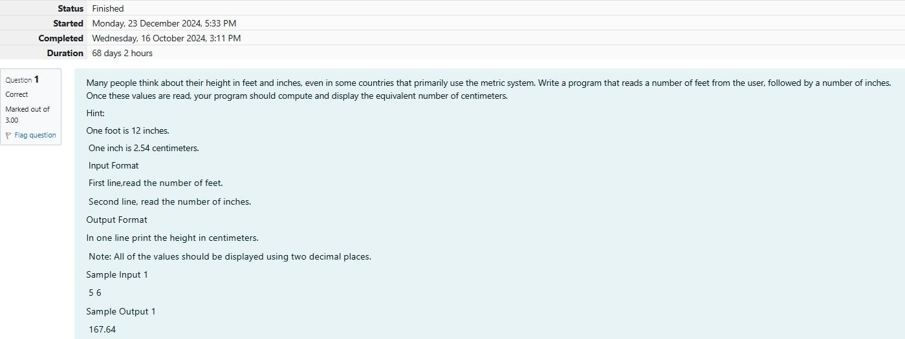

Output: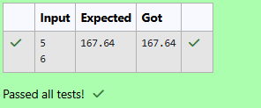

**Q2)** Create a program that reads two integers, a and b, from the user. Your program should compute and display: • The sum of a and b • The difference when b is subtracted from a • The product of a and b • The quotient when a is divided by b • The remainder when a is divided by b

Input Format

First line, read the first number. Second line, read the second number. Output Format

First line, print the sum of a and b

Second line, print the difference when b is subtracted from a Third line, print the product of a and b

Fourth line, print the quotient when a is divided by b Fifth line, print the remainder when a is divided by b Sample

Input 1 100 6 Sample Output 106 94 600 16 4

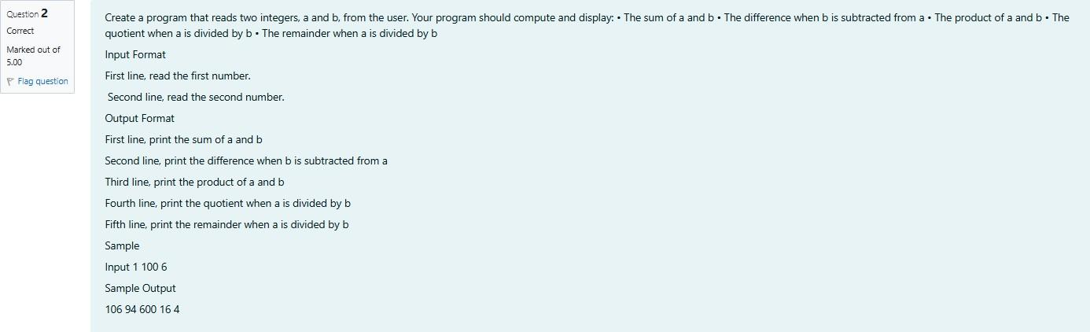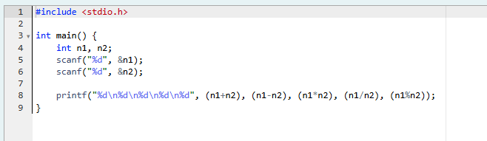

**Ouput:**

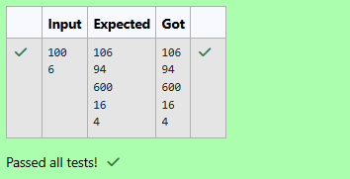

**Q3)** A bakery sells loaves of bread for $3.49 each. Day old bread is discounted by 60 percent. Write a pro- gram that begins by reading the number of loaves of day old bread being purchased from the user. Then your program should display the regular price for the bread, the discount because it is a day old, and the total price. Each of these amounts should be displayed on its own line with an appropriate label. All of the values should be displayed using two decimal places.

Input Format

Read the number of day old loaves. Output Format

First line, print Regular price: price Second line, print Discount: discount Third line, print Total: total

Note: All of the values should be displayed using two decimal places. Sample Input 1

10

Sample Output 1

Regular price: 34.90

Discount: 20.94

Total: 13.96



**Output:**

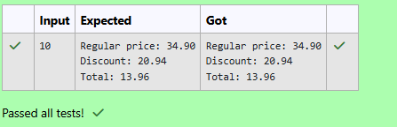

**Week-02-02-Practice Session-Coding**

Q1) Goki recently had a breakup, so he wants to have some more friends in his life. Goki has N people who he can be friends with, so he decides to choose among them according to their skills set Yi(1<=i<=n). He wants atleast X skills in his friends. Help Goki find his friends.



INPUT

First line contains a single integer X - denoting the minimum skill required to be Goki's friend. Next line contains one integer Y - denoting the skill of the person

. OUTPUT

Print if he can be friend with Goki. 'YES' (without quotes) if he can be friends with Goki else 'NO' (without quotes).



CONSTRAINTS 1<=N<=1000000

1<=X,Y<=1000000 SAMPLE INPUT 1

100 110

SAMPLE OUTPUT 1 YES

SAMPLE INPUT 2

100 90

SAMPLE OUTPUT 2 NO



**Output:**

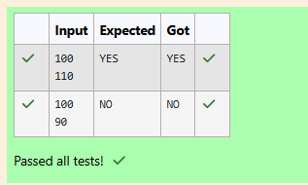

Q2) Before the outbreak of corona virus to the world, a meeting happened in a room in Wuhan. A per- son who attended that meeting had COVID-19 and no one in the room knew about it! So everyone started shaking hands with everyone else in the room as a gesture of respect and after meeting unfortunately everyone got infected! Given the fact that any two persons shake hand exactly once, Can you tell the total count of handshakes happened in that meeting? Say no to shakehands. Regularly wash your hands. Stay Safe.

Input Format

Read an integer N,the total number of people attended that meeting. Output Format

Print the number of handshakes. Constraints

0 < N < 106

SAMPLE INPUT 1

1

SAMPLE OUTPUT 0

SAMPLE INPUT 2

2

SAMPLE OUTPUT 2

1

Explanation Case 1: The lonely board member shakes no hands, hence 0. Case 2: There are 2 board mem- bers, 1 handshake takes place.



**Output:**

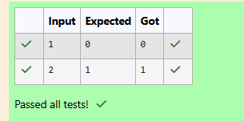

Q3) In our school days, all of us have enjoyed the Games period. Raghav loves to play cricket and is Cap- tain of his team. He always wanted to win all cricket matches. But only one last Games period is left in school now. After that he will pass out from school. So, this match is very important to him. He does not want to lose it. So he has done a lot of planning to make sure his teams wins. He is worried about only one opponent - Jatin, who is very good batsman. Raghav has figured out 3 types of bowling techniques, that could be most beneficial for dismissing Jatin. He has given points to each of the 3 techniques. You need to tell him which is the maximum point value, so that Raghav can select best technique. 3 numbers are given in input. Output the maximum of these numbers.

Input:

Three space separated integers. Output:

Maximum integer value SAMPLE INPUT

8 6 1

SAMPLE OUTPUT 8

Explanation Out of given numbers, 8 is maximum.



**Output:**

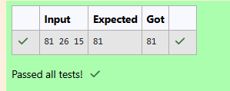

**Coding-Variables and Keywords**

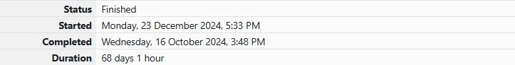

Q1) Read the code given below to learn naming conventions in identifiers. For example, consider the program given below:

#include <**stdio.h**>

**int** main()

{

**int** age = 2; // age is an integer variable

**int** firstNumber = 2; // firstNumber is an integer variable

// If there are two or more words in an identifier/variable - User can also use "camel case" style to declare a var- iable.

**int** second_number = 3; // second_number is an integer variable

// Any space cannot be used between two words of an identifier/variable; User can use underscore (_) instead of space.

**int** _i_am_also_a_valid_identifier = 4; // _i_am_also_a_valid_identifier is an integer variable

// An identifier/variable name must be start with an alphabet or underscore (_) only, no other special characters, digits are allowed as first character of the identifier/variable name.

printf("age = %d\n", age); printf("firstNumber = %d\n", firstNumber);

printf("second_number = %d\n", second_number); printf("_i_am_also_a_valid_identifier = %d\n", _i_am_also_a_valid_identifier);

return 0;

}

Fill in the missing code in the below program to print the values of the given variables.

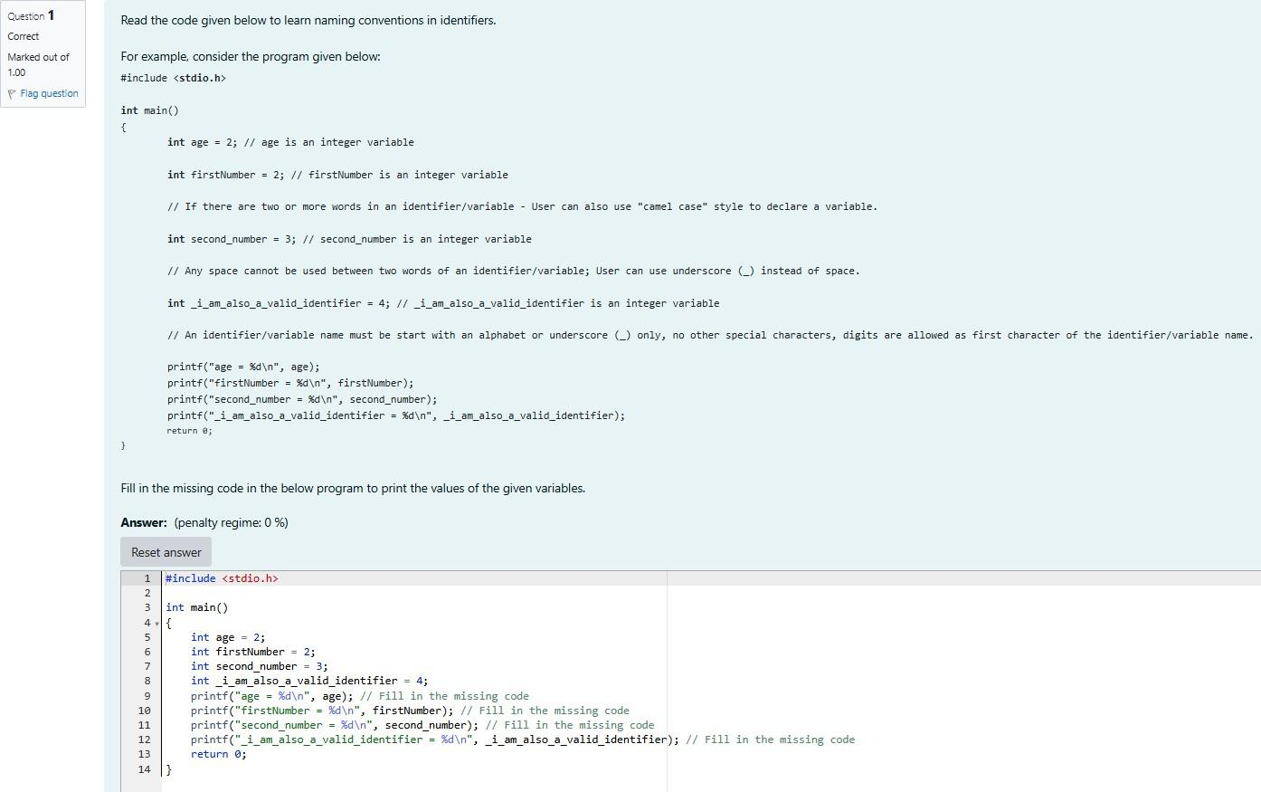

**Output:**

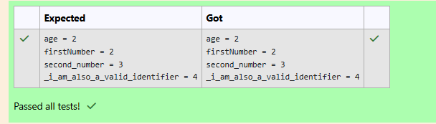

**Coding-Syntax of main() function**

Q1) Identify and correct the error in the code given below.

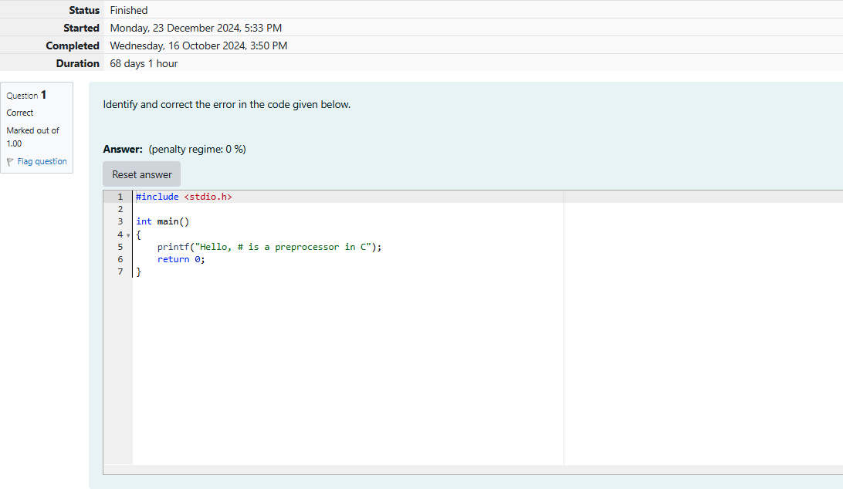

**Output:**

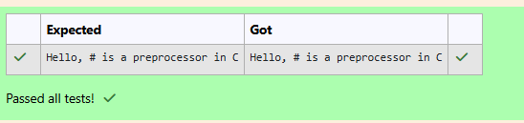

Q2) In **C** programming language, execution of the code starts with a [function](https://en.wikipedia.org/wiki/Subroutine) called main.

We shall learn more about functions in the later sections. For now, we can safely assume that **function** is the name given to a set of one or more executable statements. main() is a **user defined function**, i.e., a user (a programmer) writes the code for the main() function.

While executing a **C** program, the **Operating System (OS)** only calls the main() function in that program.

When the **OS** executes a program, the program usually returns an integer value 0 if the execution of that program is successful.

In **C**, **main()** can be written in such a way that it returns a an int.

**#include <stdio.h>**

**int main()**

**{**

printf("Sample main() function with int as return type!"); return 0;// 0 value indicates that the execution is successful

**}**

If the programmer does not specify any return type, the return type is by default considered as int.

The name of the main() function should always be in lowercase, i.e., if a function is written as Main(), it is not the main function which is called by the OS.

Read the code given below to familiarize yourself with the syntax of main() function. Retype in the space provided.

#include <stdio.h> int main()

{

printf("Impossible is nothing!"); return 0;

}



**Output:**

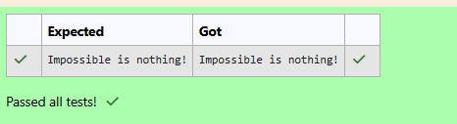

Q3) Identify and correct the error in the code given below.

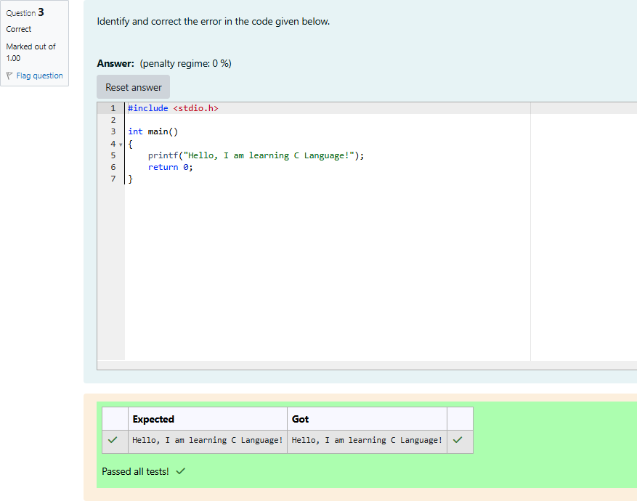

Q4) Click on Check without correcting the code.

This results in many errors because the main function is not defined correctly. Now, correct the spelling of the main function and submit the program once again.

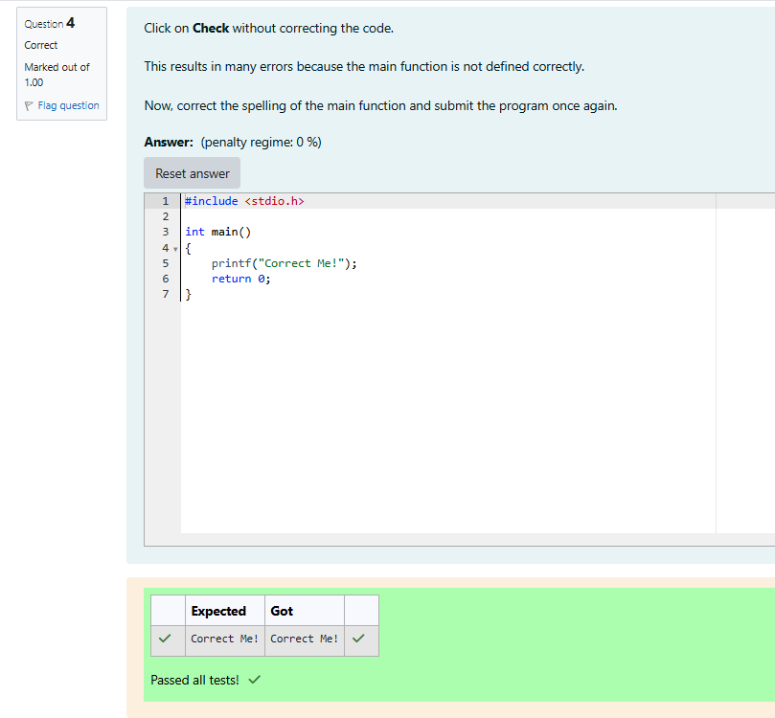

Q5) Identify and correct the error in the code given below.

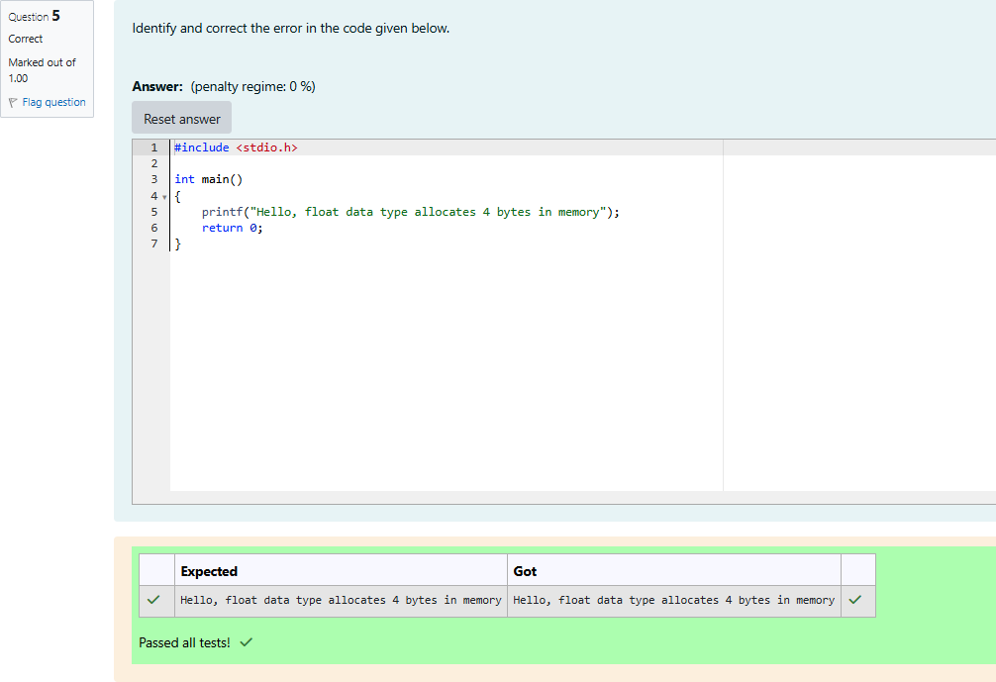

**int Data Type**

Q1) In the program given below, we shall learn how to assign values to int data type from binary, octal, hex and character literals.

Read the code given below and retype in the space provided. #include <stdio.h>

int main()

{

int binaryThree = 0b11;

printf("binaryThree value = %d\n", binaryThree); int octalEight = 010;

printf("octalEight value = %d\n", octalEight); int hexTen = 0xA;

printf("hexTen value = %d\n", hexTen); int asciiValueOfOne = '1';

printf("asciiValueOfOne value = %d\n", asciiValueOfOne); int asciiValueOfA = 'A';

printf("asciiValueOfA value = %d\n", asciiValueOfA); return 0;

}

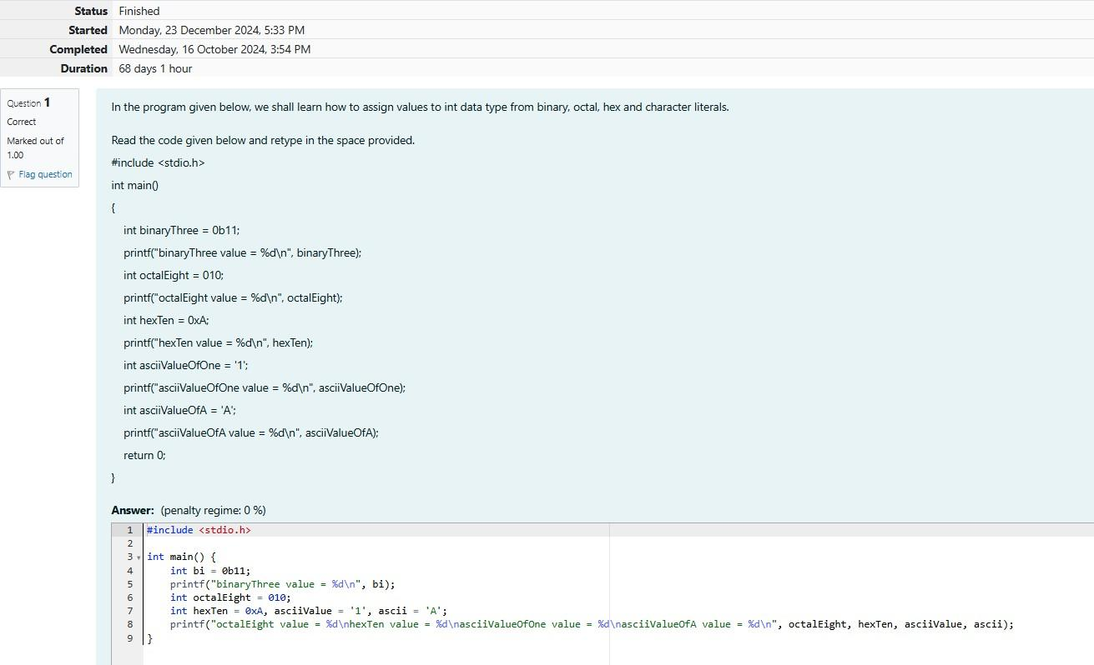

**Output:**

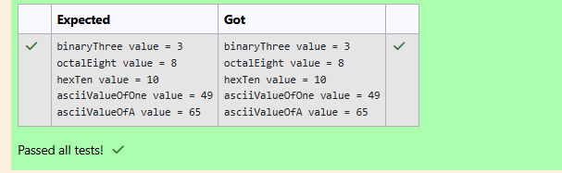

Q2) In the program given below, fill in the missing code to add two integer numbers.

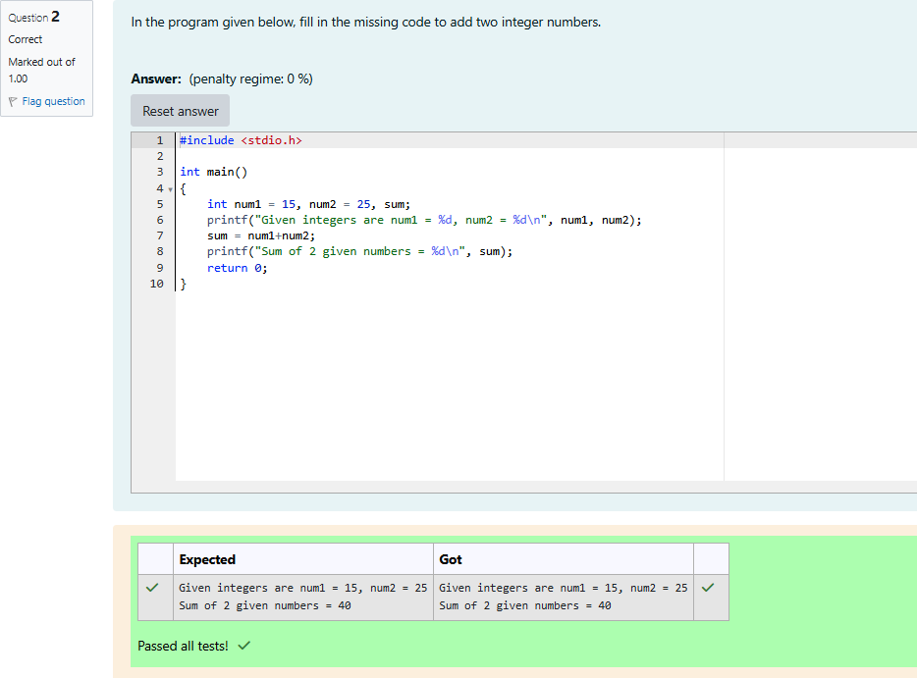

Q3) To print unsigned values on the console, use %u format character instead of %d in the **printf()** function.

Whenever an attempt is made to assign a negative number to an **unsigned int** ( For eg: unsigned int num =

-1;) the compiler does not flag it as an **error**. Instead, it will automatically convert the negative number to a positive number as shown below:

unsigned int **num** = -1;

The value stored in **num** = unsigned int **maximum_value** + **1** - **num**; The final value in **num** = 4294967295 (in a 32-bit processing system)

In the program given below, fill in the missing format characters to print signed and unsigned values.

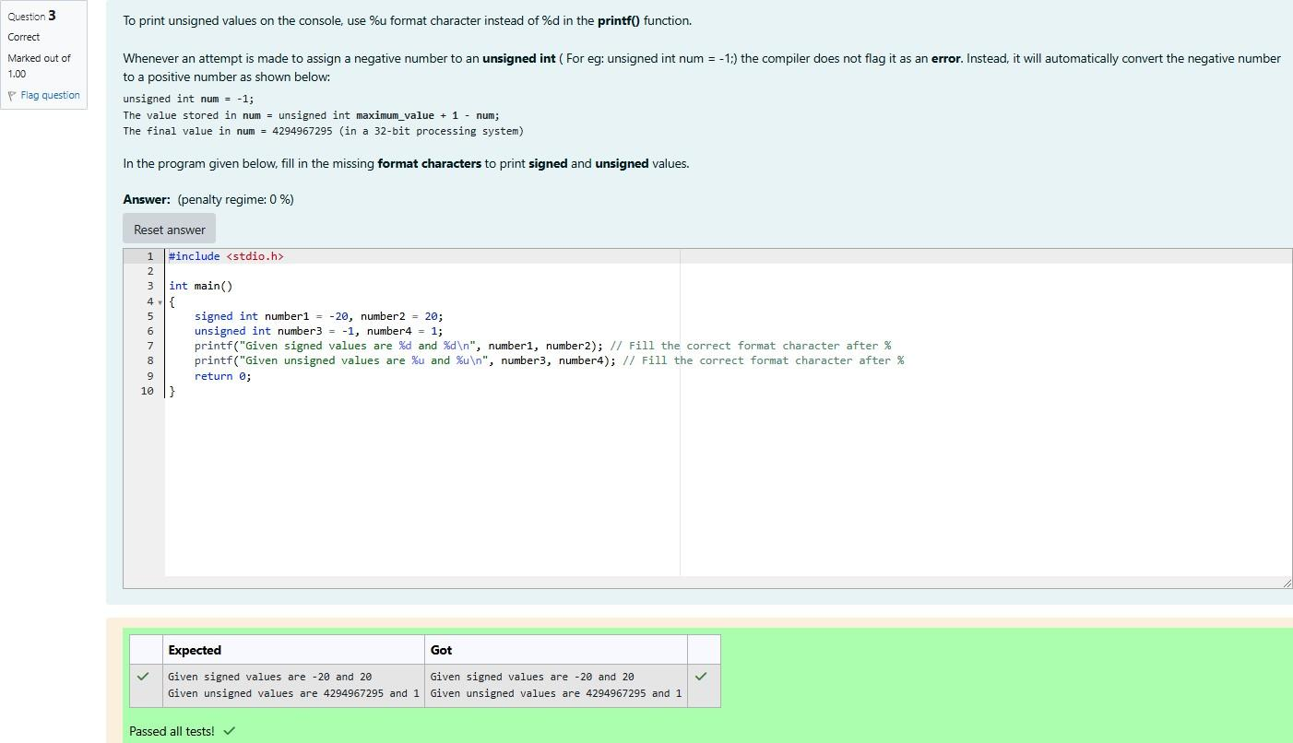

Q4) Identify the error and correct the code. [**Hint**: Verify if all variables are declared before they are first used.]

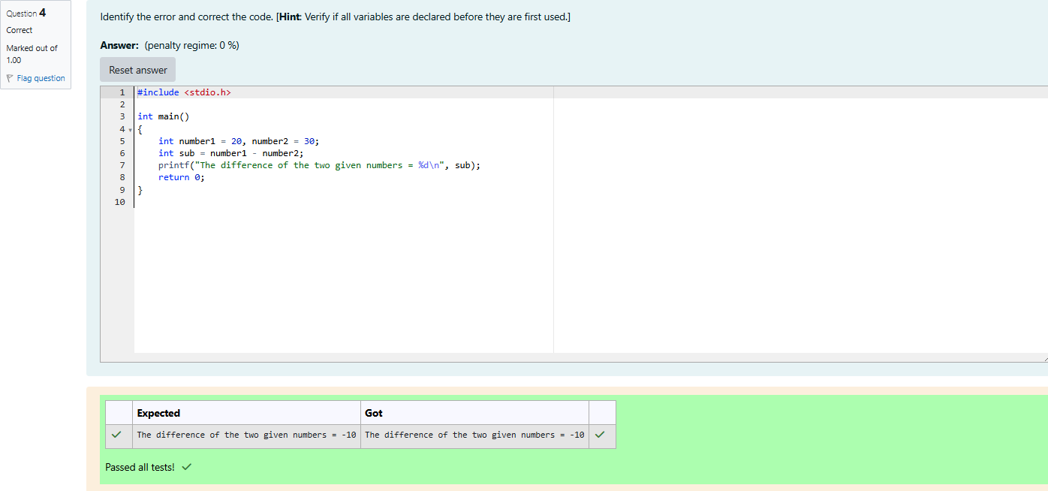

**float Data Type**

Q1)Identify and correct the errors in the code given below: Expected Output:

Given float values are num1 = 5.340000, num2 = 125.789001 The result after dividing in float format = 23.555992

The result after dividing in exponential format = 2.355599e+01

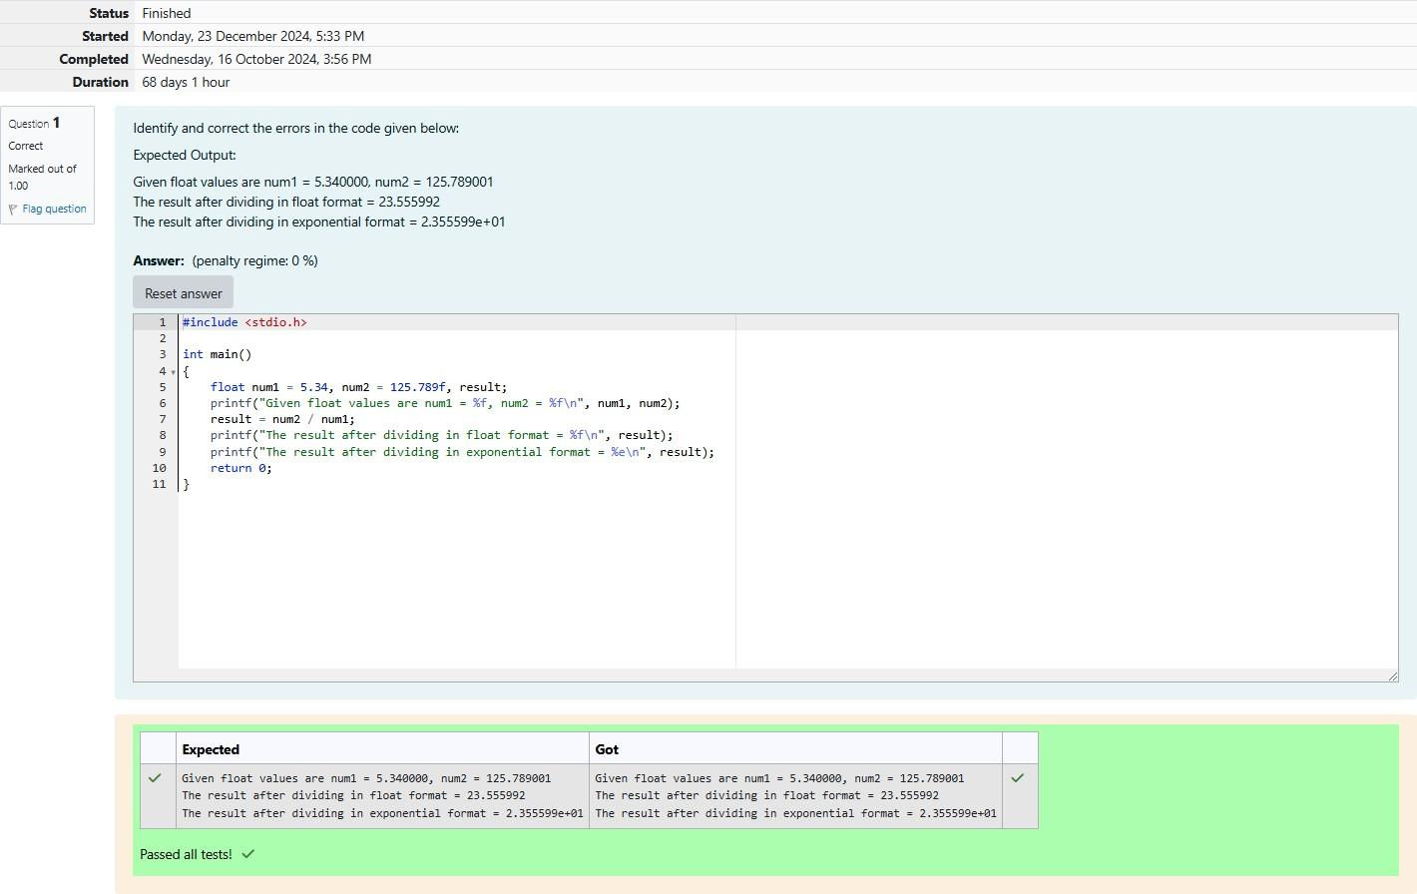

Q2) Identify and correct the errors in the code given below:

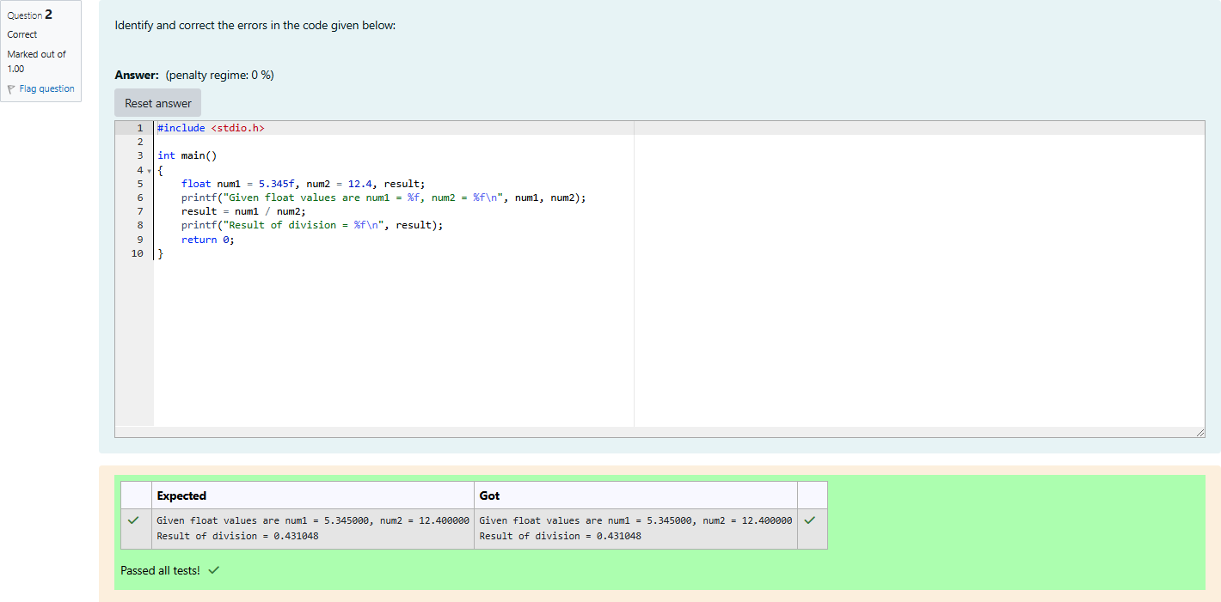

**Cricket Stadium**

Q1)There was a large ground in center of the city which is rectangular in shape. The Corporation decides to build a Cricket stadium in the area for school and college students, But the area was used as a car park- ing zone. In order to protect the land from using as an unauthorized parking zone, the corporation wanted to protect the stadium by building a fence. In order to help the workers to build a fence, they planned to

place a thick rope around the ground. They wanted to buy only the exact length of the rope that is needed. They also wanted to cover the entire ground with a carpet during rainy season. They wanted to buy only the exact quantity of carpet that is needed. They requested your help. Can you please help them by writ- ing a program to find the exact length of the rope and the exact quantity of carpet that is required?

Input format:

Input consists of 2 integers. The first integer corresponds to the length of the ground and the second inte- ger corresponds to the breadth of the ground.

Output Format:

Output Consists of two integers. The first integer corresponds to the length. The second integer corre- sponds to the quantity of carpet required.

Sample Input:

50

20

Sample Output:

140

1000

For example:

| **Input** | **Result** |
| --- | --- |
| 50 | 140 |
| 20 | 1000 |

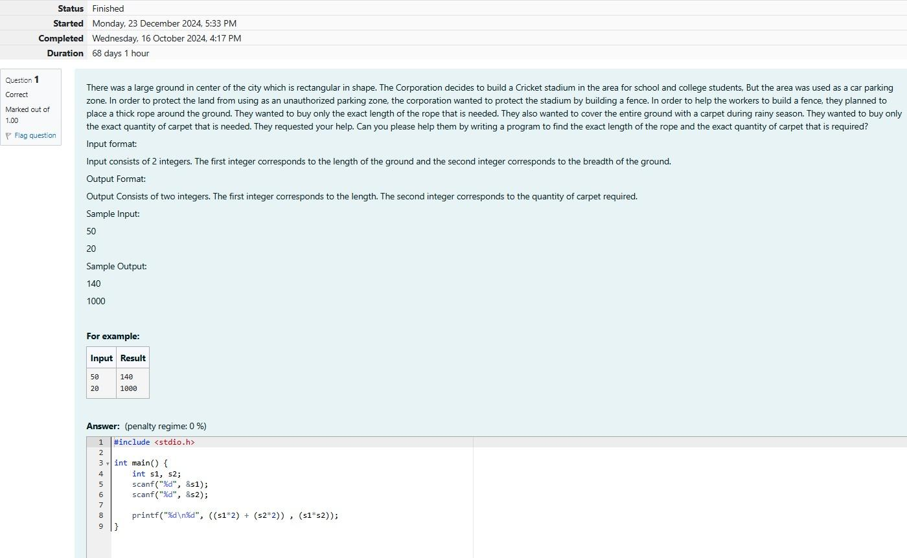

**Output:**

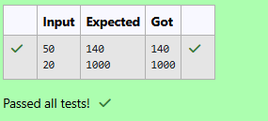

**Sports Day Celebration**

Q1)Training for sports day has begun and the physical education teacher has decided to conduct some team games. The teacher wants to split the students in higher secondary into equal sized teams. In some cases, there may be some students who are left out from the teams and he wanted to use the left out students to assist him in conducting the team games. For instance, if there are 50 students in a class and if the class has to be divided into 7 equal sized teams, 7 students will be there in each team and 1 student will be left out. That 1 student will assist the PET. With this idea in mind, the PET wants your help to auto- mate this team splitting task. Can you please help him out?

INPUT FORMAT:

Input consists of 2 integers. The first integer corresponds to the number of students in the class and the second integer corresponds to the number of teams.

OUTPUT FORMAT:

The output consists of two integers. The first integer corresponds to the number of students in each team and the second integer corresponds to the students who are left out.

SAMPLE INPUT:

60

8

SAMPLE OUTPUT:

7

4

For example:

| **Input** | **Result** |
| --- | --- |
| 60 | 7 |
| 8 | 4 |

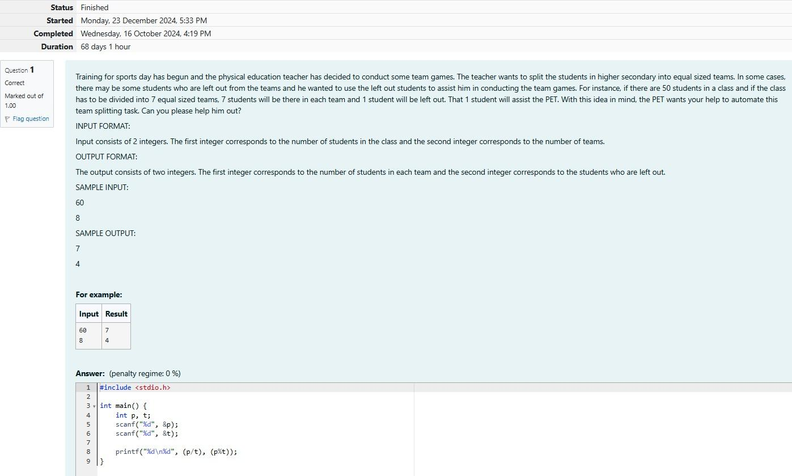

Output:

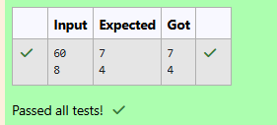

**The Newspaper Agency**

Q1) Each Sunday, a newspaper agency sells w copies of a special edition newspaper for Rs.x per copy. The cost to the agency of each newspaper is Rs.y. The agency pays a fixed cost for storage, delivery and so on of Rs.100 per Sunday. The newspaper agency wants to calculate the profit which it obtains only on Sun- days. Can you please help them out by writing a program to compute the profit if w, x, and y are given?

INPUT FORMAT:

Input consists of 3 integers: w, x, and y. w is the number of copies sold, x is the cost per copy and y is the cost the agency spends per copy.

OUTPUT FORMAT:

The output consists of a single integer which corresponds to the profit obtained by the newspaper agency. SAMPLE INPUT:

1000

2

1

SAMPLE OUTPUT:

900

For example:

| **Input** | **Result** |
| --- | --- |
| 1000 |  |
| 2 | 900 |
| 1 |  |

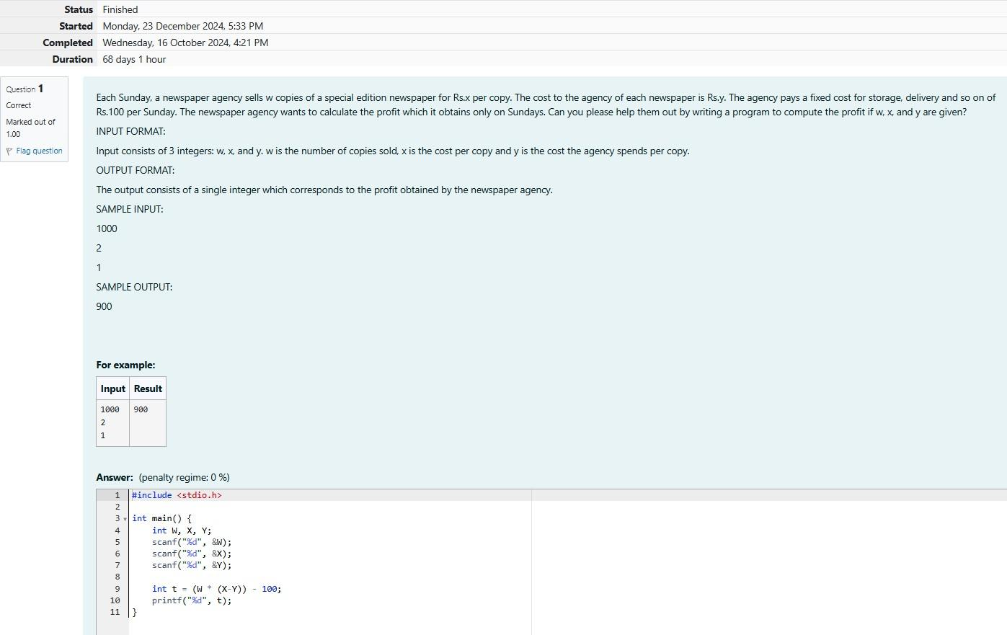

**Output:**

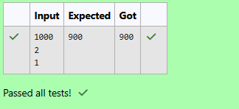

**The Chronicles of Narnia**

Q1) Four kids Peter, Susan, Edmond and Lucy travel through a wardrobe to the land of Narnia. Narnia is a fantasy world of magic with mythical beasts and talking animals.While exploring the land of narnia Lucy found Mr.Tumnus the two legged stag ,and she followed it, down a narrow path .She and Mr.Tumnus be- came friends and he offered a cup of coffee to Lucy in his small hut.It was time for Lucy to return to her family and so she bid good bye to Mr.Tumnus and while leaving Mr.Tumnus told that it is quite difficult to find the route back as it was already dark. He told her to see the trees while returning back and said that the first tree with two digits number will help her find the way and the way to go back to her home is the sum of digits of the tree and that numbered way will lead her to the tree next to the wardrobe where she can find the others. Lucy was already confused, so please help her in finding the route to her home....

Input Format:

Input consists of an integer corresponding to the 2-digit number. Output Format:

Output consists of an integer corresponding to the sum of its digits. SAMPLE INPUT:

87

SAMPLE OUTPUT:

15

For example:

| **Input** | **Result** |
| --- | --- |
| 87 | 15 |

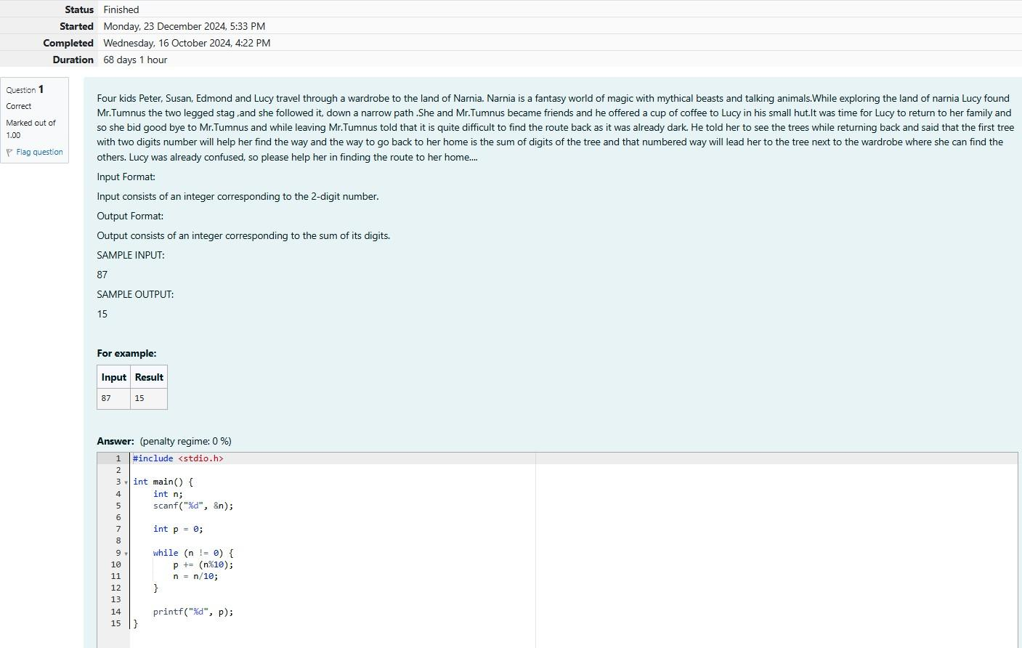

**Output:**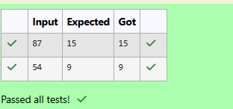

Week:03-01

Q1) Problem Statement:

Write a program to read two integer values and print true if both the numbers end with the same digit, otherwise print false.

Example: II 698 and 768 are given, program should print true as they both end with 8.

Sample Input 1

25 53

Sample Output 1

false

Sample Input 2

27 77

Sample Output 2

true

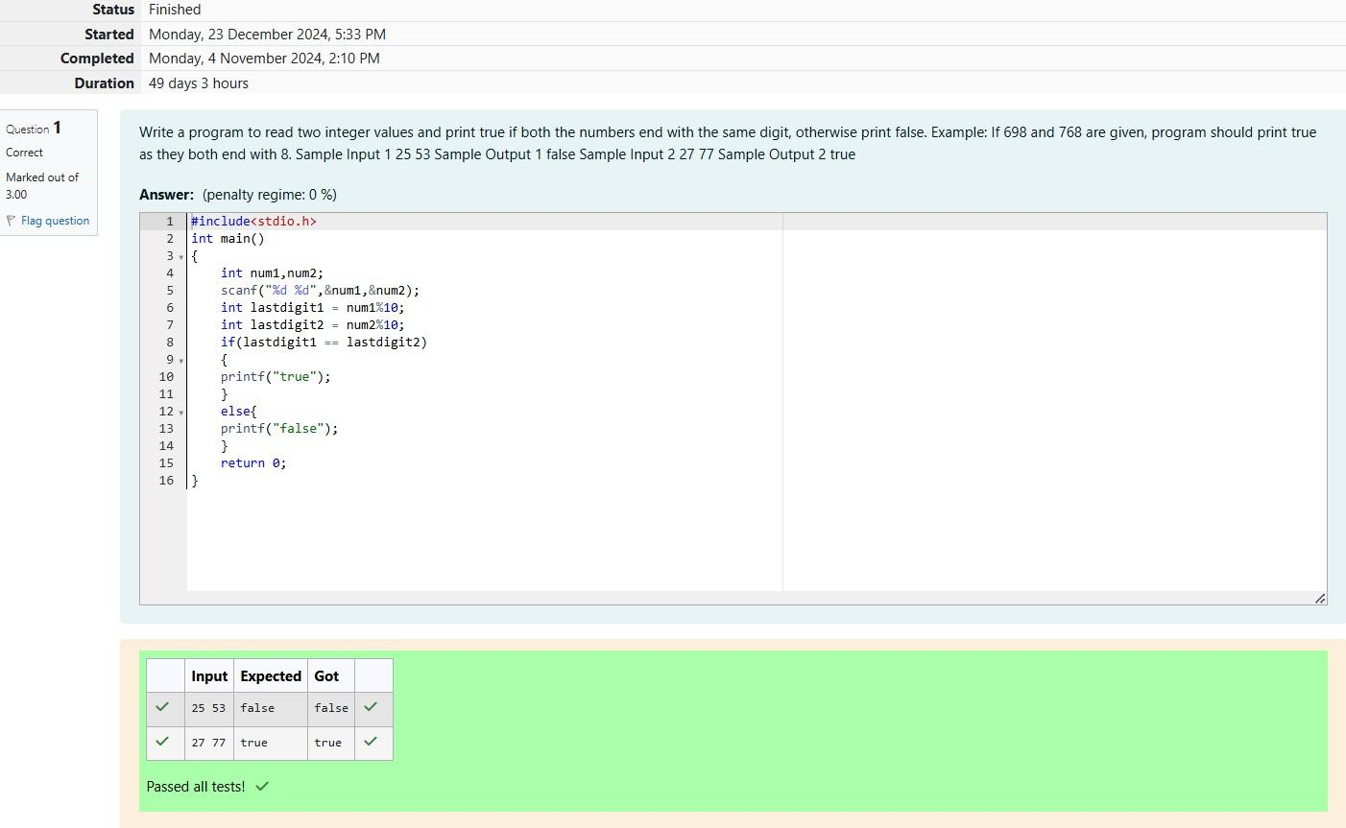

Q2) Problem Statement:

In this challenge, we're getting started with conditional statements.

Task

Given an integer, n, perform the following conditional actions:

If n is odd, print Weird

If n is even and in the inclusive range of 2 to 5, print Not Weird If n is even and in the inclusive range of 6 to 20, print Weird

If n is even and greater than 20, print Not Weird

Complete the stub code provided in your editor to print whether or not n is weird.

Input Format

A single line containing a positive integer, n. Constraints

1<n<100

Output Format

Print Weird if the number is weird; otherwise, print Not Weird.

Sample Input 0

3

Sample Output 0

Weird

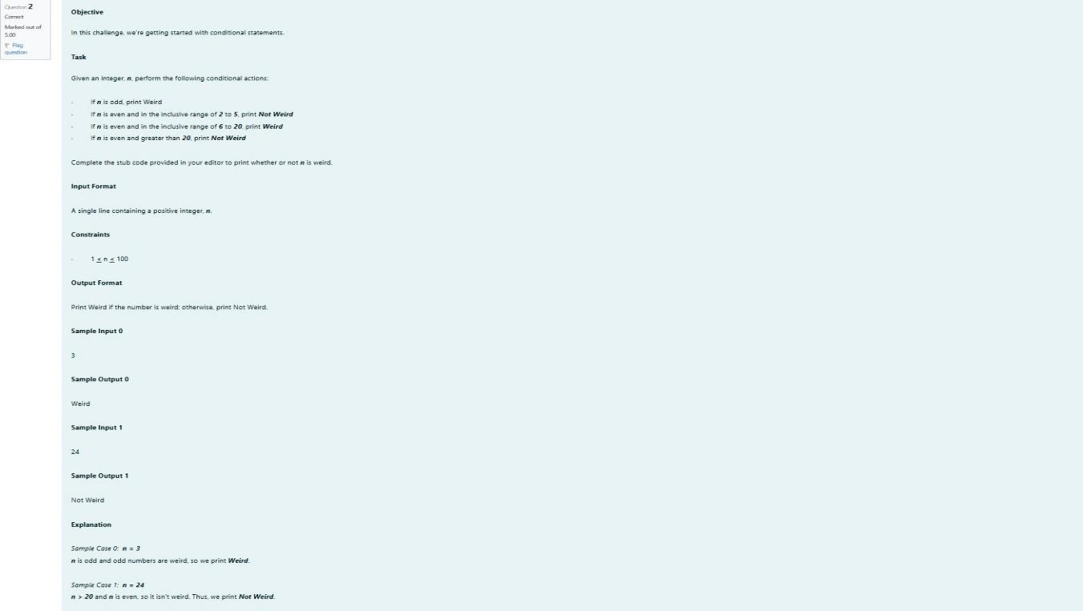

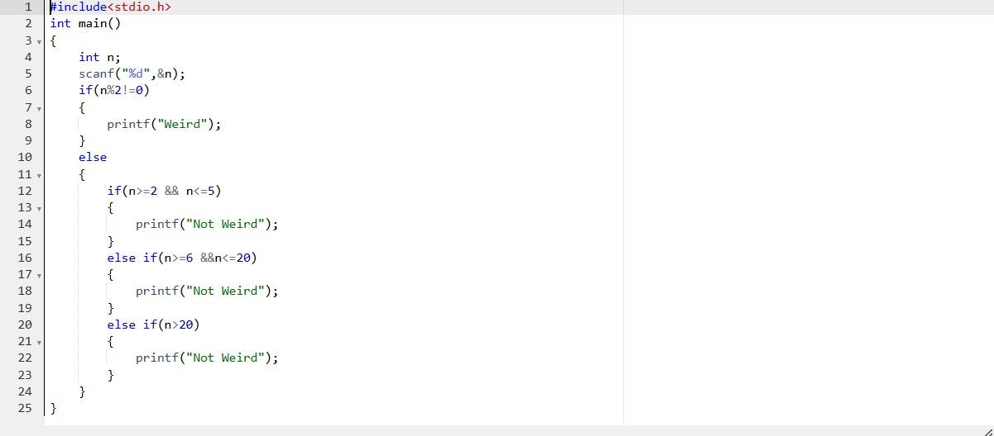

OUTPUT:

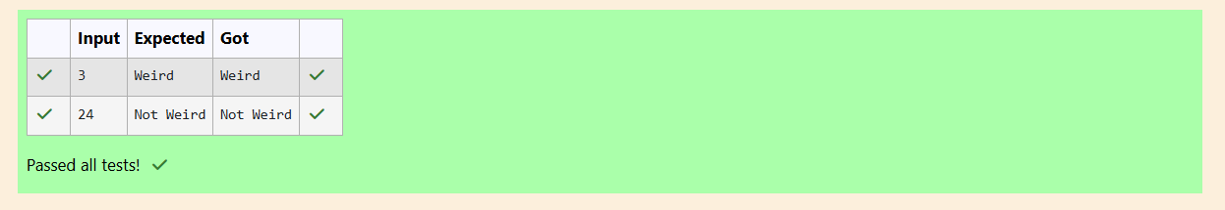

Q3) Problem Statement:

Three numbers form a Pythagorean triple if the sum of squares of two numbers is equal to the square of the third.

For example, 3, 5 and 4 form a Pythagorean triple, since 3*3+4*4=25=6*5

You are given three integers, a, b, and e. They need not be given in increasing order. If they form a Pythagorean triple, then print "yes", otherwise, print "no". Please note that the output message is in small letters.

Sample Input 1

3

5

4

Sample Output 1

Yes

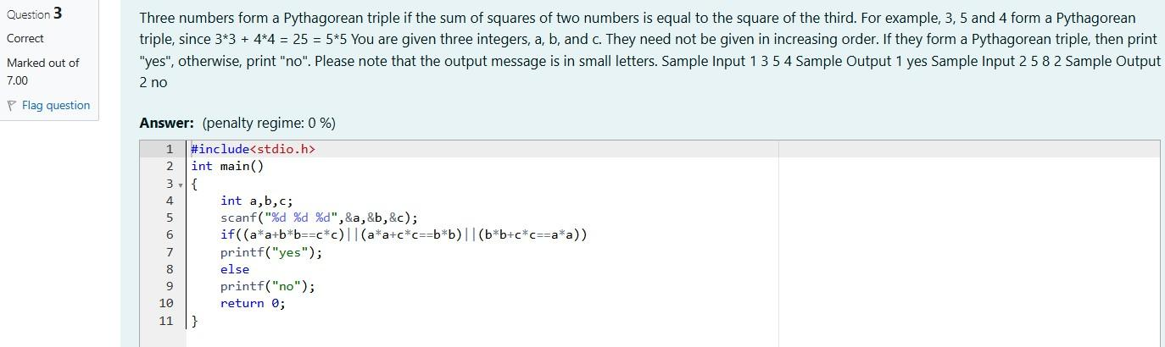

OUTPUT:

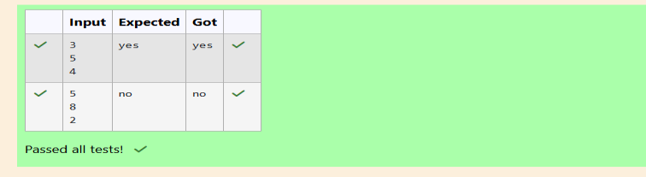

Week:03-02

Q1) Problem Statement:

Write a program that determines the name of a shape from its number of sides. Read the number of sides from the user and then report the appropriate name as part of a meaningful message. Your program should support shapes with anywhere from 3 up to (and including) 10 sides. If a number of sides outside of this range is entered then your program should display an appropriate error

message.

Sample Input 1

3

Sample Output 1

Triangle

Sample Input 2

7

Sample Output 2

Heptagon

Sample Input 3

11

Sample Output 3

The number of sides is not supported.

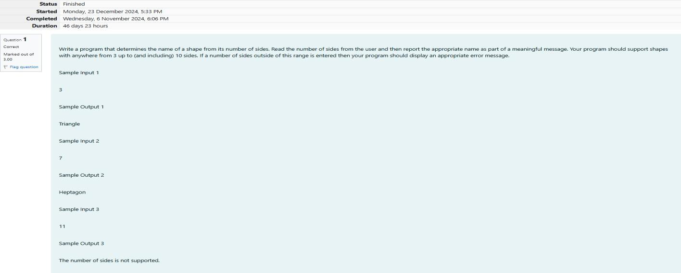

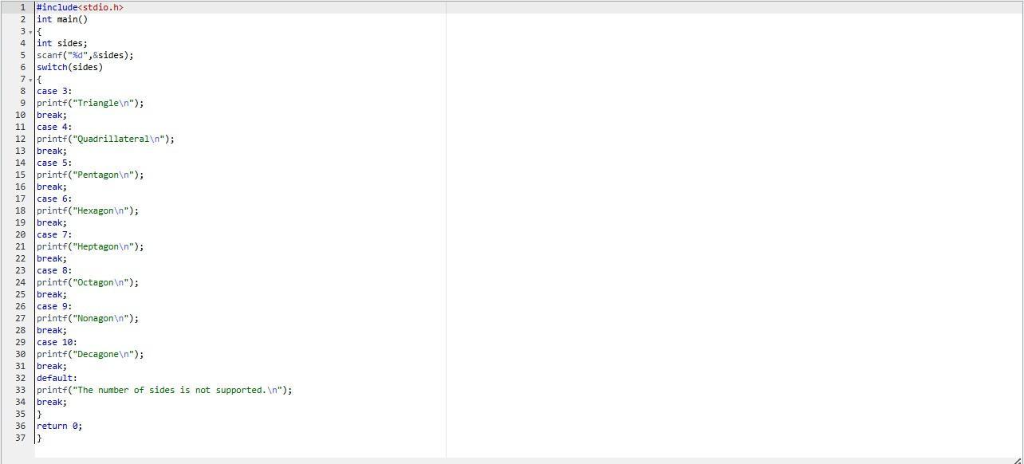

OUTPUT:

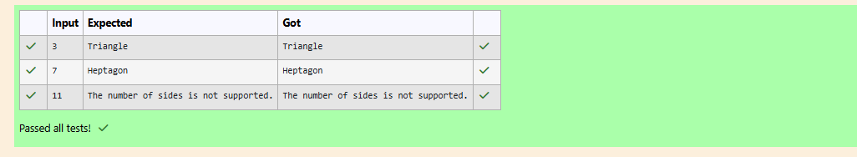

Q2) Problem Statement:

The Chinese zodiac assigns animals to years in a 12-year cycle. One 12-year cycle is shown in the table below. The pattern repeats from there, with 2012 being another year of the Dragon, and 1999 being another year of the Hare.

Year Animal

| 2000 | Dragon |
| --- | --- |
| 2001 | Snake |
| 2002 | Horne |
| 2003 | Sheep |
| 2004 | Monkey |
| 2005 | Rooster |
| 2006 | Dog |
| 2007 | Pig |
| 2008 | Rat |
| 2009 | Ox |

2010 Tiger

2011 Hare

Write a program that reads a year from the user and displays the animal associated with that year. Your program should work correctly for any year greater than or equal to zero, not just the ones listed in the table.

Sample Input 1

2004

Sample Output 1

Monkey

Sample Input 2

2010

Sample Output 2

Tiger

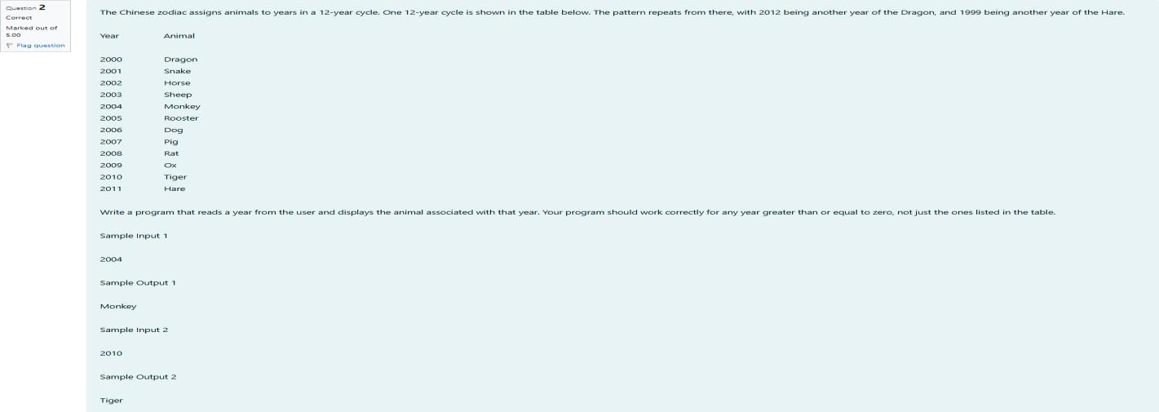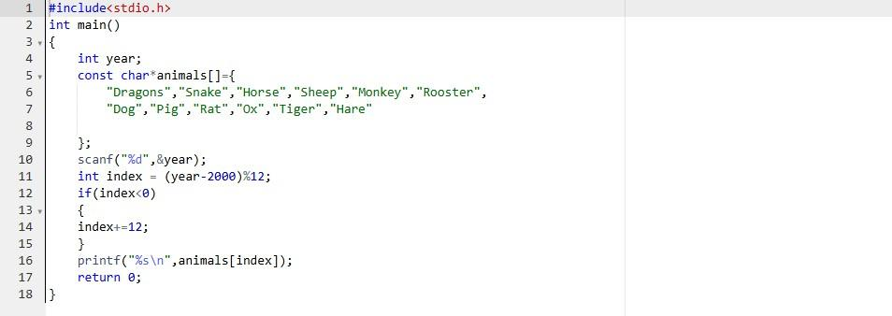

OUTPUT:

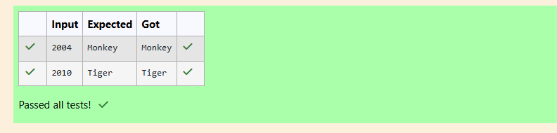

Q3) Problem Statement:

Positions on a chess board are identified by a letter and a number. The letter identifies the column, while the number identifies the row,

Write a program that reads a position from the user. Use an if statement to determine if the column begins with a black square or a white square. Then use modular arithmetic to report the color of the square in that row. For example, if the user enters al then your program should report that the

square is black. If the user enters d5 then your program should report that the square is white. Your program may assume that a valid position will always be entered. It does not need to perform any error checking.

Sample Input 1

A 1

Sample Output 1 The square is black. Sample Input 2

D 5

Sample Output 2

The square is white.

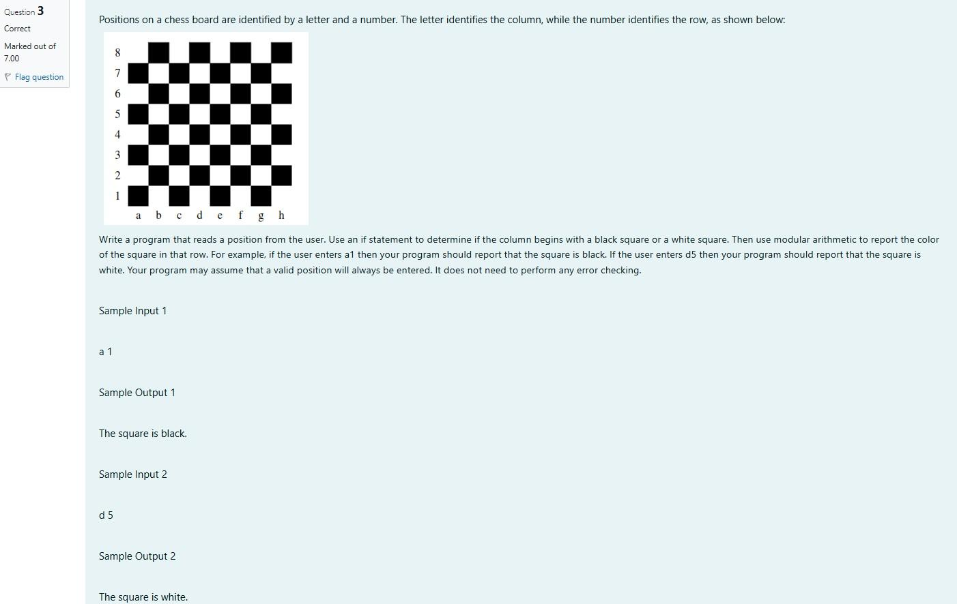

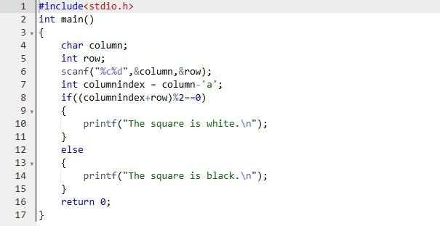

OUTPUT:

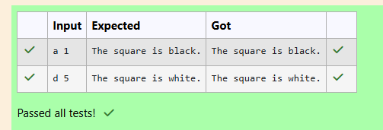

Week:03-03

Q1) Problem Statement:

Some data sets specify dates using the year and day of year rather than the year, month, and day of month. The day of year (DOY) is the sequential day number starting with day 1 on January 1st.

There are two calendars - one for normal years with 365 days, and one for leap years with 366 days. Leap years are divisible by 4. Centuries, Cent like 1900, are not leap years unless they are divisible by

400. So, 2000 was a leap year.

To find the day of year number for a standard date, scan down the Jan column to find the day of month, then scan across to the appropriate month column and read the day of year number.

Reverse the process to find the standard date for a given day of year. Write a program to print the Day of Year of a given date, month and year

Sample Input 1

18

6

2020

Sample Output 1

170

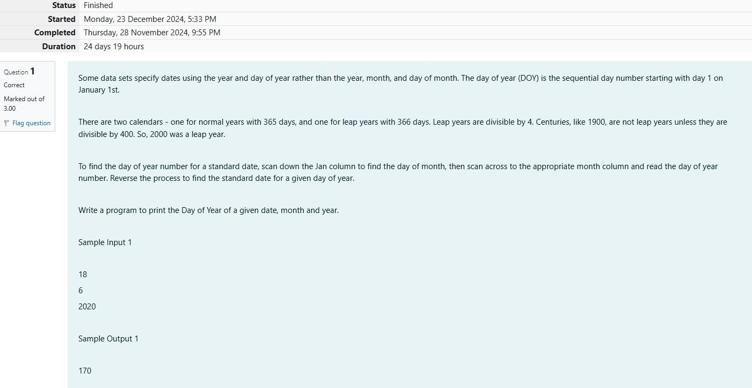

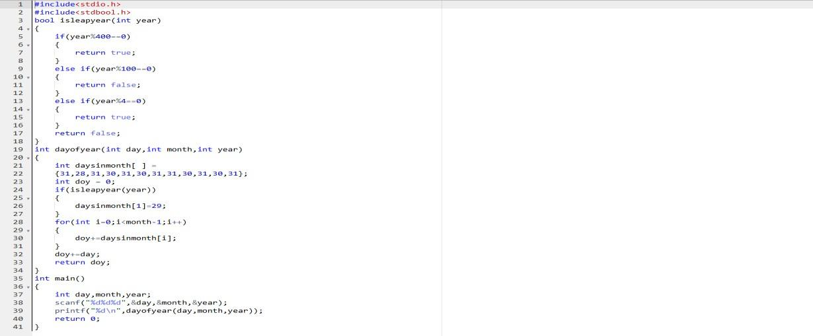

OUTPUT:

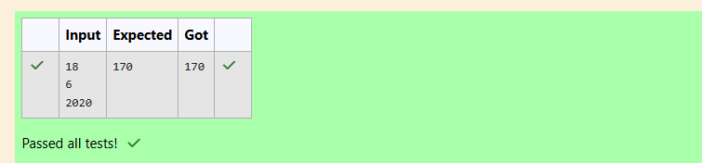

Q2) Problem Statement:

Suppandi is trying to take pan in the local village math qua. In the first round, he is asked about shapes and areas. Suppandi, is confused, he was never any good at math. And also, he is bad at

remembering the names of shapes. Instead, you will I be helping him calculate the area of shapes.

When he says rectangle, he is actually referring to a square.

When he says square, he is actually referring to a triangle.

When he says triangle, he is referring to a rectangle

And when he is confused, he just says something random. At this point, all you can do is say 0.

Help Suppandi by printing the correct answer in an integer.

Input Format

Name of shape (always in upper case R -> Rectangle, S--> Square, T->Triangle)

Length of 1 side

Length of other side

Note: In case of triangle, you can consider the sides as height and length of base

Output Format

Print the area of the shape.

Sample Input 1

T 10

20

Sample Output 1

200

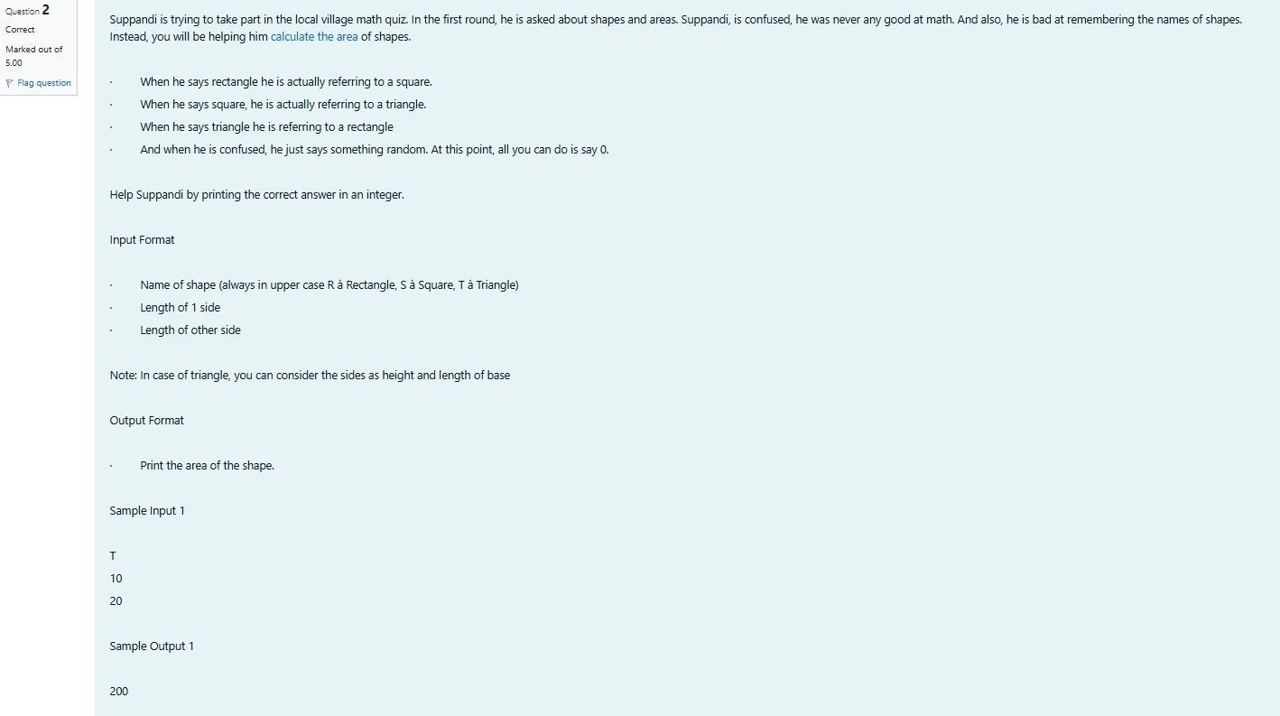

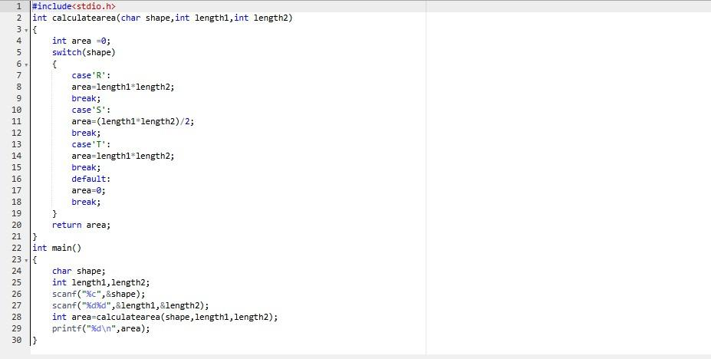

OUTPUT: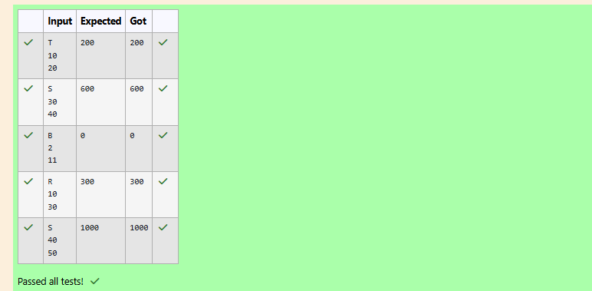

Q3) Problem Statement:

superday he arrives there. They to his home planet. It is very important for him to know which dy week with the fou. They don't follow a 10-day following days: hitney follow

Day Number Name of Day

sunday

monday

tuesday

wednesday

thursday

friday

Saturday

kryptoday

coluday

daxamday

Here are the rules of the calendar:

The calendar starts with Sunday always.

It has only 296 days. After the 296th day, it goes back to Sunday.

You begin your journey on a Sunday and will reach after n. You have to tell on which day you will arrive when you reach there.

Input format:

Contain a number n (0 <n)

Output format:

Print the name of the day you are arriving on

Sample Input

7

Sample Output Kryptonday Sample Input 1

Sample Output

Monday

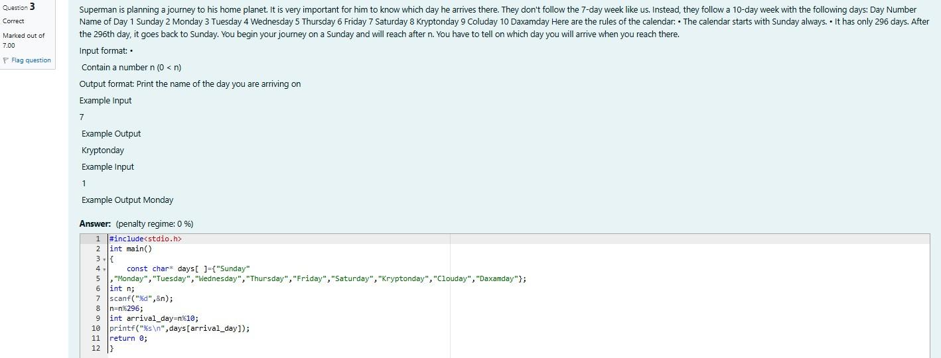

OUTPUT:

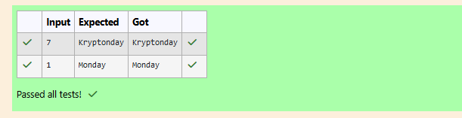

**WEEK 4**

Q1) Alice and Bob are playing a game called "Stone Game". Stone game is a two-player game. Let N be the total number of stones. In each turn, a player can remove either one stone or four stones. The player who picks the last stone, wins. They follow the "Ladies First" norm. Hence Alice is always the one to make the first move. Your task is to find out whether Alice can win, if both play the game

optimally. Input Format

First line starts with T, which is the number of test cases. Each test case will contain N number of stones.

Output Format

Print "Yes" in the case Alice wins, else print "No" Constraints

1<=T<=1000 1<=N<=10000

Sample Input and Output Input

3

1

6

7

Output Yes

Yes No

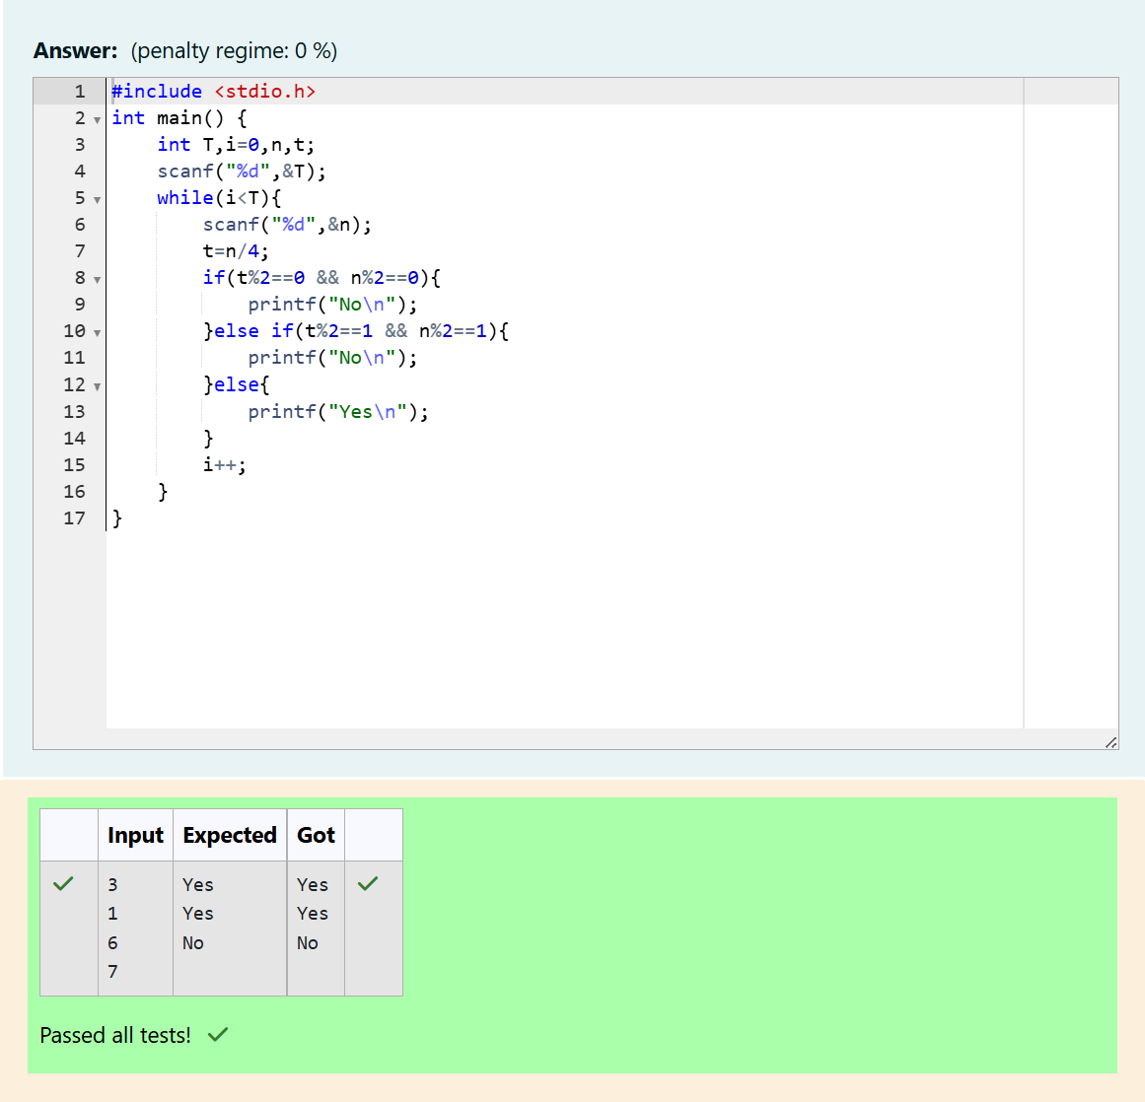

Q2) You are designing a poster which prints out numbers with a unique style applied to each of

them. The styling is based on the number of closed paths or holes present in a given number. The number of holes that each of the digits from 0 to 9 have are equal to the number of closed paths in the digit. Their values are:

1, 2, 3, 5, and 7 = 0 holes.

0, 4, 6, and 9 = 1 hole.

8 = 2 holes.

Given a number, you must determine the sum of the number of holes for all of its digits. For example, the number 819 has 3 holes.

Complete the program, it must must return an integer denoting the total number of holes in num. Constraints 1 ≤ num ≤ 109

Input Format For Custom Testing

There is one line of text containing a single integer num, the value to process. Sample Input

630

Sample Output 2

Explanation

Add the holes count for each digit, 6, 3 and 0. Return 1 + 0 + 1 = 2.

Sample Case 1 Sample Input 1288

Sample Output 4

Explanation

Add the holes count for each digit, 1, 2, 8, 8. Return 0 + 0 + 2 + 2 = 4.

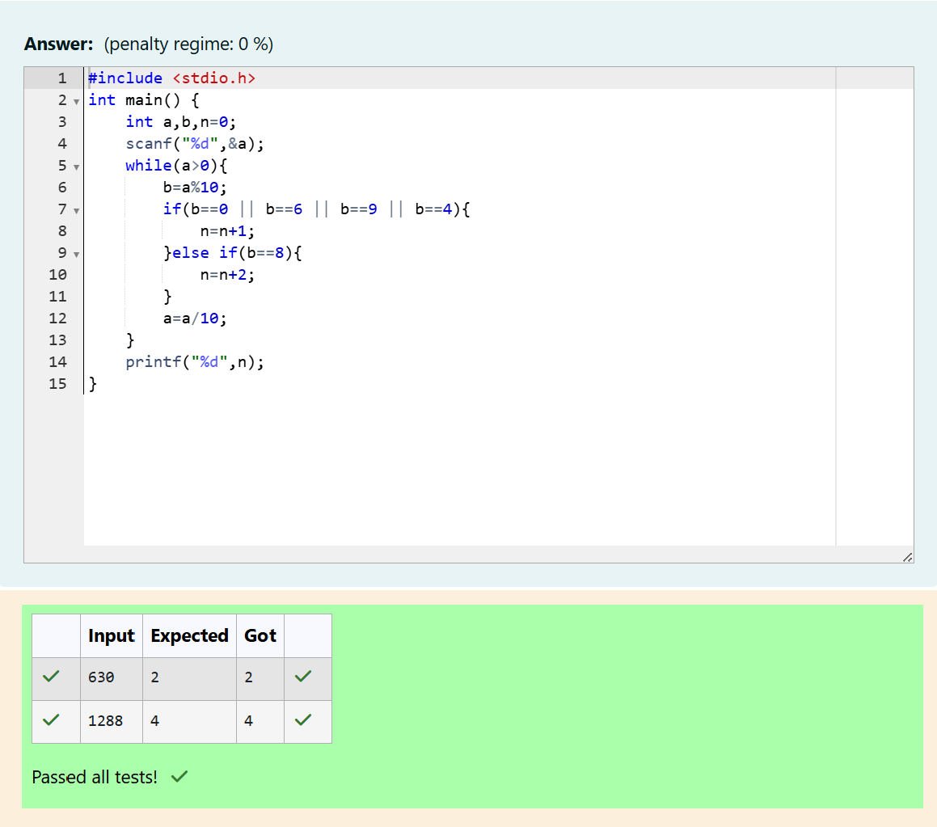

Q3) The problem solvers have found a new Island for coding and named it as Philaland. These smart people were given a task to make a purchase of items at the Island easier by distributing various coins with different values. Manish has come up with a solution that if we make coins category starting from $1 till the maximum price of the item present on Island, then we can purchase any item easily. He added the following example to prove his point.

Let’s suppose the maximum price of an item is 5$ then we can make coins of {$1, $2, $3, $4, $5}to purchase any item ranging from $1 till $5. Now Manisha, being a keen observer suggested that we could actually minimize the number of coins required and gave following distribution {$1, $2, $3}.

According to him any item can be purchased one time ranging from $1 to $5. Everyone was impressed with both of them.

Your task is to help Manisha come up with a minimum number of denominations for any arbitrary max price in Philaland.

Input Format

Contains an integer N denoting the maximum price of the item present on Philaland. Output Format

Print a single line denoting the minimum number of denominations of coins required. Constraints

1<=T<=100 1<=N<=5000

Refer the sample output for formatting Sample Input 1: 10

Sample Output 1: 4

Sample Input 2: 5

Sample Output 2: 3

Explanation: For test case 1, N=10. According to Manish {$1, $2, $3,… $10} must be distributed. But as per Manisha only {$1, $2, $3, $4} coins are enough to purchase any item ranging from $1 to $10. Hence minimum is 4.

Likewise denominations could also be {$1, $2, $3, $5}. Hence answer is still 4.

For test case 2, N=5. According to Manish {$1, $2, $3, $4, $5} must be distributed. But as per Manisha only {$1, $2, $3} coins are enough to purchase any item ranging from $1 to $5. Hence minimum is 3. Likewise, denominations could also be {$1, $2, $4}. Hence answer is still 3.

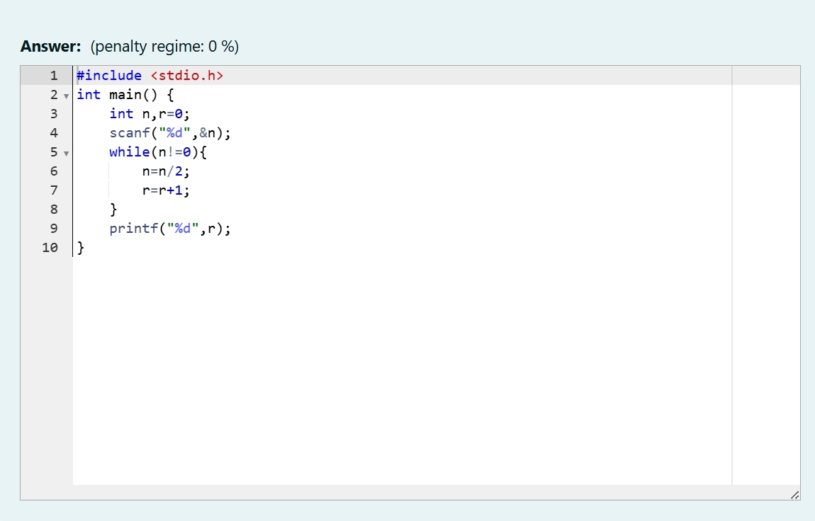

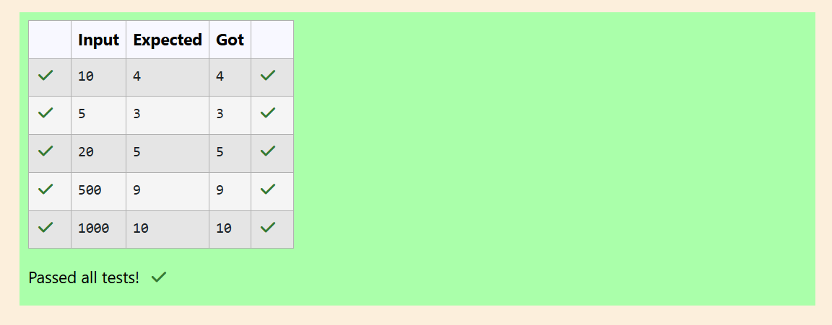

Q4) A set of N numbers (separated by one space) is passed as input to the program. The program must identify the count of numbers where the number is odd number.

Input Format: The first line will contain the N numbers separated by one space. Boundary Conditions: 3 <= N <= 50

The value of the numbers can be from -99999999 to 99999999

Output Format: The count of numbers where the numbers are odd numbers. Example

Input / Output 1:

Input:

5 10 15 20 25 30 35 40 45 50

Output:

5

Explanation:

The numbers meeting the criteria are 5, 15, 25, 35, 45

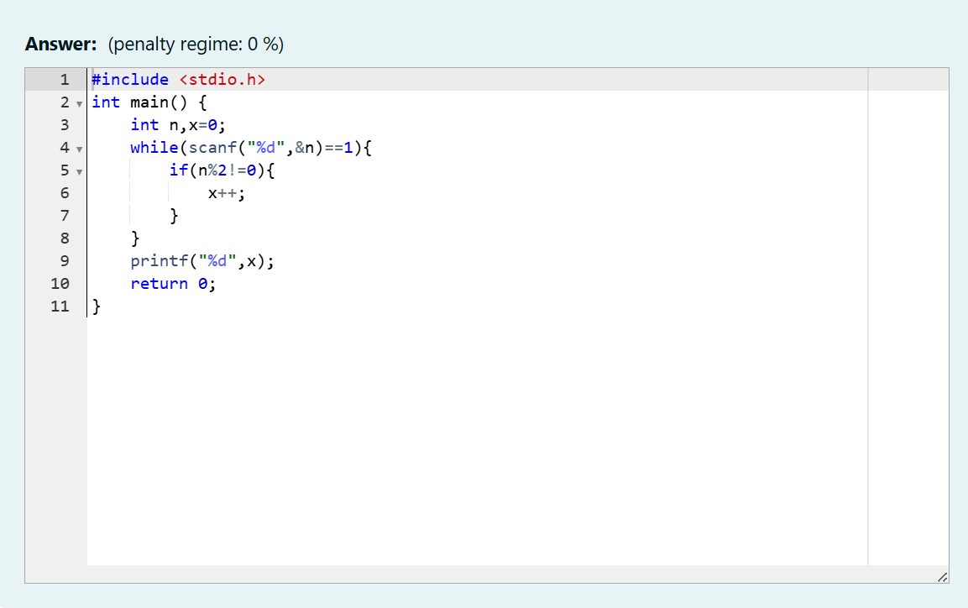

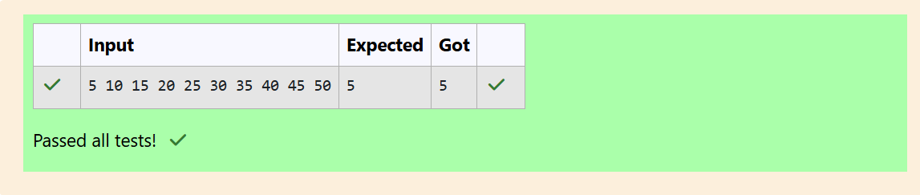

Q5) Given a number N, return true if and only if it is a confusing number, which satisfies the following condition: We can rotate digits by 180 degrees to form new digits. When 0, 1, 6, 8, 9 are rotated 180

degrees, they become 0, 1, 9, 8, 6 respectively. When 2, 3, 4, 5 and 7 are rotated 180 degrees, they become invalid.

A confusing number is a number that when rotated 180 degrees becomes a different number with each digit valid.

Example 1:

6 -> 9

Input: 6 Output: true

Explanation: We get 9 after rotating 6, 9 is a valid number and 9!=6. Example 2: 89 -> 68

Input: 89 Output: true

Explanation: We get 68 after rotating 89, 86 is a valid number and 86!=89.

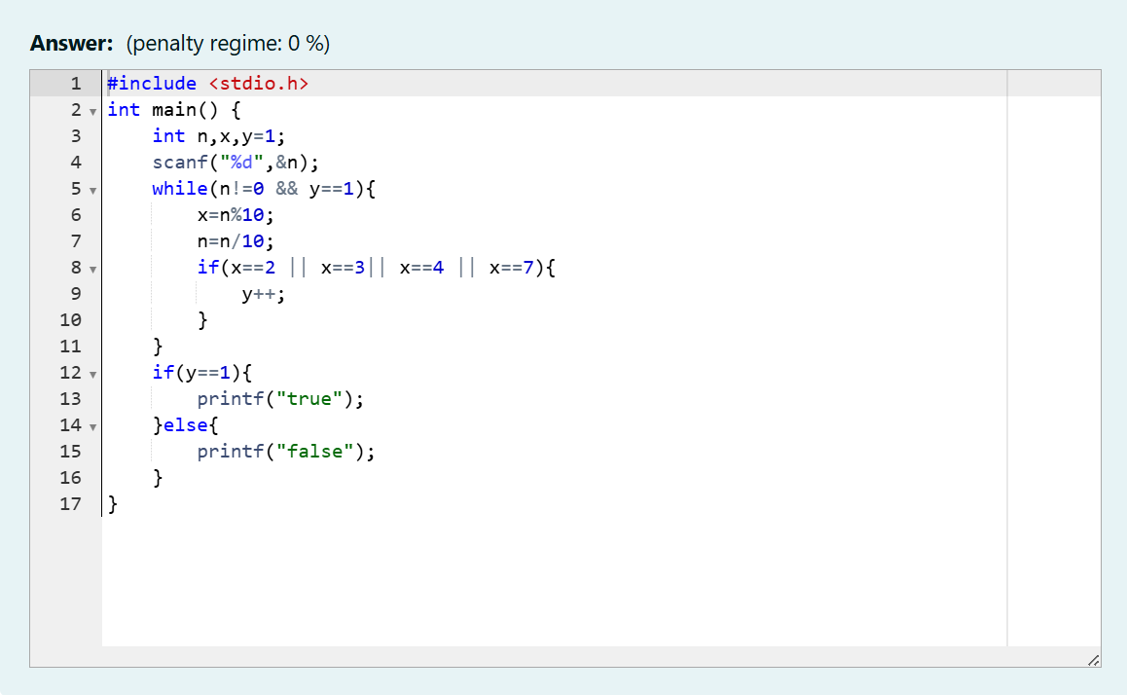

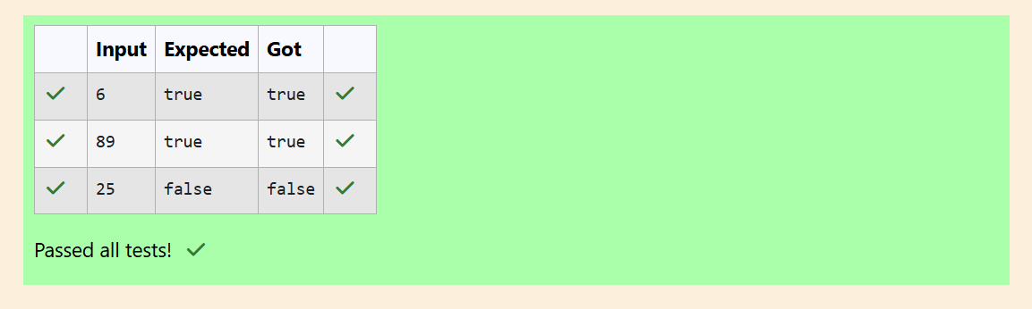

Q6) A nutritionist is labeling all the best power foods in the market. Every food item arranged in a single line, will have a value beginning from 1 and increasing by 1 for each, until all items have a value associated with them. An item's value is the same as the number of macronutrients it has. For example, food item with value 1 has 1 macronutrient, food item with value 2 has 2 macronutrients, and incrementing in this fashion.

The nutritionist has to recommend the best combination to patients, i.e. maximum total of

macronutrients. However, the nutritionist must avoid prescribing a particular sum of macronutrients (an 'unhealthy' number), and this sum is known. The nutritionist chooses food items in the increasing order of their value. Compute the highest total of macronutrients that can be prescribed to a patient, without the sum matching the given 'unhealthy' number.

Here's an illustration:

Given 4 food items (hence value: 1,2,3 and 4), and the unhealthy sum being 6 macronutrients, on choosing items 1, 2, 3-> the sum is 6, which matches the 'unhealthy' sum. Hence, one of the three needs to be skipped. Thus, the best combination is from among:

2 + 3 + 4 = 9

1 + 3 + 4 = 8

1 + 2 + 4 = 7

Since 2 + 3 + 4 = 9, allows for maximum number of macronutrients, 9 is the right answer Complete the code in the editor below.

It must return an integer that represents the maximum total of macronutrients, modulo 1000000007 (109 + 7).

It has the following:

n: an integer that denotes the number of food items k: an integer that denotes the unhealthy number Constraints

1 ≤ n ≤ 2 × 109 1 ≤ k ≤ 4 × 1015 Input Format For Custom Testing

The first line contains an integer, n, that denotes the number of food items. The second line contains an integer, k, that denotes the unhealthy number. Sample Input

0 2 2

Sample Output 0 43 3

Explanation - The following sequence of n = 2 food items: 1. 2. Item 1 has 1 macronutrients. 1 + 2 = 3; observe that this is the max total, and having avoided having exactly k = 2 macronutrients.

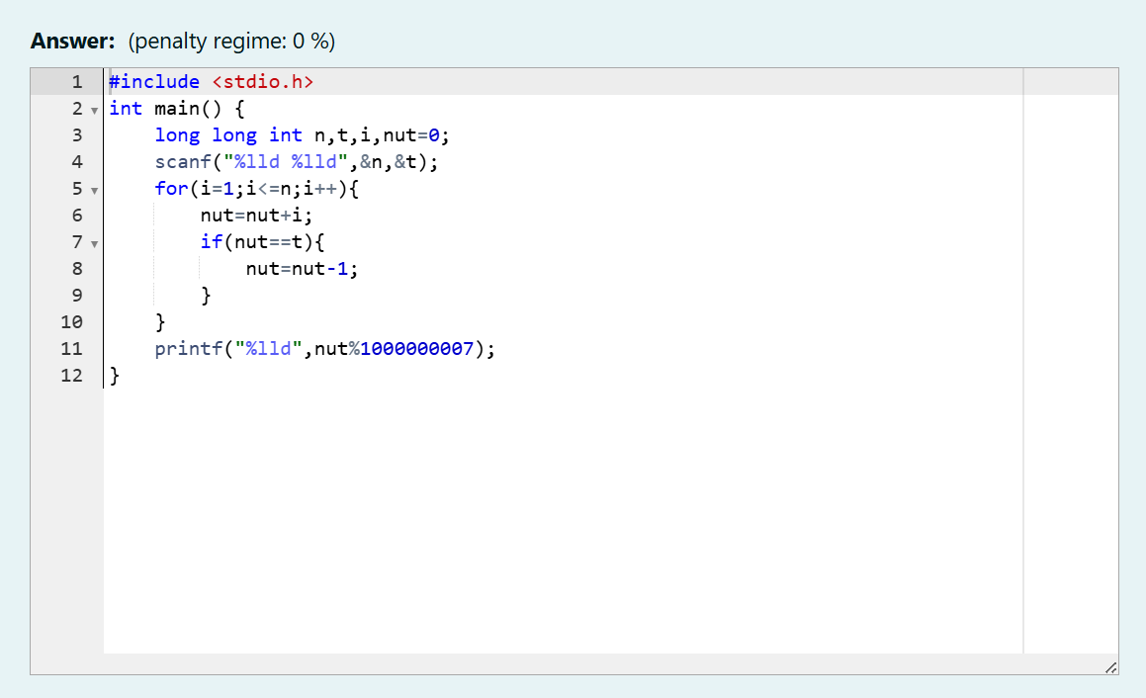

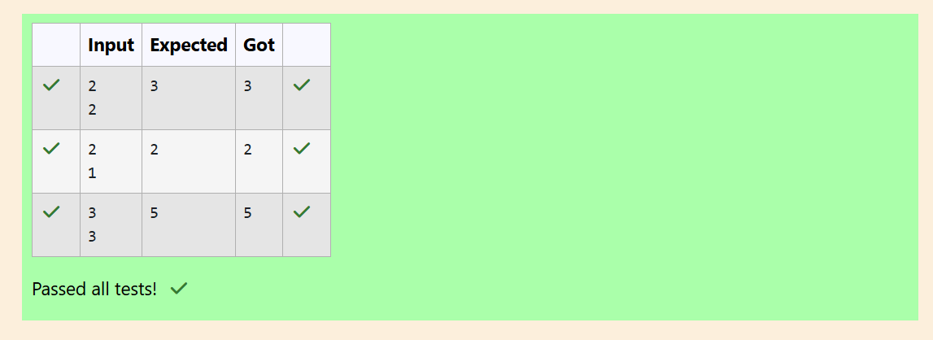

WEEK 5

Q) Write a program that prints a simple chessboard.

Input format:

The first line contains the number of inputs T.

The lines after that contain a different values for size of the chessboard Output format:

Print a chessboard of dimensions size * size. Print a Print W for white spaces and B for black spaces.

Input: 2

3

5

Output:

WBW BWB WBW WBWBW BWBWB WBWBW BWBWB WBWBW

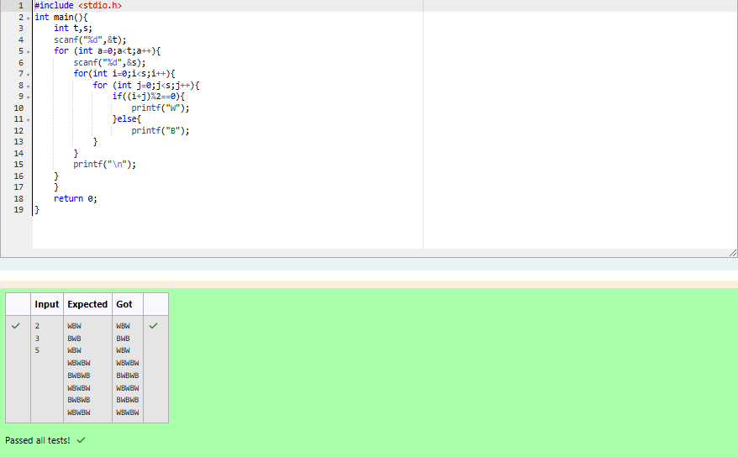

Q) Let’s print a chessboard!

Write a program that takes input:

The first line contains T, the number of test cases

Each test case contains an integer N and also the starting character of the chessboard Output Format

Print the chessboard as per the given examples Sample Input / Output

Input: 2

2 W

3 B

Output: WB

BW BWB WBW BWB

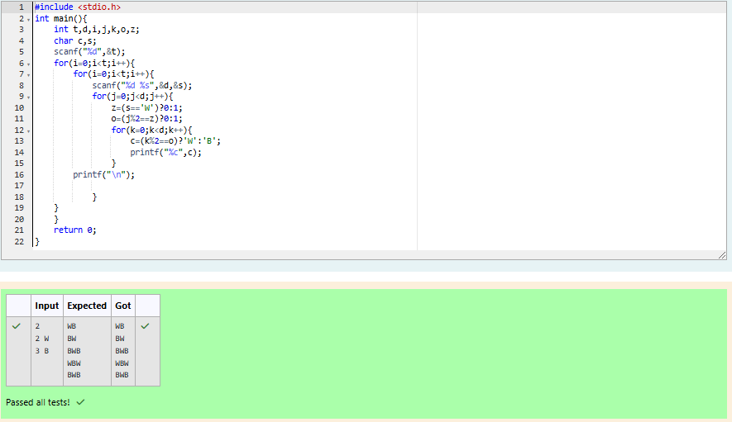

Q) Decode the logic and print the Pattern that corresponds to given input.

If N= 3

then pattern will be : 10203010011012

**4050809

****607

If N= 4, then pattern will be: 1020304017018019020

**50607014015016

****809012013

******10011

Constraints

2 <= N <= 100

Input Format

First line contains T, the number of test cases Each test case contains a single integer N Output

First line print Case #i where i is the test case number In the subsequent line, print the pattern

Test Case 1

3

3

4

5

Output

Case #1

10203010011012

**4050809

****607

Case #2

1020304017018019020

**50607014015016

****809012013

******10011

Case #3

102030405026027028029030

**6070809022023024025

****10011012019020021

******13014017018

********15016

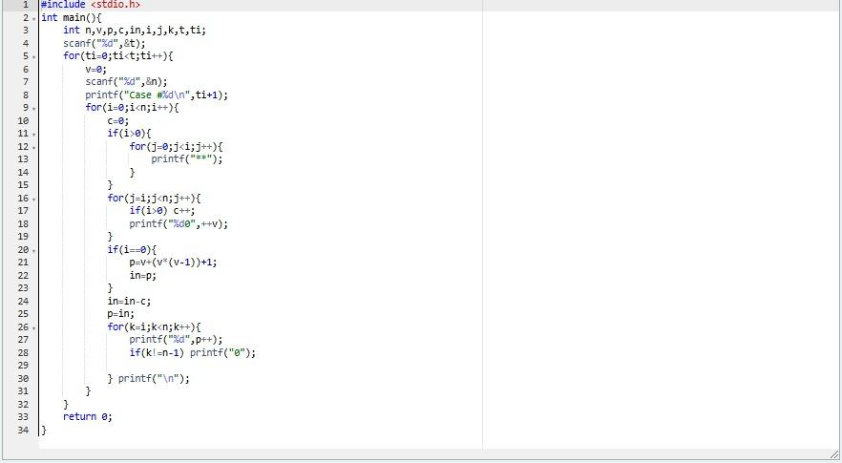

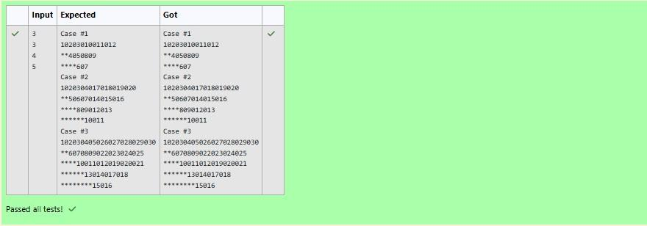

Q) The k-digit number N is an Armstrong number if and only if the k-th power of each digit sums to N.

Given a positive integer N, return true if and only if it is an Armstrong number. Example 1:

Input:

153

Output:

true Explanation:

153 is a 3-digit number, and 153 = 1^3 + 5^3 + 3^3. Example 2:

Input:

123

Output:

false Explanation:

123 is a 3-digit number, and 123 != 1^3 + 2^3 + 3^3 = 36.

Example 3: Input:

1634

Output:

true Note:

1 <= N <= 10^8

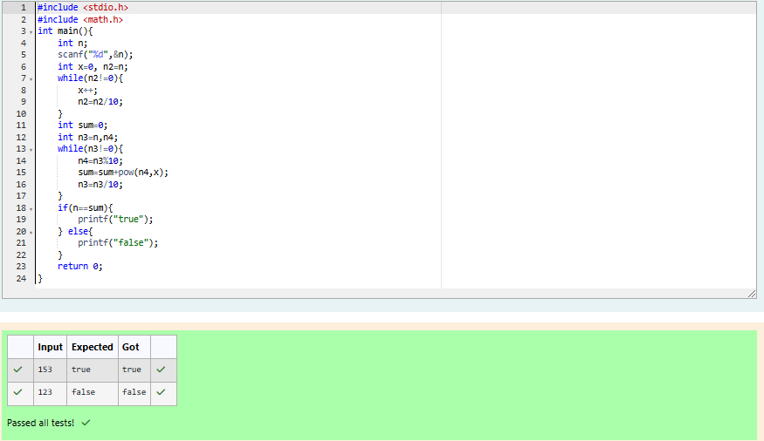

Q) Take a number, reverse it and add it to the original number until the obtained number is a palindrome. Constraints 1<=num<=99999999 Sample Input 1 32 Sample Output1 55

Sample Input 2 789 Sample Output 2 66066

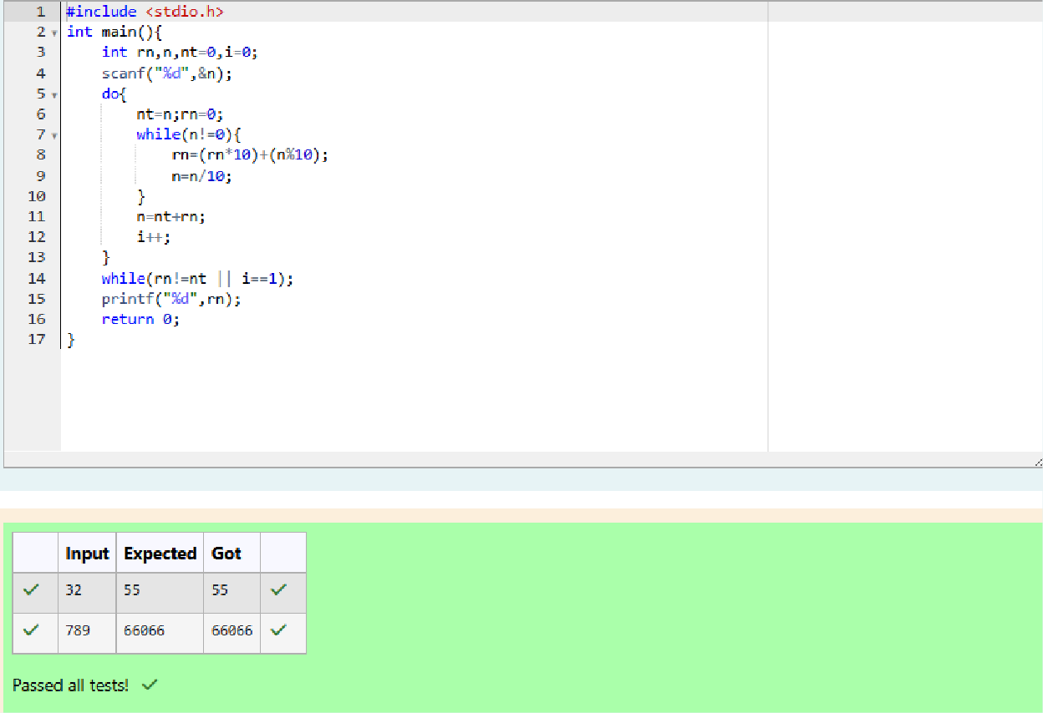

Q) A number is considered lucky if it contains either 3 or 4 or 3 and 4 both in it. Write a program to print the nth lucky number. Example, 1st lucky number is 3, and 2nd lucky number is 4 and 3rd lucky number is 33 and 4th lucky number is 34 and so on. Note that 13, 40 etc., are not lucky as they have other numbers in it.

The program should accept a number 'n' as input and display the nth lucky number as output.

Sample Input 1:

3

Sample Output 1:

33

Explanation:

Here the lucky numbers are 3, 4, 33, 34., and the 3rd lucky number is 33.

Sample Input 2:

34

Sample Output 2:

33344

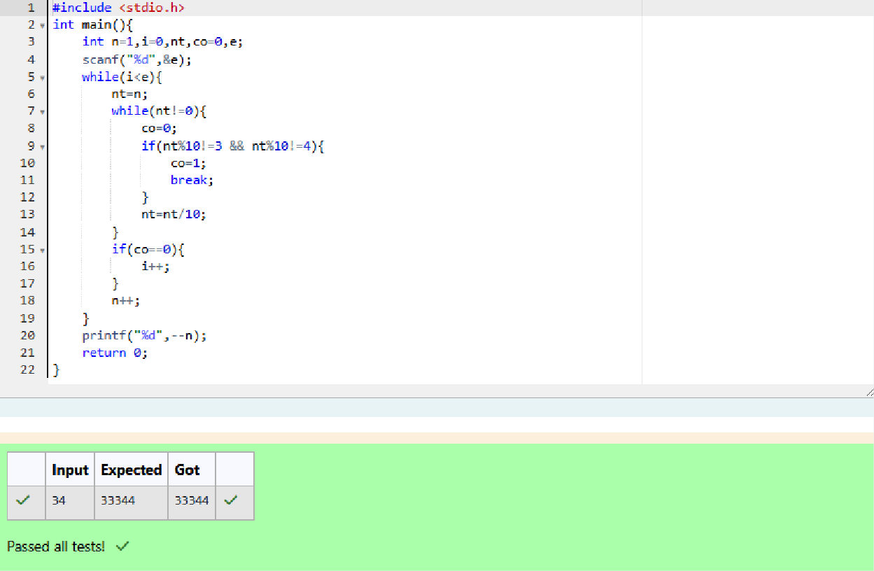

**WEEK 6**

Q1) Objective

In this challenge, we're going to use loops to help us do some simple math. Check out the Tutorial tab to learn more.

Task

Given an integer, ***n***, print its first ***10*** multiples. Each multiple ***n X i*** (where ***1 ≤ i ≤ 10***) should be printed on a new line in the form: n x i = result.

Input Format

A single integer, ***n***. Constraints

***2 ≤ n ≤ 20***

Output Format

Print ***10*** lines of output; each line ***i*** (where ***1 ≤ i ≤ 10***) contains the ***result*** of ***n X i*** in the form: n x i = result.

Sample Input 2

Sample Output 2 x 1 = 2

2 x 2 = 4

2 x 3 = 6

2 x 4 = 8

2 x 5 = 10

2 x 6 = 12

2 x 7 = 14

2 x 8 = 16

2 x 9 = 18

2 x 10 = 20

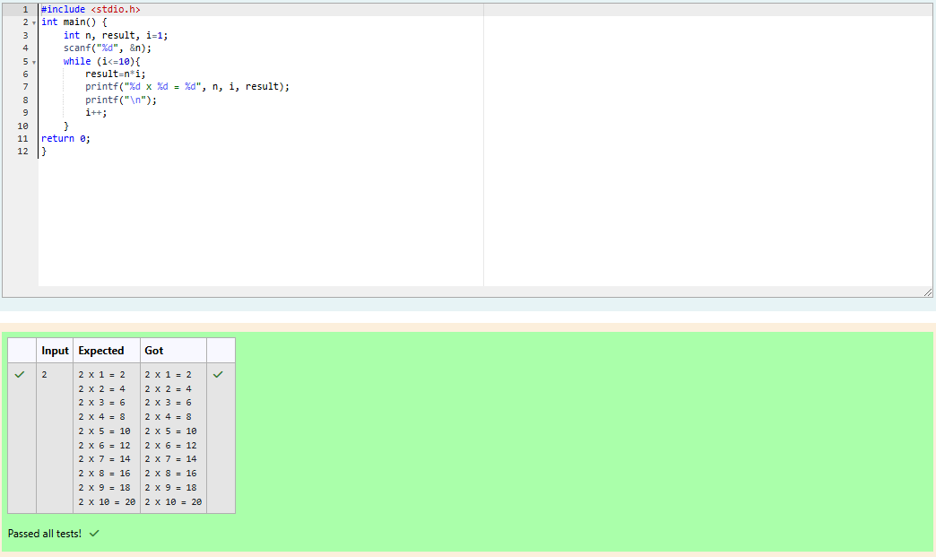

Q2) A nutritionist is labelling all the best power foods in the market. Every food item arranged in a single line, will have a value beginning from 1 and increasing by 1 for each, until all items have a value associated with them. An item's value is the same as the number of macronutrients it has. For example, food item with value 1 has 1 macronutrient, food item with value 2 has 2 macronutrients, and

incrementing in this fashion.

The nutritionist has to recommend the best combination to patients, i.e. maximum total of

macronutrients. However, the nutritionist must avoid prescribing a particular sum of macronutrients (an 'unhealthy' number), and this sum is known. The nutritionist chooses food items in the increasing order of their value. Compute the highest total of macronutrients that can be prescribed to a patient, without the sum matching the given 'unhealthy' number.

Here's an illustration:

Given *4* food items (hence value: *1,2,3* and *4*), and the unhealthy sum being *6* macronutrients, on choosing items *1, 2, 3* -> the sum is *6,* which matches the 'unhealthy' sum. Hence, one of the three needs to be skipped. Thus, the best combination is from among:

· *2 + 3 + 4 = 9*

· *1 + 3 + 4 = 8*

· *1 + 2 + 4 = 7*

Since *2 + 3 + 4 = 9,* allows for maximum number of macronutrients, 9 is the right answer.

Complete the code in the editor below. It must return an integer that represents the maximum total of macronutrients, modulo *1000000007 (109 + 7)*

It has the following:

*n:* an integer that denotes the number of food items

*k:* an integer that denotes the unhealthy number

**Constraints**

· *1 ≤ n ≤ 2 × 109*

· *1 ≤ k ≤ 4 × 1015*

Input Format for Custom Testing

The first line contains an integer, *n*, that denotes the number of food items. The second line contains an integer, *k*, that denotes the unhealthy number. **Sample Input 0**

2

2

**Sample Output 0**

3

**Explanation 0**

The following sequence of *n = 2* food items:

Item 1 has 1 macronutrients.

*1 + 2 = 3*; observe that this is the max total, and having avoided having exactly *k = 2* macronutrients.

**Sample Input 1**

2

1

**Sample Output 1**

2

**Explanation 1**

Cannot use item *1* because *k = 1* and *sum ≡ k* has to be avoided at any time.

Hence, max total is achieved by *sum = 0 + 2 = 2*.

Sample Case 2

**Sample Input for Custom Testing Sample Input 2**

3

3

**Sample Output 2**

5

**Explanation 2**

*2 + 3 = 5, i*s the best case for maximum nutrients.

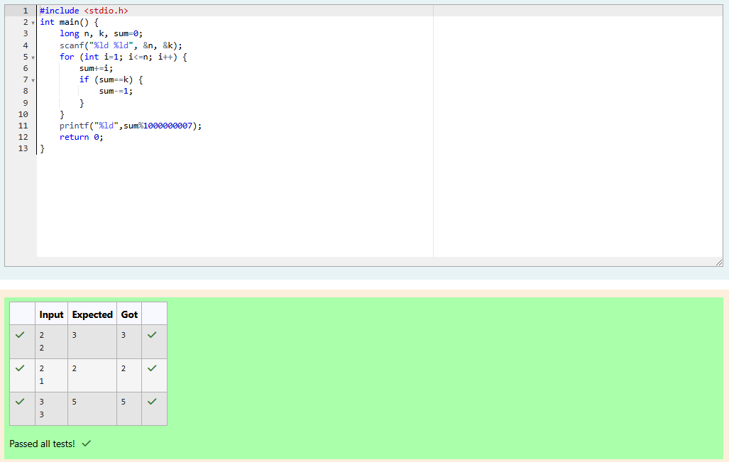

Q3) Determine all positive integer values that evenly divide into a number, its factors. Return the *pth* element of your list, sorted ascending. If there is no *pth* element, return *0*.

For example, given the number *n = 20*, its factors are *{1,2,4,5,10,20}*. Using **1-based indexing** if *p = 3*, return *4*. If *p > 6*, return *0*.

Complete the code in the editor below. The function should return a long integer value of the *pth* integer factor of *n*.

It has the following:

*n:* an integer

*p:* an integer

**Constraints**

· *1 ≤ n ≤ 1015*

· *1 ≤ p ≤ 109*

Input Format for Custom Testing

Input from stdin will be processed as follows and passed to the function. The first line contains an integer *n*, the number to factor.

The second line contains an integer *p*, the 1-based index of the factor to return.

**Sample Input 0**

10

3

**Sample Output 0**

5

**Explanation 0**

Factoring *n = 10* we get *{1, 2, 5, 10}*. We then return the *p = 3rd* factor as our answer.

**Sample Input 1**

10

5

**Sample Output 1**

0

**Explanation 1**

Factoring *n = 10* we get *{1, 2, 5, 10}*. There are only *4* factors and *p = 5*. We return *0* as our answer.

**Sample Input 2**

1

1

**Sample Output 2**

1

**Explanation 2**

Factoring *n = 1* we get *{1}*. We then return the *p = 1st* factor as our answer.

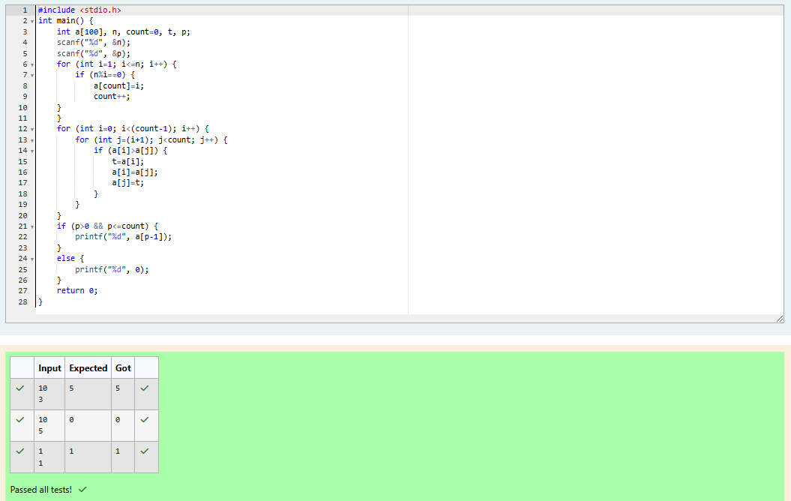

Week 07

**Q1) Problem Statement:**

Sunny and Johnny like to pool their money and go to the ice cream parlor. Johnny never buys the same flavor that Sunny does. The only other rule they have is that they spend all of their

money.Given a list of prices for the flavors of ice cream, select the two that will cost all of the money they have.For example, they have m = 6 to spend and there are flavors costing cost = [1, 2, 3, 4, 5, 6]. The two flavors costing 1 and 5 meet the criteria. Using 1-based indexing, they are at indices 1 and 4 Complete the code in the editor below. It should return an array containing the indices of the prices of the two flavors they buy, sorted ascending.

It has the following:

m: an integer denoting the amount of money they have to spend cost: an integer array denoting the cost of each flavor of ice cream **Input Format:**

The first line contains an integer, t, denoting the number of trips to the ice cream parlor. The next t sets of lines each describe a visit. Each trip is described as follows:

The integer m, the amount of money they have pooled.

The integer n, the number of flavors offered at the time.

n space-separated integers denoting the cost of each flavor: cost[cost[1], cost[2], ..., cost[n]].Note: The index within the cost array represents the flavor of the ice cream purchased.

Constraints:

1 ≤ t ≤ 50

2 ≤ m ≤ 104

2 ≤ n ≤ 104

1 ≤ cost[i] ≤ 104, ∀ i ∈ [1, n]

There will always be a unique solution.

**Output Format:**

For each test case, print two space-separated integers denoting the indices of the two flavors purchased, in ascending order.

**Sample Input:**

2

4

5

1 4 5 3 2

4

4

2 2 4 3

**Sample Output:**

1 4

1 2

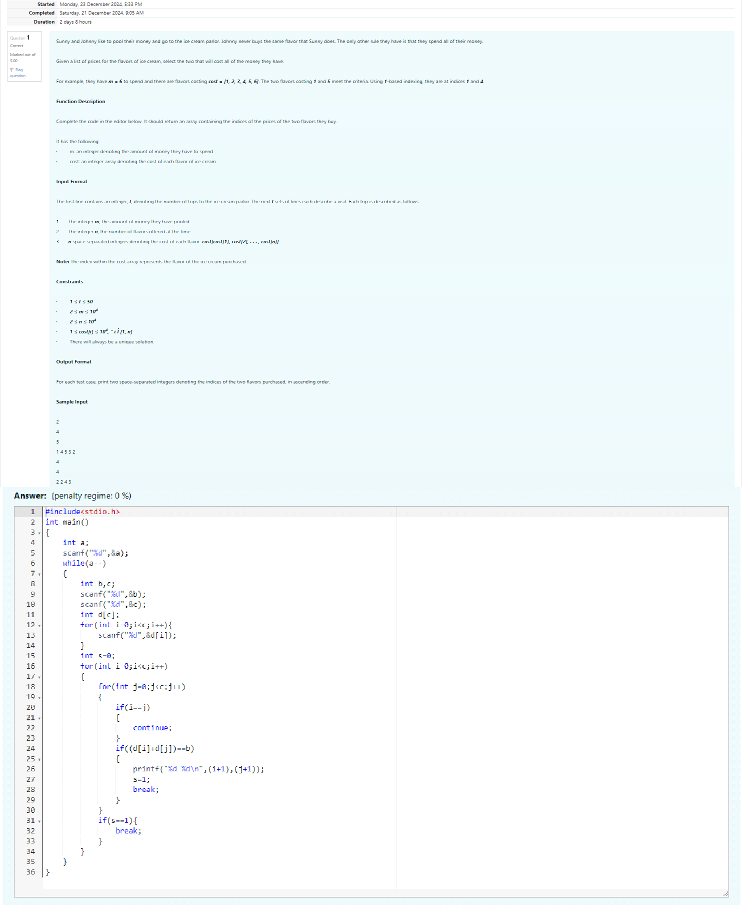

Output: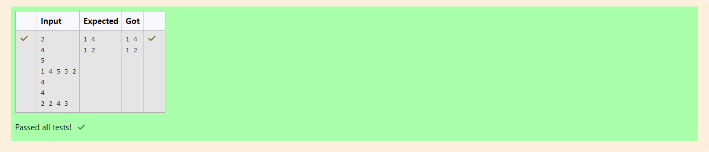

**Q2) problem statement:**

Numeros the Artist had two lists that were permutations of one another. He was very proud.

Unfortunately, while transporting them from one exhibition to another, some numbers were lost out of the first list. Can you find the missing numbers?

As an example, the array with some numbers missing, arr = [7, 2, 6, 5, 3, 5, 3]. The original array of

numbers brr = [7, 2, 5, 4, 6, 3, 5, 3]. The numbers missing are [4, 6].

**Notes:**

If a number occurs multiple times in the lists, you must ensure that the frequency of that number in both lists is the same. If that is not the case, then it is also a missing number.

You have to print all the missing numbers in ascending order.Print each missing number once, even if it is missing multiple timesThe difference between the maximum and minimum number in the

second list is less than or equal to 100.

Complete the code in the editor below. It should return a sorted array of missing numbers. It has the following:

arr: the array with missing numbers brr: the original array of numbers **Input Format:**

There will be four lines of input:

n - the size of the first list, arr

The next line contains n space-separated integers arr[i]

m - the size of the second list, brr

The next line contains m space-separated integers brr[i] Constraints:

1 ≤ n, m ≤ 2 × 105, 1 ≤ arr[i], brr[i] ≤ 2 × 104, Xmax − Xmin < 101

**Output Format:**

Output the missing numbers in ascending order.

**Sample Input:**

10

203 204 205 206 207 208 203 204 205 206

13

203 204 204 205 206 207 205 208 203 206 205 206 204

**Sample Output:**

204 205 206

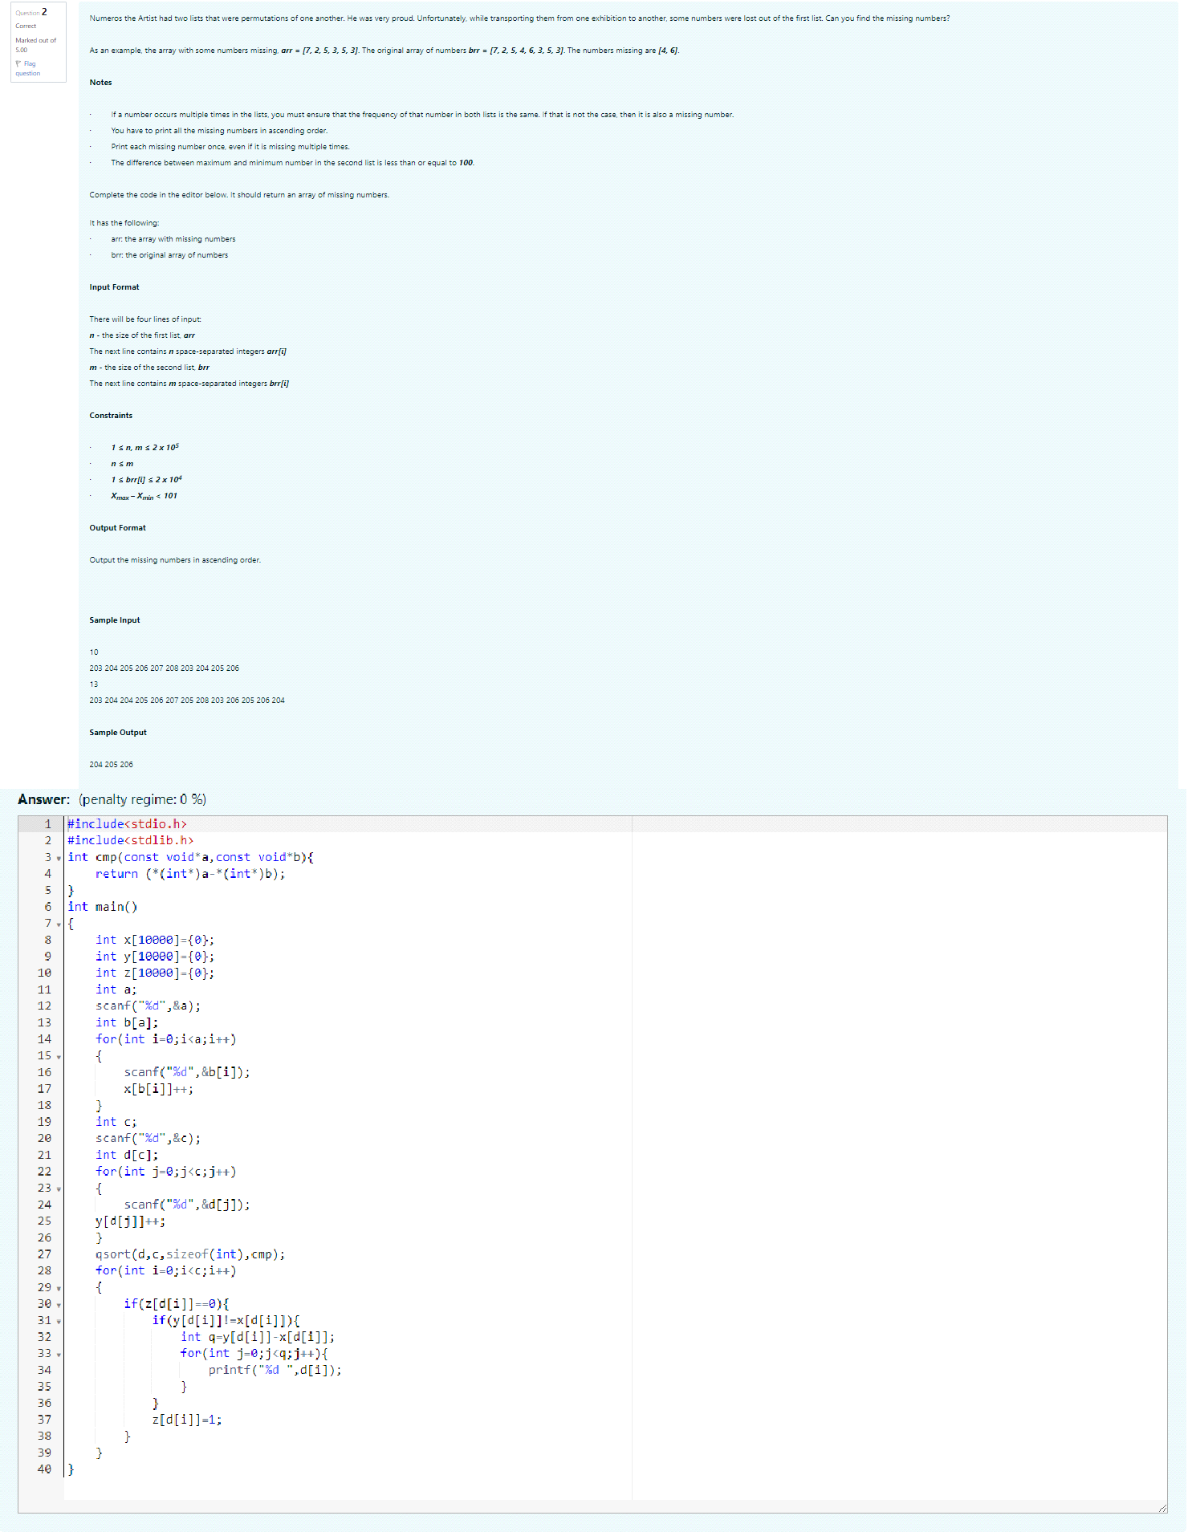

Output:

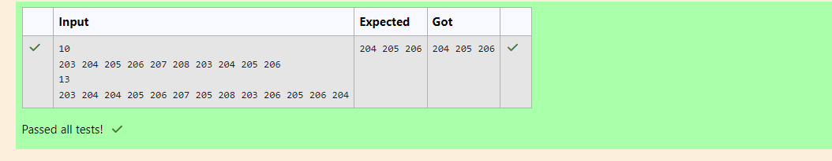

**Q3) Problem Statement:**

Watson gives Sherlock an array of integers. His challenge is to find an element of the array such that the sum of all elements to the left is equal to the sum of all elements to the right. For instance, given the array arr = [5, 6, 8, 11], 8 is between two subarrays that sum to 11. If your starting array is [1], that element satisfies the rule as left and right sums to 0. You will be given arrays of integers and must determine whether there is an element that meets the criterion.

Complete the code in the editor below. It should return a string, either YES if there is an element meeting the criterion or NO otherwise. It has the following: arr: an array of integers.

**Input Format:**

The first line contains T, the number of test cases. The next T pairs of lines each represent a test case.

The first line contains n, the number of elements in the array arr.

The second line contains n space-separated integers arr[i] where 0 ≤ i < n. Constraints:

1 ≤ T ≤ 10, 1 ≤ n ≤ 105, 1 ≤ arr[i] ≤ 2 x 104, 0 ≤ i ≤ n

**Output Format:**

For each test case print YES if there exists an element in the array, such that the sum of the elements on its left is equal to the sum of the elements on its right; otherwise print NO. **Sample Input 0:**

2

3

1 2 3

4

1 2 3 3

**Sample Output 0:**

NO YES

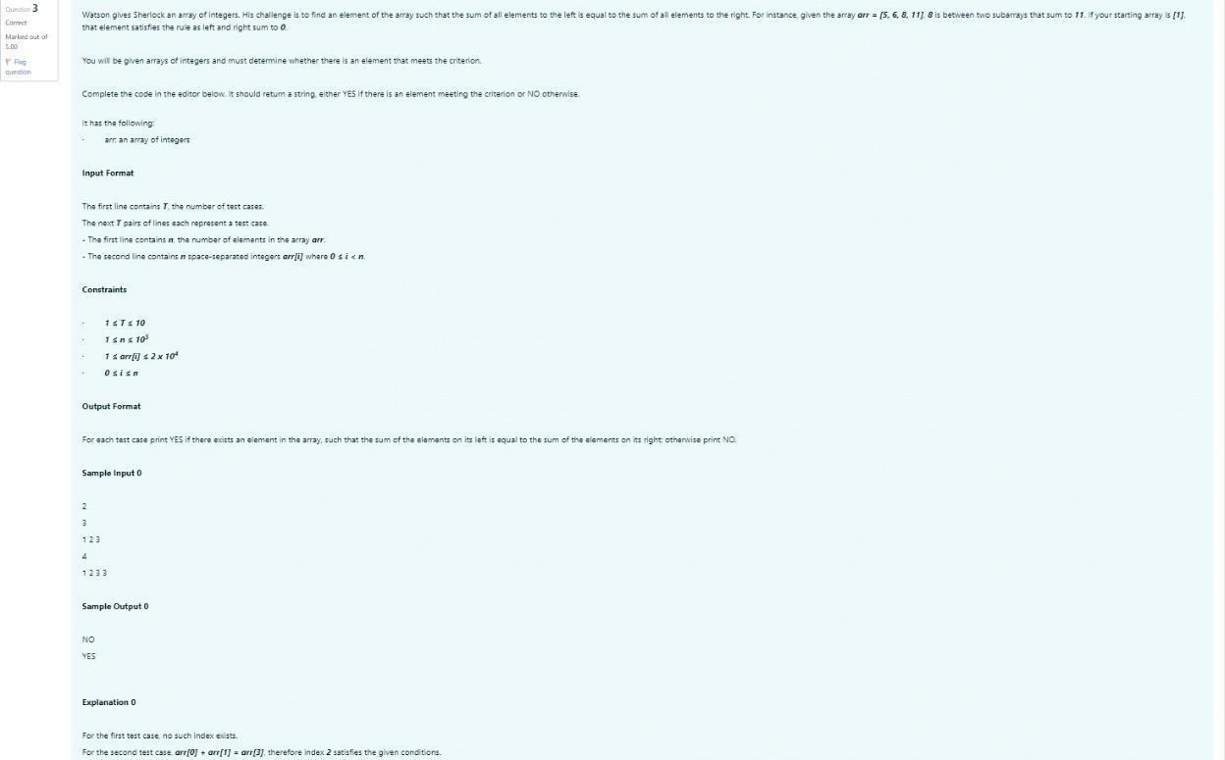

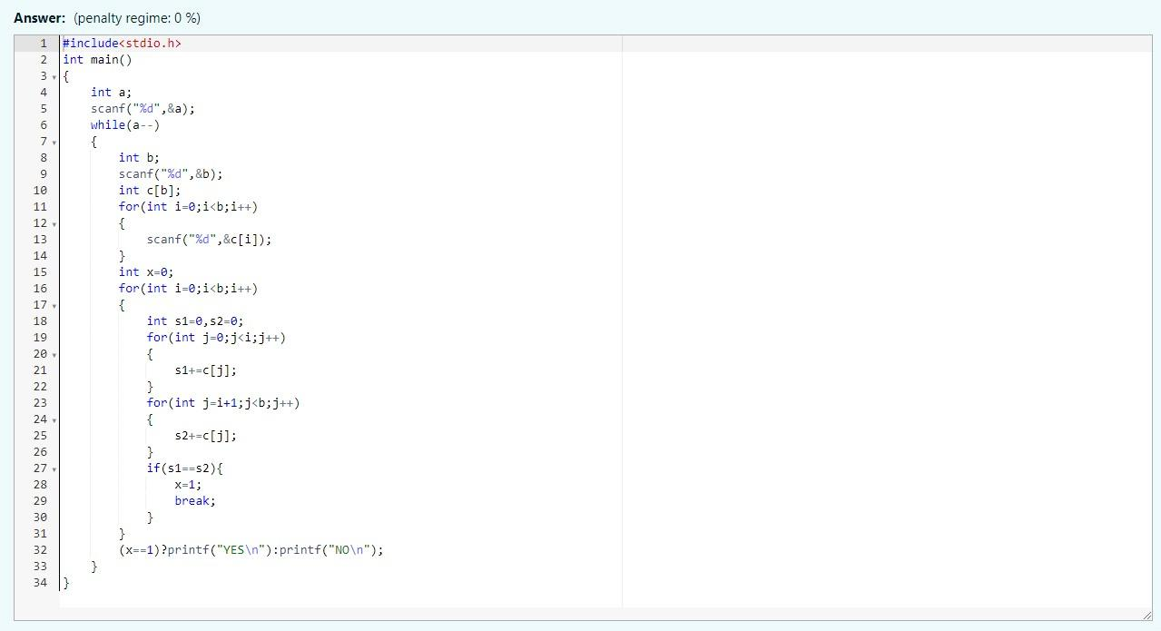

Output:

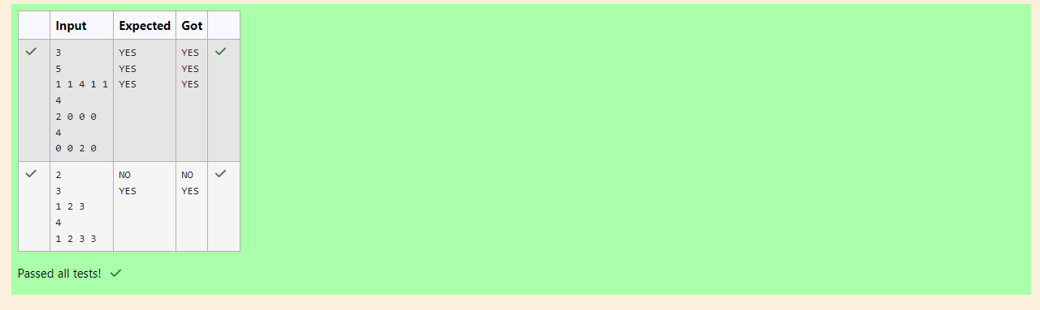

**WEEK 08 – CODING**

**Question 1** :

Coders here is a simple task for you, you have given an array of size N and an integer M. Your task is to calculate the difference between maximum sum and minimum sum of N-M elements of the given array.

Constraints:

1<=t<=10 1<=n<=1000 1<=a[i]<=1000

Input:

First line contains an integer T denoting the number of testcases. First line of every testcase contains two integer N and M. Next line contains N space separated integers denoting the elements of array

Output:

For every test case print your answer in new line SAMPLE INPUT

1

5 1

1 2 3 4 5

SAMPLE OUTPUT 4

Explanation

M is 1 and N is 5 so you have to calculate maximum and minimum sum using (5-1 =) 4 elements. Maximum sum using the 4 elements would be (2+4+5=)14. Minimum sum using the 4 elements

would be (1+2+3+4=)10. Difference will be 14-10=4

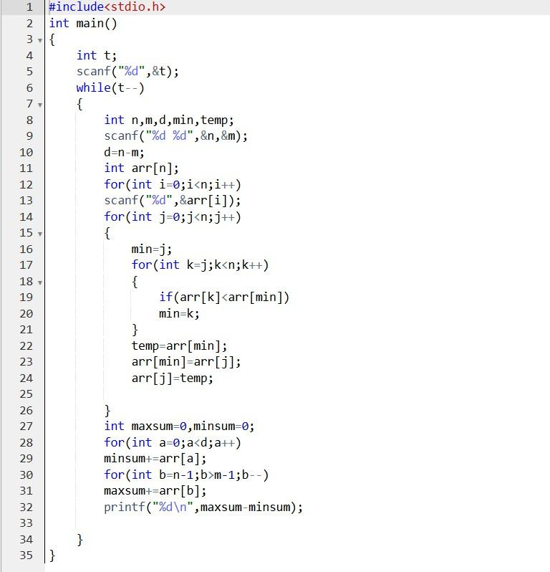

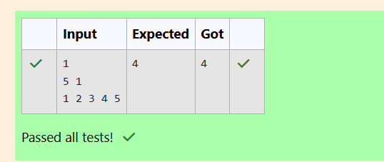

**Question 2**

A new deadly virus has infected large population of a planet. A brilliant scientist has discovered a new strain of virus which can cure this disease. Vaccine produced from this virus has various strength depending on midichlorians count. A person is cured only if midichlorians count in vaccine batch is more than midichlorians count of person. A doctor receives a new set of report

which contains midichlorians count of each infected patient, Practo stores all vaccine doctor has and their midichlorians count. You need to determine if doctor can save all patients with the vaccines he has. The number of vaccines and patients are equal.

Input Format

First line contains the number of vaccines - N. Second line contains N integers, which are strength of vaccines. Third line contains N integers, which are

midichlorians count of patients. Output Format

Print a single line containing 'Yes' or 'No'. Input Constraint

1 < N < 10

Strength of vaccines and midichlorians count of patients fit in integer. SAMPLE INPUT

5

123 146 454 542 456

100 328 248 689 200

SAMPLE OUTPUT

No

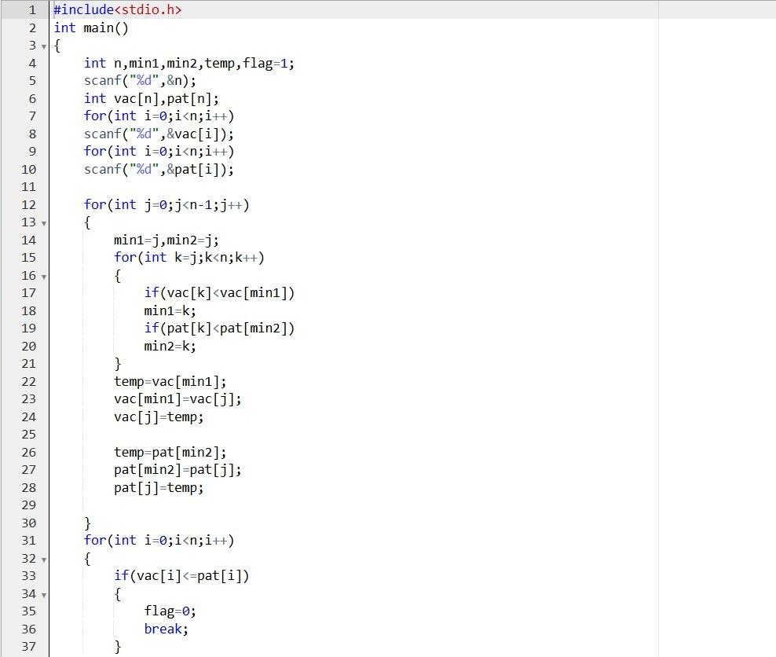

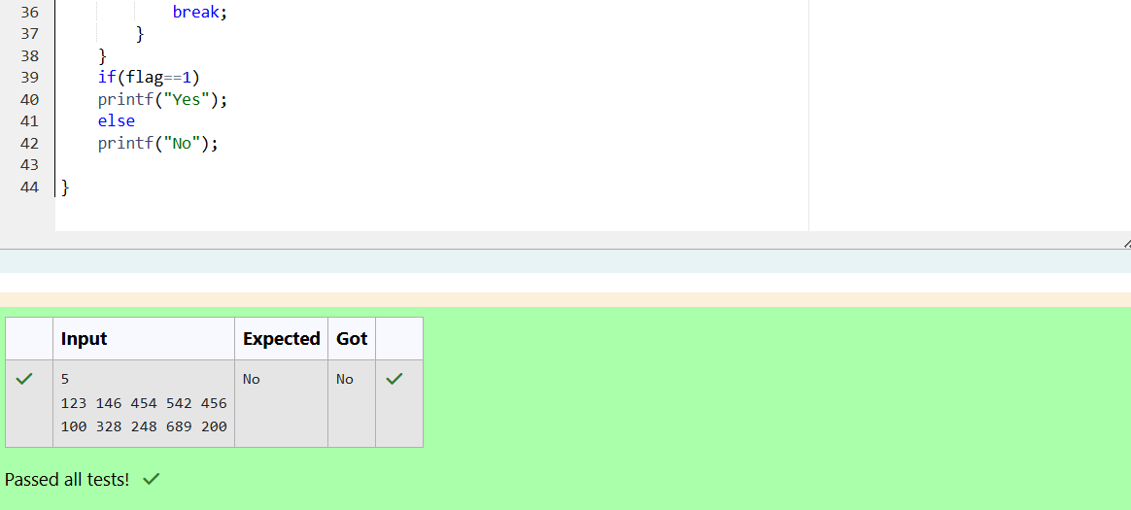

**Question 3**

You are given an array of n integer numbers a1, a2, . . . , an. Calculate the number of pair of indices (i, j) such that 1 ≤ i < j ≤ n and ai xor aj = 0.

Input format –

First line: n denoting the number of array elements-

Second line: n space separated integers a1, a2, . . . , an. Output format

Output the required number of pairs. Constraints

1 ≤ n ≤ 106

1 ≤ ai ≤ 109

SAMPLE INPUT 5

1 3 1 4 3

SAMPLE OUTPUT 2

Explanation

The 2 pair of indices are (1, 3) and (2,5)

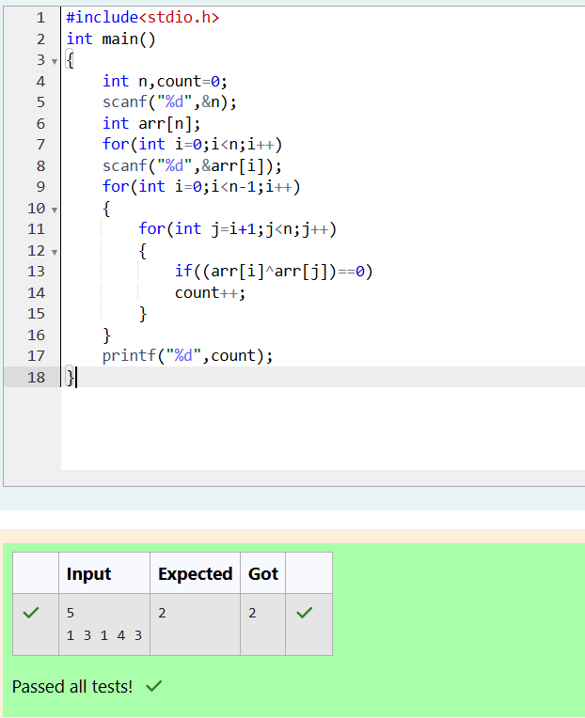

**Question 4**

You are given an array A of non-negative integers of size m. Your task is to sort the array in non-decreasing order and print out the original indices of the new sorted array.

Example: A={4,5,3,7,1}

After sorting the new array becomes A={1,3,4,5,7}. The required output should be "4 2 0 1 3"

INPUT :

The first line of input consists of the size of the array The next line consists of the array of size m

OUTPUT :

Output consists of a single line of integers CONSTRAINTS:

1<=m<=106

0<=A[i]<=106

NOTE: The indexing of the array starts with 0. SAMPLE INPUT

5

4 5 3 7 1

SAMPLE OUTPUT 4 2 0 1 3

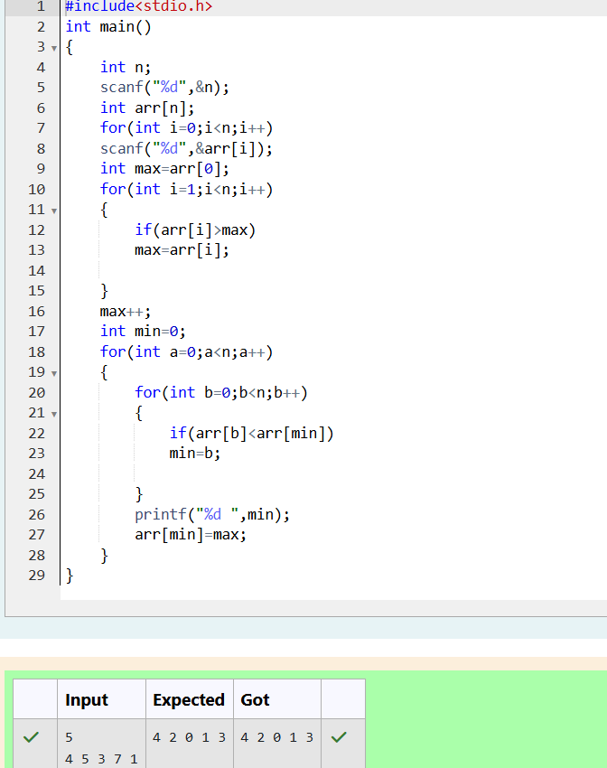

You are given a two-dimensional 3*3 array starting from A [0][0]. You should add the alternate elements of the array

And print its sum. It should print two different numbers the first being sum of A 0 0, A 0 2, A 1 1, A 2 0, A 2 2 and A 0 1,

A 1 0, A 1 2, A 2 1.

Input Format

First and only line contains the value of array separated by single space Output format

First line should print sum of A 0 0, A 0 2, A 1 1, A 2 0, A 2 2

Second line should print sum of A 0 1, A 1 0, A 1 2, A 2 1

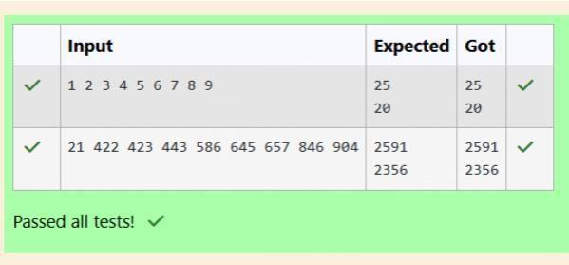

Shyam Lal, a wealthy landlord from the state of Rajasthan, being an old fellow and tired of doing hard work, decided to

Sell all his farmland and to live rest of his life with that money. No other farmer is rich enough to buy all his land so heDecided to partition the land into rectangular plots of

different sizes with different cost per unit area. So, he sold thesePlots to the farmers but made a mistake. Being illiterate, he made partitions that could be overlapping. When the Farmers came to know about it, they ran to him for compensation of extra money they paid to him. So, he decided to Return all the money to the farmers of that land which was overlapping with other farmer’s land to settle down theConflict. All the portion of conflicted land will be taken back by the landlord.To decide the total compensation, he has to calculate the total amount of money to return back to farmers with the Same cost they had purchased from him. Suppose, Shyam Lal has a total land area of 1000 x 1000 equal square blocks Where each block is equivalent to a unit square area which can be represented on the co-ordinate axis. Now find the Total amount of money, he has to return to the farmers.

Help Shyam Lal to accomplish this task.

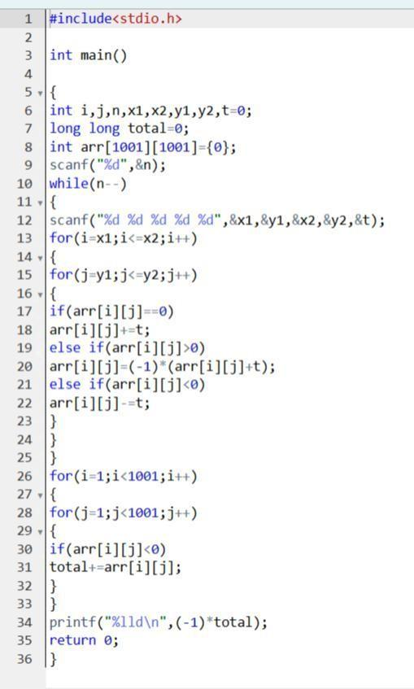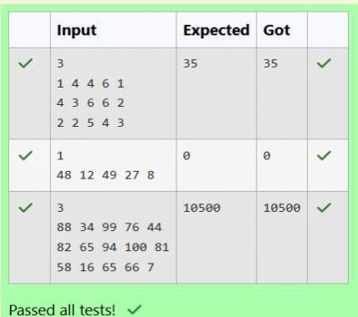

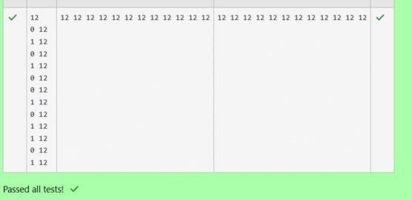Microsoft has come to hire interns from your college. N students got shortlisted out of which few were males and a few Females. All the students have been assigned talent levels. Smaller the talent level, lesser is your chance to be selected. Microsoft wants to create the result list where it wants the candidates sorted according to their talent levels,

but thereIs a catch. This time Microsoft wants to hire female candidates first and then male candidates.The task is to create a list where first all-female candidates are sorted in a

descending order and then male candidates Are sorted in a descending order. Input Format

The first line contains an integer N denoting the number of students. Next, N lines contain two space-separated Integers, ai and bi.The first integer, ai will be either 1(for a male candidate) or 0(for female candidate)The second integer, bi will be the candidate’s talent level.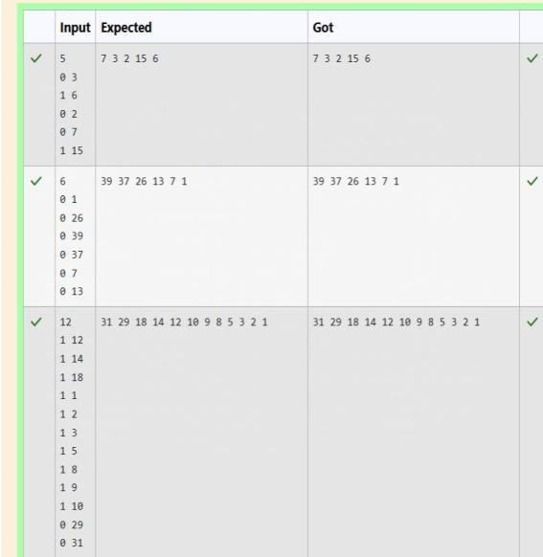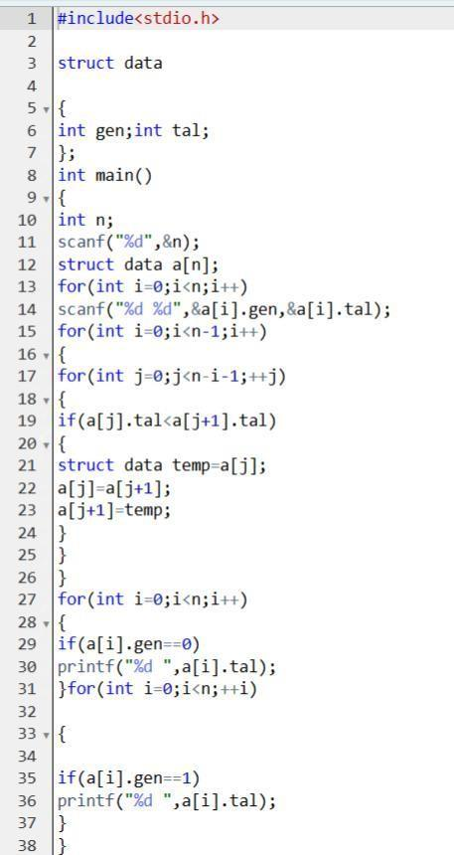

Q1)

**Week 10**

Given a string, s, consisting of alphabets and digits, find the frequency of each digit in the

given string.

Input Format

The first line contains a string, num which is the given number.

Constraints

1 ≤ len(num) ≤ 1000

All the elements of num are made of English alphabets and digits.

Output Format

Print ten space-separated integers in a single line denoting the frequency of each digit from 0 to 9.

Sample Input 0

a11472o5t6

Sample Output 0

0 2 1 0 1 1 1 1 0 0

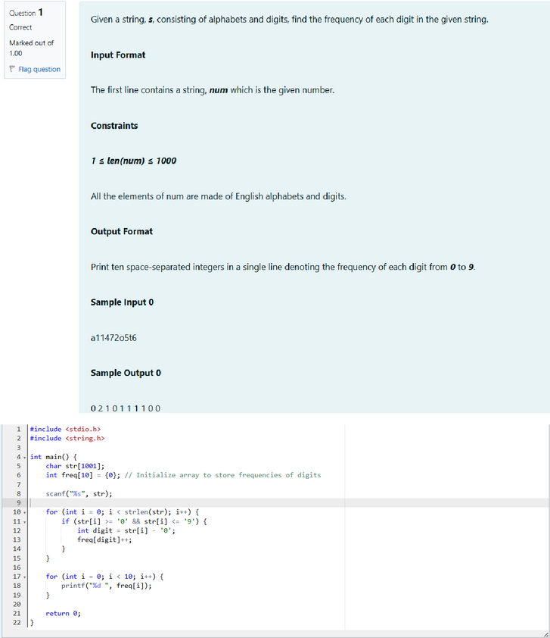

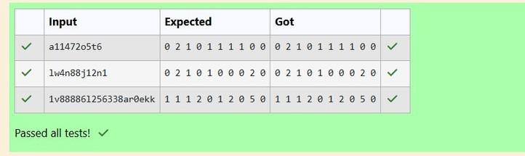

Q2) Today, Monk went for a walk in a garden. There are many trees in the garden and each tree has an English alphabet on it. While Monk was walking, he noticed that all trees with vowels on it are not in good state. He decided to take care of them. So, he asked you to tell him the count of such trees in the garden.

Note: The following letters are vowels: 'A', 'E', 'I', 'O', 'U', 'a', 'e', 'i', 'o' and 'u'.

Input Format:

The first line consists of an integer T denoting the number of test cases.

Each test case consists of only one string, each character of string denoting the alphabet (may be lowercase or uppercase) on a tree in the garden.

Output Format:

For each test case, print the count in a new line.

Constraints:

1 ≤ T ≤ 10

1 ≤ length of string ≤ 105

Sample Input

2

nBBZLaosnm JHkIsnZtTL

Sample Output

2

1

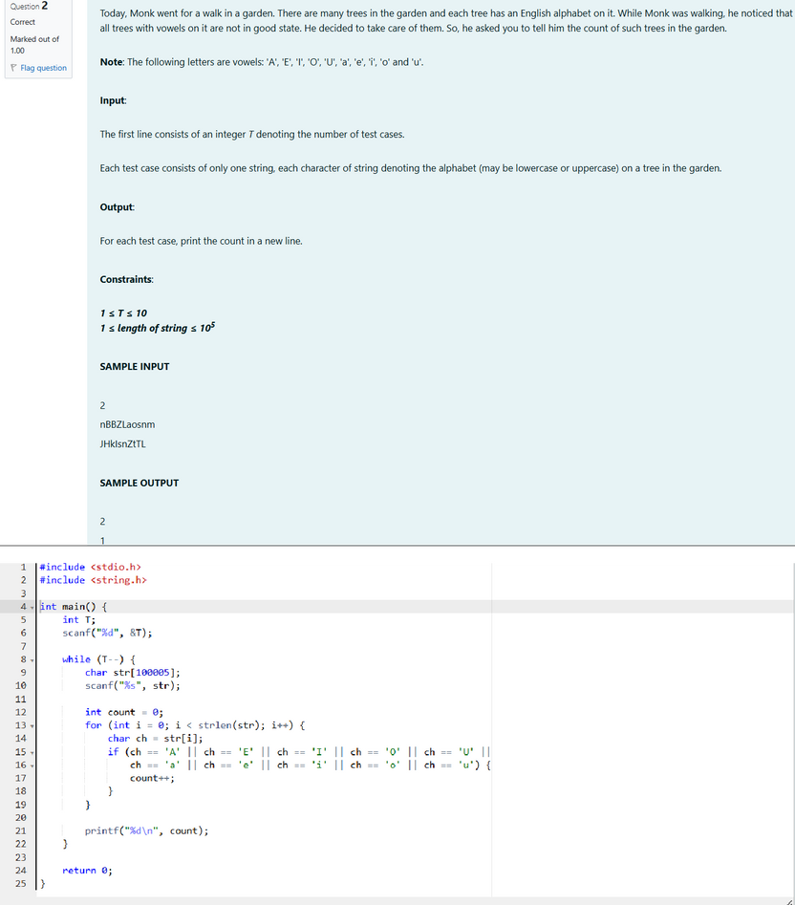

Output:

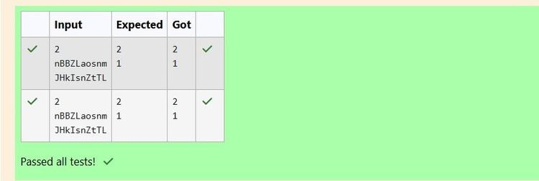

Q3)Given a sentence, s, print each word of the sentence in a new line.

Input Format

The first and only line contains a sentence, s.

Constraints

1 ≤ len(s) ≤ 1000

Output Format

Print each word of the sentence in a new line.

Sample Input

This is C

Sample Output

This is

C

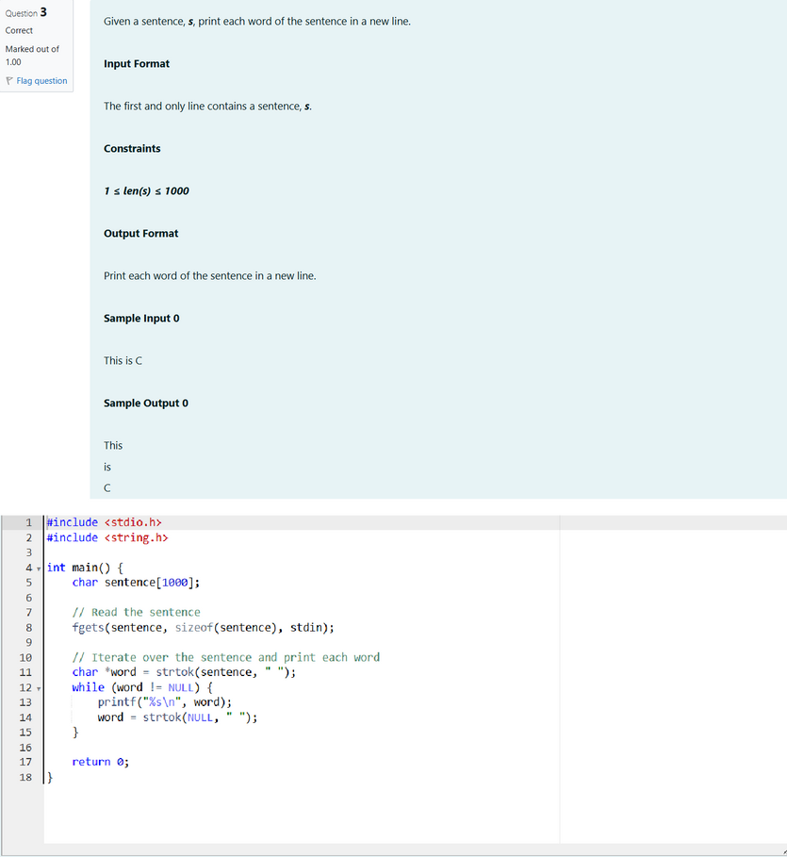

Output:

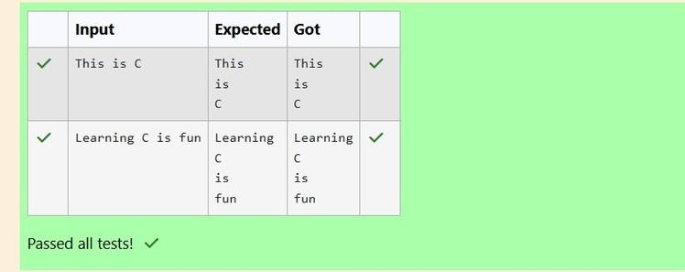

Q4) Input Format

You are given two strings, a and b, separated by a new line. Each string will consist of lower-case Latin characters ('a'-'z').

Output Format

In the first line print two space-separated integers, representing the length of a and b respectively.

In the second line print the string produced by concatenating a and b (a + b).

In the third line print two strings separated by a space, a' and b'. a' and b' are the same as a and b, respectively, except that their first characters are swapped.

Sample Input

abcd ef

Sample Output

4 2

abcdef ebcd af

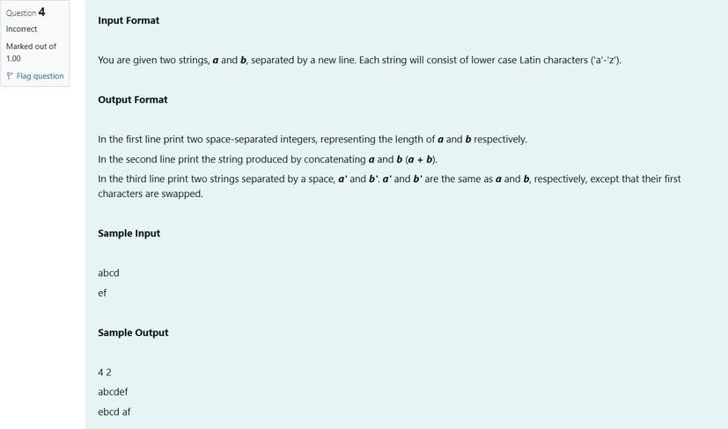

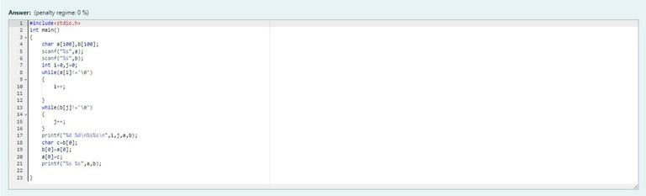

Output:

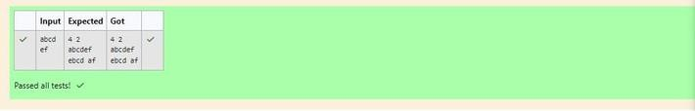

**Week 11**

**Q1)** Two strings ***A*** and ***B*** comprising of lower case English letters are compatible if they are equal or can be made equal by following this step any number of times:

· Select a prefix from the string ***A*** (possibly empty), and increase the alphabetical value of all the characters in the prefix by the same valid amount. For example, if the string is ***xyz*** and we select the prefix ***xy*** then we can convert it to ***yx*** by increasing the alphabetical value by 1. But if we select the prefix ***xyz*** then we cannot increase the alphabetical value.

Your task is to determine if given strings ***A*** and ***B*** are compatible.

**Input format**

First line: String ***A***

Next line: String ***B***

**Output format**

For each test case, print ***YES*** if string ***A*** can be converted to string ***B***, otherwise print ***NO***.

**Constraints**

***1 ≤ len(A) ≤ 1000000***

***1 ≤ len(B) ≤ 1000000***

**SAMPLE INPUT**

abaca cdbda

**SAMPLE OUTPUT**

YES

**Explanation**

The string ***abaca*** can be converted to ***bcbda*** in one move and to ***cdbda*** in the next move.

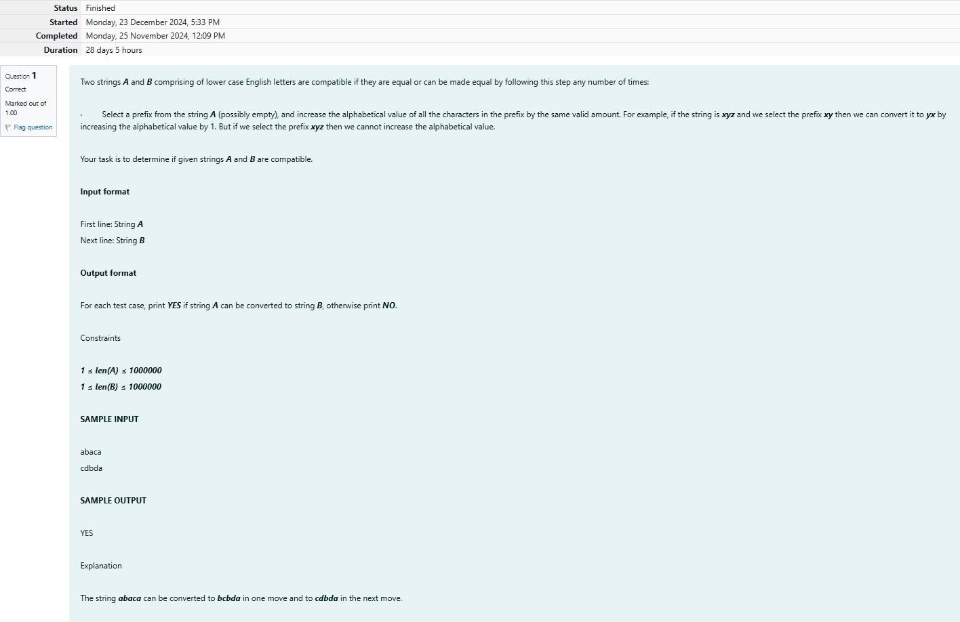

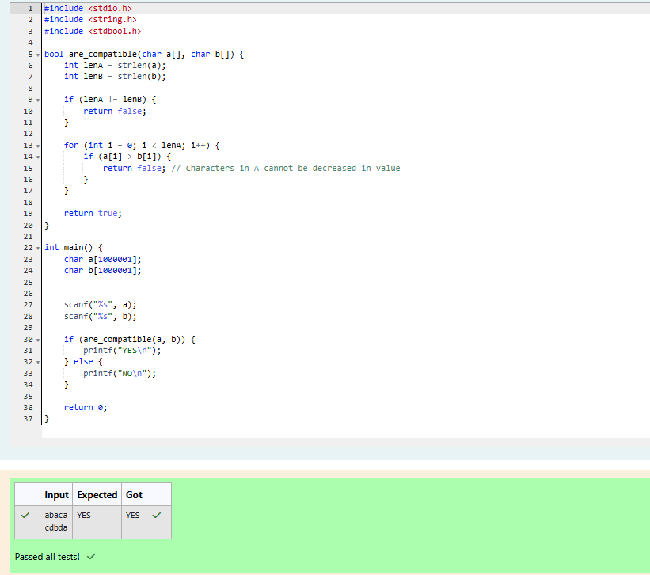

**Q2)** Danny has a possible list of passwords of Manny's facebook account. All passwords length is odd. But Danny knows that Manny is a big fan of palindromes. So, his password and reverse of his password both should be in the list.

You have to print the length of Manny's password and it's middle character.

**Note: The solution will be unique.**

**INPUT**

The first line of input contains the integer N, the number of possible passwords.

Each of the following N lines contains a single word, its length being an odd number greater than 2 and lesser than ***14***. All characters are lowercase letters of the English alphabet.

**OUTPUT**

The first and only line of output must contain the length of the correct password and its central let- ter.

**CONSTRAINTS *1 ≤ N ≤ 100* SAMPLE INPUT**

4

abc def feg cba

**SAMPLE OUTPUT**

3 b

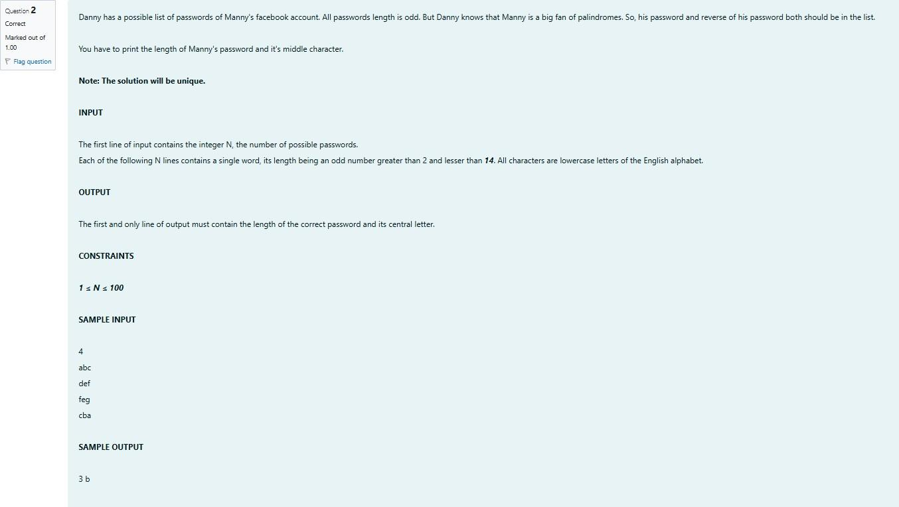

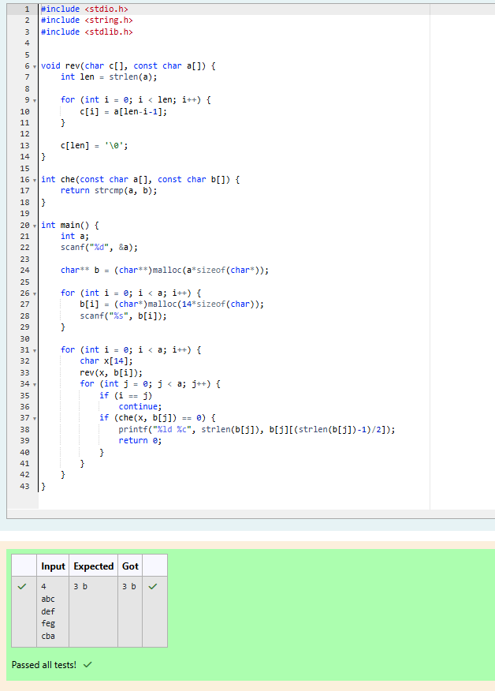

**Q3)** Joey loves to eat Pizza. But he is worried as the quality of pizza made by most of the restau- rants is deteriorating. The last few pizzas ordered by him did not taste good :(. Joey is feeling ex- tremely hungry and wants to eat pizza. But he is confused about the restaurant from where he should order. As always he asks Chandler for help.

Chandler suggests that Joey should give each restaurant some points, and then choose the restau- rant having **maximum points**. If more than one restaurant has same points, Joey can choose the one with **lexicographically smallest** name.

Joey has assigned points to all the restaurants, but can't figure out which restaurant satisfies Chan- dler's criteria. Can you help him out?

**Input:**

First line has N, the total number of restaurants.

Next N lines contain Name of Restaurant and Points awarded by Joey, separated by a space. Restau- rant name has **no spaces**, all lowercase letters and will not be more than 20 characters.

**Output:**

Print the name of the restaurant that Joey should choose.

**Constraints:**

1 <= N <= 105

1 <= Points <= 106

**SAMPLE INPUT**

3

Pizzeria 108

Dominos 145

Pizzapizza 49

**SAMPLE OUTPUT**

Dominos

**Explanation**

**Dominos** has maximum points.

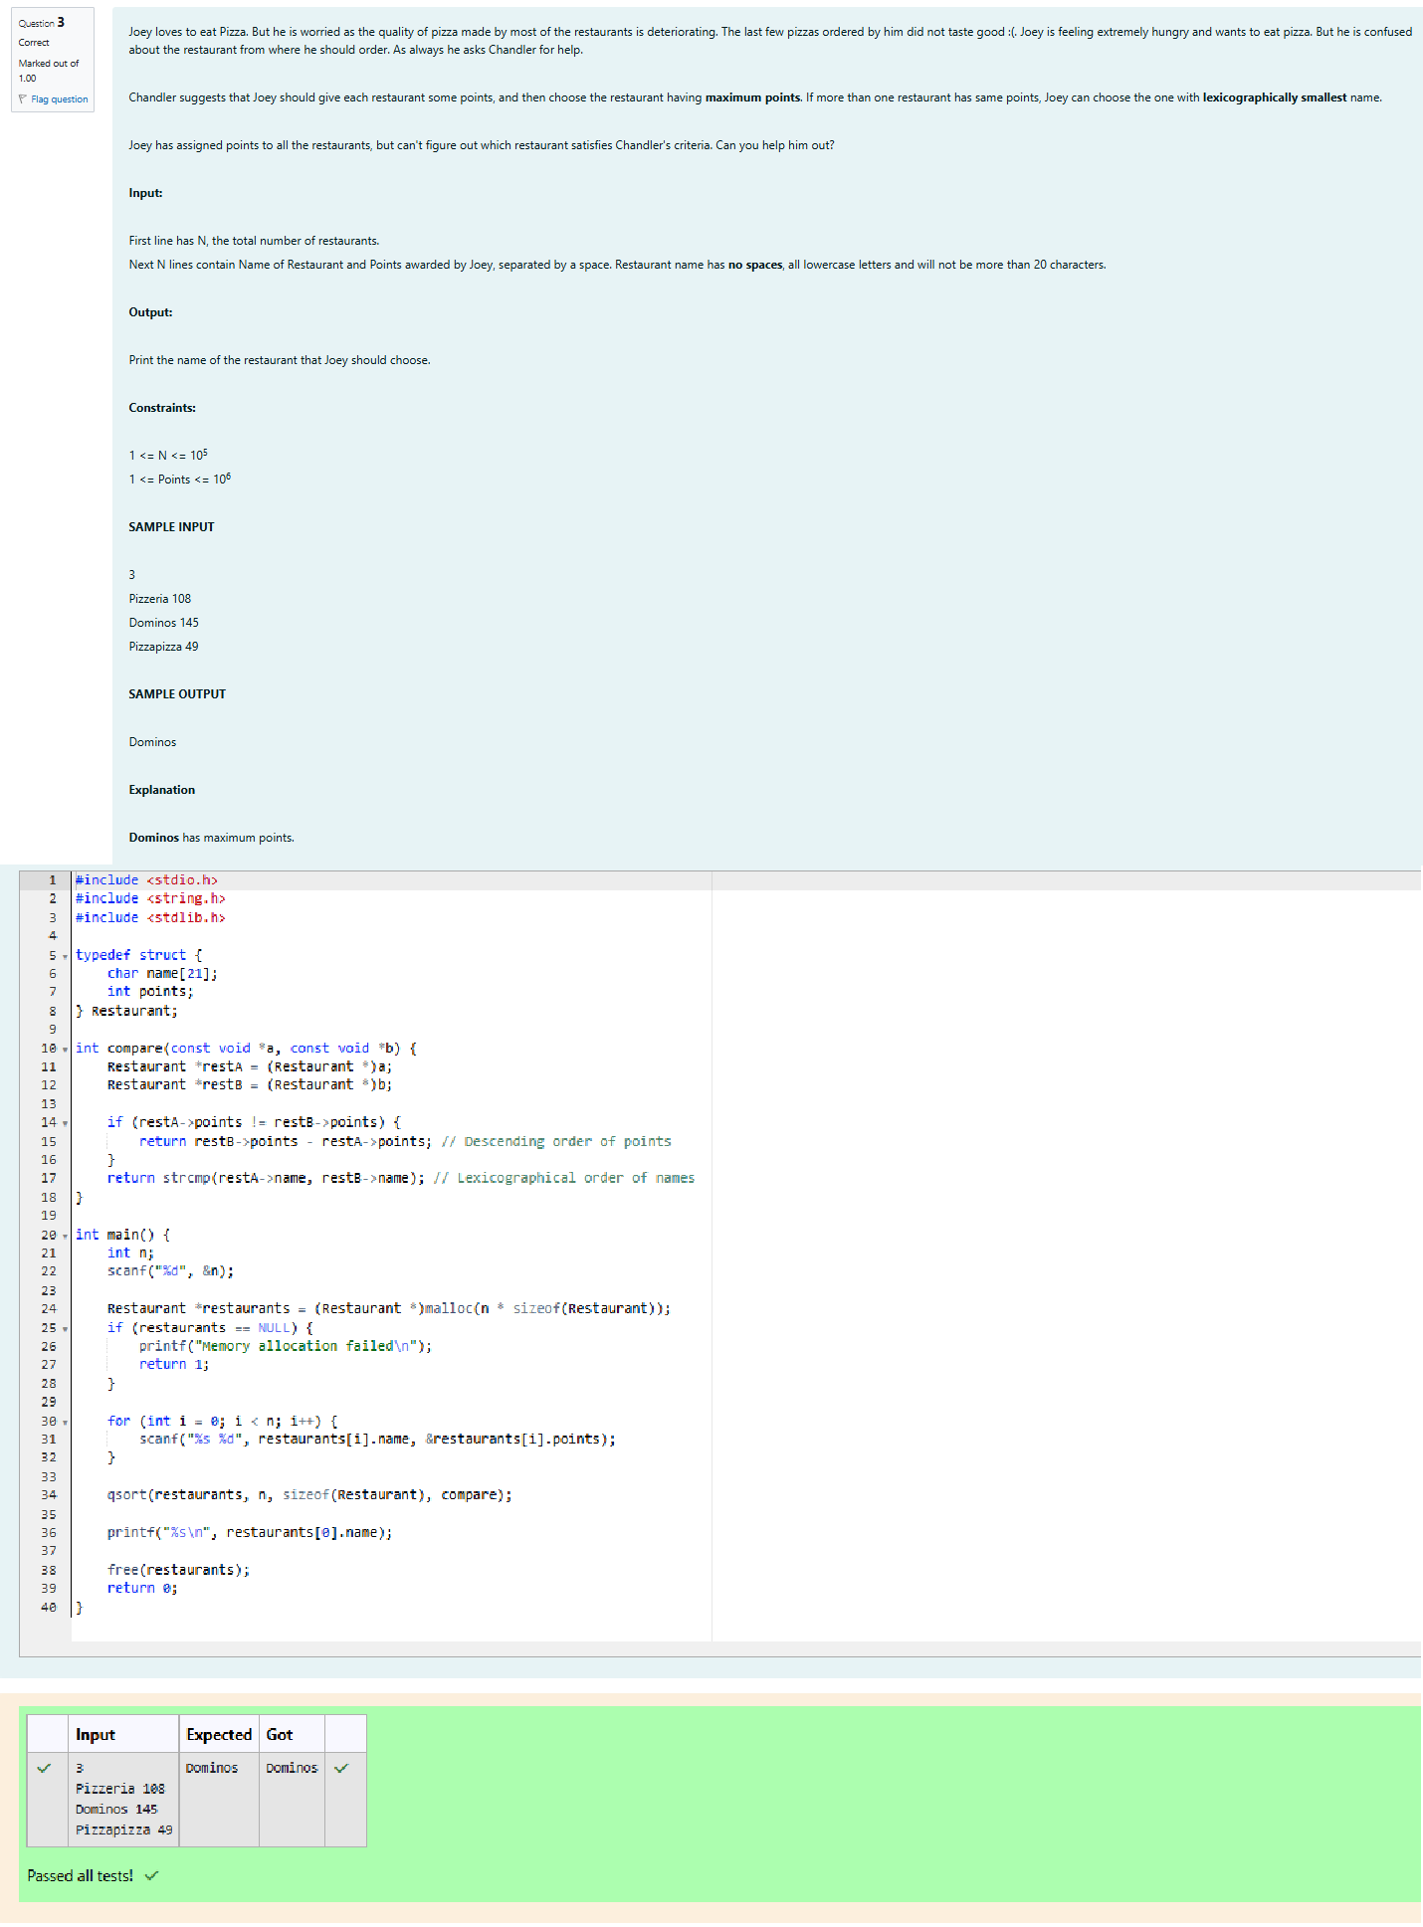

**Q4)** These days Bechan Chacha is depressed because his crush gave him list of mobile number some of them are valid and some of them are invalid. Bechan Chacha has special power that he can pick his crush number only if he has valid set of mobile numbers. Help him to determine the valid num- bers.

You are given a string "S" and you have to determine whether it is Valid mobile number or not. Mo- bile number is valid only if it is of length 10 , consists of numeric values and it shouldn't have prefix zeroes.

**Input:**

First line of input is T representing total number of test cases.

Next T line each representing "S" as described in in problem statement.

**Output:**

Print "YES" if it is valid mobile number else print "NO". Note: Quotes are for clarity.

**Constraints:**

1<= T <= 103

sum of string length <= 105

**SAMPLE INPUT**

3

1234567890

0123456789

0123456.87

**SAMPLE OUTPUT**

YES NO NO

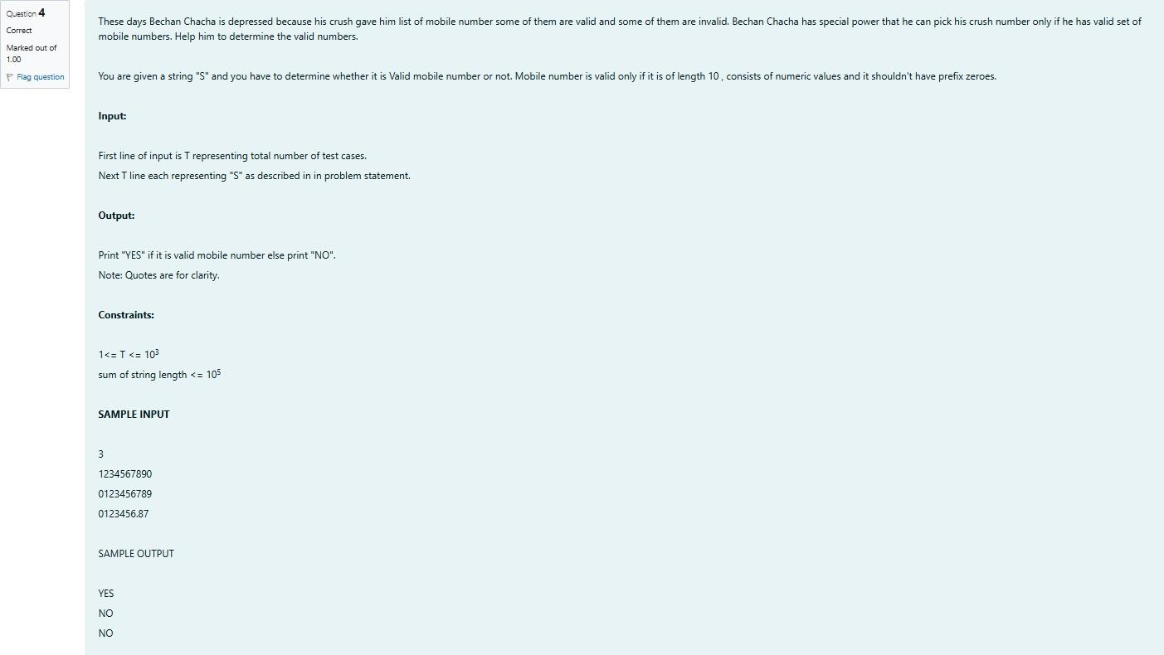

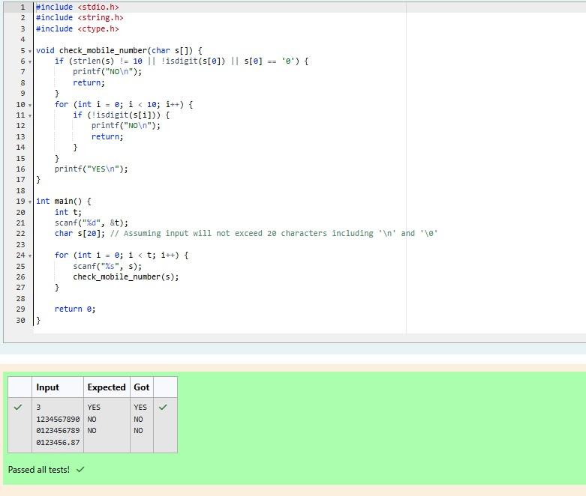

WEEK 12

A binary number is a combination of 1s and 0s. Its nth least significant digit is the nth digit starting from the right starting with 1. Given a decimal number, convert it to binary and determine the value of the the 4th least significant digit.

**Example:**

number = 23

Convert the decimal number 23 to binary number: 2310 = 24 + 22 + 21 + 20 = (10111)2.

The value of the 4th index from the right in the binary representation is 0.

**Function Description**

Complete the function fourthBit in the editor below. fourthBit has the following parameter(s):

int number: a decimal integer Returns:

int: an integer 0 or 1 matching the 4th least significant digit in the binary representation of number.

**Constraints**

0 ≤ number < 231

**Input Format for Custom Testing**

Input from stdin will be processed as follows and passed to the function. The only line contains an integer, number.

**Sample Case 0**

**Sample Input 0**

STDIN Function

32 → number = 32

**Sample Output 0**

0

**Explanation 0**

Convert the decimal number 32 to binary number: 3210 = (100000)2.

The value of the 4th index from the right in the binary representation is 0.

**Sample Case 1**

**Sample Input 1**

77 → number = 77

**Sample Output 1**

1

**Explanation 1**

Convert the decimal number 77 to binary number: 7710 = (1001101)2.

The value of the 4th index from the right in the binary representation is 1.

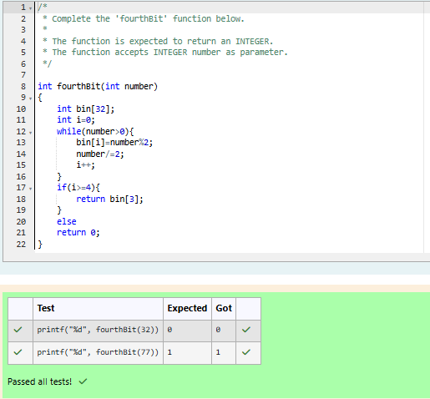

Q) Determine the factors of a number (i.e., all positive integer values that evenly divide into a number) and then return the pth element of the list, sorted ascending. If there is no

pth element, return 0.

**Example**

n = 20

p = 3

The factors of 20 in ascending order are {1, 2, 4, 5, 10, 20}. Using 1-based indexing, if p = 3, then 4 is returned. If p > 6, 0 would be returned.

**Function Description**

Complete the function pthFactor in the editor below. pthFactor has the following parameter(s):

int n: the integer whose factors are to be found int p: the index of the factor to be returned

Returns:

int: the long integer value of the pth integer factor of n or, if there is no factor at that index, then 0 is returned

**Constraints**

1 ≤ n ≤ 1015

1 ≤ p ≤ 109

Input Format for Custom Testing

Input from stdin will be processed as follows and passed to the function. The first line contains an integer n, the number to factor.

The second line contains an integer p, the 1-based index of the factor to return.

**Sample Case 0**

**Sample Input 0**

10 → n = 10

3 → p = 3

**Sample Output 0**

5

**Explanation 0**

Factoring n = 10 results in {1, 2, 5, 10}. Return the p = 3rd factor, 5, as the answer.

**Sample Case 1**

**Sample Input 1**

STDIN Function



10 → n = 10

5 → p = 5

**Sample Output 1**

0

**Explanation 1**

Factoring n = 10 results in {1, 2, 5, 10}. There are only 4 factors and p = 5, therefore 0 is returned as the answer.

**Sample Case 2**

**Sample Input 2**

1 → n = 1

1 → p = 1

**Sample Output 2**

1

**Explanation 2**

Factoring n = 1 results in {1}. The p = 1st factor of 1 is returned as the answer.

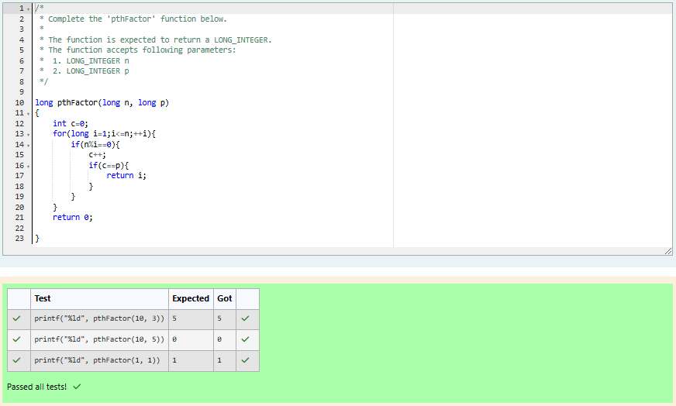

Q) You are a bank account hacker. Initially you have 1 rupee in your account, and you want exactly ***N*** rupees in your account. You wrote two hacks, first hack can multiply the amount of money you own by 10, while the second can multiply it by 20. These hacks can be used any number of time. Can you achieve the desired amount ***N*** using these hacks.

**Constraints:**

1<=T<=100

1<=N<=10^12

**Input**

The test case contains a single integer N.

**Output**

For each test case, print a single line containing the string "1" if you can make exactly N rupees or "0" otherwise.

SAMPLE INPUT 1

SAMPLE OUTPUT 1

SAMPLE INPUT 2

SAMPLE OUTPUT 0

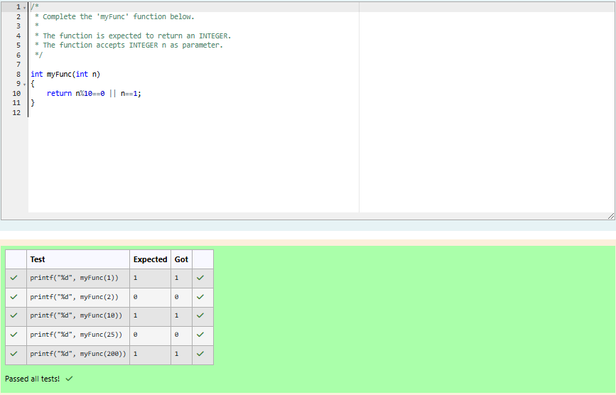

Q) Find the number of ways that a given integer, ***X***, can be expressed as the sum of the ***Nth*** powers of unique, natural numbers.

For example, if ***X = 13*** and ***N = 2***, we have to find all combinations of unique squares adding up to ***13***. The only solution is 22 + 32.

**Function Description**

Complete the powerSum function in the editor below. It should return an integer that represents the number of possible combinations.

powerSum has the following parameter(s):

X: the integer to sum to

N: the integer power to raise numbers to Input Format

The first line contains an integer ***X***. The second line contains an integer ***N***.

**Constraints**

***1 ≤ X ≤ 1000***

***2 ≤ N ≤ 10***

**Output Format**

Output a single integer, the number of possible combinations calculated.

**Sample Input 0**

10

2

**Sample Output 0**

1

**Explanation 0**

If ***X = 10*** and ***N = 2***, we need to find the number of ways that ***10*** can be represented as the sum of squares of unique numbers.

***10 = 12 + 32***

This is the only way in which ***10*** can be expressed as the sum of unique squares.

**Sample Input 1**

100

2

**Sample Output 1**

3

**Explanation 1**

***100 = (102) = (62 + 82) = (12 + 32 + 42 + 52 + 72)***

**Sample Input 2**

100

3

Sample Output 2

1

**Explanation 2**

***100*** can be expressed as the sum of the cubes of ***1, 2, 3, 4***.

***(1 + 8 + 27 + 64 = 100)***. There is no other way to express ***100*** as the sum of cubes.

