College of Engineering Trivandrum
Department of Computer Applications

RLMCA132 Object Oriented Programming Lab
Lab Cycle I

- Design a class to represent a bank account, the bank maintains two kinds of account for its customer; One called savings account and other current account.
Savings account provides compound interest and withdrawal facilities and no check book facility. The current account provides check book facility but no interest.
Current account holders should also maintains a minimum balance and if the balance falls below level a service charge is imposed.

- Implement the following Arithmetic class (not the main class, a separate user defined class). Test the class using a menu driven program.
Use the constructor to read the values (x & y), member functions to compute the result (r) and the destructor to print the result. (- shows private members, + shows public members)
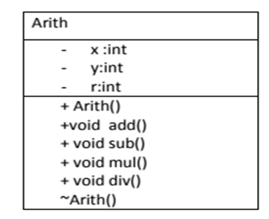
- Build a class “Stud” with the following properties and methods. Create array of student objects and do the various functions.
Properties: roll no, name, m1, m2, m3 ( marks in 3 subjects and are out of 100).
Methods:
void read(); // for reading students details
void tot(); // display the students details with total mark
void avg(); // display the students details with average mark
void check(); // for checking passed or failed(marks in 3 subject must be greater than or
equal to 45), display the students details with status pass or fail
void grade(); // distinction(>=75%),first class(>=60%), second class(>=50%).Display the
students details with percentage and grade

- Implement the following Vector class and Test it with a menu driven program. The constructor is used to set the number of elements(n) and vector elements .
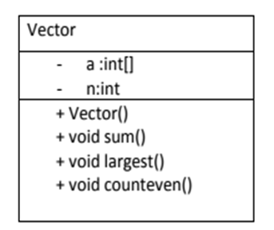
- Implement the following Sort class. Method bsort() will do bubble sort & read() and disp() functions are used to read and display the sorted list.
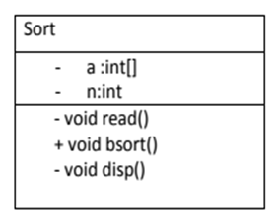
- Create a class with method str_op() to manipulate string operations like space removal, string concatenation, reversal. Use function overloading concept to implement each operation on your input.
- Create a class student that stores roll no, with member function getnum and putnum. From this derive a class test with data members mark1 and mark2 and member functions getmarks and put marks. Create another class sports that stores the sports marks. Create another class result that stores total marks.
- Creating Three-Letter String s from a Five-Letter Word: Write an application that reads a five-letter word from the user and produces every possible three-letter string that can be derived from the letters of that word. For example, the three-letter words produced from the word “bathe” include “ate,”“bat,” “bet,” “tab,” “hat,” “the” and “tea.”

Note: Complete Cycle I and submit your rough records on or before 9/02/2018.

