1 If VICTORY is coded as YLFWRUB, how can SUCCESS be coded ?

ans: VXFFHVV

1.

NUMERAL=UEALRMN

then

ALGEBRA=?

ANS: LERABGA

1.

What does this message say?

G T Y O R J O T E O U I A B G T

Hint

Count the letters and try splitting the letters up into groups.

Ans: 'Great Job You Got It'

This type of code is known as a Caesar Box (Julius Caesar was the first to write codes this way.) To decipher the message, simply divide the code into four groups of four (you can also divide them into groups such as 5 groups of 5 or 6 groups of 6 depending on the number of letters in the phrase), and rearrange them vertically like this...

G T Y O

R J O T

E O U I

A B G T

Then you read vertically column by column.

2.

carrot fiasco nephew spring rabbit

sonata tailor bureau legacy corona

travel bikini object happen soften

picnic option waited effigy adverb

report accuse animal shriek esteem

oyster

Starting with the first two words, Take the first and last letters, reading from left to right. Example: Carrot fiascO "from these pairs" the message is as follows:

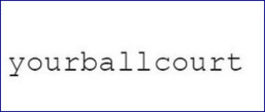

CONGRATULATIONS CODE BREAKER

3.

Can you decipher these quotes?

xkz jhggbf cab ibrbi

Hint:look into your keyboard

Ans:you passed the level

(The letters should be replaced by the corresponding letters from keyboard as bottom to top)

4.

Below, you can see some coding:

January = 1017

February = 628

March = 1335

April = 145

May = 1353

June = 1064

July = 1074

August = 186

Now deciphering the way it has been coded, can you find out how September will be coded?

January = 10|1|7

10 is the position of letter J in alphabetical order.

1 is the position of January in months.

7 is the number of letters used in the word January.

Same goes for all the months, thus

Ans: September = 19|9|9 (1999).

5.

In a coded language:

a) "Cosey Miso Ro" means "We are Goblins";

b) "Tichu KoPi Miso Pa" means "they are Evil People";

c) "Juha Liho KoPi " means "Who is Evil";

d) "Ro Miso Pi KoPi" means "the Goblins are Evil".

Hint:look for common words

Can you find out what word means "The" in this coded language ?

"The" is defined by the word "Pi".

In the statements (a), (b) and (c), common coded word is "Miso" and common normal word is "are". So, "Miso" means "are".

In the statements (a) and (d), common coded word (except "are") is "Ro" and common normal word is "Goblins". So, "Ro" means "Goblins".

Similarly, in the statements (b), (c) and (d), common coded word is "KoPi" and common normal word is "Evil". So, "KoPi" means "Evil".

Therefore, "Ro", "Miso", "KoPi" means "Goblins", "are", "Evil" respectively. Thus, in statement (d), the remaining word i.e.,

Ans: "Pi" means "the".

6.

what phrase is represented by this rebus below ?

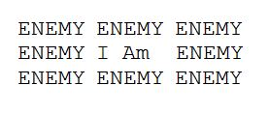

Or

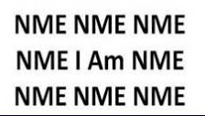

Ans: I am surrounded by enemies

7.

Solve the pictogram rebus ?

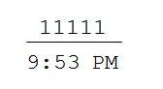

Ans: once upon a time

9.

EELS + MARK + BEST + WARY = EASY

What does HELP + BARK + WARD + LEAD equal?

Ans:Hard,

using the first letter of the first word, the second letter of the second word, etc

11.

You need to unlock a secret code using following clues

**Clue-1** : 0 7 9 (One of the numbers is correct and is placed in its correct position)

**Clue-2** : 0 3 2 (Nothing is correct)

**Clue-3** : 1 0 8 (Two numbers are correct but not placed at its correct position.)

**Clue-4** : 9 2 6 (One number is correct but not placed at its correct position.)

**Clue-5** : 6 7 8 (One number is correct but not placed at its correct position.)

Ans: 819