Severity-Aware Conformal Risk Control for Medical LLM Hallucinations
Results & Interpretation — Llama-3-8B-Instruct on the K-QA clinical benchmark
This note explains what our experiments found and what each number means, using concrete examples throughout. Every figure below is computed over 300 random calibration/test splits of 2,150 verifiable claims generated by Llama-3-8B and graded by a GPT-4o judge.

1. The data we generated
We had Llama-3-8B answer 201 real clinical questions, split each answer into atomic claims, and had the judge decide (a) whether each claim is true or a hallucination, and (b) how harmful it would be if it were wrong. This produced 5,040 claims:
Category | Count | What it means (with an example)
True | 1,819 | Supported by the physician answer. E.g. “Ibuprofen is a nonsteroidal anti-inflammatory drug.”
Hallucination | 331 | Contradicted by the answer. E.g. “Ibuprofen is safe throughout pregnancy” (it is not).
Unverifiable | 2,890 | The answer neither confirms nor denies it, so it cannot be graded — set aside.
Verifiable (used) | 2,150 | True + hallucination. All calibration and measurement happen here.

Each verifiable claim is also tagged by severity:
Severity tier | Claims | Baseline hallucination rate | Example of a claim in this tier
Dangerous | 468 | 13.2% | “Take 4 g of acetaminophen every 4 hours” — a dosing error can harm a patient.
Benign | 1,682 | 16.0% | “Acetaminophen is metabolized in the liver” — low harm if wrong.

Anchor this number: before any filtering, about 13 of every 100 dangerous claims the model produces are hallucinations. Our safety target is to bring that down to 5 in 100.

2. How to read the numbers
Four quantities appear throughout. Each is easiest to understand through an example.
Risk
Among the claims we decide to keep (show to the clinician), the fraction that are hallucinations. Lower is safer. Example: if we keep 200 dangerous claims and 9 of them are wrong, the risk is 9/200 = 0.045. A budget of 0.05 is the promise “no more than 5 wrong per 100 shown.”
Retention
Among the claims that are actually true, the fraction we keep. Higher is more useful. Example: there are 100 true dangerous claims; if the system shows 84 and withholds 16 (because it wasn’t confident enough), retention is 0.84. A withheld true claim does no harm — it is just a missed opportunity to be helpful. (Note the tension: you could force risk to zero by keeping nothing, but then retention is zero and the system is useless. The goal is to meet the risk budget while keeping retention high.)
Violation rate
We repeat the entire calibrate-then-test procedure 300 times on different random splits of the data. The violation rate is the fraction of those runs in which the dangerous risk ended up above the 0.05 budget. Example: if 84 of 300 runs exceed 0.05, the violation rate is 0.28. This tells us how reliably the promise holds — not just whether it holds on average.
AUROC (score quality)
How well the confidence score separates true claims from hallucinations. 1.0 is perfect, 0.5 is a coin flip. Concretely, our 0.87 means: pick one true claim and one hallucination at random; 87% of the time the model assigns the true one a higher confidence. This is the raw material the filtering works with.

3. The main result
We compare two ways of choosing the keep/drop threshold:
- Global — one threshold for every claim, tuned so overall hallucinations sit near 10%.
- Severity-aware (ours) — separate thresholds: dangerous claims held to ≤5% error, benign allowed up to ≤15%.
How to read the “Global” column.
The global method uses only one threshold for every claim. The separate dangerous and benign numbers in its column are therefore not two targets — they are what we measure in each tier after applying that single shared threshold. Picture one gate that every claim must clear; we then go back and count the leftover hallucination rate among the dangerous claims that got through (0.100) and among the benign ones (0.095). Both land near 10% precisely because one threshold cannot aim at two budgets — which is exactly why the dangerous tier stays stuck at twice the 5% we want. Severity-aware control, by contrast, uses a separate threshold per tier, so each tier’s risk is actually controlled rather than merely measured.
On the dangerous tier:
Metric (dangerous tier) | Global | Severity-aware | Budget
Hallucination risk | 0.100 | 0.046 | ≤ 0.05
Budget violated (of 300 splits) | 99.7% | 28% | —
True claims kept (retention) | 0.968 | 0.837 | —

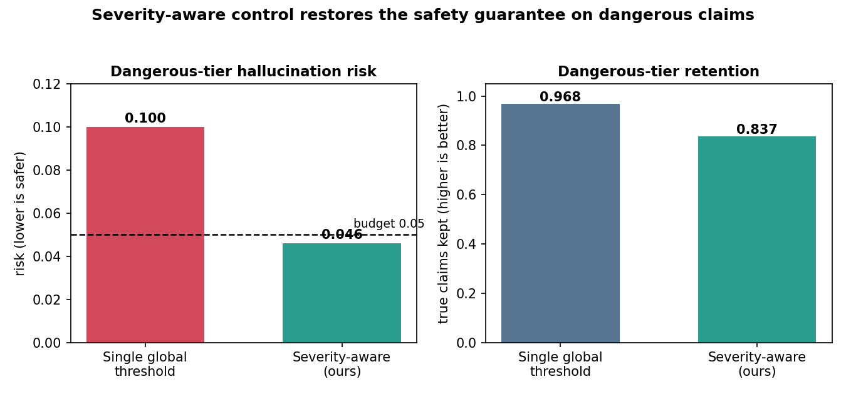

What this means, walked through with 1,000 kept dangerous claims:
- Global lets about 100 hallucinations through — double the 5% we promised. And it is not a one-off: across 300 re-runs it broke the 5% promise on 299 of them. It looks acceptable on the overall average only because benign claims vastly outnumber dangerous ones, so the dangerous failures are hidden inside the global average.
- Severity-aware lets about 46 through — inside the budget — and stays inside far more reliably (it exceeded 0.05 on only ~84 of 300 runs).
- The cost is honest and modest: of every 100 true dangerous claims we now surface 84 instead of 97. We withhold roughly 13 extra correct claims per 100 to buy that safety — and those withheld claims cause no harm, they are simply not shown.
In one line: severity-aware control roughly halves the dangerous error rate (0.100 → 0.046) and the only price is withholding a modest slice of true dangerous claims.

4. The benign side — a reallocation, not just “stricter”
Metric (benign tier) | Global | Severity-aware | Budget
Hallucination risk | 0.095 | 0.148 | ≤ 0.15
True claims kept (retention) | 0.950 | 0.998 | —

Severity-aware control is not uniformly stricter. On benign claims — where a mistake is cheap — it deliberately relaxes, allowing up to 15% error, which lets it keep almost every true benign claim (99.8%, up from 95%). So the system shifts caution toward where harm is high and eases off where harm is low. The net effect is better protection on dangerous claims and more true benign claims kept at the same time. Example: a slightly-off historical detail is allowed through so that the many correct background facts are not needlessly withheld, while every dosing claim is scrutinized hard.

5. Does the result depend on the confidence score?
We re-ran the whole comparison while swapping the confidence score, including a Random (coin-flip) score as a sanity floor. The two columns below are the severity-aware dangerous-tier risk and retention.
Confidence score | AUROC | Dangerous risk (ours) | Dangerous retention
P(true) — model self-confidence | 0.868 | 0.046 | 0.837
NLI entailment vs. answer | 0.705 | 0.047 | 0.384
Sequence log-probability | 0.593 | 0.047 | 0.257
Random (noise floor) | 0.511 | 0.047 | 0.408

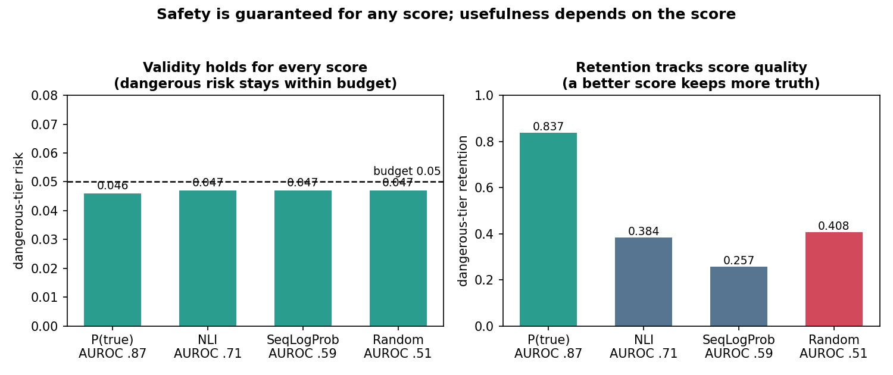

Two takeaways:
- Safety is guaranteed by the method, not by a good score. Every score — even pure coin-flip noise — keeps the dangerous risk within the 0.05 budget. Even if we ranked claims at random, the dangerous error rate stays ≤5%.
- Usefulness is what the score buys. With the model’s real confidence we keep 84% of true dangerous claims; with coin-flip noise only ~41% — technically safe but useless, because to stay safe with a meaningless score you must throw away most claims. The model’s own confidence (AUROC 0.87) is a strong score, which is why it retains so much.
Honest caveat: among the weak scores the retention numbers are close and a little noisy, because the dangerous tier is small (468 claims) — so the small differences there should not be over-read. The robust signal is that the strong score retains far more than the weak ones.

6. Limitations
- Severity tags are the GPT-4o judge’s decision, not yet validated by clinicians — our next priority.
- The dangerous tier is small (468 verifiable claims), so its numbers carry more uncertainty; we will add confidence intervals.
- The 0.05 guarantee is on the average across splits, so individual runs can exceed it — which is why the violation rate is not zero.
- These are results for one model on one dataset; a second model (Mistral-7B) is running now.

7. Bottom line
On real clinical questions with Llama-3-8B, a single global filter quietly lets dangerous medical claims through at twice the intended error rate. Making the filter severity-aware cuts that dangerous error rate roughly in half — back within budget — while still surfacing 84% of true dangerous claims and nearly all true benign ones. And because the safety comes from the method rather than the score, the guarantee is robust: it held for every confidence score we tried, even random noise.

