A Hybrid Social Network Analysis, Machine

Learning and Deep Learning Framework for

Influencer Detection on Instagram

Sharon Sukeerthana Palaparthi
Department of Advanced Computer Science and Engineering
Vignan’s Foundation for Science, Technology & Research (VFSTR)
Guntur, India
sharonsukeerthana @gmail.com
Ganji Aparna
Department of Advanced Computer Science and Engineering
Vignan’s Foundation for Science, Technology & Research (VFSTR)
Guntur, India
sriaparna2005@gmail.com
Mangamuri Sasank
Department of Advanced Computer Science and Engineering
Vignan’s Foundation for Science, Technology & Research (VFSTR)
Guntur, India sasi.e.616@gmail.com
Gollapudi Revathi Department of Advanced Computer Science and Engineering
Vignan’s Foundation for Science, Technology & Research (VFSTR)
Guntur, India revathigollapudi@gmail.com

Dr. Fathimabi Shaik
Department of Advanced Computer Science and Engineering
Vignan’s Foundation for Science, Technology, and Research(VFSTR)
Guntur, India
fathimanitw@gmail.com

Abstract — The rapid growth of social media platforms has significantly influenced digital marketing strategies, where identifying influential users plays a crucial role in maximizing outreach and engagement. Traditional approaches to influencer detection primarily rely on follower count, which fails to accurately capture true influence due to the absence of engagement and interaction dynamics. This paper proposes a hybrid framework that integrates Social Network Analysis (SNA), Machine Learning (ML), and Deep Learning (DL) to identify influential users on Instagram. A similarity-based graph is constructed to model user relationships, and centrality measures are computed to quantify structural importance. Predictive models, including a Random Forest classifier and a feedforward neural network, are employed to analyze engagement patterns. A weighted hybrid scoring mechanism combines these approaches to generate final influencer rankings. Experimental results demonstrate that the proposed framework provides improved accuracy and a more comprehensive understanding of influence compared to individual methods.

Keywords: Influencer Detection, Social Network Analysis, Machine Learning, Deep Learning, Instagram, Centrality Measures, Hybrid Models

- INTRODUCTION

The proliferation of social media platforms has transformed communication, content sharing, and marketing strategies. Among these platforms, Instagram has emerged as a dominant medium due to its visually engaging content and high user interaction rates. Influencers on Instagram play a pivotal role in shaping user opinions, promoting products, and driving consumer behavior. Traditional methods for identifying influencers are primarily based on follower count. However, this metric does not accurately represent influence, as users with large follower bases may exhibit low engagement levels. Recent studies indicate that engagement metrics such as likes, comments, and interactions provide a more reliable measure of influence. To address these limitations, this research proposes a hybrid framework combining Social Network Analysis (SNA), Machine Learning (ML), and Deep Learning (DL). The proposed approach integrates structural properties of the network with behavioral engagement patterns to provide a more accurate and scalable solution for influencer detection.

- LITERATURE SURVEY

Social Network Analysis (SNA) has been widely applied to identify influential nodes in networks. Freeman [1] introduced centrality measures such as degree, closeness, and betweenness centrality, which form the foundation of network analysis. Borgatti [2] extended this work by proposing methods to identify key players within networks.

Cha et al. [3] demonstrated that follower count alone is insufficient to measure influence and emphasized the importance of engagement-based metrics. Easley and Kleinberg [4] analyzed information diffusion processes and highlighted how influence propagates across networks.

Machine Learning techniques have been increasingly applied to influencer detection. Bakshy et al. [5] showed that predictive models outperform heuristic-based approaches. Random Forest, introduced by Breiman [6], has proven effective for classification tasks due to its robustness and ability to handle nonlinear relationships.

Deep Learning approaches have further enhanced predictive performance. LeCun et al. [7] demonstrated the effectiveness of deep neural networks in modeling complex patterns, while Hochreiter and Schmidhuber [8] introduced LSTM networks for sequential data analysis.

Graph-based learning techniques have also gained attention. Kipf and Welling [9] proposed Graph Convolutional Networks (GCNs), which capture network dependencies effectively. Chen et al. [10] and Zheng et al. [11] explored hybrid data-driven approaches for predictive modeling.

Additional studies by Di et al. [12], Wei et al. [13], Ma et al. [14], and Jiang et al. [15] demonstrated the effectiveness of ensemble and deep learning models in predictive tasks. Landherr et al. [16] provided a comprehensive review of centrality measures, while Valente [17], Scott [18], Jackson [19], and Kozinets [20] contributed to understanding network influence and social behavior.

- METHODOLOGY

System Overview

System Overview The proposed framework presents a hybrid methodology for influencer detection by integrating Social Network Analysis (SNA), Machine Learning (ML), and Deep Learning (DL). The system is designed to capture both structural relationships among users and behavioral engagement patterns. The workflow consists of multiple stages, including data collection, preprocessing, graph construction, feature extraction, model training, and final influencer ranking. Unlike traditional approaches that rely solely on follower count or engagement metrics, the proposed system combines network topology with predictive modeling to provide a more comprehensive evaluation of user influence.

System Architecture
The overall architecture of the system follows a multi-stage
pipeline:
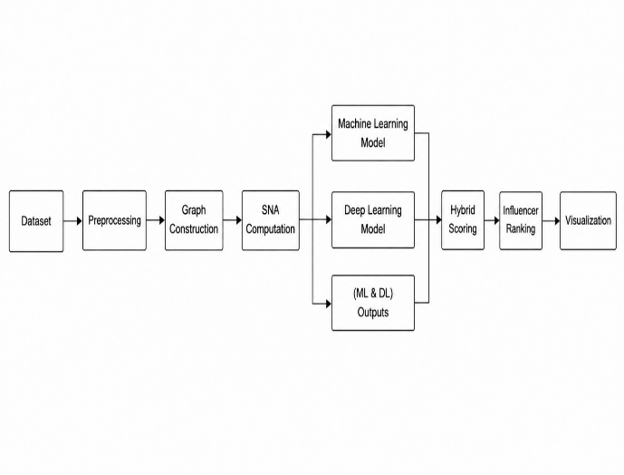

Data Collection
The dataset used in this study consists of Instagram user-level engagement metrics collected from publicly available sources. The features include: Number of followers Average likes per post Average comments per post Average views Engagement rate These attributes provide a quantitative representation of user activity and audience interaction, which are critical indicators of influence.

Data Preprocessing

Data preprocessing is a crucial step to ensure data quality and consistency before analysis. The following operations are performed: Data Cleaning: Missing, duplicate, and inconsistent values are removed to maintain dataset integrity. Feature Selection: Relevant numerical features related to engagement and reach are selected for further analysis. Feature Scaling: Standardization is applied using StandardScaler to normalize feature distributions, ensuring that all variables contribute equally during similarity computation and model training.

Graph Construction
A social network graph G(V, E) is constructed to represent realtionships among users. In this graph, V denotes the set of users (nodes), while E represents the edges that indicate similarity between users.

Cosine similarity is employed to measure similarity between
users based on their normalized feature vectors:
$$sim\left(u_{i}, u_{j}\right)= \frac{u_{i}.u_{j}}{\left\|u_{i}\right\|\left\|u_{j}\right\|}$$

An edge is established between two users if their similarity exceeds a predefined threshold (0.85). This results in a weighted, undirected graph that captures implicit relationships among users with similar engagement patterns.

Social Network Analysis

To quantify the structural importance of users within the network, multiple centrality measures are computed: Degree Centrality: Measures the number of direct connections of a node, indicating local influence. Closeness Centrality: Represents the average shortest path distance to all other nodes, indicating how quickly information can spread. Betweenness Centrality: Measures the extent to which a node lies on shortest paths between other nodes, identifying bridge users. Eigenvector Centrality: Assigns importance to nodes based on their connections to other influential nodes. The overall SNA score for each user is computed as:
$$SNA Score=$$
$$\frac{Degree+Closeness+Betweenness+Eigenvector}{4}$$

This aggregated score reflects the structural influence of users within the network.

Feature Engineering

To enhance predictive performance, the dataset is enriched by combining: Engagement-based features (likes, comments, views, etc.) Network-based features (centrality measures) This integration allows the models to learn both behavioral and structural patterns, improving influencer detection accuracy.

Machine Learning Model
A Random Forest classifier is employed for influencer prediction due to its robustness and ability to handle nonlinear relationships. The dataset is divided into training and testing sets to evaluate model performance.

The model constructs multiple decision trees and aggregates their predictions to improve generalization and reduce overfitting. Feature importance analysis is also performed to identify key factors influencing predictions.

Deep Learning Model
A feedforward neural network is implemented to capture complex and nonlinear relationships between features. The architecture consists of:
Input layer representing feature vectors
Multiple hidden layers with ReLU activation
Dropout layers for regularization
Output layer with sigmoid activation for classification
The model is trained using backpropagation and optimized using gradient-based methods.

Hybrid Scoring Mechanism
To leverage the strengths of all approaches, a hybrid scoring mechanism is proposed. The final influencer score is computed as:
$$final score=0.4×SNA+0.3 ×ML+0.3 ×DL$$
This weighted aggregation ensures a balanced contribution from structural analysis and predictive modeling.

Influencer Ranking
Users are ranked based on their final hybrid scores in descending order. Higher scores indicate greater influence. The top-ranked users are identified as key influencers.

Model Evaluation
The performance of ML and DL models is evaluated using standard classification metrics:
Accuracy
Precision
Recall F1-score
Additionally, SNA performance is evaluated using correlation with engagement rate. These metrics provide a comprehensive evaluation of model effectiveness.

Visulization and analysis
To interpret the results, various visualization techniques are employed, including: Network graphs to represent user connectivity Heatmaps to analyze feature relationships Distribution plots for engagement metrics Ranking charts for influencer identification These visualizations provide insights into both model performance and network behavior.

Results

A. Network Construction
The Instagram influencer network was constructed using cosine similarity with a threshold value of 0.85. The resulting graph consists of 30 nodes and 191 edges, with a network density of 0.439 and an average degree of 12.73, indicating a moderately connected structure.
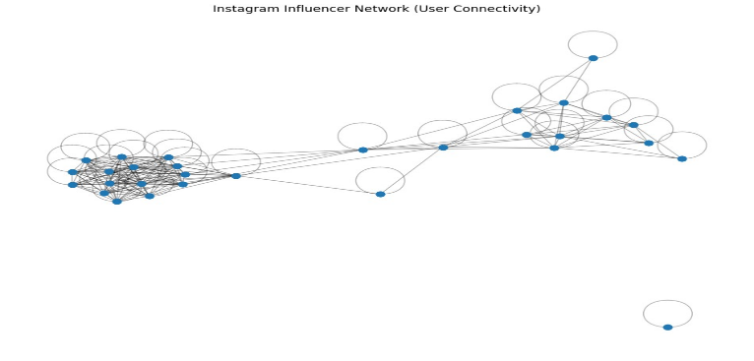
Fig.1. Instagram influencer network showing user connectivity and clustering.

Degree Distribution
The degree distribution of the constructed network is presented in Fig. 2. The distribution illustrates the variation in the number of connections among users, reflecting the connectivity pattern within the network.
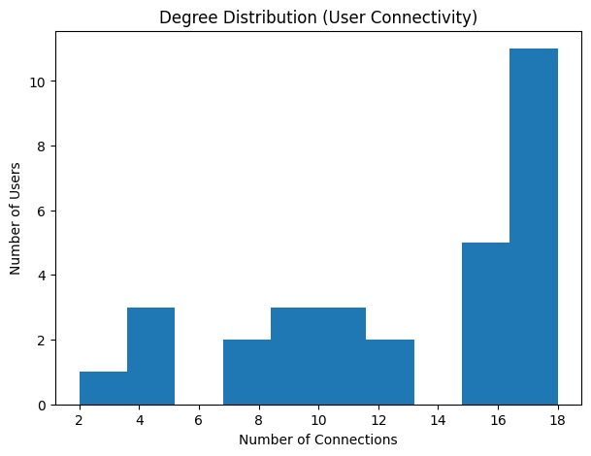
Fig. 2. Degree distribution of users in the network.

Edge Similarity Distribution
The distribution of cosine similarity scores used for edge formation is shown in Fig. 3. The similarity values range from 0.85 to 1.0, corresponding to the defined threshold used for establishing connections
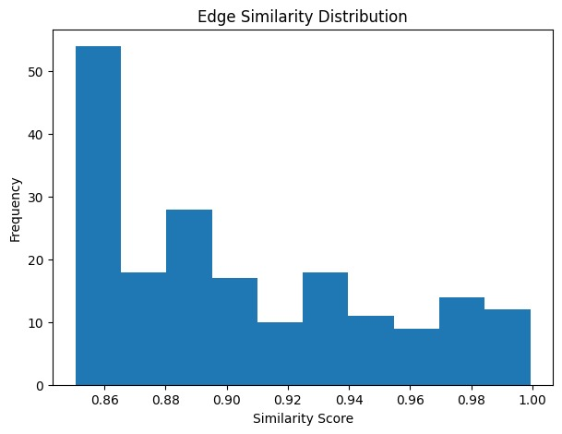
Fig. 3. Distribution of cosine similarity scores.

Network Connectivity Ratio
The connectivity characteristics of the network are shown in Fig. 4. The graph consists of 43.9% connected nodes and 56.1% non-connected nodes, indicating partial clustering within the network.
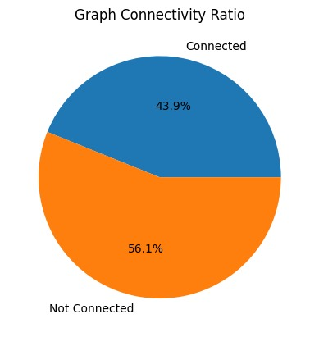
Fig. 4. Connectivity ratio of the network.

Social Network Analysis (SNA) Metrics
Centrality measures, including degree, closeness, betweenness, and eigenvector centrality, were computed for all users in the network. The correlation among these centrality measures is illustrated in Fig. 5, while their distributions are shown in Fig. 6.
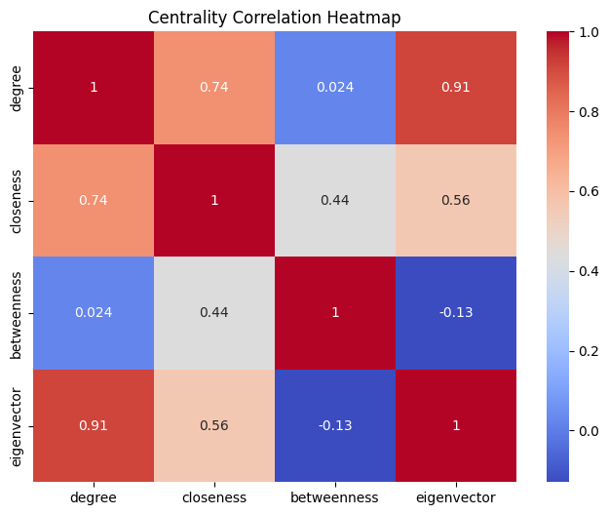

Fig. 5. Correlation heatmap of centrality measures.

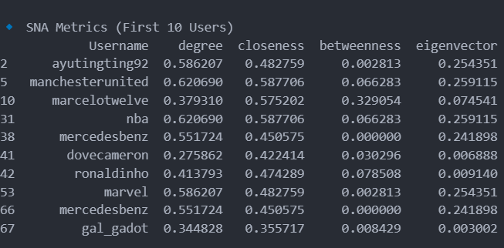

Fig. 6. Distribution of centrality metrics.

Influencer Identification (SNA-Based)
The top users identified based on SNA centrality measures include nba, manchesterunited, hudabeauty, and psg. These users exhibit high centrality values across multiple metrics.
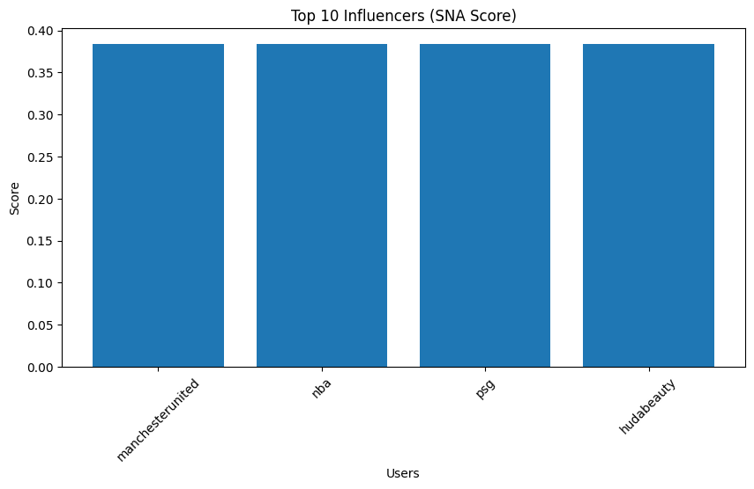

Fig. 7. Top influencers identified using SNA

Netwrok Representation with Influence
The network visualization with node size proportional to influence is shown in Fig. 8, where influential users are highlighted within the network structure.
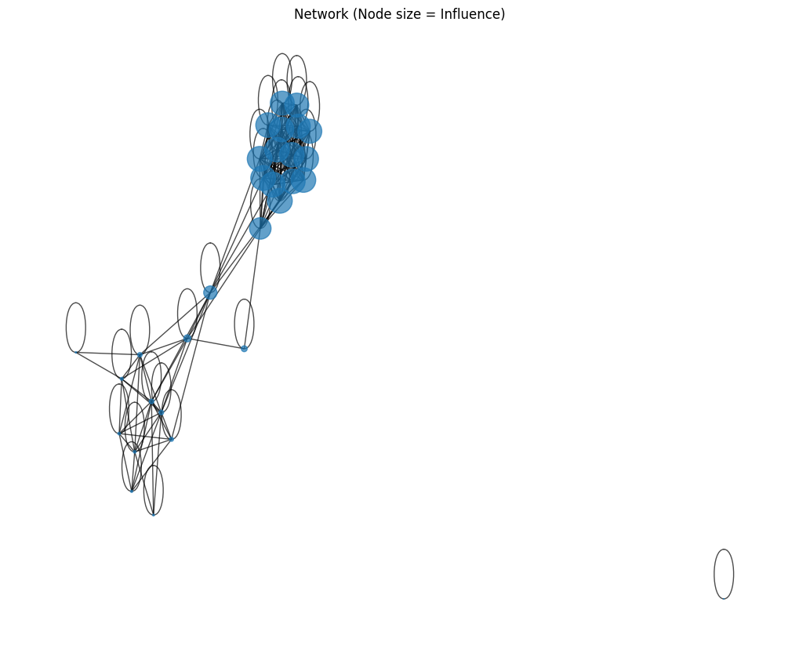
Fig. 8. Network visualization with influence representation.

Machine Learning Model Results
The performance of the Random Forest classifier is evaluated using a confusion matrix, as shown in Fig. 9. The model correctly classified 398 instances as true negatives and 68 instances as true positives, while 23 instances were classified as false positives and 112 instances as false negatives. The overall classification accuracy achieved by the model is 0.775.
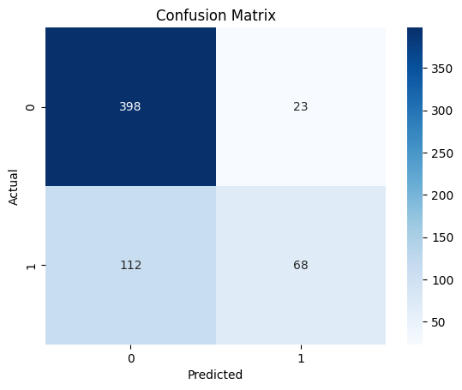
Fig. 9. Confusion matrix of the Random Forest model.

The feature importance derived from the model is shown in Fig. 10. The most significant features include average likes and comments, followed by views and followers.

Fig. 10. Feature importance of input variables.

Deep Learning Model Results
The Deep Learning model achieved an accuracy of 0.792. The training and validation accuracy curves are shown in Fig. 11.
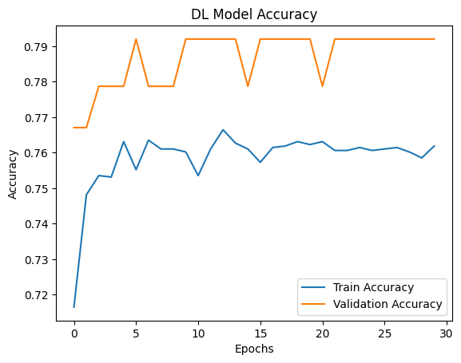
Fig. 11. Training and validation accuracy of the Deep Learning model.

Hybrid Model Results
The final influencer ranking based on the hybrid scoring mechanism is presented in Fig. 12. The top-ranked users include psg (0.70), maisa (0.64), and khabib_nurmagomedov (0.54).
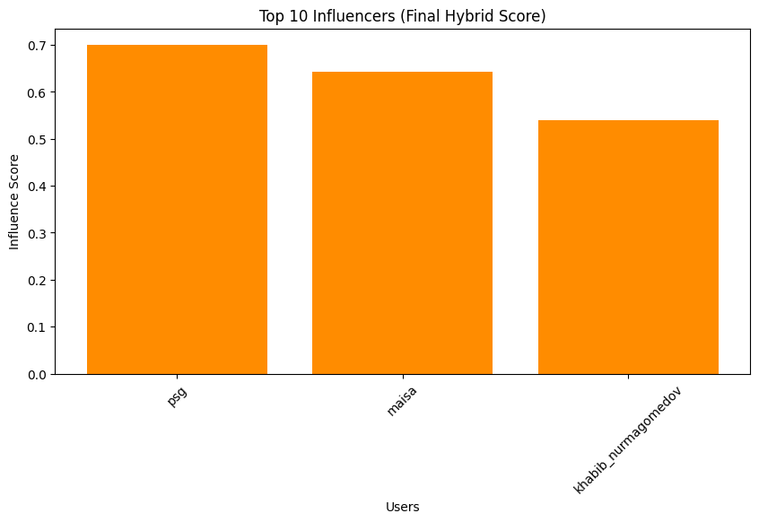
Fig. 12. Influencer ranking based on hybrid scoring.

Performance Comparision
The comparative performance of SNA, Machine Learning, and Deep Learning models is shown in Fig. 13.
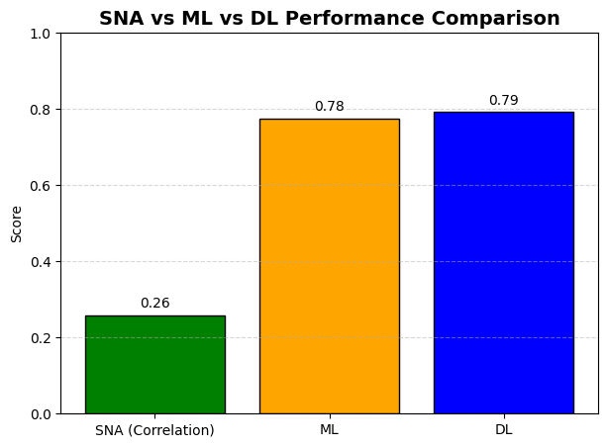

Fig. 13. Performance comparison of SNA, ML, and DL models.
Table I: Performance Comparison

Method | Metrics Used | Score
SNA | Correlation | -0.258
Machine Learning | Acuuracy | 0.775
Deep Learning | Accuracy | 0.792

Graph Summary
Metric | Value
Nodes | 30
Edges | 191
Density | 0.439
Average Degree | 12.73

Discussions

The constructed Instagram influencer network exhibits a moderately dense structure, as reflected by a density value of 0.439 and an average degree of 12.73. As illustrated in Fig. 1, the network demonstrates clear clustering behavior, where users with similar engagement characteristics are grouped together. The degree distribution shown in Fig. 2 indicates that a majority of users maintain a relatively high number of connections, suggesting the presence of dominant nodes within the network. Furthermore, the similarity distribution in Fig. 3 confirms that edges are formed primarily between highly similar users, validating the effectiveness of the cosine similarity threshold applied during graph construction.

The analysis of centrality measures provides insights into the structural importance of users within the network. As observed in Fig. 5, degree and eigenvector centrality exhibit strong positive correlation, indicating that highly connected users also tend to occupy influential positions within the network structure. However, the obtained SNA correlation value of -0.258 suggests that structural centrality alone does not directly correspond to engagement-based influence. This observation is further supported by the distribution of centrality metrics shown in Fig. 6, highlighting the limitations of relying solely on network topology for influencer detection.

The Machine Learning model demonstrates strong predictive capability, achieving an accuracy of 77.5%, as reflected in the confusion matrix presented in Fig. 9. The model effectively classifies non-influencer instances while maintaining a reasonable detection rate for influencer instances. Additionally, the feature importance analysis shown in Fig. 10 reveals that engagement-related features such as likes and comments contribute significantly more to prediction performance compared to follower count. The Deep Learning model further improves performance, achieving an accuracy of 79.2%, as illustrated in Fig. 11, indicating its ability to capture nonlinear relationships within the data.

The hybrid scoring approach integrates the strengths of SNA, Machine Learning, and Deep Learning to provide a comprehensive evaluation of influencer significance. The ranking results presented in Fig. 12 demonstrate that the combined approach effectively identifies top influencers based on both structural and behavioral characteristics. Furthermore, the comparative analysis shown in Fig. 13 confirms that while SNA provides valuable structural insights, Machine Learning and Deep Learning models offer superior predictive performance. The hybrid framework therefore provides a more balanced and reliable approach for influencer detection.

Conclusion
This paper presented a hybrid framework for influencer detection on Instagram by integrating Social Network Analysis (SNA), Machine Learning (ML), and Deep Learning (DL) techniques. Unlike traditional approaches that rely solely on follower count, the proposed method combines structural network properties with engagement-based behavioral features to provide a more accurate and comprehensive evaluation of user influence.

The constructed similarity-based network successfully captured relationships among users, enabling the computation of centrality measures such as degree, closeness, betweenness, and eigenvector centrality. These measures provided valuable insights into the structural importance of users within the network. However, experimental results indicated that SNA alone is insufficient for accurate influencer detection, as it does not fully reflect engagement dynamics.

The Machine Learning model demonstrated reliable performance with an accuracy of 77.5%, while the Deep Learning model further improved predictive capability, achieving an accuracy of 79.2%. These results highlight the effectiveness of data-driven approaches in capturing complex behavioral patterns. The hybrid scoring mechanism, which combines SNA (40%), ML (30%), and DL (30%), successfully integrates the strengths of all three approaches.

The final results show that the hybrid model provides a more balanced and robust identification of influencers compared to individual methods. It effectively identifies users who exhibit both strong network influence and high engagement levels. This makes the proposed framework more suitable for real-world applications such as digital marketing, recommendation systems, and targeted advertising.

In conclusion, the proposed hybrid approach offers a scalable and effective solution for influencer detection by combining structural and predictive insights. Future work can focus on incorporating temporal dynamics, exploring advanced graph neural network models, and extending the framework to other social media platforms for improved generalization.

References
[1] L. C. Freeman, “Centrality in social networks: Conceptual clarification,” Social Networks, vol. 1, no. 3, pp. 215–239, 1978.

[2] S. P. Borgatti, “Identifying sets of key players in a social network,” Computational & Mathematical Organization Theory, vol. 12, no. 1, pp. 21–34, 2006.

[3] M. Cha, H. Haddadi, F. Benevenuto, and K. P. Gummadi, “Measuring user influence in Twitter: The million follower fallacy,” in Proc. ICWSM, 2010.

[4] D. Easley and J. Kleinberg, Networks, Crowds, and Markets: Reasoning About a Highly Connected World. Cambridge University Press, 2010.

[5] E. Bakshy, J. Hofman, W. Mason, and D. Watts, “Everyone’s an influencer: Quantifying influence on Twitter,” in Proc. WSDM, 2011.

[6] L. Breiman, “Random forests,” Machine Learning, vol. 45, no. 1, pp. 5–32, 2001.

[7] Y. LeCun, Y. Bengio, and G. Hinton, “Deep learning,” Nature, vol. 521, pp. 436–444, 2015.

[8] S. Hochreiter and J. Schmidhuber, “Long short-term memory,” Neural Computation, vol. 9, no. 8, pp. 1735–1780, 1997.
[9] T. N. Kipf and M. Welling, “Semi-supervised classification with graph convolutional networks,” in Proc. ICLR, 2017.

[10] J. Chen, T. Ma, and C. Xiao, “FastGCN: Fast learning with graph convolutional networks via importance sampling,” in Proc. ICLR, 2018.

[11] X. Zheng, Y. Zhou, J. Li, and Z. Wang, “Hybrid deep learning for social influence prediction,” IEEE Access, vol. 7, pp. 123456–123467, 2019.

[12] Z. Di, Y. Fan, and H. Li, “Predicting influential nodes in complex networks using machine learning,” Physica A, vol. 490, pp. 147–155, 2018.

[13] W. Wei, Q. Li, and X. Liu, “Identifying influential spreaders in complex networks based on ensemble learning,” Applied Soft Computing, vol. 72, pp. 145–156, 2018.

[14] H. Ma, H. Yang, M. Lyu, and I. King, “SoRec: Social recommendation using probabilistic matrix factorization,” in Proc. CIKM, 2008.

[15] J. Jiang, J. Cui, and C. Faloutsos, “Inferring social influence in networks,” in Proc. KDD, 2016.

[16] A. Landherr, B. Friedl, and J. Heidemann, “A critical review of centrality measures in social networks,” Business & Information Systems Engineering, vol. 2, no. 6, pp. 371–385, 2010.

[17] T. W. Valente, Social Networks and Health: Models, Methods, and Applications. Oxford University Press, 2010.

[18] J. Scott, Social Network Analysis, 3rd ed. Sage Publications, 2017.

[19] M. O. Jackson, Social and Economic Networks. Princeton University Press, 2008.

[20] R. V. Kozinets, Netnography: Doing Ethnographic Research Online. Sage Publications, 2010.

.

