5-Day AICTE-Sponsored Faculty Development Programme
on Innovation and Entrepreneurship
21–25 July 2025
Organised by Vignan’s (Deemed to be University) and Vignan Technology Business Incubator (Vignan TBI)
Sponsored by AICTE, New Delhi
Venue: TBI Co-working Space, 2nd Floor, N Block, VFSTR, Vadlamudi, Guntur District, Andhra Pradesh

1. Executive Summary
Vignan’s Foundation for Science, Technology & Research (VFSTR), through Vignan Technology Business Incubator (Vignan TBI), organised a five-day AICTE-sponsored Faculty Development Programme (FDP) on Innovation and Entrepreneurship from 21 to 25 July 2025. The programme was designed to strengthen faculty understanding of entrepreneurship education, innovation practices, startup development and the support systems required to translate ideas into viable ventures.
The FDP brought together 50 faculty members representing more than 15 universities/institutions. Across 40 hours of structured sessions, expert interactions, practical activities and an industry visit, participants were introduced to key stages of the entrepreneurial journey—from identifying problems and generating ideas to customer discovery, value proposition design, business modelling, startup finance, intellectual property and action-plan preparation.
A major institutional outcome was faculty capacity building. Participants were equipped with concepts, frameworks and practical approaches that they can adapt in their own departments to guide students in innovation projects, entrepreneurship activities, pre-incubation initiatives and startup-oriented learning. The programme supports a stronger campus startup culture by enabling faculty to act as mentors and connect student ideas with incubation support.

2. Programme Snapshot
Programme | 5-Day AICTE-Sponsored Faculty Development Programme on Innovation and Entrepreneurship
Dates | 21–25 July 2025
Duration | 5 days / 40 hours
Participants | 50 faculty members
Institutional representation | Faculty from 15+ universities/institutions
Host institution | Vignan’s (Deemed to be University), VFSTR
Organising unit | Vignan Technology Business Incubator (Vignan TBI)
Sponsor | All India Council for Technical Education (AICTE), New Delhi
Venue | TBI Co-working Space, 2nd Floor, N Block, VFSTR, Vadlamudi, Guntur District, Andhra Pradesh

3. Objectives of the FDP
- Build faculty awareness of innovation, entrepreneurship and the role of educational institutions in developing entrepreneurial talent.
- Introduce practical approaches for problem identification, creativity, idea generation and customer discovery.
- Develop understanding of value propositions, Lean Startup concepts, minimum viable products (MVPs) and Business Model Canvas (BMC).
- Explain startup finance, market strategy, intellectual property and the stages of a startup journey.
- Encourage faculty to mentor student teams and support promising ideas through departmental innovation activities, pre-incubation and the TBI ecosystem.
- Help participants prepare action plans for introducing or strengthening entrepreneurship-related activities in their institutions.

4. Programme Delivery and Major Sessions
The five-day programme combined expert-led sessions, reflections, practical workshops, institutional laboratory visits, an industry visit and action planning. In addition to the scheduled visit to Sangam Dairy, participants visited VFSTR’s laboratories and Centres of Excellence, including robotics and 3D-related facilities, to observe applied technology, prototyping and practical innovation environments. The following summary follows the supplied programme schedule.
Day / Date | Topics and Activities | Learning Focus
Day 1 – 21 July 2025 | Entrepreneurship evangelisation; identifying and falling in love with problems; creativity and idea generation; innovative workshop. | Participants explored the purpose of entrepreneurship, problem-led innovation and techniques for generating and refining ideas.
Day 2 – 22 July 2025 | Customer discovery; value proposition; understanding Lean Startup; building a Minimum Viable Product (MVP). | Sessions introduced customer needs validation, value proposition development and iterative testing before investing heavily in a product.
Day 3 – 23 July 2025 | Finance for Startups (Parts I and II); understanding the Business Model Canvas through activities. | Participants were introduced to startup finance fundamentals and a structured canvas for describing customers, value, channels, costs and revenue.
Day 4 – 24 July 2025 | Go-to-market strategy; visit to centres of excellence; leading innovation and entrepreneurship activities and pre-incubation on campus. | Participants connected market-entry planning with campus innovation infrastructure through visits to university laboratories and Centres of Excellence, including robotics and 3D-related facilities, and discussed how pre-incubation can support student ideas.
Day 5 – 25 July 2025 | Industry visit to Sangam Dairy; intellectual property for startups; startup journey; action-plan development; valedictory programme and certificate distribution. | The Sangam Dairy industry visit offered industry exposure. Sessions on intellectual property, startup journeys and action planning helped participants consider how to support student innovators.

5. Resource Persons and Expertise
The programme schedule and event materials identify resource persons with experience in entrepreneurship development, incubation, startup finance, business modelling, intellectual property and innovation ecosystems. The listed speakers included:
- Dr. Ravi Chandra Raju – Ashoka Fellow and Innovation Coach.
- Dr. B. S. Rama Krishna – CEO, ASPIRE Technology Business Incubator, University of Hyderabad.
- David Samuel – Entrepreneurship Trainer and Skill Enhancement Coach.
- Praveen Dorna – Founder and CEO, Founders First Network.
- Dr. M. K. Kaushik – CEO, Vishnu Foundation TBI, Visakhapatnam.
- Ms. Ashwathy Venugopal – Headstart Network Foundation, Kerala.
- Dr. Vijaya R. Dirisala – VFSTR / Vignan TBI programme leadership.
- Dr. Vithal Kumar Lakk ineni – IKP Knowledge Park, Hyderabad (as listed in programme material).
- Surekha Nistala – Founder, Organic Hues.

6. Participation and Engagement
The FDP recorded participation by 50 faculty members drawn from more than 15 universities/institutions. The cross-institutional composition created opportunities for participants to exchange teaching practices, discuss barriers to student entrepreneurship and learn from the experiences of incubators, entrepreneurs and innovation ecosystem professionals. Participants also visited Sangam Dairy as an industry-learning activity and explored university laboratories and Centres of Excellence, including robotics and 3D facilities.
The programme used more than lecture-based delivery: the schedule included reflections on previous sessions, hands-on Business Model Canvas activities, innovation workshops, visits and action-plan development. These elements helped participants connect the concepts with practical academic and institutional settings.

7. Key Outcomes and Institutional Impact
Outcome Area | Outcome / Significance
Faculty capacity building | 50 faculty members completed a structured five-day, 40-hour learning programme focused on innovation and entrepreneurship.
Entrepreneurship mentoring readiness | Participants gained frameworks and practical concepts they can use to guide students through problem identification, idea validation, business modelling and early startup planning.
Student startup culture | The programme strengthened the foundation for faculty-led student entrepreneurship activities, including innovation clubs, idea challenges, project mentoring and startup awareness sessions.
Improved idea-to-venture understanding | Coverage of customer discovery, value propositions, Lean Startup, MVPs and go-to-market strategy introduced a staged approach for moving ideas towards market validation.
Financial and business awareness | Startup finance and Business Model Canvas sessions helped participants understand the business and financial considerations that complement technical innovation.
Intellectual property awareness | The IP session highlighted the importance of considering ownership, protection and commercialisation of ideas and inventions.
Institutional action planning | Action-plan development encouraged faculty to identify possible follow-up activities within their institutions and consider how the incubation ecosystem can support student innovators.
Industry and ecosystem exposure | Visits and expert interactions exposed participants to practical innovation environments and the wider support network available to entrepreneurs.
Impact note: The immediate documented output is the training of 50 faculty members. The expected downstream impact is that trained faculty will apply the learning to mentor students, promote entrepreneurial thinking and help build a stronger startup culture on campus. The supplied records do not quantify how many student startups were subsequently formed as a direct result of this FDP; such outcomes can be added when follow-up evidence is available.

8. Way Forward and Recommended Follow-up
- Collect institution-wise action plans from participating faculty and nominate a faculty contact for entrepreneurship activities.
- Conduct follow-up sessions to review progress on the action plans and identify faculty members who need additional mentoring or resources.
- Encourage participants to organise student idea-generation workshops, problem-discovery exercises, business-model clinics and startup awareness sessions.
- Create a pathway for promising student ideas to access Vignan TBI or the relevant incubation/pre-incubation facility for mentoring and validation.
- Track measurable outcomes over the next 3–6 months: student teams mentored, ideas screened, prototypes initiated, business models developed, incubation referrals and startups formally registered.
- Maintain supporting evidence such as attendance sheets, certificates, session photographs, feedback forms, resource-person details, visit records and action plans.

9. Photographic Documentation
The photographs below, supplied for this updated report, document faculty participation, interactive sessions and practical exposure to robotics/prototype facilities. No event poster has been included; only the provided photographs are used.
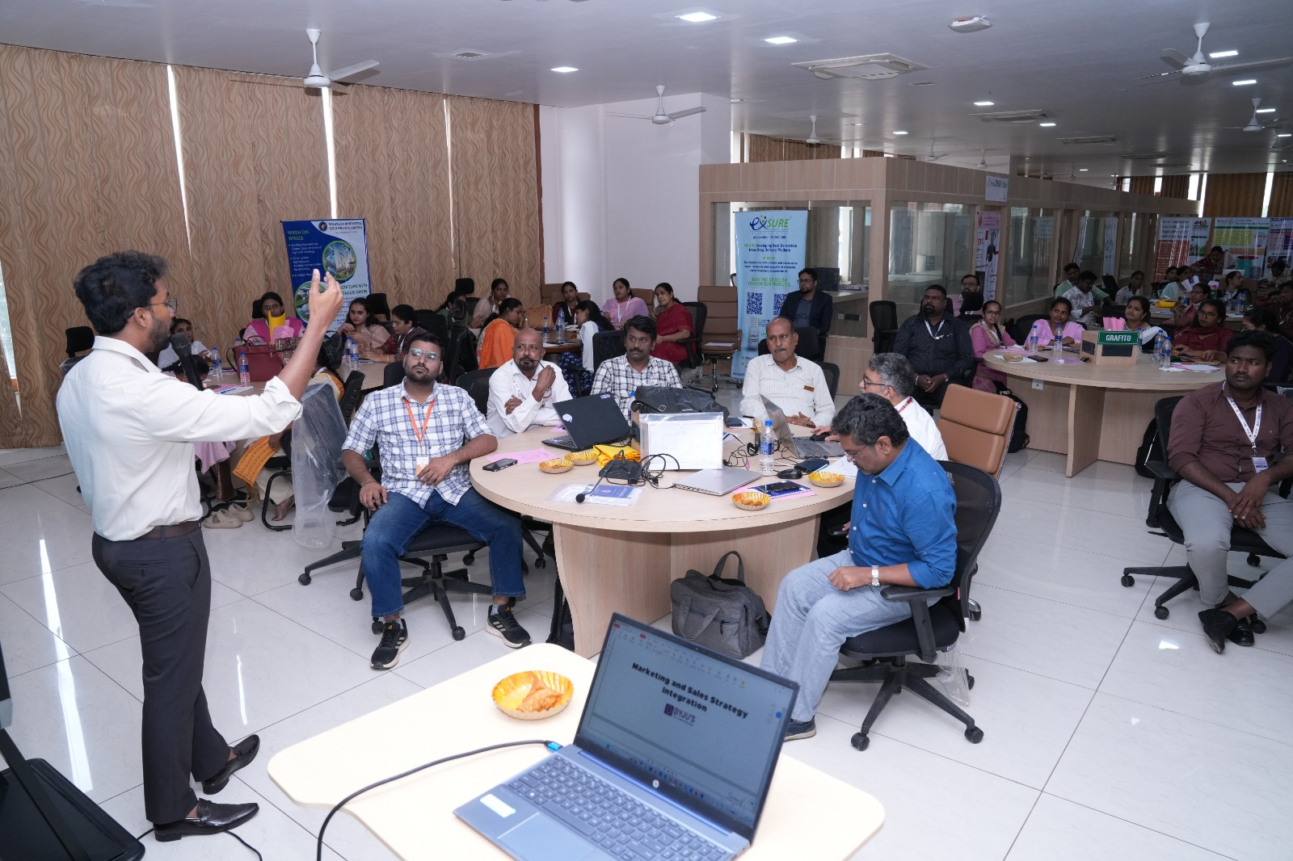
Faculty participants engaging in an interactive FDP session.
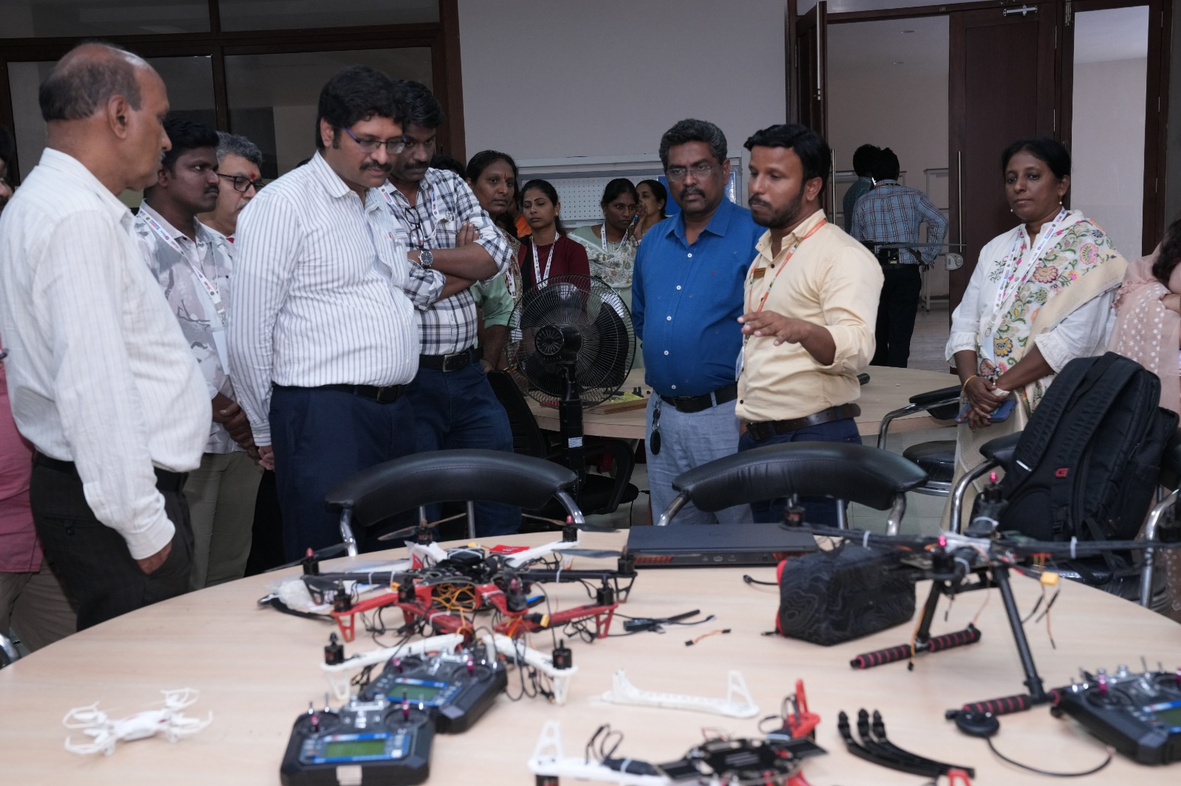
Faculty visit to robotics and prototype demonstration facilities.
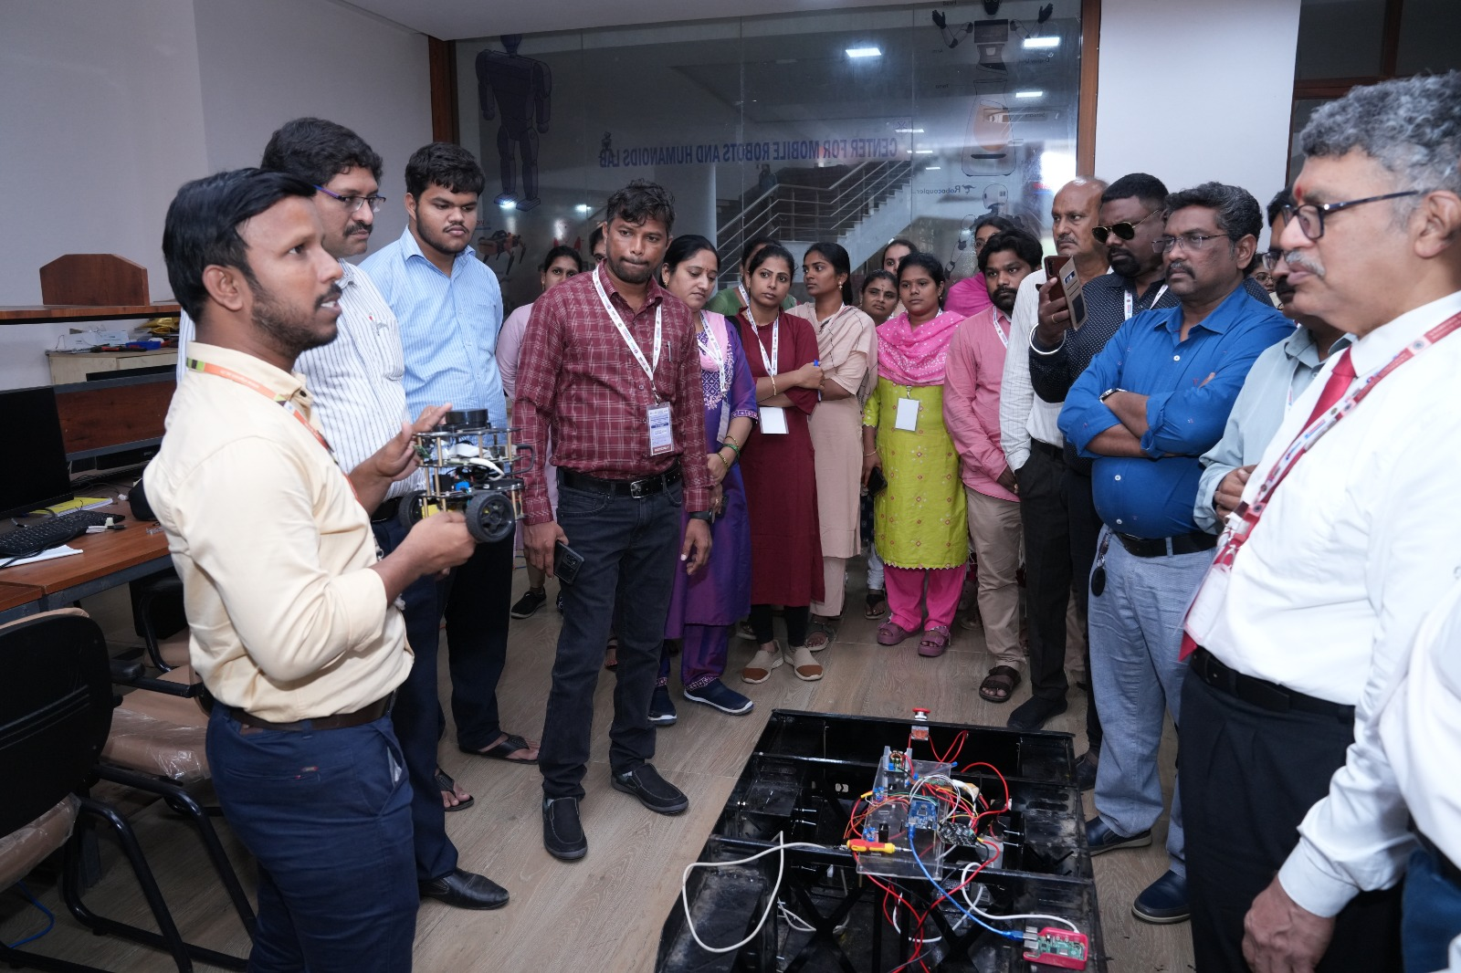
Participants observing a robotics and hands-on technology demonstration.
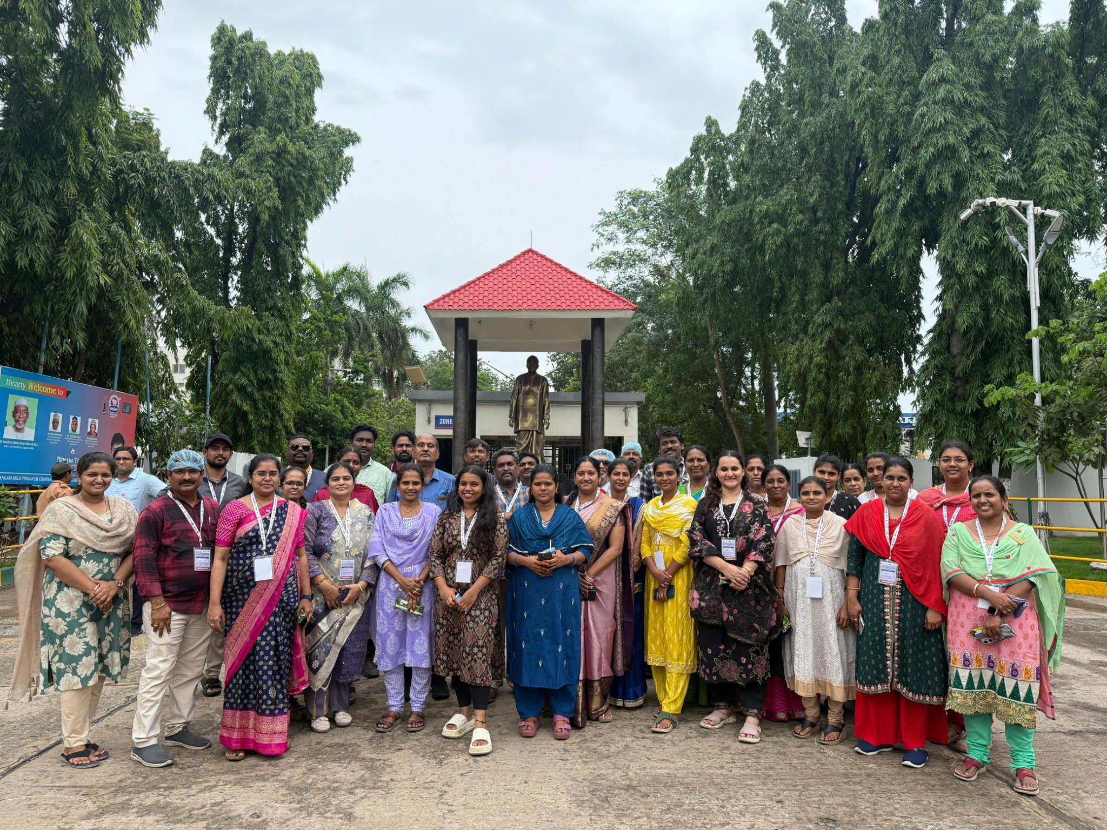
Faculty group during the programme’s practical exposure activities.
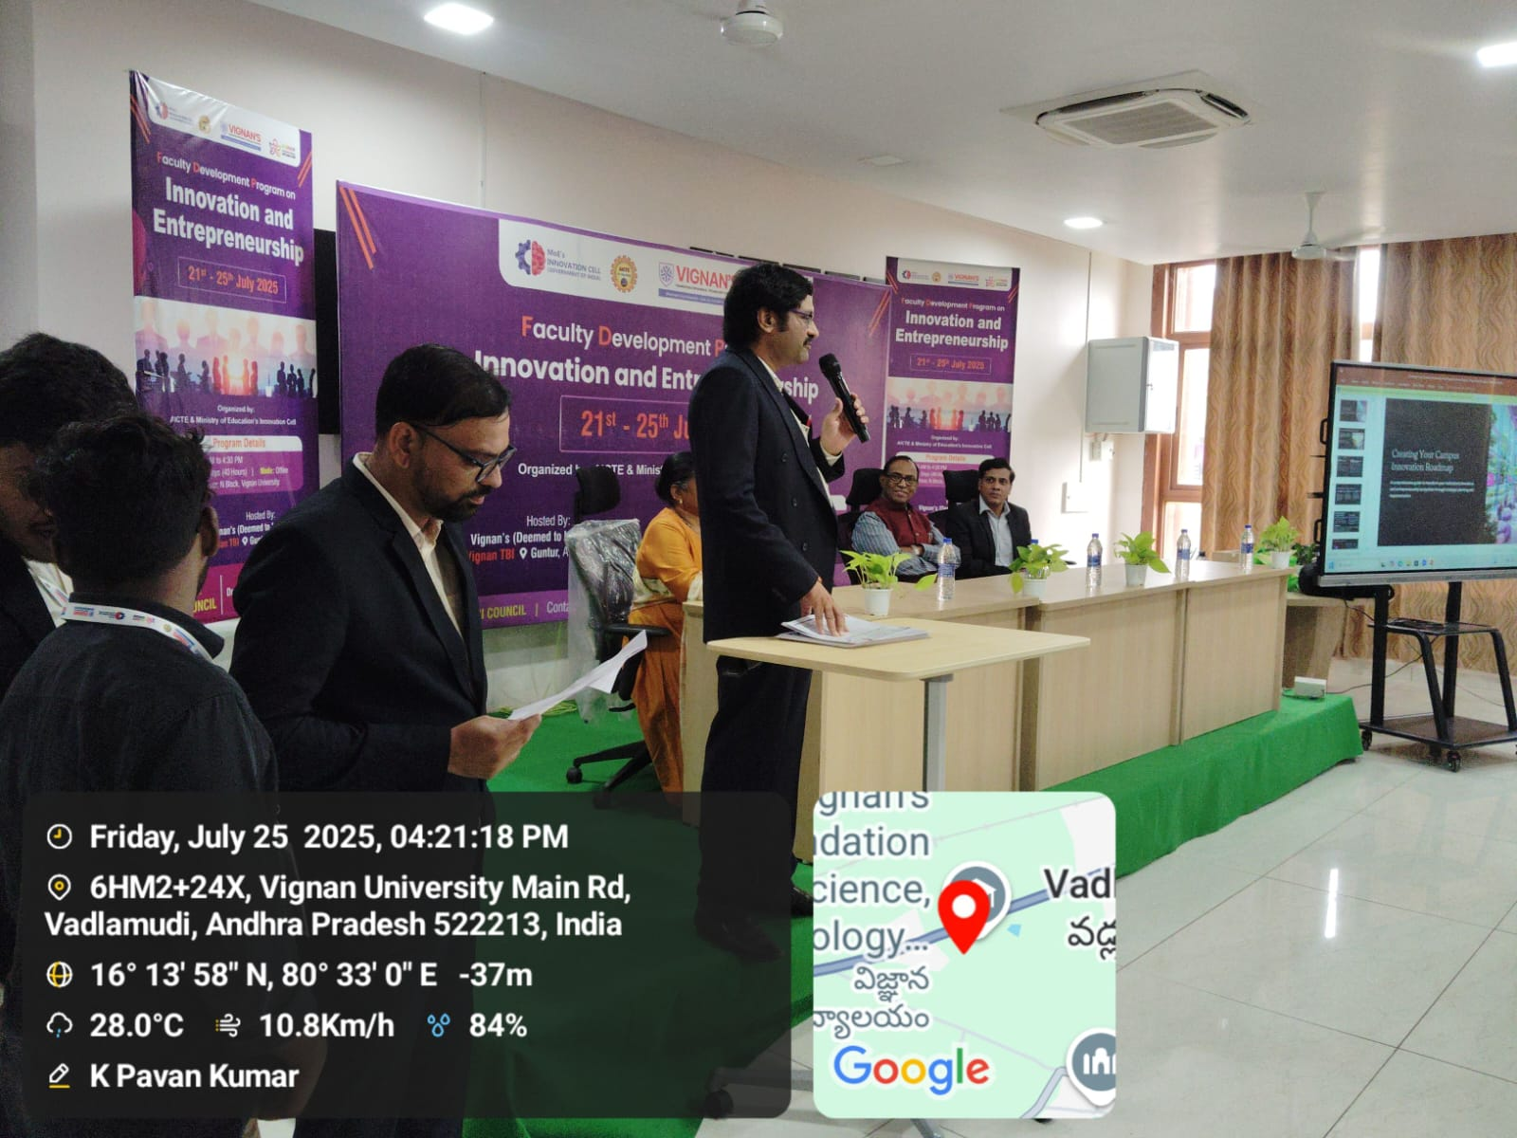
FDP session and programme proceedings at Vignan TBI.

10. Conclusion
The AICTE-sponsored Faculty Development Programme on Innovation and Entrepreneurship, conducted from 21 to 25 July 2025 at VFSTR, was an important faculty-capacity-building initiative of Vignan TBI. By training 50 faculty members from more than 15 universities/institutions over 40 hours, the programme created a broader base of educators familiar with entrepreneurship concepts, startup development frameworks and incubation support.
The programme’s value extends beyond the five-day event: trained faculty can serve as multipliers by introducing entrepreneurial thinking into classrooms, guiding students to identify real-world problems, supporting early-stage ideas and linking suitable teams with incubation resources. The Sangam Dairy industry visit and visits to university laboratories, robotics and 3D facilities, and Centres of Excellence added practical exposure to industry processes and technology-based innovation. With systematic follow-up and outcome tracking, the FDP can contribute to a sustained student innovation pipeline and a stronger startup culture across participating institutions.
Prepared for institutional documentation and management review | VFSTR TBI Council

