FOUR-DAY ENTREPRENEURSHIP DEVELOPMENT PROGRAMME (EDP)
DST–NIDHI TBI PROJECT | 15–18 MAY 2024
Venue: N-Block, 2nd Floor, VFSTR | Time: 9:00 AM – 5:00 PM
40 PARTICIPANTS | REPRESENTING VARIOUS COLLEGES AND STARTUP FOUNDERS
1. Programme Overview
The four-day Entrepreneurship Development Programme (EDP) was conducted under the DST–NIDHI TBI Project at VFSTR through Vignan Technology Business Incubator (Vignan TBI). The programme brought together 40 participants from various colleges, including startup founders and aspiring entrepreneurs. It provided a structured learning platform to build entrepreneurial awareness, explore innovation opportunities, and understand the practical steps involved in developing ideas into viable products, services, and enterprises.
2. Programme Objectives
- Encourage an entrepreneurial mindset and opportunity-oriented thinking.
- Build understanding of idea validation, product development, and business-model design.
- Introduce participants to startup ecosystem support, mentoring, and funding pathways.
- Promote networking and knowledge-sharing among students, aspiring entrepreneurs, and startup founders.
3. Guest Speakers and Expert Sessions
The programme featured six guest speakers/resource persons whose expertise covered entrepreneurship education, venture investment, finance, organisational leadership, business registration, and startup creation.
Dr. Ratnakar Samavedam
Managing Partner at HAF.VC and CEO & Investment Director at Hyderabad Angels. His profile highlights venture investment, startup funding, founder mentoring, and experience supporting high-growth companies.
Dr. Suresh Bhagavatula
Professor of Entrepreneurship at the Indian Institute of Management Bangalore. His profile highlights entrepreneurship research, startup incubation, and work with the NS Raghavan Centre for Entrepreneurial Learning.
Dr. Subbaraju
Finance expert, sharing a finance-focused perspective relevant to business planning, financial management, and startup development.
Dr. M. K. Koushik
CEO of Vishnu Foundation, bringing a leadership and organisational perspective to entrepreneurship and startup ecosystem development.
K. V. N. Lavanya
Expert in company registration processes and related business formalities, helping aspiring entrepreneurs understand the formalisation of a business.
Raviteja
Startup founder and successful businessman serving as a CEO, bringing an entrepreneur’s perspective on starting and building a business.
4. Key Learning Areas
- Entrepreneurial mindset, opportunity identification, and real-world problem-solving.
- Idea validation, customer needs, and translating ideas into products or services.
- Business Model Canvas and the foundations of business planning.
- Startup ecosystem awareness, mentoring, and potential funding opportunities.
- Team building, communication, networking, and collaboration.
- Pitch preparation and presenting business ideas to stakeholders.
5. Expected Application and Outcomes
Following the learning and expert interactions, participants can apply the programme concepts in academic, professional, and venture-building settings. Students can use opportunity-identification and problem-solving methods to develop project ideas, undertake customer and market validation, form teams, and turn suitable ideas into prototypes. They can also use business-model tools and pitching skills for project presentations, innovation competitions, and future startup initiatives.
Startup founders and aspiring entrepreneurs can apply the learning to review their value propositions, better understand customer needs, strengthen business models, identify relevant mentors and ecosystem resources, and communicate their ventures more effectively to potential partners or funders. Participants can share these practices with peers and student groups, helping extend the impact of the programme beyond the four-day sessions.
6. Programme Outcomes
- Improved awareness of entrepreneurship and venture creation as practical career pathways.
- Greater familiarity with idea validation, product thinking, business models, and pitching.
- Stronger interaction among participants from different colleges and the startup community.
- Increased readiness to develop student projects, explore prototypes, and pursue innovation-led initiatives.
- Better awareness of mentoring, networking, and possible startup-support pathways.
7. Photographic Documentation
The photographs below record participant engagement, expert-led sessions, and the collaborative learning environment.
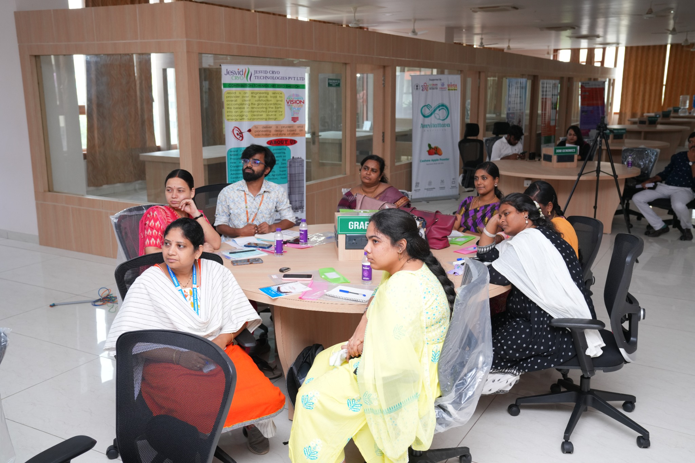  Participants engaged in group learning and discussion | 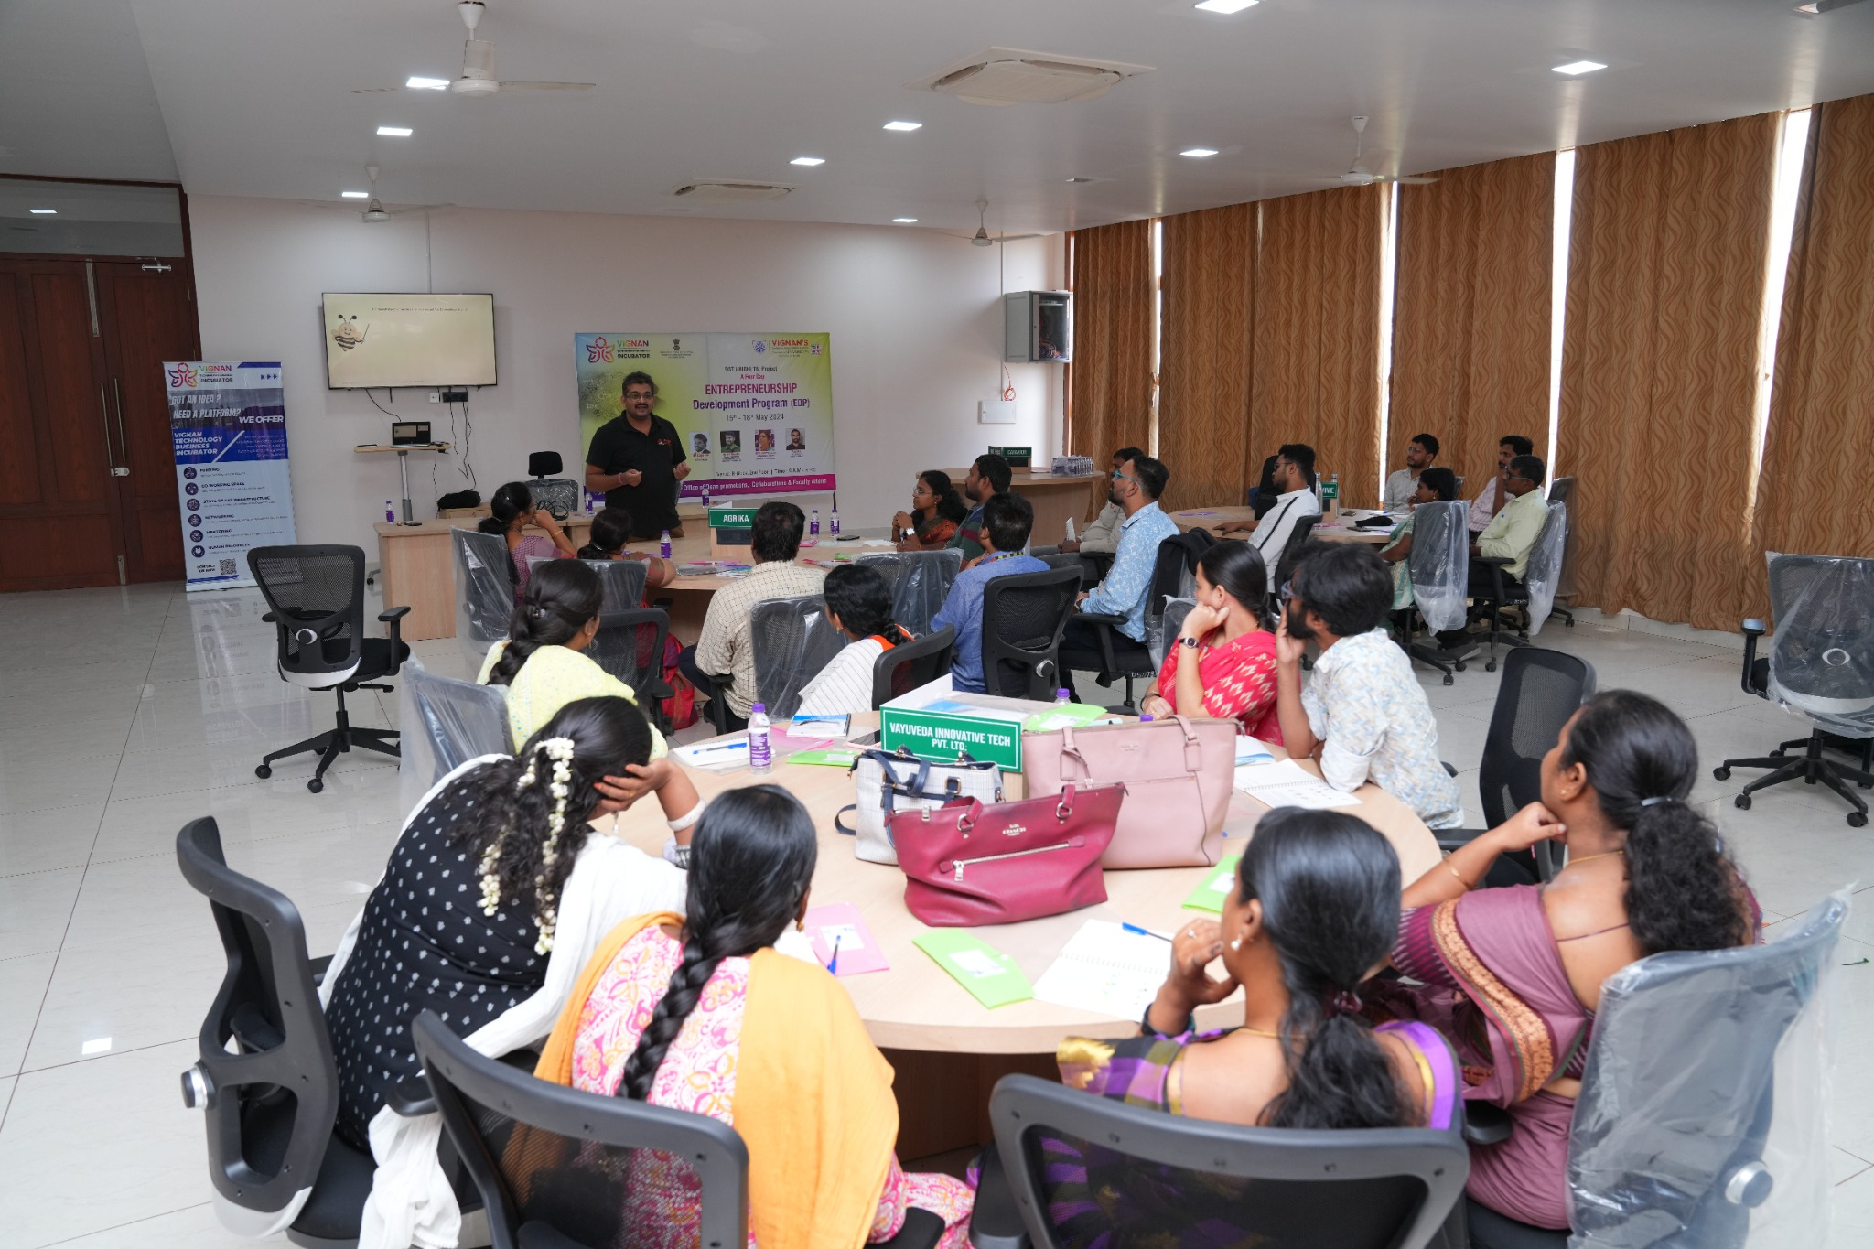  Expert session and interaction with programme participants
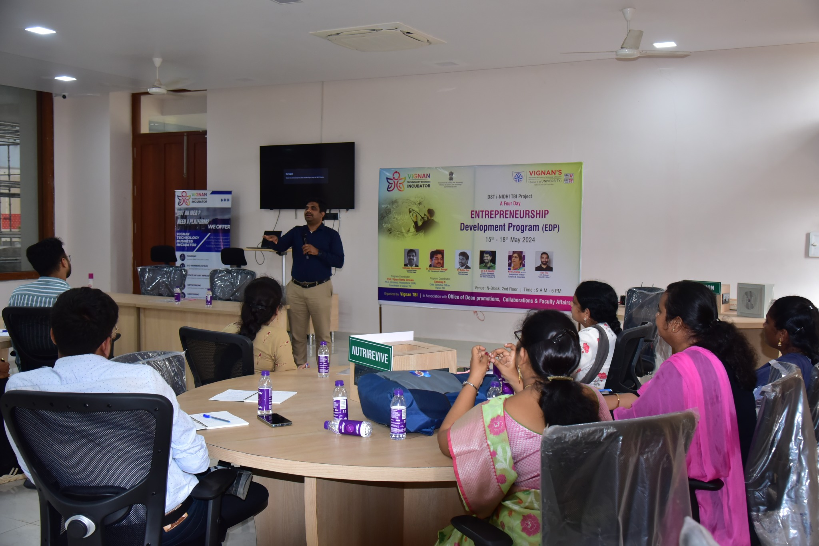
Participants attending the entrepreneurship development session
8. Conclusion
The Entrepreneurship Development Programme created a shared platform for students, startup founders, and aspiring entrepreneurs to learn about innovation and venture development. By combining expert sessions with peer interaction, the programme supported practical understanding of idea development, business-model thinking, pitching, and startup ecosystem engagement. The participation of 40 members from various colleges and the startup community contributed to a collaborative environment focused on building entrepreneurial capability and encouraging future innovation.

