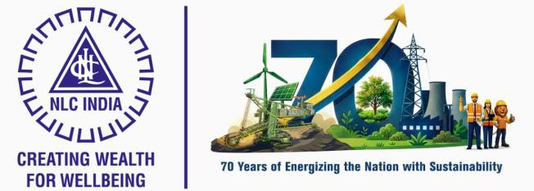

NLC INDIA LIMITED
“NAVRATNA – A GOVERNMENT OF INDIA ENTERPRISE”

INTERNSHIP REPORT ON
MINES EQUIPMENT STOPPAGE ANALYSIS

SUBMITTED BY
SASIKUMAR P
B.Tech, Artificial Intelligence and Data Science

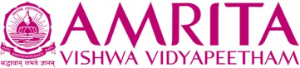

AMRITA VISHWA VIDYAPEETHAM
( An Institution Deemed to be University under Section 3 of the UGC Act, 1956)
Coimbatore – 641112, Tamil Nadu

UNDER THE GUIDANCE OF Mr. RONIJ PANDEY

DEPUTY MANAGER / COMPUTER SCIENCE MINE-I / NLC INDIA LIMITED


NLC INDIA LIMITED
("NAVRATNA" - A GOVERNMENT OF INDIA ENTERPRISE")

NEYVELI-607 801, TAMIL NADU

BONAFIDE CERTIFICATE
Certified that the Internship Training report titled "MINES EQUIPMENT STOPPAGE ANALYSIS" is the bonafide work of,

SASIKUMAR P (CB.AI.U4AID23146)

studying B.Tech, Artificial Intelligence and Data Science at AMRITA VISHWA VIDYAPEETHAM, COIMBATORE, done during the period from 28-04-2026 to 11-05-2026 at MINE-I, NLC INDIA LIMITED, NEYVELI.
His performance, conduct and attendance during the period was
.

SHRI RONIJ PANDEY
DEPUTY MANAGER/COMPUTER SCIENCE
DATE: 11-05-2026 MINE-I
PLACE: NEYVELI NLC INDIA LIMITED

Permitted to submit the internship report to college / university authorities.

ADL CHIEF MANAGER
DATE: 11-05-2026 LEARNING AND DEVELOPMENT CENTRE PLACE: NEYVELI NLC INDIA LIMITED

DECLARATION

I hereby declare that the Internship training report titled "MINES EQUIPMENT STOPPAGE ANALYSIS" is the original work done by me under the guidance of Shri, RONIJ PANDEY, DM / CS / MINE-1 NLC India Limited, Neyveli.
This internship report is for reference only and no part of the report will be published copied anywhere without the written permission from officials of NLCIL, Neyveli.

Signature of the student

SASIKUMAR P CB.AI.U4AID23146

ACKNOWLEDGEMENT

I express my sincere thanks to NLC INDIA LIMITED for providing me the opportunity to carry out the Internship Training.
I also express my sincere thanks to Shri. A Kr. Saravanabhavan, Unit Head / L&D, Shri. Sivasankaran K, Additional Chief Manager / L&D, and the Executives & staffs of Industry Institution Interaction Section / Learning & Development Centre for providing me the opportunity to carry out the Internship Training in NLC India Limited, Neyveli.
I express my gratitude to the Unit Head, Mrs. Velusamy, Deputy General Manager, Mines & Services, NLCIL, for granting me permission to undergo internship training in the Unit.
I sincerely thank Shri. Ronij Pandey, Deputy Manager / Computer Science / Mine-I / NLCIL, for providing the guidance during the internship training programme from 28-04-2026 to 11-05-2026.

ABSTRACT

The project titled “Mines Equipment Stoppage Analysis ” was developed to streamline the analysis and monitoring of mining equipment stoppages within an industrial environment. The system provides a centralized, data-driven platform for analyzing downtime records, identifying recurring failures, and improving maintenance decision-making processes. The primary objective of the project was to replace traditional manual analysis methods with a modern, efficient, and scalable analytical solution capable of processing large volumes of equipment stoppage data in real time.
The application was developed using a modern React-based frontend architecture integrated with CSV-based data processing techniques for handling industrial datasets efficiently. The system focuses on analyzing machine-wise downtime records, stoppage durations, group codes, fault descriptions, seasonal impacts, and operational trends. The platform automatically processes uploaded datasets, cleans and structures raw data, converts duration values into analyzable formats, and categorizes operational periods based on climatic conditions such as Summer, Monsoon, and Winter for enhanced environmental analysis.
The system incorporates several advanced analytical modules including machine-wise downtime aggregation, failure frequency analysis, group code and group code text mapping, average stoppage duration calculation, and identification of high-priority operational issues. Interactive dashboards and visual summaries provide clear insights into equipment performance, recurring maintenance problems, and downtime distribution across mining operations. The application also supports dynamic filtering, sorting, and statistical interpretation of downtime records, enabling engineers and operational teams to quickly identify critical failure patterns.
The successful implementation of the system significantly improves operational transparency, maintenance planning, and equipment reliability analysis. By automating the downtime evaluation process, the platform reduces manual effort, minimizes analysis errors, and supports faster maintenance response strategies. The lightweight frontend architecture ensures high performance, responsive operation, and simplified deployment without requiring complex backend infrastructure.
Overall, the project demonstrates how modern web technologies and data analytics can be effectively applied to industrial mining environments for predictive analysis and operational optimization. The proposed system establishes a strong foundation for future enhancements such as machine learning-based predictive maintenance, anomaly detection, real-time monitoring dashboards, and Industry 4.0 smart mining integration.

INDEX
CHAPTER - I 2
INTRODUCTION 2
PROFILE OF NLCIL 2
HISTORY OF NLCIL 5
VISION/MISSION OF NLCIL VISION 6
CHAPTER - II 7
CONTENT OF THE STUDY 7
- Project Objectives 6
- Scope of the Project 8
- System Architecture 8
- Architecture Components 8
- Technology Stack 9
- Features of the System 11
- Source Code 13
- Results 22
CHAPTER - III 26
CONCLUSION 26
FEEDBACK 26
REFERENCES 27

1

CHAPTER - I INTRODUCTION
NLC India Limited is one of India’s prominent public sector enterprises engaged in mining and power generation. Established in 1956 under the Ministry of Coal, Government of India, the company has grown from a single lignite mining operation into a multi-sector energy producer with wide national significance. Over the decades, NLCIL has contributed immensely to India’s energy security by supplying reliable electricity to several states across the country. Its operations include large-scale open-cast mines, lignite-based thermal power stations, coal-based power units, and rapidly expanding renewable energy projects. NLCIL is headquartered at Neyveli in Tamil Nadu and is recognized nationally for its technological advancement, operational efficiency, and commitment to sustainable energy development. The company has played a vital role in regional development, industrial growth, and employment generation, making it an integral part of India’s power sector.

PROFILE OF NLCIL
For over six decades, NLC India Limited (NLCIL) has been at the forefront of India's energy sector, leading the way in lignite mining and playing a major role in the generation of thermal and renewable energy. Since its incorporation on 14th November 1956, NLCIL has consistently contributed to India’s energy security, becoming one of the most significant Public Sector Enterprises (PSEs) in the country. As a Navratna Government of India Enterprise under the administrative control of the Ministry of Coal, NLCIL is recognized for its continuous efforts to expand andf modernize its operations, thus contributing to both national development and energy sustainability.
NLCIL operates across several states in India, including Tamil Nadu, Rajasthan, Uttar Pradesh, Odisha, Jharkhand, Gujarat, and the Andaman & Nicobar Islands, ensuring that its operations are spread across the country, fulfilling diverse regional energy needs. With a vision to provide sustainable energy, the company has grown into a leader in the sector, setting benchmarks in energy production, particularly in lignite and coal mining, as well as thermal power generation.
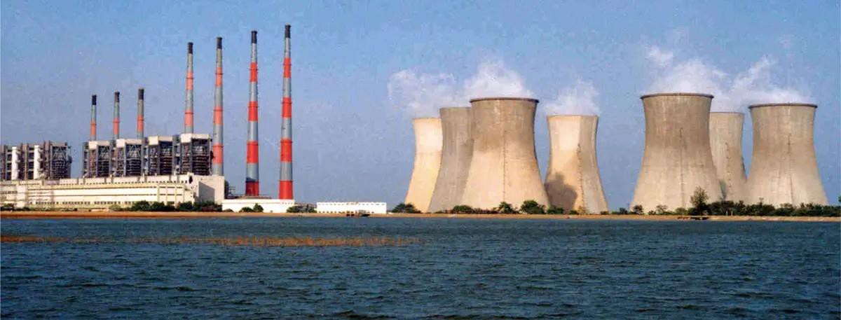

NLCIL is known for its mining operations, specifically its lignite mines. It operates three opencast lignite mines in Neyveli (Tamil Nadu) with a total installed capacity of 28 Million Tonnes Per Annum (MTPA). The mines are central to the company’s operations, providing the raw material needed for its power plants. In addition to the Neyveli mines, NLCIL also operates an opencast lignite mine at Barsingsar, Rajasthan, which has an installed capacity of 2.10 MTPA, and an open-cast coal mine at Talabira, Odisha, with a capacity of 20 MTPA.These mining operations form the backbone of NLCIL’s energy generation capabilities.
NLCIL has expanded its mining footprint with the Talabira-II & III coal mine in Odisha, with a combined coal production capacity of 20 MTPA. This mine commenced production on 26th April 2020, and achieved Commercial Operations Date (COD) on 1st April 2021. The coal mined here is utilized for both NTPL (NLC Tamil Nadu Power Limited) in Thoothukudi and NTPC’s Thermal Power Stations.
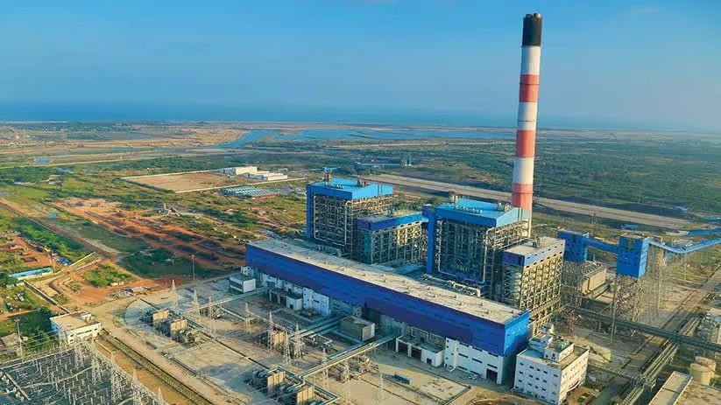

In the thermal power sector, NLCIL operates a total of four lignitebased pit- head thermal power stations at Neyveli, with a combined capacity of 3,390 MW. These power stations are crucial for the country's energy demand and are strategically located near lignite mines for easy supply of raw materials.
The company has also established a 250 MW lignite-based thermal power station at Barsingsar, Rajasthan. Further, through its joint venture with TANGEDCO, NLCIL operates a 1,000 MW coal- based thermal power station at Thoothukudi, Tamil Nadu under the subsidiary NLC Tamil Nadu Power Limited (NTPL). The joint venture between NLCIL and TANGEDCO has an equity participation ratio of 89:11.

In alignment with the growing demand for sustainable energy, NLCIL has made significant strides in the renewable energy sector. The company is currently operating 1,380 MW of solar power plants located in various districts of Tamil Nadu and the Andaman & Nicobar Islands, as well as a 51 MW wind power plant in Tirunelveli, Tamil Nadu.
In fact, NLCIL was the first Central Public Sector Enterprise (CPSE) to achieve a 1 GW capacity in solar power generation, a landmark achievement that solidifies its position as a leader in clean energy. The company has also become a member of the International Solar Alliance (ISA), contributing to global efforts to combat climate change. NLCIL aims to expand its renewable energy capacity to 6,031 MW by 2030, with plans for further solar and wind power projects in various regions across India
NLCIL has ambitious plans for the future, with a target to achieve a total power generation capacity of 17,171 MW by 2030. The company is actively pursuing expansion projects, including a 3x660 MW coal-based thermal power station at Ghatampur, Uttar Pradesh, in a joint venture with Uttar Pradesh Rajya Vidyut Utpadan Nigam Limited (UPRVUNL).
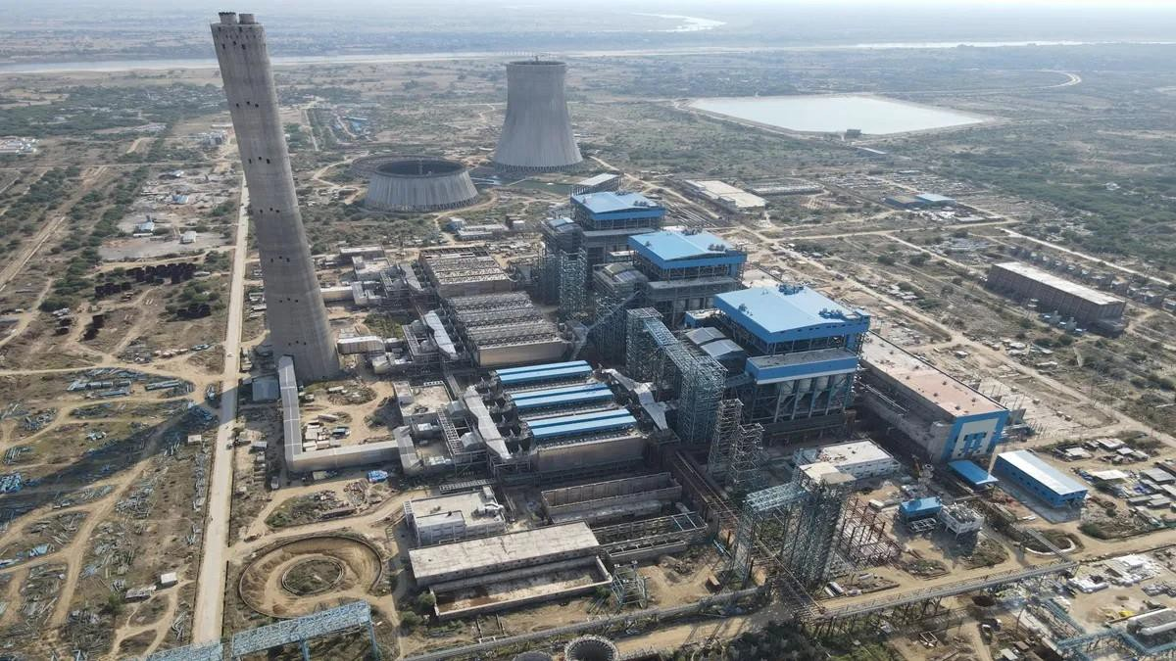

Additionally, the Talabira-II & III coal mines (20 MTPA) in Odisha and the Pachwara South Coal Block (9 MTPA) in Jharkhand are part of NLCIL’s expansion strategy. The Talabira mines began operations in 2020, with an anticipated commissioning of the Pachwara South Coal Block by 2024- 2025.
The company is also moving forward with the development of a 3,200 MW coal-based pit-head thermal power station at Talabira, Odisha, with land acquisition currently in progress.

In addition to its core activities, NLCIL has made significant moves to strengthen its position in the energy sector by forming several joint ventures and subsidiaries. One notable development is the incorporation of Coal Lignite Urja Vikas Private Limited (CLUVPL) on 10th November 2020 with Coal India Limited, which is focused on coal and lignite-based power generation projects.
On 14th June 2023, NLCIL formed a wholly owned subsidiary called NLC India Renewables Limited (NRE), aimed at managing its renewable energy assets. Another subsidiary, NLC India Green Energy Limited (NIGEL), was incorporated on 13th October 2023 to oversee the company’s future renewable energy projects
NLCIL’s contributions extend beyond energy generation. For more than six decades, the company has been actively involved in societal development by supporting various socio-economic initiatives in education, health, infrastructure, and rural development. As a responsible corporate entity, NLCIL has contributed significantly to India’s growth by providing sustainable energy solutions, creating employment opportunities, and improving the quality of life for people in the regions where it operates.

HISTORY OF NLCIL
The discovery of lignite in Neyveli occurred by accident in 1934 when a 'brown substance' was found flowing with water from an artesian well on the 620-acre farm of Rao Bahadur M. Jambulingam Mudaliar. This surprising find led him to promptly notify the British colonial administration. In response, the British Raj dispatched a team of geologists to investigate the unusual substance. After further analysis, the material was identified as lignite, a valuable resource for energy production. Recognizing the potential of this discovery, Rao Bahadur M. Jambulingam Mudaliar took a significant step by generously offering a substantial portion of his land for exploration purposes. His selfless contribution did not end there. He donated the entire 620 acres of land to the Madras Government, enabling the state to explore the rich lignite deposits beneath the surface.
This pioneering act laid the foundation for the establishment of what would become one of India’s leading mining and power generation sites. The discovery marked the beginning of Neyveli’s transformation into a hub for lignite mining, which would later play a critical role in India's energy sector.
The establishment of NLC India Limited (NLCIL) in Neyveli in the 1950s, followed by the opening of large-scale lignite mines, can be directly traced back to this fortuitous discovery. Over the years, the lignite reserves in Neyveli have contributed significantly to the country’s power generation, and the area has become a vital energy resource centre.
Rao Bahadur M. Jambulingam Mudaliar’s vision and generosity not only advanced the understanding of India’s natural resources but also played a pivotal role in shaping the nation’s energy infrastructure. His contributions continue to be remembered as the catalyst that ignited Neyveli’s legacy in lignite mining and thermal power generation.

VISION/MISSION OF NLCIL VISION
To establish ourselves as a premier mining and power corporation, recognized for our leadership in the energy sector, committed to social responsibility, and dedicated to accelerating the nation's progress through sustainable practices and innovation. We aim to provide reliable, affordable, and clean energy while creating value for all stakeholders and contributing to the socio-economic development of India.

MISSION

Enhance Capabilities in Power and Mining: We are committed to continually improving and expanding our expertise in the fields of power generation and mining. Our focus is on increasing operational efficiency, leveraging advanced technologies, and ensuring financial stability to foster growth and profitability. Promote Sustainable Development: As a socially responsible organization, we strive to integrate environmental sustainability into every aspect of our operations. We are dedicated to minimizing the ecological impact of our activities, while contributing to national goals such as clean energy transition and climate change mitigation.
Foster Social Responsibility and Community Development: We aim to improve the quality of life for communities around our operations through initiatives in education, healthcare, infrastructure development, and other areas of social welfare. By being sensitive to the needs of society, we seek to be a catalyst for positive change.
Excellence in Operations: We will continuously strive for excellence in all our processes, from mining to power generation, ensuring high standards of safety, quality, and efficiency. By adopting best practices and fostering a culture of innovation, we aim to stay ahead of industry trends and meet the growing energy demands of the nation.
Environmental Stewardship: We recognize the importance of protecting the environment and aim to set industry standards for sustainability. We are committed to adopting green technologies, reducing carbon emissions, and restoring natural habitats, ensuring that our growth aligns with the long-term health of the planet.
Through these core objectives, we aim to build a company that is not only a leader in the energy sector but also a responsible corporate citizen that contributes to the betterment of society and the environment.

CHAPTER - II

CONTENT OF THE STUDY
MINES EQUIPMENT STOPPAGE ANALYSIS
The Mines Equipment Stoppage Analysis is a web-based analytical application developed to study and monitor equipment stoppages in mining and industrial environments. In large-scale industries such as mining and power generation, frequent machine breakdowns and operational delays can significantly affect productivity, maintenance cost, and overall efficiency. The project aims to provide a centralized and automated solution for analyzing downtime records and identifying recurring operational issues.
The system processes industrial downtime datasets containing machine details, stoppage durations, group codes, and fault descriptions. Using a React-based frontend and CSV-driven data analysis techniques, the application generates meaningful insights such as machine-wise downtime trends, failure frequency analysis, seasonal impact evaluation, and recurring fault identification. The platform enables engineers and maintenance teams to efficiently monitor equipment performance and improve maintenance planning.
By replacing manual analysis methods with an interactive digital system, the project enhances operational transparency, reduces analysis time, and supports data-driven decision-making. The proposed system also provides a foundation for future integration with predictive maintenance and Industry 4.0 technologies.

Project Objectives
The primary objectives of the Mines Equipment Stoppage Analysis are:

- To develop a centralized platform for analyzing industrial equipment downtime and stoppage records efficiently.
- To automate the processing of large CSV-based industrial datasets and reduce manual analysis effort.
- To identify recurring equipment failures, operational bottlenecks, and high-downtime machines.
- To analyze machine-wise downtime duration, frequency of stoppages, and fault categories using group codes and descriptions.
- To provide visual and statistical insights that help maintenance teams improve operational efficiency and maintenance scheduling.
- To classify downtime trends based on seasonal conditions such as Summer, Monsoon, and Winter for environmental impact analysis.
- To support data-driven decision-making for predictive maintenance and industrial reliability improvement.

Scope of the Project
The scope of the project includes the development of a React-based web application capable of processing and analyzing industrial downtime datasets. The system focuses on mining and heavy industrial equipment where operational continuity is critical.
The application supports:

- Uploading and processing CSV downtime datasets.
- Mapping group codes with corresponding fault descriptions.
- Calculating total downtime, average downtime, and failure frequencies.
- Identifying the most failure-prone equipment and recurring operational issues.
- Displaying analytical summaries and interactive visual reports.
- Filtering and sorting downtime data for easier interpretation and maintenance analysis.

The project is primarily designed for industrial environments such as mining operations, power plants, and heavy machinery sectors. Future enhancements may include real-time monitoring, IoT integration, anomaly detection, and machine learning-based predictive maintenance systems.

SYSTEM ARCHITECTURE
The Mines Equipment Stoppage Analysis follows a modular and lightweight web application architecture designed for efficient processing and visualization of industrial downtime data. The system is primarily developed using a React-based frontend framework with browser-based data handling mechanisms that allow fast and responsive operation without requiring complex backend infrastructure.
The architecture is designed to ensure smooth data flow from CSV upload to analytical result generation. The system processes industrial downtime datasets through multiple stages including data acquisition, preprocessing, mapping, analysis, and visualization.

Architecture Components

Presentation Layer (Frontend)
The presentation layer is responsible for user interaction and visualization. It is developed using React.js, which provides a responsive and dynamic user interface for handling industrial data analysis operations.
The frontend performs:

    - CSV file upload
    - Data visualization

    - Dashboard rendering
    - Interactive filtering and sorting
    - Statistical summary display

The user interface is designed to provide maintenance engineers and analysts with easy access to downtime insights through tables, charts, and graphical summaries.

Analysis Layer

The analysis layer performs statistical and operational analysis on processed downtime
data.

Major analytical functions include:

    - Machine-wise downtime calculation
    - Average stoppage duration analysis
    - Failure frequency identification
    - Recurring issue detection
    - Equipment performance comparison
    - Seasonal impact analysis

This layer helps identify critical operational bottlenecks and supports maintenance planning decisions.

4.3 Visualization Layer
The visualization layer presents analytical outputs using interactive charts, tables, and dashboards.
The system provides:

- Downtime distribution charts
- Equipment performance summaries
- Group code statistics
- Machine comparison graphs
- Seasonal trend analysis

Visual representation improves understanding of industrial performance and simplifies decision-making.

TECHNOLOGY STACK
The Mines Equipment Stoppage Analysis was developed using modern web technologies and data processing techniques to ensure efficient performance, scalability, and ease of use. The selected technology stack focuses on lightweight frontend development, fast data handling, and interactive visualization for industrial analytical applications.

The system was designed to process large downtime datasets efficiently while providing a responsive and user-friendly interface for maintenance engineers and industrial analysts.
Technology Stack Summary

Component | Technology Used | Purpose
Frontend Framework | React.js | Building dynamic and responsive user interface
Programming Language | JavaScript (ES6+) | Application logic and data processing
Styling | CSS3 | User interface design and responsiveness
Data Handling | CSV Parser | Reading and processing industrial CSV datasets
Data Visualization | Chart.js | Generating analytical charts and graphs
State Management | React Hoks | Managing application state and data flow
Development Environment | Visual Studio Code | Source code development and debugging
Version Control | Git & GitHub | Project management and source control

FEATURES OF THE SYSTEM
The Mines Equipment Stoppage Analysis provides several advanced features that assist industrial maintenance teams in analyzing equipment stoppages efficiently. The system is designed to improve operational transparency, simplify downtime analysis, and support data-driven maintenance planning through automated analytical processes and interactive visualizations.

CSV-Based Data Processing
The system allows users to upload industrial downtime datasets in CSV format for analysis.
Uploaded files are automatically processed and converted into structured analytical records. Key Functions:
    - Easy CSV file upload
    - Automatic dataset reading
    - Structured data extraction
    - Support for large industrial datasets Benefits:
    - Reduces manual data entry
    - Simplifies industrial data handling
    - Enables fast processing

Group Code and Fault Mapping
The system maps equipment group codes with their corresponding fault descriptions for easier understanding of operational issues.

Key Functions:

    - Automatic group code extraction
    - Mapping with group code text
    - Categorization of failure types Benefits:
    - Simplifies fault interpretation
    - Enhances maintenance analysis
    - Improves reporting clarity

Machine-Wise Downtime Analysis
The application performs equipment-specific analysis to identify machines with high downtime frequency and duration.
Key Functions:

    - Total downtime calculation
    - Average downtime computation
    - Machine performance comparison
    - Recurring failure detection Benefits:
    - Helps identify critical equipment
    - Supports maintenance prioritization
    - Improves operational efficiency

Seasonal Downtime Analysis
The system analyzes downtime trends across different climatic conditions such as Summer, Monsoon, and Winter.

Key Functions:

    - Seasonal classification of records
    - Climate-based downtime comparison
    - Environmental trend analysis Benefits:
    - Supports preventive maintenance
    - Identifies seasonal operational risks
    - Enhances equipment planning

Interactive Dashboard and Visualization
The application provides graphical dashboards and analytical charts for simplified understanding of industrial data.

Key Functions:

    - Downtime charts and graphs
    - Failure frequency visualization
    - Equipment comparison dashboards

    - Interactive filtering and sorting Benefits:
    - Improves decision-making
    - Provides visual analytical insights
    - Enhances operational monitoring

Real-Time Analytical Processing
The system processes uploaded datasets instantly and generates analytical outputs dynamically within the browser environment.
Key Functions:
    - Fast frontend-based processing
    - Dynamic dashboard updates
    - Instant analytical summaries
    - Improves user productivity
    - Eliminates processing delays

Source Code:

Index.html:

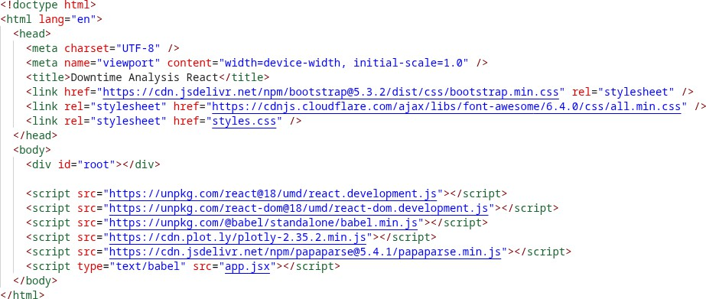

App.jsx:
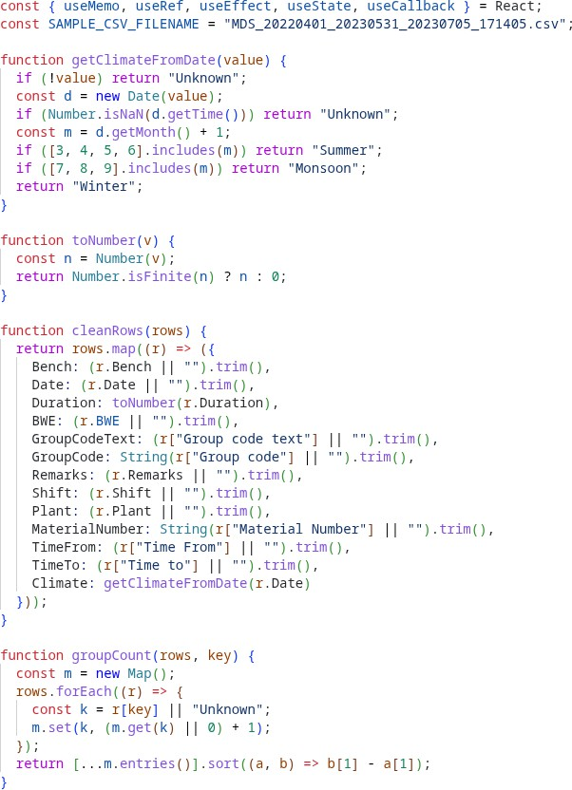
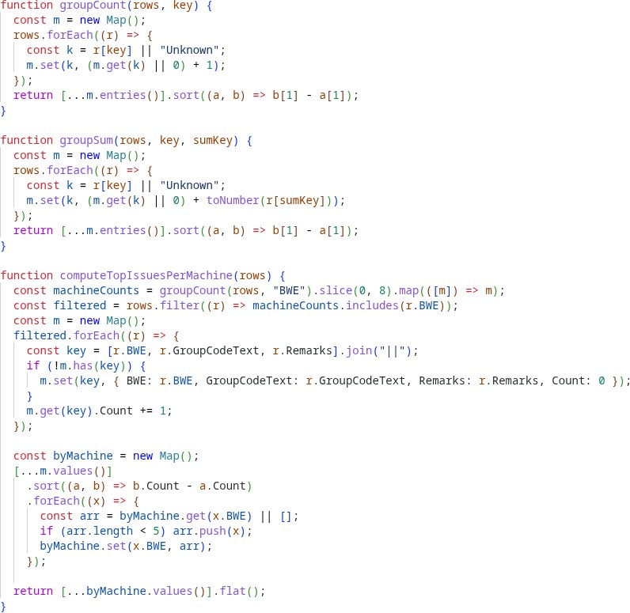

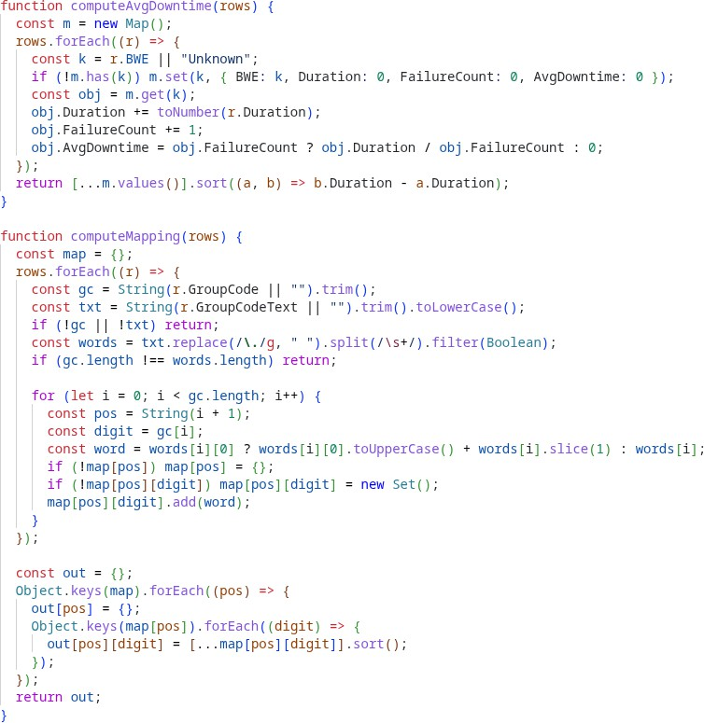
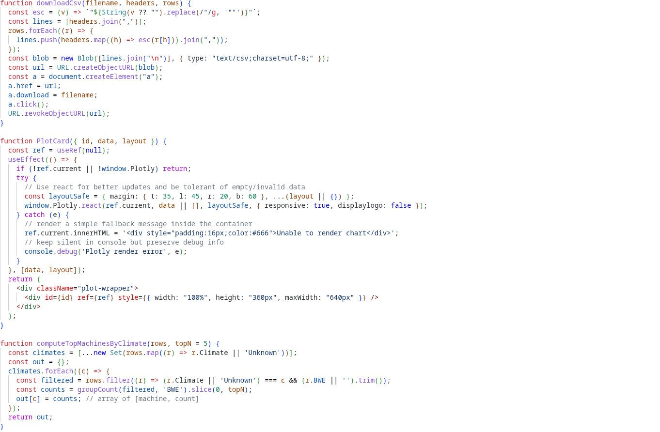

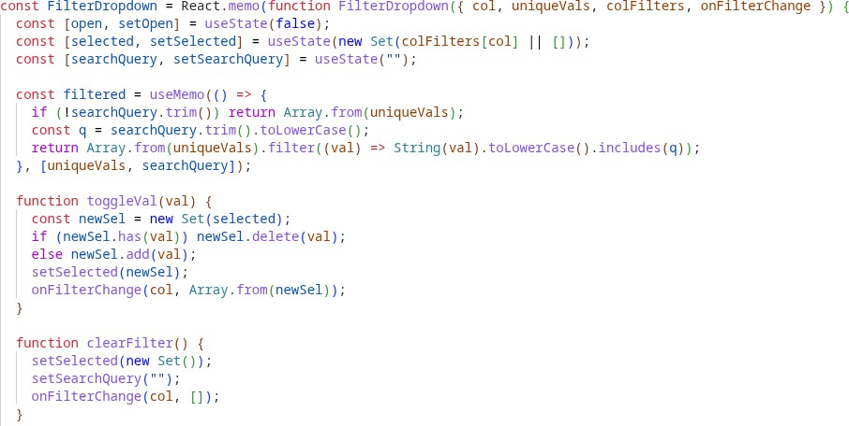
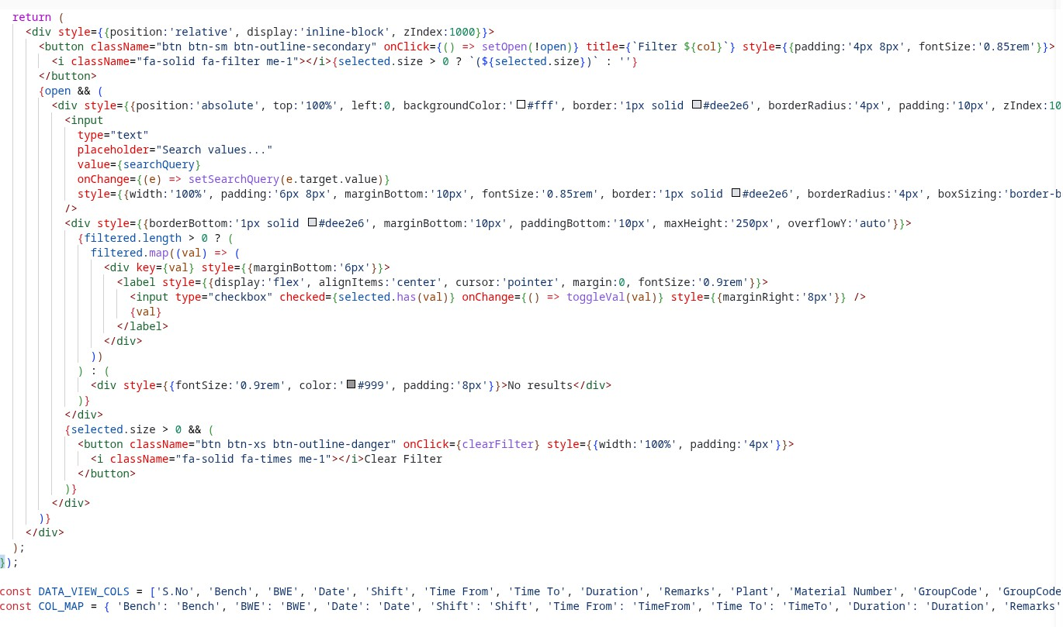

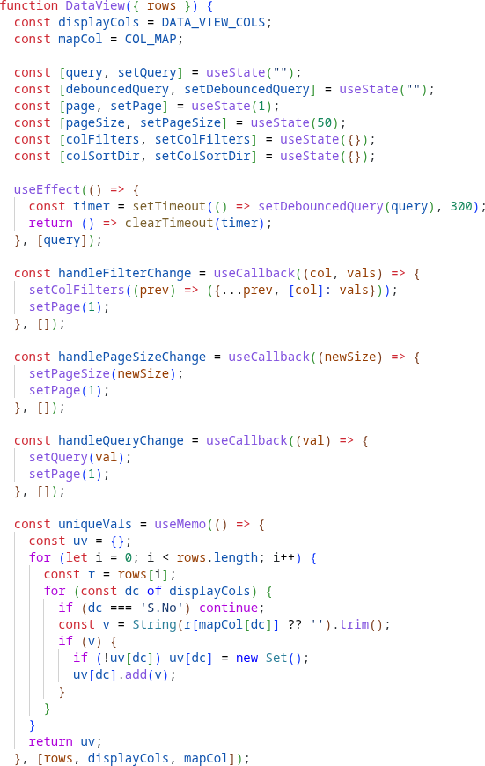
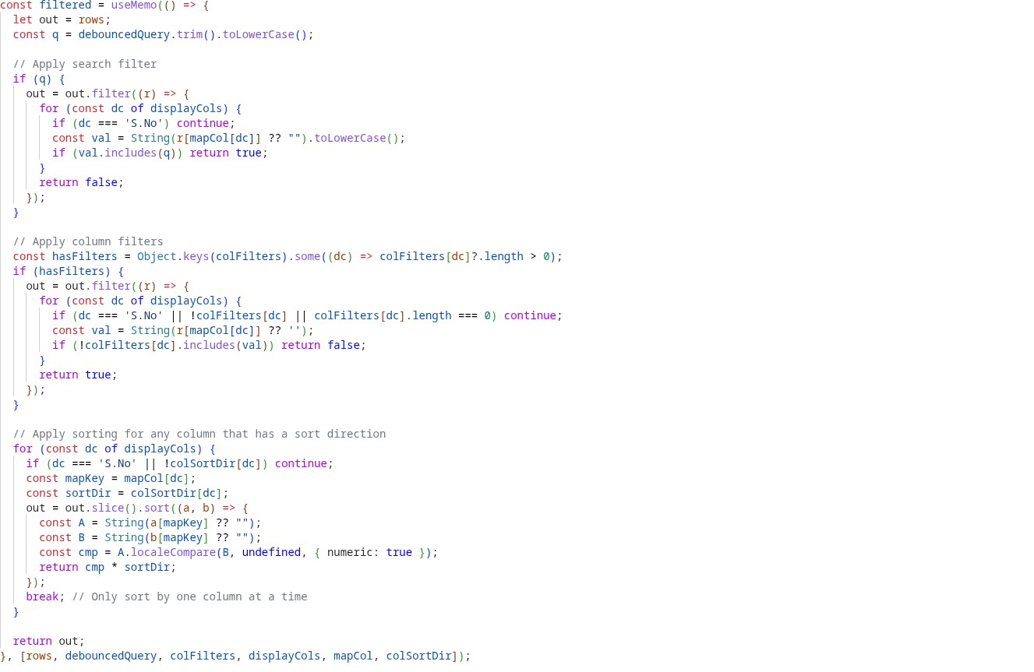

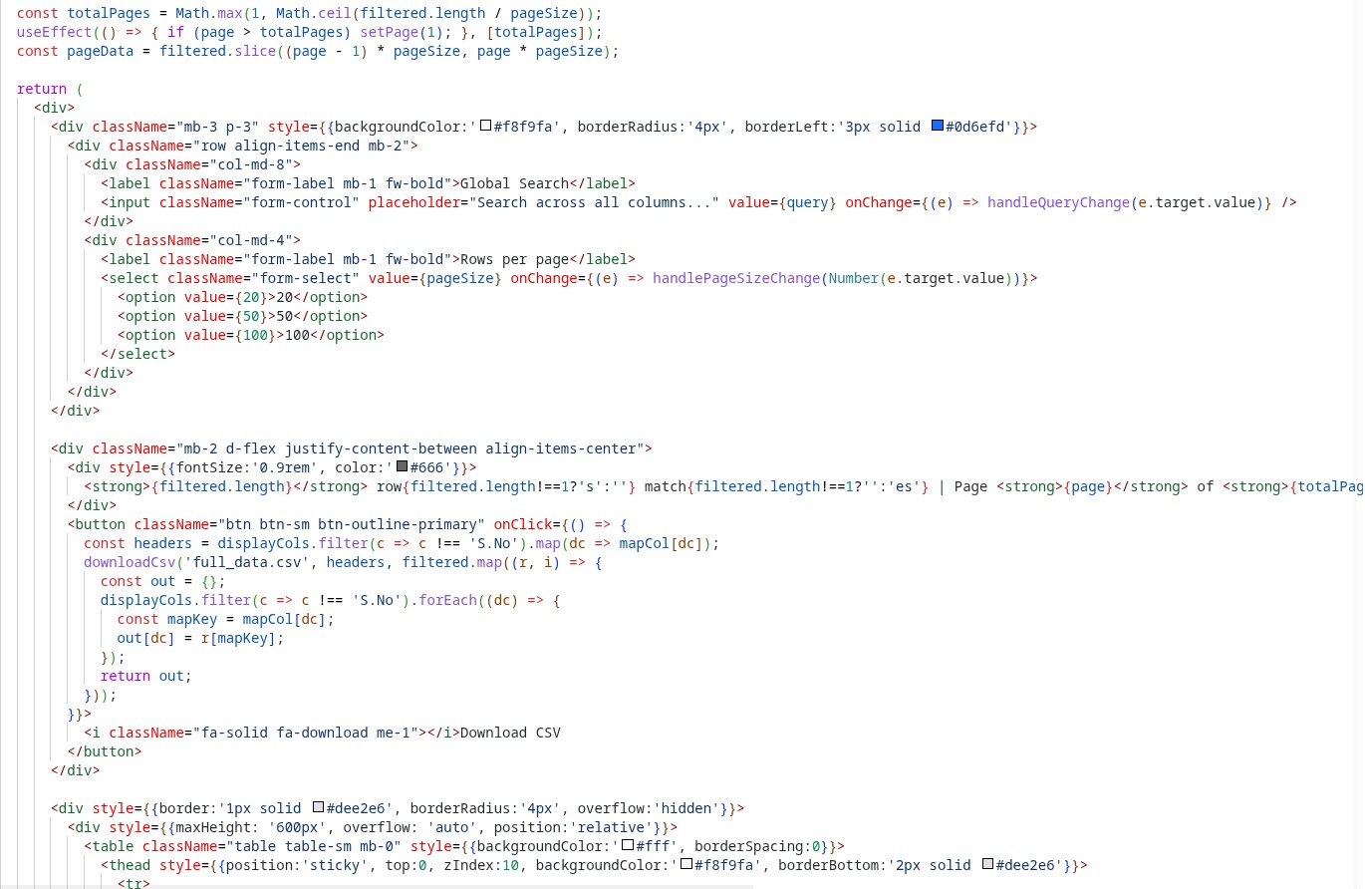
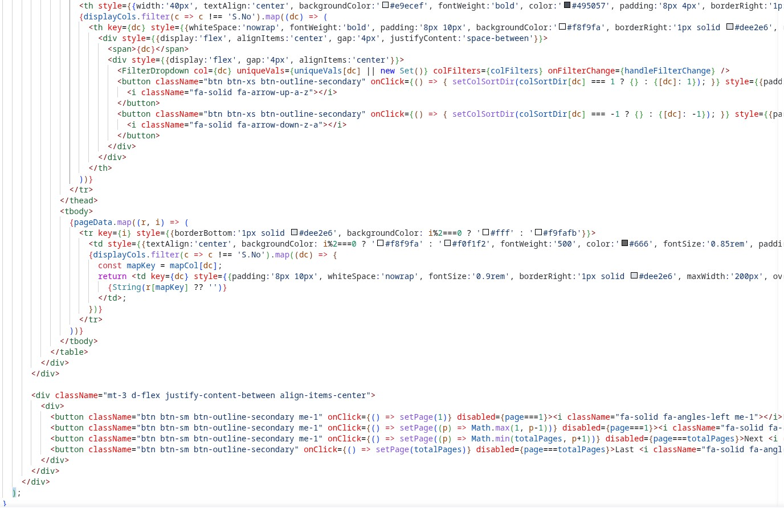

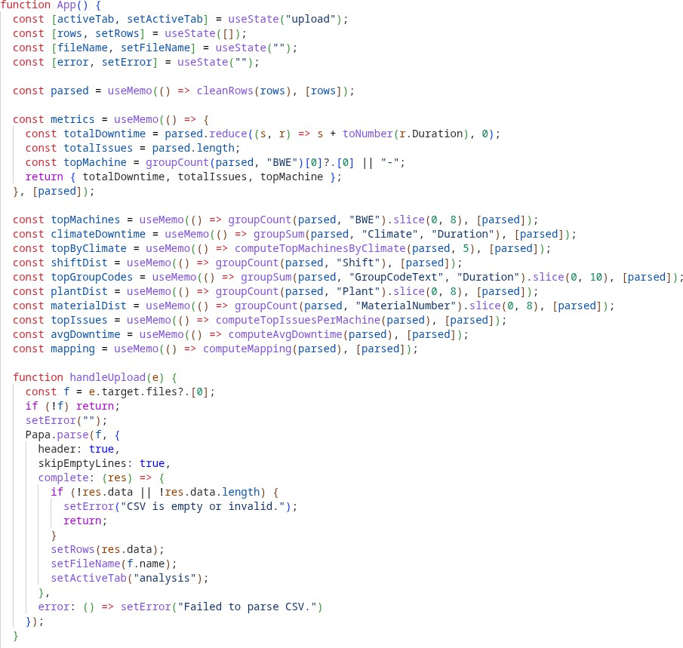
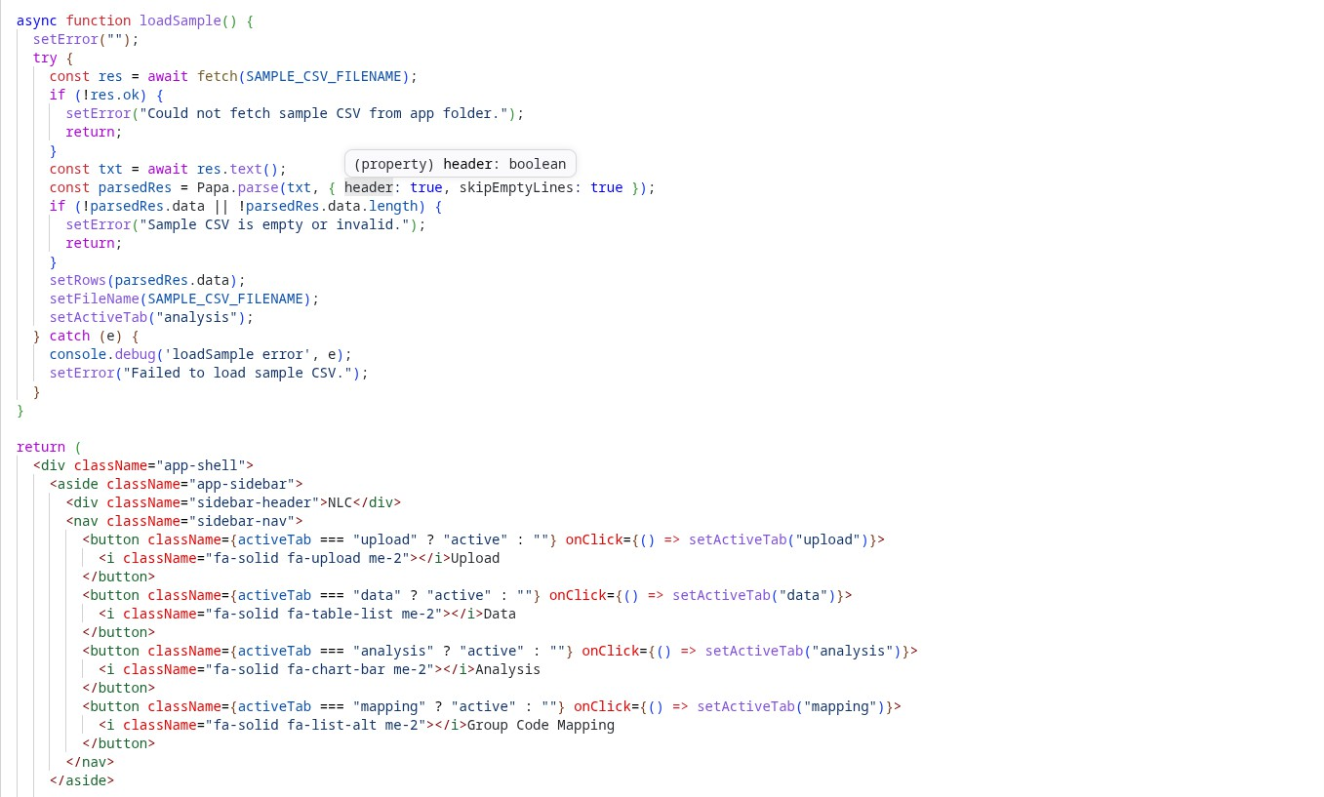

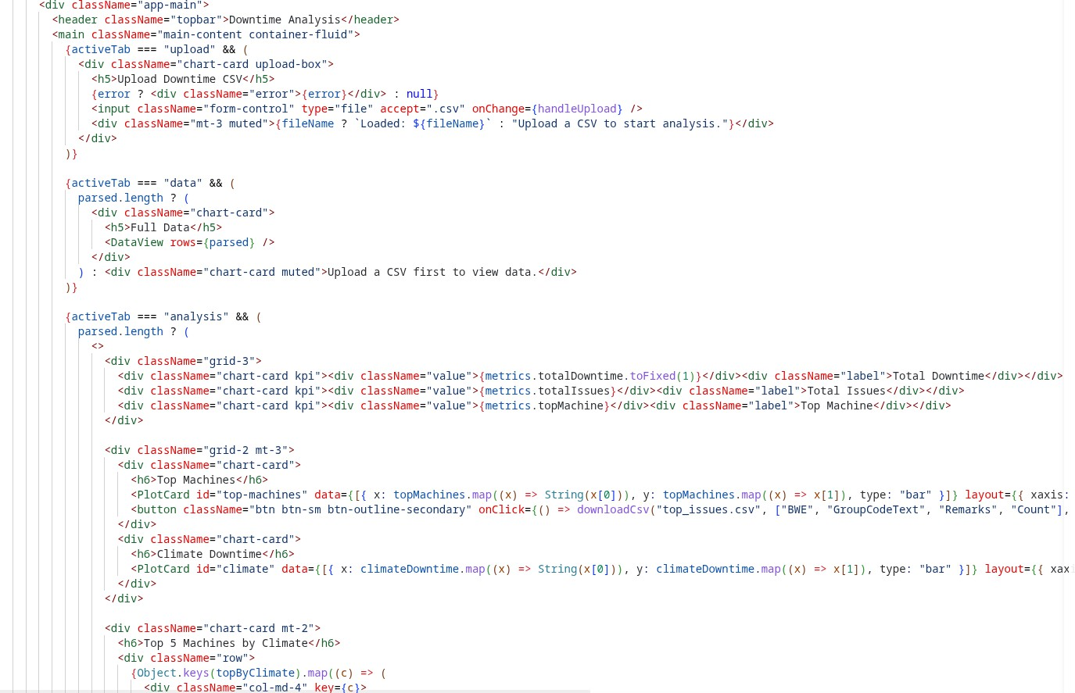
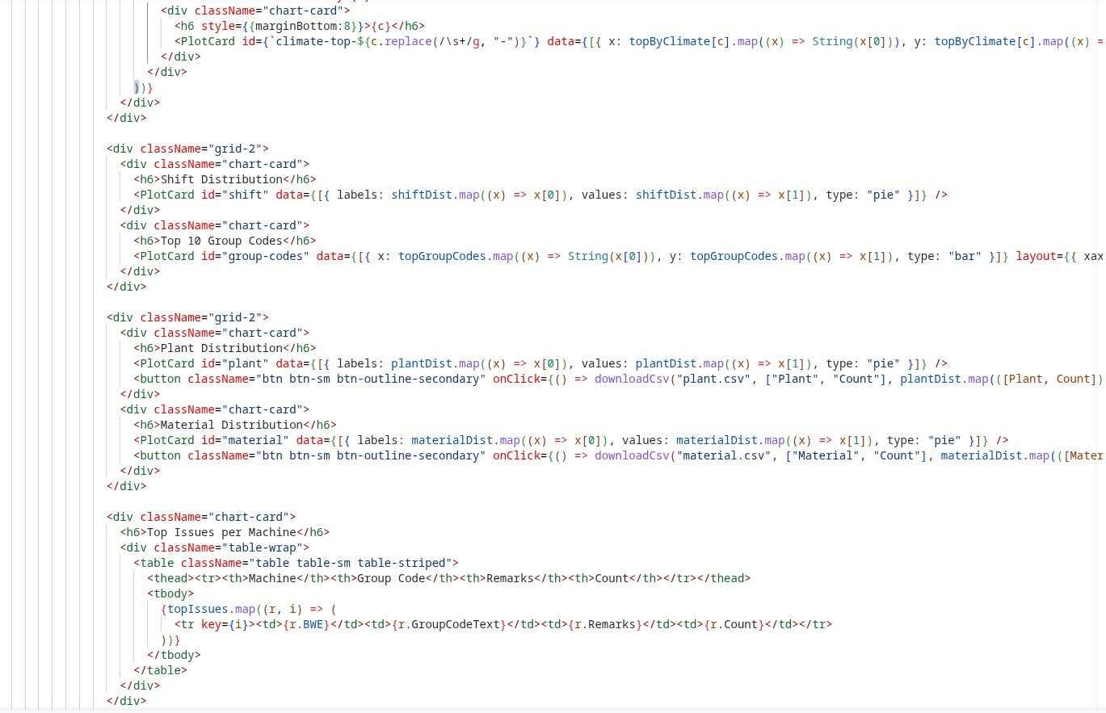

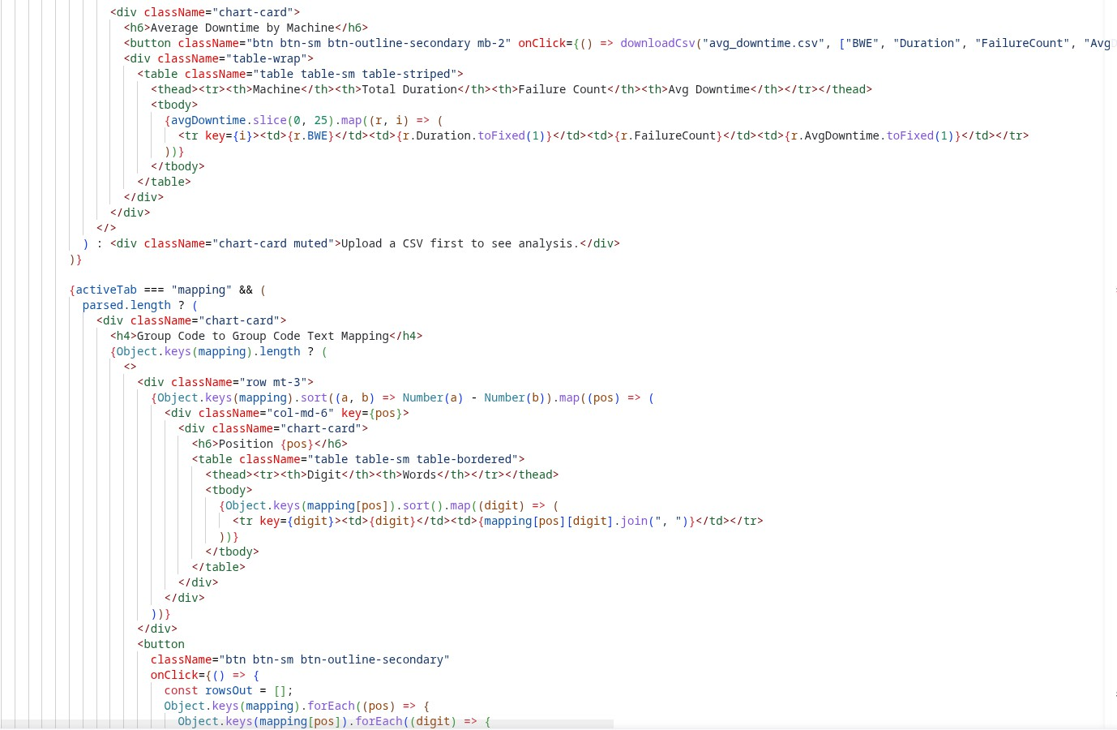
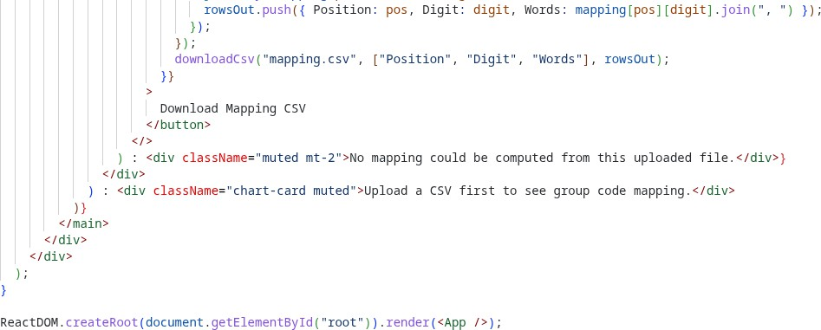

Results:

Upload :
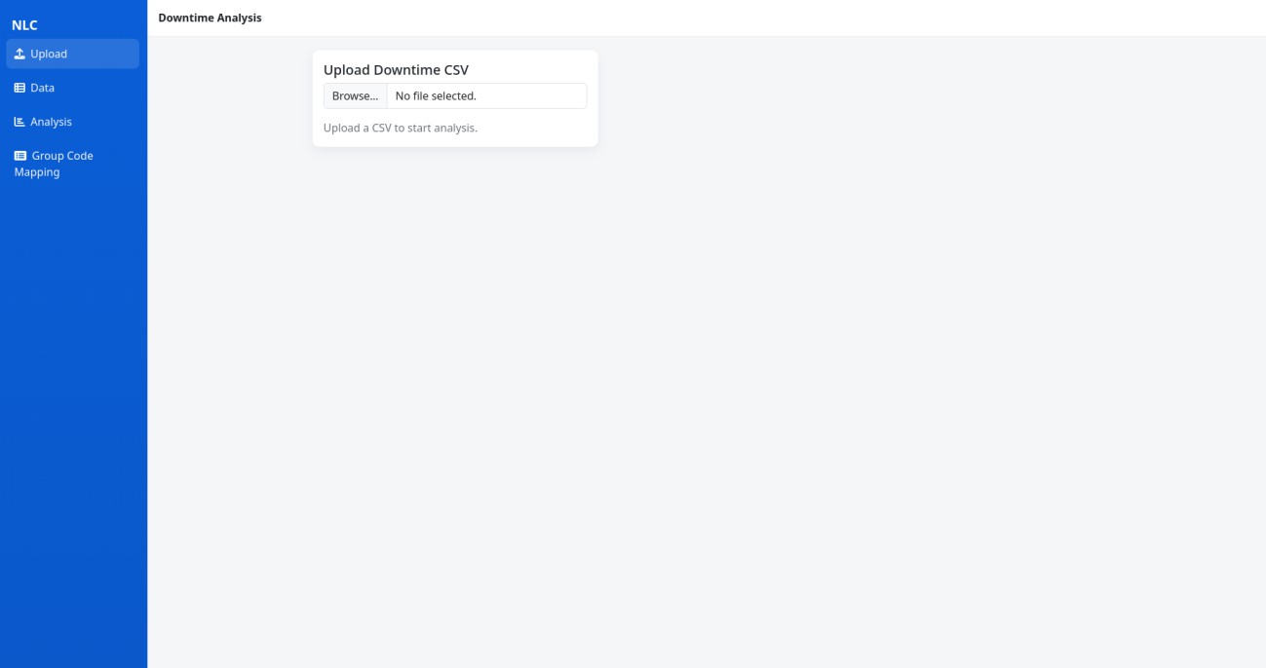

Analysis:
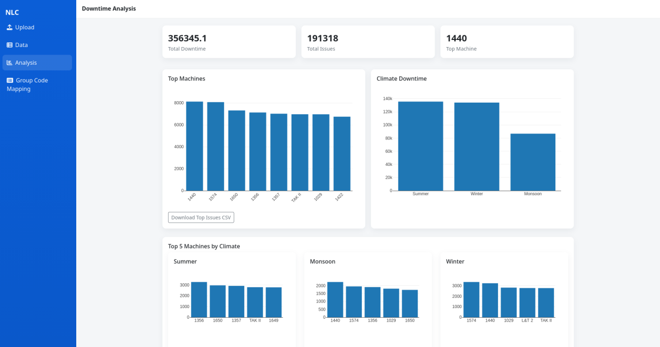

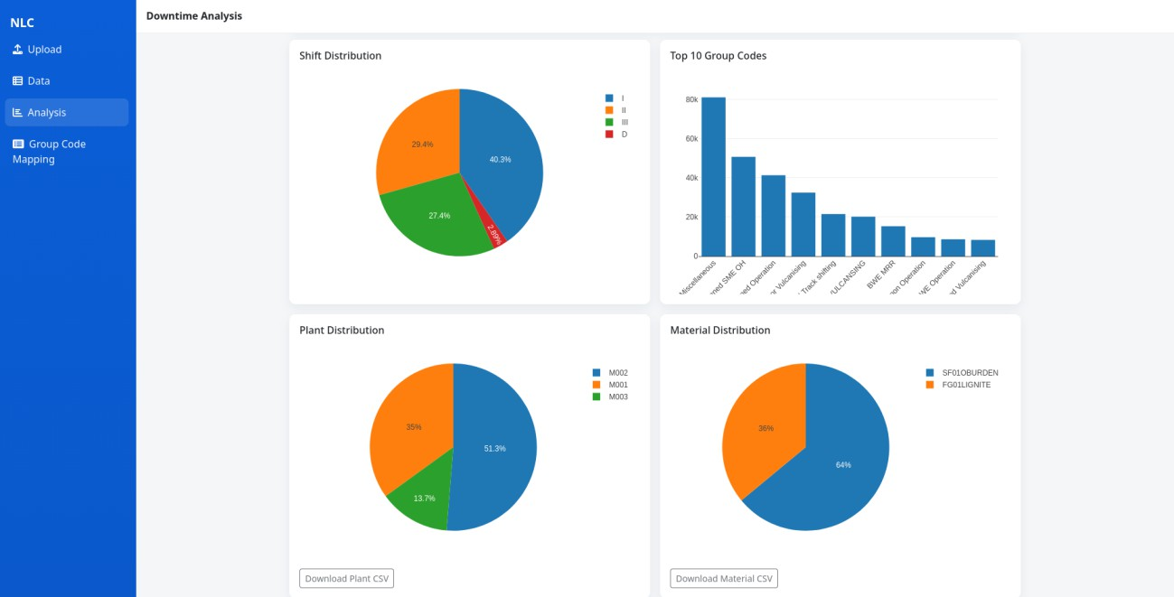
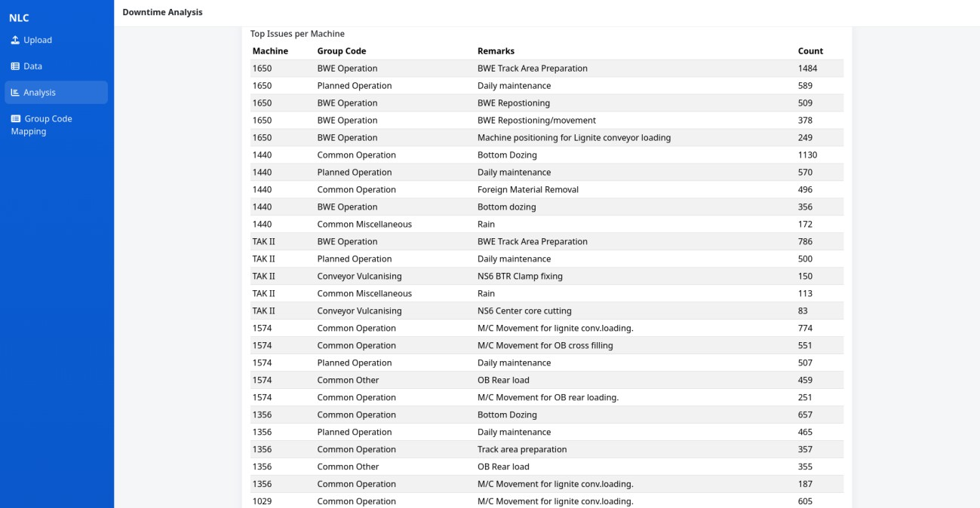

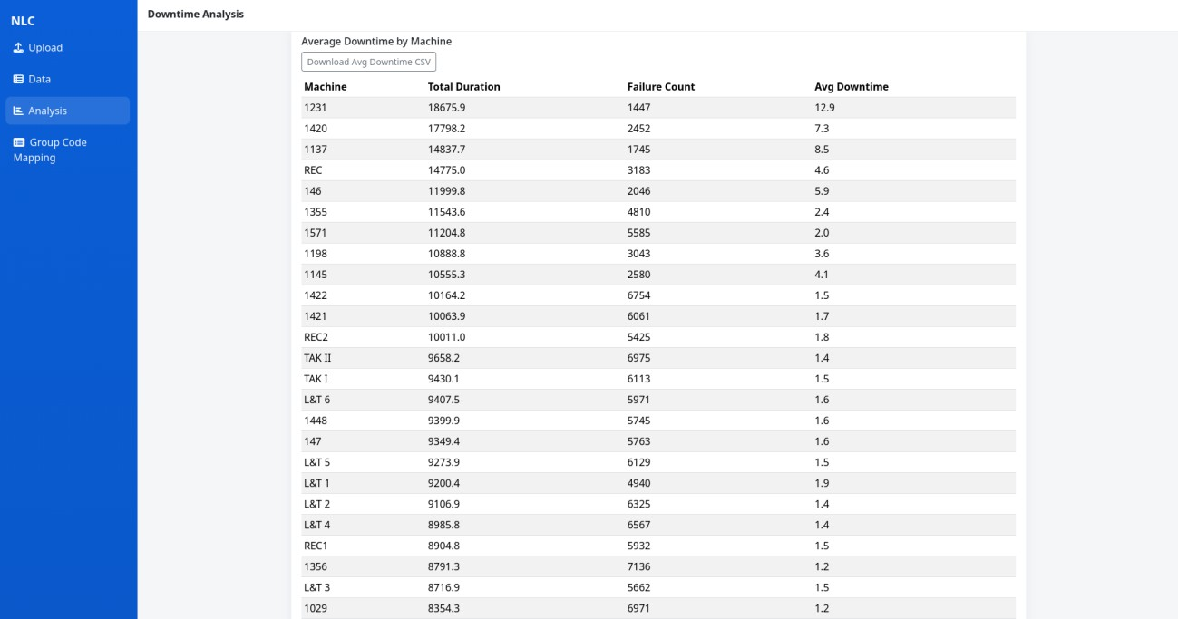

Group Code Mapping:
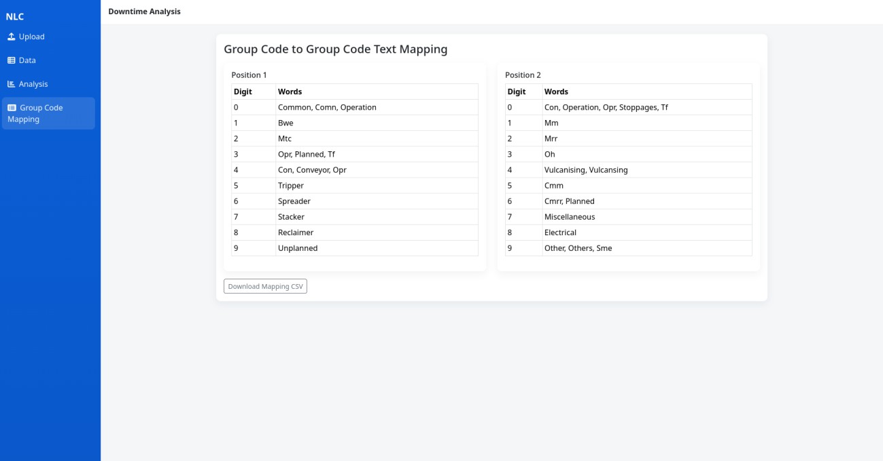

Data:
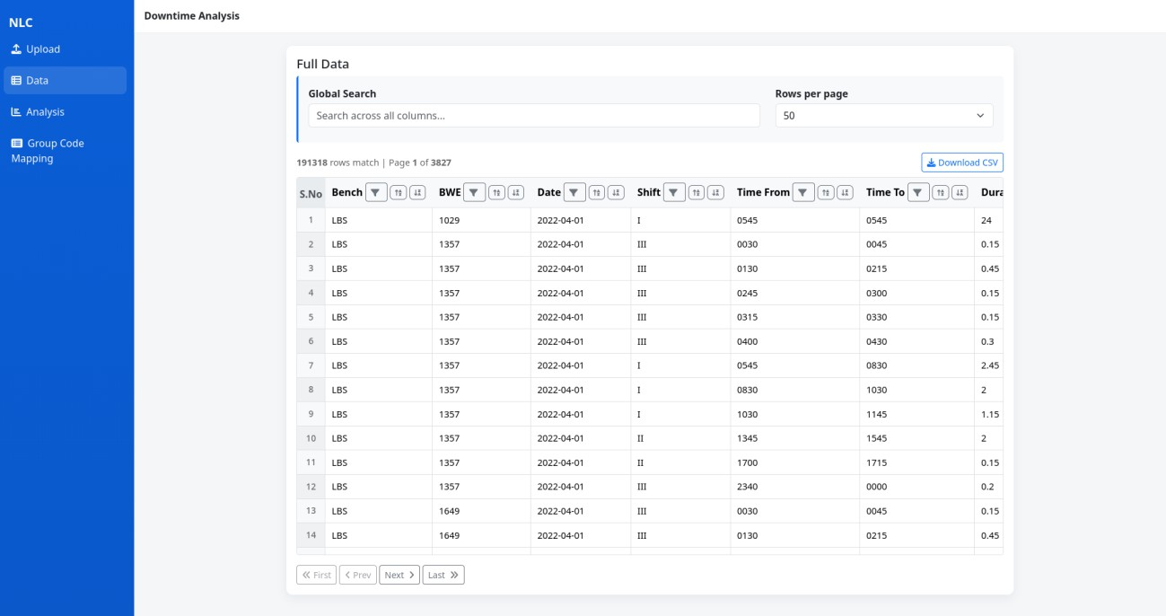

CHAPTER - III CONCLUSION
The internship project titled “Mines Equipment Stoppage Analysis ” was successfully developed and implemented to analyze and monitor industrial equipment stoppage data efficiently. The system provides a centralized and automated platform for processing industrial downtime datasets, identifying recurring equipment failures, and generating meaningful analytical insights for maintenance and operational improvement.
The project successfully demonstrated how modern web technologies and data analytics can be applied to industrial environments to improve operational transparency and reduce manual analysis effort. By utilizing a React-based frontend architecture and CSV-driven analytical workflows, the system efficiently processed large downtime datasets and generated machine-wise performance analysis, failure frequency reports, seasonal trend evaluations, and graphical dashboards.
The implementation of automated preprocessing, group code mapping, downtime calculation, and visualization modules significantly improved the accuracy and speed of industrial downtime analysis. The generated insights help maintenance engineers and operational teams identify critical equipment, prioritize maintenance activities, and reduce repeated operational failures.
The project also provided valuable practical exposure to frontend development, industrial data handling, dashboard creation, and analytical system design. It enhanced understanding of real-world industrial operations, maintenance analysis, and modern web application development methodologies.
Overall, the developed system successfully transformed traditional manual downtime analysis methods into a modern, efficient, and scalable analytical solution. The project establishes a strong foundation for future enhancements such as predictive maintenance, machine learning integration, real-time monitoring systems, IoT-based industrial analytics, and Industry 4.0 smart mining applications.

FEEDBACK
The internship training at NLC India Limited was a highly valuable and enriching learning experience. It provided practical exposure to real-world industrial environments, operational workflows, and modern analytical system development. Working on the project titled “Mines Equipment Stoppage Analysis” helped me understand the importance of equipment reliability, maintenance analysis, and data-driven decision-making in large-scale mining and industrial operations.
During the internship, I gained hands-on experience in frontend web development using React.js, industrial data processing, dashboard creation, and analytical visualization techniques. The project enhanced my understanding of handling large industrial datasets, implementing

automated analysis workflows, and generating meaningful operational insights through modern web technologies.
I sincerely express my gratitude to the officials, mentors, and technical staff of NLC India Limited for their continuous guidance, support, and encouragement throughout the internship period. Their valuable suggestions and industrial expertise greatly contributed to the successful completion of the project.
The internship significantly improved my technical knowledge, problem-solving abilities, teamwork skills, and understanding of industrial applications of software technologies. Overall, this training experience served as an important step in strengthening my practical skills and professional development for future career opportunities in software development and industrial analytics.

REFERENCES

- 1. Facebook Developers. React.js Official Documentation – Frontend component-based web application development and state management.
- 2. Mozilla Developer Network (MDN). JavaScript Documentation – File handling, data processing, and frontend scripting techniques.
- 3. Chart.js Team. Chart.js Official Documentation – Interactive charts, graphical visualization, and dashboard analytics implementation.

