

NLC INDIA LIMITED
“NAVRATNA – A GOVERNMENT OF INDIA ENTERPRISE”

INTERNSHIP REPORT ON

WEB DEVELOPMENT

SUBMITTED BY

MUKESH BABU A
B.E., COMPUTER SCIENCE AND ENGINEERING

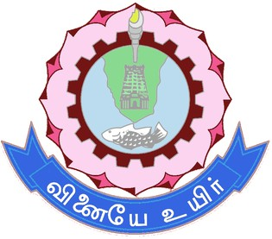

THIAGARAJAR COLLEGE OF ENGINEERING
(A Government Aided Autonomous Institution Affiliated to Anna University) Chennai – 600025, Tamil Nadu.

UNDER THE GUIDANCE OF Mr. RONIJ PANDEY

DEPUTY MANAGER / COMPUTER SCIENCE MINE-I / NLC INDIA LIMITED


NLC INDIA LIMITED
("NAVRATNA" - A GOVERNMENT OF INDIA ENTERPRISE")
NEYVELI-607 801, TAMIL NADU

BONAFIDE CERTIFICATE
Certified that the Internship Training report titled "WEB DEVELOPMENT" is the bonafide work of,

MUKESH BABU A (2303917710421314)

studying B.E., COMPUTER SCIENCE AND ENGINEERING at THIAGARAJAR
COLLEGE OF ENGINEERING, MADURAI, done during the period from 27-11-2025 to 10-12-2025 at MINE-I, NLC INDIA LIMITED, NEYVELI.
Their / His / Her performance, conduct and attendance during the period was
.

SHRI RONIJ PANDEY
DEPUTY MANAGER/COMPUTER SCIENCE
DATE: MINE-I
PLACE: NEYVELI NLC INDIA LIMITED

Permitted to submit the internship report to college / university authorities.

DEPUTY GENERAL MANAGER
DATE: LEARNING AND DEVELOPMENT CENTRE PLACE: NEYVELI NLC INDIA LIMITED

DECLARATION
I hereby declare that the Internship training report titled "WEB DEVELOPMENT" is the original work done by me under the guidance of Shri, RONIJ PANDEY, DM / CS / MINE-1 NLC India Limited, Neyveli.
This internship report is for reference only and no part of the report will be published copied anywhere without the written permission from officials of NLCIL, Neyveli.

Signature of the students

MUKESH BABU A (2303917710421314)

ACKNOWLEDGEMENT

I express my sincere thanks to NLC INDIA LIMITED for providing me the opportunity to carry out the Internship Training.
I also express my sincere thanks to Shri. A Kr. Saravanabhavan, Unit Head / L&DC, Shri. Prabakaran K, Deputy General Manager / L&DC, and the Executives & staffs of Industry Institution Interaction Section / Learning & Development Centre for providing me the opportunity to carry out the Internship Training in NLC India Limited, Neyveli.
I express my gratitude to the Unit Head, Mrs. Arul Selvi, Deputy General Manager, Mines & Services, Nlcil, for granting me permission to undergo internship training in the Unit.
I sincerely thank Shri. Ronij Pandey, Deputy Manager / Computer Science / Mine-I / Nlcil, for providing the guidance during the internship training programme from 27-11-2025 to 10-12-2025.
I sincerely thank Dr. L. Ashok Kumar , Principal / Thiagarajar College of Engineering for providing me support and guidance for the Internship.
I sincerely thank Dr. S. MercyShalinie / HOD / CSE Dept. / Thiagarajar College of Engineering for encouraging me to successfully complete the internship training.

ABSTRACT

The project titled “Web Applications: RedDesk Complaint Management System” was developed to streamline internal processes for fault reporting and resolution within an organizational framework. The system provides a centralized, digital platform for employees (Users) to submit complaints and for the technical team (Admins) to manage and track resolution workflows. The primary objective was to replace manual, inefficient reporting methods with a modern, transparent, and scalable digital solution.

The application was built using the MEN (MongoDB, Express.js, Node.js) stack, employing a Stateless, RESTful Client-Server Architecture. The application features a highly responsive and modern RedDesk branded User Interface. Key implementations include JWT Stateless Authentication and Bcrypt password hashing for robust security. The system offers specialized Admin Module features like centralized complaint management, Role-Based Access Control (RBAC), and CSV Data Export for detailed reporting. The successful implementation provides a significant efficiency gain by ensuring real-time status tracking and accountability for every reported issue.

INDEX
CHAPTER - I 1
INTRODUCTION 1
PROFILE OF NLCIL 1
HISTORY OF NLCIL 4
VISION/MISSION OF NLCIL VISION 5
CHAPTER - II 6
CONTENT OF THE STUDY 6
REDDESK: AN ENTERPRISE COMPLAINT MANAGEMENT SYSTEM 6
- Project Objectives and Scope 6
- Architectural Philosophy and Data Flow 6
  - Component Responsibility and Stack Mapping 7
  - Security and Authentication 8
- Key Features of the Admin Console 8
  - Real-Time Performance Dashboard 8
  - High-Efficiency Ticket Management Table 8
  - Advanced User Experience (UX) 9
- Project Results and Impact 12
- Internship Learning 13
- Flowchart – RedDesk Process Flow 13
- Source Code 15
- Results 24
Index.html (Hero Section) 24
Index.html (Features of the Web Application) 24
Index.html (Footer) 25
Login & Register Page 25
Profile Page 26
Admin Page 26
- Conclusion 27
CHAPTER - III 29
CONCLUSION 29
REFERENCES 29
FEEDBACK 29

CHAPTER - I INTRODUCTION
NLC India Limited is one of India’s prominent public sector enterprises engaged in mining and power generation. Established in 1956 under the Ministry of Coal, Government of India, the company has grown from a single lignite mining operation into a multi-sector energy producer with wide national significance. Over the decades, NLCIL has contributed immensely to India’s energy security by supplying reliable electricity to several states across the country. Its operations include large-scale open-cast mines, lignite-based thermal power stations, coal-based power units, and rapidly expanding renewable energy projects. NLCIL is headquartered at Neyveli in Tamil Nadu and is recognized nationally for its technological advancement, operational efficiency, and commitment to sustainable energy development. The company has played a vital role in regional development, industrial growth, and employment generation, making it an integral part of India’s power sector.

PROFILE OF NLCIL
For over six decades, NLC India Limited (NLCIL) has been at the forefront of India's energy sector, leading the way in lignite mining and playing a major role in the generation of thermal and renewable energy. Since its incorporation on 14th November 1956, NLCIL has consistently contributed to India’s energy security, becoming one of the most significant Public Sector Enterprises (PSEs) in the country. As a Navratna Government of India Enterprise under the administrative control of the Ministry of Coal, NLCIL is recognized for its continuous efforts to expand and modernize its operations, thus contributing to both national development and energy sustainability.
NLCIL operates across several states in India, including Tamil Nadu, Rajasthan, Uttar Pradesh, Odisha, Jharkhand, Gujarat, and the Andaman & Nicobar Islands, ensuring that its operations are spread across the country, fulfilling diverse regional energy needs. With a vision to provide sustainable energy, the company has grown into a leader in the sector, setting benchmarks in energy production, particularly in lignite and coal mining, as well as thermal power generation.
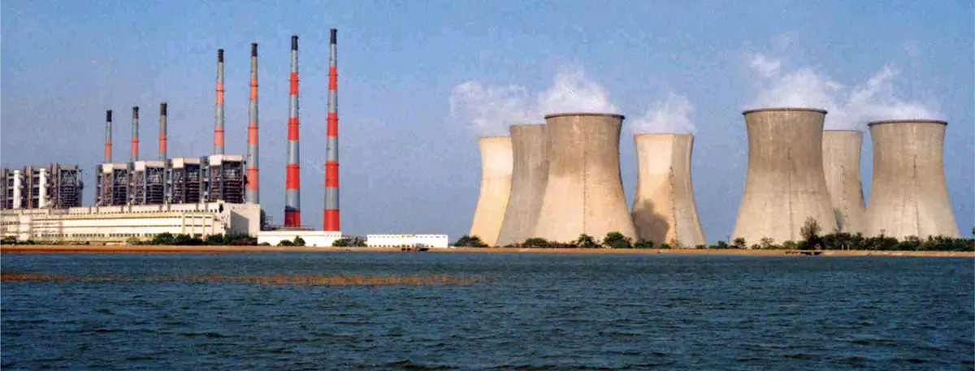

NLCIL is known for its mining operations, specifically its lignite mines. It operates three opencast lignite mines in Neyveli (Tamil Nadu) with a total installed capacity of 28 Million Tonnes Per Annum (MTPA). The mines are central to the company’s operations, providing the raw material needed for its power plants. In addition to the Neyveli mines, NLCIL also operates an opencast lignite mine at Barsingsar, Rajasthan, which has an installed capacity of 2.10 MTPA, and an open-cast coal mine at Talabira, Odisha, with a capacity of 20 MTPA.These mining operations form the backbone of NLCIL’s energy generation capabilities.
NLCIL has expanded its mining footprint with the Talabira-II & III coal mine in Odisha, with a combined coal production capacity of 20 MTPA. This mine commenced production on 26th April 2020, and achieved Commercial Operations Date (COD) on 1st April 2021. The coal mined here is utilized for both NTPL (NLC Tamil Nadu Power Limited) in Thoothukudi and NTPC’s Thermal Power Stations.
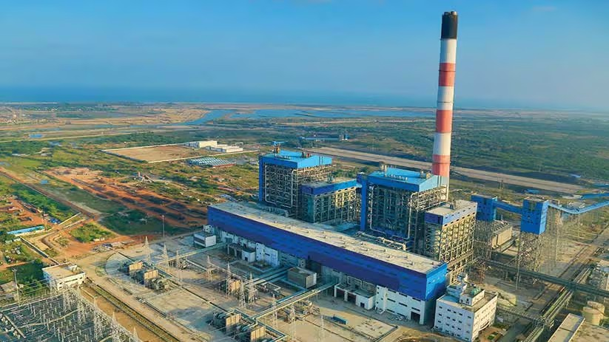

In the thermal power sector, NLCIL operates a total of four lignitebased pit- head thermal power stations at Neyveli, with a combined capacity of 3,390 MW. These power stations are crucial for the country's energy demand and are strategically located near lignite mines for easy supply of raw materials.
The company has also established a 250 MW lignite-based thermal power station at Barsingsar, Rajasthan. Further, through its joint venture with TANGEDCO, NLCIL operates a 1,000 MW coal- based thermal power station at Thoothukudi, Tamil Nadu under the subsidiary NLC Tamil Nadu Power Limited (NTPL). The joint venture between NLCIL and TANGEDCO has an equity participation ratio of 89:11.

In alignment with the growing demand for sustainable energy, NLCIL has made significant strides in the renewable energy sector. The company is currently operating 1,380 MW of solar power plants located in various districts of Tamil Nadu and the Andaman & Nicobar Islands, as well as a 51 MW wind power plant in Tirunelveli, Tamil Nadu.
In fact, NLCIL was the first Central Public Sector Enterprise (CPSE) to achieve a 1 GW capacity in solar power generation, a landmark achievement that solidifies its position as a leader in clean energy. The company has also become a member of the International Solar Alliance (ISA), contributing to global efforts to combat climate change. NLCIL aims to expand its renewable energy capacity to 6,031 MW by 2030, with plans for further solar and wind power projects in various regions across India
NLCIL has ambitious plans for the future, with a target to achieve a total power generation capacity of 17,171 MW by 2030. The company is actively pursuing expansion projects, including a 3x660 MW coal-based thermal power station at Ghatampur, Uttar Pradesh, in a joint venture with Uttar Pradesh Rajya Vidyut Utpadan Nigam Limited (UPRVUNL).
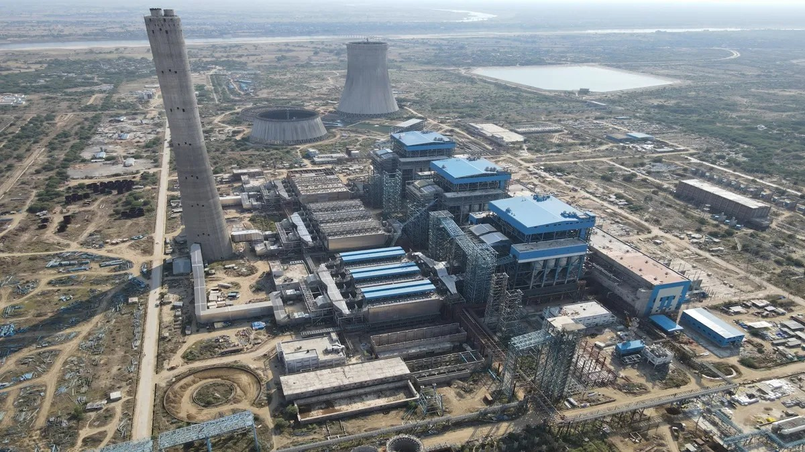

Additionally, the Talabira-II & III coal mines (20 MTPA) in Odisha and the Pachwara South Coal Block (9 MTPA) in Jharkhand are part of NLCIL’s expansion strategy. The Talabira mines began operations in 2020, with an anticipated commissioning of the Pachwara South Coal Block by 2024- 2025.
The company is also moving forward with the development of a 3,200 MW coal-based pit-head thermal power station at Talabira, Odisha, with land acquisition currently in progress.

In addition to its core activities, NLCIL has made significant moves to strengthen its position in the energy sector by forming several joint ventures and subsidiaries. One notable development is the incorporation of Coal Lignite Urja Vikas Private Limited (CLUVPL) on 10th November 2020 with Coal India Limited, which is focused on coal and lignite-based power generation projects.
On 14th June 2023, NLCIL formed a wholly owned subsidiary called NLC India Renewables Limited (NRE), aimed at managing its renewable energy assets. Another subsidiary, NLC India Green Energy Limited (NIGEL), was incorporated on 13th October 2023 to oversee the company’s future renewable energy projects
NLCIL’s contributions extend beyond energy generation. For more than six decades, the company has been actively involved in societal development by supporting various socio-economic initiatives in education, health, infrastructure, and rural development. As a responsible corporate entity, NLCIL has contributed significantly to India’s growth by providing sustainable energy solutions, creating employment opportunities, and improving the quality of life for people in the regions where it operates.

HISTORY OF NLCIL
The discovery of lignite in Neyveli occurred by accident in 1934 when a 'brown substance' was found flowing with water from an artesian well on the 620-acre farm of Rao Bahadur M. Jambulingam Mudaliar. This surprising find led him to promptly notify the British colonial administration. In response, the British Raj dispatched a team of geologists to investigate the unusual substance. After further analysis, the material was identified as lignite, a valuable resource for energy production. Recognizing the potential of this discovery, Rao Bahadur M. Jambulingam Mudaliar took a significant step by generously offering a substantial portion of his land for exploration purposes. His selfless contribution did not end there. He donated the entire 620 acres of land to the Madras Government, enabling the state to explore the rich lignite deposits beneath the surface.
This pioneering act laid the foundation for the establishment of what would become one of India’s leading mining and power generation sites. The discovery marked the beginning of Neyveli’s transformation into a hub for lignite mining, which would later play a critical role in India's energy sector.
The establishment of NLC India Limited (NLCIL) in Neyveli in the 1950s, followed by the opening of large-scale lignite mines, can be directly traced back to this fortuitous discovery. Over the years, the lignite reserves in Neyveli have contributed significantly to the country’s power generation, and the area has become a vital energy resource centre.
Rao Bahadur M. Jambulingam Mudaliar’s vision and generosity not only advanced the understanding of India’s natural resources but also played a pivotal role in shaping the nation’s energy infrastructure. His contributions continue to be remembered as the catalyst that ignited Neyveli’s legacy in lignite mining and thermal power generation.

VISION/MISSION OF NLCIL VISION
To establish ourselves as a premier mining and power corporation, recognized for our leadership in the energy sector, committed to social responsibility, and dedicated to accelerating the nation's progress through sustainable practices and innovation. We aim to provide reliable, affordable, and clean energy while creating value for all stakeholders and contributing to the socio-economic development of India.

MISSION

Enhance Capabilities in Power and Mining: We are committed to continually improving and expanding our expertise in the fields of power generation and mining. Our focus is on increasing operational efficiency, leveraging advanced technologies, and ensuring financial stability to foster growth and profitability. Promote Sustainable Development: As a socially responsible organization, we strive to integrate environmental sustainability into every aspect of our operations. We are dedicated to minimizing the ecological impact of our activities, while contributing to national goals such as clean energy transition and climate change mitigation.
Foster Social Responsibility and Community Development: We aim to improve the quality of life for communities around our operations through initiatives in education, healthcare, infrastructure development, and other areas of social welfare. By being sensitive to the needs of society, we seek to be a catalyst for positive change.
Excellence in Operations: We will continuously strive for excellence in all our processes, from mining to power generation, ensuring high standards of safety, quality, and efficiency. By adopting best practices and fostering a culture of innovation, we aim to stay ahead of industry trends and meet the growing energy demands of the nation.
Environmental Stewardship: We recognize the importance of protecting the environment and aim to set industry standards for sustainability. We are committed to adopting green technologies, reducing carbon emissions, and restoring natural habitats, ensuring that our growth aligns with the long-term health of the planet.
Through these core objectives, we aim to build a company that is not only a leader in the energy sector but also a responsible corporate citizen that contributes to the betterment of society and the environment.

CHAPTER - II

CONTENT OF THE STUDY

REDDESK: AN ENTERPRISE COMPLAINT MANAGEMENT SYSTEM

RedDesk is a robust, full-stack, modular web application engineered to significantly enhance the operational efficiency and accountability of complaints and support ticket management within large enterprises. Designed on a modern three-tier architecture, RedDesk distinguishes itself from conventional systems by enforcing a controlled workflow, delivering real-time analytics, and employing stringent role-based security via JSON Web Tokens (JWT). The system ensures efficient, auditable tracking and resolution of all support inquiries, directly contributing to superior organizational transparency and adherence to compliance standards.

Project Objectives and Scope
The primary goals guiding the development of RedDesk were focused on operational optimization and security:
- Systematization: To establish a highly structured, auditable, and categorized system for the submission, lifecycle management, and archival of all organizational complaints.
- Visibility: To implement functionality for real-time monitoring, reporting, and visualization of the status of active complaints through a performance-driven dashboard.
- Productivity: To drive workflow efficiency by designing a secure, role-based admin console that minimizes agent friction and streamlines ticket handling processes.
- Usability: To ensure a best-in-class User Experience (UX) through features like responsive design, customizable dark/light modes, advanced search, and efficient inline status updates.
- Security Compliance: To meet enterprise security requirements through the implementation of sessionless, token-based authentication (JWT) and secure data handling practices.

Architectural Philosophy and Data Flow
RedDesk employs a standard, scalable three-tier architecture with a clear separation of concerns, utilizing a “Thin-Client” Frontend approach for optimized performance. RedDesk utilizes a robust, scalable three-tier architecture as the foundation of its technical infrastructure, ensuring a clear and efficient separation of concerns. This architectural choice segments the application into distinct layers: the Presentation Tier, the Application Tier, and the Data Tier.

Presentation Tier (The Frontend)
This layer is responsible for the user interface and interaction logic. RedDesk employs a "Thin-Client" Frontend approach. This design choice means the client-side, typically a web browser, handles minimal processing and logic, primarily focusing on displaying data and capturing user input. This optimization significantly enhances performance, reduces client-side resource requirements, and simplifies updates and maintenance, as the bulk of the business logic and processing resides on the server.

Application Tier (The Middle Tier)
Often referred to as the business logic layer, this tier processes user requests, executes business rules, and acts as the intermediary between the Presentation and Data Tiers. It is where the core functionality and computational heavy lifting of the RedDesk platform take place. This layer ensures that all application logic is centralized, promoting security, scalability, and consistency.

Data Tier (The Backend)
This layer encompasses the databases and data storage mechanisms. It is responsible for the persistent storage, retrieval, and management of all application data. The Application Tier communicates with the Data Tier to read and write information, but the Presentation Tier has no direct access, upholding the principle of separation of concerns and bolstering data security.

Component Responsibility and Stack Mapping

Component | Responsibility | Technology/Implementation
Frontend (Client) | Presentation logic, user interaction, routing, session storage, and API communication initiation. | Pure HTML5, CSS3, Vanilla JavaScript (no external frameworks).
Backend (API Server) | Business logic, data validation, user authentication, authorization (RBAC), and RESTful API handling. | Defined by JavaScript Fetch API calls (e.g., PUT requests for status updates).
Database | Persistent storage for all entities, including complaints, users, and detailed status history. | Implied MongoDB or NoSQL structure, utilizing timestamp fields (_id, createdAt) for chronological tracking.

Security and Authentication
Security is foundational, leveraging JSON Web Tokens (JWT) for a highly secure, sessionless authentication protocol:
    - Token Issuance: Upon successful user login, the backend generates and returns a cryptographically signed JWT.
    - Client Storage: The client securely stores this JWT in localStorage.
    - Authorization: Every subsequent API request (e.g., fetching a list of tickets) must include the JWT in the Authorization: Bearer <token> header.
    - Access Control (RBAC): Backend middleware validates the token's integrity and expiry. Crucially, it checks the embedded user role (e.g., admin, agent) before granting access to protected endpoints, enforcing Role-Based Access Control (RBAC).

Key Features of the Admin Console
The admin console is the high-efficiency operational hub, meticulously designed for speed and data-driven management.

Real-Time Performance Dashboard
The dashboard provides immediate, aggregated Key Performance Indicators (KPIs) crucial for executive and managerial oversight.
    - Total Tickets: The aggregate volume of complaints, serving as a measure of overall system load.
    - Pending Action: A critical metric identifying unassigned or unreviewed tickets, highlighting bottlenecks in the initial processing pipeline.
    - In Progress: The current active workload, indicating resource utilization and agent engagement across ongoing tickets.
    - Resolved: The volume of successfully closed complaints, used directly in calculating organizational resolution rates and agent performance.
    - Visual Status Indicators: Color-coded iconography (e.g., red for urgent, green for resolved) provides instant visual assessment of ticket status.

High-Efficiency Ticket Management Table
The complaint table is optimized for agent workflow speed and data clarity:

    - Prioritized Sorting: Newest complaints are explicitly sorted and displayed at the top using client-side JavaScript logic, ensuring timely attention to incoming issues.
    - Inline Workflow: Agents can efficiently modify ticket status directly within the table row via a dropdown selector, eliminating the need to navigate to separate detail pages for routine updates.

    - Data Filtering and Export: Tickets can be dynamically filtered by criteria such as subject, requester, or agent. The Export CSV function supports external reporting and compliance audit requirements.
    - Detail Modals: Full complaint descriptions and history can be viewed in a
non-disruptive modal overlay, providing context without interrupting the agent's flow on the main management page.

Advanced User Experience (UX)
Modern UX standards are integrated to maximize user comfort and professionalism:

Personalized Dashboard Experience
      - The UI employs dynamic rendering to create a deeply personalized environment. Upon successful authentication, the system retrieves and prominently displays the user's essential identity details.
      - This includes the authenticated user's full name, assigned role within the system, and a corresponding avatar or profile picture. This immediate personalization fosters a sense of ownership and professionalism, ensuring users feel acknowledged and connected to the application from the moment they log in.

Flexible Theme Control
      - To accommodate diverse user preferences and working conditions, the application offers a dual-theme mechanism. It fully supports a professional, eye-strain-reducing Dark Mode and the universally familiar, standard Light Mode. Crucially, this theme preference is not transient; it is actively persisted across user sessions by utilizing the browser's localStorage API. This persistence guarantees a consistent, preferred viewing experience without requiring the user to reset the theme upon every visit.

Comprehensive Full Responsiveness
      - The interface is meticulously engineered for universal compatibility, employing advanced CSS Media Queries and flexible layouts. This ensures flawless functionality, optimal readability, and visual consistency across all devices, including desktops, tablets, and mobile phones.

Action Feedback via Toast Notifications
      - The application uses non-intrusive Toast Notifications to immediately and clearly inform users about the system's status. These brief, transient messages provide instantaneous feedback on the success or failure of user actions (e.g., saving, submitting), enhancing the application's perceived reliability and responsiveness.

Technology Stack Summary
The project was meticulously developed using a highly efficient and performance-focused technology stack, deliberately centering on core, modern web standards. This approach prioritized speed, maintainability, and a minimal reliance on large, external frameworks, ensuring the application remained lean and responsive.

Detailed Component Breakdown
Frontend Core (Vanilla JavaScript, HTML5, CSS3):
- Focus: Building a high-performance, accessible, and fast-loading user interface.
- Rationale: The decision to use Vanilla JavaScript (ES6+) was central to optimizing load times and avoiding the overhead of heavy SPA frameworks. HTML5 provided semantic structure, while CSS3 was utilized for responsive layout design, fluid animations, and high-fidelity styling.
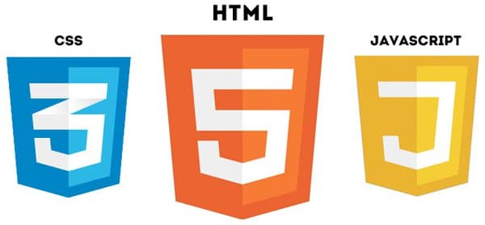

Data Communication (Fetch API - Native JS):
- Focus: Handling reliable and asynchronous data exchange between the client and the backend.
- Rationale: The native Fetch API was chosen over third-party libraries (like Axios) to minimize bundle size. It was strictly used to manage all RESTful API calls (GET, PUT, POST, DELETE), facilitating smooth data retrieval, updates, and creation of complaint records and user data.

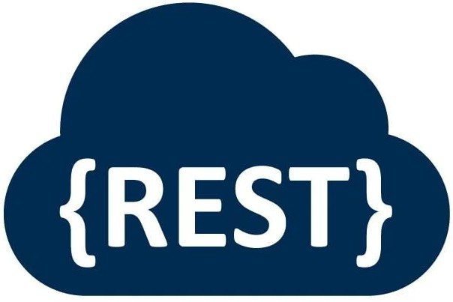

Styling & Assets (CSS Custom Properties, Google Fonts, Font Awesome):
- Focus: Establishing a consistent, professional, and easily themeable visual design.
- Rationale: CSS Custom Properties (Variables) were extensively implemented for dynamic theme management, enabling instant toggling between Dark and Light Modes across the entire application without JavaScript intervention. Google Fonts provided professional, high-quality typography, while Font Awesome delivered a comprehensive set of scalable vector icons for intuitive user feedback and navigation.


Security Mechanism (JSON Web Token - JWT):
- Focus: Implementing a secure, sessionless authentication and authorization protocol.
- Rationale: JWT (Bearer Token) was adopted to manage user sessions and securely authorize access to protected application endpoints (e.g., complaint submission, viewing history). The token-based approach ensures scalability and reduces server-side state complexity, enhancing overall system security.
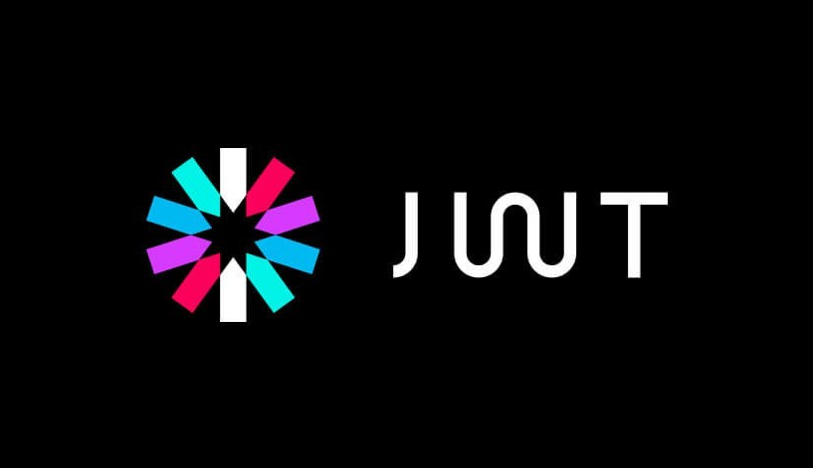

Client Storage (localStorage):
- Focus: Securely and persistently storing non-sensitive, application-critical data on the client side.
- Rationale: localStorage was utilized primarily for the secure storage of the JSON Web Token (JWT) upon successful user login. Additionally, it stores user-defined

preferences, such as the theme choice (Dark/Light Mode), ensuring a persistent and personalized user experience across sessions.

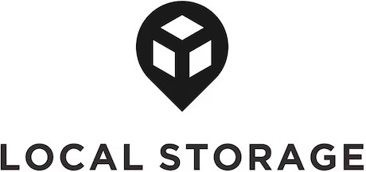

Database Structure (MongoDB - Implied Backend):
- Focus: Providing a flexible and scalable data persistence layer capable of handling diverse complaint records and history.
- Rationale: MongoDB, a NoSQL document database, is the implied technology on the backend (as is typical with a lean MERN/MEAN-like architecture). Its document-based model is ideal for storing rich, varied data structures associated with user complaints and their detailed history without needing rigid, pre-defined schemas.


Architectural Philosophy
The philosophy driving this stack selection was "Performance by Default." By relying on native browser APIs and minimal dependencies, the application achieves a low Time To Interactive (TTI) and a small initial payload size, translating directly into a superior user experience, especially on mobile devices and slower connections. This lean architecture ensures the project is highly efficient, maintainable, and well-positioned for future feature enhancements.

Project Results and Impact
The RedDesk project achieved significant success in meeting its design and operational goals:
- Compliance and Audit Trail: Successfully implemented a mandatory workflow, ensuring that all status changes are logged and timestamped, creating a clear, auditable trail that supports organizational compliance requirements.

- Agent Productivity: The inline editing and prioritized sorting features are estimated to reduce the average time spent per ticket by optimizing the agent's core workflow.
- Security Validation: The integration of JWT and granular RBAC provided a robust, enterprise-grade security layer, ensuring secure data access and management separation.
- Scalability Foundation: By relying solely on vanilla JavaScript and a RESTful API structure, the system remains highly maintainable and is capable of scaling the frontend and backend tiers independently.

Internship Learning
The development of RedDesk provided comprehensive, practical experience in key areas of enterprise software engineering:
- Full-Stack Development: Gained proficiency in orchestrating the seamless interaction between a native JavaScript client and a RESTful API server.
- Security Protocol Implementation: Expertise in deploying and validating JWT-based authentication and designing effective middleware for Role-Based Access Control (RBAC).
- UX/UI Engineering: Hands-on experience in building responsive interfaces, managing dynamic themes (Dark Mode via CSS Custom Properties), and prioritizing user-centric workflow design.
- System Architecture: Deeper understanding of the three-tier model and the performance trade-offs of using a thin-client approach for enterprise applications.

Flowchart – RedDesk Process Flow
The flowchart provides a comprehensive overview of the RedDesk Admin workflow, beginning from the moment the application is launched. As soon as the system opens, it performs an automatic verification of the stored JWT token to confirm whether the admin is already authenticated, which ensures both security and convenience. At the same time, it checks and applies the previously saved theme preference, offering a personalized and consistent user interface. If the token is valid, the admin is immediately directed to the dashboard; otherwise, the system redirects to the login page, where the admin enters the required credentials. Once the server validates these credentials, a new token is stored, and the dashboard loads successfully. Inside the dashboard, the system fetches all complaint records from the backend and displays key metrics such as total complaints, pending cases, ongoing issues, and resolved matters, helping the admin quickly understand the overall situation. The admin can then select any complaint to view its details or update its status. When the status update is confirmed, the system processes the change through an API request and updates the data in real time; if the admin chooses not to proceed, the modal simply closes without any modifications. Overall, the flowchart explains how RedDesk integrates secure authentication, theme management, efficient data retrieval, and easy complaint handling into a single, smooth, and user-friendly workflow.

FLOW CHART
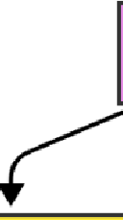
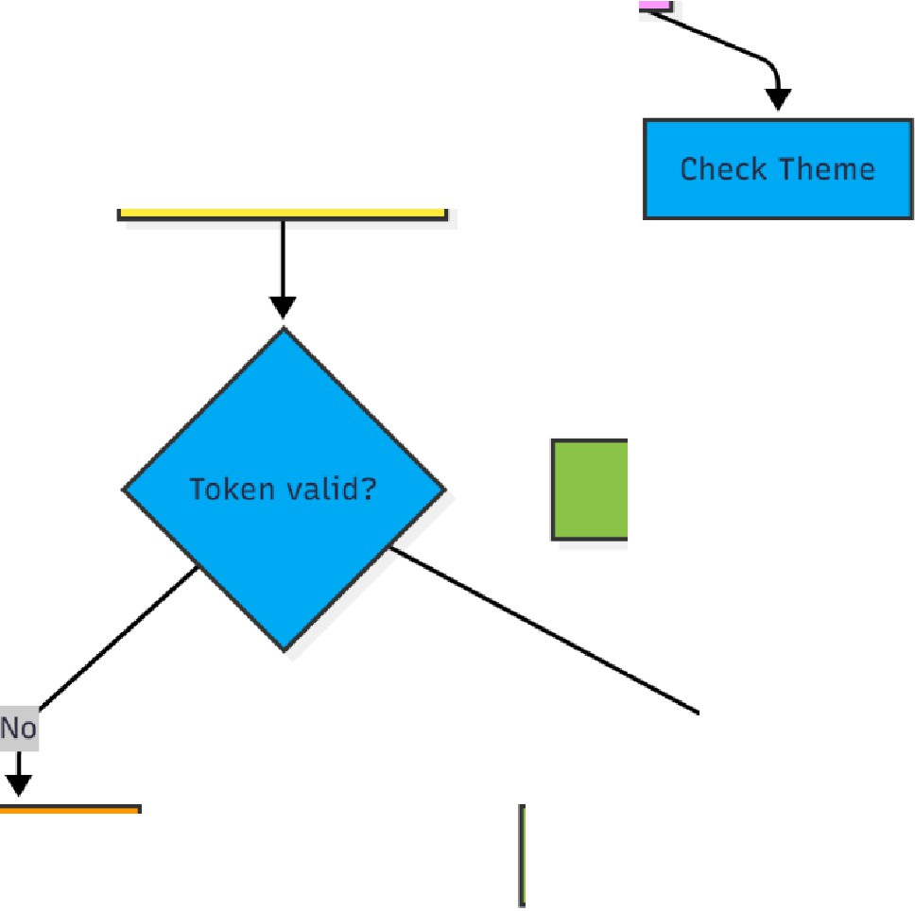

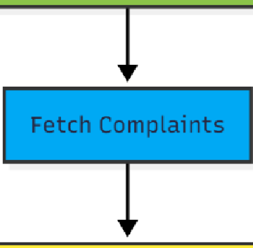
Open RedDesk
Check JWT
Apply Dark or Light
Yes
Go to Login
♦
Load Admin
Enter
Show Metrics: Total,
Pending, In Progress, Resolved
Select

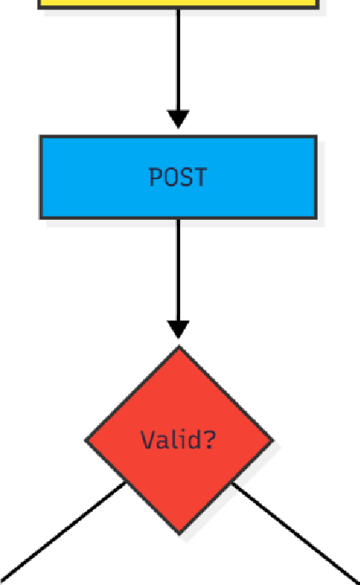
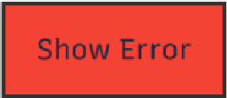
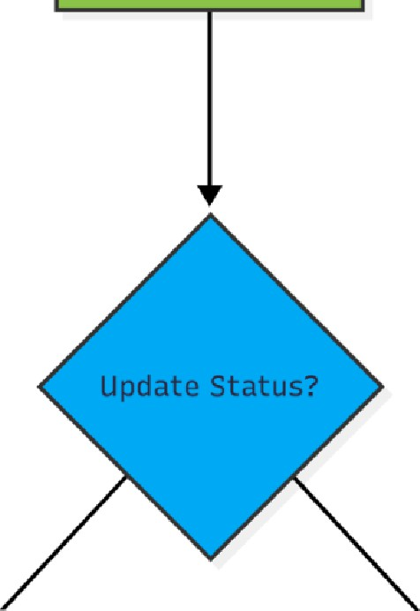
No
l
l
Store Token & Load
Dashboard
Yes

es No
♦
Update via API & Show Close Modal

Source Code Index.html
<!DOCTYPE html>
<html lang="en">

<head>
<meta charset="UTF-8">
<meta name="viewport" content="width=device-width, initial-scale=1.0">
<title>RedDesk | Enterprise Complaint Management</title>
<link rel="icon" href="Assests/Gemini_Generated_Image_uy0m45uy0m45uy0m.png">

<link href="https://fonts.googleapis.com/css2?family=Plus+Jakarta+Sans:wght@300;400;500;600; 700;800&display=swap"
rel="stylesheet">
<link href="https://cdnjs.cloudflare.com/ajax/libs/font-awesome/6.4.0/css/all.min.css" rel="stylesheet">

</head>
<body>

<div class="bg-grid-pattern"></div>
<div class="hero-spotlight"></div>

<nav class="navbar">
<div class="container nav-content">
<a href="index.html" class="brand">
<i class="fas fa-cube" style="font-size: 1.8rem;"></i> RedDesk.
</a>
<div class="nav-links">
<a href="#how-it-works" class="nav-link">How it Works</a>
<a href="#features" class="nav-link">Features</a>
<a href="#testimonials" class="nav-link">Customers</a>
</div>
<div class="nav-actions">
<a href="javascript:void(0)" onclick="handleAuthNavigation()" class="btn btn-outline"
style="border:none;">Sign In</a>
<a href="javascript:void(0)" onclick="handleAuthNavigation()" class="btn btn-primary">Get Started</a>
</div>
<i class="fas fa-bars mobile-menu-btn"></i>

</div>
</nav>

<section class="hero" id="heroSection">
<div class="container hero-grid">
<div class="hero-text">
<div class="hero-badge">
<div class="pulse-dot"></div>
<span>New Version 2.0 Is Live</span>
</div>

<h1>Turn Chaos into <br> <span class="gradient-text">Clarity.</span></h1>
<p>The enterprise complaint system built for speed. Automate workflows, track issues in real-time, and
resolve tickets faster than ever.</p>

<div class="cta-group" style="display: flex; gap: 16px; flex-wrap: wrap; justify-content: flex-start;">
<a href="javascript:void(0)" onclick="handleAuthNavigation()" class="btn btn-primary"
style="padding: 16px 36px; font-size: 1.1rem;">Start Free Trial <i class="fas fa-arrow-right"></i></a>
<a href="#how-it-works" class="btn btn-outline" style="padding: 16px 36px; font-size: 1.1rem;">How
it Works</a>
</div>

<div class="benefits-row">
<div class="benefit-item"><i class="fas fa-check-circle"></i> Instant
Setup</div>
<div class="benefit-item"><i class="fas fa-check-circle"></i> Enterprise
Ready</div>
<div class="benefit-item"><i class="fas fa-check-circle"></i> 24/7 Support</div>
</div>
</div>

<div class="hero-visual">
<div class="mockup-card" id="mockupCard">
<div class="scan-line"></div>

<div class="db-sidebar">
<div class="db-logo"><i class="fas fa-cube"></i></div>
<div class="db-icon active"><i class="fas fa-th-large"></i></div>

<div class="db-icon"><i class="fas fa-user"></i></div>
<div class="db-icon"><i class="fas fa-cog"></i></div>
</div>

<div class="db-main">
<div class="db-header">
<div class="db-title">Admin Console</div>
<div class="db-user">
<div class="db-avatar">A</div>
</div>
</div>

<div class="db-stats">
<div class="db-stat-card">
<div class="db-stat-title">Total Tickets</div>
<div class="db-stat-val">124</div>
</div>
<div class="db-stat-card">
<div class="db-stat-title">Pending</div>
<div class="db-stat-val" style="color: #F59E0B;">42</div>
</div>
<div class="db-stat-card">
<div class="db-stat-title">Resolved</div>
<div class="db-stat-val" style="color: #34D399;">82</div>
</div>
</div>

<div class="db-table-card">
<div class="db-table-header">
<div class="db-search"></div>
<div class="db-btn"></div>
</div>
<div class="db-row">
<div class="db-col-1"></div>
<div class="db-col-2"></div>
<div class="db-col-3 bg-y"></div>
<div class="db-col-4"></div>
</div>
<div class="db-row">
<div class="db-col-1"></div>
<div class="db-col-2"></div>
<div class="db-col-3 bg-g"></div>
<div class="db-col-4"></div>
</div>

<div class="db-row">
<div class="db-col-1"></div>
<div class="db-col-2"></div>
<div class="db-col-3 bg-r"></div>
<div class="db-col-4"></div>
</div>
</div>
</div>
</div>

<div class="floating-badge fb-1">
<div class="fb-icon" style="background: #34D399;"><i class="fas fa-check"></i></div>
<div>
<div
style="font-size: 0.7rem; color: var(--text-muted); text-transform: uppercase; font-weight: 700;">
Status</div>
<div>Ticket #4209 Resolved</div>
</div>
</div>
<div class="floating-badge fb-2">
<div class="fb-icon" style="background: #3B82F6;"><i class="fas fa-user-plus"></i></div>
<div>
<div
style="font-size: 0.7rem; color: var(--text-muted); text-transform: uppercase; font-weight: 700;">
Action</div>
<div>New Agent Assigned</div>
</div>
</div>
</div>
</div>
</section>

<section id="how-it-works" class="section-padding workflow" style="background: var(--bg-body);">
<div class="container">
<div class="section-header reveal">
<h2>Effortless Workflow</h2>
<p>From submission to resolution, we keep everyone in the loop.</p>
</div>

<div class="workflow-diagram reveal">
<div class="step-card">
<div class="step-icon-circle"><i class="fas fa-pen"></i></div>
<div class="step-title">1. Submit</div>
<div class="step-desc">Users report issues via a simple, intuitive portal.</div>
</div>
<div class="step-card">
<div class="step-icon-circle"><i class="fas fa-cogs"></i></div>
<div class="step-title">2. Process</div>
<div class="step-desc">Admins prioritize and assign tickets to the right
team.</div>
</div>
<div class="step-card">
<div class="step-icon-circle"><i class="fas fa-check-double"></i></div>
<div class="step-title">3. Resolve</div>
<div class="step-desc">Issue fixed and user notified automatically.</div>
</div>
</div>
</div>
</section>
<section id="features" class="section-padding" style="background: var(--bg-light);">
<div class="container">
<div class="section-header reveal">
<h2>Everything you need</h2>
<p>Powerful tools designed for modern support teams.</p>
</div>
<div class="feature-grid">
<div class="feature-card reveal">
<div class="feature-icon"><i class="fas fa-bolt"></i></div>
<h3>Real-time Updates</h3>
<p>Track status changes instantly. Users and admins get live updates via websockets.</p>
</div>
<div class="feature-card reveal">
<div class="feature-icon"><i class="fas fa-chart-pie"></i></div>
<h3>Smart Analytics</h3>
<p>Visualize performance with built-in dashboards showing resolution rates and bottlenecks.</p>
</div>
<div class="feature-card reveal">
<div class="feature-icon"><i class="fas fa-users-cog"></i></div>
<h3>Role-Based Access</h3>
<p>Granular permissions for Admins, Employees, and Managers to keep data
secure.</p>

</div>
<div class="feature-card reveal">
<div class="feature-icon"><i class="fas fa-history"></i></div>
<h3>Audit Logs</h3>
<p>Keep a detailed history of every action taken on a ticket for compliance and
review.</p>
</div>
<div class="feature-card reveal">
<div class="feature-icon"><i class="fas fa-mobile-alt"></i></div>
<h3>Mobile Responsive</h3>
<p>Manage tickets on the go with a fully responsive interface for all devices.</p>
</div>
<div class="feature-card reveal">
<div class="feature-icon"><i class="fas fa-shield-alt"></i></div>
<h3>Enterprise Security</h3>
<p>Data encryption, secure authentication, and regular backups keep your data
safe.</p>
</div>
</div>
</div>
</section>
<section id="testimonials" class="section-padding">
<div class="container">
<div class="section-header reveal">
<h2>Loved by Teams</h2>
<p>See what our users are saying about RedDesk.</p>
</div>
<div class="testimonials-grid">
<div class="review-card reveal">
<div class="stars"><i class="fas fa-star"></i><i class="fas fa-star"></i><i class="fas fa-star"></i><i class="fas fa-star"></i><i class="fas
fa-star"></i></div>
<div class="review-text">"RedDesk completely transformed how we handle internal IT requests.
Response times dropped by 40%."</div>
<div class="user-meta">
<div class="user-pic bg-u1">SJ</div>
<div class="user-info">
<h5>Sarah Jenkins</h5><span>CTO, TechFlow</span>
</div>
</div>
</div>
<div class="review-card reveal">

<div class="stars"><i class="fas fa-star"></i><i class="fas fa-star"></i><i class="fas fa-star"></i><i class="fas fa-star"></i><i class="fas
fa-star"></i></div>
<div class="review-text">"The interface is so clean and intuitive. My team didn't even need training
to start using it."</div>
<div class="user-meta">
<div class="user-pic bg-u2">MR</div>
<div class="user-info">
<h5>Mike Ross</h5><span>Ops Manager, Pearson</span>
</div>
</div>
</div>
<div class="review-card reveal">
<div class="stars"><i class="fas fa-star"></i><i class="fas fa-star"></i><i class="fas fa-star"></i><i class="fas fa-star"></i><i class="fas
fa-star"></i></div>
<div class="review-text">"Finally, a complaint system that isn't bloated with useless features. It
just works."</div>
<div class="user-meta">
<div class="user-pic bg-u3">ER</div>
<div class="user-info">
<h5>Elena Rodriguez</h5><span>HR Director, B&G</span>
</div>
</div>
</div>
</div>
</div>
</section>
<section class="cta-section">
<div class="container">
<div class="cta-box reveal">
<div class="cta-glow"></div>
<h2>Ready to streamline your workflow?</h2>
<p>Join thousands of companies using RedDesk today to solve problems faster.</p>
<a href="javascript:void(0)" onclick="handleAuthNavigation()" class="btn btn-primary"
style="padding: 16px 40px; font-size: 1.1rem; position: relative; z-index: 2;"> Create Free Account
</a>
</div>
</div>

</section>

<footer class="footer">
<div class="container">
<div class="footer-content">
<div class="footer-brand">
<div class="brand" style="margin-bottom: 16px;">
<i class="fas fa-cube"></i> RedDesk.
</div>
<p>Making complaint management effortless for teams of all sizes.</p>
</div>
<div class="footer-col">
<h5>Product</h5>
<a href="#">Features</a>
<a href="#">Security</a>
<a href="#">Enterprise</a>
</div>
<div class="footer-col">
<h5>Company</h5>
<a href="#">About Us</a>
<a href="#">Careers</a>
<a href="#">Contact</a>
</div>
<div class="footer-col">
<h5>Resources</h5>
<a href="#">Help Center</a>
<a href="#">API Docs</a>
<a href="#">Status</a>
</div>
</div>
<div class="copyright">
&copy; 2025 RedDesk Inc. All rights reserved.
</div>
</div>
</footer>
<script>
// Scroll Reveal
const observerOptions = { threshold: 0.1 };
const observer = new IntersectionObserver((entries) => { entries.forEach(entry => {
if (entry.isIntersecting) { entry.target.classList.add('active'); observer.unobserve(entry.target);
}

});
}, observerOptions);
document.querySelectorAll('.reveal').forEach(el => observer.observe(el));
// 3D Tilt Effect on Hero Card
const heroSection = document.getElementById('heroSection'); const mockupCard = document.getElementById('mockupCard'); if (window.innerWidth > 900) {
heroSection.addEventListener('mousemove', (e) => { const xAxis = (window.innerWidth / 2 - e.pageX) / 35; const yAxis = (window.innerHeight / 2 - e.pageY) / 35;
mockupCard.style.transform = `rotateY(${xAxis}deg) rotateX(${yAxis}deg)`;
});

heroSection.addEventListener('mouseleave', () => {
mockupCard.style.transform = `rotateY(-8deg) rotateX(4deg)`; // Reset to default
});
}
// Auth Navigation
function handleAuthNavigation() {
const token = localStorage.getItem('token'); const userStr = localStorage.getItem('user');

if (token && userStr) { try {
const user = JSON.parse(userStr);
const role = user.role ? user.role.toLowerCase() : ''; if (role === 'admin' || role === 'administrator') {
window.location.href = 'admin.html';
} else {
window.location.href = 'user.html';
}
} catch (e) { localStorage.clear();
window.location.href = 'login.html';
}
} else {
window.location.href = 'login.html';
}
}
</script>
</body>
</html>

Results

Index.html (Hero Section)
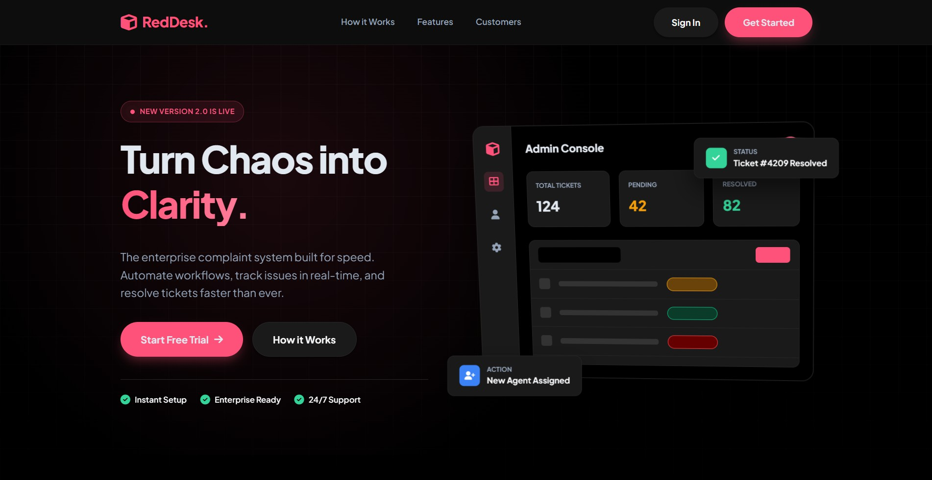

Index.html (Features of the Web Application)
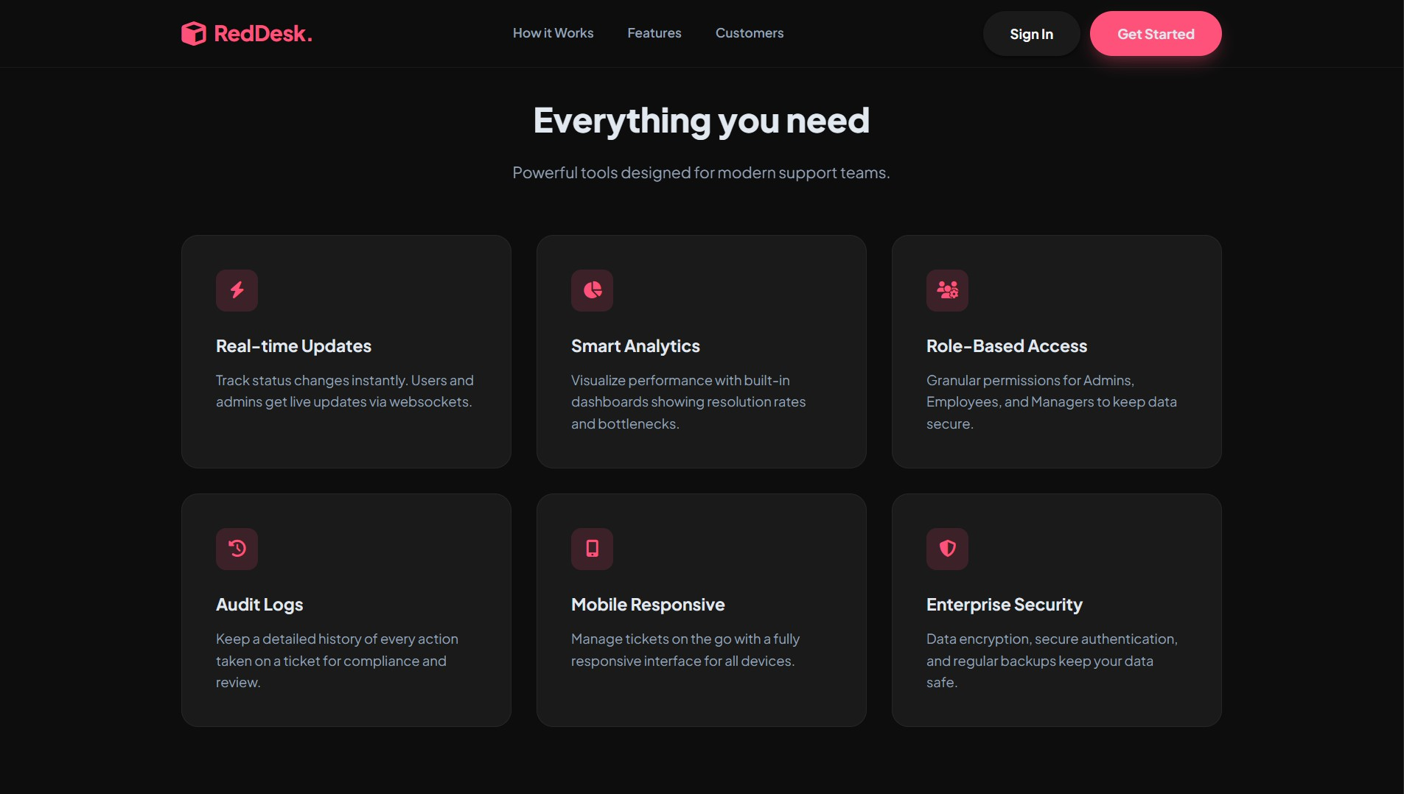

Index.html (Footer)
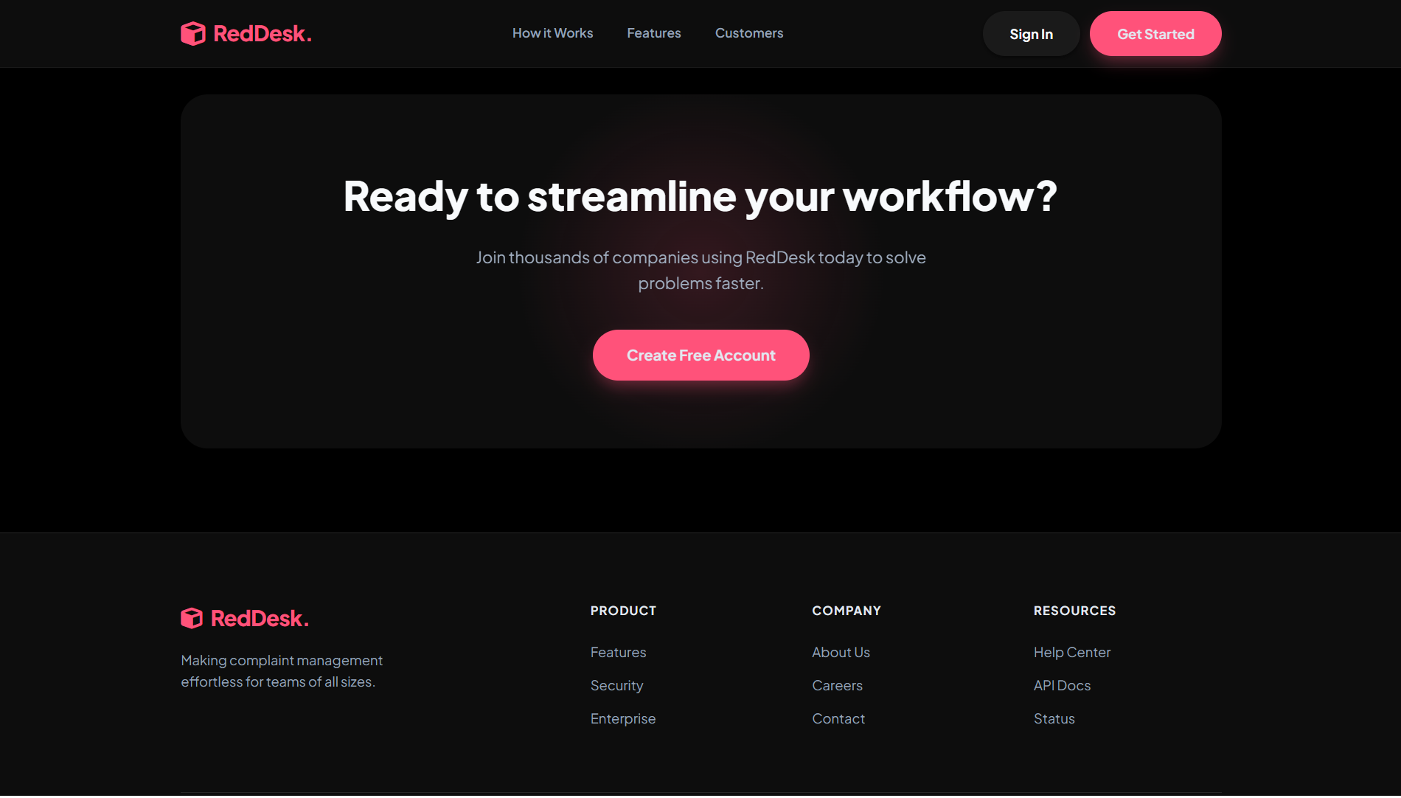

Login & Register Page
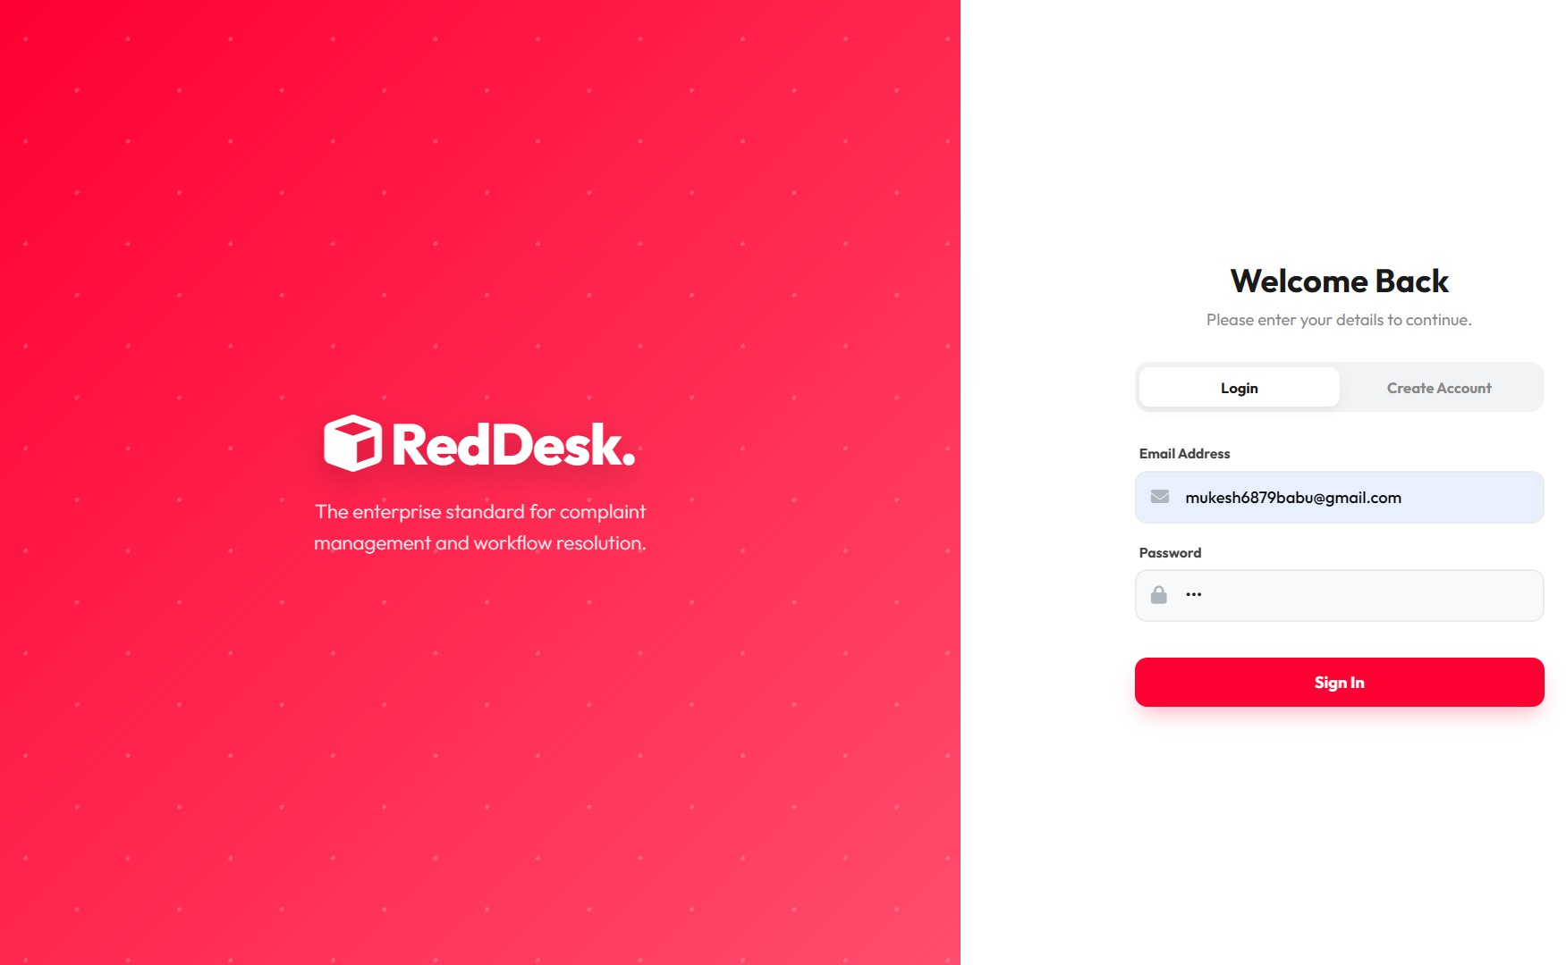

Profile Page
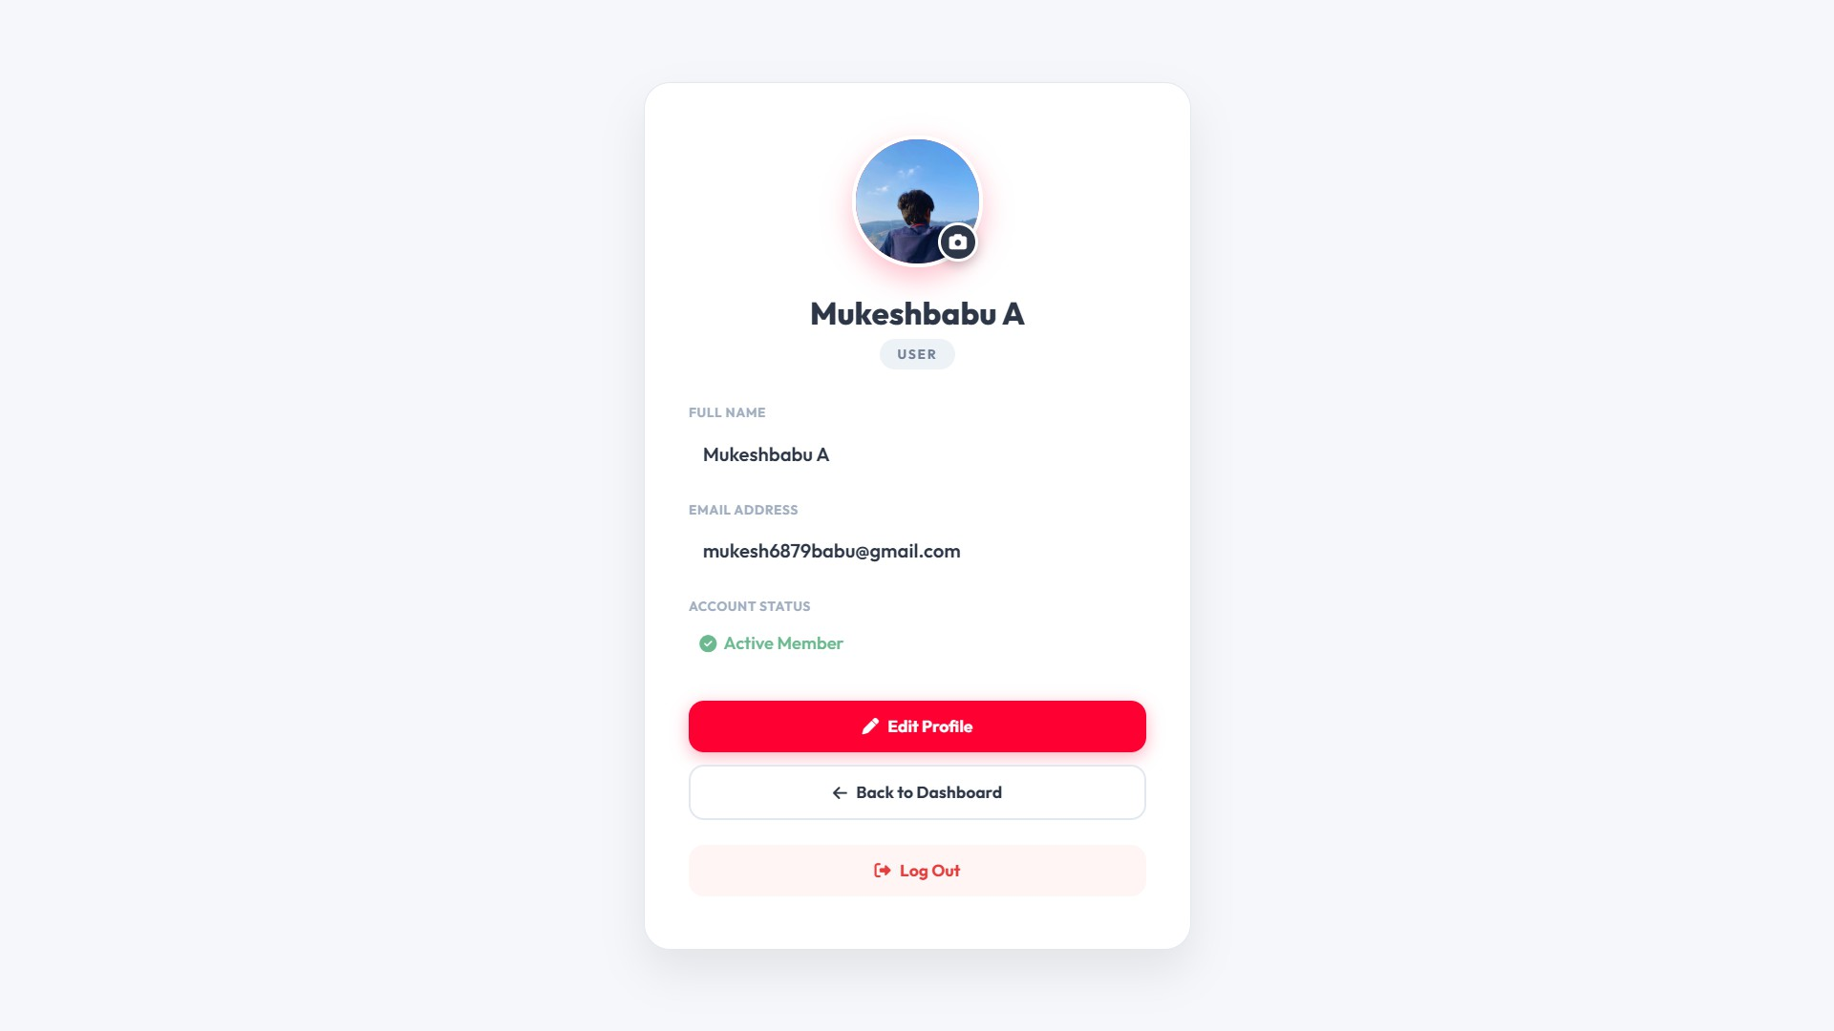

Admin Page
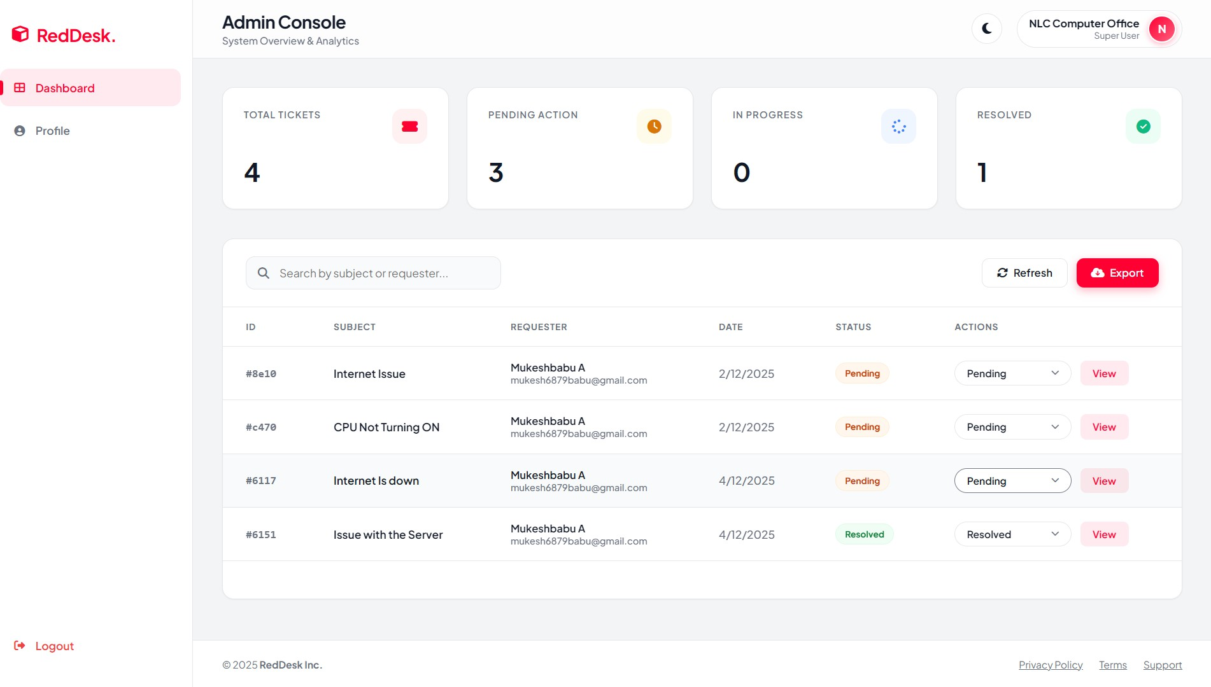

User Page
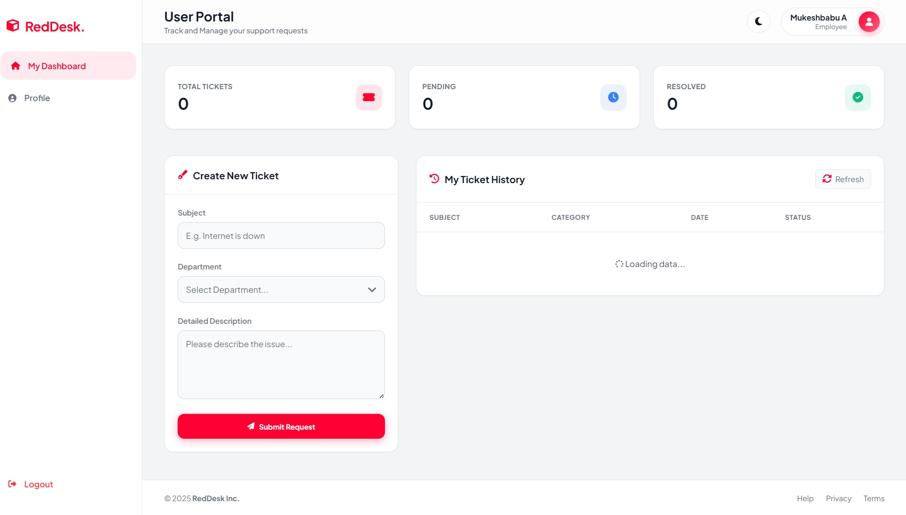

Conclusion
RedDesk is a powerful demonstration of how modern web development methodologies can be leveraged to address complex, mission-critical enterprise challenges. The system is not merely a digital complaint box; it represents a comprehensive overhaul of the complaint management lifecycle, delivering substantial, quantifiable improvements across key organizational metrics.

Core Achievements and Improvements:

- Enhanced Efficiency: By centralizing submissions, automating initial routing, and providing real-time status tracking, RedDesk dramatically reduced the manual overhead previously associated with complaint processing. This digitalization cut down response times and accelerated the resolution process, ensuring timely and effective action.
- Strengthened Security: The platform was developed with a strong focus on security, implementing robust authentication, authorization protocols, and data encryption. This protects sensitive information related to complainants and internal investigations, ensuring compliance with data privacy standards and maintaining the integrity of the process.
- Increased Accountability: RedDesk provides an auditable trail for every complaint, from submission to final resolution. Each action, status change, and assigned owner is logged, creating a clear chain of accountability. This transparency prevents complaints from being overlooked and facilitates performance review of the management process itself.

Professional Development and Learning:

The successful deployment of RedDesk served as an invaluable foundational experience. This project validated and significantly deepened my technical expertise in several critical domains:
- Secure Full-Stack Development: I gained hands-on expertise in architecting and building a scalable, secure application from the database layer to the user interface, with a particular focus on mitigating common web vulnerabilities (e.g., XSS, CSRF).
- Enterprise-Level UX Design: The design process centered on creating an intuitive, accessible user experience for diverse user groups—complainants, administrators, and specialized resolution teams. This involved implementing a thoughtful, functional user interface (UI) and refining the user experience (UX) to support complex workflows without sacrificing ease of use.
In summary, the RedDesk project successfully transformed an inefficient legacy process into a streamlined, secure, and fully accountable digital system. It stands as a significant accomplishment, demonstrating the power of technology to drive operational excellence within an enterprise setting.

CHAPTER - III CONCLUSION
The internship training culminating in the development of the RedDesk Complaint Management System (CMS) was highly successful and met all project objectives. The system provides a robust, real-time, and scalable solution for internal fault reporting and management, effectively replacing manual, time-consuming processes.
The project successfully implemented a modern MEN (MongoDB, Express.js, Node.js) Stack and adhered to industrial best practices such as Stateless Architecture, Role-Based Access Control (RBAC), and advanced security protocols like JWT Authentication and Bcrypt hashing. The practical application of theoretical knowledge in designing the responsive UI/UX and implementing complex features like CSV Data Export affirmed a strong understanding of full-stack web development.
In summary, the RedDesk CMS stands as a testament to the successful transition from theoretical concepts to a functional, secure, and commercially viable web application, providing significant value to organizational efficiency.

REFERENCES

- Moseley, Ralph & M. T. Savaliva. Developing Web Applications (2nd Edition).

- Stuttard, Dafydd & Pinto, Marcus. The Web Application Hacker’s Handbook.

- Node.js Foundation. Node.js Official Documentation – Backend runtime environment setup, configuration, and server-side development.

- Express.js Team. Express.js Documentation – REST API development, routing, middleware, and server configuration.

- MongoDB Inc. MongoDB Atlas Documentation – Cloud database setup, cluster management, deployment, and Mongoose ODM integration.

- NLC India Limited. Official Website. Available at: https://www.nlcindia.com

FEEDBACK
The internship training at NLC India Limited was an exceptionally enriching and rewarding experience. It provided me with not only a deep understanding of industrial web application development but also valuable exposure to large-scale organizational structures and workflow management.

I express my sincere and heartfelt gratitude to the management and personnel of NLC India Limited for granting me this remarkable opportunity. The practical guidance and mentorship I received from the technical team were instrumental in navigating the complexities of the RedDesk CMS project and successfully implementing the MEN Stack. The willingness of the mentors and staff to share their extensive knowledge created a highly supportive and inspiring learning environment throughout the training.
This exposure has significantly strengthened my understanding of the software development lifecycle and industrial requirements. I wholeheartedly thank everyone who contributed to making this training experience truly beneficial and foundational for my career development.

