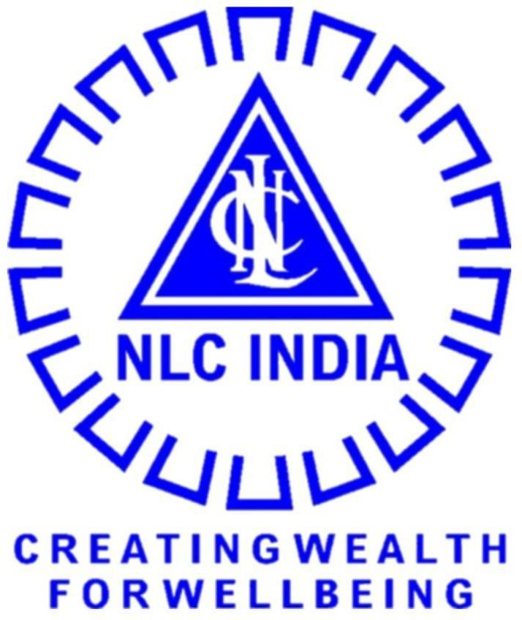

NLC INDIA LIMITED
“NAVRATNA – A GOVERNMENT OF INDIA ENTERPRISE”

INTERNSHIP REPORT ON

MINES EQUIPMENT STOPPAGE ANALYSIS

SUBMITTED BY

SASIKUMAR P
B.Tech, Artificial Intelligence and Data Science

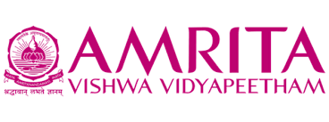
AMRITA VISHWA VIDYAPEETHAM
( An Institution Deemed to be University under Section 3 of the UGC Act, 1956)
Coimbatore – 641112, Tamil Nadu

UNDER THE GUIDANCE OF Mr. RONIJ PANDEY

DEPUTY MANAGER / COMPUTER SCIENCE MINE-I / NLC INDIA LIMITED

NLC INDIA LIMITED
("NAVRATNA" - A GOVERNMENT OF INDIA ENTERPRISE")
NEYVELI-607 801, TAMIL NADU

BONAFIDE CERTIFICATE
Certified that the Internship Training report titled "MINES EQUIPMENT STOPPAGE ANALYSIS" is the bonafide work of,

SASIKUMAR P (2303917710421314)

studying B.Tech, Artificial Intelligence and Data Science at AMRITA VISHWA VIDYAPEETHAM, COIMBATORE, done during the period from 28-04-2026 to 11-05-2026at MINE-I, NLC INDIA LIMITED, NEYVELI.
Their / His / Her performance, conduct and attendance during the period was
.

SHRI RONIJ PANDEY
DEPUTY MANAGER/COMPUTER SCIENCE
DATE: MINE-I
PLACE: NEYVELI NLC INDIA LIMITED

Permitted to submit the internship report to college / university authorities.

DEPUTY GENERAL MANAGER
DATE: LEARNING AND DEVELOPMENT CENTRE PLACE: NEYVELI NLC INDIA LIMITED
DECLARATION
I hereby declare that the Internship training report titled "MINES EQUIPMENT STOPPAGE ANALYSIS" is the original work done by me under the guidance of Shri, RONIJ PANDEY, DM / CS / MINE-1 NLC India Limited, Neyveli.
This internship report is for reference only and no part of the report will be published copied anywhere without the written permission from officials of NLCIL, Neyveli.

Signature of the students

SASIKUMAR P (2303917710421314)

ACKNOWLEDGEMENT

I express my sincere thanks to NLC INDIA LIMITED for providing me the opportunity to carry out the Internship Training.
I also express my sincere thanks to Shri. A Kr. Saravanabhavan, Unit Head / L&DC, Shri. Prabakaran K, Deputy General Manager / L&DC, and the Executives & staffs of Industry Institution Interaction Section / Learning & Development Centre for providing me the opportunity to carry out the Internship Training in NLC India Limited, Neyveli.
I express my gratitude to the Unit Head, Mrs. Arul Selvi, Deputy General Manager, Mines & Services, Nlcil, for granting me permission to undergo internship training in the Unit.
I sincerely thank Shri. Ronij Pandey, Deputy Manager / Computer Science / Mine-I / Nlcil, for providing the guidance during the internship training programme from 27-11-2025 to 10-12-2025.
ABSTRACT

The project titled “Industrial Equipment Downtime Analysis System” was developed to streamline the analysis and monitoring of mining equipment stoppages within an industrial environment. The system provides a centralized, data-driven platform for analyzing downtime records, identifying recurring failures, and improving maintenance decision-making processes. The primary objective of the project was to replace traditional manual analysis methods with a modern, efficient, and scalable analytical solution capable of processing large volumes of equipment stoppage data in real time.
The application was developed using a modern React-based frontend architecture integrated with CSV-based data processing techniques for handling industrial datasets efficiently. The system focuses on analyzing machine-wise downtime records, stoppage durations, group codes, fault descriptions, seasonal impacts, and operational trends. The platform automatically processes uploaded datasets, cleans and structures raw data, converts duration values into analyzable formats, and categorizes operational periods based on climatic conditions such as Summer, Monsoon, and Winter for enhanced environmental analysis.
The system incorporates several advanced analytical modules including machine-wise downtime aggregation, failure frequency analysis, group code and group code text mapping, average stoppage duration calculation, and identification of high-priority operational issues. Interactive dashboards and visual summaries provide clear insights into equipment performance, recurring maintenance problems, and downtime distribution across mining operations. The application also supports dynamic filtering, sorting, and statistical interpretation of downtime records, enabling engineers and operational teams to quickly identify critical failure patterns.
The successful implementation of the system significantly improves operational transparency, maintenance planning, and equipment reliability analysis. By automating the downtime evaluation process, the platform reduces manual effort, minimizes analysis errors, and supports faster maintenance response strategies. The lightweight frontend architecture ensures high performance, responsive operation, and simplified deployment without requiring complex backend infrastructure.
Overall, the project demonstrates how modern web technologies and data analytics can be effectively applied to industrial mining environments for predictive analysis and operational optimization. The proposed system establishes a strong foundation for future enhancements such as machine learning-based predictive maintenance, anomaly detection, real-time monitoring dashboards, and Industry 4.0 smart mining integration.

INDEX
CHAPTER - I 1
INTRODUCTION 1
PROFILE OF NLCIL 1
HISTORY OF NLCIL 4
VISION/MISSION OF NLCIL VISION 5
CHAPTER - II 6
CONTENT OF THE STUDY 6
REDDESK: AN ENTERPRISE COMPLAINT MANAGEMENT SYSTEM 6
- Project Objectives and Scope 6
- Architectural Philosophy and Data Flow 6
  - Component Responsibility and Stack Mapping 7
  - Security and Authentication 8
- Key Features of the Admin Console 8
  - Real-Time Performance Dashboard 8
  - High-Efficiency Ticket Management Table 8
  - Advanced User Experience (UX) 9
- Project Results and Impact 12
- Internship Learning 13
- Flowchart – RedDesk Process Flow 13
- Source Code 15
- Results 24
Index.html (Hero Section) 24
Index.html (Features of the Web Application) 24
Index.html (Footer) 25
Login & Register Page 25
Profile Page 26
Admin Page 26
- Conclusion 27
CHAPTER - III 29
CONCLUSION 29
REFERENCES 29
FEEDBACK 29

CHAPTER - I INTRODUCTION
NLC India Limited is one of India’s prominent public sector enterprises engaged in mining and power generation. Established in 1956 under the Ministry of Coal, Government of India, the company has grown from a single lignite mining operation into a multi-sector energy producer with wide national significance. Over the decades, NLCIL has contributed immensely to India’s energy security by supplying reliable electricity to several states across the country. Its operations include large-scale open-cast mines, lignite-based thermal power stations, coal-based power units, and rapidly expanding renewable energy projects. NLCIL is headquartered at Neyveli in Tamil Nadu and is recognized nationally for its technological advancement, operational efficiency, and commitment to sustainable energy development. The company has played a vital role in regional development, industrial growth, and employment generation, making it an integral part of India’s power sector.

PROFILE OF NLCIL
For over six decades, NLC India Limited (NLCIL) has been at the forefront of India's energy sector, leading the way in lignite mining and playing a major role in the generation of thermal and renewable energy. Since its incorporation on 14th November 1956, NLCIL has consistently contributed to India’s energy security, becoming one of the most significant Public Sector Enterprises (PSEs) in the country. As a Navratna Government of India Enterprise under the administrative control of the Ministry of Coal, NLCIL is recognized for its continuous efforts to expand and modernize its operations, thus contributing to both national development and energy sustainability.
NLCIL operates across several states in India, including Tamil Nadu, Rajasthan, Uttar Pradesh, Odisha, Jharkhand, Gujarat, and the Andaman & Nicobar Islands, ensuring that its operations are spread across the country, fulfilling diverse regional energy needs. With a vision to provide sustainable energy, the company has grown into a leader in the sector, setting benchmarks in energy production, particularly in lignite and coal mining, as well as thermal power generation.
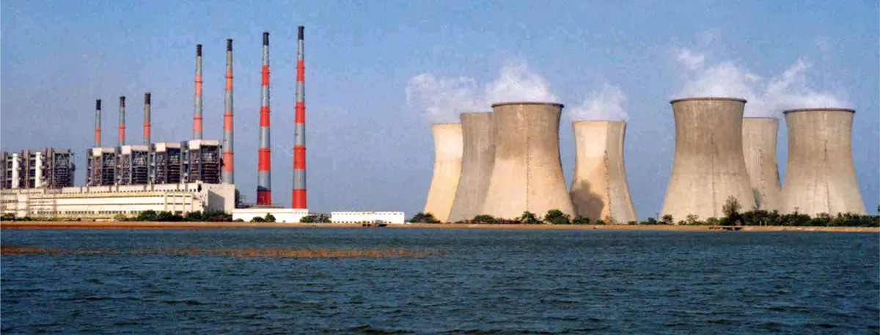

NLCIL is known for its mining operations, specifically its lignite mines. It operates three opencast lignite mines in Neyveli (Tamil Nadu) with a total installed capacity of 28 Million Tonnes Per Annum (MTPA). The mines are central to the company’s operations, providing the raw material needed for its power plants. In addition to the Neyveli mines, NLCIL also operates an opencast lignite mine at Barsingsar, Rajasthan, which has an installed capacity of 2.10 MTPA, and an open-cast coal mine at Talabira, Odisha, with a capacity of 20 MTPA.These mining operations form the backbone of NLCIL’s energy generation capabilities.
NLCIL has expanded its mining footprint with the Talabira-II & III coal mine in Odisha, with a combined coal production capacity of 20 MTPA. This mine commenced production on 26th April 2020, and achieved Commercial Operations Date (COD) on 1st April 2021. The coal mined here is utilized for both NTPL (NLC Tamil Nadu Power Limited) in Thoothukudi and NTPC’s Thermal Power Stations.
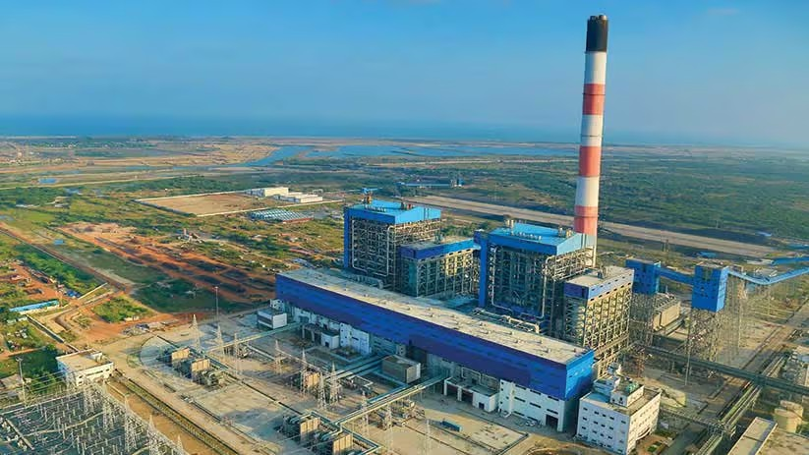

In the thermal power sector, NLCIL operates a total of four lignitebased pit- head thermal power stations at Neyveli, with a combined capacity of 3,390 MW. These power stations are crucial for the country's energy demand and are strategically located near lignite mines for easy supply of raw materials.
The company has also established a 250 MW lignite-based thermal power station at Barsingsar, Rajasthan. Further, through its joint venture with TANGEDCO, NLCIL operates a 1,000 MW coal- based thermal power station at Thoothukudi, Tamil Nadu under the subsidiary NLC Tamil Nadu Power Limited (NTPL). The joint venture between NLCIL and TANGEDCO has an equity participation ratio of 89:11.
In alignment with the growing demand for sustainable energy, NLCIL has made significant strides in the renewable energy sector. The company is currently operating 1,380 MW of solar power plants located in various districts of Tamil Nadu and the Andaman & Nicobar Islands, as well as a 51 MW wind power plant in Tirunelveli, Tamil Nadu.
In fact, NLCIL was the first Central Public Sector Enterprise (CPSE) to achieve a 1 GW capacity in solar power generation, a landmark achievement that solidifies its position as a leader in clean energy. The company has also become a member of the International Solar Alliance (ISA), contributing to global efforts to combat climate change. NLCIL aims to expand its renewable energy capacity to 6,031 MW by 2030, with plans for further solar and wind power projects in various regions across India
NLCIL has ambitious plans for the future, with a target to achieve a total power generation capacity of 17,171 MW by 2030. The company is actively pursuing expansion projects, including a 3x660 MW coal-based thermal power station at Ghatampur, Uttar Pradesh, in a joint venture with Uttar Pradesh Rajya Vidyut Utpadan Nigam Limited (UPRVUNL).
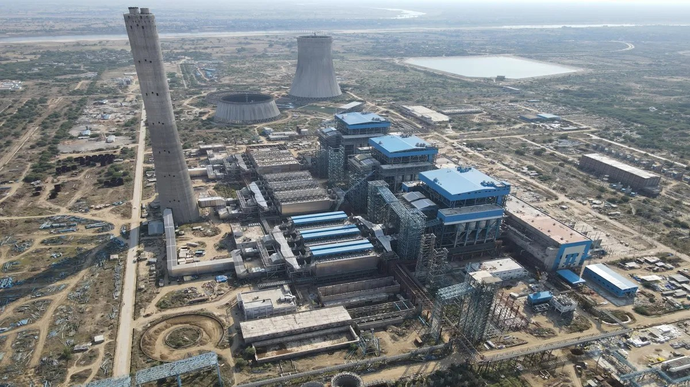

Additionally, the Talabira-II & III coal mines (20 MTPA) in Odisha and the Pachwara South Coal Block (9 MTPA) in Jharkhand are part of NLCIL’s expansion strategy. The Talabira mines began operations in 2020, with an anticipated commissioning of the Pachwara South Coal Block by 2024- 2025.
The company is also moving forward with the development of a 3,200 MW coal-based pit-head thermal power station at Talabira, Odisha, with land acquisition currently in progress.
In addition to its core activities, NLCIL has made significant moves to strengthen its position in the energy sector by forming several joint ventures and subsidiaries. One notable development is the incorporation of Coal Lignite Urja Vikas Private Limited (CLUVPL) on 10th November 2020 with Coal India Limited, which is focused on coal and lignite-based power generation projects.
On 14th June 2023, NLCIL formed a wholly owned subsidiary called NLC India Renewables Limited (NRE), aimed at managing its renewable energy assets. Another subsidiary, NLC India Green Energy Limited (NIGEL), was incorporated on 13th October 2023 to oversee the company’s future renewable energy projects
NLCIL’s contributions extend beyond energy generation. For more than six decades, the company has been actively involved in societal development by supporting various socio-economic initiatives in education, health, infrastructure, and rural development. As a responsible corporate entity, NLCIL has contributed significantly to India’s growth by providing sustainable energy solutions, creating employment opportunities, and improving the quality of life for people in the regions where it operates.

HISTORY OF NLCIL
The discovery of lignite in Neyveli occurred by accident in 1934 when a 'brown substance' was found flowing with water from an artesian well on the 620-acre farm of Rao Bahadur M. Jambulingam Mudaliar. This surprising find led him to promptly notify the British colonial administration. In response, the British Raj dispatched a team of geologists to investigate the unusual substance. After further analysis, the material was identified as lignite, a valuable resource for energy production. Recognizing the potential of this discovery, Rao Bahadur M. Jambulingam Mudaliar took a significant step by generously offering a substantial portion of his land for exploration purposes. His selfless contribution did not end there. He donated the entire 620 acres of land to the Madras Government, enabling the state to explore the rich lignite deposits beneath the surface.
This pioneering act laid the foundation for the establishment of what would become one of India’s leading mining and power generation sites. The discovery marked the beginning of Neyveli’s transformation into a hub for lignite mining, which would later play a critical role in India's energy sector.
The establishment of NLC India Limited (NLCIL) in Neyveli in the 1950s, followed by the opening of large-scale lignite mines, can be directly traced back to this fortuitous discovery. Over the years, the lignite reserves in Neyveli have contributed significantly to the country’s power generation, and the area has become a vital energy resource centre.
Rao Bahadur M. Jambulingam Mudaliar’s vision and generosity not only advanced the understanding of India’s natural resources but also played a pivotal role in shaping the nation’s energy infrastructure. His contributions continue to be remembered as the catalyst that ignited Neyveli’s legacy in lignite mining and thermal power generation.

VISION/MISSION OF NLCIL VISION
To establish ourselves as a premier mining and power corporation, recognized for our leadership in the energy sector, committed to social responsibility, and dedicated to accelerating the nation's progress through sustainable practices and innovation. We aim to provide reliable, affordable, and clean energy while creating value for all stakeholders and contributing to the socio-economic development of India.

MISSION

Enhance Capabilities in Power and Mining: We are committed to continually improving and expanding our expertise in the fields of power generation and mining. Our focus is on increasing operational efficiency, leveraging advanced technologies, and ensuring financial stability to foster growth and profitability. Promote Sustainable Development: As a socially responsible organization, we strive to integrate environmental sustainability into every aspect of our operations. We are dedicated to minimizing the ecological impact of our activities, while contributing to national goals such as clean energy transition and climate change mitigation.
Foster Social Responsibility and Community Development: We aim to improve the quality of life for communities around our operations through initiatives in education, healthcare, infrastructure development, and other areas of social welfare. By being sensitive to the needs of society, we seek to be a catalyst for positive change.
Excellence in Operations: We will continuously strive for excellence in all our processes, from mining to power generation, ensuring high standards of safety, quality, and efficiency. By adopting best practices and fostering a culture of innovation, we aim to stay ahead of industry trends and meet the growing energy demands of the nation.
Environmental Stewardship: We recognize the importance of protecting the environment and aim to set industry standards for sustainability. We are committed to adopting green technologies, reducing carbon emissions, and restoring natural habitats, ensuring that our growth aligns with the long-term health of the planet.
Through these core objectives, we aim to build a company that is not only a leader in the energy sector but also a responsible corporate citizen that contributes to the betterment of society and the environment.

CHAPTER - II

CONTENT OF THE STUDY

CHAPTER - III CONCLUSION
The internship training culminating in the development of the RedDesk Complaint Management System (CMS) was highly successful and met all project objectives. The system provides a robust, real-time, and scalable solution for internal fault reporting and management, effectively replacing manual, time-consuming processes.
The project successfully implemented a modern MEN (MongoDB, Express.js, Node.js) Stack and adhered to industrial best practices such as Stateless Architecture, Role-Based Access Control (RBAC), and advanced security protocols like JWT Authentication and Bcrypt hashing. The practical application of theoretical knowledge in designing the responsive UI/UX and implementing complex features like CSV Data Export affirmed a strong understanding of full-stack web development.
In summary, the RedDesk CMS stands as a testament to the successful transition from theoretical concepts to a functional, secure, and commercially viable web application, providing significant value to organizational efficiency.

REFERENCES

- Moseley, Ralph & M. T. Savaliva. Developing Web Applications (2nd Edition).

- Stuttard, Dafydd & Pinto, Marcus. The Web Application Hacker’s Handbook.

- Node.js Foundation. Node.js Official Documentation – Backend runtime environment setup, configuration, and server-side development.

- Express.js Team. Express.js Documentation – REST API development, routing, middleware, and server configuration.

- MongoDB Inc. MongoDB Atlas Documentation – Cloud database setup, cluster management, deployment, and Mongoose ODM integration.

- NLC India Limited. Official Website. Available at: https://www.nlcindia.com

FEEDBACK
The internship training at NLC India Limited was an exceptionally enriching and rewarding experience. It provided me with not only a deep understanding of industrial web application development but also valuable exposure to large-scale organizational structures and workflow management.
I express my sincere and heartfelt gratitude to the management and personnel of NLC India Limited for granting me this remarkable opportunity. The practical guidance and mentorship I received from the technical team were instrumental in navigating the complexities of the RedDesk CMS project and successfully implementing the MEN Stack. The willingness of the mentors and staff to share their extensive knowledge created a highly supportive and inspiring learning environment throughout the training.
This exposure has significantly strengthened my understanding of the software development lifecycle and industrial requirements. I wholeheartedly thank everyone who contributed to making this training experience truly beneficial and foundational for my career development.

