**Air Quality Monitoring**

Definition:

Air quality monitoring is the systematic process of measuring, analyzing, and assessing the composition of the air in a specific location or region to determine the presence and concentrations of various pollutants and other air quality parameters. This practice is crucial for understanding and managing air quality to protect public health, the environment, and regulatory compliance.

Materials Required:

|  |  |  |  |
| --- | --- | --- | --- |
| **Name** | **Quantity** | **Component** | |
|  |  |  | |
| **U1** | **1** | **Arduino Uno R3** | |
| **U2** | **1** | **LCD 16 x 2** | |
| **PIEZO1** | **1** | **Piezo** |  |
| **GAS1** | **1** | **Gas Sensor** | |
| **Rpot1** | **1** | **250 kΩ Potentiometer** | |
| **R2, R4, R5** | **3** | **1 kΩ Resistor** | |

**Circuit Diagram:**

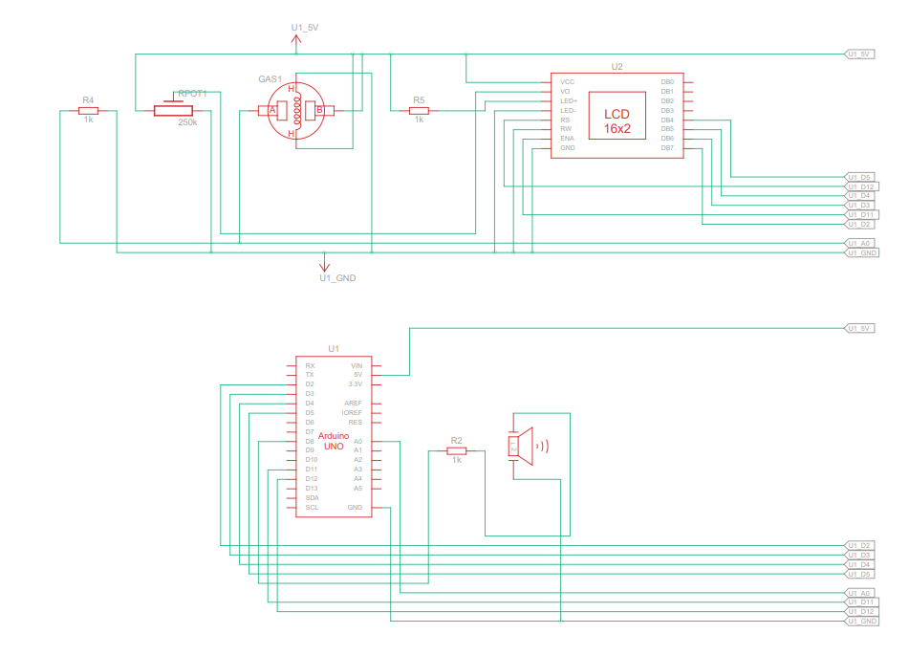

**Actual Circuit:**

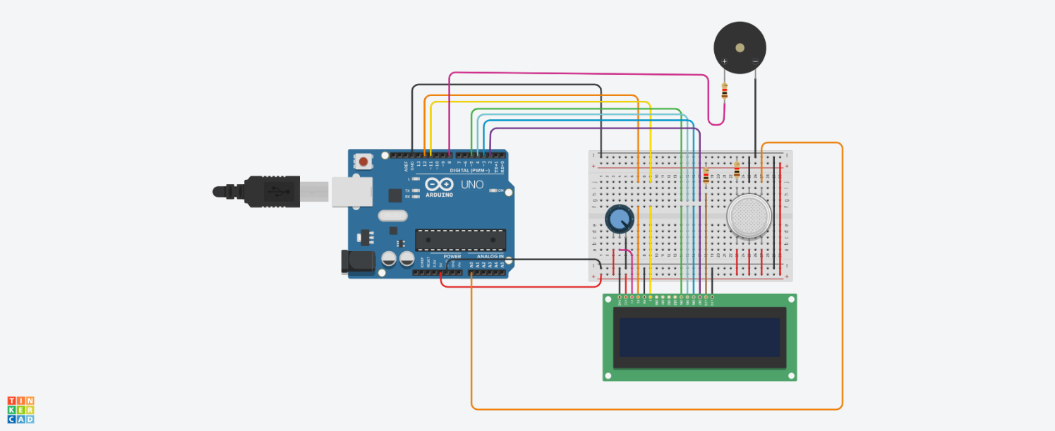

**Coding:**

#include <LiquidCrystal.h>

LiquidCrystal lcd(12,11,5,4,3,2);

int pin8 = 8;

int analogPin =A0;

int sensorValue = 0;

void setup()

{

pinMode(analogPin, INPUT);

pinMode(pin8, OUTPUT);

lcd.begin(16,2);

lcd.print("What is the air");

lcd.print("quality today?");

Serial.begin(9600);

lcd.display();

}

void loop()

{

delay(100);

sensorValue = analogRead(analogPin);

Serial.print("Air Quality in PPM = ");

Serial.println(sensorValue);

lcd.clear();

lcd.setCursor(0,0);

lcd.print ("Air Quality: ");

lcd.print (sensorValue);

if (sensorValue<=250)

{

Serial.print("Fresh Air");

Serial.print("\r\n");

lcd.setCursor(0,1);

lcd.print("Fresh Air");

}

else if (sensorValue>=250 && sensorValue<=500)

{

Serial.print("Poor Air");

Serial.print("\r\n");

lcd.setCursor(0,1);

lcd.print("Poor Air");

}

else if (sensorValue>=500)

{

Serial.print("Very Poor Air");

Serial.print("\r\n");

lcd.setCursor(0,1);

lcd.print("Very Poor Air");

}

if (sensorValue >500)

{

digitalWrite(pin8, HIGH);

}

else

{

digitalWrite(pin8, LOW);

}

}

Output:

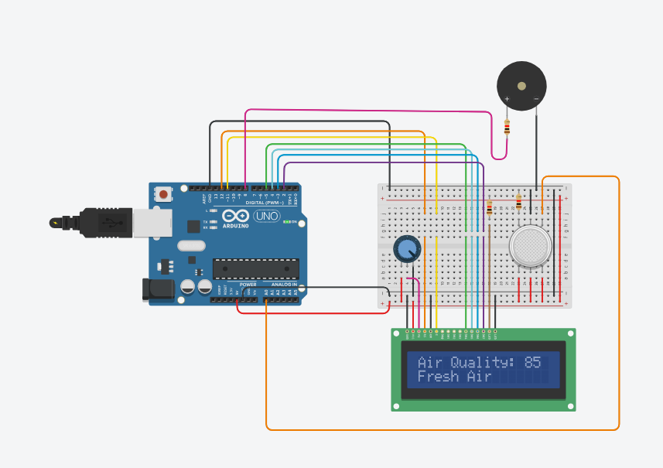

It’s the reading of Fresh Air

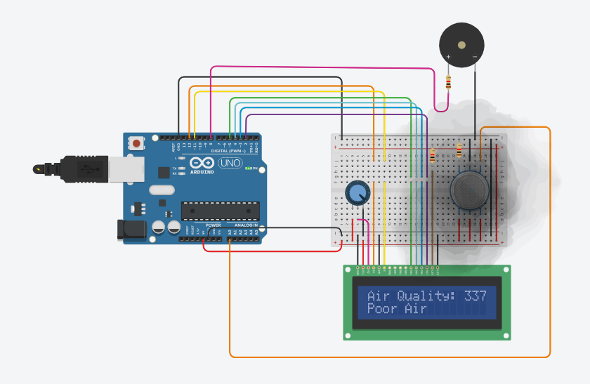

It’s the reading of Poor Air

Project Link:

<https://www.tinkercad.com/things/2n8bzIlTbSn-glorious-hillar-migelo/editel?sharecode=ghZw5PmnWZ1gFlDLS5fOiz9-QzD7hGED34hVf2FR1RA>

Uses:

1. **Public Health Protection:** Monitoring air quality helps protect human health by identifying and mitigating exposure to harmful air pollutants such as particulate matter (PM2.5 and PM10), ozone (O3), nitrogen dioxide (NO2), sulfur dioxide (SO2), carbon monoxide (CO), and volatile organic compounds (VOCs). High levels of these pollutants can lead to respiratory and cardiovascular diseases.
2. **Environmental Regulation:** Air quality monitoring data is used by regulatory agencies to establish and enforce air quality standards and regulations. These standards aim to limit pollutant concentrations in the air and protect the environment.
3. **Early Warning Systems:** Monitoring systems can provide early warnings for air quality events such as smog, wildfires, industrial accidents, or volcanic eruptions. This allows authorities to issue alerts, evacuate areas if necessary, and take appropriate measures to protect public health.
4. **Source Identification:** Air quality monitoring can help identify and locate specific sources of air pollution, such as factories, power plants, or vehicular emissions. This information can be used to target pollution control efforts more effectively.
5. **Trend Analysis:** Long-term monitoring data helps in understanding trends and changes in air quality over time. This information can be used to assess the effectiveness of pollution control policies and measures.
6. **Research and Studies:** Air quality monitoring provides valuable data for scientific research on air pollution and its impacts on health, climate, and ecosystems. Researchers use this data to gain insights into the complex interactions between air pollutants and their effects.
7. **Urban Planning:** Information from air quality monitoring is used in urban planning to make informed decisions about transportation, infrastructure development, and land use. It can help cities reduce traffic congestion, enhance public transportation, and improve green spaces to mitigate air pollution.
8. **Health Advisories:** Monitoring data can trigger public health advisories, urging vulnerable individuals (e.g., children, the elderly, and people with pre-existing health conditions) to limit outdoor activities during periods of poor air quality.
9. **Economic Impact Analysis:** Poor air quality can have significant economic consequences due to healthcare costs, decreased productivity, and damage to crops and ecosystems. Air quality monitoring helps to assess these economic impacts.
10. **Compliance Monitoring:** Industries and businesses often need to demonstrate compliance with air quality regulations. Regular monitoring helps them track emissions and demonstrate their commitment to environmental responsibility.
11. **Climate Change Research:** Air quality monitoring can provide data on greenhouse gas emissions, which are responsible for climate change. This data is crucial for understanding and addressing the impact of air quality on the global climate.
12. **International Agreements:** Monitoring data is used to fulfill obligations under international agreements and treaties related to air quality, such as the Convention on Long-Range Transboundary Air Pollution and the Paris Agreement.

Conclusion:

Air quality monitoring is an indispensable tool with wide-ranging significance for safeguarding human health, protecting the environment, and addressing the global challenges posed by air pollution. It serves as a foundational pillar in the ongoing effort to ensure clean and safe air for everyone. The critical uses of air quality monitoring, as outlined above, underscore its importance in various aspects of public health, environmental management, and policy development. By providing real-time data, early warnings, source identification, and long-term trend analysis, air quality monitoring empowers governments, industries, researchers, and communities to take informed actions aimed at improving air quality and mitigating the adverse effects of air pollution.

Team Members:

1. Rithvik Abinav K R (112821104054)
2. Prem Sai J (112821104051)
3. Sasi Kumar D (112821104308)
4. Shaik Imran (112821104064)
5. Chennavaram Dhanush (112821104701)