Explainable Misinformation Detection Across Multiple Social Media Platforms
Abstract
The widespread use of social media platforms has transformed the way information is created, shared, and consumed. While these platforms enable rapid communication, they also facilitate the large-scale spread of misinformation, leading to serious social, economic, and public health consequences. Existing misinformation detection systems are often platform-specific and require large volumes of labeled data, limiting their effectiveness in cross-platform scenarios. Moreover, the black-box nature of many machine learning models reduces transparency and user trust. This project aims to develop a generalized and explainable misinformation detection framework that operates across multiple social media platforms. By integrating domain-adaptive learning with explainable artificial intelligence techniques, the proposed system enhances robustness, scalability, and interpretability. The approach improves cross-platform generalization while ensuring transparency and trust in automated misinformation detection systems.
Introduction
Social media platforms such as Twitter, Instagram, YouTube, Reddit, and online news portals have become primary sources of information dissemination. Although these platforms provide accessibility and speed, they also contribute to the rapid spread of false or misleading information. Misinformation can influence public opinion, create panic, and lead to harmful consequences, especially during critical events such as pandemics, elections, and natural disasters.
Traditional misinformation detection approaches rely on manual verification or platform-specific machine learning models. These approaches face challenges when applied to new platforms due to differences in language usage, content structure, and user behavior. Moreover, most advanced deep learning models act as black boxes, providing predictions without clear explanations. This project addresses these challenges by proposing a generalized and explainable misinformation detection system suitable for real-world deployment.
Problem Statement
Existing misinformation detection systems are largely platform-dependent and lack generalization capability. Models trained on data from one social media platform often fail to perform effectively on other platforms due to domain shift and variations in content characteristics. Furthermore, the black-box nature of many machine learning and deep learning models makes it difficult to understand or trust their predictions. Therefore, there is a need for a generalized misinformation detection system that can operate across multiple social media platforms while providing transparent and interpretable results to users.
Objectives of the Project
- To develop a generalized misinformation detection system applicable across multiple social media platforms.
- To address domain shift using domain-adaptive learning techniques.
- To reduce dependency on large, platform-specific labeled datasets.
- To integrate explainable AI techniques for transparent and interpretable decision-making.
- To enhance trust and usability of automated misinformation detection systems.
Scope of the Project
The scope of this project focuses on detecting text-based misinformation across multiple social media platforms. The system is designed to learn generalized representations that can adapt to different platforms without extensive retraining. The project emphasizes explainability and transparency in model predictions. While the current implementation focuses on textual data, the framework can be extended to support multimodal data such as images and videos in the future.
Gap Identification
Despite extensive research in misinformation detection, several gaps remain in existing systems. Most current models are trained and evaluated on single-platform datasets, limiting their effectiveness when applied to other platforms. This platform dependency results in poor performance due to domain shift.
Another major gap is the reliance on large amounts of labeled data for each platform, which is costly and time-consuming to obtain. Additionally, many state-of-the-art models function as black boxes and fail to provide explanations for their predictions, reducing user trust and practical usability.
Existing systems often prioritize accuracy over interpretability and scalability, making them unsuitable for real-world applications that require transparency and adaptability.
Proposed System
The proposed system introduces a generalized and explainable misinformation detection framework. It leverages domain-adaptive learning to handle cross-platform variations and integrates explainable AI techniques to interpret model predictions. The system is modular, scalable, and designed for real-world applicability.
System Architecture
The proposed system follows a layered architecture comprising data preparation, feature extraction, domain adaptive learning, explainability, and output modules. Textual data collected from multiple social media platforms is initially pre-processed and transformed into numerical representations suitable for deep learning models. A domain-adaptive deep learning framework is then employed to perform generalized misinformation classification across platforms. Finally, an explainable artificial intelligence (XAI) module generates human-interpretable explanations for the model’s predictions, thereby ensuring transparency, trust, and practical usability.

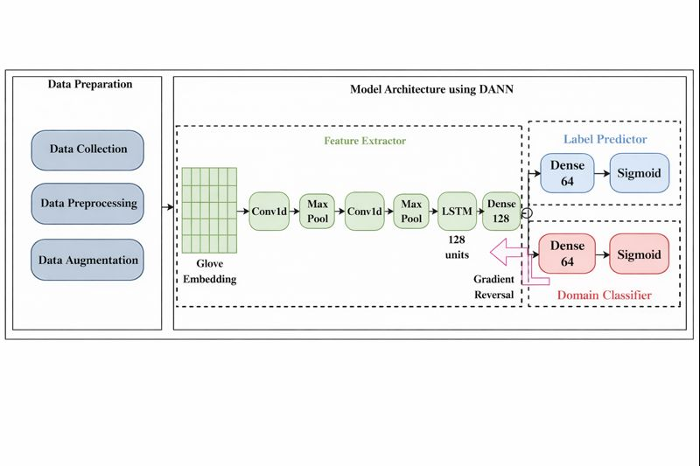

The system is built around a Domain-Adversarial Neural Network (DANN), which enables robust misinformation detection while minimizing the impact of domain differences between training and testing data. The architecture consists of three major stages:
- Data Preparation
- Feature Extraction using Deep Learning
- Dual Prediction Modules (Label Predictor and Domain Classifier)
The central objective of this architecture is to learn domain-invariant feature representations that generalize effectively across heterogeneous social media platforms.
- Data Preparation Stage
The data preparation stage ensures that the input data is clean, consistent, and suitable for deep learning-based processing.
- Data Collection
Textual data is collected from multiple sources or domains, such as different social media platforms or datasets. This diversity enables the model to learn generalized representations from heterogeneous inputs.
b) Data Preprocessing
Preprocessing operations include:
- Removal of noise and irrelevant information
- Tokenization and normalization of textual content
- Padding or truncation of sequences to ensure uniform input length
c) Data Augmentation
Data augmentation techniques are applied to:
- Increase the effective size of the dataset
- Improve model generalization capability
- Reduce overfitting during training
- Feature Extraction Module
The feature extraction module is the core component of the proposed architecture, responsible for transforming raw text into high-level representations.
a) GloVe Embedding Layer
- Converts words into dense numerical vector representations
- Captures semantic meaning and contextual relationships between words
- Serves as the input representation for subsequent deep learning layers
b) Convolutional Layers (Conv1D)
- Extract local patterns and meaningful n-gram features
- Identify important contextual patterns in sequential text data
c) Max Pooling Layers
- Reduce dimensionality of feature maps
- Retain the most significant features
- Improve computational efficiency
d) LSTM Layer (128 Units)
- Captures long-term dependencies in sequential data
- Preserves contextual information across time steps
- Enhances representation of complex linguistic patterns
e) Dense Layer (128 Neurons)
- Transforms extracted features into a compact shared representation
- Acts as a common feature space for both prediction modules
- Dual Prediction Modules
- Label Predictor Module
The label predictor performs the primary task of misinformation classification.
- Consists of a dense layer with 64 neurons
- Uses a sigmoid activation function
- Produces the final class prediction (e.g., misinformation or genuine content)
This module learns task-specific patterns from the shared feature representations.
- Domain Classifier Module
The domain classifier enables domain-adaptive learning by distinguishing between source and target domains.
- Comprises a dense layer with 64 neurons
- Uses a sigmoid activation function
- Predicts the domain of the input sample (source or target)
- Gradient Reversal Layer and Adversarial Learning
A Gradient Reversal Layer (GRL) is placed between the feature extractor and the domain classifier. During backpropagation, the GRL reverses the gradient direction, thereby enforcing adversarial learning.
This mechanism forces the feature extractor to learn representations that:
- Are informative for label prediction
- Are indistinguishable across different domains
As a result, the model learns domain-invariant and discriminative features, significantly improving generalization across multiple datasets and platforms.

- Working Principle of DANN
The working principle of the DANN-based architecture can be summarized as follows:
- The feature extractor learns representations from the input data.
- The label predictor attempts to correctly classify the task-specific labels.
- The domain classifier attempts to identify the domain of each input sample.
- The gradient reversal mechanism forces the feature extractor to confuse the domain classifier.
- The final outcome is a set of domain-invariant yet discriminative feature representations.

ARCHITECTURE DIAGRAM
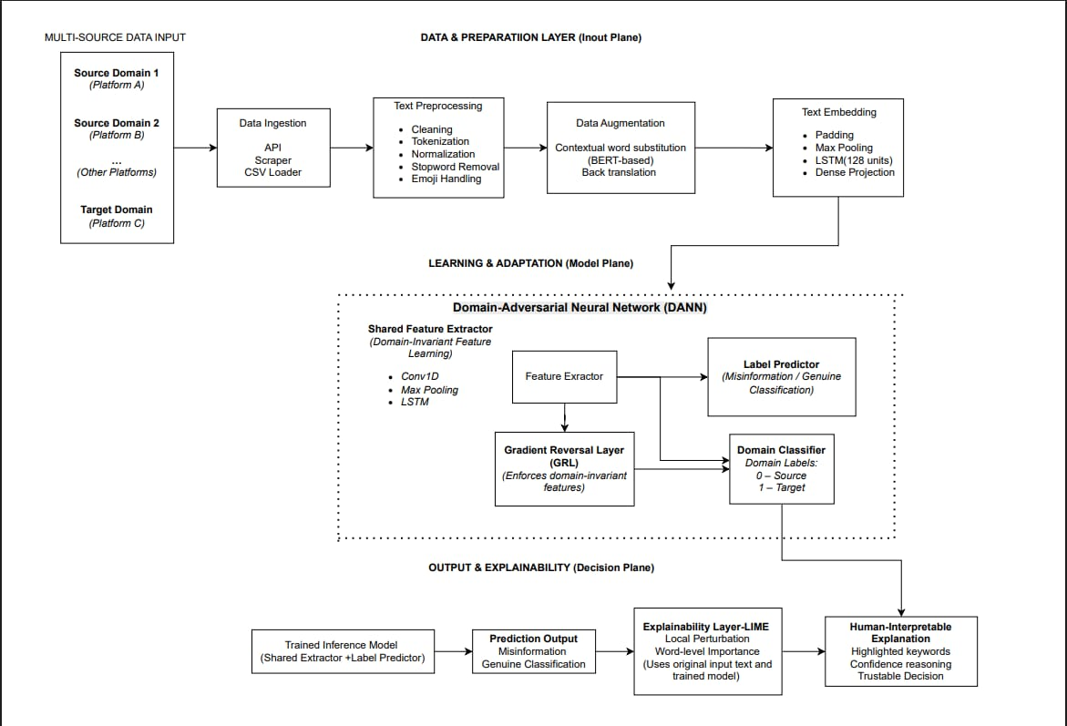
Methodology
The methodology includes the following steps:
- Collection of textual data from multiple social media platforms.
- Preprocessing of data through cleaning, normalization, and tokenization.
- Feature representation using word embeddings.
- Training a generalized classification model using domain-adaptive learning.
- Classification of content as misinformation or genuine information.
- Explanation of predictions using explainable AI techniques.
Advantages
- Cross-platform generalization capability
- Reduced requirement for platform-specific labeled data
- Improved robustness against domain variations
- Transparent and interpretable predictions
- Scalable and adaptable system design
Applications
- Social media monitoring and moderation
- Fake news detection
- Healthcare and crisis-related misinformation detection
- Public awareness and safety systems
- Decision support for policymakers
Limitations
- Focuses primarily on text-based misinformation
- Performance depends on data quality
- Requires computational resources for training deep learning models
Project Deliverables:
Primary Deliverables:
1.A generalized misinformation detection framework capable of operating across multiple social media platforms.
2.A domain-adaptive learning model based on Domain-Adversarial Neural Networks (DANN) to handle domain shift.
3.An explainable AI module that provides human-interpretable explanations for misinformation predictions.
Secondary Deliverables:
1.A well-defined system architecture and workflow suitable for real-world deployment.
2.Performance evaluation across source and target domains.
3.Visual and analytical insights to support model interpretability.
Future Enhancements
The proposed system can be further enhanced by extending it to multimodal misinformation detection and by exploring advanced language models to improve semantic understanding. The framework may also be adapted for real-time monitoring and supplemented with additional explainability techniques to provide deeper insights into model decisions.

Conclusion
This project presents an explainable approach to misinformation detection across multiple social media platforms. By addressing challenges related to domain shift and lack of transparency, the proposed system offers a scalable and trustworthy solution. The integration of domain-adaptive learning with explainable artificial intelligence improves both classification performance and interpretability. As a result, the framework is well-suited for real-world deployment where robustness, adaptability, and transparency are essential.

