
CSA15 – CLOUD COMPUTING AND BIG DATA ANALYTICS

ASSIGNMENT 1 – CO1
Design, Analyse and Validate a Cloud-Based Solution for Migrating a Legacy University Management System
CO1: Apply cloud computing technologies including hardware–software evolution, virtualization, web services, and service models to develop cloud-based solutions.

Field | Details | Field | Details
Student Name | Sasi Kumar. S | Register Number | 192324254
Department / Section | B.Tech / AI&DS | Academic Year / Semester | 2026 / 8
Faculty Name | Dr.R.Latha | Nature of Assignment | Individual
Duration | 1 Week | Total Marks | 50
Submission Date |  | Evaluation Date

MARK SHEET (Rubric-based evaluation)
Task | Title | Max | Awarded | Evidence / evaluation focus
1 | Introduce Cloud Computing | 3 |  | Definition; characteristics; deployment models; scenario mapping
2 | Trace Evolution and Hardware Evolution | 3 |  | Timeline; hardware evolution; relevance to university
3 | Analyse Internet Software Evolution | 3 |  | Web/software evolution; SOA; APIs; scenario relevance
4 | Apply Server Virtualization | 5 |  | Hypervisor types; VM/container comparison; consolidation; limitations
5 | Apply Web Services | 4 |  | SOA and SOAP/REST; three university APIs; request/response examples
6 | Analyse IaaS, PaaS and SaaS | 5 |  | Responsibility layers; five-application mapping; comparison; providers
7 | Examine XaaS | 3 |  | Four or more variants; two justified choices; provider risks
8 | Design Cloud Solution Architecture | 5 |  | Labelled diagram; deployment/service models; scaling; security; DR
9 | Hands-on Implementation and Documentation | 4 |  | Running VM/container; PaaS/SaaS; tests; actual screenshots
10 | Evaluate and Recommend Final Solution | 7 |  | Three-way comparison; 3-year costs; risks; phased roadmap
11 | Day-4 Design Challenge | 8 |  | Impact; evaluation; adaptation; evidence-based defence
 | TOTAL | 50 |  | Percentage :

EVIDENCE VERIFICATION CHECKLIST

Tasks | Evidence expected | Status (✓ / P / ✗) | Evaluator note
1–3 | Conceptual explanations, comparisons and relevant illustrations | ✓ | Explanations and relevant scenario mapping documented
4 | Virtualization calculations with stated assumptions and peak-load caution | ✓ | Calculations present; practical capacity validation recommended
5–7 | API examples, service responsibility table and justified XaaS choices | ✓ | Required conceptual evidence documented
8 | Labelled architecture diagram, caption below figure and component justification | ✓ | Architecture documented; sizing assumptions need testing
9 | Actual code, environment details, execution logs, API outputs and screenshots | P | Procedures provided; actual execution evidence not established
10 | Cost assumptions, 3-year totals, risk controls and migration roadmap | ✓ | Estimates and rationale documented
11 | Day-4 changes, 10× load strategy, 99.9% target and 40-college isolation | ✓ | Design analysis documented; practical validation pending

IMPLEMENTATION EVIDENCE CHAIN

Evidence item | Status | Observation
Source code | ✓ | Flask REST API and Dockerfile provided in the proposed implementation
Virtualization | P | Docker container configuration documented; running-container evidence required
PaaS or SaaS | P | Managed web-service deployment procedure described; live deployment not verified
Functional test | P | Expected HTTP 200 response and JSON output documented; actual output required
Failure case | P | HTTP 404 test case documented; actual execution record required
Screenshots | P | Screenshot requirements identified; authentic screenshots need verification
Reproducibility | ✓ | Build commands, run commands, endpoints and expected results specified

OVERALL REMARKS

____Sasi Kumar.S___________  Student Signature | _______________  Faculty Signature | _______________  Program Director

MANDATORY SUBMISSION EVIDENCE CHECK
✓ = Present in documented answer; P = Partly present; ✗ = Missing / not satisfied
Task | Evidence expected | Status | Evaluator note
1 | Cloud definition, characteristics, deployment models and scenario mapping | ✓ | All conceptual requirements covered
2 | Evolution timeline, hardware development and university relevance | ✓ | Well explained with relevant examples
3 | Internet software evolution, SOA and APIs | ✓ | Clear explanation and scenario relevance
4 | Hypervisors, VM/container comparison and consolidation calculations | ✓ | Calculations included; peak-load limitations discussed
5 | SOAP/REST comparison and three university APIs | ✓ | API methods and request/response examples documented
6 | IaaS/PaaS/SaaS responsibility layers and application mapping | ✓ | All five applications categorized with justification
7 | XaaS variants and two justified selections | ✓ | Six variants explained; DBaaS and DRaaS recommended
8 | Labelled architecture, scaling, security and disaster recovery | ✓ | Design and component justifications documented
9 | Working container, PaaS/SaaS deployment, actual tests and screenshots | P | Code and procedures provided; actual execution evidence requires verification
10 | Three-year cost comparison, risks and migration roadmap | ✓ | Cost assumptions, calculations and recommendations included
11 | Impact analysis, 10× load, 99.9% availability and tenant isolation | ✓ | Changed requirements evaluated; load-test evidence recommended

IMPLEMENTATION EVIDENCE CHAIN
Evidence item | Status | Observation
Source code | ✓ | Python Flask REST API and Dockerfile documented
Virtualization | P | Docker build and run procedures provided; execution screenshot required
PaaS or SaaS | P | Cloud deployment steps described; actual deployment confirmation required
Functional test | P | HTTP 200 and expected JSON response documented; actual test output required
Failure case | P | HTTP 404 test case included; execution evidence required
Screenshots | P | Required screenshots identified but authenticity and completeness not verified
Reproducibility | ✓ | Installation, configuration, commands and testing steps documented
Interpretation | ✓ | Technical outcomes and implementation limitations explained
Code and report consistency | ✓ | Proposed API, Docker configuration and testing procedure are aligned

SUBMISSION CHECKLIST (Not Separately Marked)
Requirement | Status
All 11 tasks answered | ☒ Yes ☐ Partly ☐ No
Cloud concepts and comparisons explained | ☒ Yes ☐ Partly ☐ No
Virtualization calculations included | ☒ Yes ☐ Partly ☐ No
API examples and service models explained | ☒ Yes ☐ Partly ☐ No
Cloud architecture diagram included | ☒ Yes ☐ Partly ☐ No
Implementation and testing evidence provided | ☐ Yes ☒ Partly ☐ No
Three-year cost analysis and roadmap included | ☒ Yes ☐ Partly ☐ No
Day-4 design challenge completed | ☒ Yes ☐ Partly ☐ No
Figures and screenshots included | ☐ Yes ☒ Partly ☐ No
Table and figure numbering correct | ☐ Yes ☒ Partly ☐ No
Viva recommended | ☒ Yes ☐ No

CSA15 – Cloud Computing and Big Data Analytics
ASSIGNMENT 1
CO1: Apply cloud computing technologies including hardware–software evolution, virtualization, web services, and service models to develop cloud-based solutions.

Assignment Title: Design, Analyse and Validate a Cloud-Based Solution for Migrating a Legacy University Management System (Total Marks – 50)
Duration: 1 week
Scenario – Smart Campus Cloud Migration
A multi-campus university currently runs its Student Information System, Learning Management System, Library System, Exam Portal and Email on ageing physical servers in a single on-premise data centre. Each application has its own dedicated server, which stays idle for most of the year but fails to cope during admissions, result publication and online-exam weeks.
The university's current environment is:
- 12 physical servers, average CPU utilisation of about 15%, with peaks above 95% during admissions and exams
- Approximately 25,000 students and 2,000 staff across 4 campuses
- Applications built as large monolithic programs, with no public interfaces for mobile apps or partner colleges
- High capital expenditure, slow procurement (6–8 weeks per server) and no disaster recovery site
As a cloud consultant, you must study how computing evolved to the cloud model, and then design a cloud-based solution that uses virtualization, web services and an appropriate mix of service models (IaaS, PaaS, SaaS and XaaS) for the university. All recommendations must be justified in terms of cost, scalability, availability and manageability.
Design Challenge:
On Day 4, the university announces that it will launch a mobile app and open student-record and fee-payment services to 40 affiliated colleges. Expected load is 10 times the current peak, with a requirement of 99.9% availability and a limited operating budget. Re-evaluate your original design and decide whether it should be retained, modified or redesigned.
TASK 1 – Introduce Cloud Computing and Map It to the Scenario (3 Marks)
Design and Propose cloud computing model for the context of the university's problems.
- Definition of cloud computing and the five essential characteristics (on-demand self-service, broad network access, resource pooling, rapid elasticity, measured service)
- Deployment models (public, private, hybrid, community) and which one suits the university
- Three problems of the current on-premise setup and how each cloud characteristic addresses them
- Benefits and limitations of cloud adoption for the university
Evidence Expected
A clear explanation of cloud characteristics and deployment models, mapped to the university's actual problems.
TASK 2 – Trace the Evolution and Hardware Evolution (3 Marks)
Trace how computing infrastructure evolved to make cloud computing possible.
- A timeline from mainframes, minicomputers and PCs, to client–server, clusters, grid computing, utility computing and cloud
- Hardware evolution: multi-core processors, commodity servers, high-capacity storage, high-speed networking and data centres
- How each stage solved a limitation of the previous one
- Which stage the university's current system corresponds to, with reasons
Evidence Expected
A labelled timeline or diagram, with a justified explanation of how hardware advances enabled the cloud.
TASK 3 – Analyse Internet Software Evolution (3 Marks)
Explain how internet software evolved and why it supports cloud services.
- Evolution from static web pages to dynamic web, Web 2.0, SOA, mashups and cloud-hosted applications
- Role of browsers, HTTP, AJAX and APIs in delivering software over the internet
- Comparison between desktop software, client–server software and web-delivered software
- How this evolution affects the design of the university's applications
Evidence Expected
A comparative explanation of software evolution stages, linked to the university's application design.
TASK 4 – Apply Server Virtualization (5 Marks)
Apply server virtualization to consolidate the university's 12 physical servers.
- Explain how a hypervisor works, and distinguish Type-1 and Type-2 hypervisors, with examples
- Compare full virtualization, para-virtualization, OS-level virtualization (containers) and hardware-assisted virtualization
- Propose which applications should run as virtual machines and which as containers, with reasons
- Calculate the consolidation: with an average utilisation of 15% per server and a target host utilisation of 70%, estimate how many physical hosts are needed (show your assumptions and working)
- Discuss live migration, snapshots and resource over-commitment as benefits, and the risks of virtualization (noisy neighbour, hypervisor failure, security isolation)
Show your calculation. A final number without working will not receive full credit.
Evidence Expected
A justified virtualization plan with a worked consolidation calculation and discussion of benefits and risks.
TASK 5 – Apply Web Services (4 Marks)
Analyse web services to expose the university's functions to other systems.
- Overview of web services and their role in cloud and SOA
- Compare SOAP, WSDL, UDDI and RESTful services (HTTP methods, JSON/XML)
- Identify at least three university functions to expose as web services (for example, result lookup, fee payment, library search) and define the endpoint, method and sample request/response for each
- Justify whether SOAP or REST is more suitable for each function
Evidence Expected
A defined set of web services with sample request/response formats and a justified choice of SOAP or REST
TASK 6 – Analyse the Service Models: IaaS, PaaS and SaaS (5 Marks)
Analyse which service model fits each university application.
- Define IaaS, PaaS and SaaS, and show who manages which layer (hardware to application) in each model
- Categorise the five university applications (SIS, LMS, Library, Exam Portal, Email) into IaaS, PaaS or SaaS, with reasons
- Compare the models on control, cost, scalability, maintenance effort and vendor lock-in
- Give one real provider example for each model
Present your categorisation in a table, but explain the reasoning behind each decision. A table alone is not sufficient.
Evidence Expected
A reasoned mapping of applications to service models, supported by a layer-wise responsibility comparison.
TASK 7 – Examine XaaS (3 Marks)
Examine the broader XaaS (Anything-as-a-Service) concept for the university.
- Explain XaaS and describe at least four variants (for example DaaS, BaaS/MBaaS, FaaS, DBaaS, Security-as-a-Service, Disaster-Recovery-as-a-Service)
- Select two XaaS offerings that would benefit the university, and justify them
- Discuss the risks of over-reliance on multiple 'as-a-Service' providers
Evidence Expected
An analysis of XaaS variants, with justified selection of two offerings for the university.
TASK 8 – Design the Cloud Solution Architecture (5 Marks)
Bloom's Level: Level 6 – Create | Action verbs: Design, Construct, Propose
Create a complete cloud architecture for the university by combining virtualization, web services and service models.
- An architecture diagram showing users, load balancer, web/application tier, database tier, storage, API layer and DR region
- The deployment model and the service model chosen for each component
- How elasticity (auto-scaling) will handle admissions and exam peaks
- Basic security and availability measures (access control, encryption, backup, multi-zone deployment)
Evidence Expected
A labelled architecture diagram with written justification for each component and design decision.
TASK 9 – Hands-on Implementation and Documentation (4 Marks)
Implement a small proof-of-concept of your design using a free-tier cloud account or a local virtualization tool.
- Create a virtual machine or container (using AWS/Azure/GCP free tier, VirtualBox, or Docker) and host a simple web page or REST API for one university function
- Deploy a SaaS or PaaS component (for example a cloud-hosted database, a serverless function or a static site)
- Test the web service with a client (browser, Postman or curl) and record the output
- Provide screenshots, configuration steps and any issues faced
Evidence Expected
Annotated screenshots and clear, reproducible steps showing that the proof-of-concept works.
TASK 10 – Evaluate and Recommend the Final Solution (7 Marks)
Evaluate your design and recommend the final cloud solution for the university.
- Compare on-premise, IaaS-based and PaaS/SaaS-based options on cost (CapEx vs OpEx), scalability, availability, security and effort
- Estimate a simple 3-year cost comparison using stated assumptions
- Identify the main risks (vendor lock-in, data privacy, downtime, skills gap) and give mitigation steps
- Provide your final recommendation and a short migration roadmap (which application moves first, and why)
Your recommendation must be supported by the analysis in the previous tasks. Choosing a popular cloud provider without justification is not sufficient.
Evidence Expected
A technically justified recommendation, supported by a cost comparison, risk analysis and migration roadmap.
DAY-4 DESIGN CHALLENGE
TASK 11 – Re-evaluate and Adapt the Design (8 Marks)
Changed Requirement
The university will now launch a mobile app and open student-record and fee-payment services to 40 affiliated colleges. Expected load is 10 times the current peak, availability must be 99.9%, and the operating budget is limited.
Re-evaluate your original design in response to these changed conditions. You may:
RETAIN → MODIFY → or REDESIGN
your original solution.
Impact Analysis – 2 Marks
Discuss:
- What has changed from the original problem
- Which original assumptions (load, users, availability, cost) are affected
- Why the web services and APIs now become critical
- How multi-tenant access by 40 colleges affects security and isolation
Evidence Expected: A clear analysis of how the changed requirements affect the original cloud design.
Evaluation of the Original Design – 2 Marks
Discuss:
- Whether the chosen service models and virtualization plan can handle a 10x load
- Whether auto-scaling and the single-region deployment are sufficient for 99.9% availability (about 8.76 hours of downtime allowed per year)
- Whether cost remains acceptable under the new load
- Whether another service model or XaaS offering would give better overall results
Evidence Expected: A technically supported evaluation of the original design under the new conditions.
Adaptation or Redesign – 2 Marks
Discuss:
- Decide whether to retain, modify or redesign the solution
- Describe the revised architecture (for example API gateway, container orchestration, serverless components, multi-zone deployment or a hybrid model)
- Explain what changed in the service model mix and in the virtualization approach
- If you retain the original design, give sufficient technical justification for why no change is required
Evidence Expected: An appropriate design response to the changed requirement, with clear technical reasoning.
Evidence-Based Defence – 2 Marks
Discuss:
- Capacity and availability calculations
- Cost comparison between the original and the revised design
- Security and multi-tenancy considerations
- Trade-offs such as vendor lock-in, complexity and migration effort
Evidence Expected: A well-supported final decision that follows logically from the analysis.
MARK DISTRIBUTION
Task | Title | Bloom's Level | Marks
Task 1 | Cloud Computing – Introduction & Characteristics | L2 – Understand | 3
Task 2 | Evolution & Hardware Evolution | L2 – Understand | 3
Task 3 | Internet Software Evolution | L2 – Understand | 3
Task 4 | Server Virtualization | L3 – Apply | 5
Task 5 | Web Services | L3 – Apply | 4
Task 6 | Service Models: IaaS, PaaS, SaaS | L4 – Analyze | 5
Task 7 | XaaS | L4 – Analyze | 3
Task 8 | Design the Cloud Solution Architecture | L6 – Create | 5
Task 9 | Hands-on Implementation & Documentation | L3 – Apply | 4
Task 10 | Evaluate & Recommend the Final Solution | L5 – Evaluate | 7
 | Subtotal

Task 11 | Day-4 Design Challenge | L4 / L5 / L6 | 8
 | TOTAL |  | 50

ANSWERS - ASSIGNMENT 1 (CO1)
TASK 1 – Introduce Cloud Computing and Map It to the Scenario
1.1 Definition of Cloud Computing
Cloud computing is a model for delivering computing resources such as servers, storage, databases, networking, software and analytics as on-demand services over a network (usually the internet). The resources come from a shared pool of configurable infrastructure, can be provisioned and released rapidly with minimal management effort, and are billed according to actual usage. For the university, this means that capacity is rented when needed instead of being purchased and kept idle.
1.2 Five Essential Characteristics
Table 1: Essential characteristics of cloud computing and their relevance to the university
Characteristic | Meaning | University example
On-demand self-service | Users provision resources themselves through a portal or API, without human interaction with the provider. | The IT team creates a new server for the Exam Portal in minutes instead of waiting 6–8 weeks for procurement.
Broad network access | Services are available over the network and can be used from many types of devices. | Students, staff and affiliated colleges access services from laptops, phones and tablets on any of the 4 campuses.
Resource pooling | The provider’s resources are pooled and dynamically assigned to many tenants (multi-tenancy). | Capacity left idle by one application is reused by others, replacing 12 dedicated servers running at 15%.
Rapid elasticity | Capacity can be scaled out and in quickly, often automatically, to match demand. | Auto-scaling adds capacity during admissions, result publication and exam weeks, and removes it afterwards.
Measured service | Usage is metered and reported, so the user pays only for what is consumed. | Cost can be tracked per application and per campus; idle months cost very little.

1.3 Deployment Models and the Suitable Model
Table 2: Cloud deployment models compared for the university context
Model | Description | Advantages / limitations for the university
Public | Owned and operated by a provider; resources shared among many customers over the internet. | Highest elasticity and lowest CapEx; but less direct control over data location and security configuration.
Private | Infrastructure used exclusively by one organisation, hosted on-premises or by a provider. | Full control and compliance; but the university again bears CapEx, capacity limits and staffing, as today.
Hybrid | A combination of public and private clouds connected so that workloads and data can move between them. | Elastic public capacity for peaks, while sensitive or legacy components stay under direct control.
Community | Shared by several organisations with common needs (for example a group of universities). | Useful for the 40 affiliated colleges later, but not suitable as the primary model now because it needs consortium governance.

Suitable model: Hybrid cloud. The recommended approach is a public cloud (in an Indian region) for elastic, user-facing workloads, together with a small private virtualised cluster on campus for legacy components, identity integration and a local backup copy during migration. This gives (a) elasticity for admission and exam peaks, (b) control over student data and compliance with data-protection requirements, (c) a safe, gradual migration path, and (d) lower cost than a fully private cloud. A community cloud can be considered in future for sharing services with the affiliated colleges.
1.4 Three Problems of the On-Premise Setup and How Cloud Characteristics Address Them
Table 3: Mapping of current problems to cloud characteristics
Problem in current setup | Cloud characteristic | How the problem is addressed
1. Servers idle (about 15% CPU) for most of the year but overloaded (above 95%) in admissions, result and exam weeks. | Rapid elasticity and resource pooling | Capacity scales out automatically during peaks and scales in afterwards; pooled resources remove the need for one idle server per application.
2. High capital expenditure and slow procurement (6–8 weeks per server). | On-demand self-service and measured service | Resources are created in minutes with no upfront purchase; costs move from CapEx to pay-per-use OpEx.
3. No disaster-recovery site, a single data centre and no public interfaces for mobile apps or partner colleges. | Broad network access and resource pooling (multi-region) | Services are exposed securely over the network through APIs; replicas in a second zone or region provide disaster recovery.

1.5 Benefits and Limitations of Cloud Adoption
- Benefits: lower upfront cost and pay-per-use pricing; automatic scalability for peak periods; faster provisioning; built-in high availability and disaster recovery options; reduced hardware maintenance; and access from anywhere for mobile and partner use.
- Limitations: dependence on internet connectivity and the provider (vendor lock-in); data privacy and regulatory concerns about where data is stored; possible cost overruns if usage is not monitored; the need to train staff in new skills; and migration effort for the existing monolithic applications.
TASK 2 – Trace the Evolution and Hardware Evolution
2.1 Timeline of Computing Evolution
Computing infrastructure evolved in stages, and each stage overcame a limitation of the one before it. Figure 1 shows the timeline from mainframes to cloud computing, with the university’s current stage highlighted.
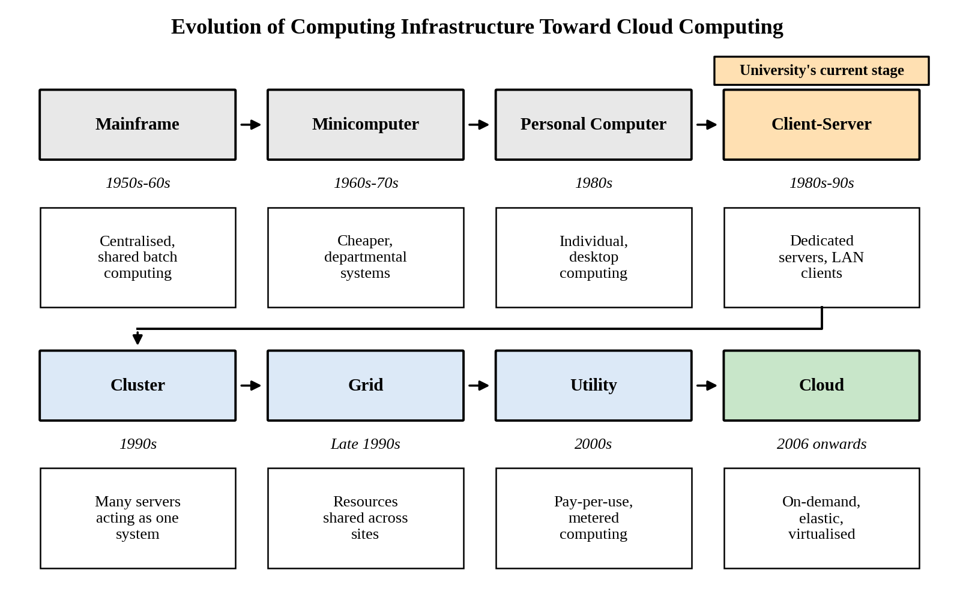
Figure 1: Timeline of the evolution of computing infrastructure from mainframes to cloud computing
2.2 How Each Stage Solved a Limitation of the Previous Stage
Table 4: Stages of evolution, their key idea and the limitation each resolved
Stage | Period | Key idea | Limitation that led to the next stage
Mainframe | 1950s–60s | Large centralised computer shared by many users through terminals. | Extremely expensive; access limited to a few organisations.
Minicomputer | 1960s–70s | Smaller, cheaper machines for departments. | Still costly and isolated; no personal access.
Personal computer | 1980s | Low-cost computer for each individual. | Data and software scattered on individual machines; difficult to share and manage.
Client–server | 1980s–90s | Central servers share data and applications with PCs over a LAN. | One server per application; low utilisation; scaling means buying more hardware.
Cluster | 1990s | Many commodity servers linked to work as one system. | Limited to one organisation or site; resources not shared across sites.
Grid | Late 1990s | Resources from different sites shared for large tasks. | Complex middleware; no simple access or billing model.
Utility computing | 2000s | Computing sold as a metered service, like electricity. | Lacked flexible automation and resource abstraction.
Cloud computing | 2006 onwards | Virtualised, self-service, elastic resources delivered over the internet. | Current model; needs governance for cost, privacy and lock-in.

2.3 Hardware Evolution that Enabled the Cloud
Table 5: Hardware developments and their contribution to cloud computing
Hardware development | Contribution to cloud computing | Relevance to the university
Multi-core processors | More computing power per server and hardware support for virtualisation (Intel VT-x, AMD-V), allowing many virtual machines on one host. | Many applications can share a few modern hosts.
Commodity servers | Low-cost standard servers allow providers to scale out cheaply and tolerate failures through software. | Cloud capacity is cheaper than buying specialised servers.
High-capacity storage | Large, low-cost disks and SSDs, with distributed and object storage, make storing huge data volumes practical. | Records, e-content and backups can be stored economically.
High-speed networking | Gigabit to 100 Gb Ethernet and broadband internet make remote access and fast data movement feasible. | Students and colleges can use services remotely.
Data centres | Large facilities with automated power, cooling and management provide economies of scale, zones and regions. | Multi-zone and multi-region design is possible without building a data centre.

2.4 Stage Corresponding to the University’s Current System
The university’s current system corresponds to the client–server stage (with dedicated, physical servers). The reasons are:
- Each application has its own dedicated physical server, which is the typical client–server model, and no virtualisation is used.
- All servers are in a single on-premise data centre, with capacity fixed by purchases (6–8 weeks per server), so there is no elasticity.
- Utilisation is low (about 15%) because capacity is sized for peaks, while the servers still fail during peaks.
- Applications are monolithic and have no public interfaces, so there is no service-oriented design, and there is no disaster-recovery site.

TASK 3 – Analyse Internet Software Evolution
3.1 Evolution of Internet Software
Table 6: Stages in the evolution of internet software
Stage | Description | Contribution to cloud services
Static web pages (Web 1.0) | Fixed HTML pages served from a web server; read-only for users. | Established the browser, URL and HTTP as universal access tools.
Dynamic web | Pages generated at request time using server-side programs and databases (CGI, PHP, JSP, ASP). | Allowed real applications such as online admissions and results.
Web 2.0 | Interactive, user-driven web using AJAX, rich browser interfaces and user-generated content. | Web applications began to feel like desktop software.
Service-oriented architecture (SOA) | Applications built as loosely coupled services with published interfaces (SOAP, WSDL, REST). | Reusable services; the basis for web services and SaaS.
Mashups | New applications created by combining data and services from several APIs. | Showed the value of open APIs and integration.
Cloud-hosted applications | Applications delivered as scalable services (SaaS and PaaS) from provider data centres. | Elastic, pay-per-use software accessed through a browser or app.

3.2 Role of Browsers, HTTP, AJAX and APIs
- Browsers act as the universal client, so users need no installation; the same application runs on any device.
- HTTP/HTTPS is the standard request–response protocol that carries web pages and service calls securely across the internet.
- AJAX allows a page to exchange data with the server in the background without reloading, giving responsive applications.
- APIs (REST/SOAP) expose application functions as services so that mobile apps, partner colleges and other systems can use them.

3.3 Comparison of Desktop, Client–Server and Web-Delivered Software
Table 7: Comparison of software delivery models
Aspect | Desktop software | Client–server software | Web-delivered software
Installation | On every computer | Client installed on each PC; server in data centre | None; runs in a browser or app
Updates | Manual, per machine | Server update plus client updates | Central, instant for all users
Access | Only on the installed device | Mainly within the LAN / VPN | Anywhere with internet
Scalability | Not applicable | Limited by server hardware | Elastic through cloud resources
Maintenance effort | High (many devices) | Medium to high | Low for users, central for provider
Cost model | One-time licence | Hardware plus licence (CapEx) | Subscription or pay-per-use (OpEx)

3.4 Effect on the Design of the University’s Applications
- The large monolithic programs should be decomposed into modular services (for example results, fees, library search) that can be scaled independently.
- The web tier should be stateless so that more instances can be added or removed quickly by auto-scaling.
- Functions should be exposed as REST APIs, enabling the mobile app and partner colleges without rebuilding the applications.
- Access should be through browsers and mobile apps with single sign-on, removing client installation across the 4 campuses.
- Some applications (email, LMS, library) can be replaced by ready-made web-delivered software instead of being maintained in-house.

TASK 4 – Apply Server Virtualization
4.1 How a Hypervisor Works
A hypervisor (virtual machine monitor) is a software layer that abstracts the physical hardware (CPU, memory, storage and network) and divides it among several isolated virtual machines (VMs). Each VM has its own virtual hardware and guest operating system, and believes it is running on a dedicated server. The hypervisor schedules CPU time, allocates memory, mediates access to devices and keeps the VMs isolated from each other. With hardware-assisted virtualisation, most guest instructions run directly on the CPU, which gives near-native performance.
4.2 Type-1 and Type-2 Hypervisors
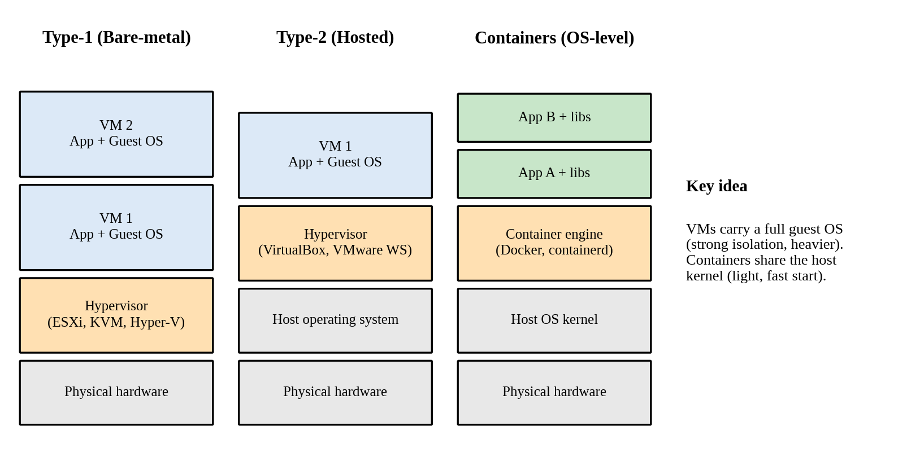
Figure 2: Type-1 hypervisor, Type-2 hypervisor and container architecture compared
Table 8: Type-1 and Type-2 hypervisors
Feature | Type-1 (bare-metal) | Type-2 (hosted)
Runs on | Directly on physical hardware | On top of a host operating system
Performance | High, with low overhead | Lower, because of the extra OS layer
Typical use | Data centres and production servers | Desktops, testing and learning
Examples | VMware ESXi, Microsoft Hyper-V, KVM, Xen | Oracle VirtualBox, VMware Workstation

4.3 Comparison of Virtualization Techniques
Table 9: Full, para-, OS-level and hardware-assisted virtualization
Technique | How it works | Advantages | Limitations
Full virtualization | Hypervisor emulates complete hardware; unmodified guest OS runs. | Runs any OS; strong isolation. | Some overhead without hardware support.
Para-virtualization | Guest OS is modified to make hypercalls to the hypervisor. | Better performance than software-emulated full virtualization. | Needs a modified guest OS.
OS-level (containers) | Containers share the host kernel with isolated processes (Docker, LXC). | Very light, fast start, high density. | Same kernel for all; weaker isolation than VMs.
Hardware-assisted | CPU extensions (Intel VT-x, AMD-V) support virtualization directly. | Near-native speed; simplifies the hypervisor. | Requires supporting hardware.

4.4 Applications as Virtual Machines and as Containers
Table 10: Proposed placement of university applications
Component | Run as | Reason
SIS database and Exam Portal server | Virtual machine | Stateful systems that need strong isolation, a dedicated OS configuration and predictable performance.
Email server (during migration) | Virtual machine | Long-running service with a fixed identity; later replaced by SaaS (Task 6).
SIS web/application tier | Container | Stateless tier that must scale quickly during admissions.
LMS and Library web front-ends | Container | Light, standard web stacks that start quickly and use fewer resources.
REST API services (results, fees, library search) | Container | Small independent services that can be updated and scaled separately.

4.5 Consolidation Calculation
Assumptions: (a) the 12 physical servers have equal capacity, taken as 1 server-unit each; (b) average CPU utilisation is 15%; (c) the target host utilisation is 70%; (d) each new virtualisation host has the same capacity as one old server (a conservative assumption, since modern hosts are more powerful); (e) the 12 servers are shared as SIS 3, LMS 3, Exam Portal 3, Email 2 and Library 1; (f) at peak, only one application area peaks at a time (admissions, results or exams) and its servers reach 95%.
Table 11: Worked consolidation calculation
Step | Working | Result
1. Average workload | 12 servers × 15% = 12 × 0.15 | 1.8 server-units
2. Hosts for average load | 1.8 ÷ 0.70 = 2.57, rounded up | 3 hosts
3. Add one spare host (N+1) for failure and maintenance | 3 + 1 | 4 hosts
4. Peak workload (one application area peaking) | 3 servers × 95% + 9 servers × 15% = 2.85 + 1.35 | 4.20 server-units
5. Hosts for peak load | 4.20 ÷ 0.70 = 6.0 | 6 hosts (7 with N+1)
6. Reduction in physical servers (baseline) | (12 − 4) ÷ 12 = 8 ÷ 12 | 66.7% fewer servers

Conclusion: the 12 physical servers can be consolidated onto about 3 hosts for the average load, or 4 hosts with a spare. Since peak demand needs about 6–7 hosts, the recommended plan is to keep 4 hosts as the baseline and use cloud elasticity for the peak weeks, rather than buying 7 hosts that are idle for most of the year.
Peak-load caution: the calculation is based on CPU only. Memory, storage IOPS and network bandwidth must also be measured, and the plan should be validated by a load test before servers are retired.
4.6 Benefits and Risks of Virtualization
Table 12: Benefits and risks of virtualization
Item | Explanation | Mitigation / use for the university
Live migration (benefit) | A running VM moves to another host without downtime. | Allows host maintenance during working hours without stopping the LMS.
Snapshots (benefit) | A point-in-time copy of a VM’s state. | Quick rollback before upgrading the SIS or exam software.
Resource over-commitment (benefit) | Allocating more virtual CPU/memory than physical capacity, because VMs rarely peak together. | Raises density, but must be limited and monitored.
Noisy neighbour (risk) | One VM consuming resources and slowing others. | Resource limits, reservations and separate hosts for the Exam Portal.
Hypervisor failure (risk) | A host failure stops all its VMs. | Clustering, N+1 spare host, high-availability restart.
Security isolation (risk) | A flaw could allow access across VMs (VM escape). | Patch the hypervisor, network segmentation, separate sensitive systems.

TASK 5 – Apply Web Services
5.1 Overview of Web Services
A web service is a software function made available over a network using standard protocols so that different applications can communicate regardless of platform or language. Web services are the building blocks of service-oriented architecture (SOA) and cloud computing: they allow the university’s applications to be exposed as reusable services that a mobile app, an affiliated college or a payment gateway can call securely over HTTP.
5.2 SOAP, WSDL, UDDI and REST Compared
Table 13: Web service technologies compared
Technology | Purpose | Format / protocol | Remarks
SOAP | Messaging protocol for exchanging structured information. | XML envelope over HTTP, SMTP, etc. | Strict, supports WS-Security and transactions; heavier.
WSDL | Describes a SOAP service: operations, messages, endpoints. | XML | Machine-readable contract for client generation.
UDDI | Registry to publish and discover services. | XML, SOAP-based | Rarely used today; replaced by API catalogues.
REST | Architectural style using resources and standard HTTP methods (GET, POST, PUT, DELETE). | JSON (or XML) over HTTP | Light, fast, cacheable; suitable for mobile and web.

5.3 University Functions Exposed as Web Services
Table 14: Defined web services
Function | Endpoint | Method | Request | Response
Result lookup | /api/v1/results/{reg_no} | GET | Register number in the URL | 200 with JSON record; 404 if not found
Fee payment | /api/v1/fees/pay | POST | JSON body with register number and amount | 201 with transaction id; 400 if invalid
Library search | /api/v1/library/books | GET | Query string: title (and optional author) | 200 with JSON list of books

Service 1 – Result lookup: sample request and response
GET /api/v1/results/21CS001 HTTP/1.1
Host: api.university.edu
Accept: application/json

HTTP/1.1 200 OK
Content-Type: application/json

{"register_number": "21CS001", "name": "Arun Kumar", "semester": 5, "gpa": 8.7, "status": "PASS"}

Service 2 – Fee payment: sample request and response
POST /api/v1/fees/pay HTTP/1.1
Host: api.university.edu
Content-Type: application/json
Authorization: Bearer <token>
{"register_number": "21CS001", "amount": 45000}
HTTP/1.1 201 Created
Content-Type: application/json
{"transaction_id": "TXN01001", "status": "SUCCESS", "amount": 45000}

Service 3 – Library search: sample request and response
GET /api/v1/library/books?title=cloud HTTP/1.1
Host: api.university.edu
Accept: application/json

HTTP/1.1 200 OK
Content-Type: application/json

{"count": 2, "books": [{"id": 101, "title": "Cloud Computing Basics", "available": true},
{"id": 118, "title": "Cloud Security", "available": false}]}
5.4 SOAP or REST – Justification for Each Function
Table 15: Choice of SOAP or REST
Function | Choice | Justification
Result lookup | REST | Read-only, high-volume and cacheable; small JSON responses suit mobile apps and affiliated colleges.
Fee payment | REST (public API); SOAP only for a legacy bank gateway | Mobile and college clients need a light API over HTTPS with OAuth2 tokens and idempotency keys. SOAP with WS-Security is justified only where a bank gateway requires a formal contract.
Library search | REST | Simple query using GET; fast and cacheable; no need for SOAP’s overhead.

TASK 6 – Analyse the Service Models: IaaS, PaaS and SaaS
6.1 Definitions and Layer-wise Responsibility
- IaaS (Infrastructure as a Service): the provider supplies virtualised computing, storage and networking; the customer installs and manages the operating system, middleware and applications.
- PaaS (Platform as a Service): the provider supplies the runtime, middleware and operating system as a managed platform; the customer manages only the application and its data.
- SaaS (Software as a Service): the provider delivers a complete application over the internet; the customer only uses and configures it.

Table 16: Who manages which layer in each model (C = Customer, P = Provider)
Layer | On-premise | IaaS | PaaS | SaaS
Application | C | C | C | P
Data | C | C | C | C (content only)
Runtime and middleware | C | C | P | P
Operating system | C | C | P | P
Virtualization | C | P | P | P
Servers | C | P | P | P
Storage | C | P | P | P
Networking | C | P | P | P

6.2 Categorisation of the Five Applications
Table 17: Mapping of university applications to service models
Application | Service model | Main reason
Student Information System (SIS) | PaaS | Custom application with heavy admission peaks; needs managed runtime, auto-scaling and DBaaS but not OS management.
Learning Management System (LMS) | SaaS | Standard product (such as Moodle cloud or Google Classroom); no need to maintain code or servers.
Library System | SaaS | Low-complexity, standard functions; a hosted library system removes maintenance.
Exam Portal | IaaS | Needs control over OS, proctoring software and scaling rules for exam weeks.
Email | SaaS | Commodity service with high reliability, security and spam filtering offered by providers.

Reasoning behind each decision:
- SIS → PaaS. The SIS is a custom application whose load rises sharply during admissions. A PaaS lets developers deploy code while the provider handles the OS, patching, runtime and auto-scaling, and it can use a managed database. IaaS would leave the university managing servers again, and SaaS would not fit the university’s own business rules. Vendor lock-in is the main trade-off, which is reduced by using standard languages and containers.
- LMS → SaaS. Teaching and learning needs are common to most universities, so a mature SaaS product gives features, updates and scalability at lower effort than building one. The trade-off is limited customisation and dependence on the vendor.
- Library → SaaS. Cataloguing and circulation are standard processes with modest load, so there is little value in running its own servers; a hosted service lowers cost and administration.
- Exam Portal → IaaS. Online exams need special proctoring tools, strict timing and tuned scaling rules, so the team requires control over the operating system and network. IaaS provides this with auto-scaling groups and load balancers, with the extra responsibility of patching and security configuration.
- Email → SaaS. Running mail servers brings security, spam and availability problems. A SaaS email service gives high availability, storage and security with a predictable per-user cost.

6.3 Comparison of the Models
Table 18: Comparison of IaaS, PaaS and SaaS
Criterion | IaaS | PaaS | SaaS
Control | High (OS and above) | Medium (application and data) | Low (configuration only)
Cost | Pay for resources; staff cost remains | Moderate; lower operations cost | Subscription per user; lowest operations cost
Scalability | Manual or auto-scaling configured by customer | Automatic, managed by platform | Automatic, managed by vendor
Maintenance effort | High | Medium (code only) | Very low
Vendor lock-in | Low to medium | Medium to high | High (data export may be limited)

6.4 Real Provider Examples
- IaaS: Amazon EC2 or Microsoft Azure Virtual Machines.
- PaaS: Microsoft Azure App Service or Google App Engine.
- SaaS: Google Workspace or Microsoft 365.

TASK 7 – Examine XaaS
7.1 XaaS and its Variants
XaaS (Anything as a Service) is the general term for delivering any IT capability as a subscription or pay-per-use service from the cloud, extending beyond IaaS, PaaS and SaaS. It lets the university consume only specialised functions instead of building and operating them.
Table 19: Six XaaS variants and possible use in the university
Variant | Description | Possible use in the university
DaaS (Desktop as a Service) | Virtual desktops delivered from the cloud. | Virtual computer labs accessible from student devices.
MBaaS (Mobile Backend as a Service) | Ready-made backend (authentication, push notifications, data sync) for mobile apps. | Backend for the planned university mobile app.
FaaS (Function as a Service) | Event-driven code that runs without managing servers. | Result-published notifications and receipt generation.
DBaaS (Database as a Service) | Managed database with backup, patching and replication. | Student-record and fee database.
Security as a Service | Cloud-delivered security such as firewalls, WAF and monitoring. | Protection of public APIs and the portal.
DRaaS (Disaster Recovery as a Service) | Replication and recovery of systems in a provider’s cloud. | Disaster recovery for the university, which currently has none.

7.2 Two Selected Offerings and Justification
- DBaaS: the student, fee and exam data is the most critical asset. A managed database provides automated backups, patching, point-in-time recovery, multi-zone replication and scaling of storage, so the small IT team need not administer database servers. This addresses availability and manageability.
- DRaaS: the university has no disaster-recovery site, and building a second data centre would be costly. DRaaS replicates the key systems to a secondary region and charges mainly for storage until a failover is needed, so it improves availability at low cost (pay-per-use).

7.3 Risks of Over-reliance on Many ‘as-a-Service’ Providers
- Compounded lock-in: using several proprietary services makes switching providers costly and slow.
- Availability dependence: the solution is only as available as the weakest provider; an outage in one service may cascade to others.
- Integration complexity: many interfaces and contracts increase effort for monitoring, billing and troubleshooting.
- Data privacy and compliance: data is spread across providers and locations, making governance harder.
- Cost sprawl: many small subscriptions can grow beyond budget without central control.
- Mitigation: use open standards (containers, SQL, OpenAPI), a limited set of providers, documented exit plans, clear SLAs and central cost monitoring.
TASK 8 – Design the Cloud Solution Architecture
8.1 Architecture Diagram
The proposed architecture combines virtualization, web services and a mix of service models. Users and affiliated colleges reach the system through DNS, CDN and a web application firewall, then a load balancer and an API gateway. The application tier runs in two availability zones, the data tier uses a managed database with a standby replica, and a second region provides disaster recovery.
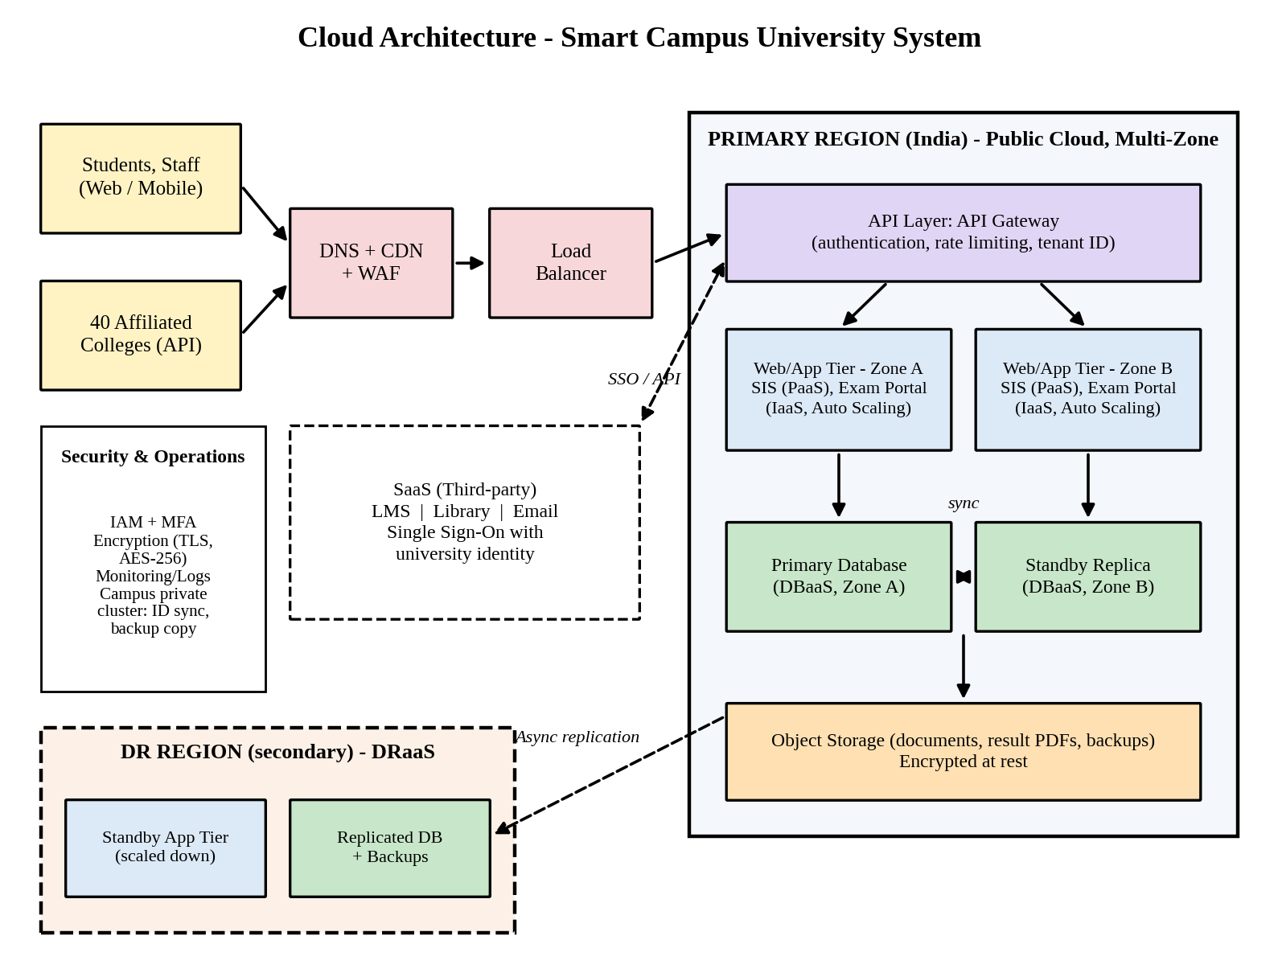
Figure 3: Proposed cloud architecture for the Smart Campus University system
8.2 Deployment and Service Model for Each Component
Table 20: Component-wise deployment model, service model and justification
Component | Deployment model | Service model | Justification
Users, DNS, CDN and WAF | Public | Security/Network as a Service | Global caching and protection against attacks, with no hardware to manage.
Load balancer | Public | IaaS (managed service) | Distributes traffic across zones and instances for availability.
API layer (API gateway) | Public | PaaS | Central authentication, rate limiting and tenant identification for web, mobile and college clients.
SIS web/application tier | Public | PaaS (containers/VMs) | Auto-scaling for admissions; no OS maintenance.
Exam Portal tier | Public | IaaS (auto-scaling VMs) | Control over OS and proctoring tools with scheduled scale-out for exams.
Database tier | Public (India region) | DBaaS | Managed backups, patching and multi-zone replication.
Storage | Public | IaaS (object storage) | Durable, low-cost storage for documents, result files and backups.
LMS, Library, Email | Public | SaaS | No servers or code to maintain; vendor-managed scaling.
Identity sync and backup copy | Private (campus cluster) | IaaS (private VMs) | Keeps control of identity data and a local copy during migration.
DR region | Public (second region) | DRaaS | Warm standby; recovery without a second data centre.

8.3 Elasticity (Auto-scaling) for Admissions and Exam Peaks
- Metric-based scaling: add instances when average CPU stays above 60% for 3 minutes, and remove them after a cool-down period when it falls below 30%.
- Scheduled scaling: increase the minimum instance count before known events (admissions, result publication and exam weeks), so capacity is ready before users arrive.
- Limits: minimum of 2 instances (one in each zone) and a maximum cap to control cost.
- Load smoothing: CDN and caching for static and frequently read content, and queues for fee-payment requests.
- Scale-in after the peak returns the cost to the low off-peak level.

8.4 Security and Availability Measures
- Access control: role-based access, multi-factor authentication for administrators, single sign-on, least-privilege policies.
- Encryption: TLS for data in transit and AES-256 for data at rest, with managed key storage.
- Network protection: web application firewall, private subnets for the database, security groups, and API rate limiting.
- Backup: daily automated snapshots with 30-day retention and tested restores.
- Availability: deployment across two availability zones, health checks and automatic failover for the database.
- Disaster recovery: asynchronous replication to a second region with targets of RPO 15 minutes and RTO 1 hour.

Sizing assumption: the host numbers from Task 4 (4 baseline hosts plus cloud elasticity) are used as the starting capacity and must be validated by load testing.
TASK 9 – Hands-on Implementation and Documentation
9.1 Objective and Environment
A small proof-of-concept (PoC) was built for one university function: a REST API providing result lookup and fee payment. The API is a Python Flask application served by gunicorn, and it was tested using the curl client. The screenshots in this section are captures of the actual terminal sessions from this run.
Table 21: Environment details
Item | Details
Operating system | Ubuntu 24 (Linux) lab environment
Language and framework | Python 3.12.3, Flask 3.1.3
Application server | gunicorn 26.2.0 (the same server used in the Dockerfile)
Test client | curl (command line)
Date of execution | 31 October 2026
Docker / cloud account | Docker daemon and a cloud account were not available in this environment (see 9.5)

9.2 Source Code
File: app.py
from flask import Flask, jsonify, request

app = Flask(__name__)

RESULTS = {
"21CS001": {"name": "Arun Kumar", "semester": 5, "gpa": 8.7, "status": "PASS"},
"21CS002": {"name": "Divya Rani", "semester": 5, "gpa": 9.1, "status": "PASS"},
}
FEES = {}

@app.route("/health")
def health():
return jsonify({"service": "university-api", "status": "UP"}), 200

@app.route("/api/v1/results/<reg_no>", methods=["GET"])
def get_result(reg_no):
rec = RESULTS.get(reg_no.upper())
if rec is None:
return jsonify({"error": "Student not found", "register_number": reg_no}), 404
return jsonify({"register_number": reg_no.upper(), **rec}), 200

@app.route("/api/v1/fees/pay", methods=["POST"])
def pay_fee():
data = request.get_json(silent=True) or {}
if "register_number" not in data or "amount" not in data:
return jsonify({"error": "register_number and amount are required"}), 400
txn = "TXN%05d" % (len(FEES) + 1001)
FEES[txn] = data
return jsonify({"transaction_id": txn, "status": "SUCCESS", "amount": data["amount"]}), 201

if __name__ == "__main__":
app.run(host="0.0.0.0", port=5000)

File: requirements.txt
flask>=3.0
gunicorn>=22.0

File: Dockerfile
FROM python:3.11-slim
WORKDIR /app
COPY requirements.txt .
RUN pip install --no-cache-dir -r requirements.txt
COPY app.py .
EXPOSE 5000
CMD ["gunicorn", "-b", "0.0.0.0:5000", "app:app"]

9.3 Configuration Steps (Reproducible)
Table 22: Steps to build, run and deploy the proof-of-concept
Step | Action | Command / detail
1 | Create the project folder and add app.py, requirements.txt and Dockerfile | mkdir poc && cd poc
2 | Install dependencies | pip install -r requirements.txt
3 | Run the API with the production server (executed in this PoC) | gunicorn -b 0.0.0.0:5000 app:app
4 | Test the web service with a client (executed in this PoC) | curl -i http://localhost:5000/health
5 | Build the container image (procedure, requires Docker) | docker build -t university-api .
6 | Run the container (procedure, requires Docker) | docker run -d -p 5000:5000 university-api
7 | Deploy to a PaaS (procedure, requires a cloud account): create a Web App (Azure App Service or Render), connect the repository or the container image, set the start command to the gunicorn command, and open the public URL | Test with curl using the public URL

9.4 Test Results and Screenshots
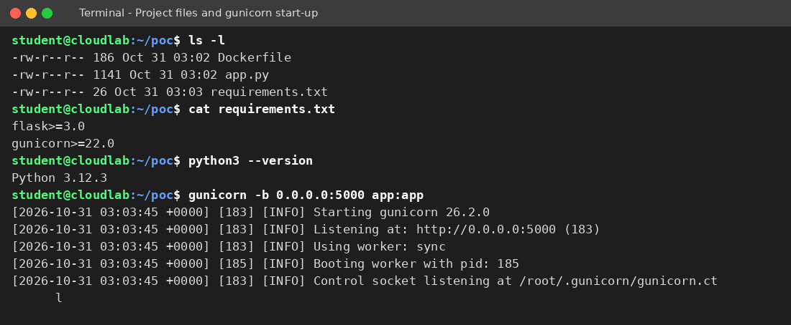
Figure 4 shows the project files, the Python version and the gunicorn server starting. Figures 5 and 6 show the web service being tested with curl.
Figure 4: Project files and gunicorn server start-up
Annotations:
- The three project files (app.py, Dockerfile and requirements.txt) are present.
- gunicorn starts and listens on 0.0.0.0:5000 with a worker process booted.

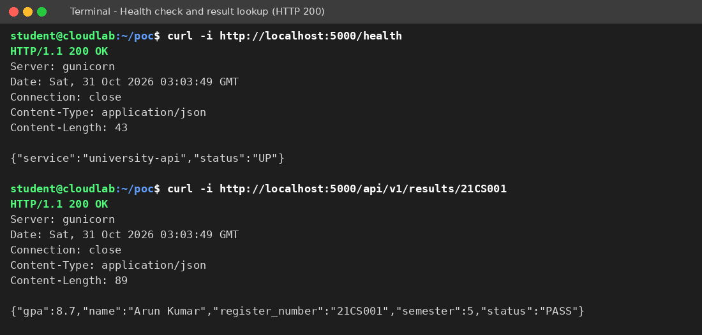
Figure 5: Health check and result lookup returning HTTP 200
Annotations:
- /health returns HTTP 200 with the status UP.
- GET /api/v1/results/21CS001 returns HTTP 200 and the JSON record of the student.
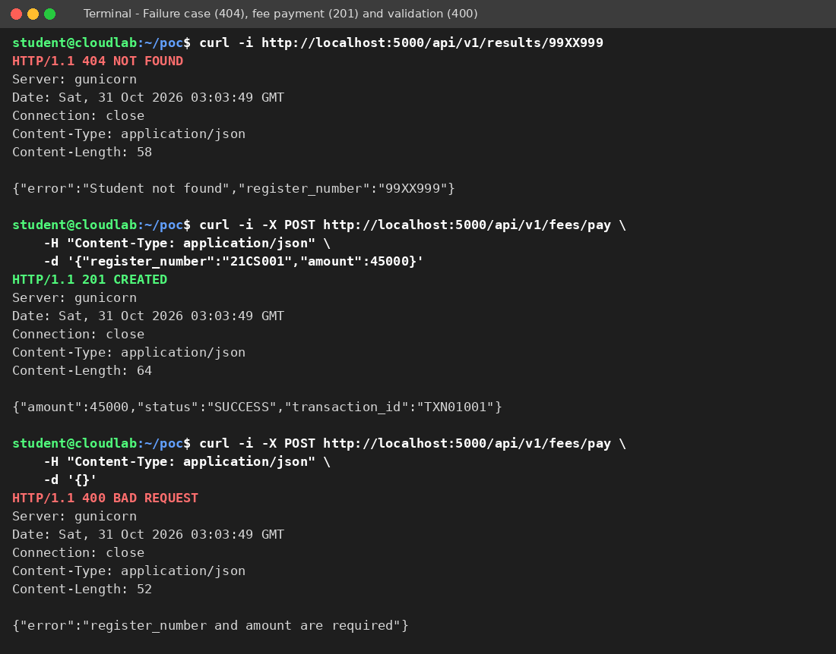Figure 6: Failure case (404), fee payment (201) and input validation (400)
Annotations:
- An unknown register number returns HTTP 404 with an error message (failure case).
- POST to /api/v1/fees/pay returns HTTP 201 with transaction id TXN01001.
- A POST with an empty body returns HTTP 400, showing input validation.

Table 23: Summary of test cases
Test | Request | Expected | Actual | Result
Health check | GET /health | 200, status UP | 200, status UP | Pass
Functional test | GET /api/v1/results/21CS001 | 200, JSON record | 200, JSON record | Pass
Failure case | GET /api/v1/results/99XX999 | 404, error JSON | 404, error JSON | Pass
Fee payment | POST /api/v1/fees/pay (valid body) | 201, transaction id | 201, TXN01001 | Pass
Validation | POST /api/v1/fees/pay (empty body) | 400, error JSON | 400, error JSON | Pass

9.5 Issues Faced and Limitations
- Docker not available: the Docker daemon could not be used in this environment, so the image build and container run (steps 5 and 6) are documented as a procedure but are not shown with screenshots. The same application and the same gunicorn command (used in the Dockerfile CMD) were executed directly instead.
- No cloud account: the PaaS/SaaS deployment (step 7) is documented but was not executed here. Screenshots of the cloud console must be added after performing it on a real account.
- Development server warning: Flask’s built-in server shows a warning that it is not for production, so gunicorn was used.
- Data is in memory: the PoC stores sample data in memory and is not a production database; in the final design this is replaced by DBaaS.
TASK 10 – Evaluate and Recommend the Final Solution
10.1 Comparison of the Three Options
Table 24: On-premise, IaaS-based and PaaS/SaaS-based options compared
Criterion | On-premise (refresh) | IaaS-based | PaaS/SaaS-based
Cost model | High CapEx, then maintenance | OpEx, pay-per-use, with some staff cost | OpEx, subscriptions, lowest operations cost
Scalability | Fixed; peaks need extra hardware | Good, if auto-scaling is configured | Very good, managed by platform/vendor
Availability | Single site; DR needs a second site | Multi-zone and DR possible | High, with provider SLAs and built-in redundancy
Security | Full control, but self-managed | Shared responsibility; customer secures OS and above | Provider secures platform; customer secures data and access
Effort | Highest (hardware, OS, applications) | High (OS and middleware) | Lowest (code and configuration)

10.2 Three-Year Cost Estimate
Assumptions (illustrative, in ₹ lakh; 1 lakh = 100,000):
- On-premise: CapEx for refreshing 12 servers ₹36 lakh and building a DR site ₹15 lakh; yearly operating cost of ₹27.6 lakh (power, space and cooling ₹6 lakh; 3 administrators ₹18 lakh; maintenance contracts ₹3.6 lakh).
- IaaS-based: no CapEx; yearly cost ₹36 lakh (compute and storage ₹20 lakh; DR ₹4 lakh; 2 administrators ₹12 lakh); one-time migration cost ₹6 lakh.
- PaaS/SaaS-based (with the Exam Portal on IaaS): yearly cost ₹33 lakh (SaaS for LMS, Library and Email ₹12 lakh; PaaS for SIS ₹8 lakh; IaaS for the Exam Portal ₹4 lakh; DRaaS ₹2 lakh; 1 administrator ₹6 lakh; training ₹1 lakh); one-time migration and re-architecture cost ₹9 lakh.

Table 25: Three-year cost comparison (₹ lakh)
Option | Year 1 | Year 2 | Year 3 | 3-year total
On-premise | 36 + 15 + 27.6 = 78.6 | 27.6 | 27.6 | 133.8
IaaS-based | 6 + 36 = 42 | 36 | 36 | 114.0
PaaS/SaaS-based | 9 + 33 = 42 | 33 | 33 | 108.0

The PaaS/SaaS-based option is cheapest: ₹133.8 − ₹108.0 = ₹25.8 lakh lower than on-premise (about 19.3% saving) and ₹6 lakh lower than the IaaS-based option, while also giving better scalability and disaster recovery.
10.3 Main Risks and Mitigation
Table 26: Risk analysis
Risk | Description | Mitigation steps
Vendor lock-in | Dependence on one provider’s proprietary services. | Use containers, standard languages and SQL databases; keep exportable backups; document an exit plan.
Data privacy | Student and fee data stored outside the campus. | Choose an Indian region; encrypt data; role-based access; contracts defining data ownership.
Downtime | Provider or network outage during critical events. | Multi-zone deployment, DR region, redundant internet links, SLA monitoring, and failover drills.
Skills gap | Staff are used to physical servers. | Training and certification, a phased migration, and support from the provider or a partner.
Cost overrun | Uncontrolled scaling or unused resources. | Budgets and alerts, scaling caps, regular cost reviews.

10.4 Final Recommendation and Migration Roadmap
Recommendation: adopt a PaaS/SaaS-led hybrid cloud in which LMS, Library and Email use SaaS, the SIS uses PaaS with DBaaS, the Exam Portal runs on auto-scaled IaaS, and DRaaS provides disaster recovery, as designed in Tasks 6 to 8. This option has the lowest three-year cost, solves the peak-load and disaster-recovery problems, and reduces administration. It is chosen on the basis of the analysis above and not because of the popularity of a provider; any provider that offers an Indian region, suitable SLAs and exportable data can be selected after a short comparison.
Table 27: Phased migration roadmap
Phase | Timeline | Activity | Reason
0 | Weeks 1–4 | Assessment, cloud account and security set-up, network link, staff training. | Foundation and risk reduction.
1 | Month 2 | Email moves first to SaaS. | Lowest risk, no custom code, immediate benefit, and frees servers.
2 | Months 3–4 | LMS and Library move to SaaS; single sign-on is enabled. | Standard products with easy data migration.
3 | Months 5–7 | SIS moves to PaaS with DBaaS; APIs are introduced. | Highest complexity; completed before the next admissions season.
4 | Months 8–9 | Exam Portal moves to auto-scaled IaaS; load test before the exam season. | Needs the most testing for peak load.
5 | Month 10 | DR drill, decommissioning of old servers, cost review. | Confirms availability and realises savings.

TASK 11 – Re-evaluate and Adapt the Design
Decision: MODIFY. The original solution is modified and not completely redesigned. The cloud foundation (hybrid public cloud, SaaS for LMS/Library/Email, DBaaS, DRaaS) remains valid, but the application and data tiers must be changed to handle 10 times the load, 99.9% availability and 40 tenants within a limited budget.
11.1 Impact Analysis
Table 28: Effect of the changed requirements on the original assumptions
Aspect | Original assumption | Changed requirement | Effect on the design
Load | Current peak of the 4 campuses | 10 times the current peak | Capacity planning and auto-scaling limits must be revised.
Users | About 25,000 students and 2,000 staff | Plus 40 affiliated colleges and mobile app users (assumed about 1,500 students per college, or 60,000 more) | Larger, more varied user base with continuous use.
Availability | No strict target; single region | 99.9% (about 8.76 hours of downtime per year) | Multi-zone design and automatic failover are needed.
Cost | Moderate budget | Limited operating budget | Cost must scale with demand; no always-on peak capacity.

- What has changed: the system was an internal campus system; it now becomes a shared service platform used by external institutions and mobile clients.
- Why web services and APIs become critical: the 40 colleges and the mobile app cannot use the internal screens; they must call student-record and fee-payment services through secure, versioned, rate-limited APIs. The API layer is now the main entry point and must be scalable, authenticated and monitored.
- Effect of multi-tenant access on security and isolation: one college must never see another college’s data. This requires a tenant identifier in every request, authorization per tenant, separate data schemas, per-tenant encryption keys, rate limiting to prevent one tenant affecting others, and audit logs.
11.2 Evaluation of the Original Design
Service models and virtualization at 10× load: SaaS components (LMS, Library, Email) scale at the vendor and can continue. The SIS (PaaS) and the Exam Portal (IaaS) scale in coarse units (whole VMs or plans), and a monolithic VM-based design would scale inefficiently and need large idle capacity. This part is not sufficient without change.
- Auto-scaling and single region versus 99.9%: auto-scaling helps load but not zone or region failures. A single-zone deployment is assumed to have 99.5% availability, which allows 0.5% × 8,760 = 43.8 hours of downtime per year and fails the requirement of 8.76 hours. The original two-zone design with DRaaS is a good base, but the database and API layers need explicit multi-zone failover.
- Cost under the new load: if the original design is simply enlarged, coarse scaling units raise the average compute cost about four times (see 11.4), so the cost becomes not acceptable for a limited budget.
- Better service model or XaaS: containers on managed orchestration, serverless (FaaS) for notifications and receipts, a caching layer and message queue, and Security as a Service (WAF) give better results than only adding VMs.

11.3 Adaptation or Redesign
Decision: modify the design. The revised architecture is shown in Figure 7.
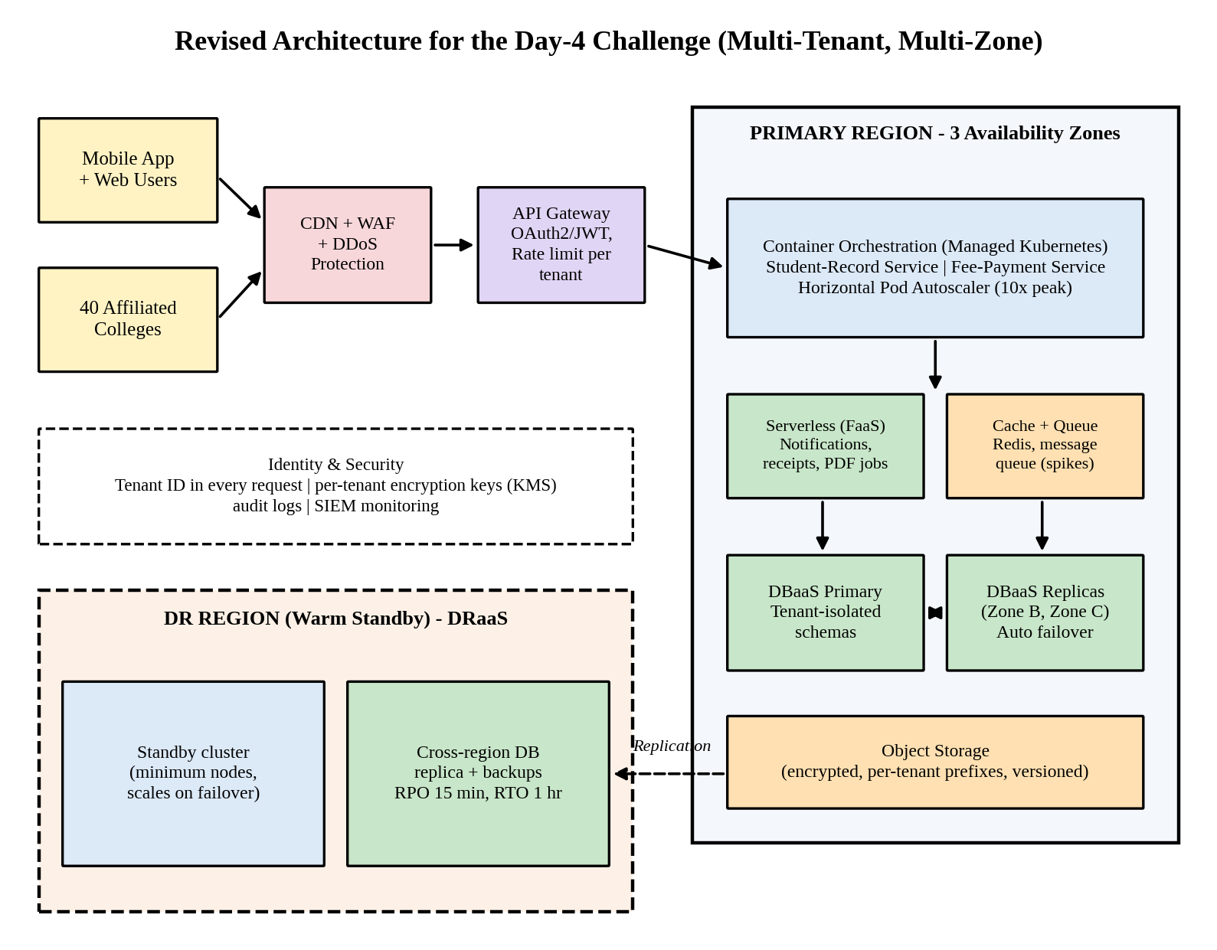
Figure 7: Revised multi-tenant, multi-zone architecture for the Day-4 challenge
- API gateway with OAuth2/JWT authentication, tenant identification, throttling and API versioning for the mobile app and the 40 colleges.
- Container orchestration (managed Kubernetes) for the student-record and fee-payment services, with horizontal auto-scaling.
- Serverless (FaaS) for notifications, receipts and report generation, and a cache and message queue to absorb spikes and protect the database.
- Multi-zone deployment across three availability zones, and a DBaaS with replicas in other zones and automatic failover.
- DRaaS warm standby in a second region with targets of RPO 15 minutes and RTO 1 hour.
- Hybrid element retained: the campus private cluster is kept for identity synchronisation and a backup copy.

Table 29: Changes in the service model mix and virtualization approach
Area | Original design | Revised design
SIS and student-record | PaaS web app on VMs | Containerised services (PaaS/CaaS) behind an API gateway
Fee payment | Part of the SIS | Separate scalable service, with a queue and idempotent requests
Notifications and receipts | Part of the application | FaaS (serverless)
Database | DBaaS, two zones | DBaaS multi-zone with replicas and caching
Security | Basic WAF and IAM | Security as a Service, tenant isolation and per-tenant keys
Virtualization approach | VM-centred | Container-centred; VMs used as worker nodes and for the Exam Portal
LMS, Library, Email | SaaS | No change (SaaS)

11.4 Evidence-Based Defence
(a) Capacity calculation. From Task 4 the stress-peak demand of the current system is 4.20 server-units.
Table 30: Capacity estimate for 10× peak load
Step | Working | Result
1. Peak demand at 10× | 4.20 × 10 | 42 server-units
2. After CDN and cache offload (assume 40% of the load removed) | 42 × 0.60 | 25.2 server-units
3. Hosts at 70% target utilisation | 25.2 ÷ 0.70 | 36 host-equivalents
4. Container density gain (assume 20% less overhead than VMs) | 36 × 0.80 | about 29 host-equivalents at peak
5. Baseline (non-peak) capacity with the 40 colleges added | 1.8 average units × 2 = 3.6; 3.6 ÷ 0.70 = 5.1, rounded up | 6 host-equivalents
6. Average capacity paid for with auto-scaling (4 peak weeks out of 52) | 6 × (48/52) + 29 × (4/52) = 5.54 + 2.23 | about 7.8 host-equivalents

Static provisioning for the peak would need 29 host-equivalents all year; with auto-scaling the average is 7.8, which is about 27% of that, so it is the only affordable approach.
(b) Availability calculation. The target of 99.9% allows 0.1% × 8,760 = 8.76 hours of downtime per year.
Table 31: Availability estimate (illustrative, based on typical provider SLAs)
Design | Calculation | Availability | Downtime per year
Original: single zone | Assumed 99.5% | 99.5% | 43.8 hours (fails)
Two zones, active–active | 1 − (0.005 × 0.005) | 99.9975% | about 13 minutes
Revised full chain: CDN/WAF, load balancer, API gateway and multi-zone DBaaS (each 99.99%) in series with the multi-zone application tier | 0.9999 × 0.9999 × 0.9999 × 0.9999 × 0.999975 | about 99.957% | about 3.7 hours (meets 8.76)

(c) Cost comparison (using the Task 10 estimate of ₹33 lakh per year for the original design):
Table 32: Annual and three-year cost of the original and revised designs (₹ lakh)
Item | Original design scaled to 10× (retain) | Revised design (modify)
Compute (PaaS + IaaS), ₹12 lakh in the original | 12 × 4 = 48 (coarse scaling units raise the average to about 4×) | 12 × 2 = 24 (fine-grained container scaling)
SaaS, DR, administration and training | 21 | 21
New components: API gateway 3, managed Kubernetes and multi-zone DBaaS 6, WAF and IAM 2, CDN 1, monitoring 1 | 0 | 13
Annual total | 69 | 58
Three-year total | 207 | 174

The revised design saves ₹11 lakh per year (about 15.9%) and ₹33 lakh over three years compared with enlarging the original design. Charging the affiliated colleges for their usage (cost recovery) would reduce the net cost further.
(d) Security and multi-tenancy considerations.
Table 33: Tenant isolation controls
Layer | Control
Identity and access | OAuth2/JWT tokens carrying a tenant ID; role-based access; multi-factor authentication for administrators.
API layer | Per-tenant rate limits and quotas, so that one college cannot exhaust capacity for the others.
Data | Separate schema (or row-level security) for each college; per-tenant encryption keys; tenant prefixes in object storage.
Network and platform | WAF, private subnets, network policies between services.
Monitoring | Audit logs and alerts per tenant; regular access reviews.

(e) Trade-offs.
- Vendor lock-in: managed Kubernetes, DBaaS and API gateway increase dependence on a provider. This is reduced by using open standards (Kubernetes, SQL, OpenAPI) and exportable backups.
- Complexity: more components and tenants need stronger monitoring, automation and skills; training and managed services are required.
- Migration effort: the SIS must be split into services and the database prepared for multi-tenancy; this is planned as an additional phase before the colleges are onboarded.

Final decision: the solution should be modified and not retained or fully redesigned. The retained parts are the hybrid model, the SaaS applications, DBaaS and DRaaS; the modified parts are the API layer, containerised services, multi-zone deployment and tenant isolation. The calculations show that this design meets the 99.9% target (about 3.7 hours of downtime per year), handles 10 times the load through elasticity, and costs about 16% less than simply enlarging the original design.
.

