CSA15 - CLOUD COMPUTING AND BIG DATA ANALYTICS
LABORATORY RECORD
SAVEETHA SCHOOL OF ENGINEERING
SAVEETHA INSTITUTE OF MEDICAL AND TECHNICAL SCIENCES
INSTITUTE OF CSE
NAME: Sasi Kumar. S
REG NO:192324254
EXPERIMENT 1: Flight Reservation System
AIM: To create a simple cloud software application for a Flight Reservation System using a Cloud Service Provider to demonstrate Software as a Service (SaaS).
PROCEDURE:
1. Open Zoho Creator and sign in using a Zoho account.
2. Create an application named Flight Reservation System.
3. Create a form named Flight Ticket.
4. Add passenger details such as Name, Email Address, and Mobile Number.
5. Add Trip Type options: One Way and Round Trip.
6. Add Flight Type options: Domestic and International.
7. Add From, To, Departure Date, and Return Date fields.
8. Add Travelers, Travel Class, and Fare Type fields with suitable options.
9. Save the form and click Access This Application.
10. Enter sample reservation details and click Submit.
11. Open the associated report to view the saved reservation.
OUTPUT: The Flight Reservation System form is displayed, a sample flight reservation is submitted successfully, and the saved reservation is shown in the associated report.
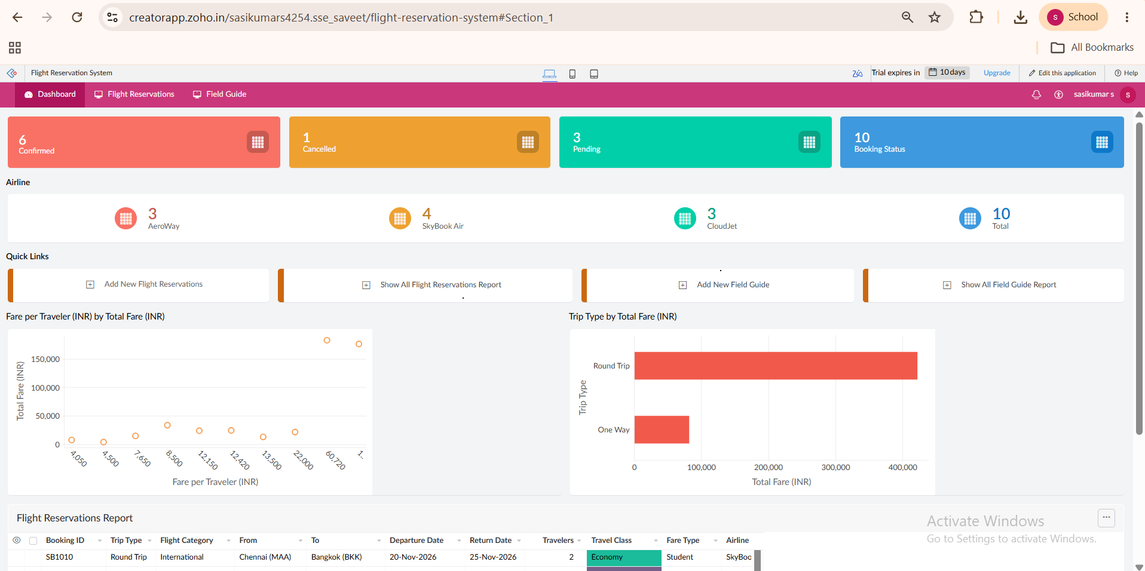
SCREENSHOT
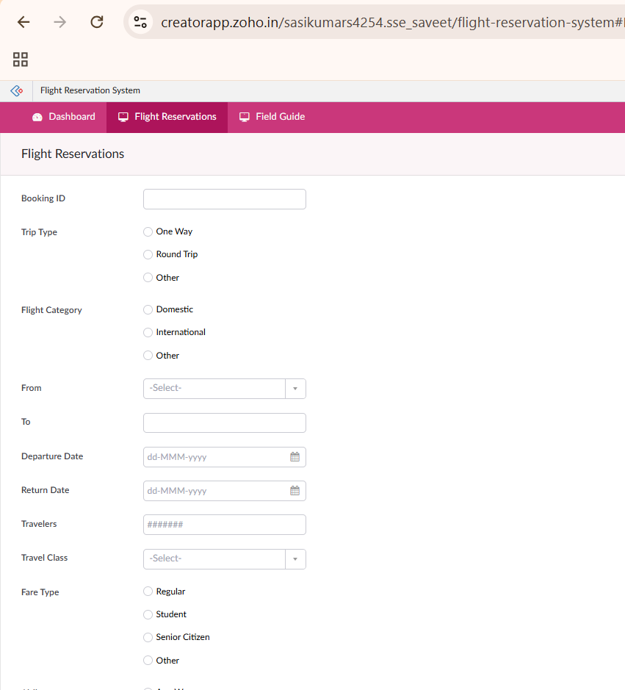
RESULT: The Flight Reservation System cloud application was created and tested successfully using the SaaS approach.

EXPERIMENT 2: Property Buying & Rental Process
AIM: To create a simple cloud software application for the Property Buying & Rental process in Chennai using a Cloud Service Provider to demonstrate SaaS.
PROCEDURE:
1. Open the selected Cloud Service Provider and sign in.
2. Create an application named Property Buying & Rental System.
3. Create a form for property details.
4. Add options for Buy and Rent.
5. Add property type options such as Commercial and Rental Agreement.
6. Add Area and Place fields.
7. Add Range and Property Value fields.
8. Save the form and access the application.
9. Enter sample Chennai property details and submit the form.
10. Open the associated report and verify the saved property record.
OUTPUT: The Property Buying & Rental form is displayed and a sample Chennai property record is successfully stored and viewed in the report.
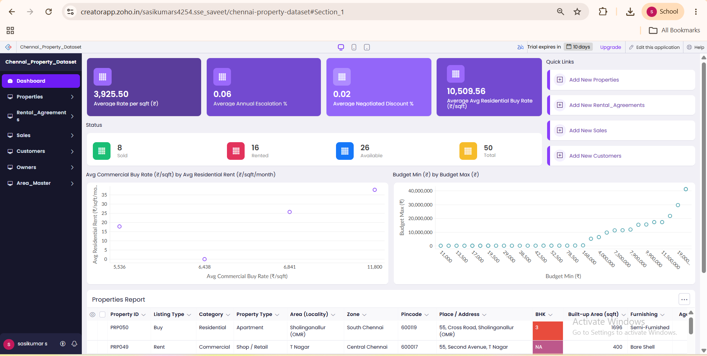
SCREENSHOT
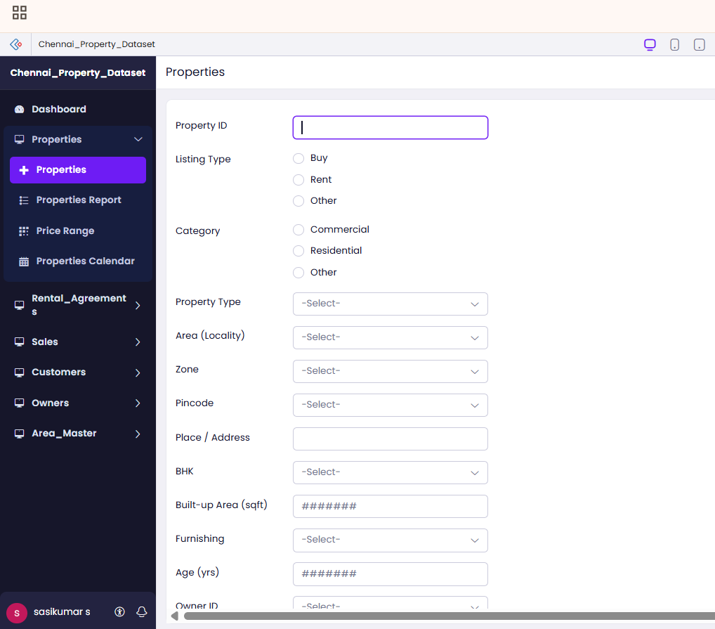

RESULT: The Property Buying & Rental Process cloud application was created and tested successfully using the SaaS approach.

EXPERIMENT 3: Car Booking Reservation System
AIM: To create a simple cloud software application for a Car Booking Reservation System using a Cloud Service Provider to demonstrate SaaS.
PROCEDURE:
1. Open the selected Cloud Service Provider and sign in.
2. Create an application named Car Booking Reservation System.
3. Create a car booking form.
4. Add a field to search/select cabs.
5. Add From and To fields.
6. Add booking type options such as Rental and Out Station.
7. Add Package Type field.
8. Add Hours/Days field according to the selected package.
9. Save and access the application.
10. Enter sample booking details and submit the form.
11. Open the associated report and verify the booking.
OUTPUT: The Car Booking Reservation form is displayed and the submitted cab booking is stored and shown in the report.
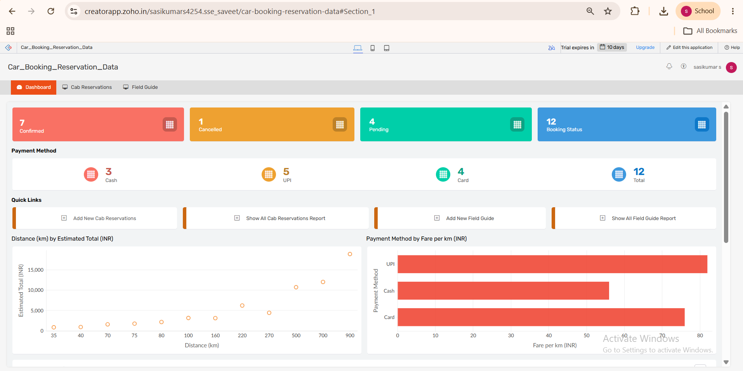
SCREENSHOT
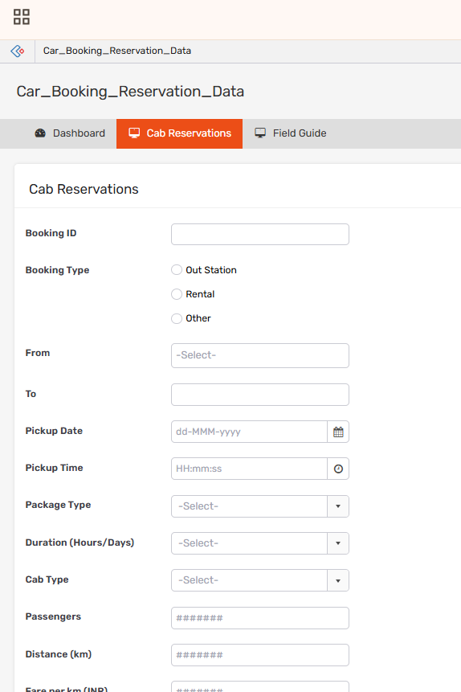

RESULT: The Car Booking Reservation System cloud application was created and tested successfully using the SaaS approach.

EXPERIMENT 4: Library Book Reservation System
AIM: To create a simple cloud software application for the SIMATS Library Book Reservation System using a Cloud Service Provider to demonstrate SaaS.
PROCEDURE:
1. Open the selected Cloud Service Provider and sign in.
2. Create an application named SIMATS Library Book Reservation.
3. Create a library book reservation form.
4. Add Title of the Book and Author fields.
5. Add Publication, Year, and Edition fields.
6. Add Number of Copies and Rack Number fields.
7. Add Status options such as Taken and Returned.
8. Save and access the application.
9. Enter sample book details and submit the form.
10. Open the associated report and verify the saved book record.
OUTPUT: The SIMATS Library Book Reservation form is displayed and the submitted book details, including rack number and status, are stored successfully.
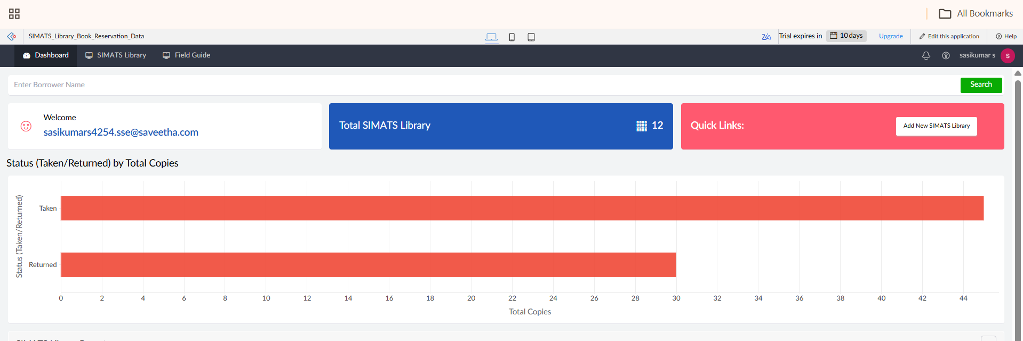
SCREENSHOT
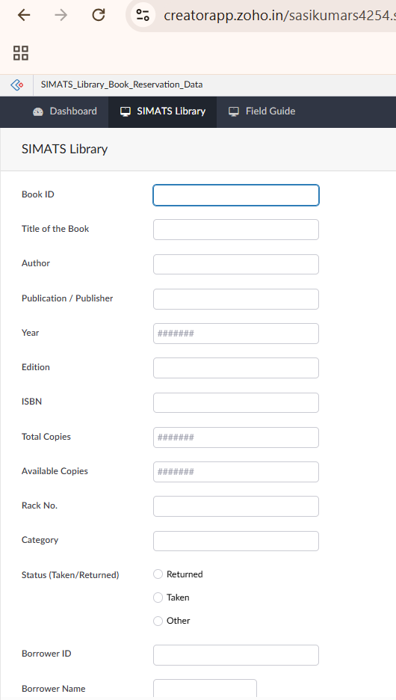

RESULT: The Library Book Reservation System cloud application was created and tested successfully using the SaaS approach.

EXPERIMENT 5: Mark Sheet Processing System
AIM: To create a simple cloud software application for a Mark Sheet Processing System using a Cloud Service Provider to demonstrate SaaS.
PROCEDURE:
1. Open the selected Cloud Service Provider and sign in.
2. Create an application named Mark Sheet Processing System.
3. Create a student mark sheet form.
4. Add Student Name and Register Number fields.
5. Add Subject and Marks fields.
6. Add Average and Percentage fields.
7. Add Rank and Overall Performance fields.
8. Save and access the application.
9. Enter sample student mark details and submit the form.
10. Open the associated report and verify the processed mark sheet record.
OUTPUT: The Mark Sheet Processing form is displayed and the submitted student marks with average, percentage, rank, and overall performance are stored in the report.
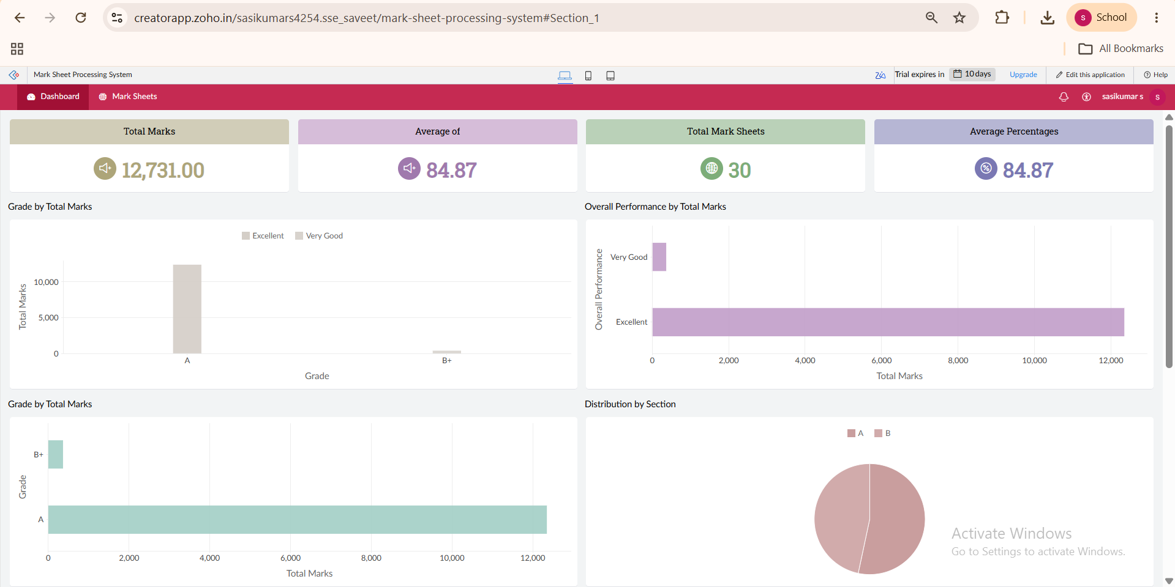
SCREENSHOT
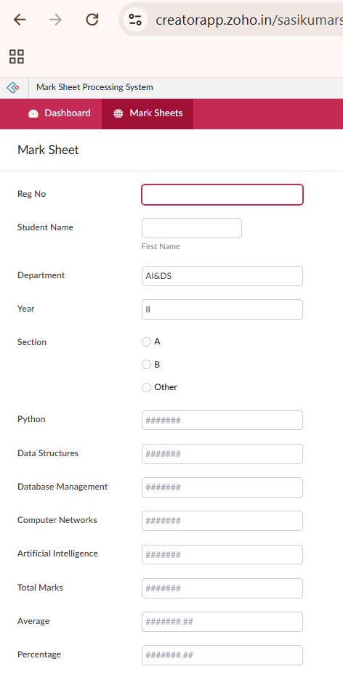

RESULT: The Mark Sheet Processing System cloud application was created and tested successfully using the SaaS approach.

EXPERIMENT 6: Payroll Processing System
AIM: To create a simple cloud software application for a Payroll Processing System using a Cloud Service Provider to demonstrate SaaS.
PROCEDURE:
1. Open the selected Cloud Service Provider and sign in.
2. Create an application named Payroll Processing System.
3. Create an employee payroll form.
4. Add Employee Name, Experience in Present Organization, and Overall Experience fields.
5. Add Basic Pay, HRA, DA, and TA fields.
6. Add Gross Pay and Net Pay fields.
7. Save and access the application.
8. Enter sample employee payroll details and submit the form.
9. Open the associated report and verify the saved payroll record.
OUTPUT: The Payroll Processing form is displayed and the employee payroll details, including gross pay and net pay, are stored successfully.
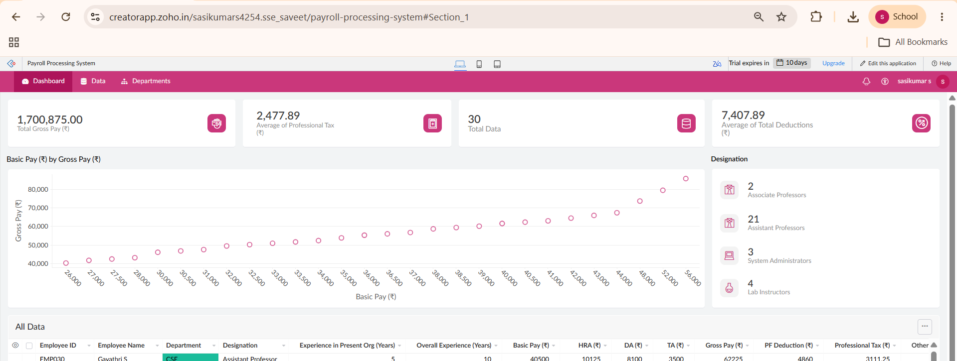
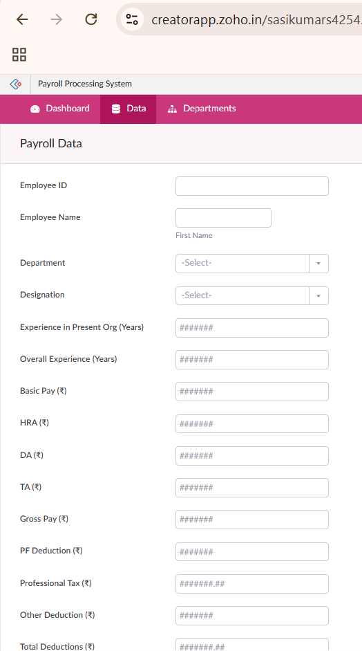
SCREENSHOT

RESULT: The Payroll Processing System cloud application was created and tested successfully using the SaaS approach.

EXPERIMENT 7: Students Attendance System
AIM: To create a simple cloud software application for a Students Attendance System using a Cloud Service Provider to demonstrate SaaS.
PROCEDURE:
1. Open the selected Cloud Service Provider and sign in.
2. Create an application named Students Attendance System.
3. Create a student attendance form.
4. Add Student Name and Course fields.
5. Add Present and Absent fields.
6. Add Course Attendance and Attendance Percentage fields.
7. Add OD Request and Grade fields.
8. Save and access the application.
9. Enter sample attendance details and submit the form.
10. Open the associated report and verify the saved attendance record.
OUTPUT: The Students Attendance form is displayed and the submitted attendance details, OD request, grade, and attendance percentage are stored in the report.
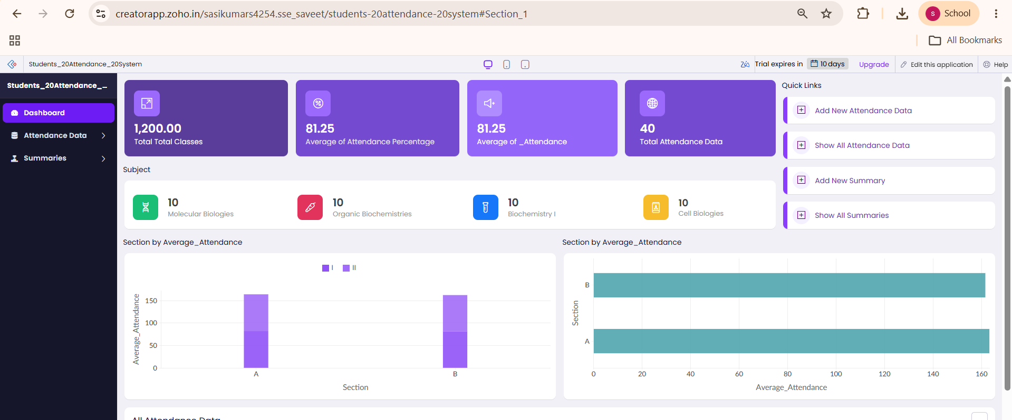
SCREENSHOT
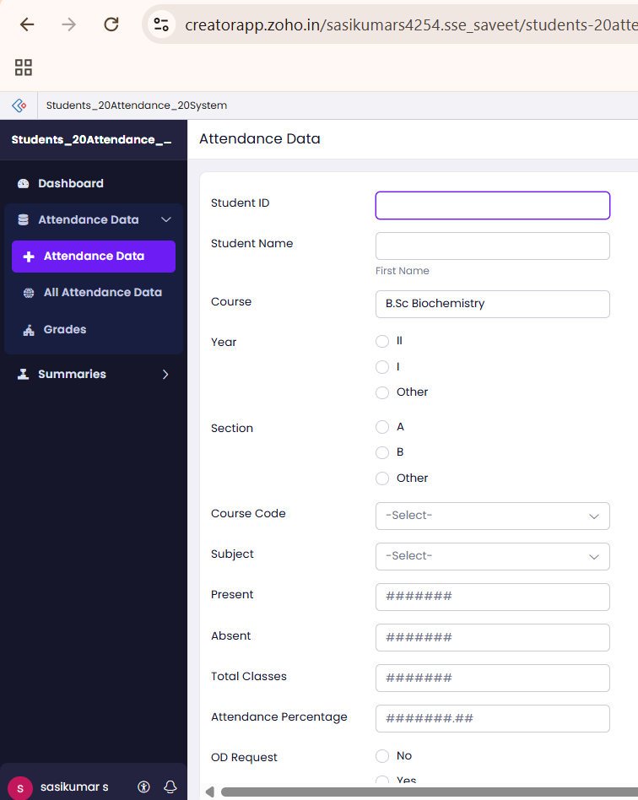

RESULT: The Students Attendance System cloud application was created and tested successfully using the SaaS approach.

EXPERIMENT 8: Student Counselling System
AIM: To create a simple cloud web application for a Student Counselling System using a Cloud Service Provider to demonstrate SaaS.
PROCEDURE:
1. Open the selected Cloud Service Provider and sign in.
2. Create an application named Student Counselling System.
3. Create a student counselling form.
4. Add Student Name, Age, Address, and Phone fields.
5. Add Subjects Studied and Year of Passing fields.
6. Add Percentage of Marks and Domain Interest fields.
7. Save and access the application.
8. Enter sample student counselling details and submit the form.
9. Open the associated report and verify the saved student record.
OUTPUT: The Student Counselling form is displayed and the submitted student academic and domain-interest details are stored successfully.
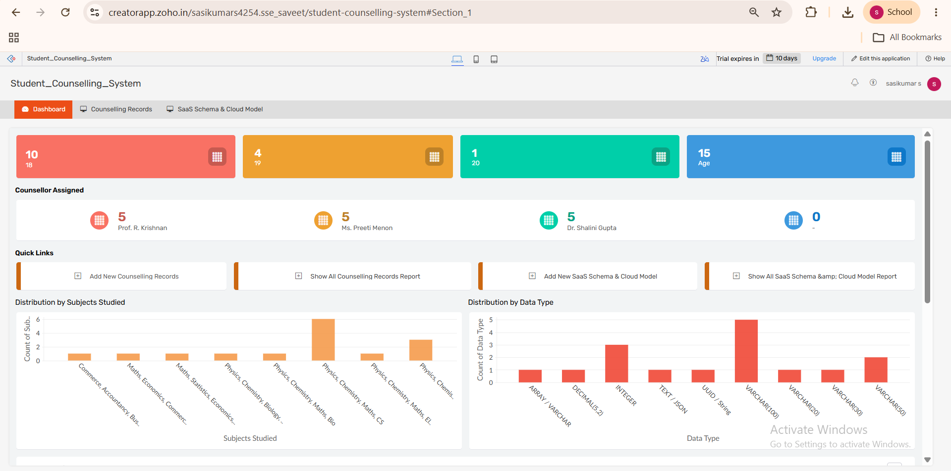
SCREENSHOT
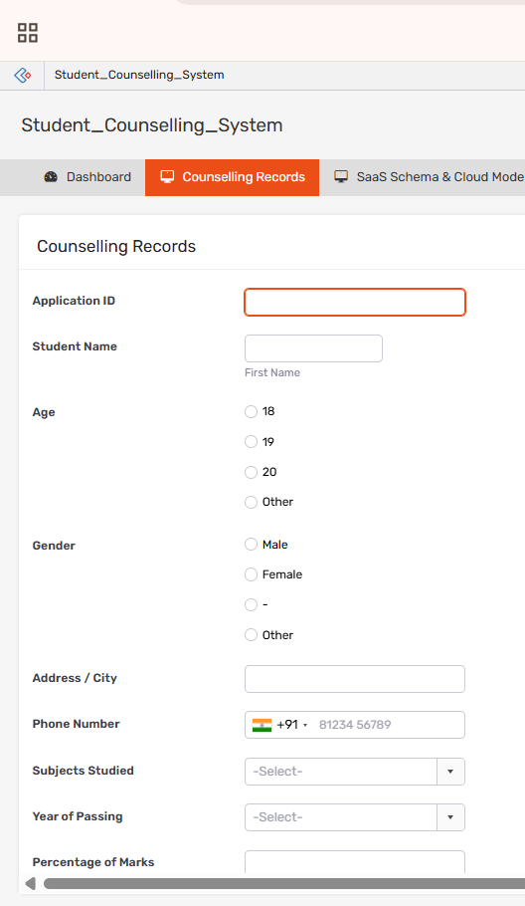

RESULT: The Student Counselling System cloud application was created and tested successfully using the SaaS approach.

EXPERIMENT 9: Hospital Information System
AIM: To create a simple cloud software application for the SIMATS Hospital Information System using a Cloud Service Provider to demonstrate SaaS.
PROCEDURE:
1. Open the selected Cloud Service Provider and sign in.
2. Create an application named SIMATS Hospital Information System.
3. Create a hospital information form.
4. Add Patient Name, Age, Address, Phone, and Email fields.
5. Add Attender Name and Attender Phone fields.
6. Add Doctor Name and Diseases fields.
7. Save and access the application.
8. Enter sample patient information and submit the form.
9. Open the associated report and verify the saved patient record.
OUTPUT: The Hospital Information form is displayed and the submitted patient, attender, doctor, and disease details are stored in the report.
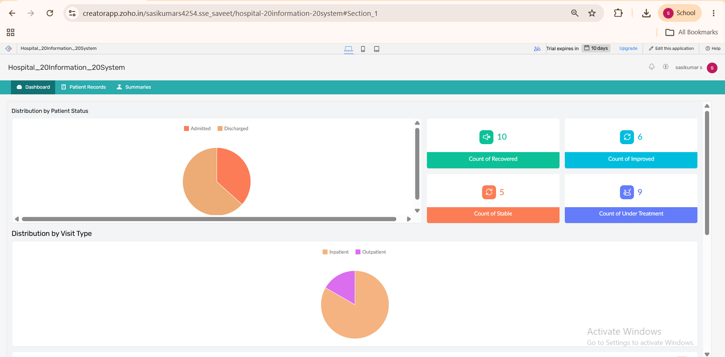
SCREENSHOT
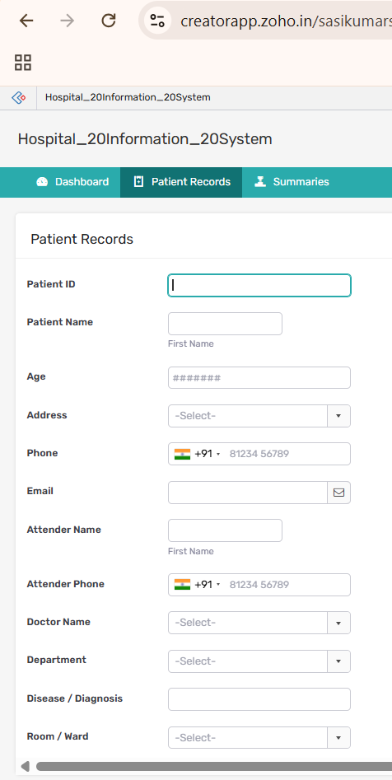

RESULT: The Hospital Information System cloud application was created and tested successfully using the SaaS approach.

EXPERIMENT 10: Student Information Application using C Program
AIM: To create a simple cloud software application to run a C program that displays student information using a Cloud Service Provider and demonstrates SaaS.
PROCEDURE:
1. Open the selected Cloud Service Provider and sign in.
2. Create an application for Student Information.
3. Create a template/form containing Student Name, Register Number, Address, Phone, and Age.
4. Add Courses and Grades fields.
5. Add Attendance Report and Progress Report fields.
6. Add Semester Mark Sheet form/details.
7. Add or configure the C program required to display the student information.
8. Run the application and enter sample student information.
9. Verify the displayed student information and reports.
OUTPUT: The cloud application runs the C program and displays the entered student information, courses, grades, attendance report, progress report, and semester mark sheet details.
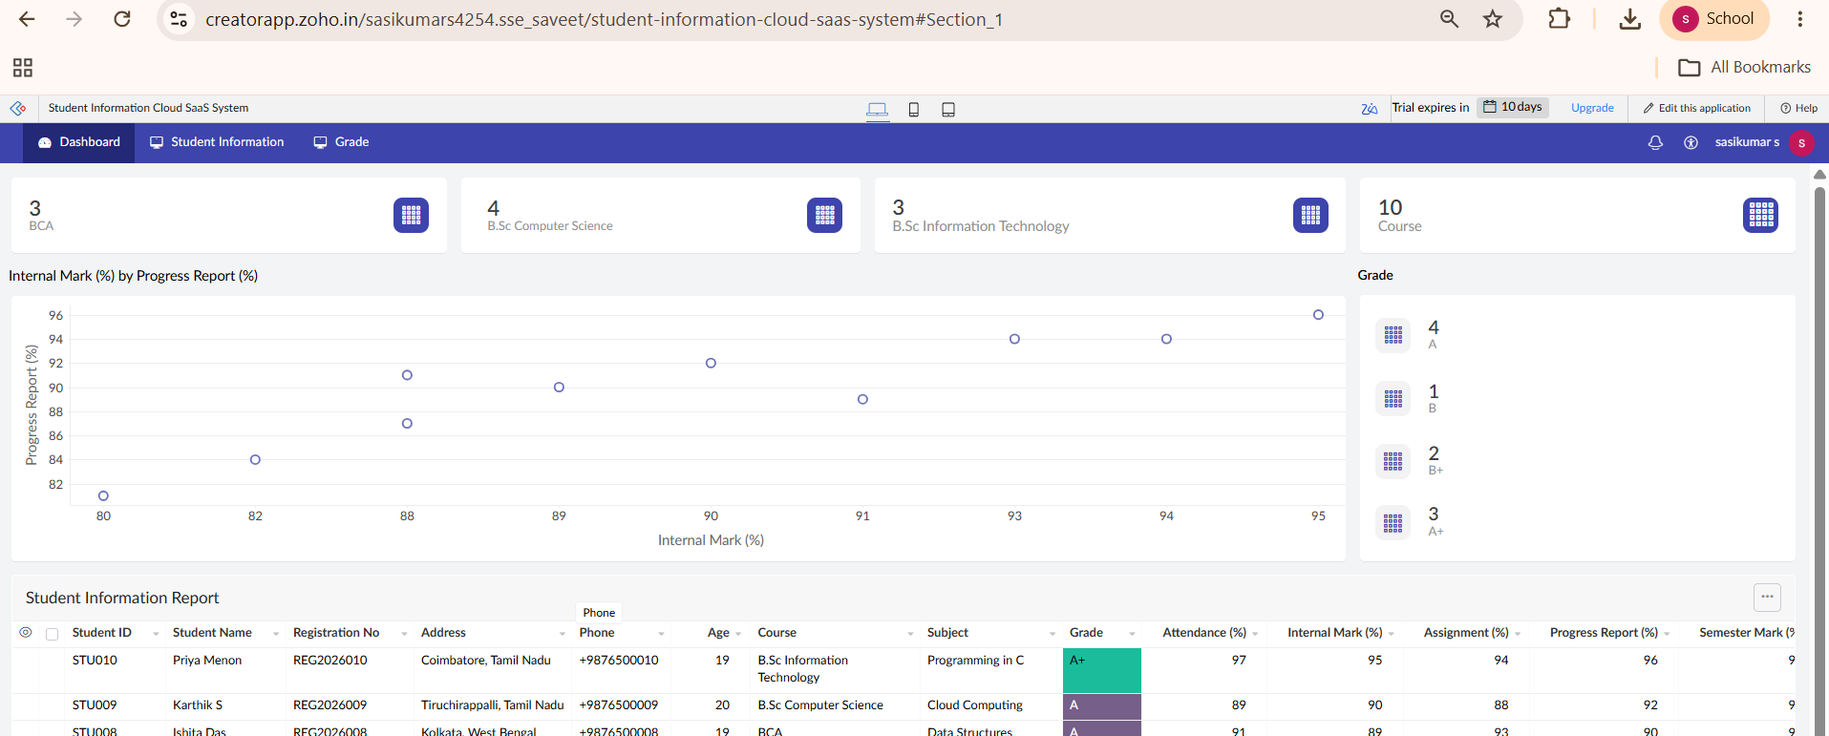
SCREENSHOT
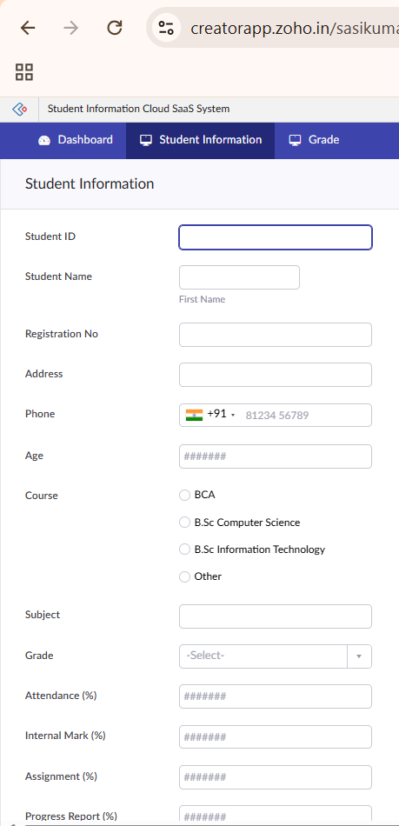

RESULT: The Student Information Application using C Program cloud application was created and tested successfully using the SaaS approach.

EXPERIMENT 11: Online Super Market
AIM: To create a simple cloud software application for an Online Super Market using a Cloud Service Provider to demonstrate SaaS.
PROCEDURE:
1. Open the selected Cloud Service Provider and sign in.
2. Create an application named Online Super Market.
3. Create a customer/order form.
4. Add Customer Name, Address, Phone, and Email fields.
5. Add Items and Quantity fields.
6. Create an item classification form to classify the available items.
7. Save and access the application.
8. Enter sample customer and item details and submit the form.
9. Open the associated report and verify the saved order details.
OUTPUT: The Online Super Market form is displayed and the submitted customer, item, quantity, and classification details are stored successfully.
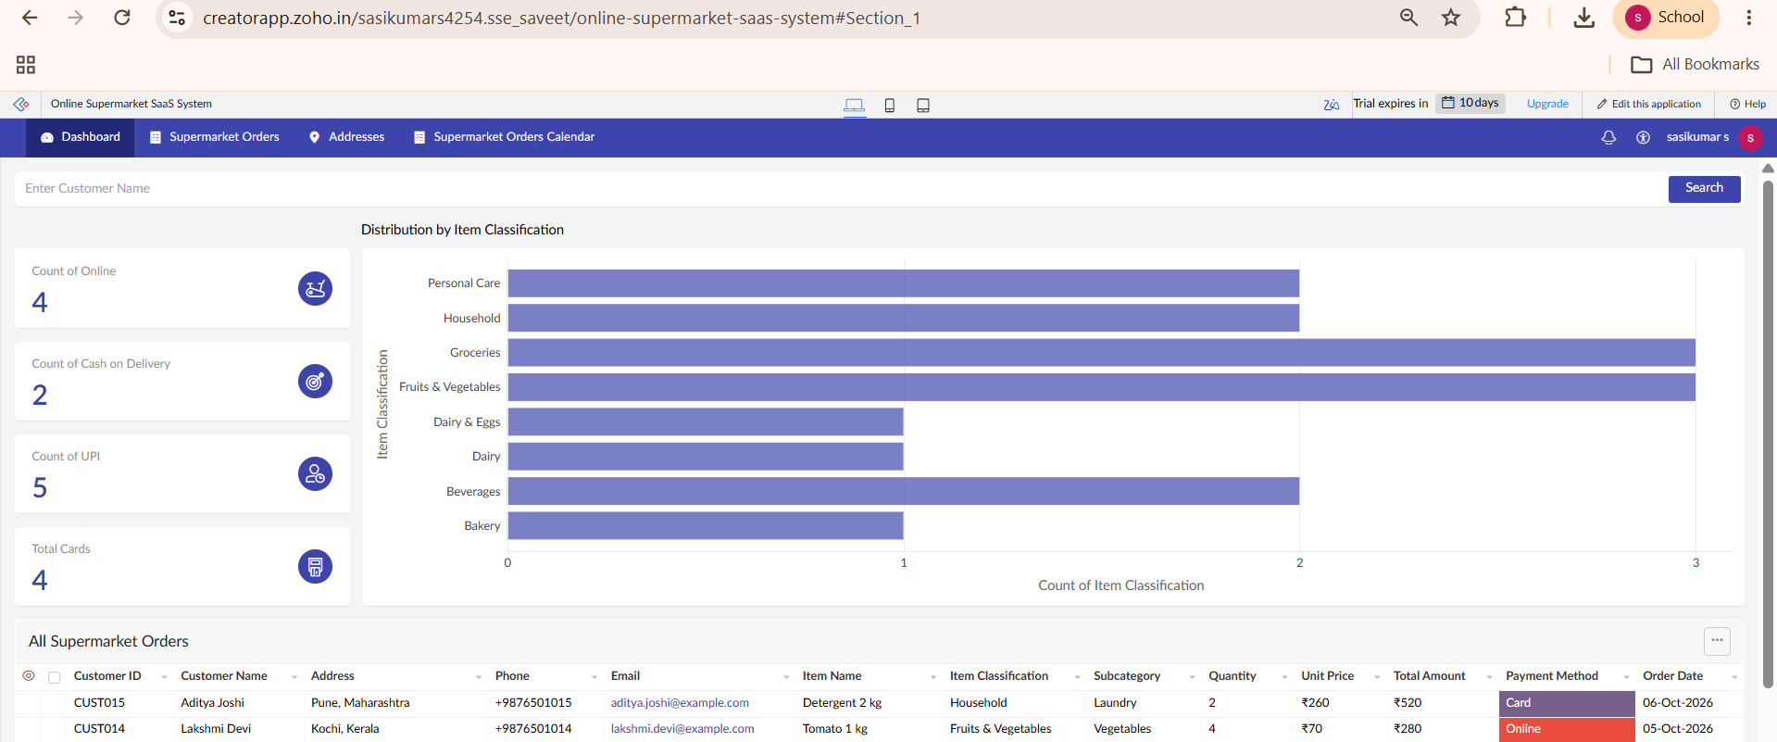
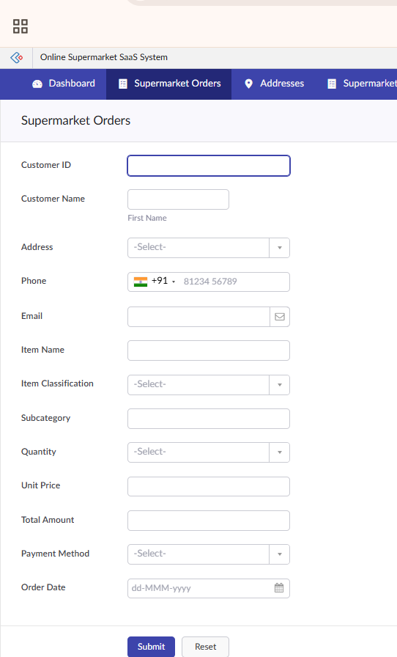
SCREENSHOT

RESULT: The Online Super Market cloud application was created and tested successfully using the SaaS approach.

