### JAVASCRIPT referernce: https://www.youtube.com/playlist?list=PLlasXeu85E9cQ32gLCvAvr9vNaUccPVNP

## Every thing in the javascript happens inside the execution Container. The Execution context is like big box and it has two componeents ibit .The first component is known as memory component and the second component is known as execution component .

## Memory component:

## It contains values in the key valu pairs format .For example we have a variable “a ” is stored here and its corresponding value follows . a:10 ---->in this it stores the values if it goes for function it stores the entire function in this format as follows : fn:{…………} **This memory component is also called variable environment**

## Code Component:

## This is the place where code get executed line by line one by one (one line at a time ).So the execution of line by line is known Syncronus and Single Threaded language . **This is also known as thread of execution .**

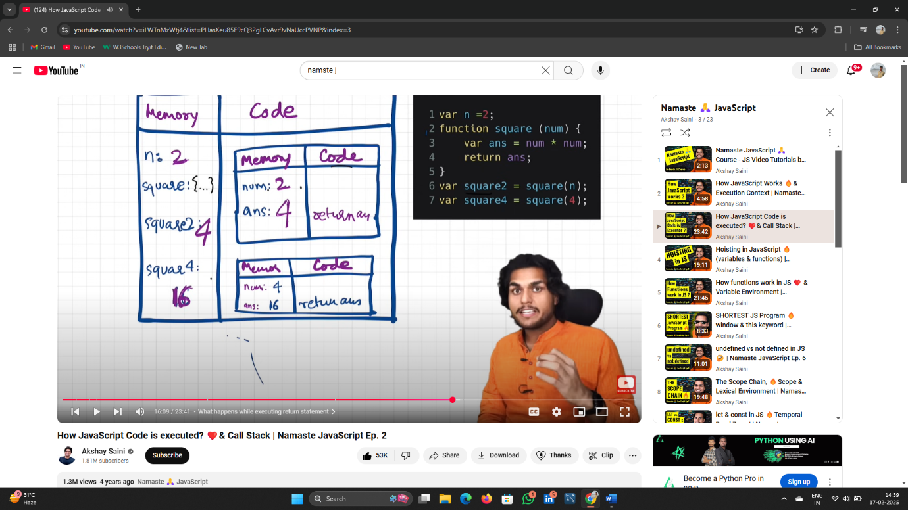

## The variable is not present in the memory it shows not defined (undefined).

## This is Because Is because we sare try to acesss the value of the variable before it entering to the memory Componeent of execution content.

## This is known as hosting.

* If It Comes for a Function it creates a variable for it stores the entire function inside it .
* Window is Global object it gets created along with the Global Execution Contex.

## This and Windows Keywords Have behaves same Window is a Global Keyword .This can be used for

* The Memory Space Allocated in the Memory Component before the declaration and assignment statement of a variable is known as Undefined.
* Because the memory component store the default value as undefined .