**A fast Multi-frame super-resolution(SR) aims to**

**restore a high-resolution video from both its corresponding**

**low-resolution frame and multiple neighboring frames, in order**

**to make full use of the inter-frame information.**

**% Load the video**

**videoFileName = 'your_video_file.mp4';**

**videoObj = VideoReader(videoFileName);**

**% Parameters**

**numKeyframes = 5; % Number of keyframes to extract**

**minFrameDiff = 150; % Minimum color variance to consider a frame as a keyframe**

**% Initialize variables**

**keyframes = zeros(videoObj.Height, videoObj.Width, 3, numKeyframes);**

**keyframeIndex = 1;**

**prevFrame = readFrame(videoObj);**

**while hasFrame(videoObj)**

**currFrame = readFrame(videoObj);**

**% Calculate color variance using Euclidean distance between frames**

**colorVariance = sqrt(sum((double(currFrame) - double(prevFrame)).^2, 3));**

**% Check if the color variance is above the threshold**

**if sum(colorVariance(:)) > minFrameDiff**

**keyframes(:, :, :, keyframeIndex) = currFrame;**

**keyframeIndex = keyframeIndex + 1;**

**if keyframeIndex > numKeyframes**

**break;**

**end**

**end**

**prevFrame = currFrame;**

**end**

**% Display keyframes**

**figure;**

**for i = 1:numKeyframes**

**subplot(1, numKeyframes, i);**

**imshow(uint8(keyframes(:, :, :, i)));**

**title(['Keyframe ' num2str(i)]);**

**end**

oad the video videoFileName = 'your_video_file.mp4'; videoObj = VideoReader(videoFileName); % Parameters numKeyframes = 5; % Number of keyframes to extract minFrameDiff = 150; % Minimum color variance to consider a frame as a keyframe % Initialize variables keyframes = zeros(videoObj.Height, videoObj.Width, 3, numKeyframes); keyframeIndex = 1; prevFrame = readFrame(videoObj); while hasFrame(videoObj) currFrame = readFrame(videoObj); % Calculate color variance using Euclidean distance between frames colorVariance = sqrt(sum((double(currFrame) - double(prevFrame)).^2, 3)); % Check if the color variance is above the threshold if sum(colorVariance(:)) > minFrameDiff keyframes(:, :, :, keyframeIndex) = currFrame; keyframeIndex = keyframeIndex + 1; if keyframeIndex > numKeyframes break; end end prevFrame = currFrame; end % Display keyframes figure; for i = 1:numKeyframes subplot(1, numKeyframes, i); imshow(uint8(keyframes(:, :, :, i))); title(['Keyframe ' num2str(i)]); end

Replace **'your_video_file.mp4'** with the path to your video file. This code reads frames from the video, calculates color variance between consecutive frames, and selects frames as keyframes if the color variance exceeds a certain threshold (**minFrameDiff**). The extracted keyframes are then displayed.

Keep in mind that this algorithm is quite basic and may not work well for all types of videos. More sophisticated algorithms can consider factors like motion analysis, object detection, and scene changes to determine keyframes. Additionally, you might need to fine-tune the parameters based on the characteristics of your videos.

Top of Form

BICUBIC INTERPOLATION SR

% Bicubic Color Video Super-Resolution Algorithm

% Parameters

scale_factor = 2; % Scaling factor

input_video = 'input_video.mp4'; % Input video filename

output_video = 'output_video_superres.mp4'; % Output video filename

% Read the input video

inputObj = VideoReader(input_video);

num_frames = inputObj.NumberOfFrames;

frame_height = inputObj.Height;

frame_width = inputObj.Width;

% Create VideoWriter object for the output video

outputObj = VideoWriter(output_video, 'MPEG-4');

outputObj.FrameRate = inputObj.FrameRate;

open(outputObj);

% Process each frame

for frame_idx = 1:num_frames

% Read the current frame

input_frame = read(inputObj, frame_idx);

% Resize the frame using bicubic interpolation

output_frame = imresize(input_frame, scale_factor, 'bicubic');

% Write the super-resolved frame to the output video

writeVideo(outputObj, output_frame);

end

% Close the output video

close(outputObj);

disp('Super-resolution completed.');

Make sure to replace **'input_video.mp4'** with the actual filename of your input video and **'output_video_superres.mp4'** with the desired filename for the output super-resolved video. You can adjust the **scale_factor** to control the level of upscaling.

Keep in mind that this is a basic example, and more advanced techniques can yield better results, such as using deep learning-based approaches like convolutional neural networks (CNNs). If you're looking for higher-quality results, you might consider exploring those methods.

SRCNN

Make sure you have the necessary image processing toolbox and deep learning toolbox installed in MATLAB.

% SRCNN Color Video Super-Resolution Algorithm

% Load the SRCNN model (you need to have the trained model)

load('srcnn_model.mat'); % Load your trained SRCNN model here

% Set the scale factor (e.g., 2x, 3x, 4x)

scale_factor = 2;

% Read the video

video_file = 'input_video.mp4'; % Input video file

output_video = 'output_video.mp4'; % Output video file

video_reader = VideoReader(video_file);

video_writer = VideoWriter(output_video, 'MPEG-4');

open(video_writer);

while hasFrame(video_reader)

% Read a frame

frame = readFrame(video_reader);

% Preprocess the frame

scaled_frame = imresize(frame, 1/scale_factor);

normalized_frame = double(scaled_frame) / 255.0;

% Apply SRCNN super-resolution

super_res_frame = predict(srcnn_model, normalized_frame);

% Postprocess the frame

super_res_frame = uint8(super_res_frame * 255);

interpolated_frame = imresize(super_res_frame, scale_factor);

% Write the frame to the output video

writeVideo(video_writer, interpolated_frame);

end

close(video_writer);

disp('Super-resolution completed and saved.');

Please note that for this code to work, you need to have a pre-trained SRCNN model (**srcnn_model.mat**) that is compatible with the MATLAB deep learning framework. This model should be trained on a large dataset of high-resolution images and should be able to upscale images by the desired scale factor.

Also, keep in mind that real-world implementations might involve more advanced techniques, handling various video formats, and optimizing the processing pipeline for better performance.

SRGAN

Implementing the entire SRGAN (Super-Resolution Generative Adversarial Network) algorithm for color video super-resolution in MATLAB requires a significant amount of code and resources. However, I can provide you with a high-level overview of the steps and main components involved in the algorithm. You might need to combine this with your knowledge of MATLAB and deep learning frameworks like TensorFlow or PyTorch to implement the actual code.

Here's an outline of the steps involved in implementing SRGAN for color video super-resolution:

1. **Dataset Preparation:** Gather a dataset of high-resolution color video frames along with their corresponding low-resolution versions.
2. **Generator and Discriminator Networks:** Implement the generator and discriminator networks using a deep learning framework like TensorFlow or PyTorch. The generator network takes a low-resolution image as input and aims to produce a high-resolution output. The discriminator network attempts to distinguish between real high-resolution images and generated high-resolution images.
3. **Loss Functions:** Define the loss functions for both the generator and discriminator. The generator loss consists of a content loss (typically using mean squared error) and an adversarial loss (using the discriminator's output). The discriminator loss involves distinguishing between real and generated images.
4. **Training Loop:** Set up a training loop where you alternately update the generator and discriminator networks. During each iteration, pass a batch of low-resolution images through the generator to obtain high-resolution images. Compute the loss for both the generator and discriminator and perform gradient descent to update the network parameters.
5. **Super-Resolution Video Generation:** To perform super-resolution on a video, process each frame of the video using the trained generator. Upscale the frame using the generator, and then combine the processed frames to create the final high-resolution video.
6. **Evaluation:** Evaluate the performance of your trained SRGAN on a separate validation dataset. Calculate metrics such as PSNR (Peak Signal-to-Noise Ratio) and SSIM (Structural Similarity Index) to assess the quality of the generated images.
7. **Fine-Tuning and Hyperparameter Tuning:** Experiment with different hyperparameters, network architectures, and training strategies to achieve better results.

Due to the complexity of the SRGAN algorithm, providing a complete code implementation here is not feasible. However, you can refer to existing SRGAN implementations in deep learning frameworks like TensorFlow or PyTorch as a starting point and adapt them for your specific needs. Online code repositories, forums, and tutorials can also be valuable resources for getting practical examples and guidance on implementing SRGAN for color video super-resolution.

Top of Form

Regenerate

AMC

Adaptive Motion Compensation is a technique used in video compression to improve the efficiency of encoding by reducing the temporal redundancy between frames. Here's a basic outline of how you might approach implementing it for color video:

1. **Video Input**: Load the color video sequence that you want to apply adaptive motion compensation to.
2. **Frame Division**: Divide each frame of the video sequence into blocks. A common block size is 8x8 or 16x16 pixels.
3. **Motion Estimation**: For each block in the current frame, search for the best matching block in a reference frame (previous frame) using a motion estimation algorithm like the Full Search algorithm or Diamond Search algorithm. Calculate the motion vectors for each block.
4. **Motion Compensation**: Using the calculated motion vectors, perform motion compensation for each block by shifting the corresponding block from the reference frame to the current frame's position.
5. **Adaptive Selection**: Compare the original block and the motion-compensated block. If the difference between them is below a certain threshold, use the motion-compensated block; otherwise, use the original block. This threshold can be determined based on the video content and desired quality.
6. **Color Processing**: Since this is for color video, you'll need to perform the above steps for each color channel (typically Red, Green, and Blue). You can also explore techniques to handle the chroma channels (U and V components) in YUV color space separately.
7. **Output**: Store the resulting motion-compensated frames and any necessary information for decoding.

% Load the video sequence

video = load_video('color_video.mp4');

% Define block size and other parameters

block_size = 8;

threshold = 10;

% Loop through each frame

for frame_idx = 2 : num_frames

current_frame = video(frame_idx);

reference_frame = video(frame_idx - 1);

% Loop through each block

for row = 1 : block_size : frame_height

for col = 1 : block_size : frame_width

% Extract the current block from the current frame

current_block = current_frame(row : row + block_size - 1, col : col + block_size - 1, :);

% Perform motion estimation to find the best matching block

motion_vector = motion_estimation(current_block, reference_frame, block_size);

% Perform motion compensation using the motion vector

motion_compensated_block = motion_compensation(reference_frame, motion_vector, block_size);

% Compare the original and motion-compensated blocks

residual = current_block - motion_compensated_block;

% Adaptive selection

if sum(abs(residual(:))) < threshold

motion_compensated_frame(row : row + block_size - 1, col : col + block_size - 1, :) = motion_compensated_block;

else

motion_compensated_frame(row : row + block_size - 1, col : col + block_size - 1, :) = current_block;

end

end

end

% Store the resulting motion-compensated frame

motion_compensated_video(frame_idx, :, :, :) = motion_compensated_frame;

end

Keep in mind that this is just a simplified representation and actual implementation can vary based on the specific algorithms you choose and the requirements of your project. Additionally, you might want to consider handling issues like boundary conditions, handling edge blocks, and implementing more sophisticated motion estimation algorithms for better performance.

Remember that creating a robust and efficient implementation of Adaptive Motion Compensation for color video requires a solid understanding of video compression concepts and algorithms, as well as good MATLAB programming skills.

DCSCN

DCSCN (Deeply-Recursive Super-Resolution Convolutional Network) is a deep learning architecture commonly used for image super-resolution tasks. While it can be extended to handle color images and videos, creating a full MATLAB implementation for DCSCN for color video is beyond the scope of a single response due to its complexity. However, I can provide you with a basic outline of the steps you would need to follow and some example code snippets to get you started.

Please note that the following code snippets are meant to give you an idea of the structure and process. You would need to adapt and expand them to create a functional DCSCN implementation for color video in MATLAB.

1. **Loading and Preprocessing:**

% Load video frames

videoReader = VideoReader('input_video.mp4');

numFrames = videoReader.NumberOfFrames;

% Initialize cell array to store frames

frames = cell(1, numFrames);

% Read frames and preprocess

for i = 1:numFrames

frames{i} = double(read(videoReader, i));

end

1. **DCSCN Model:**

You would need to define the architecture of the DCSCN model using MATLAB's deep learning toolbox or external deep learning frameworks like TensorFlow or PyTorch. Below is a simplified example of how you could define a DCSCN-like model in MATLAB:

layers = [

imageInputLayer([None, None, 3], 'Name', 'input')

convolution2dLayer(3, 64, 'Padding', 'same', 'Name', 'conv1')

reluLayer('Name', 'relu1')

% ... Add more layers as needed

convolution2dLayer(3, 3, 'Padding', 'same', 'Name', 'convFinal')

regressionLayer('Name', 'output')

];

options = trainingOptions('adam', 'InitialLearnRate', 1e-3, 'MaxEpochs', 50);

% Train the model using your high-resolution training data

% model = trainNetwork(XTrain, YTrain, layers, options);

**Super-Resolution Inference:**

% Load the trained DCSCN model

% model = load('trained_dcscn_model.mat');

% Initialize cell array to store super-resolved frames

superResolvedFrames = cell(1, numFrames);

% Perform super-resolution on each frame

for i = 1:numFrames

inputFrame = frames{i};

% Perform super-resolution using the trained model

superResolvedFrame = predict(model, inputFrame); % You need to adapt this part

superResolvedFrames{i} = superResolvedFrame;

end

**Saving the Result:**

outputVideo = VideoWriter('output_video_dcscn.mp4', 'MPEG-4');

outputVideo.FrameRate = videoReader.FrameRate;

open(outputVideo);

% Write super-resolved frames to the output video

for i = 1:numFrames

writeVideo(outputVideo, uint8(superResolvedFrames{i}));

end

close(outputVideo);

Remember that building an effective DCSCN model requires careful tuning of hyperparameters, a large dataset for training, and substantial computational resources. Additionally, using a deep learning framework like TensorFlow or PyTorch might provide better support for building and training complex models like DCSCN. The code snippets provided here are a starting point, and you'll need to customize and expand upon them to create a functional implementation for your specific use case.

ESPCN

ESPCN is a deep learning-based approach for single-image super-resolution, and it can be adapted for video super-resolution as well.

In this example, I'll assume you have access to the MATLAB Deep Learning Toolbox and have already trained an ESPCN model for super-resolution. If not, you would need to first train the model on your own dataset and then use it for video super-resolution.

% Load pre-trained ESPCN model

load('espcn_model.mat'); % Replace with the actual path to your trained model

% Read video file

videoFile = 'input_video.mp4'; % Replace with your input video file path

outputVideoFile = 'output_video_espcn.mp4'; % Replace with desired output video path

videoReader = VideoReader(videoFile);

videoWriter = VideoWriter(outputVideoFile, 'MPEG-4');

open(videoWriter);

while hasFrame(videoReader)

% Read the next frame

frame = readFrame(videoReader);

% Convert frame to double and normalize to [0, 1]

frame = im2double(frame);

% Apply ESPCN super-resolution

% Assuming your ESPCN model is named 'espcnNet'

superResFrame = predict(espcnNet, frame);

% Convert super-resolved frame back to [0, 1] range

superResFrame = max(0, min(1, superResFrame));

% Convert super-resolved frame to uint8 for writing to video

superResFrame = im2uint8(superResFrame);

% Write the super-resolved frame to the output video

writeVideo(videoWriter, superResFrame);

end

% Close the video writer

close(videoWriter);

disp('Video super-resolution completed.');

Please note that this code assumes you've already trained an ESPCN model (not shown here) and saved it as a MATLAB .mat file. You'll need to replace **'espcn_model.mat'** with the actual path to your trained model file.

Additionally, make sure to replace **'input_video.mp4'** with the path to your input video file and **'output_video_espcn.mp4'** with the desired path for the output video.

Keep in mind that this is a simplified example, and you might need to adapt it to your specific needs and make sure your model, video files, and paths are set up correctly.

The Plug and Play Prior (PPP) is a framework used in image denoising and restoration tasks that combines traditional optimization-based image priors with deep learning-based denoising techniques. This method was introduced by Venkatakrishnan et al. in the paper "Plug-and-Play Priors for Model-Based Reconstruction" in 2013.

The idea behind PPP is to incorporate a denoising algorithm as a "plug-in" into an optimization framework while utilizing the prior knowledge about natural images. The algorithm alternates between two steps: a denoising step and a prior-update step. The overall algorithm aims to minimize an objective function that combines the data-fidelity term (related to the measured noisy image) and a regularization term based on the image prior.

The mathematical model of the Plug and Play Prior method can be summarized as follows:

Given an observed noisy image y, the goal is to estimate a clean image x. The PPP method seeks to minimize the following objective function:

E(x) = F(y, x) + λ * R(x)

where:

* E(x) is the total energy or objective function to be minimized.
* F(y, x) is the data-fidelity term that measures the closeness of the estimated image x to the observed noisy image y.
* R(x) is the regularization term based on the image prior, which encourages certain properties of natural images.
* λ is the regularization parameter that balances the importance of the data-fidelity and regularization terms.

The Plug and Play Prior method involves two main steps:

1. **Denoising Step**: In this step, a denoising algorithm, typically a deep learning-based denoiser, is applied to the observed noisy image y. This step aims to reduce the noise while preserving the underlying structures in the image. The denoised image is denoted as z.
2. **Prior-Update Step**: In this step, the regularized prior term is updated based on the denoised image z. This update helps to refine the regularization term and better match the estimated image to the properties of natural images. This can involve various techniques, such as updating the regularization parameters or adapting the prior model.

The algorithm iterates between these two steps, gradually refining the estimated image to better match the observed noisy image while still adhering to the prior information.

It's important to note that the specifics of the denoising algorithm used in the denoising step and the form of the regularization term R(x) can vary depending on the application and the specific implementation. The PPP framework provides a flexible and modular approach for combining traditional image processing techniques with deep learning-based denoising methods.

Top of Form

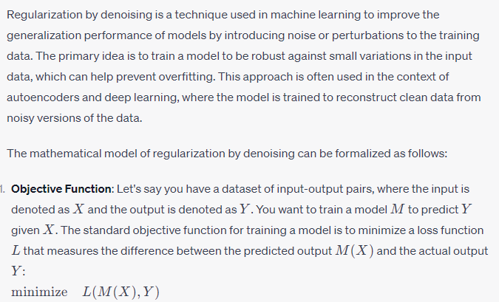

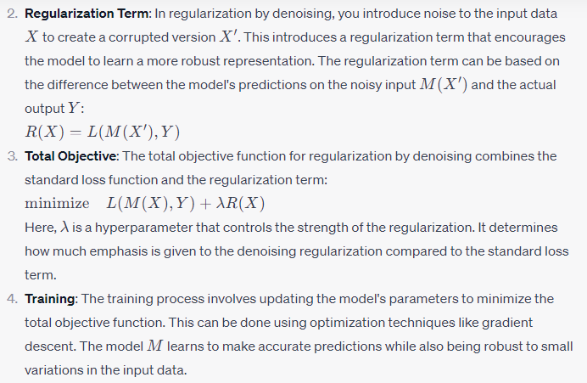

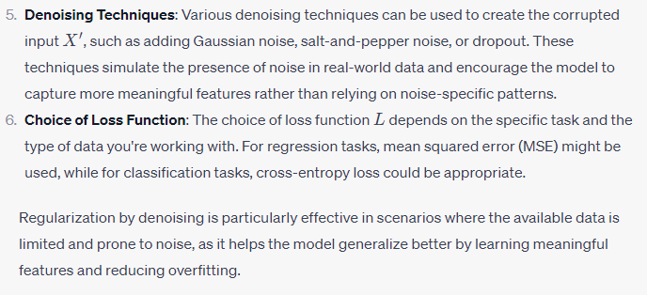

Efficient and Parallel Multiframe Video Super-Resolution (VSR) involves enhancing the resolution of a video by using multiple frames as input, and doing so in an efficient and parallelizable manner to handle real-time or near-real-time applications. Here's a general outline of a mathematical model that could represent such a process:

Let's denote:

* **LR(t)**: The low-resolution frame at time t.
* **HR(t)**: The high-resolution frame at time t (ground truth).
* **SR(t)**: The super-resolution frame at time t (predicted output).
* **F**: Number of frames used for multiframe VSR (e.g., F = 3 for a 3-frame model).
* **D**: Depth of the network architecture.
* **W**: Width of the network architecture.
* **H**: Height of the network architecture.

The goal is to find a mapping function **M** that maps LR frames to SR frames, such that SR(t) ≈ M(LR(t-F+1), LR(t-F+2), ..., LR(t)).

The mathematical model could be formulated as follows:

1. **Input Data**:
   * LR frames: LR(t-F+1), LR(t-F+2), ..., LR(t)
2. **Feature Extraction**: Extract features from each LR frame using a neural network with the architecture and parameters defined by D, W, and H. This process produces feature maps:
   * **F(t-F+1)**, **F(t-F+2)**, ..., **F(t)**
3. **Temporal Fusion**: Combine the extracted features from multiple frames to capture temporal information. This can be done through operations like convolutional or recurrent layers. The combined feature map could be denoted as:
   * **Fusion(t)**
4. **Spatial Upsampling**: Use transposed convolutions or other upsampling techniques to increase the spatial resolution of **Fusion(t)**. This step generates an intermediate high-resolution feature map:
   * **Intermediate_SR(t)**
5. **Reconstruction**: Apply additional convolutional layers to refine the intermediate high-resolution feature map and generate the final super-resolution feature map:
   * **Final_SR(t)**
6. **Output Generation**: Convert the final super-resolution feature map to the final super-resolution image SR(t) using appropriate activation functions and scaling.
7. **Loss Calculation**: Compute the loss between the predicted SR(t) and the ground truth HR(t) using a suitable loss function such as mean squared error (MSE) or perceptual loss.
8. **Optimization**: Use gradient descent-based optimization algorithms (e.g., Adam, SGD) to update the network's parameters to minimize the loss function.

For parallelization, you can apply techniques such as model parallelism (splitting the network across multiple devices) and data parallelism (splitting the input data across multiple devices) to speed up the training and inference processes.

Remember that the actual architecture, layer configurations, loss functions, and optimization strategies can vary based on the specific requirements and constraints of your problem. The outline provided above serves as a general mathematical model that you can adapt to your specific needs.

Top of Form

Regenerate