**VETRI IT SYSTEMS PRIVATE LIMITED**

**PROJECT REPORT**

**PROJECT TITLE: Vetri Super Market**

**1. Project Overview**

**Project Name:** Vetri Super Market  
**Project Assigned Date:** 16-06-2025  
**Planned Completion Date:** 23-06-2025  
**Delivery Date:** 21-05-2025

**2. Project Team**

* **Project Manager:** Mahesh Samuthiram
* **Designer:** Malathy
* **Developer(s):** T. Sasikala
* **Testing Team:** Yoga Varshini

**3. Technology Stack**

**Frontend:**

* **HTML5, CSS3, JavaScript**
* **React.js**
* **Bootstrap CSS for styling**

**4. Project Objectives**

**1. User-Friendly Interface**

* Develop a responsive and intuitive UI using React and Bootstrap.
* Ensure easy navigation between pages like Home, Products, Cart, Checkout, and Orders.

**2. Product Management**

* Display categorized products with search and filter options.
* Show product details: name, price, image, description, and availability.

**3. Shopping Cart Functionality**

* Allow users to add, remove, and update quantities in the cart.
* Calculate total price dynamically and reflect it in the UI.

**4. Order Checkout Flow**

* Implement a step-by-step order process: Cart → Checkout → Confirmation.
* Include form validation for billing/shipping information.
* Display order summary and success confirmation after purchase**.**

**5. Authentication**

* Enable user login/register functionality.
* Allow order history viewing for logged-in users**.**

**5. Project Scope**

**1. Project Overview**

The goal of this project is to develop a web-based platform that allows Payment and billing data to automatically generate bills in a secure, efficient, and user-friendly manner.

**2. Key Features:**

**1. User Interface (Frontend)**

* Home page with banners or featured products
* Product listing page with categories and filters
* Product details page
* Shopping cart and checkout page
* Order confirmation screen
* Responsive layout using React and Bootstrap

**2. Product Management**

* Display product details: image, name, price, quantity, description
* Search and category-based filtering
* Pagination (if needed)

**3.Cart & Checkout Functionality**

* Add/remove/update product quantity in the cart
* Calculate subtotal, tax, and total
* Collect user billing/shipping info via forms
* Display order summary

**4. State Management**

* Cart, order details, and optionally user info using useState/useContext or Redux

**5. Optional Features**

* Simple authentication (login/register)
* Order history page for logged-in users
* Admin-only pages for product and order management

**6.Technology Stack**

* Frontend: React.js with React Router
* Styling: Bootstrap / custom CSS
* API or Data: Local JSON data or mock API (e.g., FakeStoreAPI)
* Deployment: Hosted on Vercel, Netlify, or GitHub Pages

**5. Project Modules**

**1. Home Module**

* Displays welcome message, banners, and featured products
* Includes navigation links to products, cart, and contact
* Optionally shows promotional offers or a hero section

**2. Product Listing Module**

* Fetch and display a list of products
* Category filters (e.g., Fruits, Vegetables, Snacks, Dairy)
* Search bar for finding products
* Grid or list view of product cards

**3. Product Details Module**

* Clicking a product opens detailed view
* Shows product image, price, description, stock status
* "Add to Cart" button functionality

**4. Cart Module**

* Displays products added by the user
* Ability to:
  + Change quantity
  + Remove items
  + View price summary
* Total cost calculation (with tax/shipping if needed)

**5. Checkout Module**

* Form to enter:
  + Customer name
  + Address
  + Contact info
* Order summary section
* Confirm order button

**6. Order Confirmation Module**

* Displays a success message upon placing an order
* Shows order ID and brief summary
* Option to return to Home or view more products

**7. Authentication Module *(Optional)***

* Login and register pages
* Validate user credentials
* Maintain session (localStorage / context)

**6. Project Code**

**Frontend Code (HTML):**

**Github link:** [**https://github.com/SasikalaThennarasu5/Webdevelopment/tree/main/Prototype/VetriSuperMarket/VetriSuperMarket**](https://github.com/SasikalaThennarasu5/Webdevelopment/tree/main/Prototype/VetriSuperMarket/VetriSuperMarket)

**Home.html:**

[**https://github.com/SasikalaThennarasu5/Webdevelopment/blob/main/Prototype/VetriSuperMarket/VetriSuperMarket/src/pages/Home.css**](https://github.com/SasikalaThennarasu5/Webdevelopment/blob/main/Prototype/VetriSuperMarket/VetriSuperMarket/src/pages/Home.css)

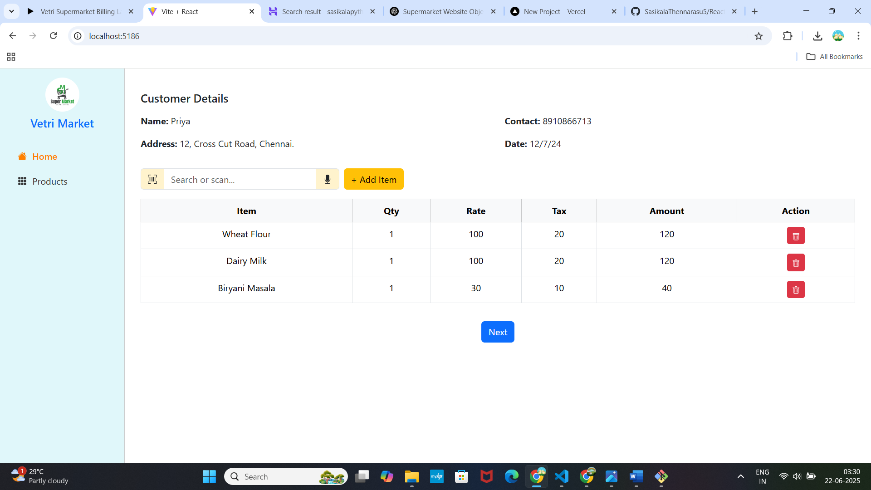

**import React from 'react';**

**import { useNavigate } from 'react-router-dom';**

**import Button from 'react-bootstrap/Button';**

**import { Trash } from 'react-bootstrap-icons';**

**import { useCart } from '../context/CartContext';**

**import { MicFill, UpcScan } from 'react-bootstrap-icons';**

**const Home = () => {**

**const navigate = useNavigate();**

**const { customer, cart, setCart } = useCart();**

**const handleRemove = (id) => {**

**setCart(cart.filter((item) => item.id !== id));**

**};**

**return (**

**<div className="container py-4">**

**<h5 className="mb-3">Customer Details</h5>**

**<div className="row mb-3">**

**<div className="col-md-6 col-12">**

**<p><strong>Name:</strong> {customer.name}</p>**

**<p><strong>Address:</strong> {customer.address}</p>**

**</div>**

**<div className="col-md-6 col-12">**

**<p><strong>Contact:</strong> {customer.contact}</p>**

**<p><strong>Date:</strong> {customer.date}</p>**

**</div>**

**</div>**

**<div className="d-flex align-items-center gap-2 mb-3 flex-wrap">**

**<div className="input-group" style={{ maxWidth: '350px' }}>**

**<span className="input-group-text bg-warning-subtle">**

**<UpcScan />**

**</span>**

**<input className="form-control" placeholder="Search or scan..." />**

**<span className="input-group-text bg-warning-subtle">**

**<MicFill />**

**</span>**

**</div>**

**<Button variant="warning" onClick={() => navigate('/products')}>**

**+ Add Item**

**</Button>**

**</div>**

**<div className="table-responsive">**

**<table className="table table-bordered text-center">**

**<thead className="table-light">**

**<tr>**

**<th>Item</th>**

**<th>Qty</th>**

**<th>Rate</th>**

**<th>Tax</th>**

**<th>Amount</th>**

**<th>Action</th>**

**</tr>**

**</thead>**

**<tbody>**

**{cart.map((item, index) => (**

**<tr key={index}>**

**<td>{item.name}</td>**

**<td>{item.qty}</td>**

**<td>{item.rate}</td>**

**<td>{item.tax}</td>**

**<td>{(item.rate + item.tax) * item.qty}</td>**

**<td>**

**<Button variant="danger" size="sm" onClick={() => handleRemove(item.id)}>**

**<Trash />**

**</Button>**

**</td>**

**</tr>**

**))}**

**</tbody>**

**</table>**

**</div>**

**<div className="text-center mt-3">**

**<Button variant="primary" onClick={() => navigate('/billing')}>**

**Next**

**</Button>**

**</div>**

**</div>**

**);**

**};**

**export default Home;**

**Products page**:

[**https://github.com/SasikalaThennarasu5/Webdevelopment/blob/main/Prototype/VetriSuperMarket/VetriSuperMarket/src/pages/Products.jsx**](https://github.com/SasikalaThennarasu5/Webdevelopment/blob/main/Prototype/VetriSuperMarket/VetriSuperMarket/src/pages/Products.jsx)

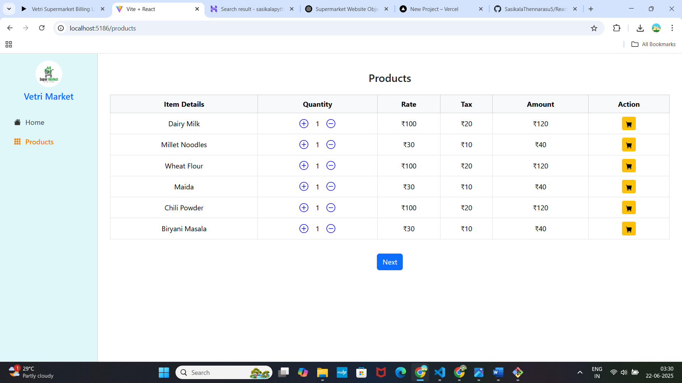

**// File: src/pages/Products.jsx**

**import React, { useState } from 'react';**

**import { useNavigate } from 'react-router-dom';**

**import Button from 'react-bootstrap/Button';**

**import Form from 'react-bootstrap/Form';**

**import { PlusCircle, DashCircle,CartFill } from 'react-bootstrap-icons';**

**import { useCart } from '../context/CartContext';**

**const productList = [**

**{ id: 1, name: 'Dairy Milk', rate: 100, tax: 20 },**

**{ id: 2, name: 'Millet Noodles', rate: 30, tax: 10 },**

**{ id: 3, name: 'Wheat Flour', rate: 100, tax: 20 },**

**{ id: 4, name: 'Maida', rate: 30, tax: 10 },**

**{ id: 5, name: 'Chili Powder', rate: 100, tax: 20 },**

**{ id: 6, name: 'Biryani Masala', rate: 30, tax: 10 },**

**];**

**const Products = () => {**

**const navigate = useNavigate();**

**const { cart, setCart } = useCart();**

**const [quantities, setQuantities] = useState({});**

**const handleQtyChange = (id, value) => {**

**const qty = Math.max(1, parseInt(value) || 1);**

**setQuantities((prev) => ({ ...prev, [id]: qty }));**

**};**

**const addToCart = (product) => {**

**const qty = quantities[product.id] || 1;**

**const exists = cart.find((item) => item.id === product.id);**

**if (exists) {**

**alert(`${product.name} is already in cart!`);**

**return;**

**}**

**const newItem = {**

**...product,**

**qty,**

**};**

**setCart([...cart, newItem]);**

**alert(`${product.name} added to cart!`);**

**};**

**return (**

**<div className="container py-4">**

**<h4 className="mb-4 text-center">Products</h4>**

**<div className="table-responsive">**

**<table className="table table-bordered text-center align-middle">**

**<thead className="table-light">**

**<tr>**

**<th>Item Details</th>**

**<th>Quantity</th>**

**<th>Rate</th>**

**<th>Tax</th>**

**<th>Amount</th>**

**<th>Action</th>**

**</tr>**

**</thead>**

**<tbody>**

**{productList.map((product) => {**

**const qty = quantities[product.id] || 1;**

**const totalAmount = (product.rate + product.tax) * qty;**

**return (**

**<tr key={product.id}>**

**<td>{product.name}</td>**

**<td style={{ maxWidth: '100px' }}>**

**<div className="d-flex justify-content-center align-items-center gap-3">**

**<PlusCircle**

**size={20}**

**color="blue"**

**style={{ cursor: 'pointer' }}**

**onClick={() =>**

**setQuantities((prev) => ({**

**...prev,**

**[product.id]: (prev[product.id] || 1) + 1,**

**}))**

**}**

**/>**

**<span>{qty}</span>**

**<DashCircle**

**size={20}**

**color="blue"**

**style={{ cursor: 'pointer' }}**

**onClick={() =>**

**setQuantities((prev) => ({**

**...prev,**

**[product.id]: Math.max(1, (prev[product.id] || 1) - 1),**

**}))**

**}**

**/>**

**</div>**

**</td>**

**<td>₹{product.rate}</td>**

**<td>₹{product.tax}</td>**

**<td>₹{totalAmount}</td>**

**<td>**

**<Button**

**variant="warning"**

**size="sm"**

**onClick={() => addToCart(product)}**

**>**

**<CartFill />**

**</Button>**

**</td>**

**</tr>**

**);**

**})}**

**</tbody>**

**</table>**

**</div>**

**<div className="text-center mt-3">**

**<Button variant="primary" onClick={() => navigate('/')}>**

**Next**

**</Button>**

**</div>**

**</div>**

**);**

**};**

**export default Products;**

**Billing.html:**

[**https://github.com/SasikalaThennarasu5/Webdevelopment/blob/main/Prototype/VetriSuperMarket/VetriSuperMarket/src/pages/Billing.jsx**](https://github.com/SasikalaThennarasu5/Webdevelopment/blob/main/Prototype/VetriSuperMarket/VetriSuperMarket/src/pages/Billing.jsx)

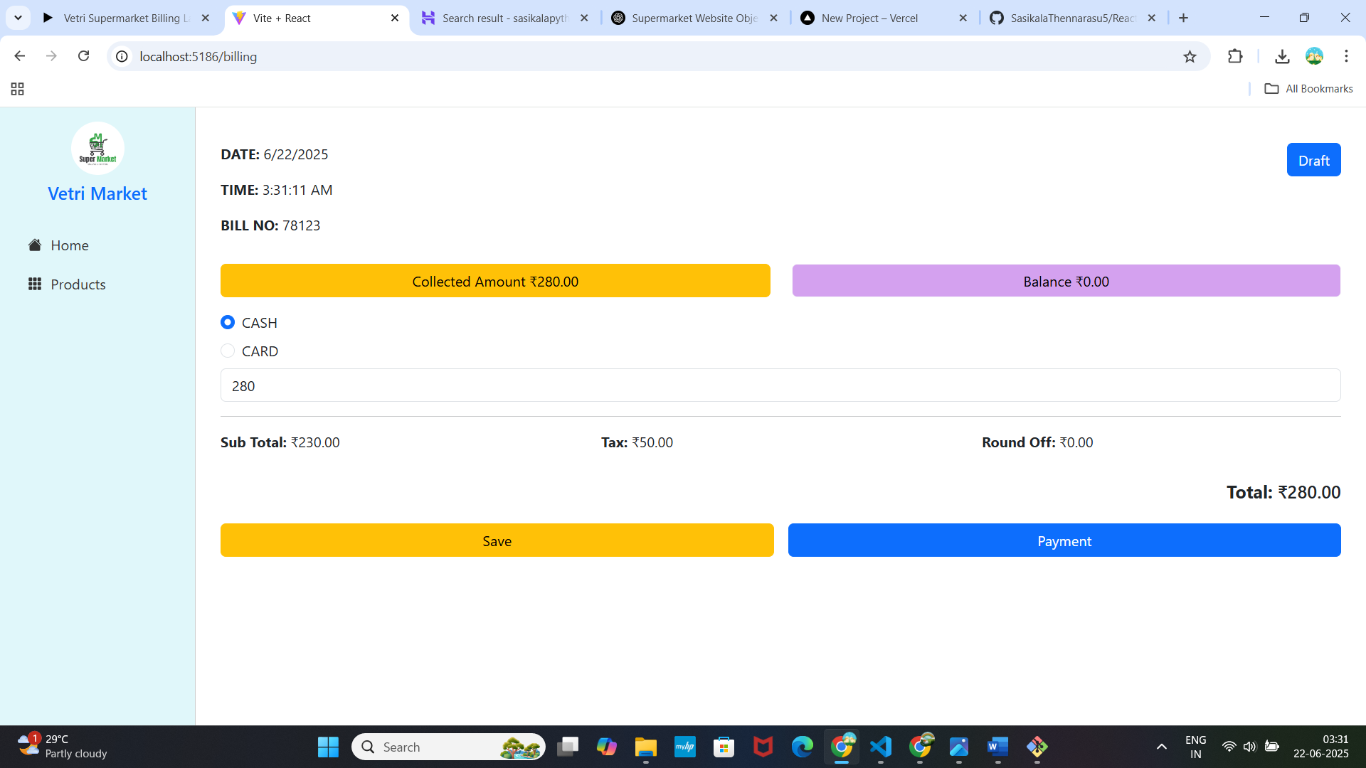

**// File: src/pages/Billing.jsx**

**import React, { useState } from 'react';**

**import { useNavigate } from 'react-router-dom';**

**import { useCart } from '../context/CartContext';**

**import Button from 'react-bootstrap/Button';**

**const Billing = () => {**

**const navigate = useNavigate();**

**const { cart } = useCart();**

**const subtotal = cart.reduce((sum, item) => sum + item.rate * item.qty, 0);**

**const tax = cart.reduce((sum, item) => sum + item.tax * item.qty, 0);**

**const roundOff = 0;**

**const total = subtotal + tax + roundOff;**

**const [mode, setMode] = useState('CASH');**

**const [receivedAmount, setReceivedAmount] = useState(total);**

**const balance = receivedAmount - total;**

**return (**

**<div className="container py-4">**

**<div className="row mb-3">**

**<div className="col-md-6 col-12 mb-3 mb-md-0">**

**<p><strong>DATE:</strong> {new Date().toLocaleDateString()}</p>**

**<p><strong>TIME:</strong> {new Date().toLocaleTimeString()}</p>**

**<p><strong>BILL NO:</strong> 78123</p>**

**</div>**

**<div className="col-md-6 col-12 text-md-end text-start">**

**<Button variant="primary">Draft</Button>**

**</div>**

**</div>**

**<div className="row mb-3">**

**<div className="col-sm-6 col-12 mb-2 mb-sm-0">**

**<Button className="w-100" variant="warning">**

**Collected Amount ₹{total.toFixed(2)}**

**</Button>**

**</div>**

**<div className="col-sm-6 col-12">**

**<Button className="w-100" variant="light" style={{ backgroundColor: '#d4a1ef' }}>**

**Balance ₹{balance.toFixed(2)}**

**</Button>**

**</div>**

**</div>**

**<div className="mb-3">**

**<div className="form-check mb-2">**

**<input**

**className="form-check-input"**

**type="radio"**

**id="cash"**

**name="paymentMode"**

**checked={mode === 'CASH'}**

**onChange={() => setMode('CASH')}**

**/>**

**<label className="form-check-label" htmlFor="cash">CASH</label>**

**</div>**

**<div className="form-check mb-2">**

**<input**

**className="form-check-input"**

**type="radio"**

**id="card"**

**name="paymentMode"**

**checked={mode === 'CARD'}**

**onChange={() => setMode('CARD')}**

**/>**

**<label className="form-check-label" htmlFor="card">CARD</label>**

**</div>**

**<input**

**className="form-control"**

**type="number"**

**value={receivedAmount}**

**onChange={(e) => setReceivedAmount(+e.target.value)}**

**placeholder="Received Amount"**

**/>**

**</div>**

**<hr />**

**<div className="row mb-3">**

**<div className="col-12 col-md-4">**

**<p><strong>Sub Total:</strong> ₹{subtotal.toFixed(2)}</p>**

**</div>**

**<div className="col-12 col-md-4">**

**<p><strong>Tax:</strong> ₹{tax.toFixed(2)}</p>**

**</div>**

**<div className="col-12 col-md-4">**

**<p><strong>Round Off:</strong> ₹{roundOff.toFixed(2)}</p>**

**</div>**

**</div>**

**<div className="text-end mb-4">**

**<h5><strong>Total:</strong> ₹{total.toFixed(2)}</h5>**

**</div>**

**<div className="d-grid d-md-flex gap-3">**

**<Button variant="warning" className="w-100 w-md-auto">Save</Button>**

**<Button variant="primary" className="w-100 w-md-auto" onClick={() => navigate('/order-complete')}>**

**Payment**

**</Button>**

**</div>**

**</div>**

**);**

**};**

**export default Billing;**

**Invoice.html:**

[**https://github.com/SasikalaThennarasu5/Webdevelopment/blob/main/Prototype/VetriSuperMarket/VetriSuperMarket/src/pages/Invoice.jsx**](https://github.com/SasikalaThennarasu5/Webdevelopment/blob/main/Prototype/VetriSuperMarket/VetriSuperMarket/src/pages/Invoice.jsx)

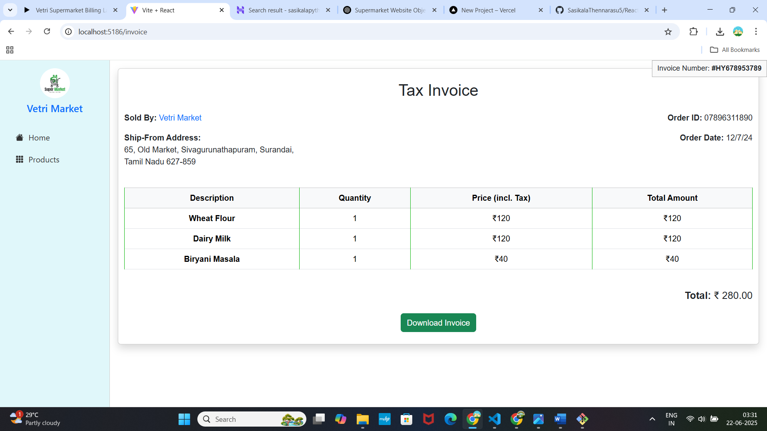

**// File: src/pages/Invoice.jsx**

**import React from 'react';**

**import { useNavigate } from 'react-router-dom';**

**import { useCart } from '../context/CartContext';**

**import Button from 'react-bootstrap/Button';**

**import autoTable from 'jspdf-autotable';**

**import jsPDF from 'jspdf'; // optional for tables**

**import '../styles/Invoice.css';**

**const Invoice = () => {**

**const navigate = useNavigate();**

**const { cart, customer } = useCart();**

**const totalAmount = cart.reduce(**

**(sum, item) => sum + (item.rate + item.tax) * item.qty,**

**0**

**);**

**const handleDownload = () => {**

**const doc = new jsPDF();**

**// Title**

**doc.setFontSize(18);**

**doc.text('Vetri Market - Tax Invoice', 14, 20);**

**// Customer Info**

**doc.setFontSize(12);**

**doc.text(`Invoice #: HY678953789`, 14, 30);**

**doc.text(`Customer: ${customer.name}`, 14, 40);**

**doc.text(`Address: ${customer.address}`, 14, 50);**

**doc.text(`Contact: ${customer.contact}`, 14, 60);**

**doc.text(`Date: ${customer.date}`, 14, 70);**

**// Table Data**

**const tableData = cart.map((item) => [**

**item.name,**

**item.qty,**

**item.rate + item.tax,**

**(item.rate + item.tax) * item.qty,**

**]);**

**autoTable(doc, {**

**startY: 80,**

**head: [['Item', 'Qty', 'Price (incl. Tax)', 'Total']],**

**body: tableData,**

**});**

**// Total**

**doc.text(`Total Amount: ₹${totalAmount.toFixed(2)}`, 14, doc.lastAutoTable.finalY + 10);**

**console.log("Generating PDF...");**

**// Save PDF**

**doc.save('invoice.pdf');**

**alert('Invoice downloaded successfully!');**

**navigate('/thank-you');**

**};**

**return (**

**<div className="container py-4 invoice-container shadow rounded bg-white">**

**<h2 className="text-center mb-4 invoice-title">Tax Invoice</h2>**

**<div className="row mb-4">**

**<div className="col-md-6">**

**<p><strong>Sold By:</strong> <span className="text-primary">Vetri Market</span></p>**

**<p><strong>Ship-From Address:</strong><br />**

**65, Old Market, Sivagurunathapuram, Surandai,<br />**

**Tamil Nadu 627-859**

**</p>**

**</div>**

**<div className="col-md-6 text-md-end mt-3 mt-md-0">**

**<p className="invoice-number-box">Invoice Number: <strong>#HY678953789</strong></p>**

**<p><strong>Order ID:</strong> 07896311890</p>**

**<p><strong>Order Date:</strong> {customer.date}</p>**

**</div>**

**</div>**

**<div className="table-responsive mb-4">**

**<table className="table table-bordered text-center invoice-table">**

**<thead className="table-light">**

**<tr>**

**<th>Description</th>**

**<th>Quantity</th>**

**<th>Price (incl. Tax)</th>**

**<th>Total Amount</th>**

**</tr>**

**</thead>**

**<tbody>**

**{cart.map((item, index) => (**

**<tr key={index}>**

**<td><strong>{item.name}</strong></td>**

**<td>{item.qty}</td>**

**<td>₹{item.rate + item.tax}</td>**

**<td>₹{(item.rate + item.tax) * item.qty}</td>**

**</tr>**

**))}**

**</tbody>**

**</table>**

**</div>**

**<div className="text-end mb-4">**

**<h5><strong>Total:</strong> ₹ {totalAmount.toFixed(2)}</h5>**

**</div>**

**<div className="text-center">**

**<Button variant="success" onClick={handleDownload}>**

**Download Invoice**

**</Button>**

**</div>**

**</div>**

**);**

**};**

**export default Invoice;**

**Order Complete.html:**

[**https://github.com/SasikalaThennarasu5/Webdevelopment/blob/main/Prototype/VetriSuperMarket/VetriSuperMarket/src/pages/OrderComplete.jsx**](https://github.com/SasikalaThennarasu5/Webdevelopment/blob/main/Prototype/VetriSuperMarket/VetriSuperMarket/src/pages/OrderComplete.jsx)

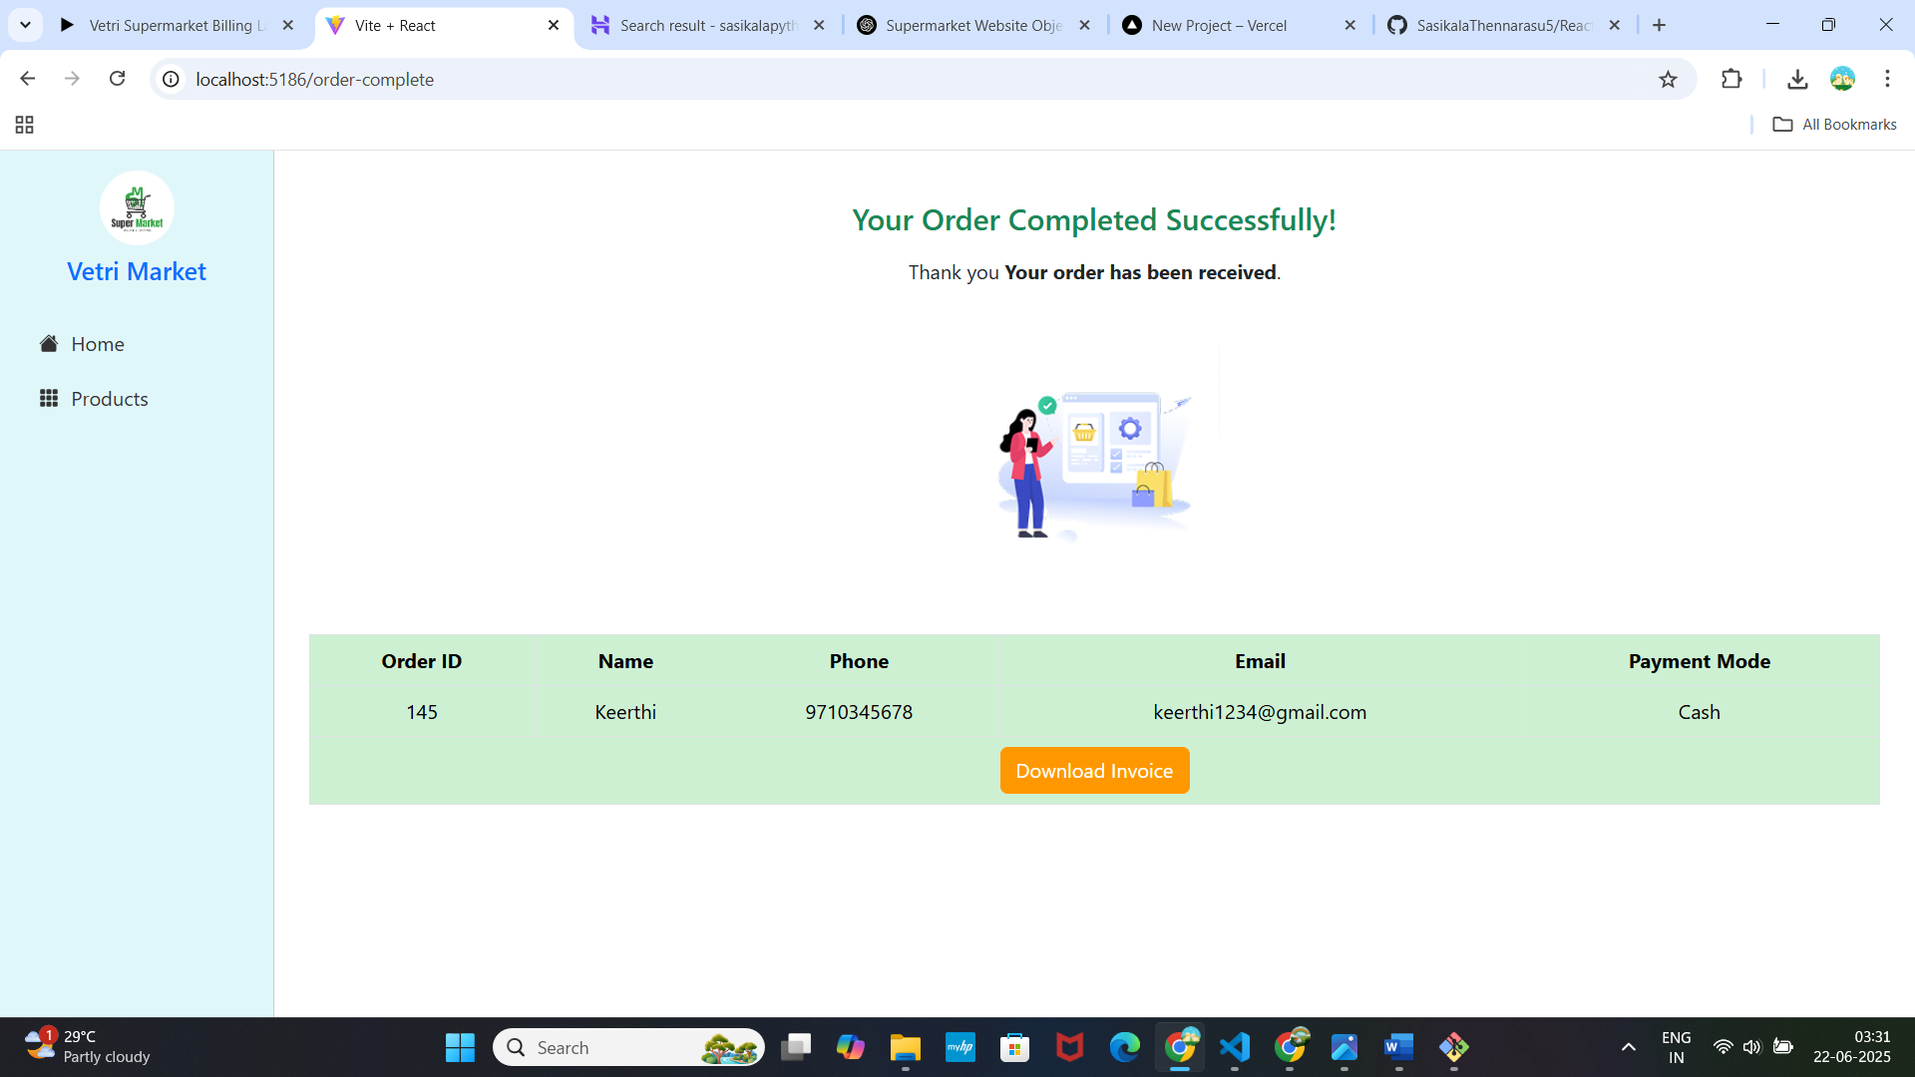

**import React from 'react';**

**import { useNavigate } from 'react-router-dom';**

**import Button from 'react-bootstrap/Button';**

**const OrderComplete = () => {**

**const navigate = useNavigate();**

**const cellStyle = { backgroundColor: '#CEF0D2' };**

**return (**

**<div className="container py-4 text-center">**

**<h4 className="text-success mb-3">Your Order Completed Successfully!</h4>**

**<p>Thank you <strong>Your order has been received</strong>.</p>**

**<div className="my-4">**

**<img**

**src="/images/completed.png"**

**alt="Thank You"**

**className="img-fluid my-4"**

**style={{ maxWidth: '200px' }}**

**/>**

**</div>**

**{/* 2x5 Summary Table */}**

**<div className="table-responsive mb-4">**

**<table className="table table-bordered text-center">**

**<thead>**

**<tr>**

**<th style={cellStyle}>Order ID</th>**

**<th style={cellStyle}>Name</th>**

**<th style={cellStyle}>Phone</th>**

**<th style={cellStyle}>Email</th>**

**<th style={cellStyle}>Payment Mode</th>**

**</tr>**

**</thead>**

**<tbody>**

**<tr>**

**<td style={cellStyle}>145</td>**

**<td style={cellStyle}>Keerthi</td>**

**<td style={cellStyle}>9710345678</td>**

**<td style={cellStyle}>keerthi1234@gmail.com</td>**

**<td style={cellStyle}>Cash</td>**

**</tr>**

**<tr>**

**<td colSpan={5} style={cellStyle}>**

**<Button**

**style={{**

**backgroundColor: '#FF9800',**

**borderColor: '#FF9800',**

**color: 'white',**

**}}**

**onClick={() => navigate('/invoice')}**

**>**

**Download Invoice**

**</Button>**

**</td>**

**</tr>**

**</tbody>**

**</table>**

**</div>**

**</div>**

**);**

**};**

**export default OrderComplete;**

**Thankyou.html:**

[**https://github.com/SasikalaThennarasu5/Webdevelopment/blob/main/Prototype/VetriSuperMarket/VetriSuperMarket/src/pages/ThankYou.jsx**](https://github.com/SasikalaThennarasu5/Webdevelopment/blob/main/Prototype/VetriSuperMarket/VetriSuperMarket/src/pages/ThankYou.jsx)

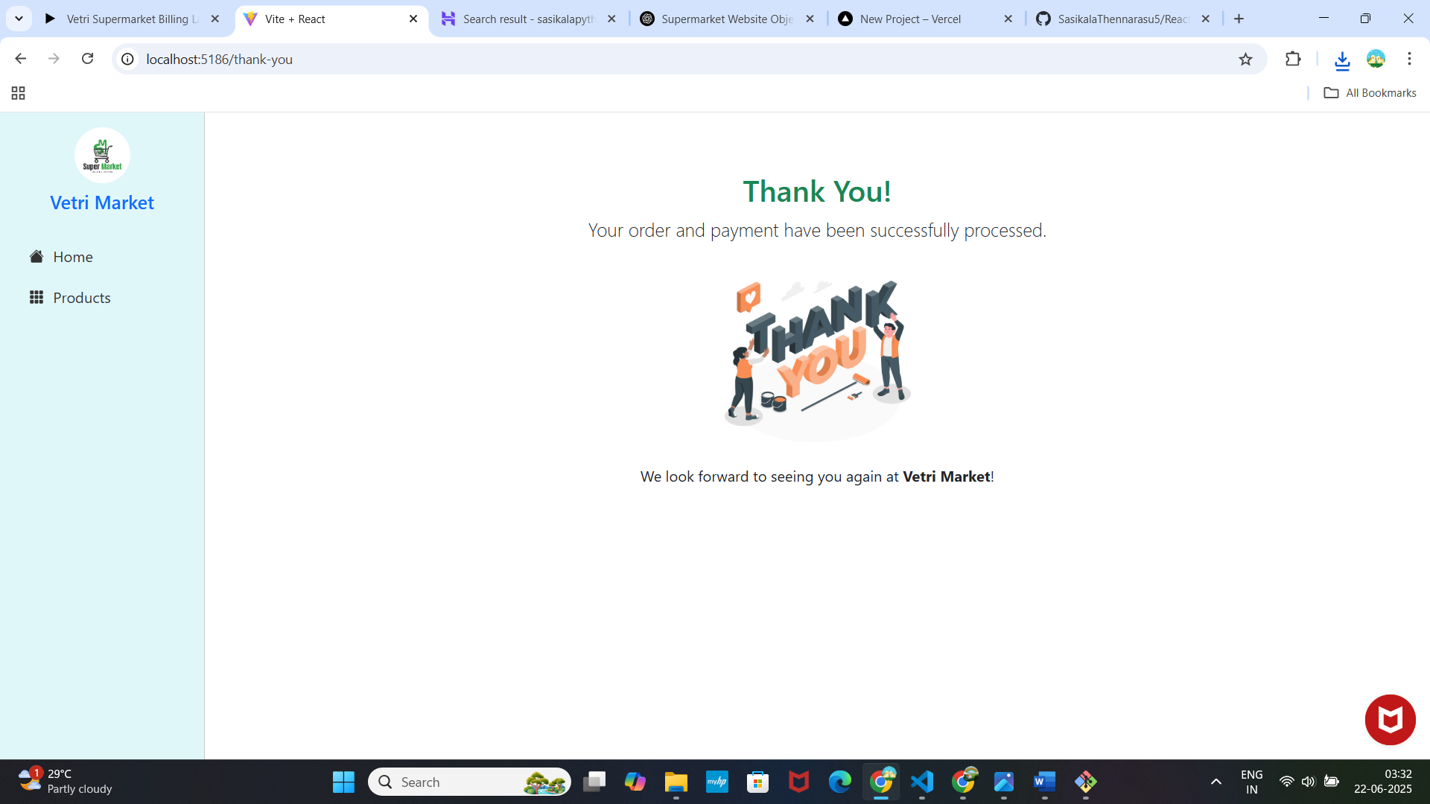

**// File: src/pages/ThankYou.jsx**

**import React from 'react';**

**const ThankYou = () => {**

**return (**

**<div className="container text-center py-5">**

**<h2 className="text-success">Thank You!</h2>**

**<p className="lead">Your order and payment have been successfully processed.</p>**

**<img src="/images/thank you.png" alt="Thank You" className="img-fluid my-4" style={{ maxWidth: '200px' }} />**

**<p>We look forward to seeing you again at <strong>Vetri Market</strong>!</p>**

**</div>**

**);**

**};**

**export default ThankYou;**

**sidebar.jsx:**

**import React from 'react';**

**import { NavLink } from 'react-router-dom';**

**import { HouseFill, Grid3x3GapFill } from 'react-bootstrap-icons';**

**import '../styles/Sidebar.css';**

**const Sidebar = () => {**

**return (**

**<div className="sidebar-custom p-3 d-flex flex-column min-vh-100">**

**<div className="text-center mb-4">**

**<img src="/images/logo.png" alt="Logo" className="rounded-circle mb-2" width="60" height="60" />**

**<h5 className="m-0 text-primary">Vetri Market</h5>**

**</div>**

**<NavLink**

**to="/"**

**className={({ isActive }) =>**

**`nav-link-custom ${isActive ? 'active' : ''}`**

**}**

**>**

**<HouseFill /> Home**

**</NavLink>**

**<NavLink**

**to="/products"**

**className={({ isActive }) =>**

**`nav-link-custom ${isActive ? 'active' : ''}`**

**}**

**>**

**<Grid3x3GapFill /> Products**

**</NavLink>**

**</div>**

**);**

**};**

**export default Sidebar;**

**CartContext.jsx:**

**import { createContext, useContext, useState } from 'react';**

**const CartContext = createContext();**

**export const useCart = () => useContext(CartContext);**

**export const CartProvider = ({ children }) => {**

**const [customer, setCustomer] = useState({**

**name: 'Priya',**

**contact: '8910866713',**

**address: '12, Cross Cut Road, Chennai.',**

**date: '12/7/24',**

**});**

**const [cart, setCart] = useState([]);**

**return (**

**<CartContext.Provider value={{ customer, setCustomer, cart, setCart }}>**

**{children}**

**</CartContext.Provider>**

**);**

**};**

**8. Conclusion**

The Super Market Website project successfully demonstrates the development of a modern, responsive e-commerce application using React. It provides users with a seamless shopping experience, allowing them to browse products, add items to a cart, and complete a checkout process efficiently. By implementing key features such as product listing, cart management, order confirmation, and optional authentication, the project meets its objectives of creating a user-friendly and interactive web solution for grocery shopping.

Overall, the project highlights strong frontend development skills, best practices in UI design, and practical knowledge of building single-page applications. It sets a foundation for future improvements such as backend integration, real-time inventory, and payment gateways.

**Prepared By:** T. Sasikala  
**Date:** 21-05-2025  
**Reviewed By:** Mahesh samuthiram  
**Approved By:** Mahesh samuthiram