**PROJECT NAME: AMAZON E-COMMERCE WEBSITE**

**Pages:**

Login / Sign up Page > Home page > Product Page > Buying options > Payment Gateway.

**Login page:** To login into a amazon website first we have to create an account.

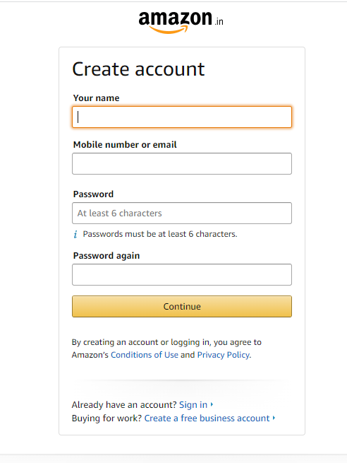

**Sign in Page** If you already created an account, just sign in with your mobile number.

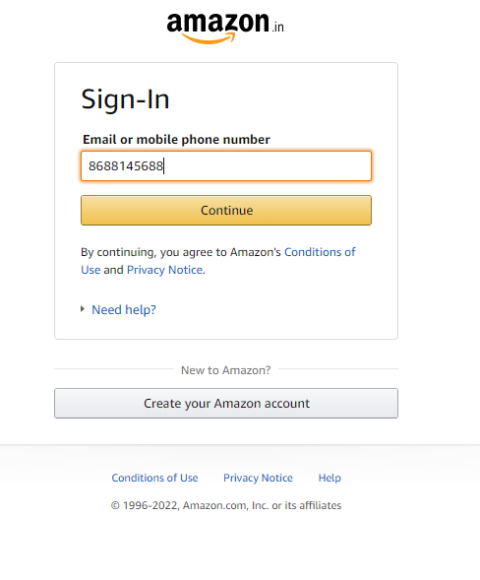

**Home page** The Homepage offers various navigating features including shopping, menu, find product, add to cart, payment etc. as shown in the below image.

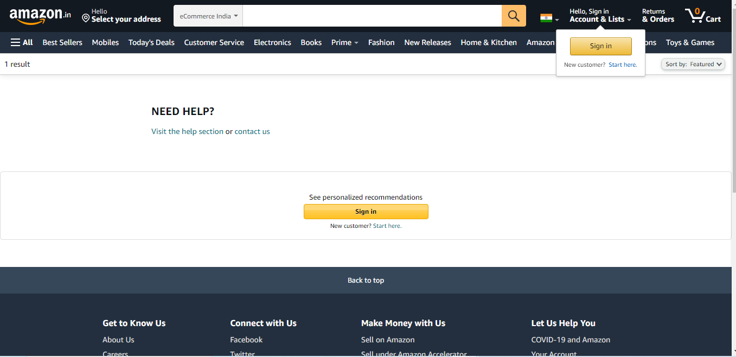

**Product Page** It contains different types of products like electronics, books, groceries, Accessories, amazon prime(video and audio).

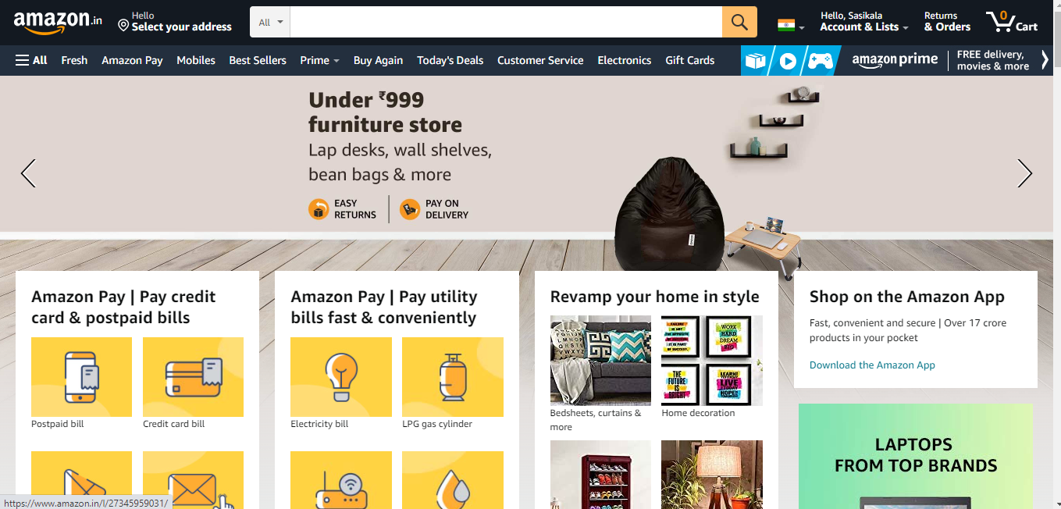

**Buying options/Add to cart**: Select the particular item which it is useful to the customer and add to cart.

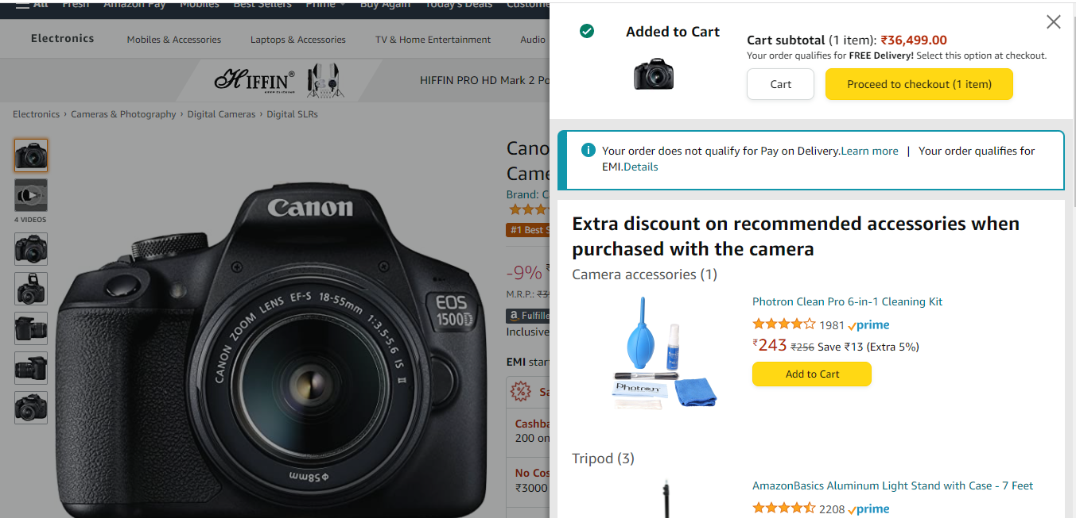

**Payment Gateway**: Mention the address details and proceed to pay.

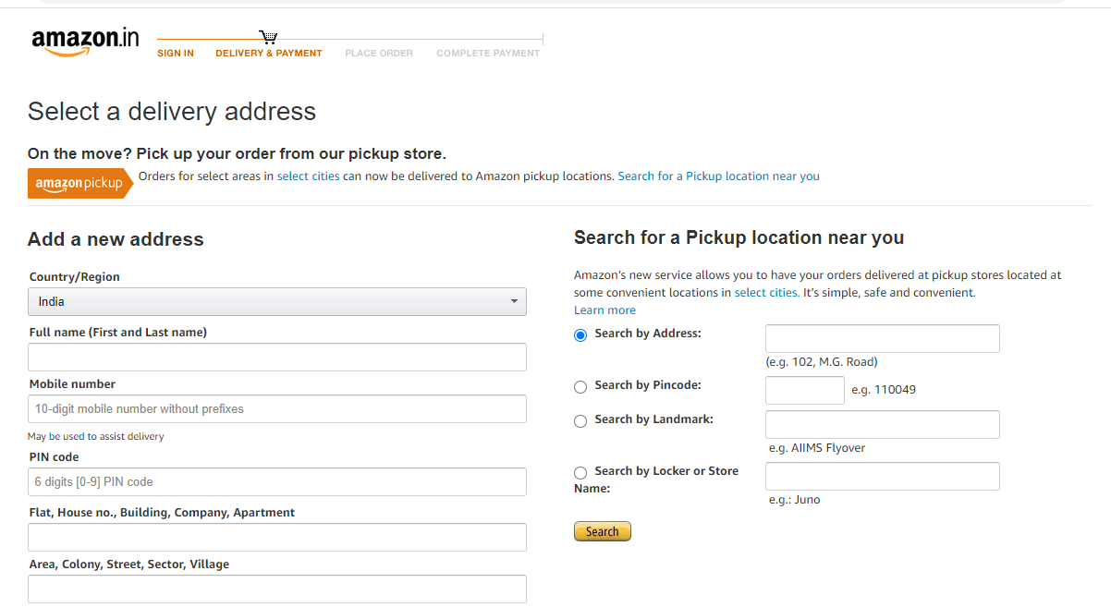

**Delivery:** The product is delivered to the end user.

**Technologies used:**

**Front-end:**

* HTML5
* CSS3
* JAVASCRIPT
* BOOTSTRAP
* Reactjs

**Back-end:**

* Nodejs
* Expressjs

**Database:**

* Mangodb.

**Created by**

**Sasikala Pemmanaboidi**