Healthcare Management:
Patient Readmission Prediction
Excel Exploratory Data Analysis (EDA) Report

1. Executive Summary
This report documents the Excel-based exploratory data analysis performed for the Healthcare Management: Patient Readmission Prediction project using the cleaned UCI Diabetes hospital-encounter dataset.
The objective of this phase was to understand the structure and distribution of the data, summarize important numerical variables, examine readmission patterns by age and gender, describe race composition, and validate the 30-day readmission target before progressing to SQL analysis.

2. Analytical Definition
The unit of analysis is a hospital encounter. Each row represents an encounter, not necessarily a unique patient; therefore, counts in this report are encounter counts unless explicitly stated otherwise.
Readmission means a subsequent hospital admission after discharge from the preceding hospitalization. The project target defines a 30-day readmission as 1 when the subsequent admission occurs within 30 days after discharge, and 0 for NO or >30-day readmission.

3. Descriptive Statistics
Excel Data Analysis ToolPak was used to generate descriptive statistics for key numerical variables. The output included mean, standard error, median, mode, standard deviation, sample variance, kurtosis, skewness, range, minimum, maximum, sum, count, and the 95% confidence-level margin of error.
Variable | Mean | Median | Mode | Std. Dev. | Skewness | Min | Max
time_in_hospital | 4.396 | 4 | 3 | 2.985 | 1.134 | 1 | 14
num_lab_procedures | 43.096 | 44 | 1 | 19.674 | -0.237 | 1 | 132
num_procedures | 1.340 | 1 | 0 | 1.705 | 1.316 | 0 | 6
num_medications | 16.021 | 15 | 0 | 8.128 | 1.327 | 1 | 81
number_outpatient | 0.369 | 0 | 0 | 1.267 | 8.833 | 0 | 42
number_emergency | 0.198 | 0 | 0 | 0.930 | 22.856 | 0 | 76
number_inpatient | 0.635 | 0 | 0 | 1.263 | 3.614 | 0 | 21
number_diagnoses | 7.423 | 8 | 9 | 1.934 | -0.877 | 1 | 16

3.1 Key Findings
- The average hospital stay was 4.40 days, with a median of 4 days and a standard deviation of 2.99 days.
- Hospital length of stay had positive skewness of 1.13, indicating a right-skewed distribution with a longer upper tail.
- Laboratory procedures had a mean of 43.10 and median of 44, with skewness close to zero, indicating comparatively limited asymmetry.
- Procedure and medication counts were positively skewed, indicating that a smaller number of encounters had relatively high counts.
- Prior outpatient, emergency, and inpatient utilization had a median of zero, meaning zero prior visits were typical in these variables.
- Prior emergency utilization was extremely right-skewed (22.86), with most encounters near zero and a small number having much higher utilization.
- The number of diagnoses had a mean of 7.42 and median of 8, with negative skewness of approximately -0.88.
Important interpretation note: a mean that is close to the median does not prove that there are no outliers. Outliers require additional assessment using visualizations or IQR/percentile-based methods.

4. Distribution Analysis
Three targeted histograms were created to examine variables with different distributional characteristics.

Hospital Length of Stay
The distribution was concentrated toward shorter stays and declined as length of stay increased. The right tail was consistent with the positive skewness of 1.13 and the relationship Mode (3) < Median (4) < Mean (4.40).

Prior Emergency Visits
The distribution was extremely concentrated near zero. A small number of encounters extended to much higher prior emergency-visit counts, consistent with skewness of 22.86.

Number of Medications
The distribution showed moderate positive skewness. Encounter frequency concentrated around moderate medication counts and declined toward higher counts, consistent with a mean of 16.02, median of 15, and skewness of 1.33.

5. 30-Day Readmission by Age Group and Gender
A PivotTable was used to calculate 30-day readmission counts, total encounters, and readmission rates by age group and gender. Because readmitted_30d is binary, its sum represents the number of 30-day readmissions and its average represents the readmission proportion.
Age Group | Female Readm. | Female Enc. | Female Rate | Male Readm. | Male Enc. | Male Rate | Total Readm. | Total Enc. | Overall Rate
[0-10) | 1 | 83 | 1.20% | 2 | 78 | 2.56% | 3 | 161 | 1.86%
[10-20) | 24 | 402 | 5.97% | 16 | 289 | 5.54% | 40 | 691 | 5.79%
[20-30) | 177 | 1114 | 15.89% | 59 | 543 | 10.87% | 236 | 1657 | 14.24%
[30-40) | 242 | 2162 | 11.19% | 182 | 1613 | 11.28% | 424 | 3775 | 11.23%
[40-50) | 511 | 4811 | 10.62% | 516 | 4874 | 10.59% | 1027 | 9685 | 10.60%
[50-60) | 851 | 8572 | 9.93% | 817 | 8684 | 9.41% | 1668 | 17256 | 9.67%
[60-70) | 1206 | 11061 | 10.90% | 1296 | 11421 | 11.35% | 2502 | 22483 | 11.13%
[70-80) | 1635 | 13985 | 11.69% | 1434 | 12081 | 11.87% | 3069 | 26068 | 11.77%
[80-90) | 1282 | 10515 | 12.19% | 796 | 6682 | 11.91% | 2078 | 17197 | 12.08%
[90-100) | 223 | 2003 | 11.13% | 87 | 790 | 11.01% | 310 | 2793 | 11.10%
Total | 6152 | 54708 | 11.25% | 5205 | 47055 | 11.06% | 11357 | 101766 | 11.16%
Overall, 11,357 of 101,766 encounters were classified as 30-day readmissions, giving an overall rate of 11.16%. Female encounters had an overall rate of 11.25%, compared with 11.06% for male encounters. The largest age-group rate was observed in [20-30) at 14.24%, while the largest absolute number of 30-day readmissions occurred in [70-80) with 3,069.
These are descriptive findings only. The analysis does not establish causality or statistical significance. The Unknown gender category contains only three encounters and should not be used for substantive interpretation.

6. Race Distribution
Race | Encounters | Approx. Share
Caucasian | 76,099 | 74.78%
AfricanAmerican | 19,210 | 18.88%
Unknown | 2,273 | 2.23%
Hispanic | 2,037 | 2.00%
Other | 1,506 | 1.48%
Asian | 641 | 0.63%
The dataset is predominantly composed of Caucasian encounters (76,099), followed by AfricanAmerican encounters (19,210). The remaining categories represent substantially smaller portions of the dataset. This describes dataset composition and should not be interpreted as evidence of different readmission risk by race.
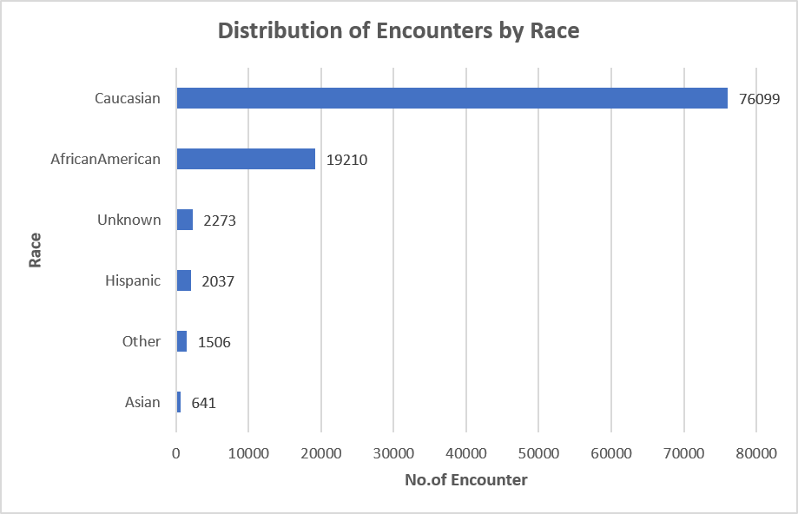

7. Distribution of Original Readmission Categories
Readmission Category | Encounters | Share
<30 | 11,357 | 11.16%
>30 | 35,545 | 34.92%
NO | 54,864 | 53.92%
Total | 101,766 | 100.00%
More than half of the encounters (53.92%) had no recorded readmission, 34.92% had a subsequent readmission after 30 days, and 11.16% had a readmission within 30 days.
The 11,357 observations in the original <30 category exactly match the 11,357 observations identified by the engineered readmitted_30d target, providing an internal consistency check.
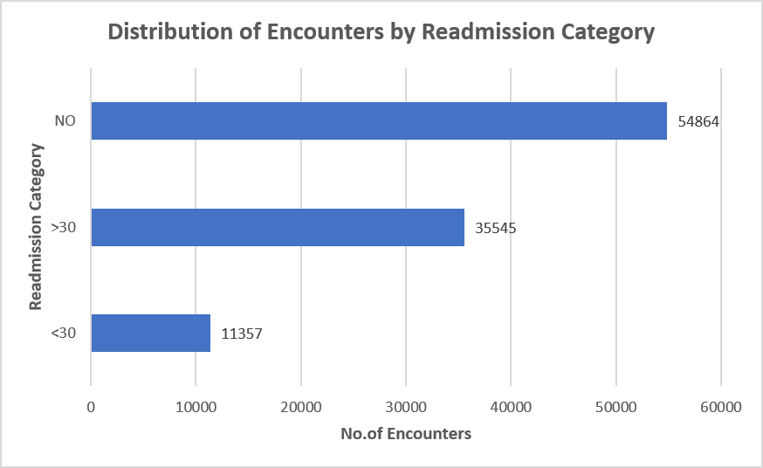

8. Overall EDA Conclusions
- The Excel EDA established the distributional profile of key encounter-level variables.
- Hospital stay, procedure count, medication count, and prior utilization variables show varying degrees of positive skewness.
- Prior emergency utilization is particularly skewed, with most encounters having no prior emergency visits.
- The overall 30-day readmission rate is 11.16% across 101,766 encounters.
- Female and male overall 30-day readmission rates are similar, although differences vary by age group.
- The race distribution is highly concentrated in the Caucasian category; this is a dataset-composition finding rather than a risk conclusion.
- The original readmission category and engineered binary target are consistent, with 11,357 <30 encounters corresponding to readmitted_30d = 1.

9. Transition to SQL
The Excel-based exploratory data analysis established the initial analytical foundation for the Patient Readmission Prediction project. The analysis examined the distribution and characteristics of key clinical and encounter-level variables, identified important patterns in hospital utilization, and evaluated 30-day readmission patterns across demographic groups.
The next phase will extend this analysis using SQL for structured data management, encounter-level aggregation, KPI development, and reproducible analytical queries. Subsequent phases will incorporate Python-based statistical analysis and machine learning, followed by Tableau-based visualization and executive reporting.
Together, these stages form an end-to-end healthcare analytics workflow designed to support identification of patients at elevated risk of 30-day hospital readmission.

Appendix A. Interpretation Guide for the Main Descriptive Statistics
Statistic | Meaning
Mean | Average value of the observations.
Standard Error | Measures the precision of the estimated sample mean; it is not the average error of individual observations.
Median | Middle observation after ordering the data.
Mode | Most frequently occurring value.
Standard Deviation | Measures how dispersed individual observations are around the mean.
Sample Variance | Squared measure of sample dispersion.
Kurtosis | Excel ToolPak excess kurtosis; positive values indicate heavier tails than a normal distribution.
Skewness | Measures asymmetry; positive values indicate a longer right tail and negative values a longer left tail.
Range | Maximum minus minimum.
Minimum | Smallest observed value.
Maximum | Largest observed value.
Sum | Total of all observations.
Count | Number of non-missing observations used in the calculation.
Confidence Level (95%) | Excel ToolPak margin of error around the estimated mean at the 95% confidence level.

