Healthcare Management:
Patient Readmission Prediction
SQL Data Management & Validation Report

1. Purpose of the SQL Phase
The SQL phase establishes a structured, reproducible analytical environment for the cleaned hospital-encounter dataset. The objective is to use MySQL for data storage, validation, aggregation, KPI calculation, and healthcare readmission analysis.
The primary analytical outcome remains 30-day readmission, represented by the binary field readmitted_30d, where 1 indicates a readmission within 30 days after discharge and 0 represents NO or greater-than-30-day readmission.

2. SQL Environment
Component | Configuration
DBMS | MySQL
Client Tool | MySQL Workbench
Database | Healthcare_Mangement
Main Analytical Table | diabetic_data
Source Dataset | Cleaned diabetic hospital-encounter CSV

3. Dataset and Table Structure
The cleaned source dataset contains 101,766 hospital encounters and 51 variables. A dedicated MySQL table named diabetic_data was created to store the dataset.
The schema was designed according to the semantic meaning of the variables rather than storing every field as text. Numeric utilization and count variables were assigned integer types, while categorical and clinical-code fields were stored as character data.
Field / Group | MySQL Type | Reason
encounter_id | BIGINT | Unique encounter identifier.
patient_nbr | BIGINT | Patient identifier; may occur across multiple encounters.
age | VARCHAR(20) | Age is stored as bracketed categories such as [70-80).
diag_1 / diag_2 / diag_3 | VARCHAR(20) | ICD-9 diagnosis codes can contain numeric and alphabetic characters.
Medication fields | VARCHAR(20) | Categorical values such as No, Steady, Up and Down.
readmitted | VARCHAR(20) | Original three-category readmission field.
readmitted_30d | TINYINT | Binary project target: 0 or 1.

4. CSV Import Process
The cleaned CSV was imported into the diabetic_data table after the table schema was created and validated.

4.1 Initial Import Issue
The MySQL Workbench Table Data Import Wizard initially failed with the error "Column 'metformin-pioglitazone' specified twice." The table remained empty after the failed attempt; a row-count check confirmed 0 imported rows.

4.2 Schema Correction
During schema verification, it was identified that the medication field glimepiride-pioglitazone had not initially been included. The missing column was added with VARCHAR(20), positioned between glipizide-metformin and metformin-rosiglitazone.
The schema was rechecked using DESCRIBE diabetic_data. The required 51-column structure was present, including glimepiride-pioglitazone and the final readmitted_30d target.

4.3 Successful Import
The CSV was subsequently loaded successfully using MySQL's local file-loading mechanism. The final imported row count was 101,766.

5. SQL Data Validation
Before starting analytical SQL tasks, the imported table was independently validated against the results already established during the Excel phase.
Validation Check | Result | Status
Total rows | 101,766 | Matched
Unique encounter_id values | 101,766 | Matched
Duplicate encounter IDs | 0 | Matched
readmitted_30d = 0 | 90,409 | Matched
readmitted_30d = 1 | 11,357 | Matched
30-day readmission rate | 11.16% | Matched
Race distribution | Matched Excel results | Matched
Missing-value checks | Matched expected results | Matched

6. Target Validation
The binary target readmitted_30d was validated using a grouped frequency query. The dataset contains 11,357 encounters with readmitted_30d = 1 and 90,409 encounters with readmitted_30d = 0.
The SQL calculation independently reproduced the overall 30-day readmission rate of 11.16%, which is consistent with the Excel EDA.
This cross-tool agreement provides an important reproducibility check: the core outcome metric is consistent between the spreadsheet analysis and the SQL database.

7. Data Quality and Modeling Principles Established
- Hospital encounters are the primary unit of analysis. Total encounters should not automatically be described as the number of unique patients.
- encounter_id is unique across the 101,766 records in the imported analytical table.
- Clinical diagnosis codes are stored as text because ICD-9 codes may contain alphabetic characters.
- Age remains a categorical bracket rather than being incorrectly cast directly to an integer.
- Categorical medication variables are stored as text.
- The engineered readmitted_30d variable is stored as a binary numeric field.
- Unknown and NULL are treated as conceptually different: Unknown is an intentional category, while NULL represents unavailable information.
- SQL validation is performed before analytical queries to establish data integrity and reproducibility.

8. SQL-Based Healthcare Analysis

Total Hospital encounters are represented in the dataset
Business Objective
Determine the total volume of hospital encounters available for analysis.
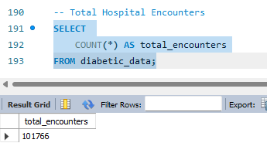

Finding:
The dataset contains 101,766 hospital encounters available for analysis.

Most frequently recorded diagnoses among hospital encounters.
Business Objective
Identify the 10 most frequently recorded diagnosis codes across hospital encounters by combining the primary,
secondary, and additional diagnosis fields (diag_1, diag_2, and diag_3).
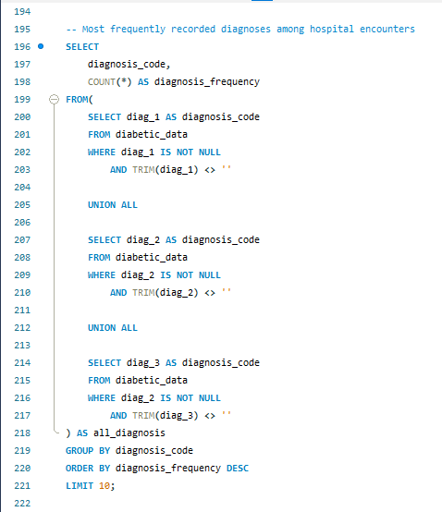

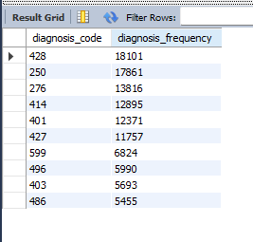
Finding:
Diagnosis code 428 was the most frequently recorded diagnosis across the three diagnosis fields, appearing 18,101
times, followed by codes 250 and 276 with 17,861 and 13,816 occurrences, respectively.

Calculate the average length of hospital stay for each admission type
Business Objective:
Determine the average length of hospital stay across different admission types and compare hospitalization patterns by
admission category.
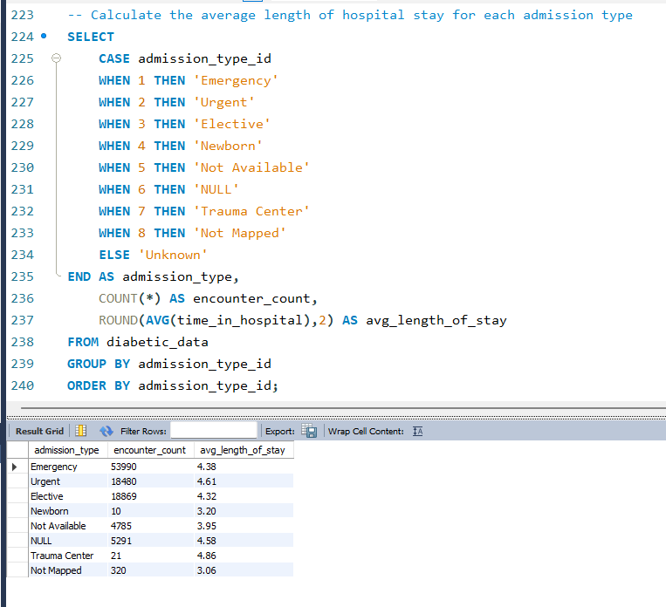

Finding:
Urgent admissions had an average hospital stay of 4.61 days, while Emergency admissions averaged 4.38 days and
Elective admissions averaged 4.32 days. Trauma Center encounters had the highest average stay at 4.86 days, although
only 21 encounters were recorded in this category.

Number of hospital encounters resulted in a 30-day readmission, and what percentage of all
encounters do they represent?
Business Objective:
Quantify the number of hospital encounters resulting in a 30-day readmission and calculate their proportion of total
hospital encounters.

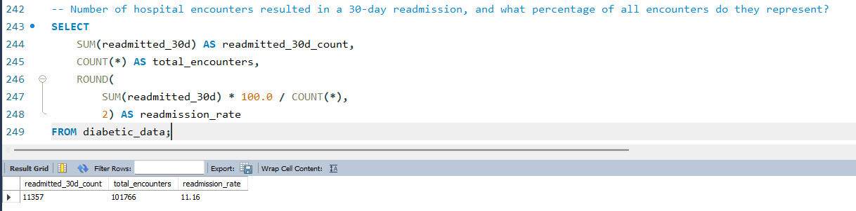

Finding:
Of the 101,766 hospital encounters in the dataset, 11,357 resulted in a 30-day readmission, representing 11.16% of all
encounters.

Important interpretation
This 11.16% is the encounter-level 30-day readmission rate, not necessarily the percentage of unique patients who were readmitted.
Hospital encounters distribution across different age groups

Business Objective:
Determine the distribution of hospital encounters across age groups to understand which age segments account for the
largest share of healthcare utilization in the dataset.

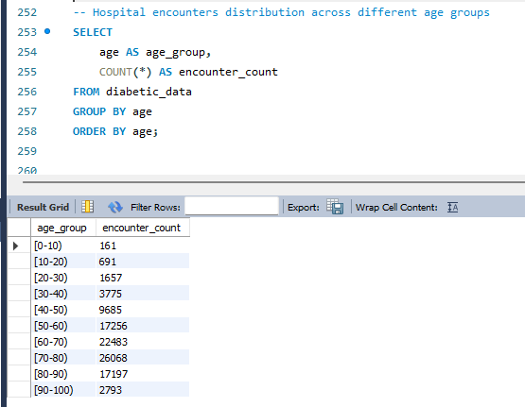

Finding:
Hospital encounters were concentrated among older age groups. The 70-80 age group recorded the highest number of
encounters with 26,068, followed by the 60-70 age group with 22,483 encounters. The 80-90 and 50-60 age groups
accounted for 17,197 and 17,256 encounters, respectively. In contrast, the younger age groups had substantially fewer
encounters, with the 0-10 age group recording only 161 encounters.

Most frequently performed procedures during Hospital encounters

Business Objective:
Determine the frequency of hospital encounters by the number of procedures performed, in order to understand the
distribution of procedural utilization across encounters.

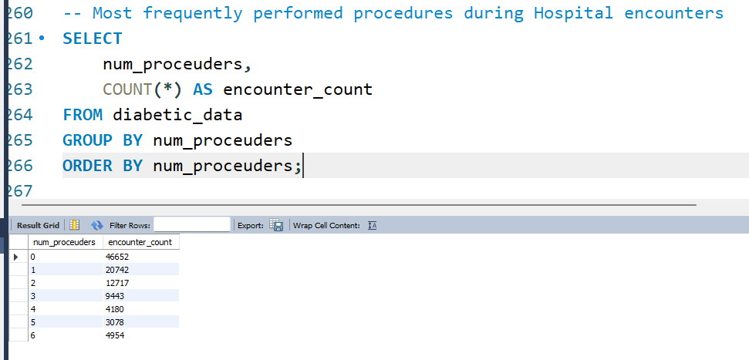

Finding:
Encounters with no recorded procedures were the most common, accounting for 46,652 of the 101,766 hospital
encounters. Encounters involving one procedure were the second most frequent category, with 20,742 encounters. The
frequency generally decline as the number of procedures increased, although 6-procedure encounters (4,954) were
more frequently than 4- and 5-procedure encounters.
Average number of medications prescribed vary across age groups

Business Objective:
Compare the average number of medications prescribed across different age groups to understand how medication
utilization varies with patient age.

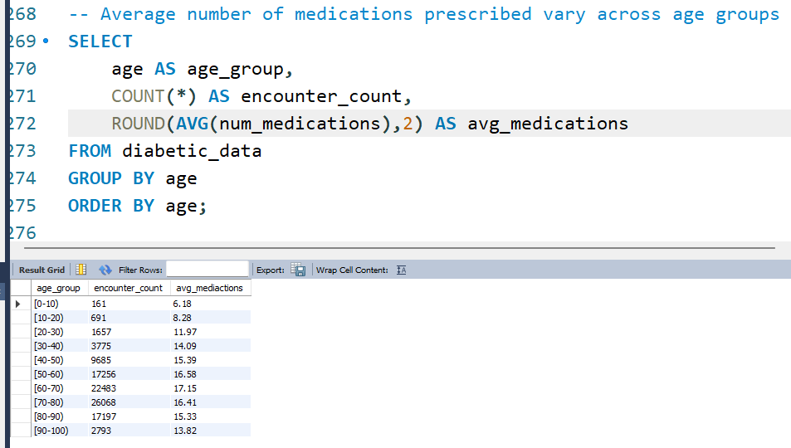

Finding:
Average medication utilization generally increased with age, rising from 6.18 medications per encounter in the [0-10)
age group to a peak off 17.15 medications in the [60-70) age group. Average medication utilization then declined
among older groups, reaching 13.82 medications per encounter in the [90-100) age group.

The distribution of readmission rates vary across different payer codes

Business Objective:
Compare 30-day readmission rates across payer-code categories to identify differences in readmission patterns
among encounters associated with different payer groups.
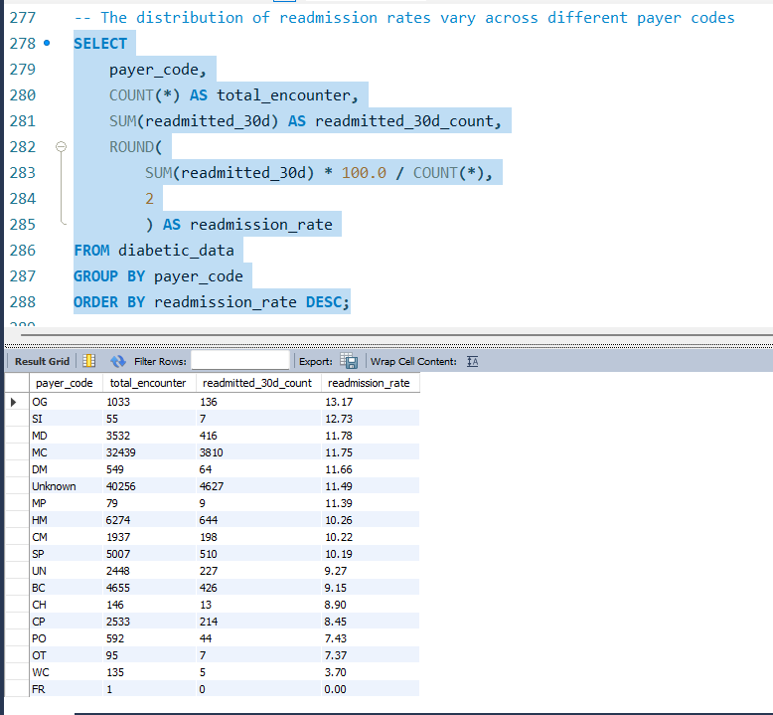

Finding:
30-day readmission rates varied across payer-code categories, ranging from 0.00% to 13.17%. Payer code OG had the
highest observed readmission rate at 13.17%, followed by SI at 12.73% and MD at 11.78%. In contrast, WC recorded a
rate of 3.70%, while FR recorded 0.00%.
5. Key Analytical Observations
- The SQL database contains 101,766 hospital encounters with unique encounter identifiers.
- The baseline 30-day readmission rate is 11.16%, based on 11,357 readmitted encounters.
- Hospital encounters are concentrated in older age groups, particularly [70-80) and [60-70).
- Encounters with zero recorded procedures are the most common procedure-count category.
- Average medication utilization peaks in [60-70) at 17.15 medications per encounter before declining in older age groups.
- Diagnosis code 428 is the most frequently recorded code across the three diagnosis fields.
- Payer-code readmission rates vary, but low-volume payer categories require caution because their rates are unstable.

6. Analytical Guardrails Applied
- Hospital encounter and unique patient are treated as different units of analysis.
- The binary readmitted_30d target is used consistently for 30-day readmission analysis.
- Age brackets are treated as categorical values rather than incorrectly converted directly to integers.
- Diagnosis-code frequency is distinguished from clinical interpretation of diagnosis codes.
- Procedure-count analysis is distinguished from procedure-name analysis because individual procedure codes are not present in num_procedures.
- Small sample sizes are considered before interpreting subgroup averages or rates.
- Descriptive SQL comparisons are not interpreted as causal relationships.

9. Healthcare Utilization & Patient Profile KPIs

Unique Patients VS Hospital Encounters
Business Objective:
Determine the number of unique patients represented in the dataset and compare it with the total number of hospital
encounters to understand the extent of repeat healthcare utilization.

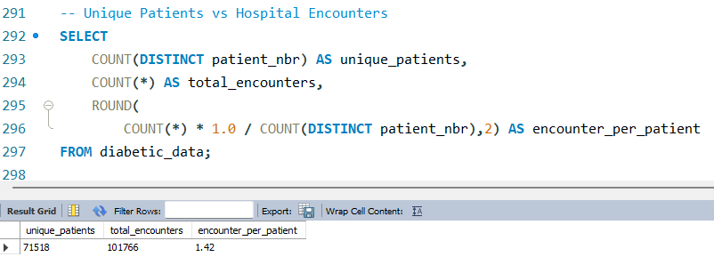

Finding:
The dataset contains 71,518 unique patients across 101,766 hospital encounters, resulting in an average of 1.42 encounters per patient. This indicates that the dataset includes repeat encounters for a portion of the patient population rather than representing one encounter per patient.
The Proportion of Hospital encounters involved an emergency visits
Business Objective:
Determine the proportion of hospital encounters associated with emergency utilization to understand
the role of emergency care within the overall encounter volume.
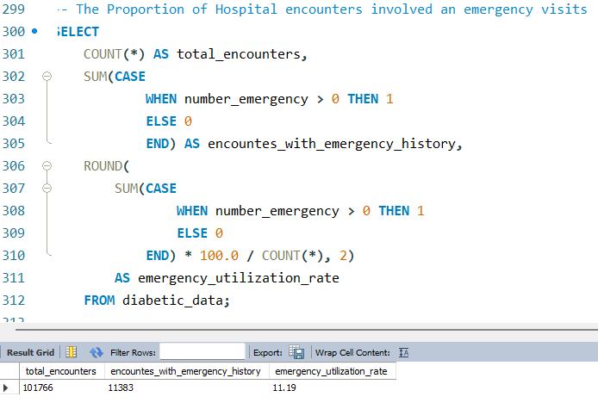

Finding:
Among the 101,766 hospital encounters, 11,383 were associated with patients who had at least one
prior emergency visit, representing 11.19% of all encounters.

The Proportion of hospital encounters involved patients with a history of prior inpatient visits
Business Objective:
Determine the proportion of hospital encounters associated with patients who had at least one prior
inpatient visit, providing an indicator of previous inpatient healthcare utilization.
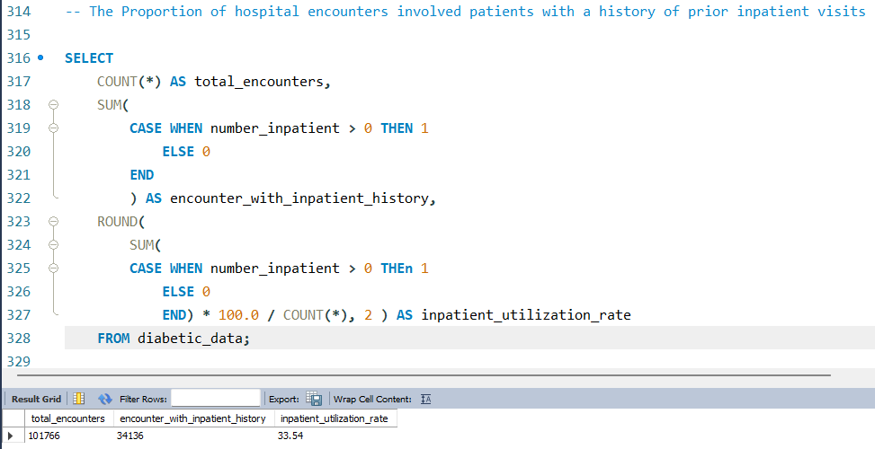

Finding:
Of the 101,766 hospital encounters, 34,136 involved patients who had at least one prior inpatient visit during the
preceding year, representing 33.54% of all encounters.

Total diagnosis codes are recorded per hospital encounter
Business Objective:
Determine the number of diagnosis codes documented across the three diagnosis fields (diag_1, diag_2,
and diag_3) for each hospital encounter to understand the level of diagnostic complexity represented in
the dataset.
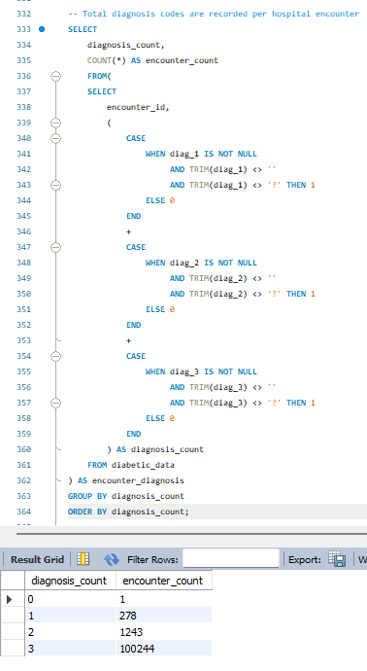

Finding:
Diagnosis documentation was highly concentrated at three recorded diagnosis codes per encounter. Of the 101,766 encounters, 100,244 (98.51%) contained three valid diagnosis codes, while 1,243 (1.22%) contained two and 278 (0.27%) contained one. Only one encounter had no valid diagnosis code recorded.
Medication Distribution across hospital encounters
Business Objective:
Determine the distribution of the number of medications prescribed during hospital encounters to understand the medication burden across the dataset.
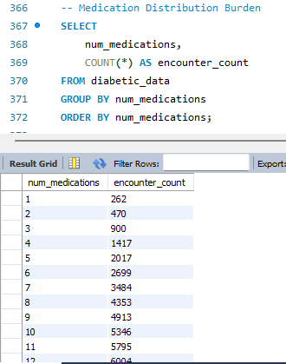

Findings:
Medication burden varied substantially across hospital encounters, ranging from 1 to 81 medications. The most frequently observed medication count was 13 medications, recorded in 6,086 encounters. Encounter frequency generally increased from lower medication counts toward the 13-medication peak and subsequently declined as medication counts increased, producing a positively skewed distribution with a long upper tail.

10. 30-Day Readmission Risk Analysis
To examine how 30-day readmission rates vary across key patient, clinical, and healthcare-utilization characteristics, and identify patterns associated with higher or lower readmission rates.
The 30-day readmission rate vary across different age groups
Business Objective:
To compare 30-day readmission rates across different age groups and identify age groups with relatively higher or lower observed readmission rates.
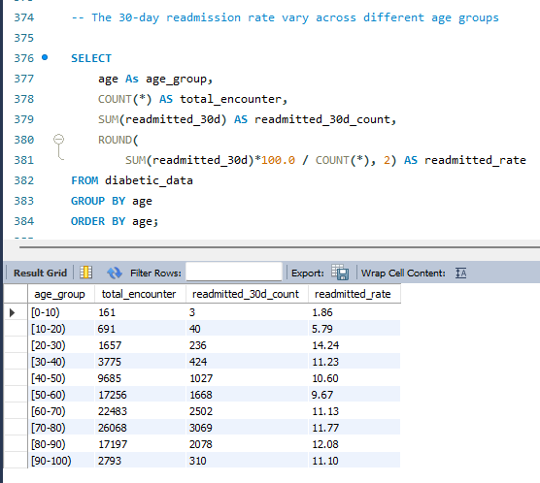

Finding:
30-day readmission rates varied considerably across age groups. The highest observed rate was 14.24% among encounters in the [20-30) age group, followed by 12.08% in [80-90) and 11.77% in [70-80). The lowest rate was observed in [0-10) at 1.86%.

30-day readmitted vary by Gender
Business Objective:
Compare 30-day readmission rates across gender categories to identify differences in readmission patterns between female and male encounters.

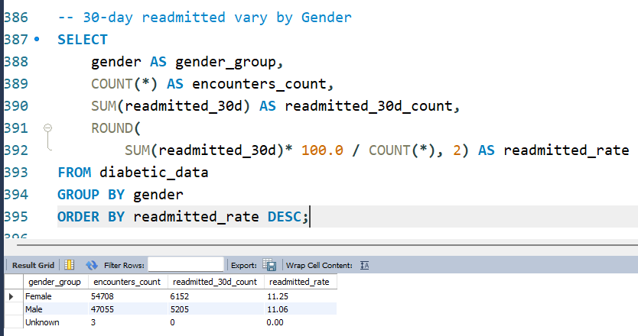

Finding:
The 30-day readmission rate was 11.25% among female encounters and 11.06% among male encounters. Female encounters therefore had a slightly higher observed readmission rate than male encounters, with a difference of 0.19 percentage points.
Female encounters exhibited a marginally higher observed 30-day readmission rate than male encounters (11.25% vs. 11.06%). The small difference suggests limited variation in readmission rates by gender in this dataset.
The 30-day readmission rate vary across different racial groups
Business Objective:
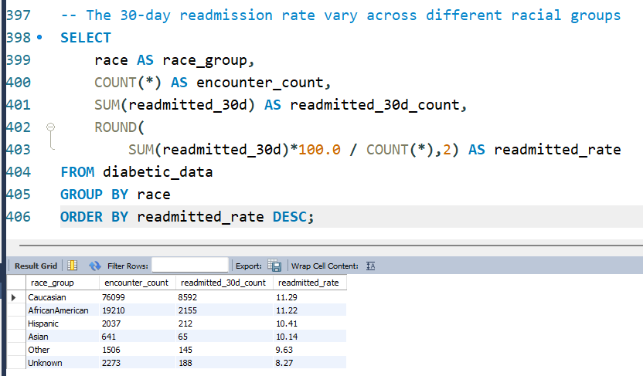
To compare 30-day readmission rates across racial groups and identify groups with relatively higher or lower observed readmission rates.

Finding:
The observed 30-day readmission rates varied modestly across racial groups, ranging from 8.27% among encounters classified as Unknown to 11.29% among Caucasian encounters. Caucasian and African American encounters had rates slightly above the overall baseline of 11.16%, while Hispanic, Asian, Other, and Unknown groups were below the baseline.
The 30-day readmission rate vary across different admission types
Business Objective:
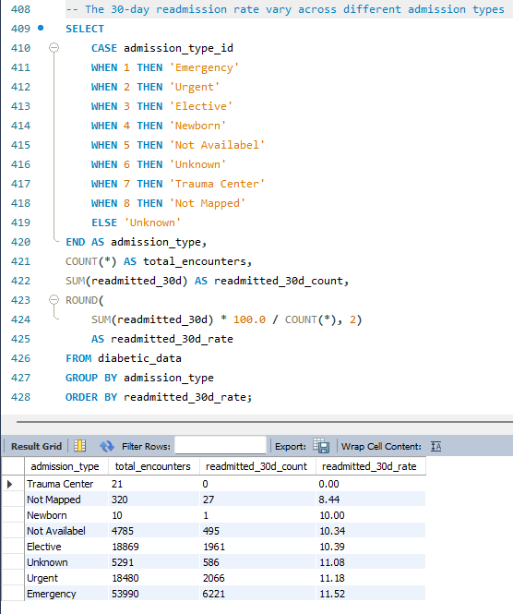
To compare 30-day readmission rates across different admission types and identify admission categories with relatively higher or lower observed readmission rates.

Finding:
The observed 30-day readmission rate varied across admission types, ranging from 0.00% for Trauma Center encounters to 11.52% for Emergency encounters. Emergency admissions had the highest readmission rate among the major admission categories, slightly exceeding the overall baseline of 11.16%, while Elective admissions recorded a lower rate of 10.39%.
Among the major admission categories, Emergency encounters showed the highest observed 30-day readmission rate at 11.52%, while Elective encounters had a rate of 10.39%. The difference between these two major categories was relatively modest, at 1.13 percentage points. Results for categories with very small encounter volumes should be interpreted cautiously.
The 30-day readmission rate vary across different payer codes
Business Objective:
To compare 30-day readmission rates across different payer categories and identify payer groups with relatively higher or lower observed readmission rates.

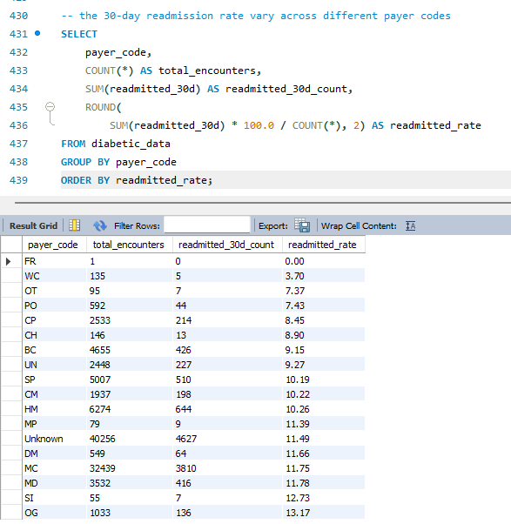

Findings:
The observed 30-day readmission rate varied across payer codes, ranging from 0.00% to 13.17%. Among payer categories with substantial encounter volumes, OG had the highest observed readmission rate at 13.17%, followed by MD at 11.78%, MC at 11.75%, and DM at 11.66%. Several payer categories had rates below the overall baseline of 11.16%.
Payer-specific readmission rates showed moderate variation, but the stability of these estimates differed substantially because payer groups had very different encounter volumes. Therefore, payer-level readmission rates should be interpreted alongside encounter counts rather than used as standalone indicators of readmission risk.
30-day readmission rate vary across different medical specialties
Business Objective:
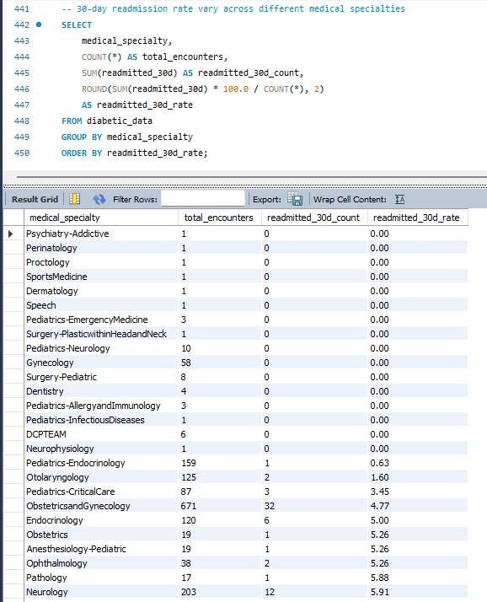
To compare 30-day readmission rates across medical specialties and identify specialties with relatively higher or lower observed readmission rates.

Medical Specialty | Encounters | Readmissions | Rate
Nephrology | 1,613 | 248 | 15.38%
Physical Medicine & Rehabilitation | 391 | 60 | 15.35%
Surgery-Vascular | 533 | 74 | 13.88%
Psychiatry | 854 | 104 | 12.18%
Family/General Practice | 7,440 | 883 | 11.87%
Internal Medicine | 14,635 | 1,646 | 11.25%
Emergency/Trauma | 7,565 | 846 | 11.18%
Cardiology | 5,352 | 425 | 7.94%
Orthopedics-Reconstructive | 1,233 | 92 | 7.46%

Finding:
30-day readmission rates varied substantially across medical specialties. Among specialties with relatively larger encounter volumes, Nephrology (15.38%), Physical Medicine and Rehabilitation (15.35%), and Surgery-Vascular (13.88%) had the highest observed readmission rates, exceeding the overall baseline of 11.16%. In contrast, Cardiology (7.94%) and Orthopedics-Reconstructive (7.46%) recorded lower observed readmission rates.
Medical specialty showed considerable variation in observed 30-day readmission rates; however, the reliability of specialty-level comparisons varied substantially because encounter volumes differed greatly across specialties. Higher-volume specialties provide more stable descriptive estimates, while rates for specialties with very few encounters should be interpreted cautiously. The large number of encounters with unknown medical specialty also represents a significant data-quality consideration.

30-day readmission rate vary across different diagnoses
Business Objective:
To compare 30-day readmission rates across diagnosis codes and identify diagnoses associated with relatively higher or lower observed readmission rates.
SQL SYNTAX:
SELECT
medical_specialty,
COUNT(*) AS total_encounters,
SUM(readmitted_30d) AS readmitted_30d_count,
ROUND(SUM(readmitted_30d) * 100.0 / COUNT(*), 2)
AS readmitted_30d_rate
FROM diabetic_data
GROUP BY medical_specialty
ORDER BY readmitted_30d_rate;

-- 30-day readmission rate vary across different diagnoses
SELECT
diagnosis_code,
COUNT(*) As total_encounters,
SUM(readmitted_30d) AS readmitted_30d_count,
ROUND(
SUM(readmitted_30d)*100.0 / COUNT(*),
2) AS readmission_rate
FROM(
SELECT DISTINCT
encounter_id,
diag_1 as diagnosis_code,
readmitted_30d
FROM diabetic_data
WHERE diag_1 IS NOT NULL
AND TRIM(diag_1) <> ''
AND TRIm(diag_1) <> '?'

UNION

SELECT DISTINCT
encounter_id,
diag_2 AS diagnosis_code,
readmitted_30d
FROM diabetic_data
WHERE diag_2 IS NOT NULL
AND TRIM(diag_2) <> ''
AND TRIM(diag_2) <> '?'

UNION

SELECT DISTINCT
encounter_id,
diag_3 AS diagnosis_code,
readmitted_30d
FROM diabetic_data
WHERE diag_3 IS NOT NULL
AND TRIM(diag_3) <> ''
AND TRIM(diag_3) <> '?'
)AS diagnosis_encounter

GROUP BY diagnosis_code
ORDER BY readmission_rate DESC;

Key Findings based on the Results:
Using the overall readmission rate of 11.16% as our baseline, several frequently occurring diagnoses showed higher observed readmission rates.

Diagnosis Code | Encounters | Readmissions | Readmission Rate
403 | 5,693 | 893 | 15.69%
585 | 3,937 | 618 | 15.70%
440 | 1,437 | 246 | 17.12%
250.6 | 3,158 | 556 | 17.61%
250.7 | 1,142 | 219 | 19.18%
250.41 | 518 | 113 | 21.81%
250.43 | 121 | 27 | 22.31%
428 | 17,464 | 2,290 | 13.11%
276 | 12,961 | 1,577 | 12.17%
496 | 5,990 | 726 | 12.12%

Several common diagnoses were below the overall baseline. For example, diagnosis 250 had 17,861 encounters with an observed readmission rate of 8.10%, while 401 had 12,371 encounters and a rate of 8.02%.
Diagnosis-specific readmission rates varied considerably across ICD-9 codes. Several diagnoses with substantial encounter volumes, including codes 403, 585, 440, and 250.6, showed readmission rates above the overall 11.16% baseline. However, diagnosis codes with very small encounter volumes produced highly variable rates and were therefore not considered reliable indicators of elevated readmission risk.

CONCLUSION
The SQL analysis established a comprehensive descriptive understanding of the hospital encounter population and its 30-day readmission patterns.
Across 101,766 hospital encounters and 71,518 unique patients, the overall 30-day readmission rate was 11.16%. The analysis identified meaningful variation in readmission rates across demographic characteristics, admission types, payer categories, medical specialties, and diagnosis codes.
The analysis also demonstrated important healthcare utilization patterns, including an average of 1.42 encounters per patient, 11.19% emergency utilization, and 33.54% prior inpatient utilization. Diagnosis and medication burden further highlighted the clinical complexity present across hospital encounters.
Most importantly, the SQL analysis established that readmission patterns should not be interpreted using percentages alone. Encounter volume, missingness, repeated patient encounters, and clinical context must be considered when evaluating apparent differences between groups.
Overall, the SQL phase provides a strong analytical foundation for the ReadmitGuard project by establishing the dataset's structure, key healthcare KPIs, readmission baseline, and major descriptive patterns.

