1. **Download below 3 services**

<https://github.com/Sasikar/it-eurekaServer>

<https://github.com/Sasikar/it-blueHarvestTransactionalService>

<https://github.com/Sasikar/it-blueHarvestAccountServices>

1. **Please run below services in following Order ONLY**

1st🡺 it-eurekaServer

2nd🡺 it-blueHarvestTransactionalService

3rd🡺 it-blueHarvestAccountServices

1. **Open** [**http://localhost:7777/h2-console**](http://localhost:7777/h2-console)

Provide JDBC URL🡺 jdbc:h2:mem:testdb

UserName 🡺sa

Password🡪sa  
and then click next

Screenshot for reference.

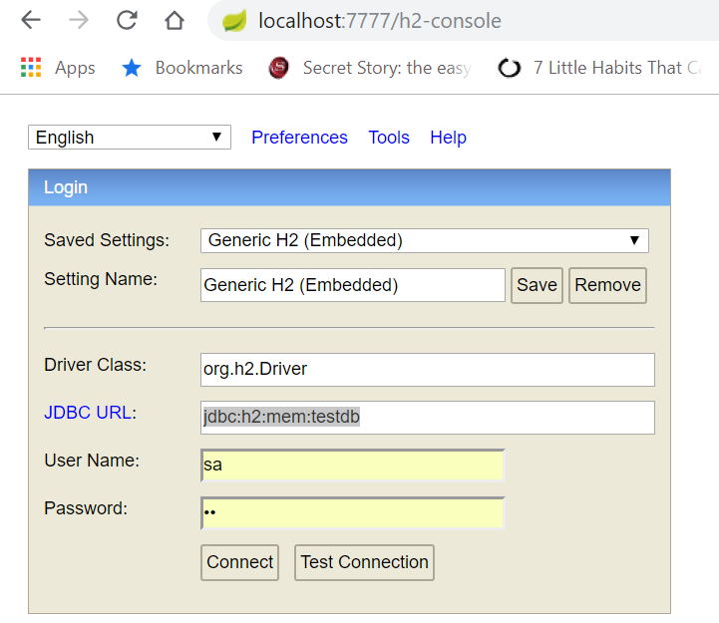

Once you click next in memory db opens like this

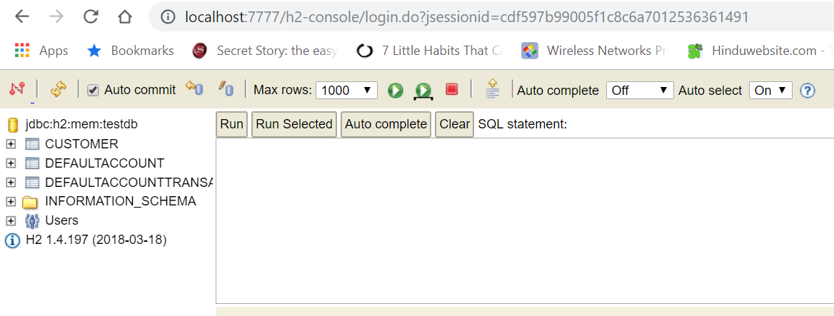

For accountService some existing customers are already inserted via src\main\resources\data.sql

Same data you can observe here in all these 3 tables.

By executing select command. screenshot for same

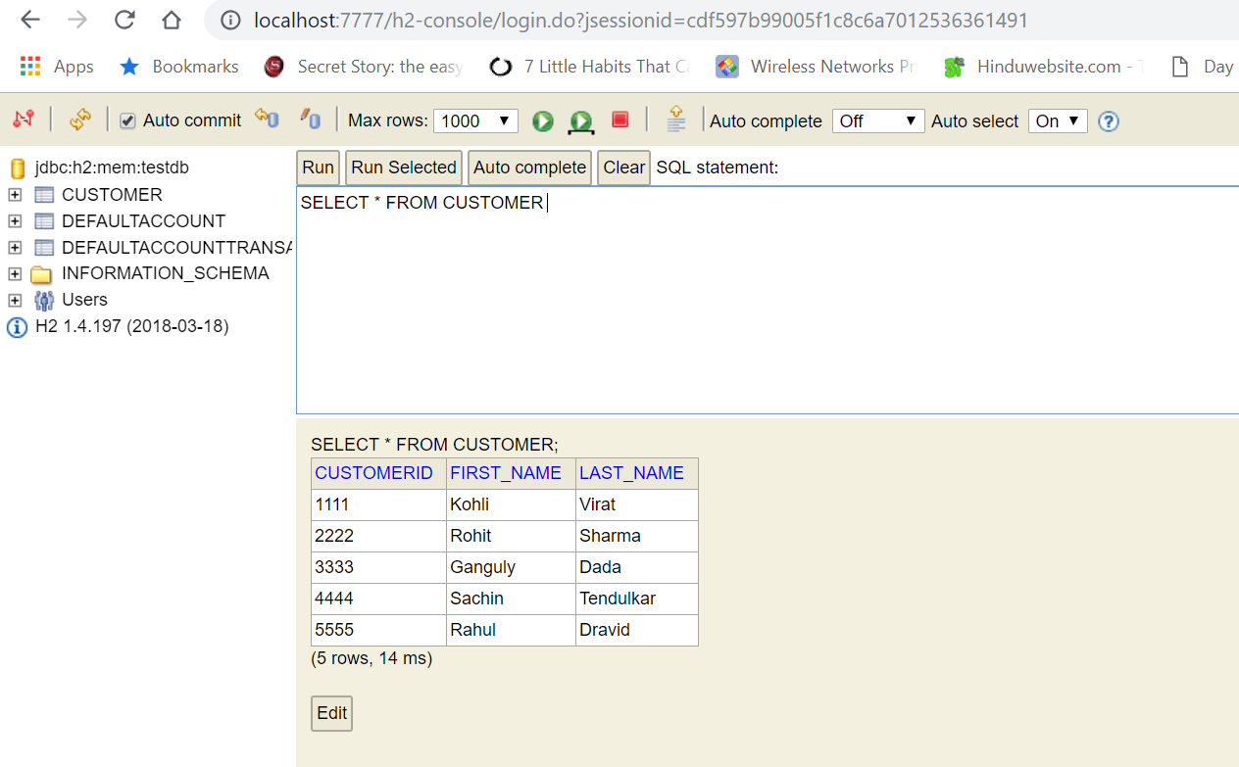

**4. Open** [**http://localhost:8888/h2-console**](http://localhost:8888/h2-console)

Provide same credentials, screenshot for same

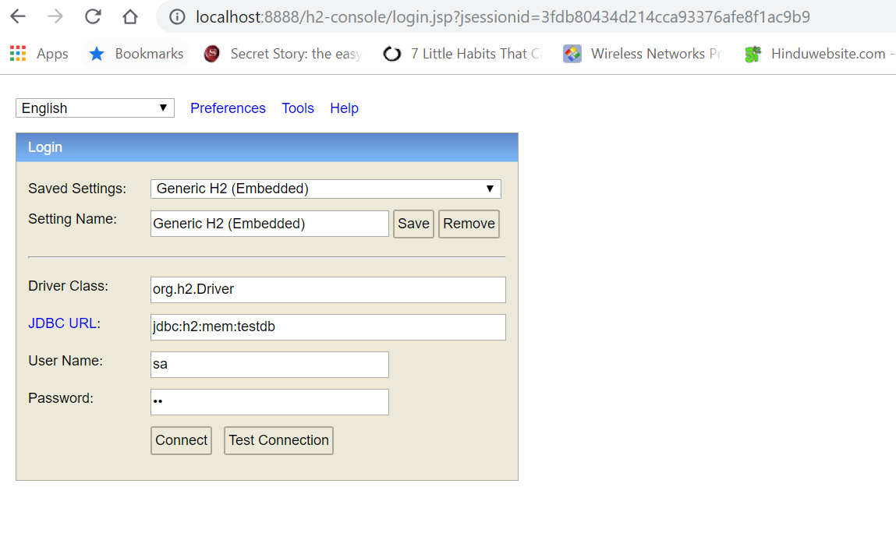

Click on connect and fire select query as below

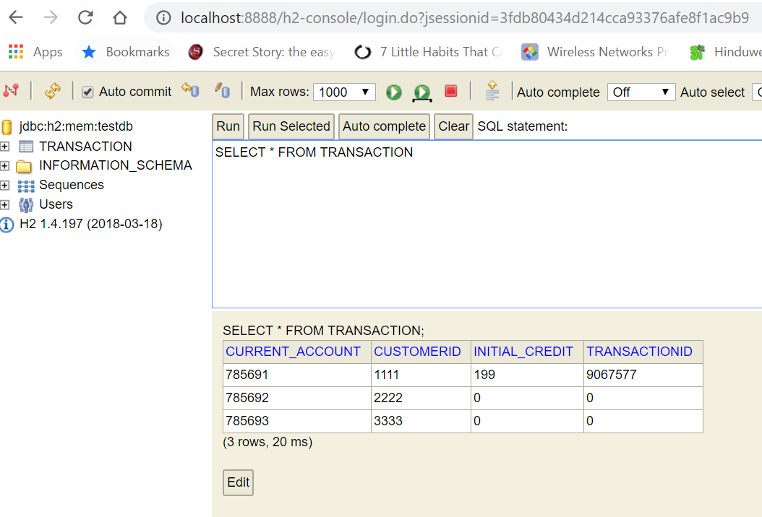

1. **API end point testing**

**Install postman plugin to chrome browser to test endpoint**

**Import post man collection**

**Hit below URL in browser. It will automatically opens postman**

<https://www.getpostman.com/collections/16e2d2bf604df164794a>

**1st endpoint details:**

url: **http://localhost:7777/create/currentaccount**

method : POST

body:

{

"customerId":4444,

"initialCredit":0

}

Screenshot:

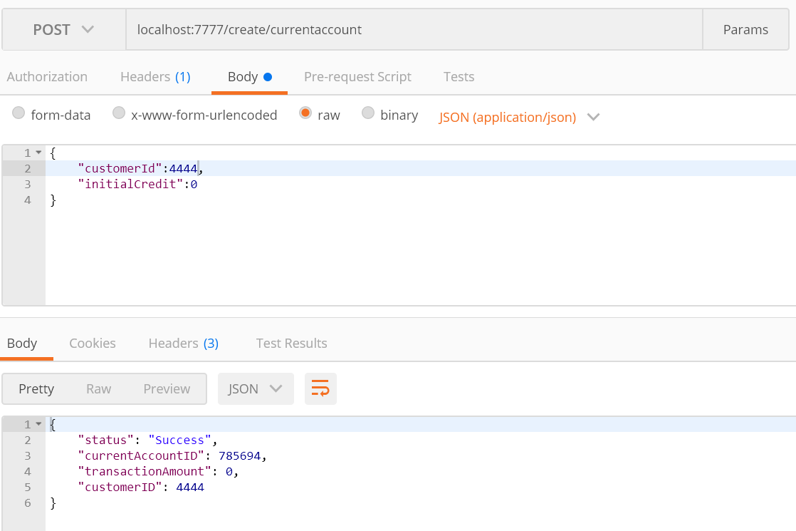

**Once we got success response, hit**

[**http://localhost:8888/h2-console/**](http://localhost:8888/h2-console/) **in browser we can see new transaction will be inserted in DB.**

**2nd endpoint details:**

**url:** localhost:7777/userinfo/3333

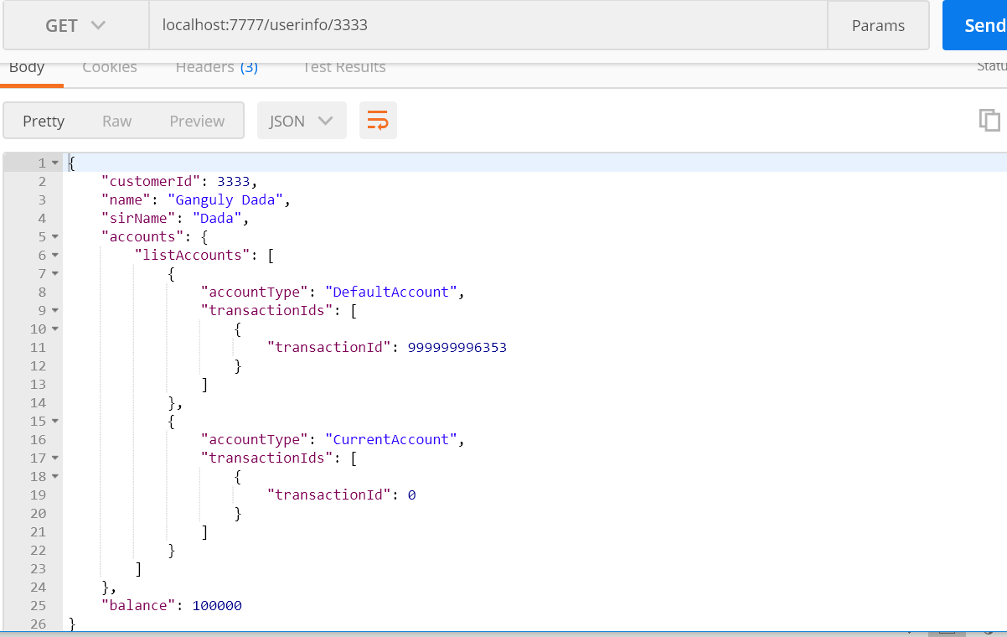

**Additional info:**

**For services to check running staus.**

**Hit in browser**

[**http://localhost:8761/**](http://localhost:8761/)