1. INTRODUCTION

*Overview

Develop an App for the Property Management where Buyer can order

His requirements and get the Appropriate details of the property. According

To his interest just provide him with some discounts upto what extent he

Can get the discount.

[1]

*Purpose

Salesforce is your customer platform, designed to help your sell,

Service, market, analyze, and connect with your customers. Provide the

Security for two different profiles like for marketing and sales team.

**2. Problem Definition & Design Thinking**

**\***  Empathy Map

* Ideation & Brainstorming Map

* Courses videos completed screen shot

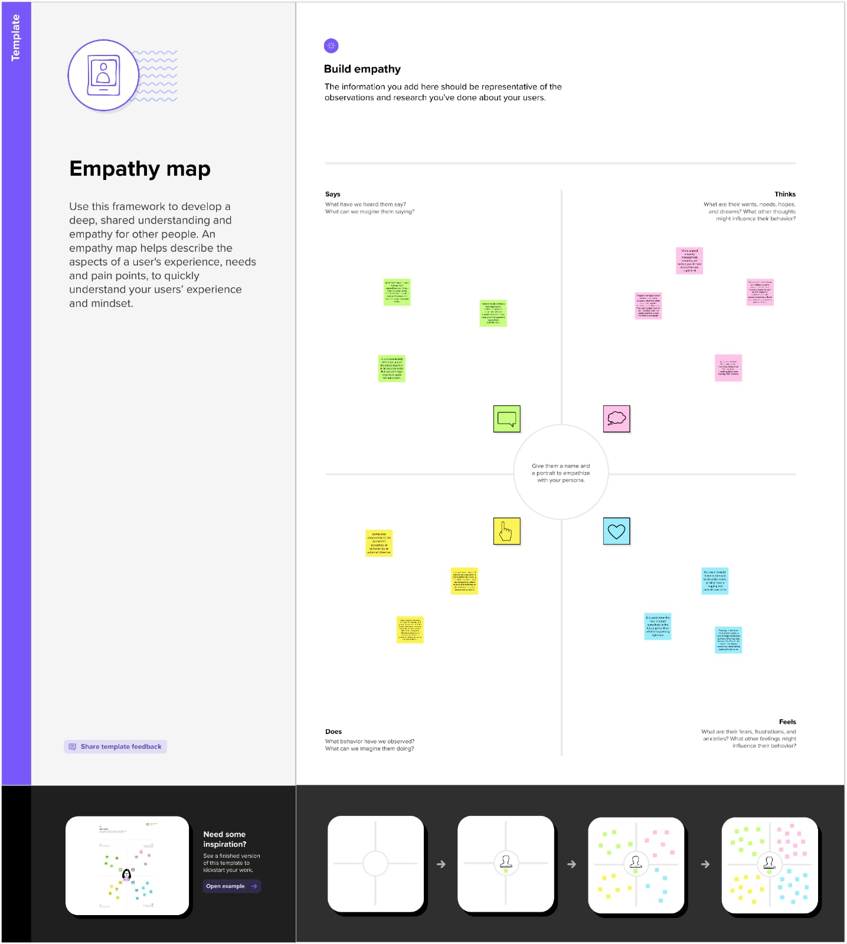

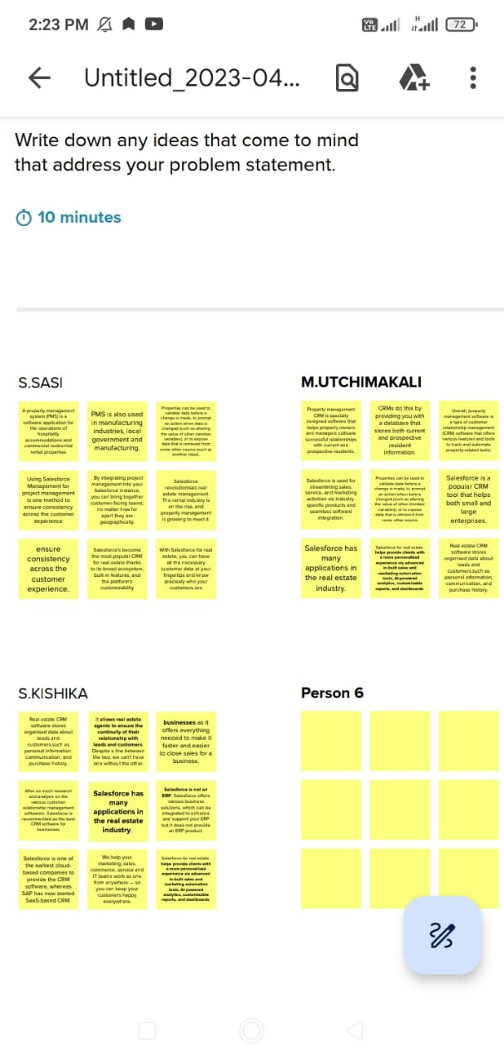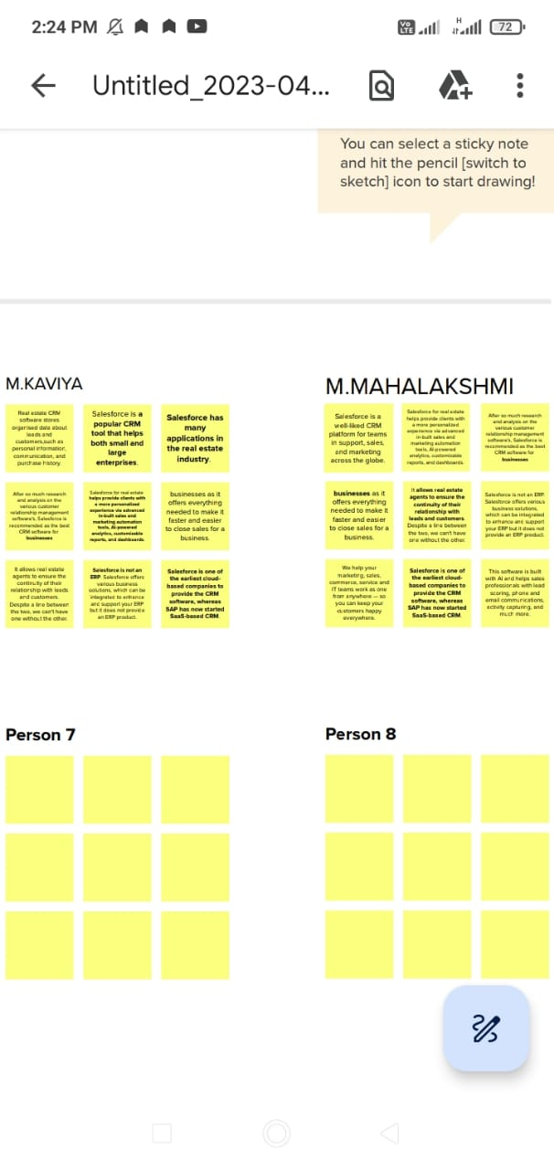**3**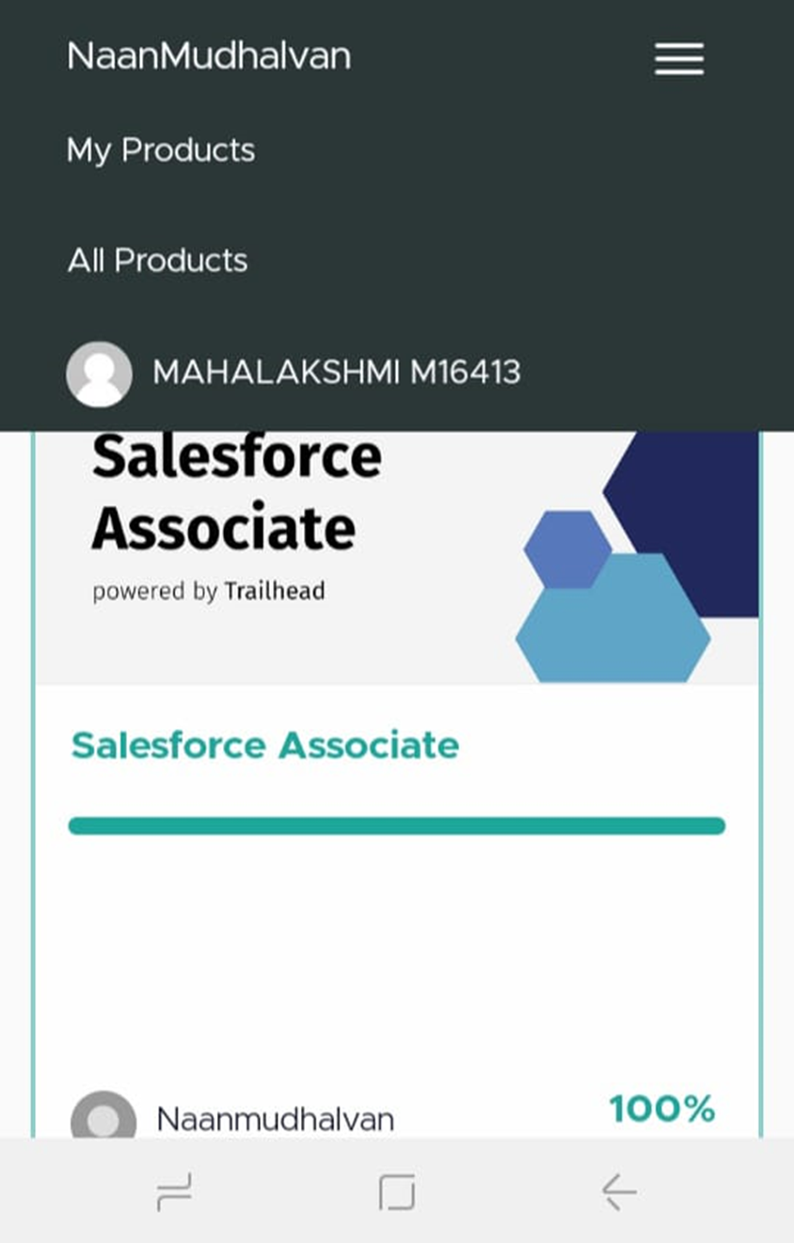

|  |  |  |
| --- | --- | --- |
| Object name | Fields names | Data types |
| Guy | Management | Text |
| Girl | Property | Text |
| Day | Management | Text |
| Child | Application | Text |
| Boy | Salesforce | Text |

**3. Activity and screenshot**

**To create an object:**

**\*Go to setup, click object manager**

**\*Click create and select custom object**

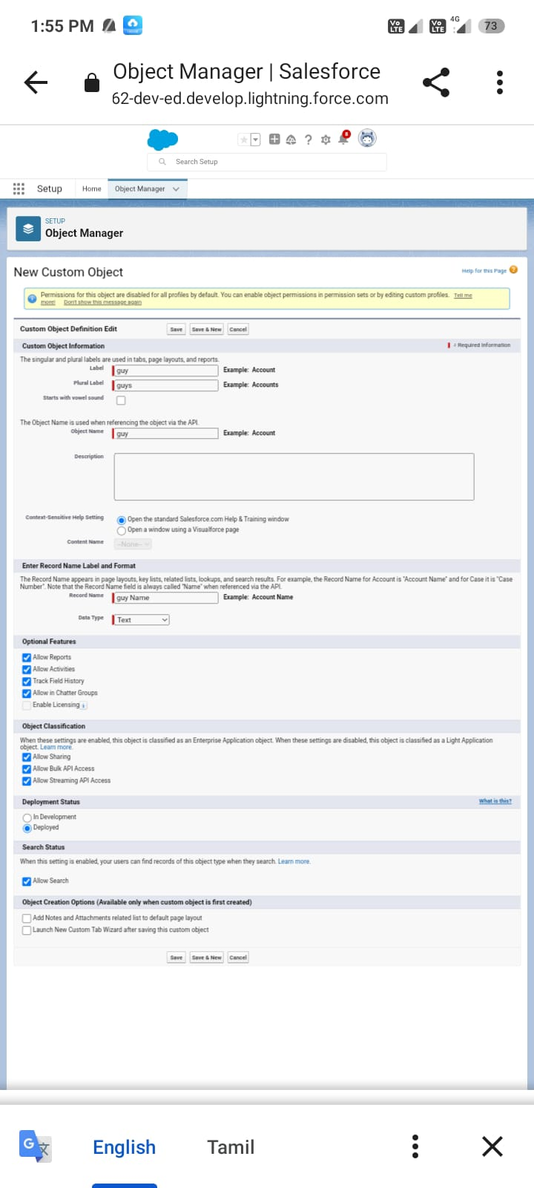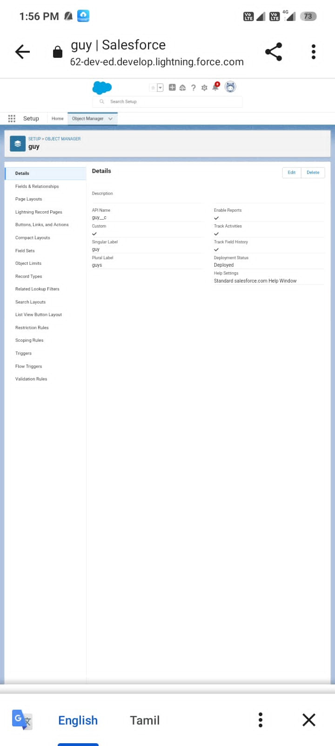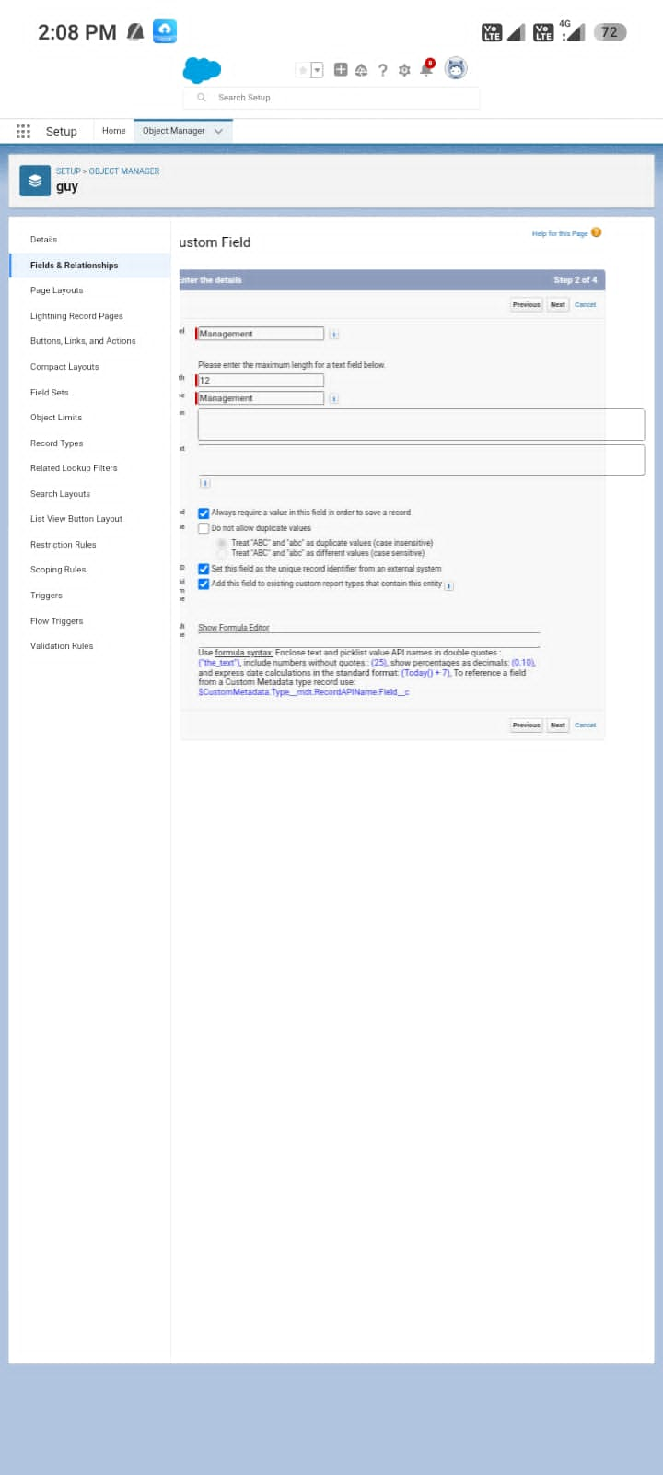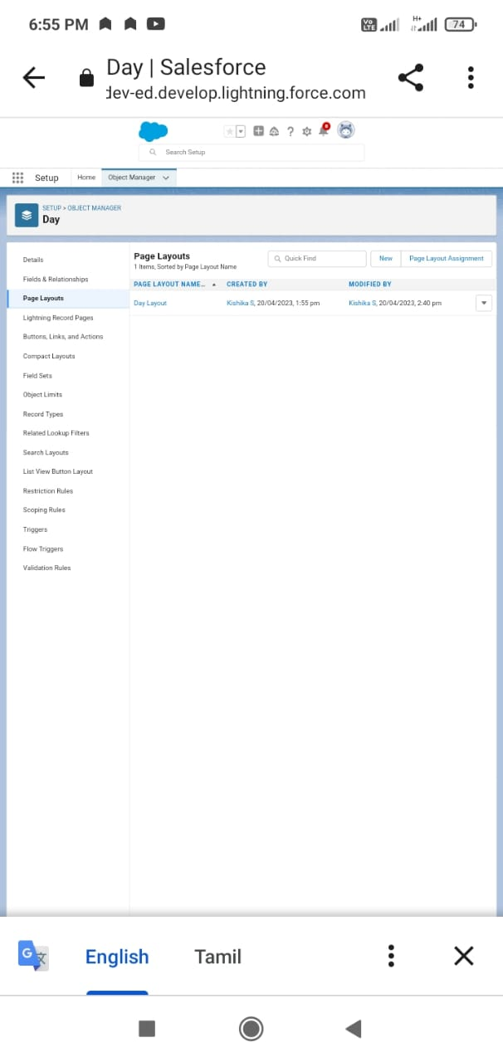

**4. Trailhead profile public URL:**

Team lead : <https://trailblazer.me/id/sasi2004>

Team Member 1: <https://trailblazer.me/id/uthaya1911>

Team Member 2: <https://trailblazer.me/id/kaviya02>

Team Member 3: <https://trailblazer.me/id/mlakshmi229>

Team Member 4: <https://trailblazer.me/id/kishika13>

**Advantages and Disadvantages**

There is a wide range of report widgets that allow you to analyze the performance of the business from different angles. Salesforce enables rapid customization for most business processes and for different industries.Solution in the cloud

With Salesforce, you can take your business wherever you are, like in the cloud. As a result, businesses need fewer resources at the office to do business. Every employee can access CRM from all over the world and contribute to overall productivity.

Compatibility

It does not matter which browser your company uses (or which employee works remotely). Internet Explorer, Chrome or Opera, Salesforce has its CRM compatible with all major browsers. This makes social media functionality like Chatter very easy to use, which can help businesses find collaboration. The appearance of popular social networks makes it very familiar and easy for users to understand. Features such as news viewing, status updates, link sharing, and file downloads are available directly from the panel.

**Application:**

**Breal Estate is a Chilean company established in 2013,**

**which, in a strategic alliance with Salesforce.com,**

**develops an application for managing properties.**

**BReal (www.breal.cl) is an application that incorporates**

**all the functions necessary to manage different**

**processes of the real estate sector with the best**

**practices in mind. It is delivered as a service (SaaS) and**

**accessed via Internet from any device.**

**Salesforce.com (www.salesforce.com) provides the**

**technological platform that supports the data storage, the**

**security elements and protocols and the information**

**backup in redundant servers in the EEUU, Europe and**

**Asia, and a series of transversal functions such as**

**messaging, information intelligence system, alarm**

**management, change logs, user profiles, among many**

**others.**

**Conclusion:**

**This case study aims at providing a solution for real estate management. In this case, the clients are responsible to sell the units of a development and needed a solution to handle lead generation, worksheet submission, customer handling, closing the deal, pricing calculation, automated payment reminders and related functionality.**

**As an internal user, the client should be able to create and update Projects and Units, generate leads manually as well as automatically through various sources such as Facebook, Instagram etc., convert the leads into contact, account and opportunity as they progress in the pipeline, close the deal and generate automatic payment records for the customer as per the final selling price and the deposit structure of the Project. They should also be able to generate and send signed documents and should receive automated reminders to follow up with the buyer for payments etc.**

**Future Scope:**

Salesforce is the world’s largest cloud Customer Relationship Management (CRM), designed to help you build client interactions, develop apps, and integrate with other systems. If you’re an IT professional looking for a way to specialize in a particular field with promising career possibilities, Salesforce is a go-to choice today.

Salesforce certifications are an excellent approach to developing technical knowledge and skills in the world’s most popular CRM platform. Because the number of end-users on the Salesforce platform is growing, getting started with Salesforce now feels more appropriate and essential than ever. There is a scarcity of highly skilled Salesforce professionals in enterprises and multinational companies.

While exploring what’s in it for me in the Salesforce ecosystem, look at the Salesforce Admin Career Path because that is usually the first step for any newcomer.

Now, let’s get to the basics and learn what Salesforce is all about and the future scope of Salesforce.

1.