***RESUME***

**SASI KIRAN JETTI**

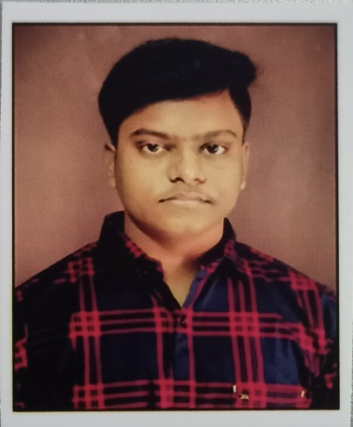

**EMAIL: - sasikiranjetti@gmail.com**

**Linkedin:https://www.linkedin.com/in/sasi-kiran-jetti-974640223**

Mobile No:8790304268

**CAREER OBJECTIVE**:

* Looking for a challenging career which demands the best of my professional ability in terms of technical and analytical skills, and helps me in broadening and enhancing my current skill set and knowledge.

**ACADEMIC QUALIFICATIONS:**

|  |  |  |  |  |
| --- | --- | --- | --- | --- |
| Course | Institution | Board/University | Year of  Completion | CGPA |
| B.Tech  (CSE) | University College of engineering Kakinada | JNTU,  Kakinada | 2024 | 8.0  (up to III-1) |
| Intermediate | NRI ACADEMY, Ongole. | Board of Intermediate Education. | 2020 | 9.94 |
| SSC | Sri Ramm High School, Santhapeta, Ongole, Prakasam(Dt). | Board of Secondary  Education. | 2018 | 10.0 |

**TECHNICAL SKILLS:**

* Programming Languages : C,cpp,java, Basics of Python,html.
* Softwares: Microsoft Word, Excel.
* Technical writing
* Project Management

**SKILLS :**

* Good Communication Skills.
* Good in Team Work.
* Good in Problem Solving.
* Proper Time management.
* Problem solving.

**AREA OF INTEREST:**

* Like playing cricket and Badminton.
* Travelling
* Listening music and Reading Books.
* Browsing the internet.

**WORKSHOP & COURSES:**

* Done A WORKSHOP ON “Cyber security”.
* Done Workshop on “Data Science”.
* AWS certified on Cloud computation.

**INTERNSHIPS:**

* Done an internship on “Full stack development” conducted by “APSCHELMS”.

**PROJECTS**

* Mini project:
* Title : “Robotic surveillance car” using UNO Arduino
* Domain : Hardware and software
* Description: This project is to help the people to surveillance the surroundings of our house ,or office,etc.. using Ultrasonic sensor with the range desired by the user using Arduino.

**STRENGTHS:**

* Consistency towards my goal.
* Creative thinking ability.
* Self-motivated.

**ACHIEVEMENTS:**

* First Prize in Quiz competition in a T.V Program.
* Won prize in the field of dance in a cultural fest.
* Won many tournaments in Cricket.

**PERSONAL PROFILE:**

* Father Name :Jetti Suresh
* Date Of Birth : 25-12-2002
* Language Proficiency : English, Telugu,Hindi
* Address :37-1-398/A, Dharavari thota, Ongole(M), Prakasam(Dt.), AP.

**DECLARATION:**

I, Sasi Kiran Jetti hereby declare that all the information given above is true and correct to the best of my knowledge and belief.

Date :

Place : Kakinada

(J. Sasi Kiran)