YASHARTH SHARMA
D i g i t a l M a r k e t i n g L e a d

Experience

+91-9754047596

 yasharth.sh15@gmail.com
 linkedin.com/in/yasharthsharma  Shubhalaya Smiles, Bhopal

EDUCATION

MBA (Marketing & Finance)
Institute of Professional Education & Research 2021 - 2023

BA Hons. (Public Administration)
Jagran Lakecity University
2017 - 2020

SKILLS & EXPERTISE
Meta Ads
Influencer Marketing SEM
Content Creation & Marketing Telegram Promotions Creative Strategy
Google Analytics
May 2022- Present
HPS Lab Designs, Bhopal (M.P)
Digital Marketing Lead
Achieved exceptional results on Facebook with successful campaigns, accumulating over 10 million views and a click-through rate (CTR) of 3% and above.
Led a dynamic team of 3, comprised of two digital marketers and a proficient video editor, driving Ajjas' digital presence through strategic campaigns.
Conceptualized, directed, and performed in more than 15 compelling ad shoots, yielding excellent results in Facebook advertising.
Produced 50+ informative YouTube videos, establishing a prominent digital persona for the Ajjas brand.
Spearheaded over 15 highly fruitful influencer marketing campaigns, generating 5 million plus views with an impressive ROI of over 300%.
Orchestrated substantial growth on the brand's YouTube channel, boosting daily views from 50 to 1,500, and total views from 48,000 to over 300,000 in just 4 months, all achieved organically.
Elevated Ajjas' Instagram presence, increasing organic reach from 4,000 to 40,000 per month.

Key Achievements

400%

Leadership skills 10M+
100+

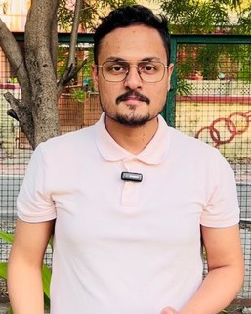

LANGUAGE
English Hindi
ROI in Video Ads

Organic & Paid Videos Generated
Meta Ad views with 3% CTR

5M+
Views generated through 15
influencers

