VIBHANSHU YADAV (Data Engineer) 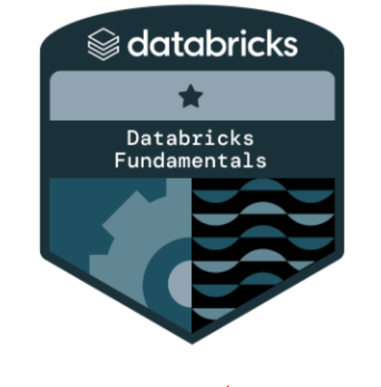
Bengaluru, India | +91-9792263333 | vibhanshuyadav166@gmail.com |

Professional Summary:
Experienced Data Engineer with 5 years in Data warehousing, Data Lake, ETL, and Business Intelligence. Proficient in Databricks, Databricks SQL, and Azure Data Factory for orchestrating data pipelines. Additionally, skilled in DataStage for ETL workflows. Familiar with Linux, Airflow, and DevOps practices.

Work Experience

DATA ENGINEERING ANALYST (Optum Global Solutions)
Oct 2021 – PRESENT

Project: Unified Data Warehouse Client: UHG Methodology: Agile

Tools: Databricks, Azure Data Factory, Spark SQL, Pyspark, IBM Infosphere DataStage Designer, SQL, Python, UNIX, GitHub, Apache Airflow, Jenkins

Job Role: Data Engineer
- Developed Spark applications using Spark-SQL and PySpark in Azure Databricks for data extraction, transformation, and aggregation from multiple file formats.
- Migrated DataStage ETL jobs to Azure Databricks.
- Utilized notebooks within Databricks for exploratory data analysis, code development, and collaboration.
- Orchestrated Azure Databricks workflows using Azure Data Factory.
- Designing, constructing and maintain data pipelines that gather, process and store large volumes of health insurance data.
- Collaborating with cross-functional teams to ensure data quality, security and availability for analysis and decision making· Integrating various data sources and implementing data transformation processes to support downstream and data analysts and various other stake holders in extracting insights from the data.

ASSISTANT SYSTEM ENGINEER (TATA CONSULTANCY SERVICES)
JULY 2019 – Oct 2021
Project: DATAHUB Client: FIRM T&D

Tools: IBM Infosphere DataStage Designer, SQL, UNIX, JIRA

Job Role: ETL Developer
- Creating DataStage ETL jobs to load the data from Source to target database.
- Cleaning and applying business logics before loading data to target databases.
- Deploying Created jobs to QA, DEV and PROD.
- Supporting the ETL jobs and making enhancements if required.

Page 2

Project: DATAHUB Support Client: FIRM T&D

Tools: IBM Infosphere DataStage Director, SQL, UNIX, Autosys, WinSCP, Putty.

Job Role: ETL Developer/ Support Executive

- Scheduling and monitoring ETL jobs according to the client requirement.
- Backtracking ETL errors from DataStage director client by viewing logs and performance statistics.
- Root Cause Analysis of ETL and database level errors occurred while functioning of jobs.
- Advanced Performance Tuning of jobs with proper analysis.
- Solving and on call troubleshooting the data level errors with client and end user.

Methodology: L3 support

Technical Skills
- ETL Tools: Azure Data Factory, DataStage,Azure Databricks
- Programming Languages: Python, SQL, Spark SQL, Pyspark
- Cloud Platforms: Azure, GCP
- DevOps and Version Control: Linux, Airflow, GitHub
- Database and Storage: Teradata, Oracle, Azure SQL Database, Azure Data Lake Storage (ADLS), Blob Storage

Education
- B.Tech (ECE) SRMCEM Lucknow (2019)
- 70.4 % Agg.

