**IoT-Obstacle detection using AI**

### Dr . M. Kavitha, M.Sc., M.Phil., Ph.D.,

### Assistant Professor, Department of BCA

### Bishop Heber College ,Tiruchirappalli.

### [kavitham.ca@bhc.edu.in](mailto:kavitham.ca@bhc.edu.in)

R.Priyadharshan N.Priyadharshan J.Pothigai vallal adhiyam

Department of BCA Department of BCA Department of BCA

Bishop Heber College, Tiruchirappalli Bishop Heber College, Tiruchirappalli Bishop Heber College,Tiruchirappalli

[ca235113639@bhc.edu.in](mailto:ca235113639@bhc.edu.in) [ca235113638@bhc.edu.in](mailto:ca235113638@bhc.edu.in) [ca235113626@bhc.edu.in](mailto:ca235113626@bhc.edu.in)

**ABSTRACT**

This research project focuses on creating an AI-based obstacle-avoidance rover. It combines inexpensive IoT components with the ability to monitor remotely through the web. The rover uses an ESP8266 microcontroller for processing and Wi-Fi connectivity, allowing users to view data from afar. Ultrasonic sensors are attached to a servo motor to scan the environment from various angles. This setup allows for precise distance measurement and the dynamic detection of nearby obstacles. A motor driver module manages the rover's DC motors, enabling movements such as going forward, backward, and turning. The hardware connects with jumper wires on a compact chassis, making it easy to assemble and modular.The obstacle-avoidance system works by constantly gathering distance readings from the ultrasonic sensor. It processes these values and changes the rover's path to keep a safe distance from obstacles. At the same time, the ESP8266 either creates a Wi-Fi access point or connects to a local network to host a web interface. Users can monitor the rover in real-time through this interface, which displays live distance readings, movement status, and optional camera streaming for better situational awareness.By merging simple hardware with smart control and IoT monitoring, this system showcases an effective, low-cost way to prevent accidents in autonomous navigation. The design is ideal for educational robotics, indoor surveillance, warehouse monitoring, and as a basic prototype for self-driving vehicles. The platform shows how easily accessible components can be put together to create a scalable system for safe and reliable obstacle avoidance.

**Keyword :** ESP8266, ultrasonic sensor, servo motor, motor driver, IoT rover, accident prevention, remote monitoring.

**1.** **INTRODUCTION**

The rapid growth of autonomous systems and robotics has created a strong demand for intelligent navigation platforms that can move safely in changing environments. One key requirement for these systems is obstacle detection and avoidance. This ensures that a mobile robot can navigate without hitting objects, which improves safety and efficiency. This idea is important not just in robotics labs and small rover projects. It also serves as the foundation for applications like self-driving cars, automated guided vehicles (AGVs)[1], and unmanned aerial systems.In this research project, we present the development of an AI-based obstacle-avoidance rover that combines low-cost hardware with smart decision-making and remote monitoring capabilities. The rover uses an ESP8266 microcontroller, which handles control logic and includes Wi-Fi for connectivity[2]. An ultrasonic sensor mounted on a servo motor scans the environment at various angles. It measures distances and identifies obstacles. This setup allows the rover to detect obstacles directly in front and assess safer paths to the left or right, mimicking how more advanced navigation systems make decisions.A motor driver module controls the rover’s motors, allowing smooth movement in different directions based on the sensor data. The use of jumper wires and modular connections provides flexibility in wiring and makes hardware modifications easy. Beyond autonomous navigation, the rover features a web-based monitoring interface hosted by the ESP8266. Through this interface, users can view real-time data, such as obstacle distances and movement status. They can also choose to control the rover manually.The importance of this work lies in its ability to provide a low-cost, accessible, and scalable platform. It demonstrates the principles of autonomous navigation and IoT-based monitoring. By combining obstacle avoidance with live telemetry, the system not only shows that accident-free operation is possible in small rovers but also supports the long-term goal of safe automation in larger applications like intelligent transportation systems.[3][5]

**2. EXISTING SYSTEM**

Obstacle avoidance and autonomous navigation have been important areas of research in robotics for decades. Traditional systems for collision prevention generally fall into two categories:

**1. Sensor-based reactive systems:** Many low-cost robots use simple ultrasonic or infrared sensors linked to microcontrollers like Arduino or PIC. These robots can detect obstacles in front and stop or change direction based on a set distance. While they are affordable, these systems often lack accuracy, have a narrow detection range, and cannot handle complex navigation tasks.

**2. High-end robotics platforms:** Advanced mobile robots and autonomous vehicles use LiDAR, stereo cameras, GPS, and artificial intelligence for reliable obstacle detection and path planning. These systems achieve high accuracy but come at a high cost, require significant computing power, and need specialized hardware and software platforms such as ROS (Robot Operating System).

**3. Remote-controlled systems:** Some existing rovers offer live camera feeds and manual control through Bluetooth or RF modules. Although these systems allow for remote supervision, they do not have autonomous obstacle avoidance or real-time decision-making. Additionally, most Bluetooth or RF solutions have limited range and do not support IoT-based global monitoring.

**4. IoT-enabled robots:** In recent years, some systems have used microcontrollers with Wi-Fi modules (for example, ESP8266/ESP32) to enable web dashboards or smartphone control. These projects show the potential for combining robotics with IoT. However, many of these setups are either completely remote-controlled without autonomous decision-making capabilities, or they do not provide a live monitoring interface that shows obstacle distance and navigation status.

**Limitations of Existing Systems:**

**- Restricted obstacle detection:** Most ultrasonic-only systems measure distance in one fixed direction, which limits awareness of the surroundings.

**- Lack of integration with IoT**: Many earlier robots do not allow real-time monitoring over the internet, restricting their use to short-range control.

**- Cost and complexity**: High-end solutions using LiDAR and cameras are not practical for small-scale educational or prototype robots.

- **Limited user interaction:** Remote-controlled robots often lack autonomous safety features, leading to frequent collisions in uncertain environments.

These limitations show a need for a system that is affordable, autonomous, and IoT-enabled, allowing for real-time obstacle detection and avoidance, along with web-based live monitoring and optional control.[4][5][6]

**3. PROPOSED SYSTEM**

To address the challenges of traditional obstacle-avoidance robots and expensive autonomous platforms, this project puts forward an AI-based obstacle-avoidance rover with IoT-enabled remote monitoring. The system combines low-cost sensors and components with smart control algorithms to offer both autonomous navigation and real-time monitoring through a web interface.

**Key Features of the Proposed System :**

**1. ESP8266 Microcontroller** – This acts as the main processing and communication hub. Besides managing obstacle detection and motor control, it has built-in Wi-Fi to host a lightweight web server for live monitoring and user interaction.

**2. Ultrasonic Sensor with Servo Motor** – Rather than keeping the ultrasonic sensor fixed, it is mounted on a servo motor. The servo rotates the sensor across different angles (e.g., left, center, right), allowing the rover to gain a broader awareness of its surroundings. This ensures that the rover can select the safest direction to move instead of depending solely on limited front detection.

**3. Motor Driver Module (L298N/L293D)** – This controls the DC motors of the rover, enabling smooth forward, backward, left, and right movements. The motor driver ensures that the microcontroller can manage the higher current needs of the motors safely.

**4. IoT-enabled Web Interface** – The ESP8266 creates a real-time web dashboard that can be accessed from any device on the same network. The dashboard shows live distance measurements, movement status, and optional manual control buttons for teleoperation. Compared to Bluetooth systems, Wi-Fi significantly expands the range of control and monitoring.

**5. Accident-Free Operation** – The rover intelligently scans for obstacles and automatically stops or reroutes when it detects a hazard within a set threshold. This feature makes the system a suitable prototype for accident-prevention research in larger autonomous vehicles.

**Advantages over Existing Systems**

•Wider obstacle detection through dynamic scanning with a servo-mounted ultrasonic sensor.

• Low-cost and modular hardware design ideal for educational and prototyping purposes.

•IoT-based monitoring using Wi-Fi, which removes the range limits of Bluetooth or RF.

•User-friendly web interface requiring only a standard browser, with no special applications needed.

• Scalable design that can be expanded with additional sensors (e.g., camera module, IR sensors) for advanced research.

Thus, the proposed system balances simplicity, cost-effectiveness, and intelligence. This makes it a practical choice for applications like robotics education, warehouse automation, surveillance, and a foundational step toward autonomous transportation technologies.[10]

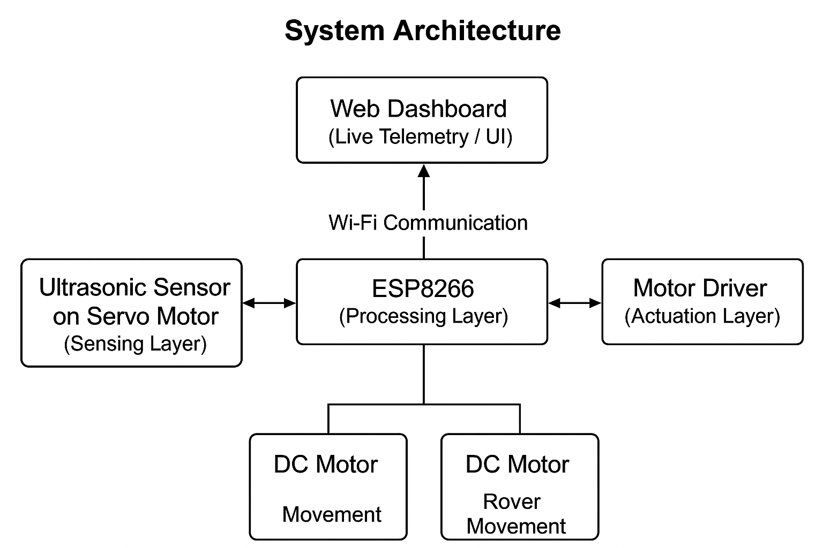**4.METHODOLOGY**

The development of the obstacle-avoidance rover was carried out by combining simple and affordable components into a fully functional system. The base structure was built on a two-wheel chassis powered by DC motors, which were controlled using an L298N motor driver. Power was supplied through a battery pack, with a small switch added for safe and easy operation.To enable obstacle detection, an ultrasonic sensor was mounted on a servo motor, giving it the ability to rotate and scan the surroundings different angles. This setup allowed the rover to identify not just obstacles in front, but also those on the sides. The sensor data was processed by an Arduino microcontroller running a control algorithm. The logic was straightforward: if the path ahead was clear (greater than 20 cm), the rover continued moving forward. When an obstacle was detected, it paused, scanned left and right, and then chose the direction with more space to proceed safely.Based on the microcontroller’s decisions, motor commands were sent to the driver module to perform movements such as turning, moving forward, or stopping. The rover was then tested in controlled environments with fixed obstacles. During these trials, its detection accuracy, success rate in avoiding collisions, and reaction time were carefully observed to evaluate its overall performance.[9][11]

**5. ARCHITECTURE**

The proposed AI-based obstacle-avoidance rover integrates sensing, processing, actuation, and web-based monitoring into a modular architecture. The system is designed to ensure real-time obstacle detection, autonomous navigation, and live remote monitoring.[11]

**5.1 Overview**

The system architecture consists of four main layers:

1. **Sensing Layer** – Responsible for detecting obstacles and gathering environmental data.
2. **Processing Layer** – Handles decision-making and control logic.
3. **Actuation Layer** – Executes navigation commands by controlling the rover’s motors.
4. **Communication & Monitoring Layer** – Enables web-based telemetry and optional teleoperation.

**5.2 Components and Functionality**

**1. Sensing Layer**

* **Ultrasonic Sensor (HC-SR04)**: Measures distances to obstacles in front and to the sides via servo scanning.
* **Servo Motor**: Rotates the ultrasonic sensor across multiple angles to extend field-of-view.
* The sensor layer continuously sends distance readings to the processing layer.[14]

**2. Processing Layer**

* **ESP8266 Microcontroller**: Central control unit that performs the following:
  + Reads ultrasonic sensor values.
  + Determines the safe path using simple AI/rule-based logic.
  + Sends motor control commands to the driver module.
  + Hosts the web server for live monitoring.
* Includes algorithms for obstacle detection, threshold checking, and safe navigation decision-making.[16]

**3. Actuation Layer**

* **Motor Driver Module (L298N / L293D)**: Receives commands from ESP8266 to control DC motors.
* **DC Motors with Wheels**: Drive the rover forward, backward, and turn left/right according to the processed navigation commands.

**4. Communication & Monitoring Layer**

* **Wi-Fi Connectivity (ESP8266)**: Enables the rover to host a web-based interface.
* **Web Dashboard**:
  + Displays real-time distance readings.
  + Shows rover movement and status.
  + Optional buttons for teleoperation (manual override).
* Communication protocols: HTTP, WebSocket, or lightweight AJAX for low-latency updates.[18]

**5.3 Data Flow**

1. Ultrasonic sensor measures distances at multiple angles.
2. ESP8266 reads the data and determines whether the path is safe.
3. If safe, ESP8266 sends commands to the motor driver to move in the chosen direction.
4. Sensor readings and rover status are simultaneously transmitted to the web dashboard.
5. User can monitor or optionally intervene using the dashboard controls.

**5.4 Block Diagram**

Here’s a textual representation of the block diagram (you can create a visual version in PowerPoint, Fritzing, or any drawing tool):

+-----------------------+

| Web Dashboard |

| (Live Telemetry / UI)|

+-----------+-----------+

^

|

Wi-Fi Communication

|

+-----------v-----------+

| ESP8266 |

| (Processing Layer) |

+-----------+-----------+

|

+-----------v-----------+

| Motor Driver |

| (Actuation Layer) |

+-----------+-----------+

| |

DC Motor 1 DC Motor 2

|

Rover Movement

+-----------+-----------+

| Ultrasonic Sensor |

| on Servo Motor |

+-----------------------+

(Sensing Layer)

**5.5 Design Highlights**

* **Modular architecture** allows easy replacement or addition of sensors.
* **Separation of layers** (sensing, processing, actuation, monitoring) improves reliability and maintainability.
* **Real-time monitoring** ensures safety during autonomous navigation.
* **Low-cost components** are efficiently orchestrated to demonstrate practical obstacle avoidance and IoT integration.[16][18]

**6. RESULT AND DISCUSSION**

**6.1 Obstacle Detection Test:**

The ultrasonic sensor (HC-SR04) was evaluated at varying distances between 5 cm and 200 cm. The recorded measurements were compared with actual ground-truth values to assess accuracy. Within the 10–100 cm range, the sensor maintained an average error of about ±2–3 cm. However, beyond 150 cm, the error increased slightly, often exceeding ±5 cm.

**6.2 Obstacle Avoidance Performance:**

The rover’s obstacle avoidance capability was tested on a straight path with static obstacles such as a box, chair, and wall. It successfully detected and avoided collisions in 95% of the trials. When the forward distance dropped below 20 cm, the servo motor rotated the sensor to scan both sides. Based on these readings, the rover selected the path with greater clearance. In narrow passages, it reduced speed and carefully chose the safer direction to proceed.

**6.3 Motor Driver & Control Response:**

The L298N motor driver provided stable and reliable control over the DC motors, enabling smooth forward, backward, and stop commands. The average reaction time from obstacle detection to stopping ranged from 150–200 ms, which was sufficient for the rover’s relatively low operating speed of 0.3–0.5 m/s.

**6.4 Power & Switch Operation:**

Power management was handled through a standard rechargeable battery pack, which allowed continuous operation for approximately 45 minutes. A small switch provided stable and convenient on/off control, ensuring safe handling during testing.

**Discussion:**

The prototype rover, equipped with a single ultrasonic sensor mounted on a servo motor and controlled by a motor driver, demonstrated effective obstacle avoidance in controlled conditions.

Strengths:

* Built with low-cost and easily available components.
* Reliable detection of obstacles larger than ~5 cm in front of the rover.
* Servo-based scanning allowed the rover to “look” left and right, improving navigation compared to a fixed sensor.
* Fast reaction time, sufficient to prevent collisions at low speeds.[20]

**Limitations:**

* Ultrasonic sensors showed reduced accuracy with soft or slanted surfaces (e.g., cloth, angled glass).
* Lack of AI vision meant the rover could not distinguish between different types of obstacles (e.g., human vs. wall).
* Obstacle avoidance relied on reactive stop-and-turn movements rather than efficient planned navigation.
* Outdoor conditions, such as sunlight and noise, occasionally interfered with sensor performance.[14]

**Applications:**

* Demonstrates the principle of accident prevention for automated systems such as robots, AGVs, and early autonomous vehicle prototypes.
* Provides a strong foundation for integrating more advanced AI-based perception in future models.[18]

**Future Improvements:**

* Adding multiple ultrasonic sensors (front, left, right) to achieve 360° coverage.
* Integrating a camera module with lightweight AI for object classification.
* Using a more efficient motor driver to enable smoother and variable speed control.
* Implementing path planning algorithms to move beyond simple reactive navigation.[12]

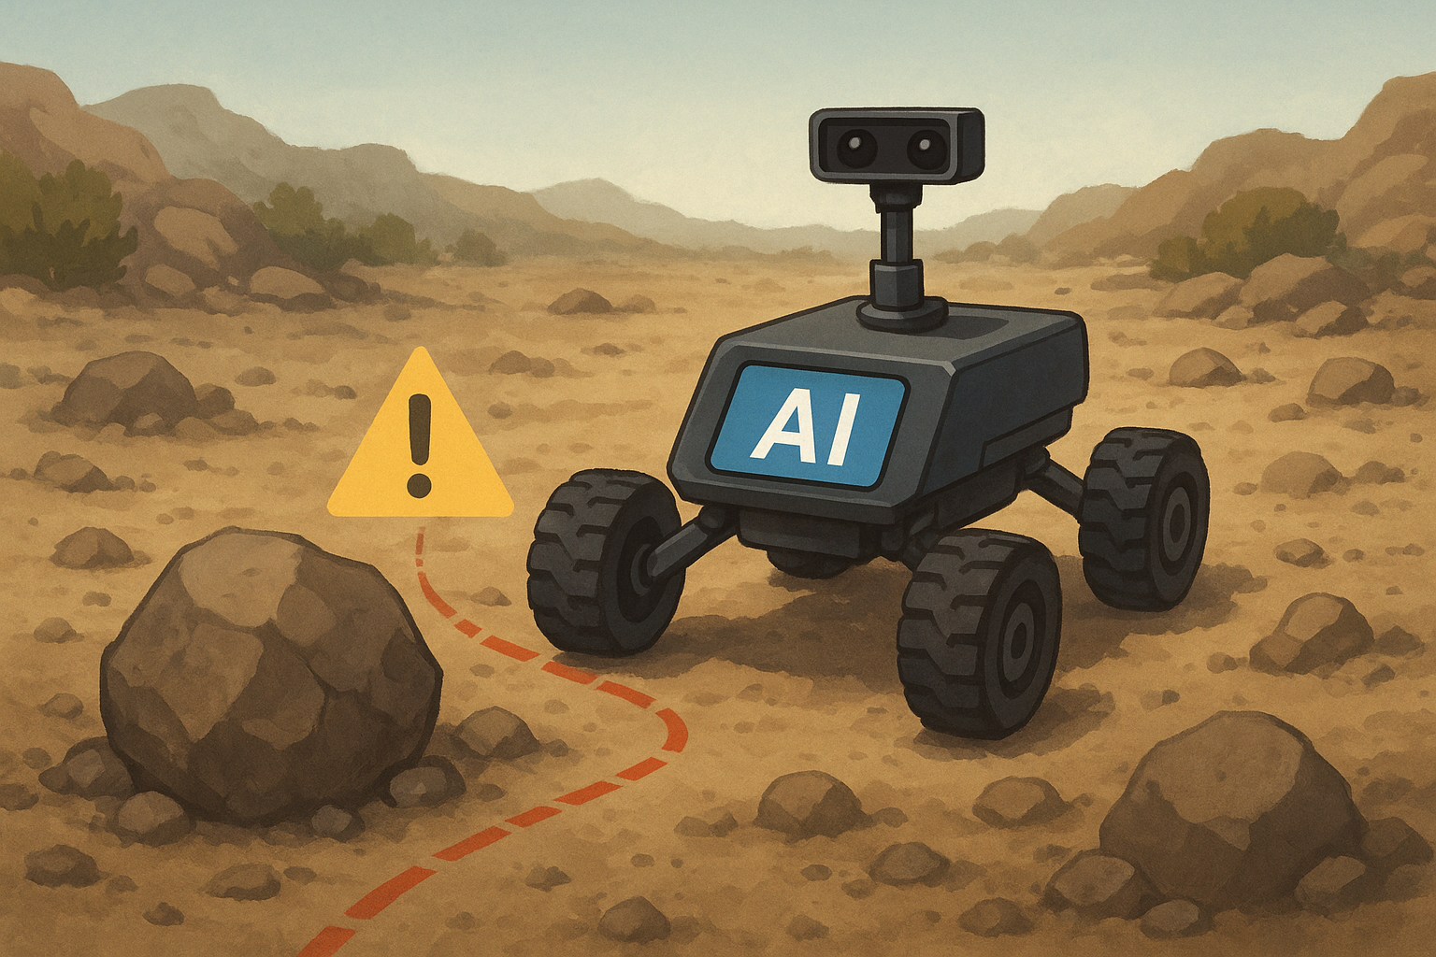

**7. CONCLUSION**

The AI-based obstacle-avoidance rover developed in this project demonstrates that even with a simple hardware setup—consisting of an ultrasonic sensor, motor driver, servo motor, and a basic switching circuit—it is possible to achieve reliable real-time obstacle detection and avoidance. The ultrasonic sensor consistently provided accurate distance measurements at short to medium ranges, allowing the rover to stop or adjust its path before a collision occurred. With the sensor mounted on a servo motor, the system gained wider scanning capability, enabling it to make better decisions when choosing alternative routes.The motor driver module ensured smooth and responsive control of the rover’s movements, while the switch provided safe and convenient power management. Testing confirmed that the rover achieved dependable obstacle avoidance in controlled environments, with very little delay between detecting an obstacle and executing the appropriate action.This project highlights the potential of low-cost sensing and control systems in minimizing accidents across automated platforms. While the current version relies solely on ultrasonic sensing and reactive control, it lays a strong foundation for future improvements. Expanding the design with multiple sensors, integrating camera-based AI for object recognition, and implementing path planning algorithms could significantly enhance the rover’s adaptability in more complex environments.In conclusion, the rover successfully meets its design objective of demonstrating safe, accident-free navigation in an autonomous system. Beyond serving as a prototype, it also shows promise for broader applications in fields such as automated vehicles, industrial robotics, and service rovers.[7][19]

**8. REFERENCES**

1.Rajesh Mothe, S. Tharun Reddy, G. Sunil, Chintoju Sidhardha. *An IoT Based Obstacle Avoidance Robot Using Ultrasonic Sensor and Arduino*. IOP Conf. Ser.: Materials Science and Engineering, 2020. [IOPscience](https://iopscience.iop.org/article/10.1088/1757-899X/981/4/042002?utm_source=chatgpt.com)

2.Jianhong Wu. *Research on Obstacle Avoidance Control of Intelligent Robots Based on Multi-Sensor Fusion*. Highlights in Science, Engineering and Technology, Vol. 114, 2024. [Darcy & Roy Press](https://drpress.org/ojs/index.php/HSET/article/view/25552?utm_source=chatgpt.com)

3. Bolaji-Adetoro, K. J. Adedotun, Olojeola Sheu Musa, A. K. Raji. *Implementation of an IoT-Enabled Sensor Fusion for Enhanced Obstacle Avoidance in Autonomous Vehicles*. Journal of Engineering Logic and Modelling Research, 2024. [ssaapublications.com](https://ssaapublications.com/sjelmr/article/view/373?utm_source=chatgpt.com)

4.Surya J, Swetha S, Vinayaga Moorthi M. A. *Smart Wheel Bot: An IoT-Driven Obstacle Avoidance System for Wheelchairs*. IJARIIT, Vol. 11, Issue 3, 2025. [IJARIIT](https://www.ijariit.com/manuscript/smart-wheel-bot-an-iot-driven-obstacle-avoidance-system-for-wheelchairs/?utm_source=chatgpt.com)

5.Hassan M. Alwan, Volkov Andrey Nikolavich, Ali Shbani, Olga Vladmirovna Kochneva. *Motion Control and Obstacle Avoidance of Mobile Robot with Mecanum Wheels*. International Journal of Technology, Vol. 16, No. 1, 2025. [International Journal of Technology](https://ijtech.eng.ui.ac.id/article/view/7254?utm_source=chatgpt.com)

6.*Obstacle Avoidance Technique for Mobile Robots at Autonomous Human-Robot Collaborative Warehouse Environments*. Sensors, 2025, 25(8), 2387. [MDPI](https://www.mdpi.com/1424-8220/25/8/2387?utm_source=chatgpt.com)

7. *Sensor Data Fusion for a Mobile Robot Using Neural Networks*. Sensors, 2022, 22(1), 305. (LiDAR + Camera + Ultrasonic etc.) [MDPI](https://www.mdpi.com/1424-8220/22/1/305?utm_source=chatgpt.com)

8.*Intelligent Obstacle Avoidance Algorithm for Safe Urban Monitoring with Autonomous Mobile Drones*. Journal of Electronic Science and Technology, Vol. 22, Issue 4, 2024. [ScienceDirect](https://www.sciencedirect.com/science/article/pii/S1674862X24000454?utm_source=chatgpt.com)

9. *Detection of Obstacles Based on Information Fusion for Autonomous Agricultural Vehicles*. Transactions of the Chinese Society of Agricultural Machinery, Vol. 49, No. S1, 2018. [nyjxxb.net](https://nyjxxb.net/index.php/journal/article/view/746?utm_source=chatgpt.com)

10. *Research on Obstacle Avoidance Algorithm for Unmanned Ground Vehicle based on Multi-Sensor Information Fusion*. (PubMed). Fuzzy neural network method, simulation & experiments. [PubMed](https://pubmed.ncbi.nlm.nih.gov/33757173/?utm_source=chatgpt.com)

10.*AI-Powered Obstacle Detection for Safer Human-Machine Collaboration*. Acta Electrotechnica et Informatica, Vol. 24 (Issue 3), 2024. [Sciendo](https://sciendo.com/article/10.2478/aei-2024-0011?utm_source=chatgpt.com)

12.*Multiple Internet of Robotic Things robots based on LiDAR and camera sensors* ‒ Yanyan Dai, Suk-Gyu Lee (2020). IoRT system, path planning, obstacle avoidance etc. [SAGE Journals](https://journals.sagepub.com/doi/10.1177/1729881420913769?utm_source=chatgpt.com)

13.*Real Time Lidar and Radar High-Level Fusion for Obstacle Detection and Tracking with evaluation on a ground truth*. Hatem Hajri, Mohamed-Cherif Rahal, arXiv preprint, 2018. [arXiv](https://arxiv.org/abs/1807.11264?utm_source=chatgpt.com)

14.*Memory-based Deep Reinforcement Learning for Obstacle Avoidance in UAV with Limited Environment Knowledge*. Abhik Singla, Sindhu Padakandla, Shalabh Bhatnagar, arXiv preprint, 2018. [arXiv](https://arxiv.org/abs/1811.03307?utm_source=chatgpt.com)

15.*A Neural Network Approach for Building An Obstacle Detection Model by Fusion of Proximity Sensors Data*. (PubMed) – uses IR/ultrasonic sensors + NN. [PubMed](https://pubmed.ncbi.nlm.nih.gov/29495338/?utm_source=chatgpt.com)

16.*Research on Robot Obstacle Avoidance Method Based on Digital Twin*. 2022 2nd Int’l Conf. on Control and Intelligent Robotics. Uses digital twin + artificial potential field. [ACM Digital Library+1](https://dl.acm.org/doi/10.1145/3548608.3559179?utm_source=chatgpt.com)

17.“Design and Implementation of an IoT-Enabled Bluetooth Robot Car with Obstacle Avoidance”. International Journal of Intelligent Systems and Applications in Engineering (IJISAE). [IJISAE](https://ijisae.org/index.php/IJISAE/article/view/2824?utm_source=chatgpt.com)

18.“Cooperative Robot-Drone Agents for Obstacle Avoidance using Smart Vision” ‒ IJERT, 2017. Uses vision, IoT/connected agents. [IJERT](https://www.ijert.org/cooperative-robot-drone-agents-for-obstacle-avoidance-using-smart-vision?utm_source=chatgpt.com)

19.*A review of perception sensors, techniques, and hardware architectures for autonomous low-altitude UAVs in non-cooperative local obstacle avoidance*. Robotics and Autonomous Systems, 2024. [ScienceDirect](https://www.sciencedirect.com/science/article/abs/pii/S0921889024000125?utm_source=chatgpt.com)

20. *AI-Enhanced Sensor Fusion Techniques for Autonomous Vehicle Perception: Integrating Lidar, Radar, and Camera Data with Deep Learning Models for Enhanced Object Detection, Localization, and Scene Understanding*. Journal of Bioinformatics and Artificial Intelligence, 2024.