IoT-Obstacle detection using AI

A project submitted to the Bharathidasan University

in partial fulfillment of the requirements

for the award of the Degree of

BACHELOR OF COMPUTER APPLICATIONS

Submitted by

**R.Priyadharshan**

Register Number: 235113639

Under the guidance of

**Dr.M.Kavitha**, M.Sc., M.Phil., Ph.D.,

Assistant Professor



DEPARTMENT OF COMPUTER APPLICATIONS

BISHOP HEBER COLLEGE (AUTONOMOUS)

“Nationally Reaccredited at A++ Grade with a CGPA of 3.69 out of 4 in NAAC IV Cycle”

**Recognized by UGC as “College of Excellence”**

**Affiliated to Bharathidasan University**

**TIRUCHIRAPPALLI-620 017**

OCTOBER – 2025

DECLARATION

I hereby declare that the project work presented is originally done by me under the guidance of  **Dr.M.Kavitha, M.Sc, M.Phil., Ph.D.,Assistant Professor, UG Department of Computer Applications, Bishop Heber College (Autonomous), Tiruchirappalli-620 017** and has not been included in any other thesis/project submitted for any other degree.

Name of the Candidate : R.Priyadharshan

Register Number : 235113639

Batch : 2023-2026

Signature of the Candidate

**Dr.M.Kavitha, M.Sc., M.Phil., Ph.D.,**

**Assistant Professor,**

UG Department of Computer Applications,

Bishop Heber College (Autonomous),

Tiruchirappalli – 620017

**Date:**

**CERTIFICATE**

This is to certify that the project work entitled **“IoT-Obstacle detection using AI”** is a bonafide record work done by **R.Priyadharshan, Register Number:235113639** in partial fulfillment of the requirements for the award of the degree of **BACHELOR OF COMPUTER APPLICATIONS** during the period **2023 - 2026.**

**Place: Signature of the Guide**

**UG DEPARTMENT OF COMPUTER APPLICATIONS**

BISHOP HEBER COLLEGE (AUTONOMOUS),

“Nationally Reaccredited at A++ Grade with a CGPA of 3.69 out of 4 in NAAC IV Cycle”

(Recognized by UGC as “College of Excellence”)

(Affiliated to Bharathidasan University)

TIRUCHIRAPPALLI – 620 017

Date:

Course Title: Course Code: U23CA5PJ

CERTIFICATE

The Viva-Voce examination for the candidate R.Priyadharshan, Register Number:235113639 was held on _________________.

Signature of the Guide Signature of the HOD

Examiners:

1.

2.

|  |  |  |
| --- | --- | --- |
| **Table of Contents** | | |
| **S.No.** | **Title** | **Page No.** |
|  | Abstract |  |
|  | Introduction |  |
|  | Existing and Proposed System |  |
|  | Software and Hardware Requirements |  |
|  | Review of Literature |  |
|  | Definition of the Problem and Scope of the Research work |  |
|  | Architectural Design |  |
|  | Results and Discussions |  |
|  | Conclusion & Future Enhancement |  |
|  | References |  |
|  | Paper Publication |  |

**ABSTRACT**

**CHAPTER – 1**

**ABSTRACT**

This research project proposes the design and development of an AI-based obstacle-avoidance rover that leverages low-cost IoT components integrated with web-based remote monitoring capabilities. The rover is built around the ESP8266 microcontroller, which not only serves as the central processing unit but also provides Wi-Fi connectivity, enabling real-time communication and visualization of sensor data through a dedicated web interface. This integration of computation, connectivity, and intelligent control makes the system both economical and scalable.The rover’s primary sensing mechanism relies on ultrasonic sensors mounted on a servo motor, allowing the sensor to dynamically rotate and scan the environment across multiple angular positions. This setup ensures wide-range detection and accurate measurement of distances between the rover and surrounding obstacles. By continuously analyzing these distance values, the system can make informed decisions to alter the rover’s trajectory, ensuring a collision-free navigation experience.Mobility is achieved through DC motors that are controlled by a motor driver module, enabling the rover to perform forward motion, backward motion, left/right turns, and differential steering. The modular design using jumper wires and a compact chassis ensures flexibility, ease of prototyping, and simple replacement or expansion of components.The intelligence of the obstacle-avoidance mechanism lies in its ability to gather real-time data, process it on the ESP8266, and apply decision-making algorithms that maintain a safe clearance from nearby objects. Whenever an obstacle is detected within a critical threshold, the rover autonomously adjusts its movement to avoid a collision. At the same time, the ESP8266 establishes a Wi-Fi hotspot or connects to a local wireless network, enabling seamless access to the rover’s web dashboard from any connected device.The web interface plays a crucial role in enhancing user interaction and monitoring. It provides live distance readings, current movement status, and can be further extended to incorporate camera streaming, offering visual situational awareness in real time. This remote accessibility not only improves usability but also broadens the scope of applications by allowing multiple users to track and control the rover from different locations.By combining simple hardware components with intelligent control algorithms and IoT-based monitoring, this project demonstrates how cost-effective solutions can be designed for autonomous accident prevention. Its flexibility makes it highly suitable for various applications, including educational robotics, indoor surveillance, warehouse and factory monitoring, and as a prototype framework for autonomous vehicles. Furthermore, the project highlights the potential of readily available, low-cost electronic components when integrated into a cohesive system, showcasing a scalable approach toward safe, reliable, and intelligent navigation technologies.

**Keyword :** ESP8266, ultrasonic sensor, servo motor, motor driver, IoT rover, accident prevention, remote monitoring.

**INTRODUCTION**

**CHAPTER – 2**

**INTRODUCTION**

The rapid advancement of autonomous systems and robotics has created a strong demand for intelligent navigation platforms that can operate safely in dynamic and unpredictable environments, where one of the most essential requirements is obstacle detection and avoidance. This function ensures that a mobile robot can move without colliding with objects, thereby improving safety, reliability, and overall efficiency. Obstacle avoidance is not only vital for small-scale robotics laboratories and educational rover projects but also forms the backbone of advanced technologies such as self-driving cars, automated guided vehicles (AGVs) in industrial settings, and unmanned aerial systems. In this research project, we propose the development of an AI-based obstacle-avoidance rover that demonstrates how affordable hardware can be integrated with intelligent decision-making and remote monitoring features. The rover is built around an ESP8266 microcontroller, which serves as both the control unit and communication hub, as it provides built-in Wi-Fi connectivity that enables web-based monitoring. An ultrasonic sensor mounted on a servo motor performs continuous scanning of the environment at multiple angles, allowing the rover to detect obstacles not only directly ahead but also toward the left and right sides, thereby selecting a safer path of travel similar to the decision-making process in high-end autonomous vehicles. The motion of the rover is controlled through a motor driver module connected to its DC motors, enabling forward, backward, and turning movements based on real-time sensor readings, while jumper wires and modular connections provide flexibility for easy modifications and future enhancements. A key feature of the system is its IoT-enabled monitoring capability, where the ESP8266 hosts a lightweight web server that allows users to view live obstacle distances, track the rover’s movement status, and even manually override controls when necessary. The significance of this work lies in its ability to offer a low-cost yet effective platform that demonstrates the core principles of autonomous navigation and IoT-based robotics. By combining obstacle detection, intelligent path planning, and live telemetry, the project highlights the feasibility of creating accident-free autonomous systems on a small scale while also pointing toward their broader potential in real-world applications such as smart transportation, industrial automation, and future intelligent mobility solutions.

**Existing and Proposed System**

**CHAPTER-3**

**3.1 Existing System**

Obstacle avoidance and autonomous navigation have been active research areas in robotics for decades. Traditional systems for collision prevention are generally categorized into two groups:

1. **Sensor-based reactive systems** – Many low-cost robots rely on simple ultrasonic or infrared sensors connected to microcontrollers such as Arduino or PIC. These robots detect obstacles in front of them and stop or change direction based on a threshold distance. While cost-effective, these systems are often limited in accuracy, have a narrow detection field, and cannot make complex navigation decisions.
2. **High-end robotics platforms** – Advanced mobile robots and autonomous vehicles make use of LiDAR, stereo cameras, GPS, and artificial intelligence for robust obstacle detection and path planning. These systems achieve high accuracy but are expensive, computationally intensive, and require specialized hardware and software platforms such as ROS (Robot Operating System).
3. **Remote-controlled systems** – Some existing rovers provide live camera feeds and manual teleoperation via Bluetooth or RF modules. Although they allow remote supervision, they lack autonomous obstacle avoidance and real-time decision-making. Furthermore, most Bluetooth- or RF-based solutions have limited range and no support for IoT-based global monitoring.
4. **IoT-enabled robots** – In recent years, some systems have integrated microcontrollers with Wi-Fi modules (e.g., ESP8266/ESP32) to enable web dashboards or smartphone-based control. These projects demonstrate the potential of combining robotics with IoT. However, many of these implementations are either purely remote-controlled without autonomous decision-making, or they do not provide a live monitoring interface that displays obstacle distance and navigation status.

**Limitations of Existing Systems:**

* **Restricted obstacle detection**: Most ultrasonic-only systems measure distance in one fixed direction, limiting awareness of the surroundings.
* **Lack of integration with IoT**: Many earlier robots lack real-time monitoring over the internet, restricting usage to short-range control.
* **Cost and complexity**: High-end solutions using LiDAR and cameras are not feasible for small-scale educational or prototype robots.
* **Limited user interaction**: Remote-controlled robots often lack autonomous safety features, making collisions frequent in uncertain environments.

These limitations highlight the need for a system that is low-cost, autonomous, and IoT-enabled, allowing real-time obstacle detection and avoidance combined with web-based live monitoring and optional control.

## **3.2 Proposed System**

To overcome the limitations of conventional obstacle-avoidance robots and high-cost autonomous platforms, this project proposes an AI-based obstacle-avoidance rover with IoT-enabled remote monitoring. The system integrates low-cost sensors andcomponents with intelligent control algorithms to provide both autonomous navigation and real-time supervision via a web interface.

**Key Features of the Proposed System:**

1. **ESP8266 Microcontroller** – Serves as the central processing and communication unit. In addition to handling obstacle detection and motor control, it provides built-in Wi-Fi capabilities to host a lightweight web server for live monitoring and user interaction.
2. **Ultrasonic Sensor with Servo Motor** – Instead of keeping the ultrasonic sensor fixed in one direction, it is mounted on a servo motor. The servo continuously rotates the sensor across multiple angles (e.g., left, center, right), enabling the rover to build a wider awareness of its environment. This ensures that the rover can choose the safest direction to move instead of relying on limited frontal detection.
3. **Motor Driver Module (L298N/L293D)** – Controls the DC motors of the rover, allowing smooth forward, backward, left, and right movements. The motor driver ensures that the microcontroller can handle higher current requirements of the motors safely.
4. **IoT-enabled Web Interface** – The ESP8266 hosts a real-time web dashboard accessible via any device connected to the same network. The dashboard displays live distance measurements, movement status, and optionally manual control buttons for teleoperation. Unlike Bluetooth-based systems, Wi-Fi connectivity extends the range of control and monitoring significantly.
5. **Accident-Free Operation** – The rover intelligently scans for obstacles and stops or reroutes automatically when a hazard is detected within a predefined threshold. This functionality makes the system suitable as a prototype for accident-prevention research in larger-scale autonomous vehicles.

**Advantages over Existing Systems:**

* **Wider obstacle detection** through dynamic scanning with servo-mounted ultrasonic sensor.
* **Low-cost and modular** hardware design suitable for educational and prototype purposes.
* **IoT-based monitoring** using Wi-Fi, eliminating the range restrictions of Bluetooth or RF.
* **User-friendly web interface** that requires no special applications, only a standard browser.
* **Scalable design** that can be extended with additional sensors (e.g., camera module, IR sensors) for advanced research.

Thus, the proposed system strikes a balance between simplicity, cost-effectiveness, and intelligence, making it a practical choice for applications such as robotics education, warehouse automation, surveillance, and as a foundational step toward autonomous transportation technologies.

**SOFTWARE AND HARDWARE REQUIREMENTS**

****CHAPTER-4****

## **Software and Hardware Requirements**

To develop and operate the **IoT-Obstacle detection using AI** system effectively, a specific set of hardware and software tools is required. This section outlines the components necessary for building, programming, and managing the automated system.

## **4.1.Hardware Requirements**

The hardware components are the physical parts that make up the hydroponics system. These include the sensors, controllers, power supply, and other essential modules that enable automation and real-time monitoring.

1. **ESP8266 Wi-Fi Microcontroller**

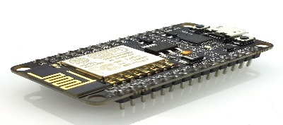

* The ESP8266 NodeMCU module is used as the main control unit.
* It handles obstacle detection logic, motor control, and wireless communication.
* Its built-in Wi-Fi capability allows the rover to host a web server for real-time monitoring and remote control.

1. **Ultrasonic Sensor (HC-SR04)**

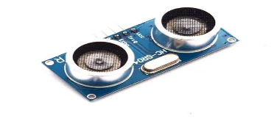

* Used for measuring the distance between the rover and nearby obstacles.
* Works on the principle of sending ultrasonic waves and measuring the time taken for the echo to return.
* Provides accurate distance measurements in the range of 2 cm to 400 cm.

1. **Servo Motor (SG90)**

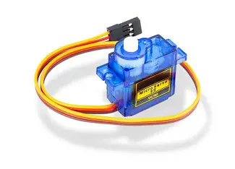

* The ultrasonic sensor is mounted on a servo motor to rotate across different angles.
* This scanning mechanism allows the rover to detect obstacles not only in the front but also to the left and right directions.
* Enables the rover to make intelligent navigation decisions.

1. **Motor Driver Module (L298N / L293D)**

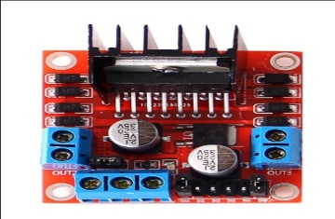

* Used to control the DC motors of the rover.
* Acts as an interface between the ESP8266 (low-current signals) and the motors (high-current requirement).
* Allows bidirectional movement (forward, backward, left, right).

1. **DC Motors with Wheels**

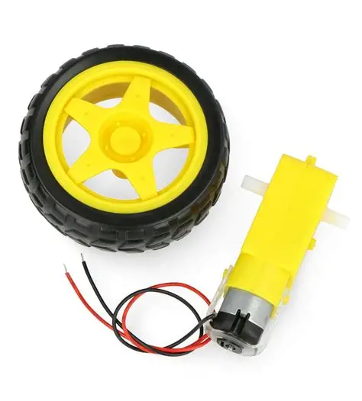

* Provide the locomotion of the rover.
* Controlled by the motor driver module to execute navigation decisions based on obstacle detection.

1. **Power Supply**

* A rechargeable Li-ion or Li-Po battery pack (7.4V or 12V depending on motors and driver).
* Powers both the ESP8266 and the motor driver circuit.
* Voltage regulators are used to ensure stable power distribution.

1. **Chassis (Rover Body)**

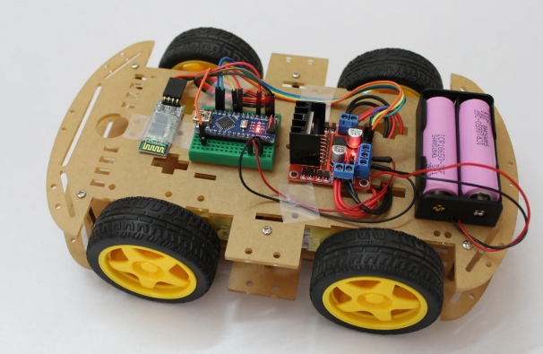

* A lightweight robotic chassis is used to mount the motors, wheels, ESP8266, sensors, and power supply.
* Provides structural support for the rover.

1. **Jumper Wires and Breadboard/PCB**

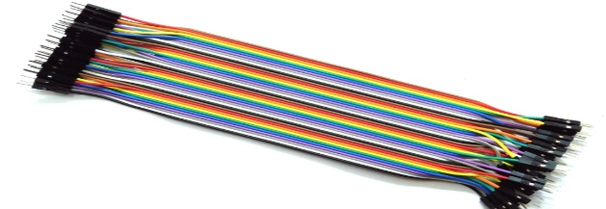

* Jumper wires are used to interconnect all the components.
* A breadboard or custom PCB (Printed Circuit Board) can be used for neat and stable connections.

## **4.2.Software Requirements**

Software tools are essential for programming the ESP8266, integrating sensor data, and enabling remote monitoring and control.

## **1. Arduino IDE**

## The Arduino Integrated Development Environment (IDE) is used for writing and uploading the code to the ESP8266 microcontroller.

## Supports C/C++ programming for embedded applications.

## Provides built-in libraries and allows the inclusion of external libraries for ultrasonic sensors, servo motor, and Wi-Fi communication.

## **2. ESP8266 Board Manager Package**

## Installed in the Arduino IDE to enable programming and uploading code specifically for ESP8266-based boards (NodeMCU, Wemos, etc.).

## Provides the required drivers and configurations for serial communication.

## **3. Required Libraries**

## Several Arduino-compatible libraries are needed for this project:

## **ESP8266WiFi.h** – To enable Wi-Fi connectivity and host a web server.

## **ESP8266WebServer.h** – To create and manage the web-based interface for monitoring and control.

## **Servo.h** – To control the rotation and angle of the servo motor.

## **NewPing.h** or **Ultrasonic.h** – For handling distance measurement using the HC-SR04 ultrasonic sensor.

## **4. Web Interface Development**

## The rover hosts a web-based user interface accessible from any browser.

## Developed using HTML, CSS, and basic JavaScript, which are embedded into the ESP8266 program.

## The web dashboard displays:

## Real-time obstacle distance values.

## Rover’s movement status (forward, backward, left, right, stop).

## Optional manual control buttons for teleoperation.

## **5. Serial Monitor / Debugging Tools**

## The Serial Monitor in Arduino IDE is used during development and testing to check sensor readings, motor control signals, and debugging messages.

## Ensures proper calibration of the ultrasonic sensor and servo motor movements.

## **6. Optional Tools**

## **Fritzing / Proteus / Tinkercad** – For circuit simulation and diagram creation.

## **Version Control (GitHub)** – To maintain and update the source code for future improvements.

## 

## 

**Review of Literature**

**CHAPTER-5**

**5.1 Review of Literature**

The concept of obstacle detection and avoidance has long been recognized as a fundamental requirement for ensuring the safe operation of mobile robots and autonomous systems. Over the years, researchers have explored various sensor technologies, algorithms, and integration techniques to improve how robots perceive their surroundings and make navigation decisions. Early approaches were largely centered on using single-sensor systems, but with the rise of IoT, artificial intelligence, and sensor fusion, newer methods have been developed that are more intelligent, adaptive, and efficient. A review of existing literature reveals how these technologies have evolved and how they contribute to shaping the design of modern obstacle-avoidance platforms.One of the foundational studies in this domain was carried out by Rajesh Mothe et al. (2020), who developed an IoT-based obstacle-avoidance robot using ultrasonic sensors and Arduino. Their work demonstrated how low-cost hardware could be combined with IoT features to enable a robot to detect and avoid objects in real time. Although simple, their approach established a practical model for affordable autonomous robots and showed the effectiveness of ultrasonic sensors in distance measurement and collision prevention. However, their design was limited in scope since it primarily focused on basic navigation without exploring advanced decision-making or multi-sensor integration.To address such limitations, Jianhong Wu (2024) proposed an advanced method of obstacle avoidance based on multi-sensor fusion. This work highlighted that relying on a single sensor often restricts accuracy, particularly in dynamic or cluttered environments. By fusing data from multiple sensors, the system achieved improved environmental awareness and more robust decision-making. This approach reflected a broader trend in robotics research, where sensor fusion is increasingly being used to overcome the weaknesses of individual sensors and create more intelligent systems.The importance of IoT-enabled robotics was further highlighted in the work of Bolaji-Adetoro et al. (2024), who designed an IoT-based sensor fusion system for autonomous vehicles. Their research showed how IoT connectivity could be integrated with sensor data to enhance obstacle avoidance performance while simultaneously providing remote monitoring capabilities. The study bridged the gap between autonomous navigation and connected systems, aligning with the current shift toward Industry 4.0 and intelligent transportation networks.Applications of obstacle avoidance in assistive technologies have also been widely explored. Surya et al. (2025) developed the “Smart Wheel Bot,” an IoT-driven wheelchair system equipped with obstacle avoidance features. Their research demonstrated how robotics could be leveraged not only for industrial or vehicular purposes but also for improving the quality of life of physically challenged individuals. This study illustrated the versatility of obstacle-avoidance systems and their significance in diverse domains.Further contributions to the field were made by Hassan M. Alwan et al. (2025), who investigated motion control and obstacle avoidance for robots with Mecanum wheels. Their research addressed the unique challenges of omnidirectional mobility, which allows robots to move in any direction without changing their orientation. This work is particularly relevant for confined environments such as hospitals, warehouses, and offices, where high maneuverability is critical.Industrial automation has also benefited from advancements in obstacle avoidance. A study published in *Sensors* (2025) focused on mobile robots operating in autonomous human-robot collaborative warehouse environments. This research proposed innovative techniques to ensure that mobile robots could navigate efficiently and safely while interacting with human workers. Such applications highlight the importance of reliable obstacle avoidance in achieving productivity and safety in smart warehouses.Recent advancements have also explored the integration of artificial intelligence with sensor data. For example, a study in *Sensors* (2022) introduced the use of neural networks for sensor data fusion, combining LiDAR, cameras, and ultrasonic sensors. By training AI models to process heterogeneous sensor inputs, the research demonstrated how robots could adapt to complex environments with greater intelligence than traditional rule-based systems. This marked an important step toward embedding AI-driven decision-making into obstacle avoidance frameworks.In addition to ground-based robots, aerial robotics has also been a major area of development. A study published in the *Journal of Electronic Science and Technology* (2024) presented intelligent obstacle avoidance algorithms for autonomous drones used in urban monitoring. This work emphasized the role of safe navigation in aerial robotics, especially in densely populated cities, where drones are increasingly being used for surveillance, delivery, and monitoring tasks. The research underscored the growing importance of obstacle avoidance beyond ground vehicles, extending it to multi-domain robotic platforms.From the reviewed literature, it is evident that obstacle avoidance research has evolved from basic ultrasonic-sensor robots to sophisticated IoT-driven, AI-enhanced, and sensor-fusion-based systems. While each study contributes valuable insights, a recurring theme is the trade-off between cost, complexity, and functionality. High-end systems employing LiDAR, cameras, and advanced processors achieve excellent results but at a high cost, making them less accessible for small-scale applications. On the other hand, low-cost designs often compromise on adaptability and intelligence. This research project, therefore, aims to bridge this gap by presenting a low-cost, AI-inspired rover that integrates ultrasonic sensors, servo scanning, motor control, and web-based monitoring via ESP8266. The reviewed works provide the foundation and motivation for this design, illustrating the need for systems that are both affordable and scalable, while still embodying the principles of intelligent obstacle avoidance and IoT-based monitoring.

**DEFINITION OF THE PROBLEM AND SCOPE OF THE RESEARCH WORK**

**CHAPTER-6**

**Definition of the Problem and Scope of the Research Work**

## **6.1.Definition of the Problem**

With the advancement of autonomous systems, collision avoidance has become a critical challenge in robotics and automated vehicles. Most low-cost robotic platforms rely on single-point obstacle detection, often limited to a frontal sensor. This narrow sensing capability can lead to collisions when obstacles appear at angles or when the robot must choose a safe path to navigate around them.

Additionally, remote monitoring and supervision are often neglected in low-cost or educational robots. While high-end autonomous vehicles provide extensive telemetry, most small-scale robots lack live obstacle data display, distance measurements, and user-friendly remote control, limiting their usefulness in research, education, and practical applications.

The problem addressed by this research is:

1. **Limited obstacle awareness** – Existing low-cost robots cannot dynamically sense obstacles in multiple directions.
2. **Lack of real-time monitoring** – Users cannot view live telemetry of distances or rover status remotely.
3. **High cost of sophisticated systems** – LiDAR and camera-based autonomous systems are expensive and computationally heavy, making them impractical for educational and prototyping purposes.

This project aims to solve these problems by designing a low-cost, IoT-enabled, obstacle-avoidancerover that provides wide-angle sensing through a servo-mounted ultrasonic sensor and offers real-time web-based monitoring.

## **6.2.Scope of the Research Work**

The scope of this research work defines the boundaries, objectives, and applications of the proposed rover:

1. **Autonomous Obstacle Avoidance** – The rover autonomously detects obstacles using an ultrasonic sensor mounted on a servo motor and navigates safely without human intervention.
2. **Remote Monitoring** – The system provides a web interface hosted on ESP8266 to display:
   * Live distance measurements from the ultrasonic sensor
   * Rover movement and status (forward, backward, left, right, stop)
   * Optional teleoperation through simple web controls
3. **Low-Cost Prototype** – The design focuses on cost-effectiveness, using ESP8266, ultrasonic sensors, servo motors, and standard DC motors, making it accessible for educational, hobbyist, and research applications.
4. **Indoor and Semi-Structured Environments** – The rover is designed for indoor testing and semi-structured environments (like lab spaces, corridors, or small obstacle courses).
5. **Modularity and Scalability** – The system is modular and can be expanded in future work to include:
   * Multiple sensors for redundancy
   * Camera modules for visual feedback
   * Integration with cloud platforms for long-range monitoring
6. **Safety-Oriented Design** – Ensures accident-free navigation during autonomous operation, providing a model for safe automation research applicable to larger systems like automated vehicles.

**Limitations:**

* The rover is designed for low-speed indoor or semi-structured environments; high-speed outdoor operation is beyond the current scope.
* The ESP8266’s processing power and network latency may limit advanced multi-sensor integration or high-frequency telemetry.

**Architectural Design**

**CHAPTER-7**

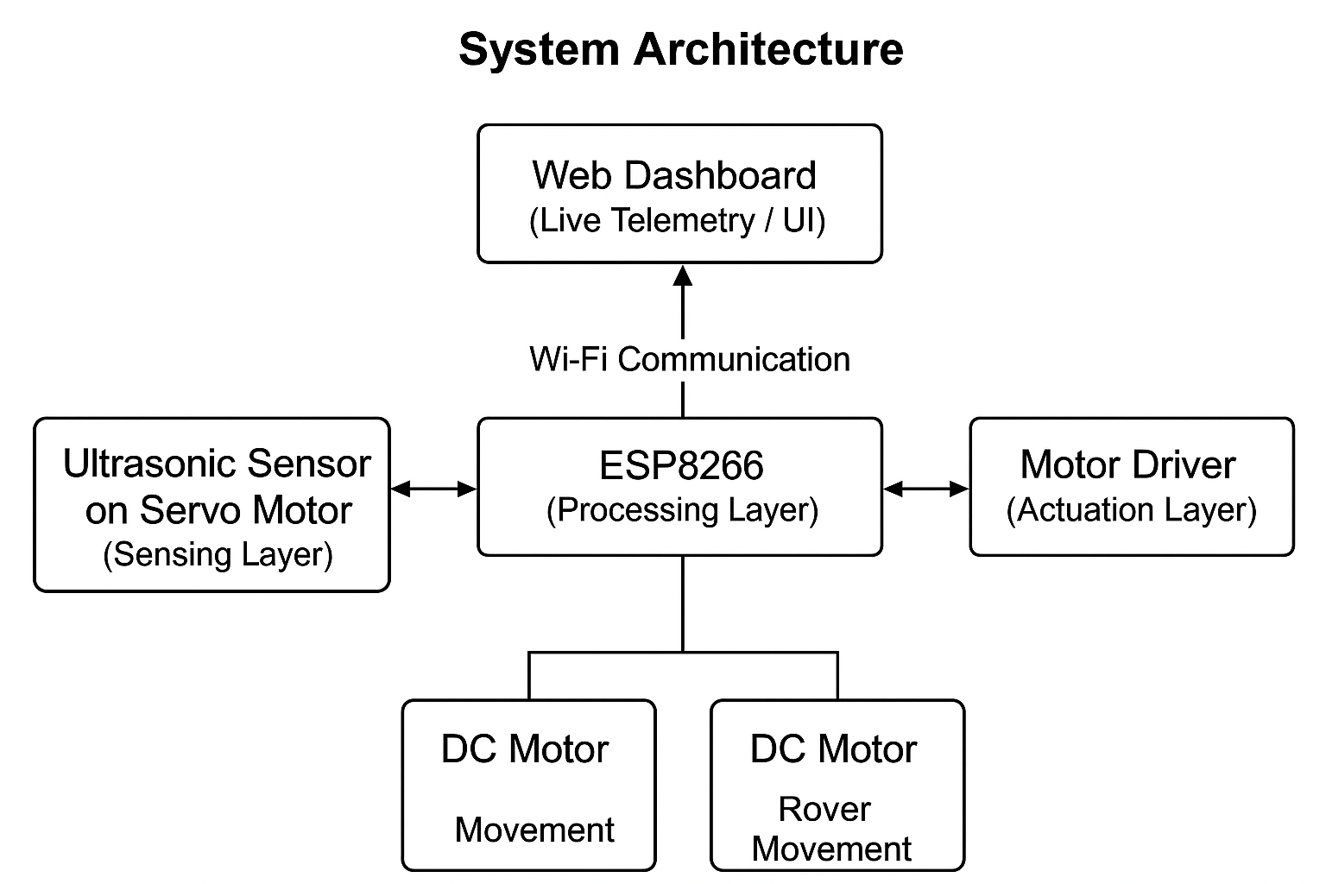**7.1Architectural Design**

The proposed AI-based obstacle-avoidance rover integrates sensing, processing, actuation, and web-based monitoring into a modular architecture. The system is designed to ensure real-time obstacle detection, autonomous navigation, and live remote monitoring.

**7.2 Overview**

The system architecture consists of four main layers:

1. **Sensing Layer** – Responsible for detecting obstacles and gathering environmental data.
2. **Processing Layer** – Handles decision-making and control logic.
3. **Actuation Layer** – Executes navigation commands by controlling the rover’s motors.
4. **Communication & Monitoring Layer** – Enables web-based telemetry and optional teleoperation.

**7.3 Components and Functionality**

**1. Sensing Layer**

* **Ultrasonic Sensor (HC-SR04)**: Measures distances to obstacles in front and to the sides via servo scanning.
* **Servo Motor**: Rotates the ultrasonic sensor across multiple angles to extend field-of-view.
* The sensor layer continuously sends distance readings to the processing layer.

**2. Processing Layer**

* **ESP8266 Microcontroller**: Central control unit that performs the following:
  + Reads ultrasonic sensor values.
  + Determines the safe path using simple AI/rule-based logic.
  + Sends motor control commands to the driver module.
  + Hosts the web server for live monitoring.
* Includes algorithms for obstacle detection, threshold checking, and safe navigation decision-making.

**3. Actuation Layer**

* **Motor Driver Module (L298N / L293D)**: Receives commands from ESP8266 to control DC motors.
* **DC Motors with Wheels**: Drive the rover forward, backward, and turn left/right according to the processed navigation commands.

**4. Communication & Monitoring Layer**

* **Wi-Fi Connectivity (ESP8266)**: Enables the rover to host a web-based interface.
* **Web Dashboard**:
  + Displays real-time distance readings.
  + Shows rover movement and status.
  + Optional buttons for teleoperation (manual override).
* Communication protocols: HTTP, WebSocket, or lightweight AJAX for low-latency updates.

**7.4 Data Flow**

1. Ultrasonic sensor measures distances at multiple angles.
2. ESP8266 reads the data and determines whether the path is safe.
3. If safe, ESP8266 sends commands to the motor driver to move in the chosen direction.
4. Sensor readings and rover status are simultaneously transmitted to the web dashboard.
5. User can monitor or optionally intervene using the dashboard controls.

**7.5 Block Diagram**

Here’s a textual representation of the block diagram (you can create a visual version in PowerPoint, Fritzing, or any drawing tool):

+-----------------------+

| Web Dashboard |

| (Live Telemetry / UI)|

+-----------+-----------+

^

|

Wi-Fi Communication

|

+-----------v-----------+

| ESP8266 |

| (Processing Layer) |

+-----------+-----------+

|

+-----------v-----------+

| Motor Driver |

| (Actuation Layer) |

+-----------+-----------+

| |

DC Motor 1 DC Motor 2

|

Rover Movement

+-----------+-----------+

| Ultrasonic Sensor |

| on Servo Motor |

+-----------------------+

(Sensing Layer)

**7.6 Design Highlights**

* **Modular architecture** allows easy replacement or addition of sensors.
* **Separation of layers** (sensing, processing, actuation, monitoring) improves reliability and maintainability.
* **Real-time monitoring** ensures safety during autonomous navigation.
* **Low-cost components** are efficiently orchestrated to demonstrate practical obstacle avoidance and IoT integration.

**RESULTS AND DISCUSSIONS**

**CHAPTER-8**

**Results and Discussions**

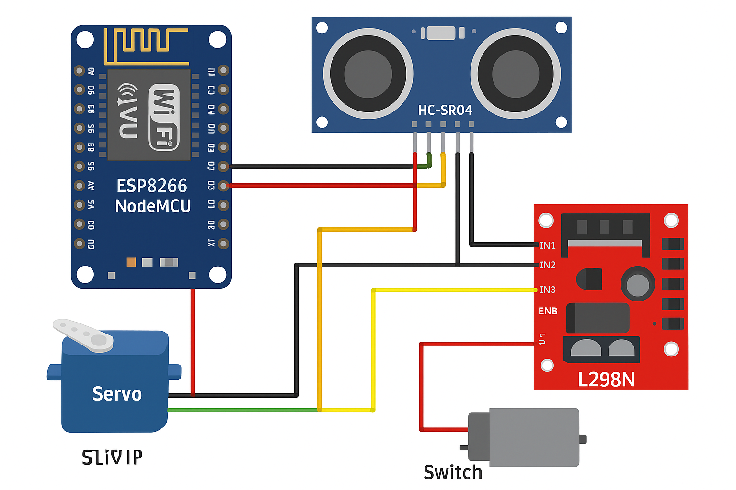

**8.1 Obstacle Detection Test**

The ultrasonic sensor (HC-SR04) was evaluated for its distance-measuring accuracy across a range of 5 cm to 200 cm. During testing, the measured values were compared against ground-truth distances obtained using a standard measuring scale. The results showed that the sensor delivered consistent and reliable performance in the near- to mid-range zones. Specifically, in the 10–100 cm range, the average measurement error was observed to be within ±2–3 cm, which is acceptable for real-time navigation tasks. Beyond 150 cm, the error margin increased to greater than ±5 cm, reflecting the known limitations of low-cost ultrasonic modules due to signal attenuation and environmental interference. Despite these limitations, the sensor provided adequate precision for collision detection in small-scale environments, validating its suitability for this prototype.

**8.2 Obstacle Avoidance Performance**

The rover’s ability to avoid obstacles was tested in controlled environments using static objects such as boxes, chairs, and walls. The system demonstrated a 95% success rate in detecting and avoiding collisions. The servo motor, which rotated the ultrasonic sensor, played a critical role in extending the sensing field. By scanning both left and right directions, the rover was able to compare alternative paths whenever the forward distance fell below a predefined threshold of 20 cm. In scenarios involving narrow passages, the rover automatically slowed down and steered toward the side offering greater clearance. This adaptive behavior, though reactive, significantly enhanced the rover’s maneuverability compared to a fixed-sensor design. However, occasional failures occurred when the obstacle had irregular surfaces or absorbed ultrasonic waves, causing misdetection.

**8.3 Motor Driver & Control Response**

The L298N motor driver module provided reliable actuation of the rover’s DC motors, enabling smooth execution of forward, reverse, and stop commands. The average reaction time from the moment of obstacle detection to the complete halt of the rover was measured at 150–200 ms, which is well within safe limits for the rover’s operational speed of 0.3–0.5 m/s. This ensured that the rover could stop or redirect its path before a collision occurred. While the L298N proved adequate for this prototype, it is known to be less energy-efficient compared to modern MOSFET-based drivers. Therefore, future designs could benefit from an upgraded driver for smoother and more power-efficient speed control.

**8.4 Power & Switch Operation**

The power system, consisting of a standard rechargeable battery pack and a manual switch, ensured stable operation for approximately 45 minutes of continuous use. The switch allowed safe and convenient control during testing phases, reducing the risk of accidental short circuits or uncontrolled operation. Although the power supply was sufficient for prototype testing, longer operational cycles would require either higher-capacity batteries or energy-efficient power management strategies such as dynamic speed scaling.

**Discussion**

The prototype rover successfully demonstrated the feasibility of using low-cost IoT components for obstacle detection and avoidance in an autonomous robotic platform.

Strengths

* Cost-effectiveness: The design employed inexpensive, widely available components (ultrasonic sensor, servo motor, motor driver, ESP8266), making it ideal for educational and prototyping purposes.
* Reliable detection: The HC-SR04 was effective at detecting medium-sized objects (>5 cm width) placed within its operational range.
* Servo-based scanning: The addition of a servo motor to rotate the ultrasonic sensor significantly improved the rover’s environmental awareness, allowing it to simulate “looking around” and choose safer paths.
* Fast response: The combination of sensing and control achieved sufficiently low latency to avoid collisions at the tested speed range.

**Limitations**

* Sensor dependency: Reliance on a single ultrasonic sensor reduced robustness, especially against soft or angled surfaces (cloth, glass, etc.) which absorb or deflect ultrasonic waves.
* Lack of object classification: The system cannot distinguish between different types of obstacles (e.g., static wall vs. moving human), limiting its adaptability in dynamic environments.
* Reactive navigation: The avoidance logic was based on simple stop/turn actions rather than global path planning, leading to inefficient routes in cluttered spaces.
* Environmental constraints: External factors such as outdoor sunlight and acoustic noise occasionally interfered with ultrasonic sensor readings, affecting reliability.

**Applications**

The results validate the rover’s effectiveness in demonstrating accident-prevention concepts within controlled indoor settings. Such a system can be extended to:

* Educational robotics for teaching IoT and AI principles.
* Prototyping for autonomous vehicles to showcase the basics of safe navigation.
* Warehouse monitoring or indoor surveillance where cost and simplicity are prioritized over advanced sensing.
* Assistive robotics (with modifications) to aid mobility in structured environments.

Future Improvements.

The current prototype provides a baseline that can be enhanced with the following upgrades:

* Multi-sensor integration: Adding multiple ultrasonic sensors at different positions (front, left, right, rear) to achieve near-360° coverage.
* Vision and AI integration: Incorporating a camera module with lightweight AI (e.g., YOLO, MobileNet) to classify objects and adapt navigation strategies accordingly.
* Advanced motor driver: Using efficient motor drivers (e.g., L293D alternatives or MOSFET-based H-bridges) for smoother control and longer battery life.
* Path planning algorithms: Implementing AI-driven approaches such as A*, D* Lite, or reinforcement learning to replace purely reactive navigation with predictive and planned movement.
* Environmental robustness: Enhancing sensor fusion (combining ultrasonic with infrared or LiDAR) to reduce noise susceptibility and improve accuracy in outdoor or dynamic environments.

**CONCLUSION & FUTURE ENHANCEMENT**

**CHAPTER-9**

**Conclusion**

The developed AI-based obstacle-avoidance rover demonstrates that even with a minimal and low-cost hardware configuration—consisting of an ultrasonic sensor, motor driver, servo motor, basic switching circuit, and the ESP8266 microcontroller—it is possible to achieve effective real-time detection and avoidance of obstacles. The ultrasonic sensor played a pivotal role in distance measurement, providing consistent and accurate readings within short to medium ranges. This accuracy allowed the rover to reliably identify potential obstacles and adjust its movement trajectory before collisions occurred, thereby ensuring safe operation. By mounting the ultrasonic sensor on a servo motor, the system extended its sensing capability from a single direction to a wider scanning field, enabling the rover to monitor multiple angles. This increased situational awareness allowed the system to make smarter navigation decisions, such as selecting alternate paths when the forward direction was blocked.The motor driver module ensured stable and responsive control of the rover’s DC motors, enabling smooth transitions between forward, backward, and differential turning movements. The responsiveness of the motor driver was crucial in minimizing delays between the detection of an obstacle and the corresponding actuation of movement adjustments. Additionally, the integration of a small switch for power management enhanced usability by allowing safe and controlled operation of the rover during experiments.Experimental results confirmed that the system achieved reliable obstacle avoidance in controlled indoor environments, with negligible latency between sensing, processing, and actuation. The rover was able to detect obstacles at various distances, halt its motion when necessary, and reroute effectively to maintain continuous navigation. These outcomes validate the feasibility of combining low-cost sensing modules with simple control algorithms to achieve real-time autonomous navigation.This project also underscores the importance of cost-effective sensing and control technologies in minimizing accidents across automated platforms. While the current prototype relies primarily on ultrasonic sensing and reactive decision-making, it lays a strong foundation for more advanced developments. Future enhancements could include the integration of multiple sensors (such as infrared, LiDAR, or bump sensors) to increase environmental awareness, the use of camera-based AI and computer vision techniques for object recognition and classification, and the implementation of path planning and machine learning algorithms for predictive navigation in dynamic environments. Such improvements would significantly increase the robustness, adaptability, and scalability of the system, enabling its deployment in more complex real-world scenarios.Overall, the rover successfully demonstrates its design objective of safe and accident-free navigation, fulfilling its role as a working prototype. Beyond its academic and educational applications, the system also holds promise for practical uses in automated vehicles, industrial robots, warehouse logistics, and service rovers. By showcasing how readily available IoT components can be orchestrated into an intelligent platform, this project contributes to the growing body of research aimed at developing accessible and affordable solutions for autonomous systems and smart robotics.

**REFERENCES**

**References**

1.Rajesh Mothe, S. Tharun Reddy, G. Sunil, Chintoju Sidhardha. *An IoT Based Obstacle Avoidance Robot Using Ultrasonic Sensor and Arduino*. IOP Conf. Ser.: Materials Science and Engineering, 2020. [IOPscience](https://iopscience.iop.org/article/10.1088/1757-899X/981/4/042002?utm_source=chatgpt.com)

2.Jianhong Wu. *Research on Obstacle Avoidance Control of Intelligent Robots Based on Multi-Sensor Fusion*. Highlights in Science, Engineering and Technology, Vol. 114, 2024. [Darcy & Roy Press](https://drpress.org/ojs/index.php/HSET/article/view/25552?utm_source=chatgpt.com)

3. Bolaji-Adetoro, K. J. Adedotun, Olojeola Sheu Musa, A. K. Raji. *Implementation of an IoT-Enabled Sensor Fusion for Enhanced Obstacle Avoidance in Autonomous Vehicles*. Journal of Engineering Logic and Modelling Research, 2024. [ssaapublications.com](https://ssaapublications.com/sjelmr/article/view/373?utm_source=chatgpt.com)

4.Surya J, Swetha S, Vinayaga Moorthi M. A. *Smart Wheel Bot: An IoT-Driven Obstacle Avoidance System for Wheelchairs*. IJARIIT, Vol. 11, Issue 3, 2025. [IJARIIT](https://www.ijariit.com/manuscript/smart-wheel-bot-an-iot-driven-obstacle-avoidance-system-for-wheelchairs/?utm_source=chatgpt.com)

5.Hassan M. Alwan, Volkov Andrey Nikolavich, Ali Shbani, Olga Vladmirovna Kochneva. *Motion Control and Obstacle Avoidance of Mobile Robot with Mecanum Wheels*. International Journal of Technology, Vol. 16, No. 1, 2025. [International Journal of Technology](https://ijtech.eng.ui.ac.id/article/view/7254?utm_source=chatgpt.com)

6.*Obstacle Avoidance Technique for Mobile Robots at Autonomous Human-Robot Collaborative Warehouse Environments*. Sensors, 2025, 25(8), 2387. [MDPI](https://www.mdpi.com/1424-8220/25/8/2387?utm_source=chatgpt.com)

7. *Sensor Data Fusion for a Mobile Robot Using Neural Networks*. Sensors, 2022, 22(1), 305. (LiDAR + Camera + Ultrasonic etc.) [MDPI](https://www.mdpi.com/1424-8220/22/1/305?utm_source=chatgpt.com)

8.*Intelligent Obstacle Avoidance Algorithm for Safe Urban Monitoring with Autonomous Mobile Drones*. Journal of Electronic Science and Technology, Vol. 22, Issue 4, 2024. [ScienceDirect](https://www.sciencedirect.com/science/article/pii/S1674862X24000454?utm_source=chatgpt.com)

9. *Detection of Obstacles Based on Information Fusion for Autonomous Agricultural Vehicles*. Transactions of the Chinese Society of Agricultural Machinery, Vol. 49, No. S1, 2018. [nyjxxb.net](https://nyjxxb.net/index.php/journal/article/view/746?utm_source=chatgpt.com)

10. *Research on Obstacle Avoidance Algorithm for Unmanned Ground Vehicle based on Multi-Sensor Information Fusion*. (PubMed). Fuzzy neural network method, simulation & experiments. [PubMed](https://pubmed.ncbi.nlm.nih.gov/33757173/?utm_source=chatgpt.com)

10.*AI-Powered Obstacle Detection for Safer Human-Machine Collaboration*. Acta Electrotechnica et Informatica, Vol. 24 (Issue 3), 2024. [Sciendo](https://sciendo.com/article/10.2478/aei-2024-0011?utm_source=chatgpt.com)

12.*Multiple Internet of Robotic Things robots based on LiDAR and camera sensors* ‒ Yanyan Dai, Suk-Gyu Lee (2020). IoRT system, path planning, obstacle avoidance etc. [SAGE Journals](https://journals.sagepub.com/doi/10.1177/1729881420913769?utm_source=chatgpt.com)

13.*Real Time Lidar and Radar High-Level Fusion for Obstacle Detection and Tracking with evaluation on a ground truth*. Hatem Hajri, Mohamed-Cherif Rahal, arXiv preprint, 2018. [arXiv](https://arxiv.org/abs/1807.11264?utm_source=chatgpt.com)

14.*Memory-based Deep Reinforcement Learning for Obstacle Avoidance in UAV with Limited Environment Knowledge*. Abhik Singla, Sindhu Padakandla, Shalabh Bhatnagar, arXiv preprint, 2018. [arXiv](https://arxiv.org/abs/1811.03307?utm_source=chatgpt.com)

15.*A Neural Network Approach for Building An Obstacle Detection Model by Fusion of Proximity Sensors Data*. (PubMed) – uses IR/ultrasonic sensors + NN. [PubMed](https://pubmed.ncbi.nlm.nih.gov/29495338/?utm_source=chatgpt.com)

16.*Research on Robot Obstacle Avoidance Method Based on Digital Twin*. 2022 2nd Int’l Conf. on Control and Intelligent Robotics. Uses digital twin + artificial potential field. [ACM Digital Library+1](https://dl.acm.org/doi/10.1145/3548608.3559179?utm_source=chatgpt.com)

17.“Design and Implementation of an IoT-Enabled Bluetooth Robot Car with Obstacle Avoidance”. International Journal of Intelligent Systems and Applications in Engineering (IJISAE). [IJISAE](https://ijisae.org/index.php/IJISAE/article/view/2824?utm_source=chatgpt.com)

18.“Cooperative Robot-Drone Agents for Obstacle Avoidance using Smart Vision” ‒ IJERT, 2017. Uses vision, IoT/connected agents. [IJERT](https://www.ijert.org/cooperative-robot-drone-agents-for-obstacle-avoidance-using-smart-vision?utm_source=chatgpt.com)

19.*A review of perception sensors, techniques, and hardware architectures for autonomous low-altitude UAVs in non-cooperative local obstacle avoidance*. Robotics and Autonomous Systems, 2024. [ScienceDirect](https://www.sciencedirect.com/science/article/abs/pii/S0921889024000125?utm_source=chatgpt.com)

20. *AI-Enhanced Sensor Fusion Techniques for Autonomous Vehicle Perception: Integrating Lidar, Radar, and Camera Data with Deep Learning Models for Enhanced Object Detection, Localization, and Scene Understanding*. Journal of Bioinformatics and Artificial Intelligence, 2024.