Detecting Industrial Worker Distraction Caused by Mobile Phone Usage Using Object Detection and Pose Estimation Models

^{ABHINAV ANIL}
School of Computer Science and Engineering, Vellore Institute of Technology, Chennai, India¹

Abstract – Quantum computers bring a lot of potential, as well as danger, to the future of cryptography. There are many systems which deliver security through the use of conventional public key cryptography (PKC), the majority of the communications over secure public networks today are using PKC to provide that level of security. The advent of the quantum computer may lead to a compromise of the existing public key systems because they will be able to finish off the current PKC encryption methods with the increased speed offered via quantum computing. A solution to the above problem with regard to providing secure communications via the principles of quantum physics, is through the use of Quantum Key Distribution (QKD). This project aims to introduce a QKD solution for the problem of providing secure email communications using the principles of QKD and also be compatible with the existing protocols used for email communications today. The solution will be a hybrid system that will consist of a frontend client, a backend encryption engine, and a simulated QKD Key Management Entity (KME). The results of the testing performed for this paper demonstrate that it is possible to incorporate quantum security into the existing communications infrastructure, as there is no need to overhaul the current communications infrastructure, with as part of the solution, an entirely new method of communicating between parties.
Keywords – Quantum Key Distribution, ETSI GS QKD 014, Hybrid Encryption, SMTP Security, IMAP Protocol

I. INTRODUCTION
The concept of secure communications, i.e., digital existence, includes various forms of communication that differ in email usage for individuals, organizations, and governments. The existing popular methods of encryption are RSA and ECC (Elliptic Curve Cryptography), which are based on various computational assumptions, but each of these computational assumptions will be outdated due to its inefficiency against the advent of quantizing, i.e., Quantum Computer Technology = QCT, and availability of large-scale quantum computers. Shor's Algorithm will be able to break this method of public-key cryptography, thus destroying data privacy.

The other issue that is related to encryption is related to "Harvest Now, Decrypt Later" (HNDL), which allows for harvesting of information that is currently available but does not need to be decrypted presently, as it would only be decrypted when proper technology is developed.

Quantum Key Distribution gives a mathematically safe system for the distribution of keys with the help of quantum mechanics principles like no cloning theorem and measurement disturbance. The no cloning theorem guarantees that any eavesdropping in the distribution of the key will instantly alert the users [5]. The implementation of Quantum Key Distribution in the network, however, faces many critical issues with respect to routing, scalability, and its implementation in the existing infrastructure [2].

Quantum Key Distribution can be integrated into the optical network as well as the 5G network for the safe transfer of information over a large distance [8]. The researchers are particularly focused on merging the Quantum Key Distribution technology with classical as well as quantum communication for developing strong communication channels [10].

In this project, I implemented a quantum-safe email client using traditional email services like SMTP and IMAP with Quantum Key Distribution technology for a safe email system. In order to ensure maximum security, there are different levels of security, allowing the user to select the appropriate encryption according to their requirements for maximum confidentiality.

II. BACKGROUND STUDY
Quantum Key Distribution (QKD) forms the basis for the whole project. It is a secure communication technique where quantum mechanics is used to generate a secure encryption key between two parties. This is different from other secure key exchange techniques since they use complex mathematical concepts. Instead, they use the properties of light to detect any interception of the keys. If the keys are intercepted, they are immediately discarded.

Post-Quantum Cryptography (PQC) is an advanced mathematical concept developed to provide security against the power of the next quantum computers. This is important since current cryptographic techniques such as RSA can be compromised by the power of the next quantum computers. However, the Post-Quantum Cryptography technique uses "lattice-based" problems that are hard to crack even by the next quantum computers.

One Time Pad (OTP) is a traditional cryptographic technique where a message is encrypted using a random secret key of the same length. This technique is unbreakable since it is mathematically impossible to break the encryption. This project uses the QKD technique to generate the unique and long keys necessary to achieve this.

III. LITERATURE SURVEY

There has been a rise in the number of research studies carried out in the domain of quantum secure communications over the past few years, with a focus on the successful integration of QKD with the existing network architecture. There are a number of researchers who have focused on the hurdles as well as the solutions with respect to the implementation of QKD-based security in the real world.

A research study carried out by Anantraj et al. focused on the double-edged nature of quantum computing, which can not only offer security benefits to the network with the aid of QKD but can also pose a threat to the classical cryptography system, proving that enhancement of the security of the network can be done with the aid of QKD as well as the security of the quantum computing environment [1].

The problems that are faced in the routing and scalability of the QKD network have also been addressed by a number of researchers. A study was carried out by Kong on the problems faced in the routing of the QKD network that relies on the trusted nodes for the purpose of routing [2].

In addition to the problems faced in the implementation of the QKD network, a number of researchers have also addressed the problems faced in the implementation of post-quantum cryptography. Teague et al. have addressed the problems faced by the cloud platforms in the implementation of post-quantum cryptography.

They have highlighted the importance of deploying the quantum-resistant math. [3]

Other researchers have also addressed the problems faced in the implementation of QKD by making it leaner and safer. Mukit et al. have proposed a discrete modulated continuous variable QKD method that is better at handling noise and provides tighter security by incorporating decoy states along with better error correction methods. [4]

Purushottam et al. have shown the immense potential of QKD. They have shown the capability of QKD to coexist with classical encryption to provide secure links free from both classical and quantum attacks [5].

QKD network feasibility on a large scale has been shown through practical experiments. Mehic et al. have developed a virtual network ecosystem of QKD for the Czech national grid. This experiment shows how QKD can be integrated into the existing network to address the security needs of the country [6].

On similar lines, Sena et al. have shown the deployment of the QLine system to provide a metropolitan network of QKD. This experiment was done on the OpenQKD testbed located in Berlin. This experiment shows the feasibility of incorporating a QKD network into a metropolitan network to provide high-quality communication [7].

The integration of the latest technology with the existing technology of QKD is still under investigation. Oliveira et al. have proposed a solution to the integration of free-space optics communications and 5G technology to provide secure key exchange in heterogeneous environments [8].
Aside from QKD, some researchers were also seeking other methods for secure key generation aside from QKD. Al-Hyari et al. proposed a method of generating strong encryption keys through the utilization of chaotic maps along with the Collatz conjecture. The proposed solution was proven to be very promising in enhancing the level of randomness of generated keys in image cryptography [9].

Lastly, Carlos et al. proposed that the concept of hybrid security mechanisms be adopted, which incorporates classical cryptography, post-quantum cryptography, and QKD. The result obtained by the authors of this proposed solution is that it is the most realistic solution that is also optimal in attaining secure communication in a quantum environment [10].

IV. PROPOSED SSTEM

The main innovation in this scheme is that it allows for the integration of high-level quantum security protocols into existing email systems like Gmail or Yahoo without requiring any modifications to the underlying mail servers. In fact, existing solutions for secure email systems like PGP use classical asymmetric encryption that is known to be vulnerable to quantum computer attacks in the future; however, QuMail proposes a hybrid model.

My three major goals with this project was:
- Protocol agnosticism: To make sure it works with existing email clients, I used standard SMTP and IMAP protocols instead of a completely new one.
- Security tiers: I added the option to have 4 security levels for the email client from extremely secure QKD OTP-based encryption to no encryption at all. This also made sure that the email client can send and receive mails from other mail users.
- Standard implementation: For the Quantum Key Distributor (QKD) simulator I implemented the ETSI GS QKD 014 API standard, making it compatible with any future work on this space.

The operational workflow of sending a secure message commences when the user chooses a target recipient and a security level using the React-based frontend. This request is sent via a context-isolated IPC bridge to the Electron main process. This request is then forwarded to the FastAPI backend via the Electron main process. By default, the system uses a localhost connection on the network address 127.0.0.1 to connect to the internal services. However, this can be set using environment variables. Once the request is sent to the backend, the request is forwarded to the QKD simulator to obtain a 256-bit quantum-derived key via a standardized POST request to the endpoint “/enc_keys.” When the security level is set to L3 Hybrid, the system uses an ephemeral Kyber-512 keypair to encapsulate a shared secret. The session key is obtained by concatenating the QKD-derived key with the Kyber-derived shared secret. This is then passed through a SHA-256 hash function. The ciphertext is encoded as a series of PEM blocks embedded in the body of the email sent via SMTP on port 587 using the STARTTLS protocol. Additionally, custom MIME headers are used to make the emails automatically detectable.

The decryption and retrieval process starts with the client sending an IMAP SSL fetch to synchronize the inbox. The system uses a mapping and quoting function for handling unusual mailbox names. For example, the names of the mail folders are enclosed within square brackets, as shown in the Gmail client. Once the backend identifies a message with a header containing the string "X-Quantum-Encryption: true," the message is identified for decryption. Once the user selects the identified message, the backend uses regex to obtain the PEM blocks from the email body, as received within the email. The JSON object within the email is used to obtain a specific key_id, which is used by the backend to obtain the decryption key by sending a POST request to the /dec_keys endpoint of the simulator. The decryption or decapsulation, which is the reverse of the AES-256-CFB decryption or the Kyber decapsulation, is rendered within the Email Reader component.

V. SYSTEM ARCHITECTURE

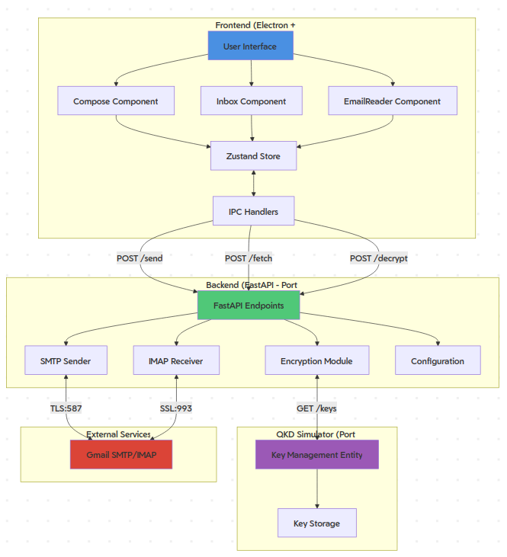
Fig. 1: Overall system architecture with all components
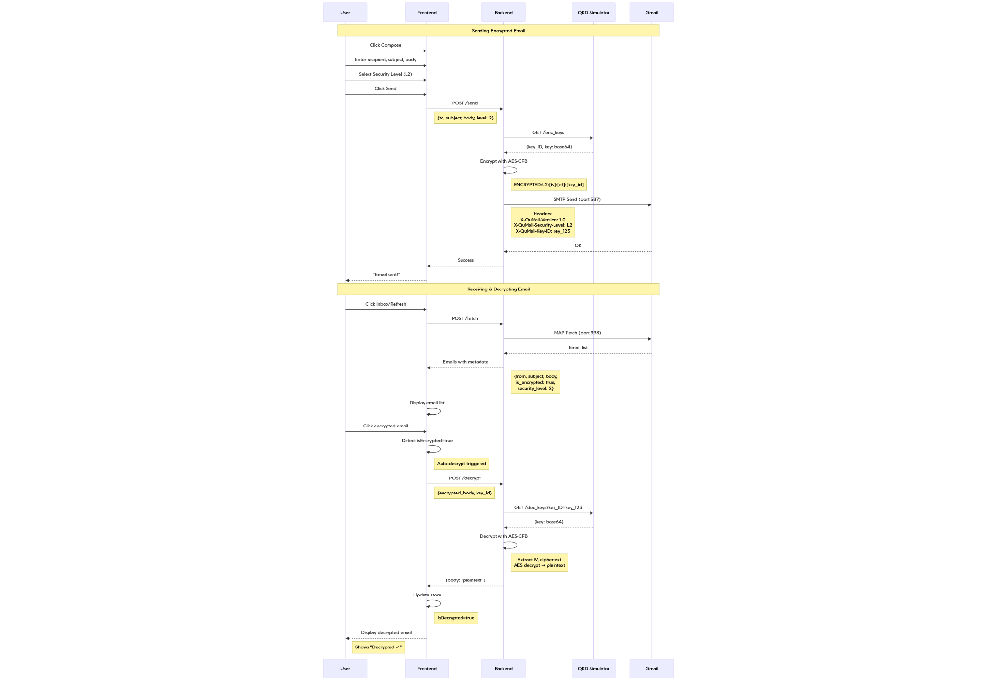
Fig. 2: Sequence diagram
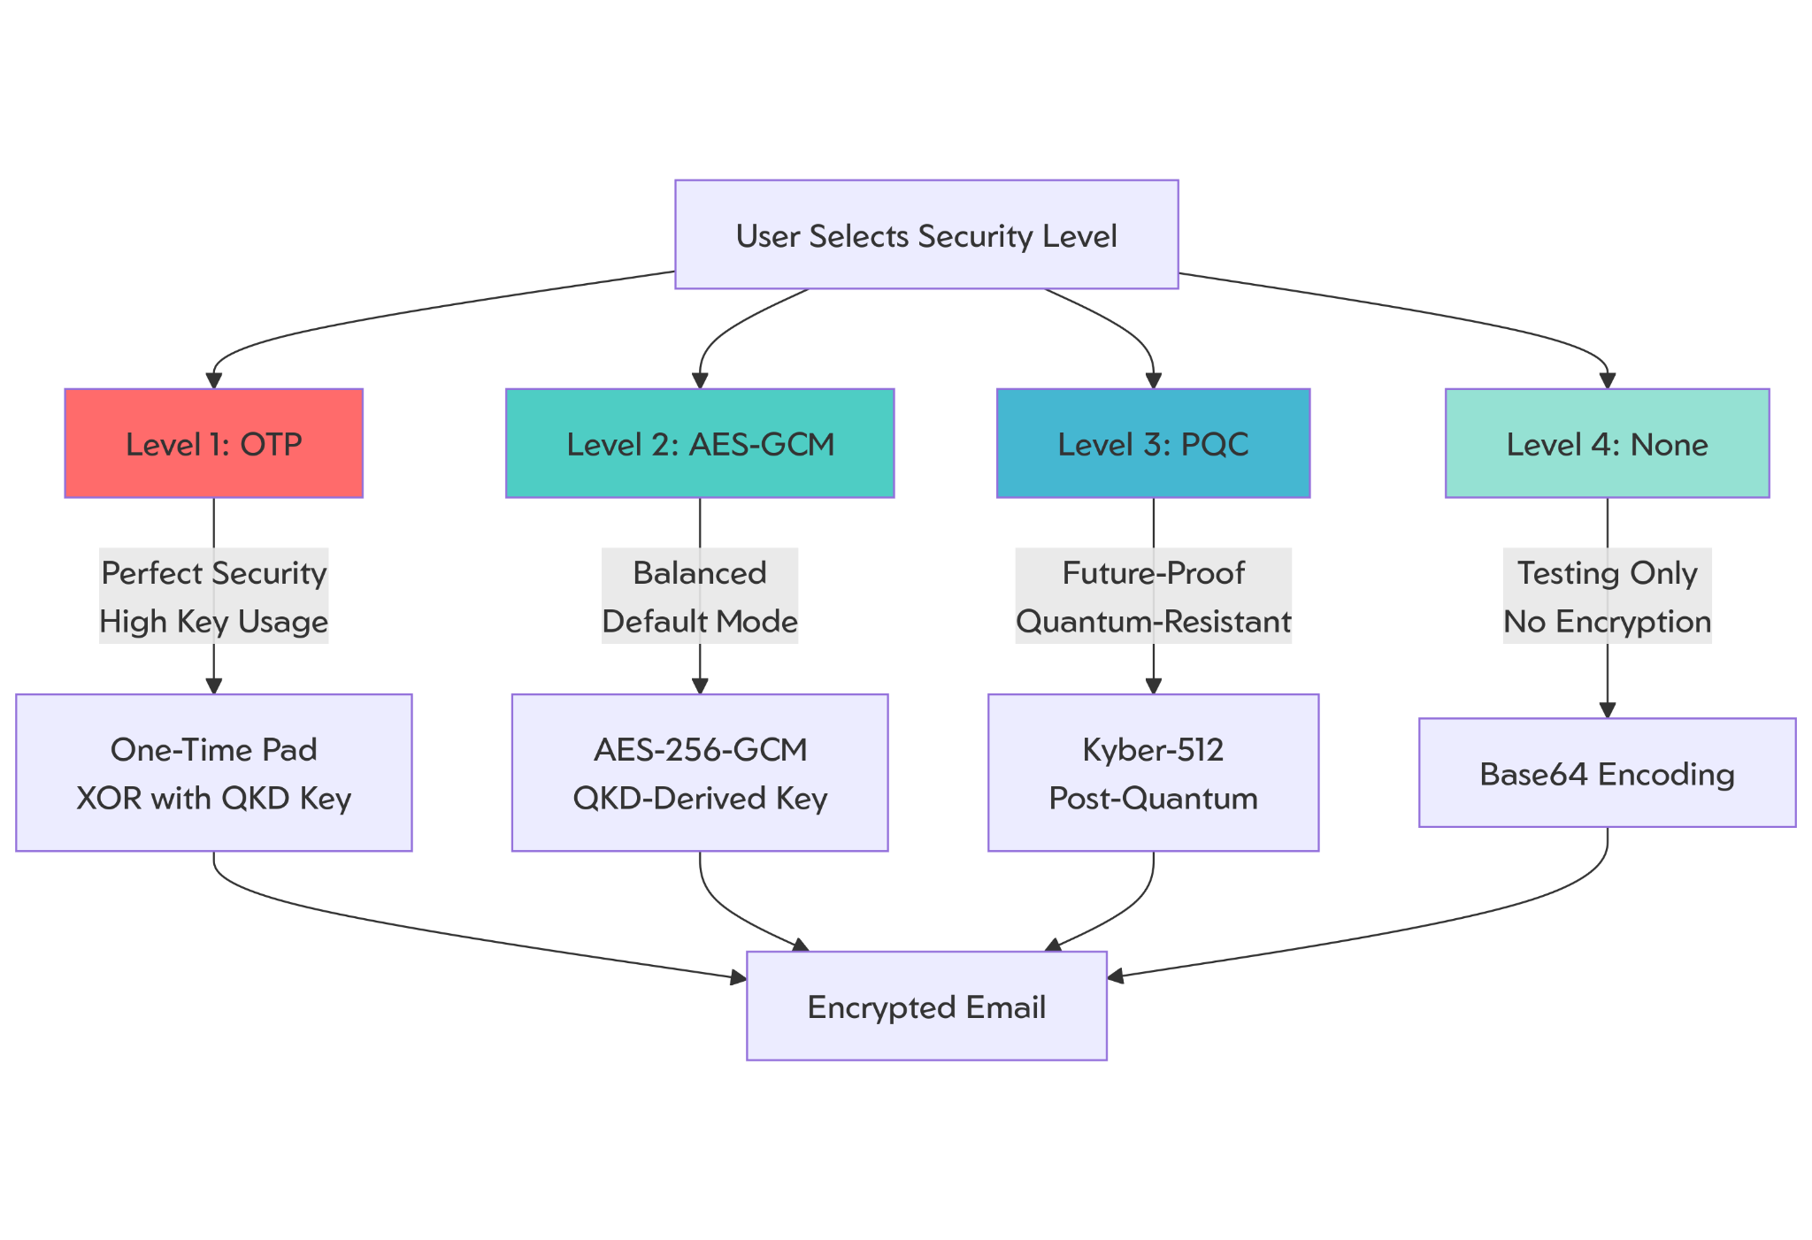
Fig. 3: Security Architecture

VI. PROTOCOL LAYERS

- Application Interface Layer
The top layer deals with the high-level user interfaces. This layer utilizes IPC (Inter-Process Communication) via an Electron bridge for secure communication of user intent from the React-based frontend to the system processes.
Service Coordination Layer

The central intelligence of the system is handled by this layer. The requests are handled internally via RESTful HTTP. This layer is the coordinator between the desktop shell and the cryptographic microservices.

- Cryptographic Provisioning Layer
The role of this layer is to ensure the security of the message content before leaving the environment. The ETSI GS QKD 014 is utilized for the negotiation of quantum keys with the secure access entity.

- Secure Transport Layer
Once the data is encrypted, it is ready for transmission outside the environment. The SMTP protocol with STARTTLS is utilized for sending emails. The IMAP protocol with SSL is utilized for receiving emails. The message body is already quantum-encrypted, but the connection to the mail server is also encrypted using traditional industry-standard encryption.

- Network Infrastructure Layer
The foundation layer consists of the standard set of protocols in the TCP/IP suite. It offers the bare-bones reliable transport that is required for the upper layers to communicate with public mail servers such as Gmail or Yahoo over the internet in an opaque text format.

VII. TESTBED SETUP

The hardware used to test this was an Acer Nitro 16 (AN16-51) laptop with AMD Ryzen 7 7840 HS, NVIDIA RTX 4060 Mobile GPU and 16 GB of RAM. The laptop was running on CachyOS (Linux 6.19.6-2-cachyos) which is based on Arch Linux.

For the frontend, node.js 25.7.0 was used. Python 3.13.5 was used for the QKD-simulator and backend.

VIII. SCREENSHOTS

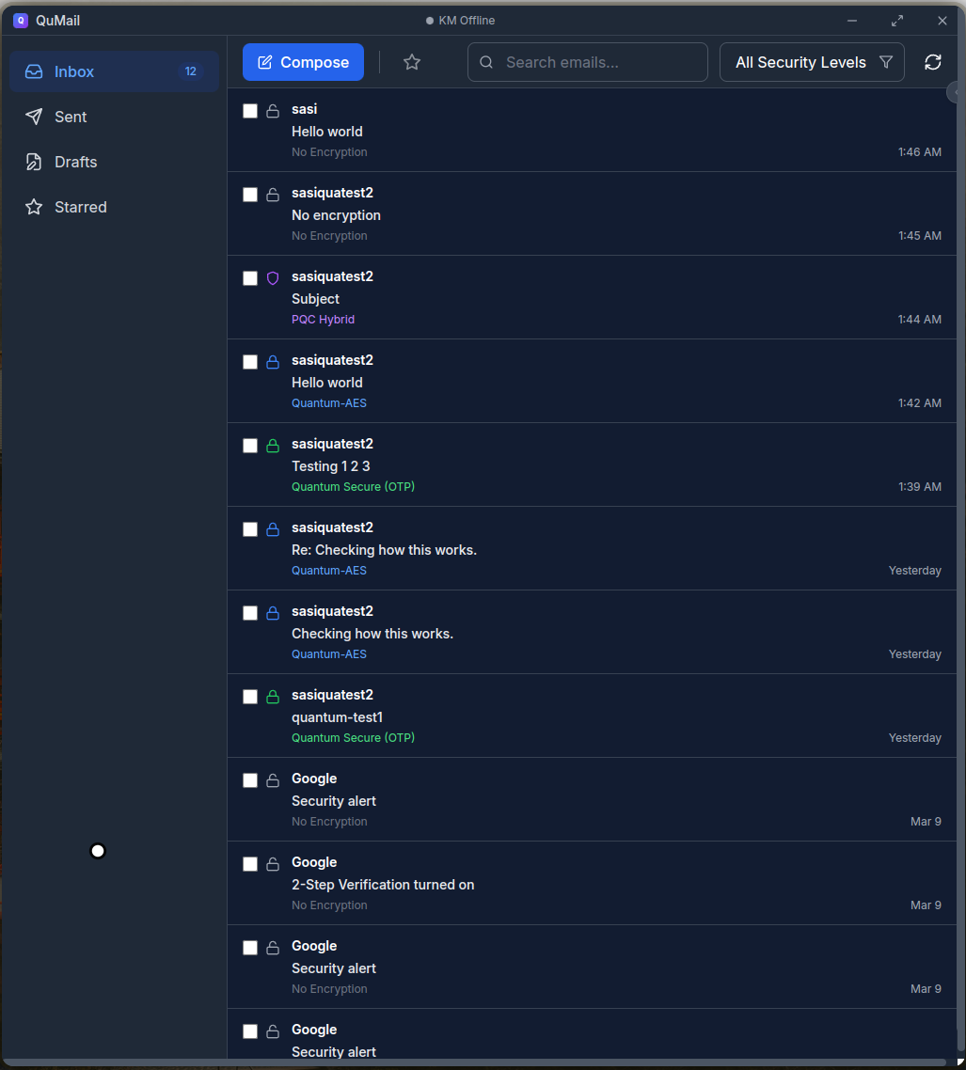
Fig. 4: Inbox
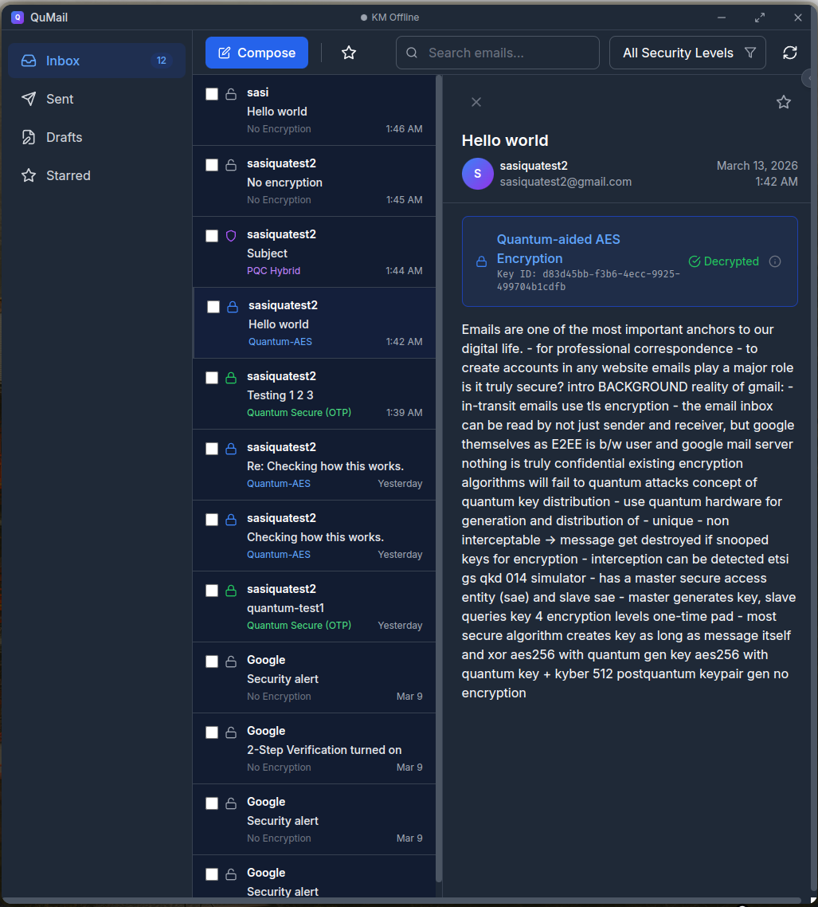
Fig. 5: Mail page
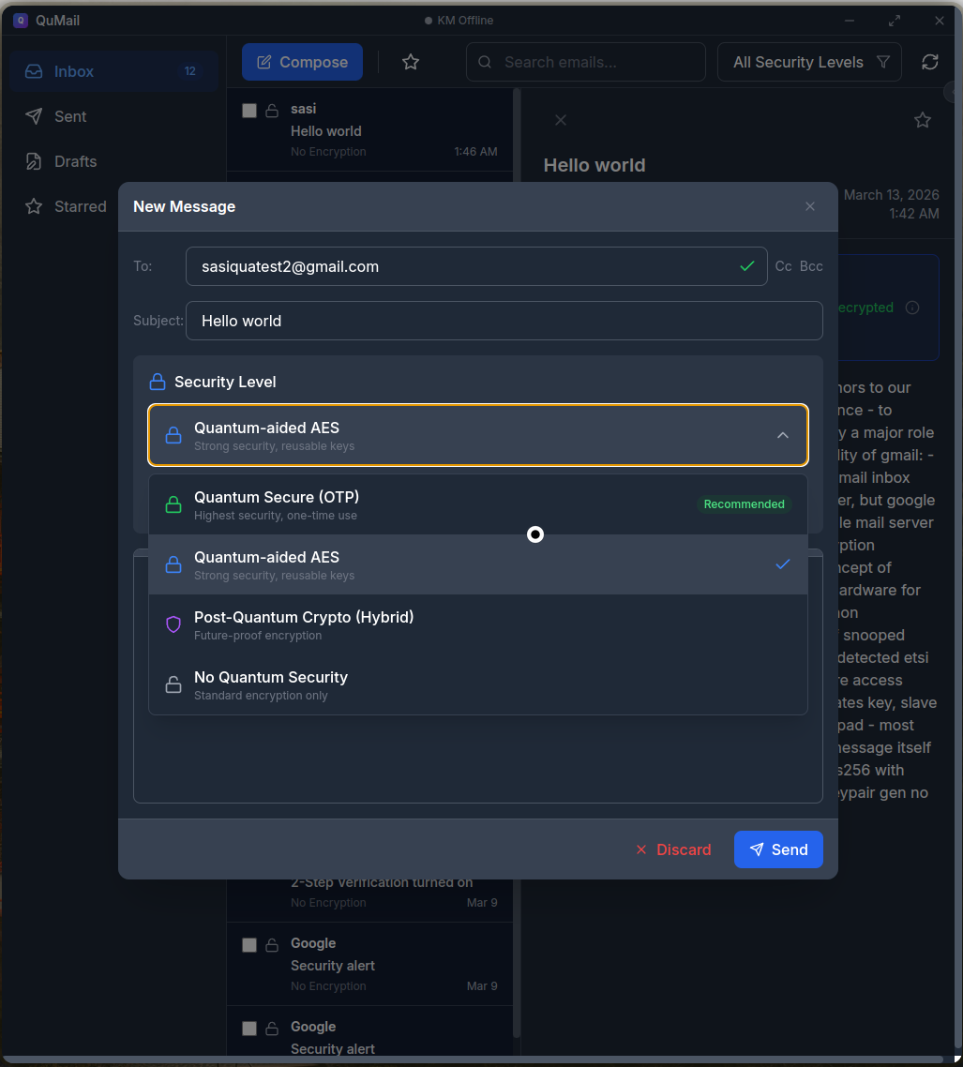Fig. 6: Email compose with security selection
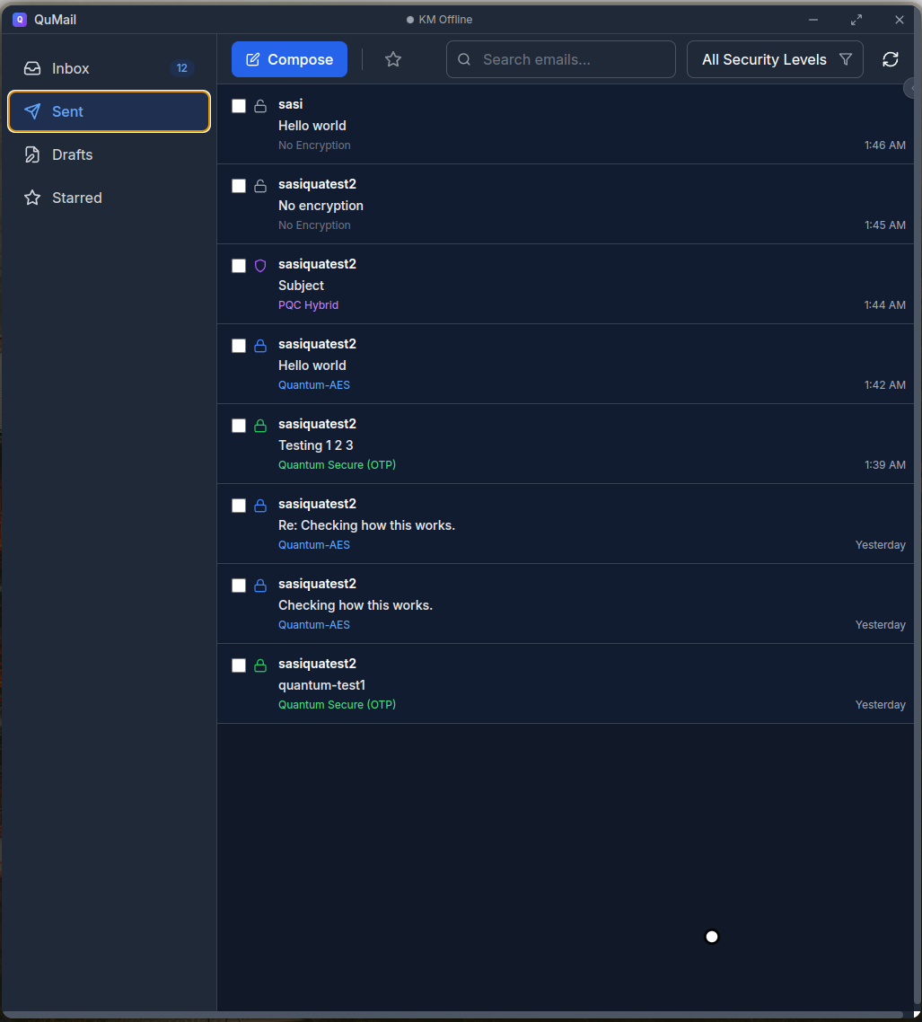
Fig. 7: Sent Emails page
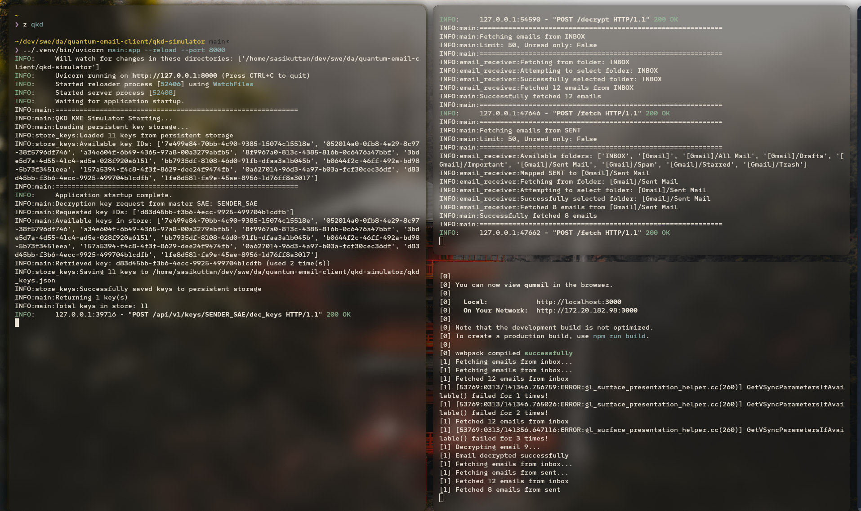
Fig. 8: Logs with list of available QKD keys

VIII. REFERENCES
[1]I. Anantraj, B. Umarani, C. Karpagavalli, C. Usharani and S. J. Lakshmi, ”Quantum Computing’s Double-Edged Sword Unravelling the Vulnerabilities in Quantum Key Distribution for Enhanced Network Security,” 2023 International Conference on Next Generation Electronics (NEleX), Vellore, India, 2023, pp. 1-5, doi: 10.1109/NEleX59773.2023.10420896.
[2] P. -Y. Kong, ”Challenges of Routing in Quantum Key Distribution Networks with Trusted Nodes for Key Relaying,” in IEEE Communications Magazine, vol. 62, no. 7, pp. 124-130, July 2024, doi: 10.1109/MCOM.023.2300376.
[3] T. Teague, M. Mahzabin, A. Nelson, D. Andrews and M. Huang, ”Towards Cloud-based Infrastructure for Post-Quantum Cryptography Side-channel Attack Analysis,” 2023 IEEE Design Methodologies Conference (DMC), Miami, FL, USA, 2023, pp. 1-6, doi: 10.1109/DMC58182.2023.10412485.
[4] A. Mukit, M. S. H. Bijoy, S. M. Choudhury and M. T. Mahmud, ”Discrete Modulated Continuous-Variable Quantum Key Distribution: Security and Noise Tolerance Enhanced by Decoy States and Effective Error Correction Protocol Integration,” 2023 IEEE International Conference on Telecommunications and Photonics (ICTP), Dhaka, Bangladesh, 2023, pp. 1-5, doi: 10.1109/ICTP60248.2023.10490525.
[5] V. V. Purushottam, M. S and N. Guruprasad, ”Enhancing Security in Communication Networks through Quantum Key Distribution,” 2024 International Conference on IoT, Communication and Automation Technology (ICICAT), Gorakhpur, India, 2024, pp. 23-26, doi: 10.1109/ICICAT62666.2024.10922867.
[6] Mehic, M., Dervisevic, E., Fazio, P., and Voznak, M. (2025). Virtual quantum key distribution network ecosystem: The national Czech QKD network. IEEE Network. Advance online publication. https://doi.org/10.1109/MNET.2025.3540705
[7] Sena, M., Harder, G., Döring, R., Braun, R., Ritter, M., Holschke, O., Kaplan, M., and Geitz, M. (2025). Deploying the Qline system for a QKD metropolitan network on the Berlin OpenQKD testbed. IEEE Photonics Journal, 17(1), 1–11. https://doi.org/10.1109/JPHOT.2024.3510900
[8] Oliveira, R. D., Zhang, P., Davidson, Z. C. M., Hugues Salas, E., Kosmatos, E. A., Stavdas, A., Lord, A., Rarity, J., Nejabati, R., and Simeonidou, D. (2024). On the integration and control of quantum key distribution over free-space optics and 5G networks. In Proceedings of the 2024 International Conference on Optical Network Design and Modeling (ONDM) (pp. 1–6). IEEE. https://doi.org/10.1109/ONDM61578.2024.10582626
[9] Al-Hyari, A., Abu-Faraj, M. M., and Al-Taharwa, I. (2024). Generating powerful encryption keys for image cryptography with chaotic maps by incorporating Collatz conjecture. IEEE Access, 12, 3127–3145. https://doi.org/10.1109/ACCESS.2024.3349470
[10] Carlos, M., et al. (2025). Enhanced network security protocols for the quantum era: Combining classical and post-quantum cryptography, and quantum key distribution. IEEE Journal on Selected Areas in Communications. Advance online publication. https://doi.org/10.1109/JSAC.2025.356801

