Elizabeth Perez

Professor Monshi

CMSC 203

2/19/2020

Lab 4 Screenshots

Task #4

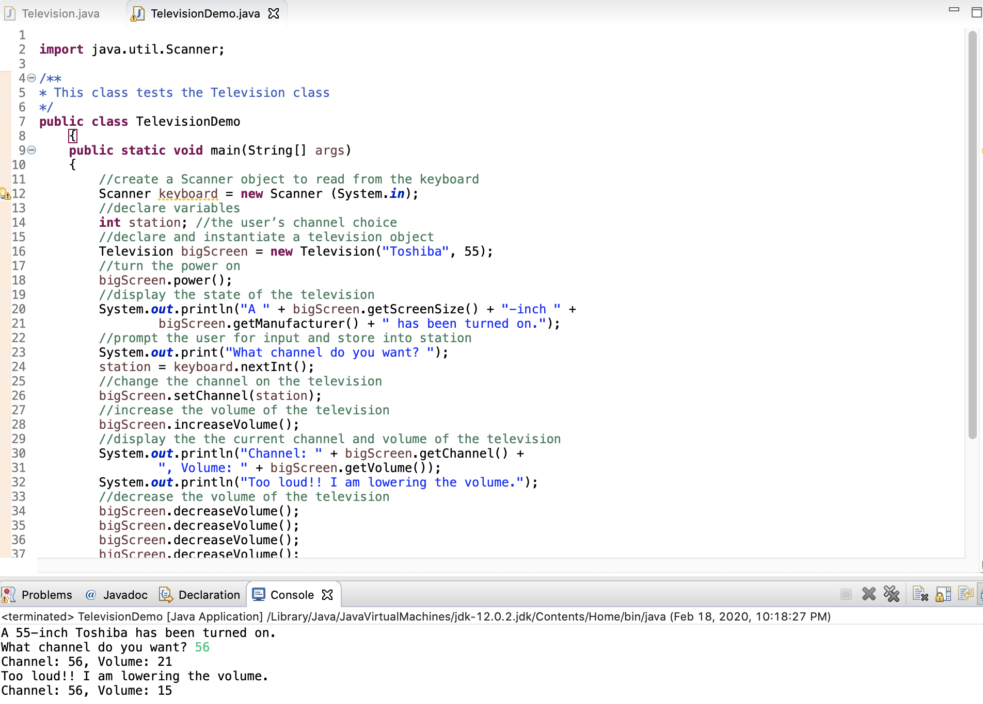

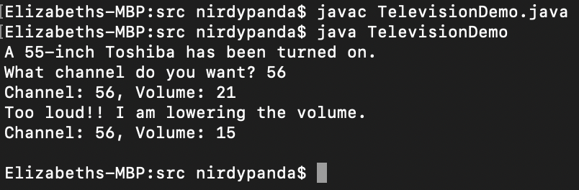

Task #5

