PROJECT

**GroceryGenius: Smart Grocery Shopping Assistant with Basket Analysis**

VEMU INSTITUTE OF TECHNOLOGY

Team members

204M1A04A4

R SASI KUMAR ACHARI (team lead)

204M1A0474

M MANJUNADHA

204M1A0463

K KOUSHIK KUMAR REDDY

introduction

* Market basket analysis is a data mining technique used by retailers to understand the purchasing patterns of customers. It involves identifying which items are frequently purchased together in transactions.

# Market basket analysis:-

* Market basket analysis is a data mining technique used to identify relationships between items that are frequently purchased together in transactions. Also known as association analysis or affinity analysis, market basket analysis aims to uncover patterns of co-occurrence or associations among products bought by customers.

# Applications:-

Market Basket Analysis has several applications, including:

- Cross-selling and upselling strategies

- Product placement optimization

- Customer segmentation and targeting

- Promotional campaign planning

# Purpose:-

The purpose of this analysis is to:

-Discover associations and relationships among products.

- Provide insights for optimizing product placement and promotions.

-Enhance cross-selling and customer targeting strategies.

# Steps followed:-

* Data Preparation
* Algorithm Selection
* Association Rule Mining

# Data preparation:-

* Before running Market Basket Analysis, ensured data is properly formatted:
* - Transaction data in a tabular format with each row representing a transaction and columns representing items purchased.

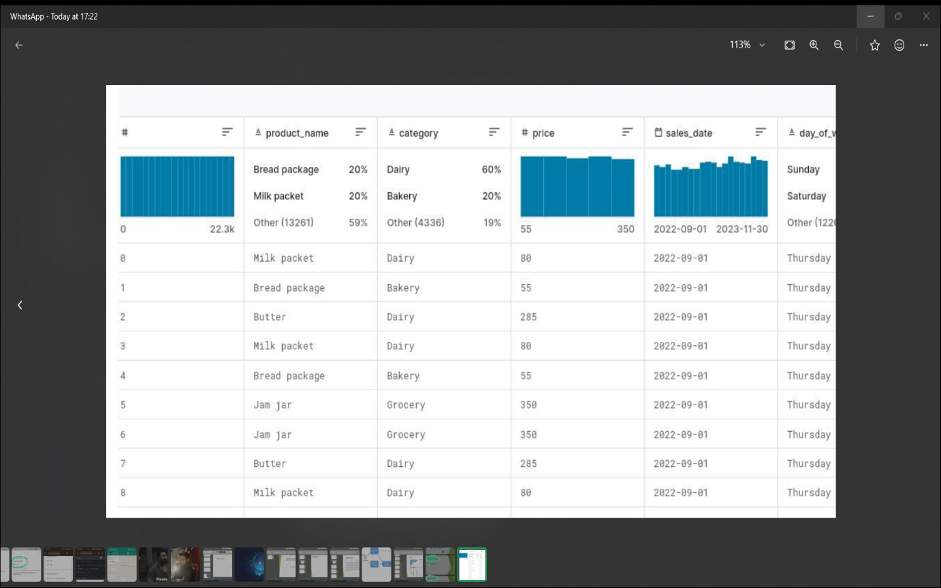

## Algorithm selection

* Apriori Algorithm: Popular for its simplicity and efficiency in finding frequent itemsets.
* The Apriori algorithm is a classic algorithm used for association rule mining in transactional databases. It is designed to discover frequent itemsets within a dataset and generate association rules based on these itemsets. The algorithm is widely used in market basket analysis and other applications where the goal is to uncover relationships between items in transactions.

# Association rule mining

* Perform association rule mining on your dataset:
* - Set minimum support and confidence thresholds.
* - Identify frequent itemsets and generate association rules.
* - Interpret the results to derive meaningful insights

# Interpreting result

* Understand and interpret the results obtained from Market Basket Analysis:
* - Identify strong association rules (e.g., {Milk, Bread} -> {Eggs}).
* - Analyze support, confidence, and lift metrics to prioritize rules.

# Implementation

* Demonstrate how to implement Market Basket Analysis using code snippets or examples:
* Python with libraries like mlxtend or pandas

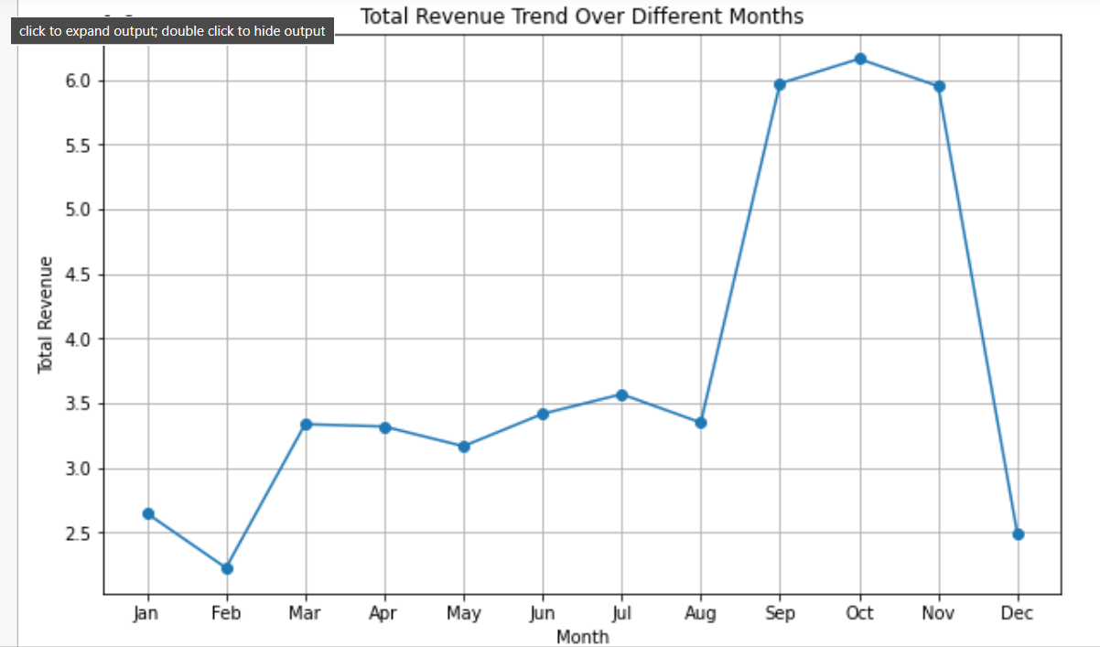

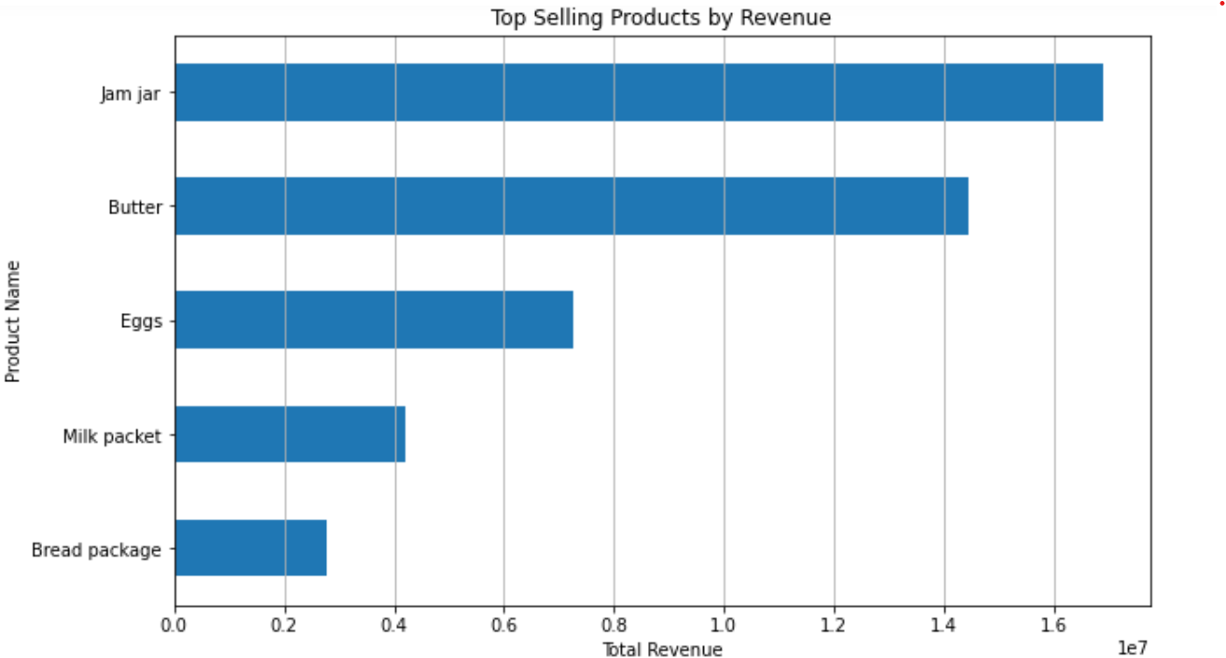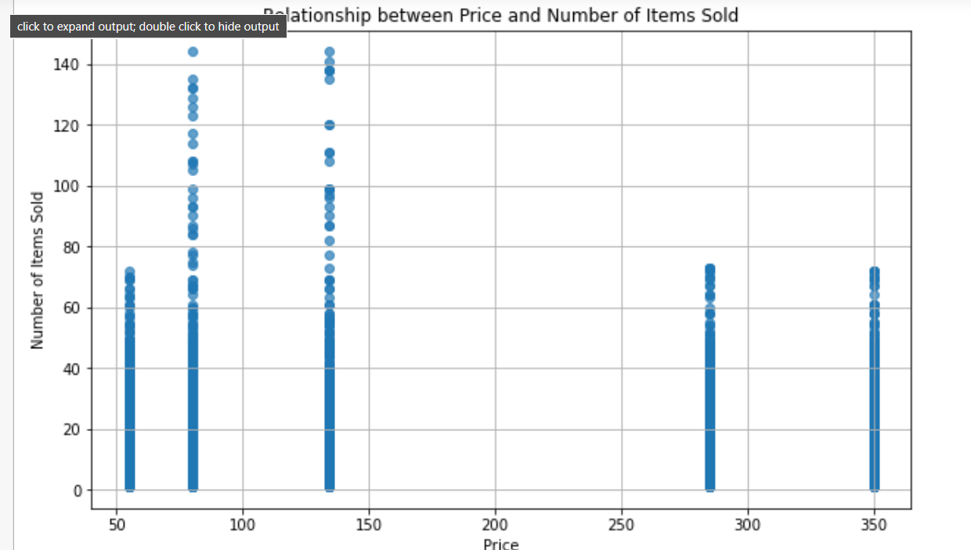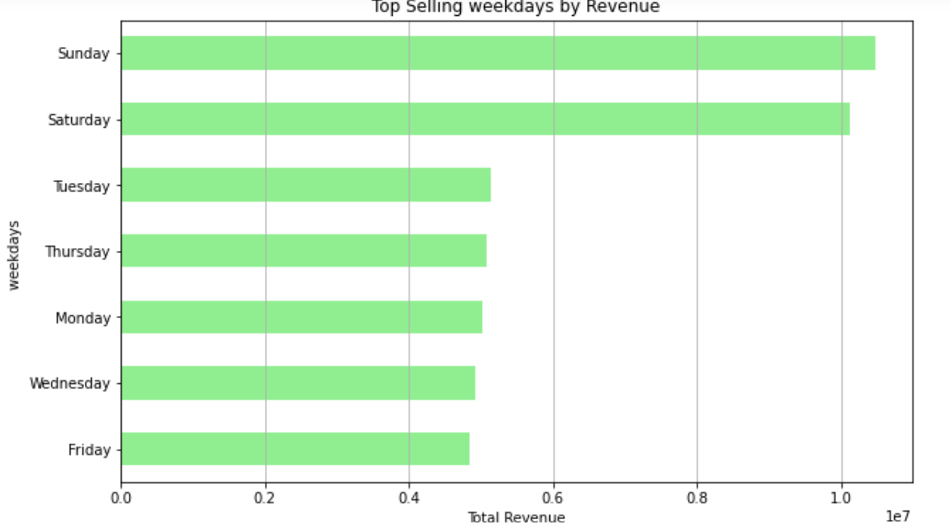

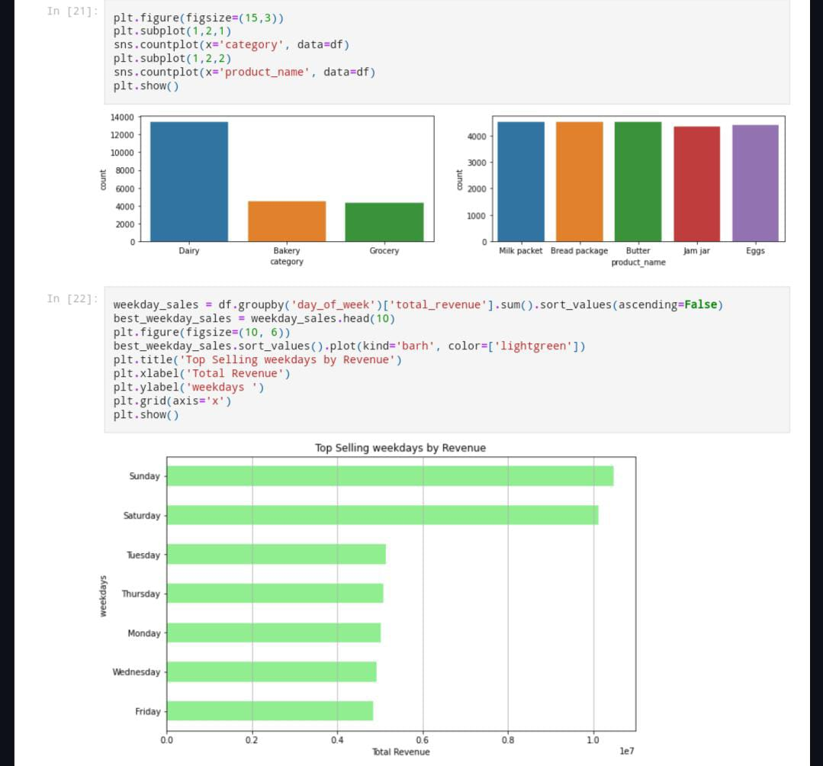

# Case studies

1. Problem Statement

A grocery store wants to understand customer purchasing behavior to optimize product placement and promotional strategies. The store aims to identify which items are frequently bought together and generate actionable insights for improving sales and customer experience.

2. Data Collection

The grocery store collects transaction data over a period of one month, recording the items purchased together in each transaction.

3. Data Exploration

Dataset: Transaction data containing lists of items purchased together.

Example dataset:

TransactionID Items

1 Bread, Milk

2 Bread, Butter

1. Milk, Butter

Data Preparation:

* Convert the transaction data into a suitable format for market basket analysis, such as a list of lists representing transactions.

4. Market Basket Analysis Process

* a. Data Preprocessing
* Convert Data: Transform the transaction data into a one-hot encoded format suitable for analysis.
* b. Generate Frequent Itemsets
* Apriori Algorithm: Use the Apriori algorithm to identify frequent itemsets (sets of items that occur together frequently).
* c. Generate Association Rules
* Association Rule Mining: Use association rule mining to derive meaningful rules from the frequent itemsets.

5. Interpretation of Results

Frequent Itemset:

- Identify which item combinations are frequently purchased together (e.g., Bread and Milk).

Association Rules:Discover relationships between items, such as if a customer buys Bread, they are likely to also buy Butter (confidence=0.7).

* 6. Insights and Recommendations

Based on the market basket analysis results:

- Place frequently co-purchased items closer to each other on shelves to encourage cross-selling.

- Design targeted promotions and discounts for item combinations identified as strong associations.

- Optimize inventory management based on popular item combinations to meet customer demand.

* 7. Implementation and Monitoring

Implement the recommended strategies derived from market basket analysis and continuously monitor customer purchasing patterns to refine strategies and improve business outcomes.

This case study outlines the steps involved in performing market basket analysis for a grocery store, from data collection and preprocessing to generating insights and actionable recommendations. Customize the analysis based on specific business goals and datasets to derive valuable insights for enhancing retail operations and customer satisfaction.

# Conclusion

In conclusion, the market basket analysis project conducted for the grocery store has provided valuable insights into customer purchasing behavior and has potential implications for improving business strategies. Here are key takeaways and a summary of the project's findings:

1. Understanding Customer Behavior:

- Market basket analysis has allowed us to uncover patterns and associations among products that are frequently purchased together.

- We identified popular item combinations and gained insights into customer preferences and buying habits.

2. Actionable Insights Derived:

- By analyzing frequent itemsets and association rules, we discovered meaningful relationships between products.

- This information can be leveraged to optimize product placement, design effective promotions, and enhance cross-selling strategies.

3. Business Recommendations:

- Place related items in close proximity on shelves to facilitate cross-selling and increase basket size.

- Implement targeted promotions and discounts on item combinations with high association to drive sales and customer engagement.

4. Operational Implications:

- Market basket analysis can guide inventory management decisions, ensuring optimal stock levels for frequently co-purchased items.

- It can also inform assortment planning, allowing the store to cater to customer preferences and demand more effectively.

5. Future Directions:

- Continuously monitor customer behavior and refine strategies based on changing trends and preferences.

- Explore advanced techniques like personalized recommendations based on individual shopping patterns for enhanced customer experience.

6. Overall Impact:

- The insights gained from market basket analysis have the potential to positively impact revenue generation, customer satisfaction, and operational efficiency.

- By leveraging data-driven approaches, the grocery store can stay competitive in the market and better meet the needs of its diverse customer base.

In conclusion, market basket analysis serves as a powerful tool for retailers to uncover hidden patterns in transaction data and translate them into actionable strategies that drive business growth and customer loyalty. By harnessin