Journel by Alexander Kulka for a mechanical Keyboard:

First Session, June 28

So I designed the schematic with the switches diodes and sorted them by rows and collums

Obrázok, na ktorom je text, diagram, číslo, písmo

Obsah vygenerovaný pomocou AI môže byť nesprávny.

I designed this with the help of a tutorial where he build a keyboard from scratch, in this session I also made the keyboard layout in keyboard layout edititor:

Obrázok, na ktorom je klávesnica

Obsah vygenerovaný pomocou AI môže byť nesprávny.

This is the raw code:

["Esc",{x:1},"F1","F2","F3","F4",{x:0.5},"F5","F6","F7","F8",{x:0.5},"F9","F10","F11","F12",{x:0.25},"PrtSc","Scroll Lock","Pause\nBreak"],

[{y:0.5},"~\n`","!\n1","@\n2","#\n3","$\n4","%\n5","^\n6","&\n7","*\n8","(\n9",")\n0","_\n-","+\n=","|\n\\","Back Space",{x:0.25},"Insert","Home","PgUp",{x:0.25},"Num Lock","/","*","-"],

[{w:1.5},"Tab","Q","W","E","R","T","Y","U","I","O","P","{\n[","}\n]",{w:1.5,h:2,w2:2.25,h2:1,x2:-0.75,y2:1},"Enter",{x:0.25},"Delete","End","PgDn",{x:0.25},"7\nHome","8\n↑","9\nPgUp",{h:2},"+"],

[{w:1.75},"Caps Lock","A","S","D","F","G","H","J","K","L",":\n;","\"\n'",{x:5.75},"4\n←","5","6\n→"],

[{w:2.25},"Shift","Z","X","C","V","B","N","M","<\n,",">\n.","?\n/",{w:2.75},"Shift",{x:1.25},"↑",{x:1.25},"1\nEnd","2\n↓","3\nPgDn",{h:2},"Enter"],

[{w:1.25},"Ctrl",{w:1.25},"Win",{w:1.25},"Alt",{a:7,w:6.25},"",{a:4,w:1.25},"Alt",{w:1.25},"Win",{w:1.25},"Menu",{w:1.25},"Ctrl",{x:0.25},"←","↓","→",{x:0.25,w:2},"0\nIns",".\nDel"]

Session time: 7 hours.

June 29th:

I started working on the pcb:

Obrázok, na ktorom je snímka obrazovky, elektronika, okruh, elektrinžinierstvo

Obsah vygenerovaný pomocou AI môže byť nesprávny.

Which I set up with the build in keyboard layout tool in Kicad. I also started wiring it but the lag was way too much to even start with it, it took me 3 hours only to do a few cables so I decided to try use freerouter tool, I worked on this for like 5 hours and it just wouldn’t work, I really tried everything. I give ☹… I actually don’t but this is enough for today.

Time spent: 8 fric*ing hours like what

July 2nd: So again tried freerouter… BIG mistake I hate it so much why does it even exist… So apart from that I actually started wiring: 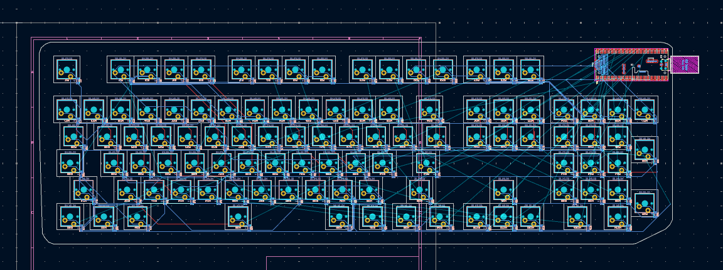

I changed to a pi pico (orpheus pico) because I realized I copied the setup from that one tutorial and didnt want to do that, after wiring like half of it I realized something... hard to see on the pic but I wondered, why do the Gpio pins on the pico need to be connected?? Well... as I looked at my schematic I realized my dumb*ss dindnt connect the rows, so I fixed that. Here is the new schematic:

Obrázok, na ktorom je text, číslo, diagram, písmo

Obsah vygenerovaný pomocou AI môže byť nesprávny.

I have to do everything again… :§

Time spent: 6 hours

July 16th:

So I finally finished wiring the PCB after many many problems (they are all my fault lol)

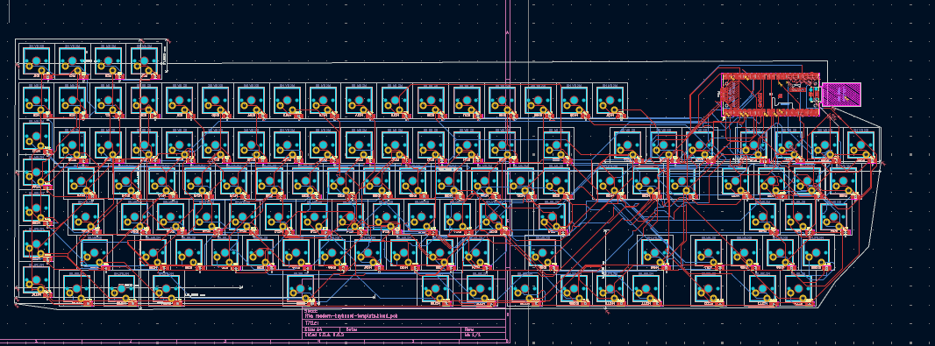

The wiring is so messy but everything works, I had to fix like 600 errors…

Also, as you see in the pcb I changed the keyboard layout into a custum one which uses all my keys as the one before didn’t do that (why is chatgpt so dumb he couldn’t change like 2 lines of code like what).

Time spent: 12 hours

July 16-17th: Hopefully last session (prob not as I suck at Fusion 360 like help)

SO I pretty much made the case after much suffering…. I had problems figuring out how big the case should be and all of the dimensions, but I made it work:

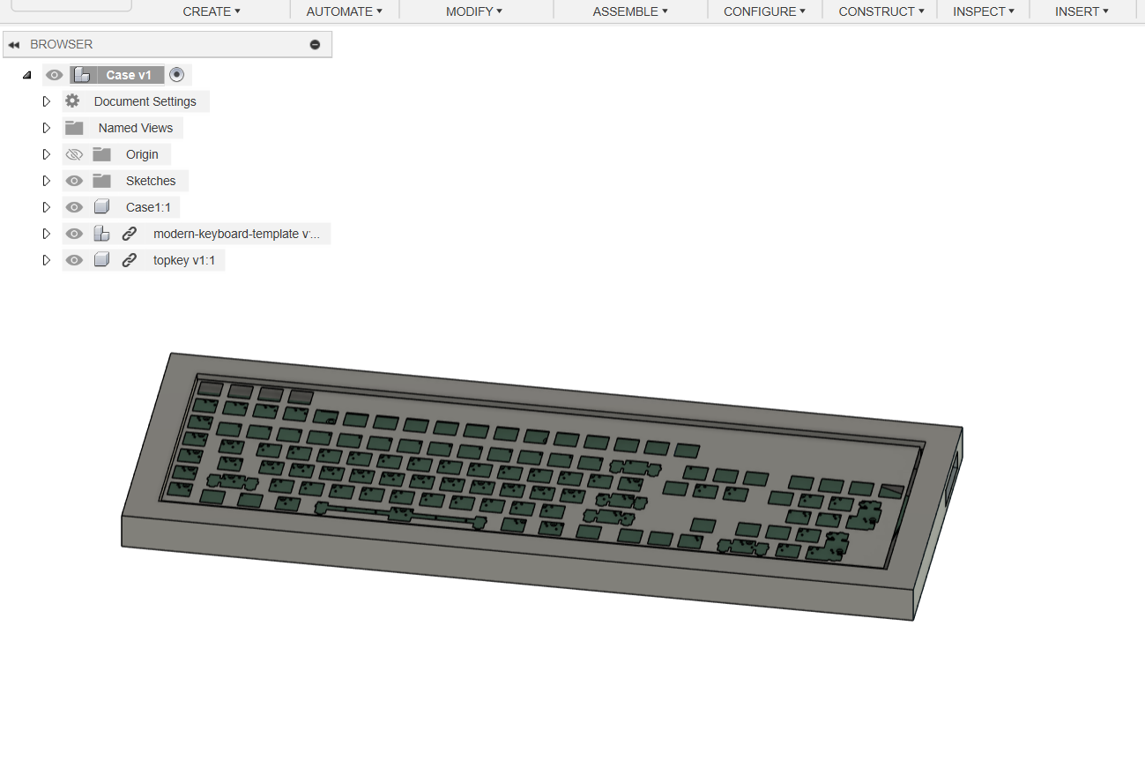

I got the top from a CAD generator

Time spent: 5 hours

July 17th:

Made Firmware for the pico and keyboard

Time spent: 1 hour (I don’t know what to show here lol)