**BLUETOOTH CONTROLLED AUTONOMOUS ROBOVAC**

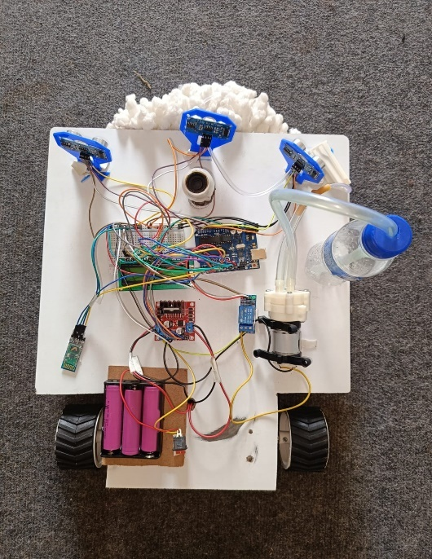

Bluetooth-Controlled Autonomous RoboVac is a smart and efficient cleaning robot designed to simplify household cleaning tasks. This is equipped with sensors that enable it to map out your and navigate around obstacles with ease. Using brush system, the RoboVac effectively cleans dust, dirt from hard floors and carpets. What sets it apart is its Bluetooth control feature, allowing users to operate the RoboVac via a smartphone or tablet. This means you can start, stop, or schedule cleaning sessions from anywhere. Additionally, the RoboVac has battery system and water control mechanism using gluecose drip system, ensuring it's always ready to clean. With customizable cleaning modes and a low-profile design, it can effortlessly clean under furniture and in hard-to-reach areas. **Block Diagram:**

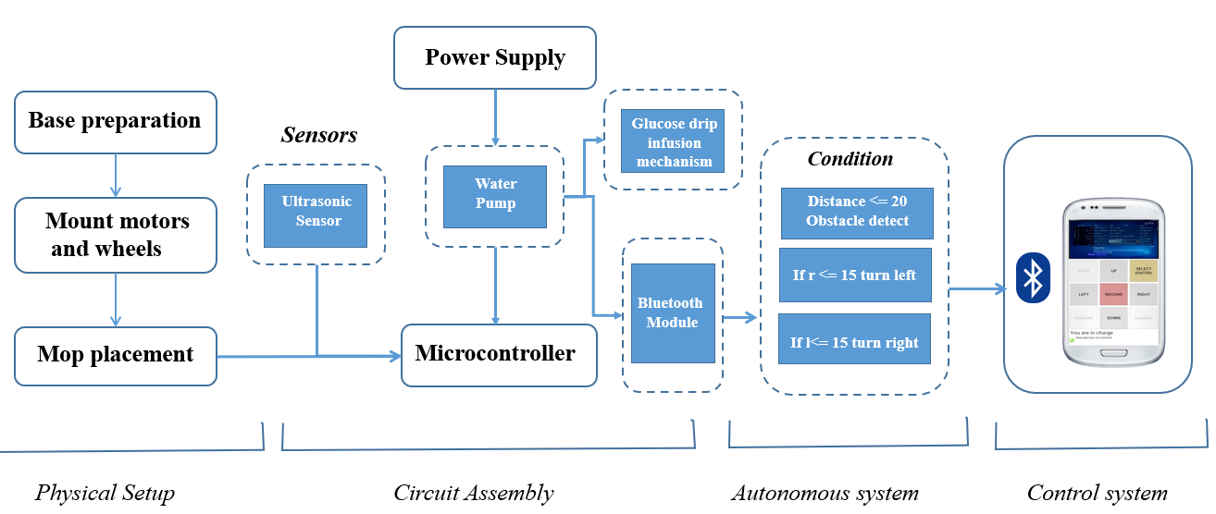

**Components Requirements:**

* HC-05 Bluetooth Modules
* Arduino Uno
* L293D Motor Driver Board
* Bread Board
* Potentiometer
* 3x HC-SR04 Ultrasonic Sensors
* 3x Clamps for Ultrasonic Sensors
* 16x2 LCD Display
* Single Channel 5V Relay Module
* 2x 100 RPM Geared Motors
* 2x Wheels for Motors
* 2x Clamps for Motors
* 12V Diaphragm Water Pump
* 3x 18650 Lithium-ion Batteries
* Cell Holder or 3x Single Cell Holders
* Male/Female Headers
* Screw Terminal
* On/Off Switch
* Spinning Mop
* Vinyl Tubing
* Glucose Drip Pipe
* Jumper Wire
* Water bottle
* Doulbe sided tape

**Circuit Digram:**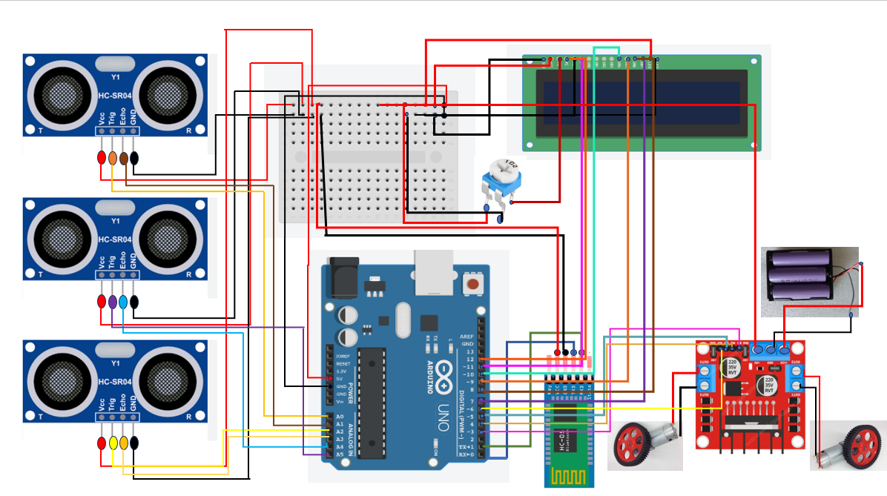

**PROCEDURE:**

**Base Preparation:**Start by preparing the base of the RoboVac. This can be made using a wooden board or any other suitable material. Cut the base according to the desired design and ensure it is sturdy and of the appropriate size for the components.

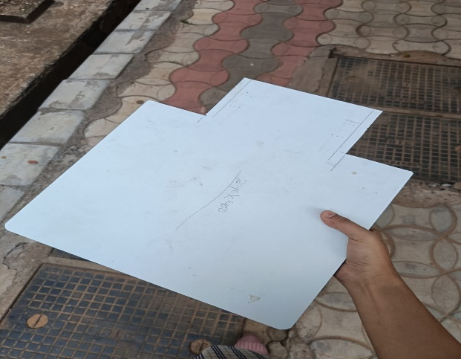

**Hardware Assembly:**Motor and Wheel Attachment: Attach the gear motor to the base using motor clamps and ensure it is securely fixed. Then, attach the wheels to the gear motors to facilitate movement. 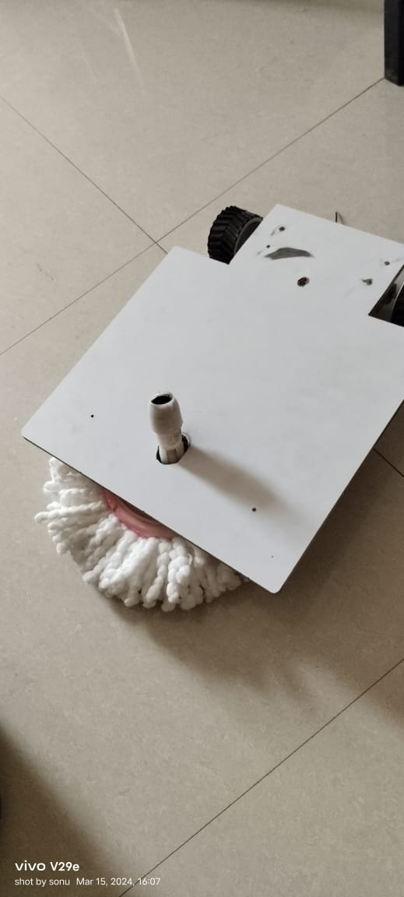

Sensor Placement: Create holes for the ultrasonic sensor and securely attach it to the base using clamps. Also, create a hole for mounting the mop or cleaning mechanism.

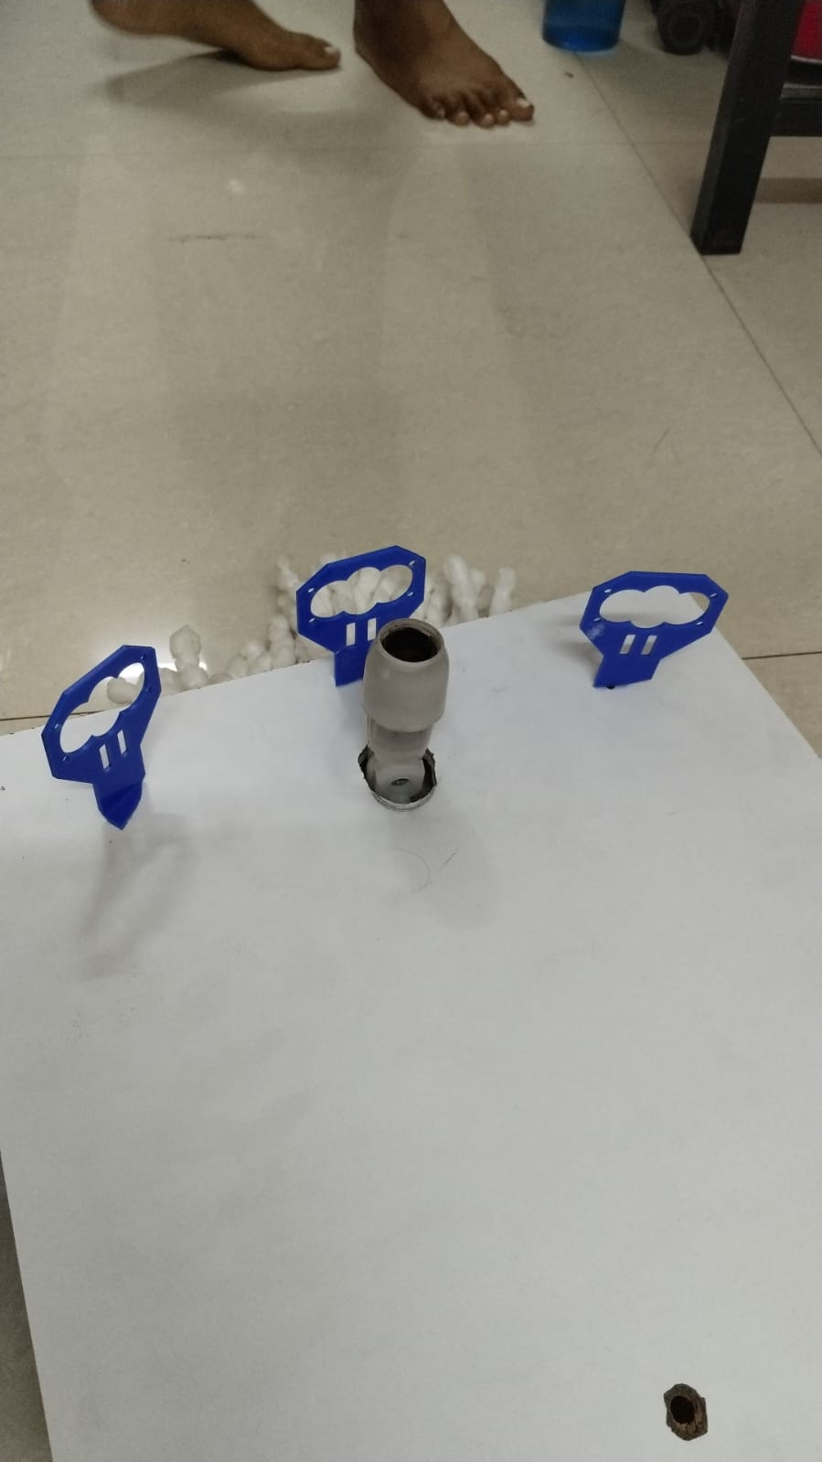**Circuit Connection:**Gather Components: Bring together all the necessary components such as the microcontroller, motor drivers, Bluetooth module, and sensors.

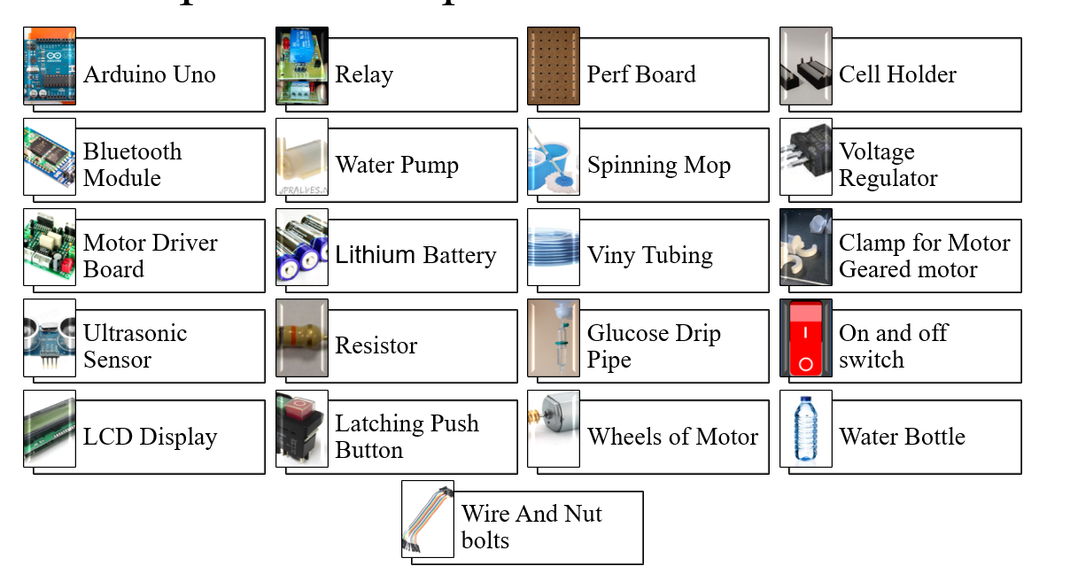Circuit Assembly: Connect the motors to the motor drivers, the sensors to the microcontroller, and the Bluetooth module to enable communication. 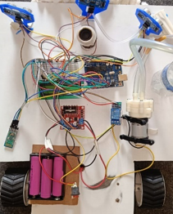

* Code Upload:Arduino IDE Installation: If not already installed, download and install the Arduino IDE on your computer.Download Arduino IDE: Go to the Arduino website and download the latest version of the Arduino IDE (Integrated Development Environment) for your operating system (Windows, macOS, or Linux).Install Arduino IDE: Once the download is complete, open the downloaded file and follow the installation instructions provided by the installer.

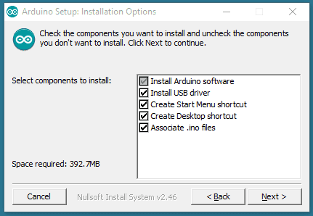

Connect Arduino Board: If you haven't already, connect your Arduino board to your computer using a USB cable. Make sure the board is recognized by your computer.Launch Arduino IDE: After installation, launch the Arduino IDE. You should see a blank sketch (program) window.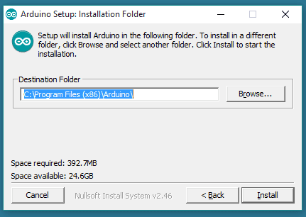

Set Board and Port: Go to the "Tools" menu and select "Board." Choose the appropriate Arduino board you're using (e.g., Arduino Uno, Arduino Mega, etc.). Then, go to the "Tools" menu again and select "Port." Choose the port to which your Arduino board is connected (it will typically be something like COM3.

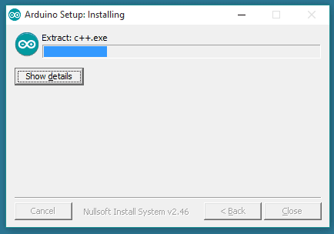

• go to **Sketch > Include Library > Manage Libraries**

• Under the search bar type **'NewPing'**

• Install the **NewPing** library by **Tim Eckel**

• Similarly search for **'LiquidCrystal'**

• Install the **LiquidCrystal** library by **Arduino** (in newer versions of IDE it might be already intalled)

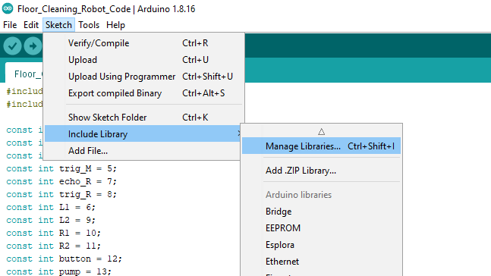 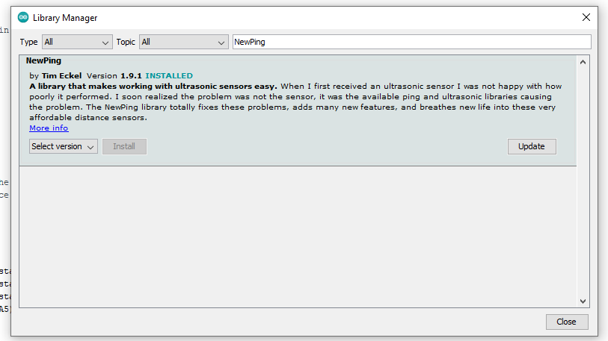

Code Implementation: Write or obtain the code for controlling the motors, reading sensor data, and enabling Bluetooth communication. Paste the code in the Arduino IDE and upload it to the microcontroller.App Configuration:

First install the app from following link

<https://filehippo.com/android/download_bluetooth-serial-controller-16/>

To configure the control interface for the Bluetooth-controlled autonomous RoboVac, follow these steps:**Adjust Display Settings:**Access Preferences and select Portrait under Orientation. You can also opt for a White Background if desired.**Button Visibility:**Navigate to Button > Visibility and select buttons 2, 5, 6, 7, and 10 while unchecking the others.Set Button Size:Under Portrait, adjust the button size to 100 to ensure proper visibility.Naming Buttons:Go to Button > Name and label Button 2 as Forward, Button 5 as Left, Button 6 as Pump, Button 7 as Right, and Button 10 as Back.Assigning Commands:Proceed to Button > Command to assign specific character commands to each button:**Forward (Button 2): 'F'Left (Button 5): 'L'Pump ON (Button 6): 'P'Right (Button 7): 'R'Back (Button 10): 'B'**Setting Stop Commands:To ensure the robot stops when the button is released, configure the Stop Commands under Button > Command > Stop Command for buttons 2, 5, 6, 7, and 10:**Button 2: 'S'Button 5: 'S'Button 6: 'p' (for pump off)Button 7: 'S'Button 10: 'S'**

By following these steps, you can create a basic Bluetooth-controlled autonomous RoboVac using readily available materials and simple electronic components.

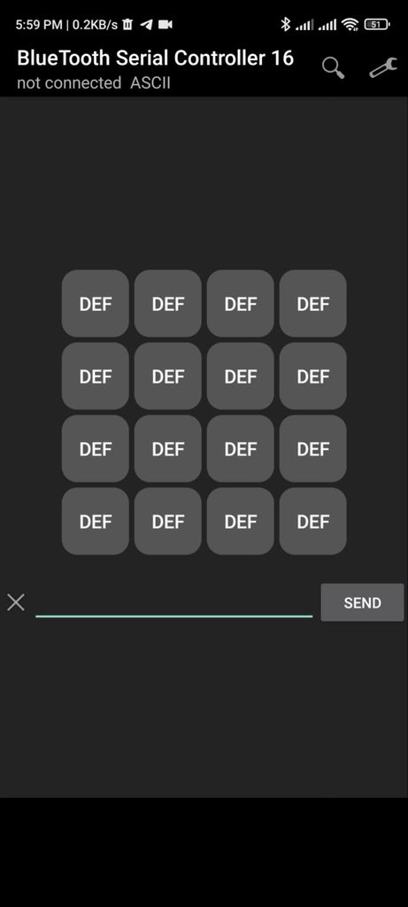 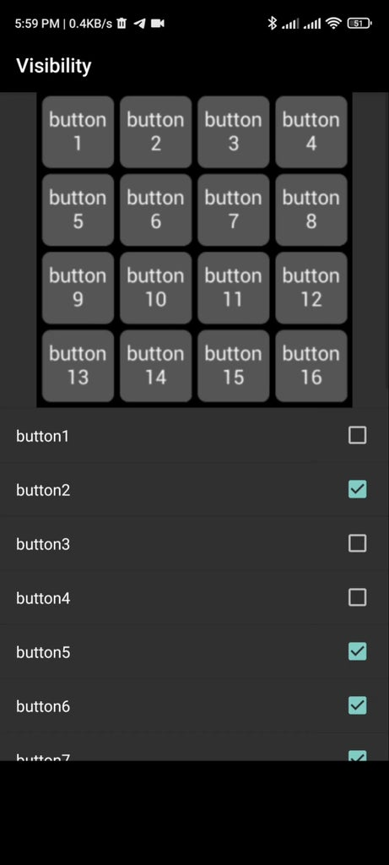 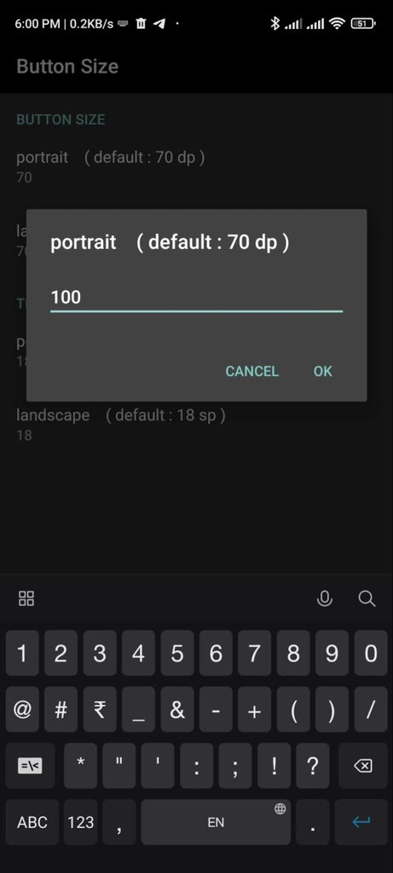 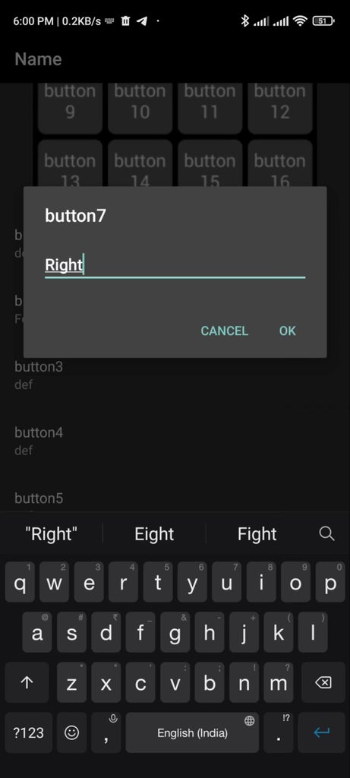

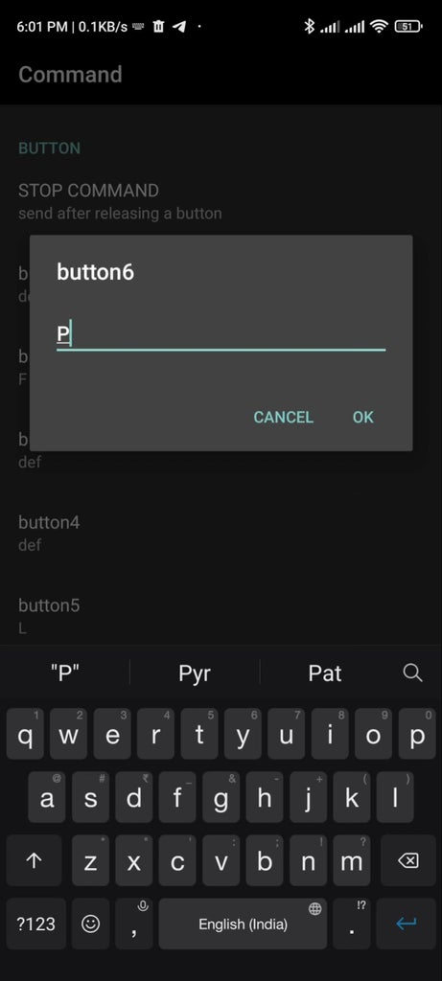 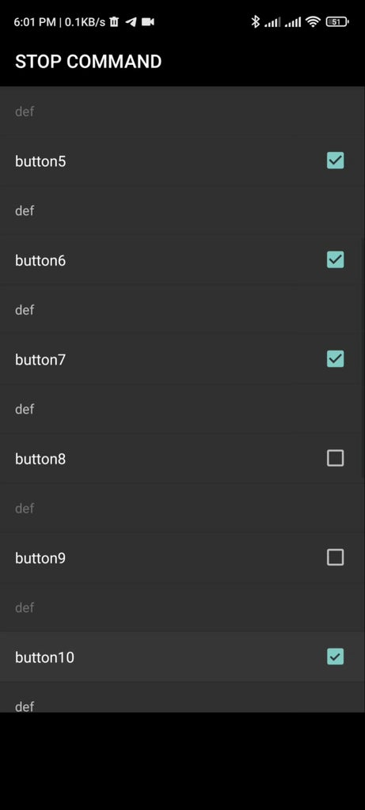 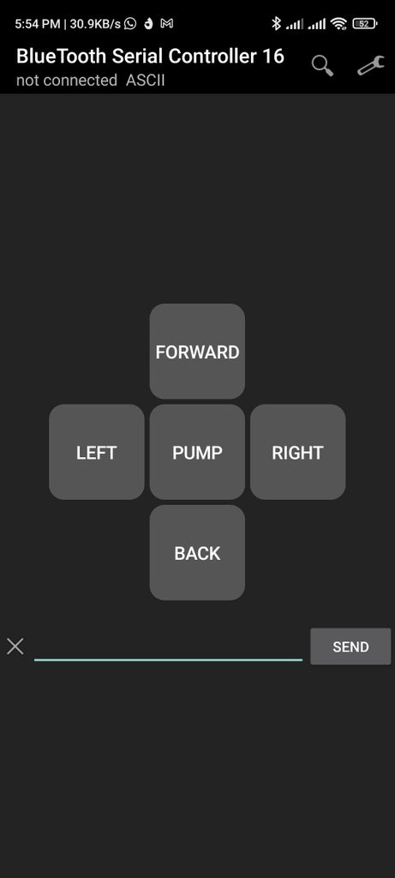

Now on the switch and app also then connect with bluetooth and control through buttons.

Here is the final view of the robovac.

 