Rules:

-All labels and texts what ever we are seeing should come from properties file

1. Tabs

--------

-Home

-Works

-Gallery

-Blog

-Contact

2. There is a chance to redirect to particular social media (Will implement at the end)

Tabs Description:

1. Home

* As of now its displaying 3 photos . So we will display best 3 photos till now

1. Work

- As of now it has 3 sub categories(we can add categories as per our requirements):

Based on categories we will display photos.

2.1. All : studio pics+Landscape

2.2. Studio: specific to studio

2.3. Landscapes: specific to landscapes

Note: Here also we will display some photos(no of photos will finalize during development)

On Each photo click onepopup will come and it will display the image. After that we can display the previous and next image.

1. Gallery

* Some of other images we will display in dissorted order.
* Again in this only 6 photos will be clickable. Rest photos will be not clickable just for display purpose those are.
* Again all clickable photos you can share some information. Like some memories related to that photo etc.

Note: Again here we can increase the photos as per your requirement.

1. Blog

* It contains different categories (SPORTS,NATURE,WILD,TRAVEL,FOOD)
* It displays some information about the pic . you can write blogs

The look and the actions on those blogs we will handle as per requirement .

1. Contact

-Address

- The Person who wants to write you or for photography want to contact they can drop their name, emailId, and purpose of contact(message).

- Or else they can contact you through mobile no.

Note1: The overall idea for the V1 is to finalize the needs look and feel. As of now in website all photos are hard coded. And all given informations are static.

Note2: So in V1 we will display contents dynamically as per our requirement.

Note3: And in V2 we will purely work how can we upload these photos from ui itself . After that automatically site will reflect with latest content.

Note4: Will work on redirect to social media

For eg: if one follower want to see your fb profile they can click on that. So that it will redirect to your fb profile

Like that for other social contacts.

**Home**

One Upload symbol will be there . when we will click on that It will open one page . And in that page there should be one upload button. When we will click on upload button windows default choose file option will come. When we will choose image another popup will come at center with progress bar on top. Followed by image and then image name. once we will click on done all selected files will be added to “All Media File”. Cancel then it wont add.

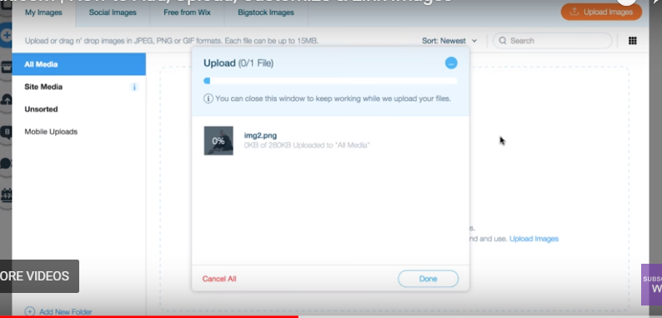

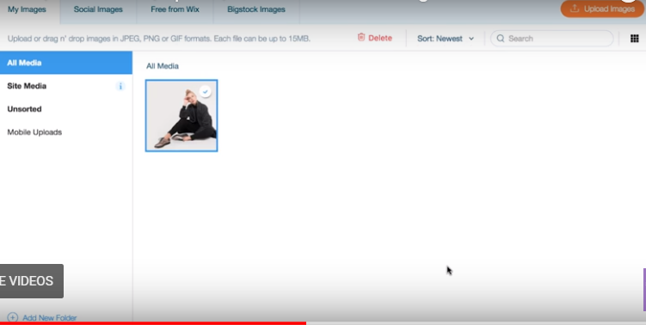

Select image from all media files link,edit all options will display. As of now consider link option only.

When we will click on the link one popup will display with Page names shown below. Click on done image will be linked to that page. Go and check on that particular page.

