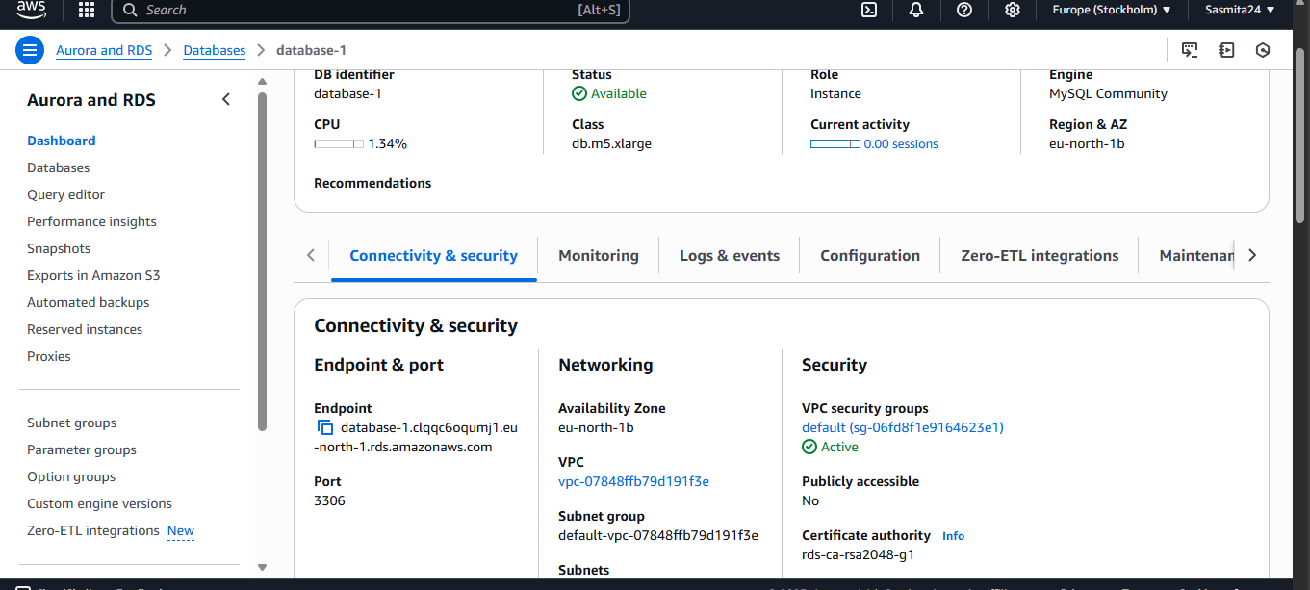

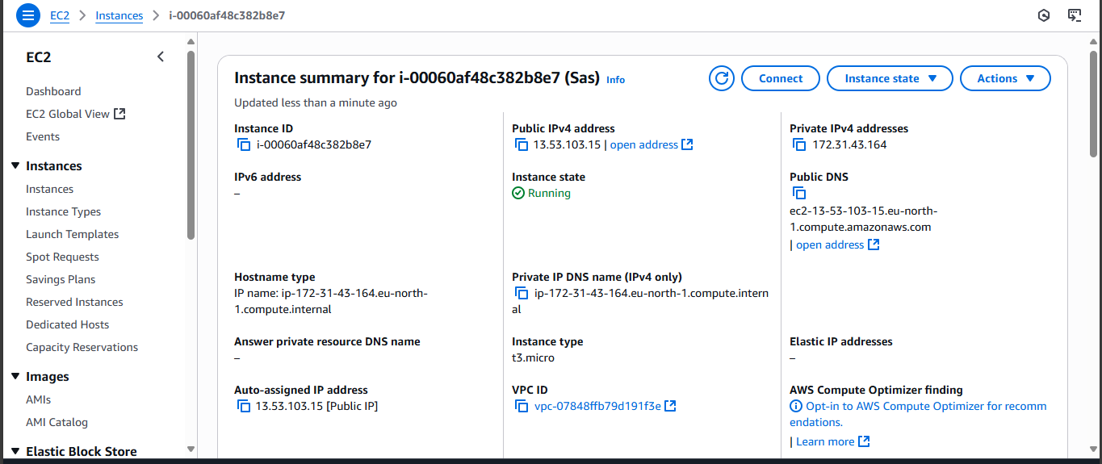

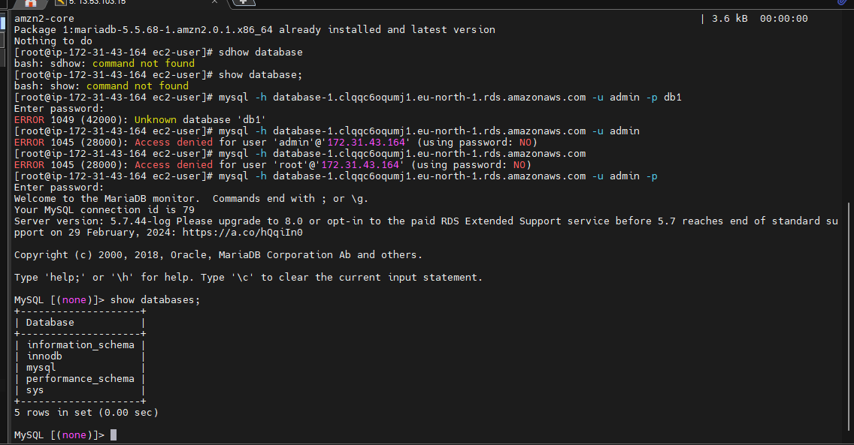

**[root@ip-172-31-43-164 ec2-user]# history**

**1 yum install -y mysql**

**2 -mysql -h database-1.clqqc6oqumj1.eu-north-1.rds.amazonaws.com -u admin -p database-1**

**3 -mysql -h database-1.clqqc6oqumj1.eu-north-1.rds.amazonaws.com -u admin -p**

**4 mysql -h database-1.clqqc6oqumj1.eu-north-1.rds.amazonaws.com -u admin -p**

**5 mysql -h database-1.clqqc6oqumj1.eu-north-1.rds.amazonaws.com -u admin -p**

**6 mysql -h database-1.clqqc6oqumj1.eu-north-1.rds.amazonaws.com -u admin -p database-1**

**7 mysql -h database-1.clqqc6oqumj1.eu-north-1.rds.amazonaws.com -u admin -p database-1**

**8 mysql -h database-1.clqqc6oqumj1.eu-north-1.rds.amazonaws.com -u admin -p database-1**

**9 mysql -h database-1.clqqc6oqumj1.eu-north-1.rds.amazonaws.com -u admin -p db1**

**10 show database**

**11 clr**

**12 return**

**13 r**

**14 yum install -y mysql**

**15 sdhow database**

**16 show database;**

**17 mysql -h database-1.clqqc6oqumj1.eu-north-1.rds.amazonaws.com -u admin -p db1**

**18 mysql -h database-1.clqqc6oqumj1.eu-north-1.rds.amazonaws.com -u admin**

**19 mysql -h database-1.clqqc6oqumj1.eu-north-1.rds.amazonaws.com**

**20 mysql -h database-1.clqqc6oqumj1.eu-north-1.rds.amazonaws.com -u admin -p**

**21 history**

**[root@ip-172-31-43-164 ec2-user]#**