AI-Powered Palm Reading and Intelligent Chatbot
Technical report - NIBM Kandy Innovation Centre, Digital Image Processing, ICA 01
Student name / ID: ______________________ Date: ______________
Academic note. Palmistry is a cultural / entertainment practice, not a scientifically validated method for predicting personality, health, wealth, relationships or future events. Do not use this output for medical, financial, employment, relationship or other consequential decisions.

1. Overview and architecture
The application lets a user upload separate left- and right-palm photographs, checks them, runs a classical OpenCV pipeline, marks the creases it can find with confidence, and then asks a Gemini model - grounded in a curated palmistry knowledge base - for a structured reading. A chatbot answers follow-up questions using the same features and report. It is a Streamlit app; the code is split into modules (segmentation, validation, preprocessing, features, knowledge_base, llm, report) so each task of the brief maps to one file. The central design rule is that the computer-vision stage makes observations and the LLM only interprets them: the model never sees the photographs, only a JSON of detected features.
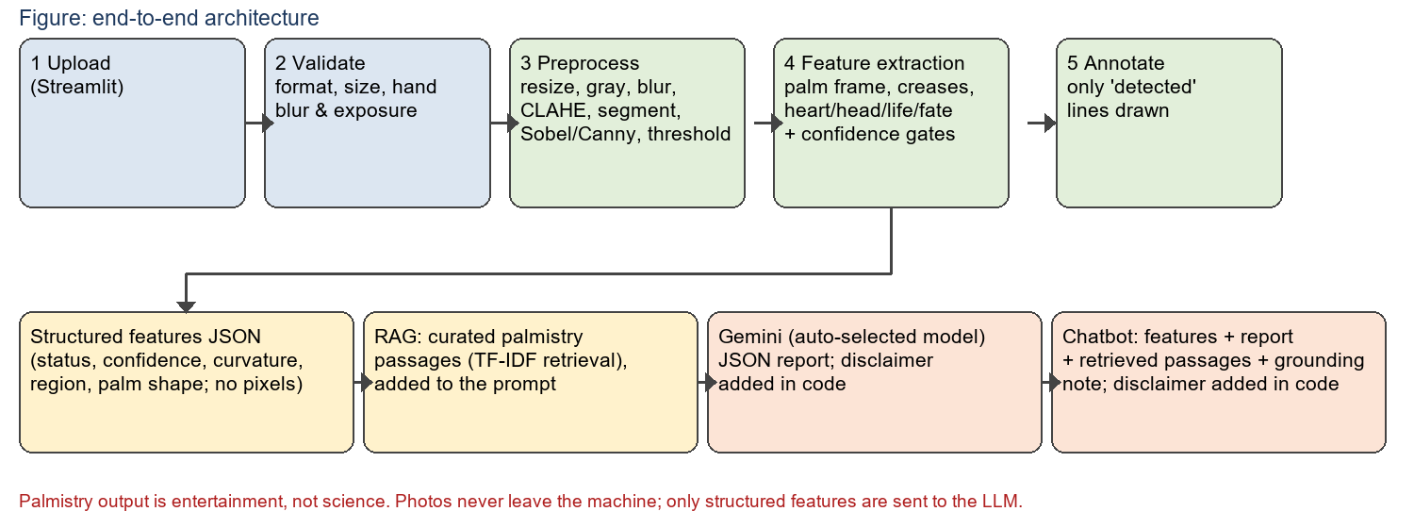
Figure 1. System architecture and data flow.

2. Input validation (Task 1)
Files must be JPG/JPEG/PNG, at most 15 MB, and decodable (Pillow verifies the file; EXIF rotation from phones is applied). Image quality is judged on the hand only, found by the adaptive segmenter of Section 3, because measuring the whole frame made a plain white wall look 'overexposed' and 'blurry'. Checks: resolution (shortest side >= 400 px); hand coverage (>= 12% of the frame, otherwise 'no clear palm'); blur, measured as the width of the hand's silhouette edge (step height divided by peak gradient, limit 5 px at 800 px wide); exposure (hand mean grey level in 35-230, and at most 20% blown-out pixels); and cut-off hands (hand touching two or more image sides; the wrist may leave through one). Every failure gives an actionable message and the user re-uploads in the same slot.
Why edge width instead of Laplacian variance: the Laplacian scales with contrast, so pale skin on a white wall scored 'blurry' even when sharp. Edge width is contrast-independent, and Table 2 shows it separating sharp from blurred hands across skin tones.

3. Image processing pipeline (Task 2)
Every stage is returned and displayed as a before/after comparison in the UI (Figure 2 is the same sequence on a synthetic hand). Each technique and the reason for it:
Technique | Parameters | Justification
Resize + min-max normalise | width 900 px | Pixel-based kernels and thresholds need a fixed scale; normalising reduces exposure differences.
RGB to grayscale | - | Creases are brightness valleys; colour adds noise to edge detection.
Gaussian blur | 5x5, sigma 1.2 | Suppresses skin grain and sensor noise that create false edges, keeps crease-scale structure.
CLAHE | clip 3.0, 8x8 tiles | Local contrast boost for faint creases; the clip limit prevents the noise amplification and blown highlights of plain global equalisation. Histogram before/after is shown.
Adaptive hand segmentation | Otsu on Lab distance from border colour; Otsu on Cr; 2-means on Cr/Cb; fixed range; GrabCut fallback | Fixed YCrCb/HSV ranges failed on deep skin tones. Candidates are scored on size, solidity and border contact, so the image chooses its own threshold.
Morphology (open/close/fill) | 5x5 ellipse | Cleans the mask; kept small because larger closing welded neighbouring fingers together (found and fixed during testing).
Black-hat transform | 21x21 ellipse | Highlights thin dark lines on a lighter background - exactly a crease.
Sobel and Canny | Sobel 3x3; Canny 0.66x / 1.33x palm median | Sobel shows gradient strength; Canny thins to 1-px edges via hysteresis. Shown side by side.
Global Otsu vs adaptive threshold | adaptive: Gaussian, block 31, C = -6 | One global threshold fails under uneven light; the adaptive threshold decides per neighbourhood. Both are shown.
Close + open on the binary map | 5x5 close, 2x2 open | Joins small gaps in crease strokes and removes specks before skeletonisation.

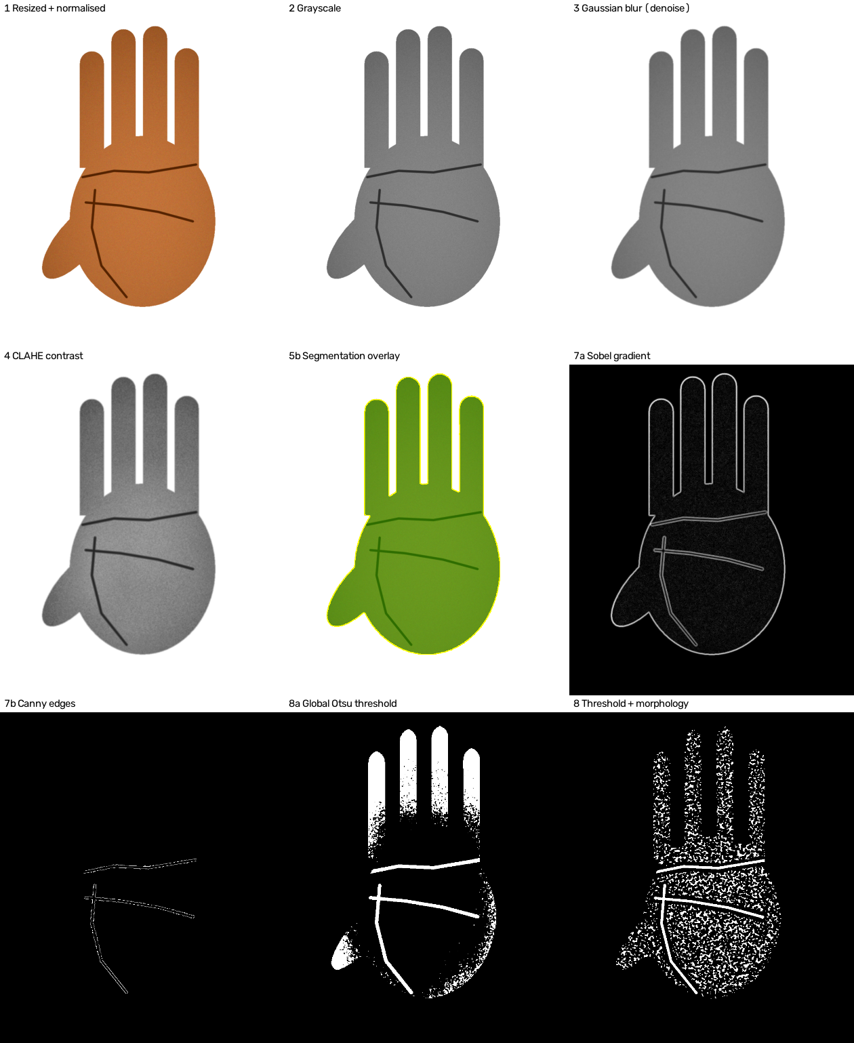
Figure 2. Pipeline stages on a synthetic hand (generated by tests/synthetic.py, not a real palm).

4. Feature extraction (Task 3)
Palm frame. The distance transform gives the palm radius; opening the hand mask with a disc of 0.6 r removes the fingers, and the remainder is the palm (its centroid is the palm centre). Connected pieces of 'hand minus palm' are finger blobs. The thumb is the blob lowest along a first-pass finger direction; the direction is then re-estimated from the four fingers only (this cut the direction error from about 5 to about 1.3 degrees on the synthetic hands). The thumb defines the 'thumb side' axis, so the frame is independent of rotation and of left/right mirroring. The 'fewer than four fingers' warning counts finger blobs excluding the thumb.
Crease candidates. The adaptive-threshold crease map inside the palm is dilated slightly to bridge gaps, skeletonised (Zhang-Suen), and cut at junctions so touching lines separate. Candidate length is measured as arc length (a diagonal skeleton step is longer than an orthogonal one), at most 60 candidates are scored.
Scoring and honesty. Each candidate is scored 0-1 against each line type from its length, orientation and position in the palm frame (heart: horizontal, upper palm; head: horizontal, middle; life: vertical, thumb side; fate: vertical, centre), and matched greedily, best first, one crease per line. A line is 'detected' only when the score >= 0.55, the crease is at least 7% darker than the palm's mean brightness (absolute depth, measured before CLAHE and normalisation) and its ridge response is >= 2.0x the palm's own texture level; 'uncertain' if it scores >= 0.3 but fails a gate; otherwise 'not_detected'. Only detected lines are drawn; uncertain and absent lines are listed in a legend on the image and in the table, never drawn. Palm shape (square/rectangular) and finger length (short/long) from silhouette ratios give an 'Earth/Air/Fire/Water' hand type; thresholds 1.15 and 0.8 are justified in code comments and are heuristics, not validated on a dataset.
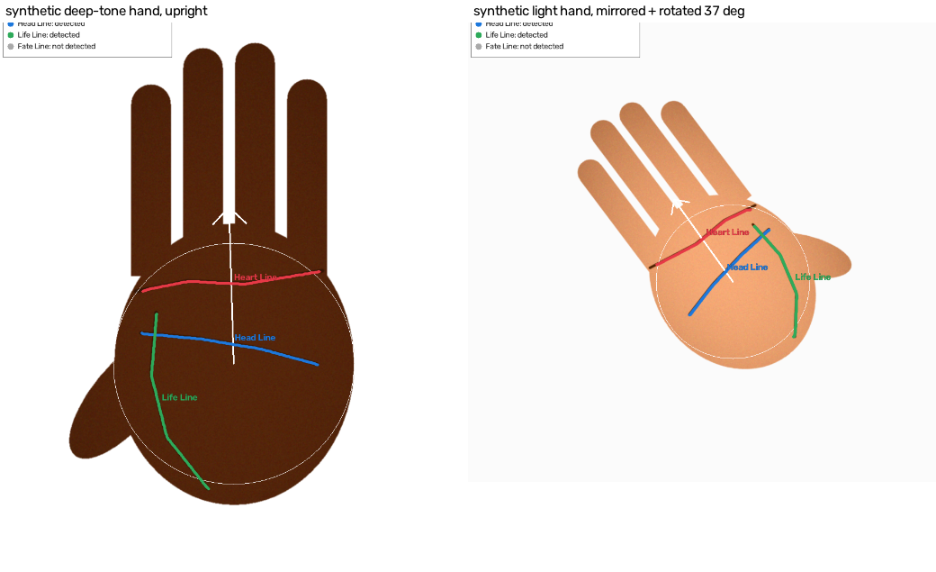
Figure 3. Annotated output with the legend (synthetic hands; only detected lines are drawn, the fate line is absent by construction).

5. LLM specialisation (Task 4)
- Model and provider. Google Gemini through the google-genai SDK. gemini-2.0-flash is retired (Google's deprecations page lists 2026-06-01), so the app asks the API which models the key can use and takes the first of gemini-3.6-flash, gemini-3.8-flash, gemini-3.5-flash-lite, gemini-2.5-flash; GEMINI_MODEL overrides. Missing key, rejected key (401/403), unknown model (404), quota (429), network and invalid-JSON errors each produce a specific message.
- Specialisation mechanism. general-purpose LLM + retrieval-augmented generation over 20 curated palmistry passages (heart, head, life, fate lines, hand types, career, finance, relationships, left-vs-right, future, safety), retrieved with a TF-IDF cosine retriever. For the report, passages for detected/uncertain lines, the hand type and the general themes are injected; passages for undetected lines are not. For chat, the top four passages for the question are added.
- Input/output format. the structured feature JSON of both palms (per line: status, confidence, curvature, prominence, start/end region; palm shape, hand type, notes). Pixel paths and tuning values are stripped. Output: JSON with nine sections (palm characteristics, major lines, personality, career, finance, relationships, future narrative, left vs right, uncertainty); the disclaimer is added in code.
- Prompts and safeguards. the system prompt (a) allows only features present in OBSERVED_FEATURES and requires 'not detected' / 'uncertain' wording, (b) separates Observed from Traditional interpretation, (c) demands hedged language and forbids predictions, medical, financial, legal or relationship advice, (d) restricts claims to the retrieved knowledge, (e) restates the disclaimer. Temperature 0.4 for the report.

6. Chatbot design (Task 5)
Each turn sends the system prompt, the feature JSON, the generated report, passages retrieved for the question, and the last 12 messages. If the question names a line (heart/head/life/fate) whose status is not 'detected' on one or both palms, a deterministic QUESTION_GROUNDING note is added saying so and forbidding a description of that line for that palm; only general tradition may be explained, labelled as such. The entertainment disclaimer is appended to every answer in code if the model did not include it. Streamlit reruns the script on every chat message, so validation and analysis are cached per file contents and only the model call happens per turn. These guards are prompt-level; there is no verifier that checks the answer against the feature JSON.

7. Testing and findings
Automated tests (pytest, warnings treated as errors): 120 passed in 177.71s (0:02:57). They cover file validation, hand-region blur/exposure, segmentation, line detection, honest labelling, palm-shape thresholds, retrieval, and the LLM layer with a FAKE client (prompts, grounding note, disclaimers, model choice, error messages). The fake client proves the plumbing, not what a real model would answer.
Table 1. Segmentation IoU against ground truth on synthetic hands (mean and minimum over 4 poses: upright, rotated 90, rotated 37 and mirrored, rotated 180 and mirrored).
Skin tone | Old fixed YCrCb/HSV range | Adaptive segmentation
light | 0.990 (min 0.990) | 0.993 (min 0.991)
medium | 0.987 (min 0.987) | 0.994 (min 0.992)
dark | 0.996 (min 0.994) | 0.993 (min 0.992)
deep | 0.000 (min 0.000) | 0.993 (min 0.991)

Table 2. Validation metrics on synthetic hands (edge width and brightness are measured on the hand).
Case | Edge width (px) | Hand brightness | Verdict
sharp | 2.7 | 149.1 | accepted
Gaussian blur sigma 1 | 3.28 | 149.1 | accepted
Gaussian blur sigma 2 | 4.46 | 149.1 | accepted
Gaussian blur sigma 3 | 5.72 | 149.3 | rejected: blurry
Gaussian blur sigma 5 | 7.73 | 149.8 | rejected: blurry
pale skin, white wall (old bug case) | 2.72 | 197.2 | accepted
deep skin, good light | 2.69 | 47.7 | accepted
brightness x1.4, pale skin | 2.47 | 249.5 | rejected: overexposed
brightness x0.4, dark skin | 2.68 | 24.6 | rejected: too dark

Table 3. Test findings. D = detected (confidence), U = uncertain (not drawn), ND = not detected. 'S' pairs are SYNTHETIC stand-ins computed when this report was built; they are not real palms.
Image | Validation | Measured | Lines (heart, head, life, fate) | Notes
S1 (light skin) Left | accepted | edge 2.72 px, bright 197.2, hand 0.315 | heart D 0.75, head D 0.74, life D 0.72, fate ND | -
S1 (light skin) Right | accepted | edge 2.69 px, bright 197.2, hand 0.315 | heart D 0.75, head D 0.74, life D 0.73, fate ND | -
S2 (medium, rotated) Left | accepted | edge 2.57 px, bright 149.3, hand 0.159 | heart D 0.74, head D 0.75, life D 0.7, fate ND | -
S2 (medium, rotated) Right | accepted | edge 2.51 px, bright 149.3, hand 0.159 | heart D 0.73, head D 0.74, life D 0.71, fate ND | -
S3 (deep skin, grey bg) Left | accepted | edge 2.68 px, bright 47.7, hand 0.315 | heart D 0.75, head D 0.75, life D 0.72, fate ND | -
S3 (deep skin, grey bg) Right | accepted | edge 2.56 px, bright 47.8, hand 0.316 | heart D 0.75, head D 0.74, life D 0.72, fate ND | -
S-fail (blurry + cut-off) Left | REJECTED: blurry | edge 7.73 px, bright 149.8, hand 0.316 | not processed (rejected by validation) | -
S-fail (blurry + cut-off) Right | REJECTED: hand cut off | edge 2.88 px, bright 150.1, hand 0.45 | not processed (rejected by validation) | -
Real pairs 1-3, left/right | NOT RUN - no real photos were available when this report was built | - | - | Run tools/run_photo_tests.py, then rebuild
Real failure case | NOT RUN | - | - | -

Table 4. Live Gemini report and chatbot results.
NOT RUN - no Gemini API key was available when this report was built, so no live report or chatbot answer is quoted. After running tools/run_photo_tests.py --chat with a key, rebuild this report to include the four-turn transcripts per pair (including a question about a line that was not detected).

8. Limitations
- Real-photo accuracy is unproven here. Automated tests use synthetic hands; thresholds (edge width, crease depth/contrast, score bars, palm-shape ratios) were set on them and must be checked against real photos.
- Rule-based detection. Line finding uses hand-written geometry and a heuristic score, not a trained model; the confidence is not a probability. Fate lines are often legitimately absent.
- Backgrounds. A cluttered or skin-coloured background defeats the colour-distance segmenters; GrabCut is only a fallback, and the validator rejects photos with no hand-like region.
- Approximate shape labels. Hand type comes from silhouette ratios and is affected by finger spread, tilt and wrist cropping.
- Handedness and chat guard. Left/right is taken from the upload slot; the chat grounding is prompt-based, not verified.
- Palmistry. It has no scientific validity for personality, health, wealth, relationships or the future; nothing here should inform real decisions.

9. Acknowledgements and AI assistance
Third-party components: OpenCV (opencv-python-headless), NumPy, scikit-image (skeletonize), Pillow, Streamlit, Google google-genai SDK and Gemini API, pytest, python-docx. The palmistry passages were written for this project from widely repeated popular teaching. Much of the code, tests, documentation and this report's builder script were drafted with AI assistance (Claude Code, Anthropic) and then run and checked by the author, as section 10 of the brief requires to be declared.

