NeuroTraffic
Streamlit Dashboard UI Guide
Every Screen, Every Element, Explained
URL: http://localhost:8501
October 2026

Table of Contents
1. How to Open the Dashboard
2. Home Page — System Overview
3. Live Monitor — Real-Time Anomaly Detection
3.1 Header Bar (Title, Status Badge, Controls, Timestamp)
3.2 Metrics Row (Total Zones, Normal, Anomaly, Disruption, Avg Score)
3.3 NYC Scattermap (Interactive Map)
3.4 Anomaly Score Distribution Chart
3.5 Active Disruptions Panel
3.6 Top Anomaly Zones Table
4. Other Dashboard Pages
5. Navigation and Sidebar

1. How to Open the Dashboard
The NeuroTraffic dashboard is a Streamlit web application (Python). It reads data from HDFS via the WebHDFS REST API.

Prerequisites:
- Docker containers must be running (docker-compose up -d) so HDFS is available
- Python 3.8+ with Streamlit installed (pip install streamlit pandas plotly requests)
- Streaming pipeline output must exist in HDFS (/data/streaming/output/latest.csv)

Start command:
streamlit run 08_dashboard/app.py

This opens the dashboard at http://localhost:8501. The dashboard has 5 pages:

Page | URL Path | Purpose
Home | / | System status overview: HDFS connection, disruption count, pipeline diagram, data health checks
Live Monitor | /live_monitor | Real-time NYC map with anomaly scores, auto-refreshing every 3-30 seconds
Simulator | /simulator | Pick a subway line and see predicted cascade disruptions from the GBT model
Explorer | /explorer | Historical trends: disruption timeline, borough breakdown, zone-level deep dives
Analytics | /analytics | ML model metrics: confusion matrix, feature importance, ROC curve, graph stats

2. Home Page — System Overview
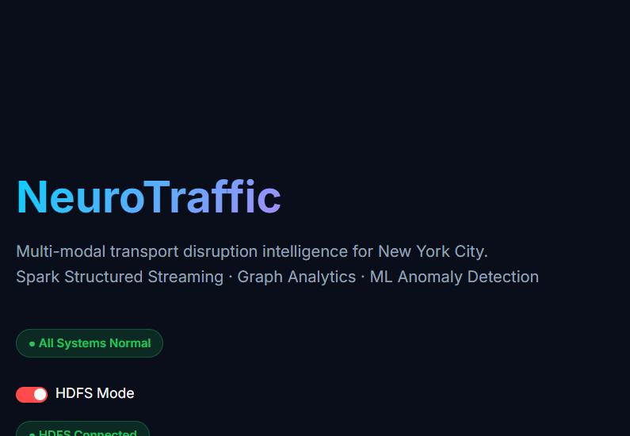
Figure 1: Home page — NeuroTraffic system overview
The home page is the first thing you see. Every element explained:

Element | What It Does
NeuroTraffic title | Gradient text (cyan to purple) — the project name. Below it: 'Multi-modal transport disruption intelligence for New York City' and the tech stack tags.
All Systems Normal badge | Green badge when no disruptions are active. Turns red with disruption count if any zone has anomaly_score >= 0.80.
HDFS Mode toggle | Switch between reading data from HDFS (via WebHDFS API on port 9870) or from local files. HDFS mode requires Docker containers running.
HDFS Connected badge | Green = HDFS is reachable. Red = cannot connect to namenode:9870. The dashboard falls back to local files if HDFS is unavailable.
Quick metrics row | Shows current disruption count, total zones monitored, and pipeline status at a glance.
Navigation buttons | Links to each dashboard page (Live Monitor, Simulator, Explorer, Analytics). Also accessible from the sidebar.

3. Live Monitor — Real-Time Anomaly Detection
URL: http://localhost:8501/live_monitor
This is the main operational page. It shows a real-time map of all 263 NYC taxi zones with their anomaly scores, updated every few seconds.

3.1 Header Bar
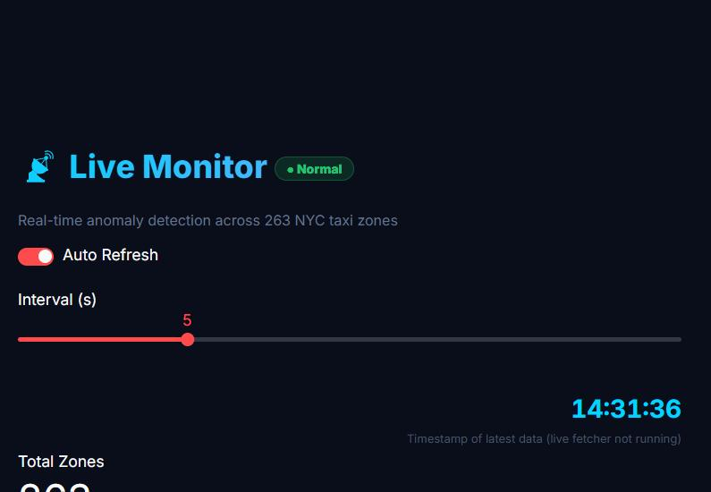
Figure 2: Live Monitor header — title, status badge, controls, timestamp
The header contains four sections side by side:

Element | Explanation
Live Monitor title | The page title with a satellite dish icon. The gradient color changes: cyan-to-purple when normal, red-to-orange when a disruption is active.
Status Badge | Green 'Normal' pill when all zones are under the disruption threshold. Changes to red 'DISRUPTION — [Line]' when any zone has is_disruption=1, showing the affected subway line.
Subtitle text | Shows 'Real-time anomaly detection across 263 NYC taxi zones' in normal mode. During disruption: shows count of disruption zones and anomaly zones.
Auto Refresh toggle | When ON (red toggle), the page automatically reloads at the selected interval. Turn OFF to freeze the display for analysis.
Interval (s) slider | Controls refresh speed: 3, 5, 10, 15, or 30 seconds. Default is 5s. Lower = more responsive but higher load. The page calls st.rerun() after sleeping this many seconds.
Timestamp (14:31:36) | Shows the NYC time of the latest data row in latest.csv. The cyan number is the actual timestamp. Below it: 'X seconds ago' if the live fetcher is running, or 'live fetcher not running' if using old data.

3.2 Metrics Row
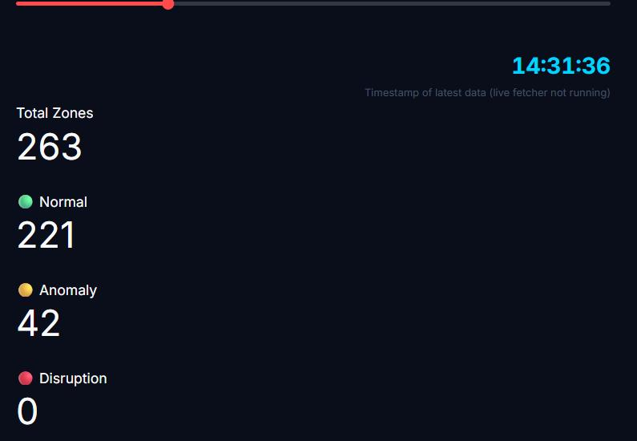
Figure 3: Metrics row — zone counts by status
Five metric cards displayed in a row, each with a label and a large number:

Metric | Explanation
Total Zones: 263 | The total number of NYC TLC taxi zones being monitored. This is always 263 — it covers all of Manhattan, Brooklyn, Queens, Bronx, Staten Island, and airports (JFK, LGA, EWR).
Normal (green): 221 | Zones with anomaly_score < 0.50. These zones have traffic patterns matching their historical baselines. Normal operations — nothing unusual.
Anomaly (yellow): 42 | Zones with anomaly_score between 0.50 and 0.80. Something is off — maybe higher taxi demand, unusual bike usage, or weather impact. Worth monitoring but not critical.
Disruption (red): 0 | Zones with anomaly_score >= 0.80 AND is_disruption=1 flag. These zones have a strong disruption signature: subway ridership crashed while taxi and bike demand surged (cascade effect).
Avg Score: 0.115 | The mean anomaly score across all 263 zones. Values close to 0 = calm city. Values above 0.3 mean widespread unusual activity. Useful for spotting city-wide events (snowstorm, parade, concert).

How anomaly_score is calculated:
- The streaming pipeline computes z-scores comparing current values to historical baselines (per zone, per hour, per weekday/weekend)
- anomaly_score = 0.4 * max(0, -z_subway) + 0.3 * max(0, z_pickups) + 0.3 * max(0, z_bikes)
- Interpretation: subway ridership DROP (negative z) × 40% + taxi pickup SPIKE × 30% + bike start SPIKE × 30%
- This captures the disruption cascade: when subway breaks, people switch to taxis and bikes

3.3 NYC Scattermap (Interactive Map)
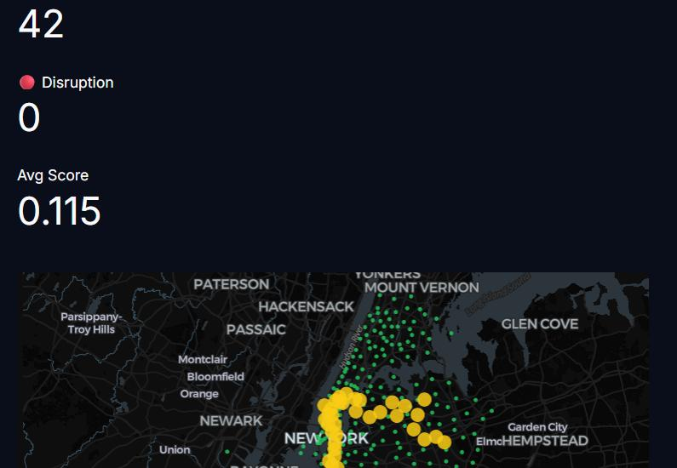
Figure 4: NYC map — 263 taxi zones as colored dots on a dark satellite-style map
This is a Plotly Scattermap using the CARTO dark-matter tile set. Each dot represents one of the 263 NYC taxi zones, positioned at the zone's centroid (latitude/longitude).

Dot Colors:
Color | Score Range | Meaning
Green | < 0.50 | NORMAL — Traffic patterns match historical expectations. Zone operating normally.
Yellow | 0.50 - 0.80 | ANOMALY — Unusual activity detected. Could be weather impact, event, or early signs of disruption.
Red | >= 0.80 | CRITICAL — Major disruption detected. Subway ridership crashed, taxi/bike demand surging. Has a pulsing red ring animation for visual emphasis.

Dot Sizes:
- Dots scale with anomaly_score — higher score = larger dot. This makes critical zones visually dominant.
- Size formula: anomaly_score (clamped 0.05-1.0) × 14 + 4 pixels

Hover Tooltip:
- Hover over any dot to see: Zone name, Anomaly Score, Borough, Subway Line, MTA alert severity, PageRank
- PageRank comes from the GraphX analysis — it measures how important this zone is in the city's transport network

Legend:
- Bottom-right of the map: NORMAL (green), ANOMALY (yellow), CRITICAL (red)
- Click a legend item to hide/show that category

Map Interactions:
- Scroll to zoom in/out (warning: if you scroll on the map while on the page, it zooms the map instead of scrolling the page)
- Click and drag to pan
- Double-click to zoom in on a specific area

3.4 Anomaly Score Distribution Chart
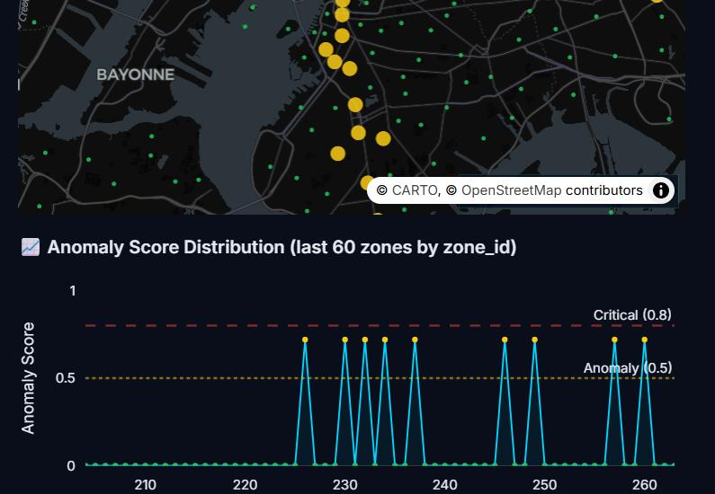
Figure 5: Anomaly Score Distribution — line chart with threshold lines
This line chart shows the anomaly score for the last 60 zones (sorted by zone_id, from zone ~204 to 263).

Element | What It Shows
X-axis (Zone ID) | The TLC taxi zone number (204-263). Each zone is a specific neighborhood: 161=Midtown, 236=Upper East Side, etc.
Y-axis (Anomaly Score) | Score from 0 to 1. The chart shows the full range so you can see the relative severity.
Cyan line with dots | The anomaly score per zone. Dots are colored: green (< 0.5), yellow (0.5-0.8), red (> 0.8). The area below is lightly filled in cyan.
Red dashed line (0.8) | Critical threshold — labeled 'Critical (0.8)'. Zones above this line are flagged as disruptions if the z-score pattern matches.
Yellow dotted line (0.5) | Anomaly threshold — labeled 'Anomaly (0.5)'. Zones between 0.5 and 0.8 are marked as anomalies.
Spikes (tall peaks) | Zones where anomaly scores spike above the thresholds. In this screenshot, several zones around 225-265 show repeated spikes to ~0.72 — these are anomaly zones.

Reading this chart:
- Mostly flat near 0 = calm city, most zones are normal
- Periodic spikes that stay below 0.5 = mild variations, nothing to worry about
- Spikes between 0.5-0.8 = anomalies worth monitoring (the yellow dots in the chart)
- Spikes above 0.8 = critical disruptions requiring attention

3.5 Active Disruptions Panel
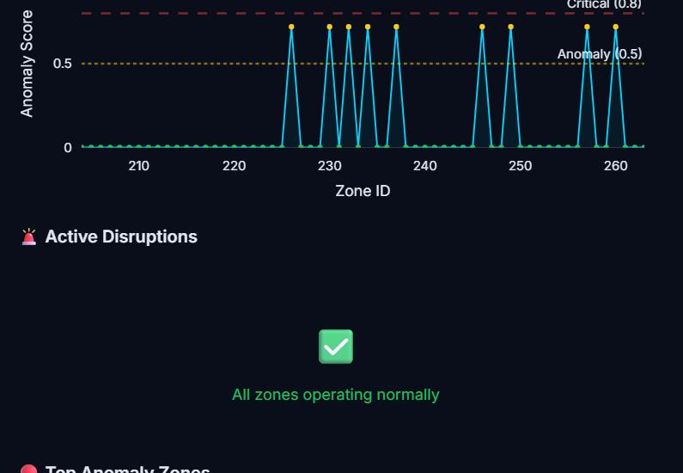
Figure 6: Active Disruptions — shows green checkmark when no disruptions, or a table during events
This panel appears below the chart:

When no disruptions (anomaly_score < 0.80):
- Shows a green checkmark icon with 'All zones operating normally'
- This means no zone has triggered the is_disruption=1 flag

During a disruption:
- Shows a table with columns: Zone name, Anomaly Score, Affected subway Line, MTA severity
- Sorted by score (worst first), limited to top 10
- The MTA severity comes from the live MTA service alerts — higher = more severe disruption
- The header also changes to show the disrupted line name and zone count

3.6 Top Anomaly Zones Table
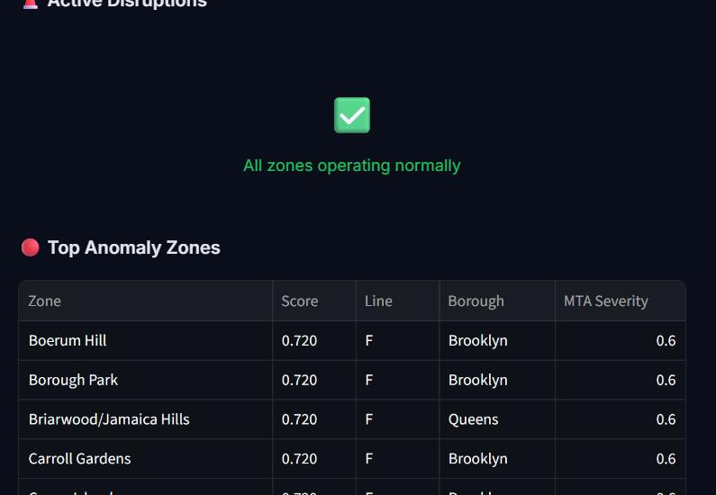
Figure 7: Top Anomaly Zones — table showing the 8 highest-scoring zones
This table appears whenever there are anomaly zones (score >= 0.50). It shows the top 8 most anomalous zones:

Column | What It Shows
Zone | The human-readable name of the taxi zone (e.g., Boerum Hill, Borough Park, East Village). These come from the TLC taxi zone shapefile.
Score | The anomaly score (0-1). In this screenshot, all top zones show 0.720 — this means they all have the same level of deviation from their baselines.
Line | The subway line most associated with this zone. 'F' means the F subway line runs through or near these zones. During a live disruption, this is the disrupted line.
Borough | Which NYC borough: Manhattan, Brooklyn, Queens, Bronx, or Staten Island. Most anomalies cluster in Brooklyn and Manhattan (highest transit density).
MTA Severity | A 0-1 score from the MTA service alerts API. 0.6 means a moderate alert is active on the associated line. 0 = no alert, 1.0 = severe disruption (full line shutdown).

4. Other Dashboard Pages

4.1 Simulator (/simulator)
The Simulator lets you test 'what if' scenarios:
- Pick a subway line from the dropdown (e.g., A, C, E, F, 1, 2, 3...)
- Adjust the disruption severity slider (0.0 to 1.0)
- The GBT machine learning model predicts which zones would be affected
- A map and table show the predicted cascade: which neighborhoods see taxi surges, bike demand spikes, and complaint increases
- This uses the trained GBT classifier from 06_ml/disruption_detector.scala

4.2 Explorer (/explorer)
The Explorer shows historical analysis:
- Disruption timeline: a time-series chart of anomaly events from 2022-2024
- Borough breakdown: which boroughs had the most disruptions
- Zone-level deep dive: select a zone and see its hourly patterns, peak hours, seasonal trends
- Data comes from the combined_v3 dataset and predictions Parquet files

4.3 Analytics (/analytics)
The Analytics page shows ML model performance:
- GBT Classifier metrics: AUC-ROC, Accuracy, Precision, Recall, F1 Score
- Confusion matrix: True/False Positives/Negatives as a 2x2 grid
- Feature importance: bar chart showing which features matter most (subway_ridership, taxi_pickups, hour_of_day, etc.)
- GraphX statistics: PageRank distribution, community detection results, node degree distribution
- All metrics come from evaluation_metrics.json saved by the ML pipeline

5. Navigation and Sidebar
The Streamlit sidebar (click the arrow at top-left to expand) provides:
- Page navigation links: Home, Live Monitor, Simulator, Explorer, Analytics
- Each page has its own icon and label
- The sidebar collapses automatically on the Live Monitor page to maximize map space
- The sidebar styling matches the dark theme with cyan accents (#00d4ff)

Dark Theme:
- The entire dashboard uses a custom dark theme (#090e1a background)
- Text is light (#e2e8f0), accents are cyan (#00d4ff)
- Metric cards have subtle borders with 15% opacity cyan glow
- Buttons have a gradient (cyan to blue) with hover lift effect
- This theme is applied via CSS injection in each page, not via Streamlit's built-in theming

Scrollbar:
- Custom thin scrollbar (6px width) with cyan thumb on dark track
- Matches the overall dark theme

