NeuroTraffic
Docker, HDFS & Spark Web UI Guide
How to Open, Navigate, and Understand Every Element
Big Data Project — NeuroTraffic Pipeline
October 2026

Table of Contents
1. How to Start the Docker Cluster
2. HDFS NameNode Web UI (port 9870)
2.1 Overview Tab
2.2 Summary Section
2.3 Datanodes Tab
2.4 File Browser (Utilities > Browse)
2.5 Other Tabs
3. Spark Master Web UI (port 8080)
3.1 Master Status
3.2 Workers Table
3.3 Applications Section
4. Spark Application UI (port 4040)
5. DataNode Web UI (port 9864/9865/9866)
6. Port Reference Map

1. How to Start the Docker Cluster
Before you can access any web UI, you need Docker Desktop running and the containers started.

Step-by-Step
- Open Docker Desktop (search 'Docker Desktop' in Windows Start menu)
- Wait until the Docker icon in the system tray shows 'Docker Desktop is running'
- Open a terminal (PowerShell or Command Prompt) in the project folder (F:\Big_Data_Project)
- Run: docker-compose up -d
- Wait ~30 seconds for all services to initialize
- Verify with: docker ps (should show 7 containers: namenode, 3 datanodes, spark-master, 2 spark-workers)

The 7 Containers
Container | Role | Port | URL
namenode | HDFS master node | 9870, 9000 | http://localhost:9870
datanode1 | HDFS storage node 1 | 9864 | http://localhost:9864
datanode2 | HDFS storage node 2 | 9865 | http://localhost:9865
datanode3 | HDFS storage node 3 | 9866 | http://localhost:9866
spark-master | Spark cluster manager | 8080, 7077, 4040 | http://localhost:8080
spark-worker-1 | Spark executor node 1 | (internal 8081) | Via Spark Master UI
spark-worker-2 | Spark executor node 2 | (internal 8081) | Via Spark Master UI

To stop everything: docker-compose down
To check status: docker ps

2. HDFS NameNode Web UI (port 9870)
Open in your browser: http://localhost:9870
This is the main HDFS administration interface. The NameNode is the brain of the Hadoop Distributed File System — it tracks where every file block is stored across the 3 DataNodes.

2.1 Navigation Bar
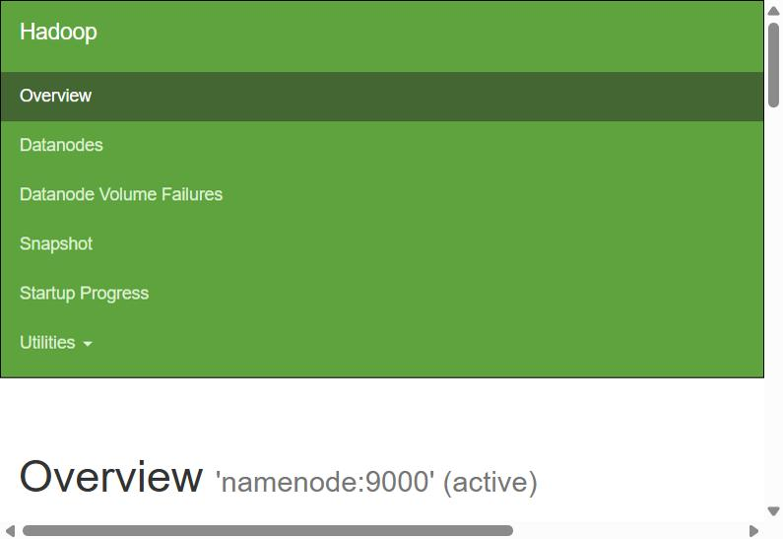
Figure 1: HDFS NameNode — Navigation bar and Overview heading
The green navigation bar at the top has these tabs:

Tab | What It Shows
Overview | Main status page: version, cluster ID, storage summary, live/dead nodes, journal status
Datanodes | Table of all DataNodes with their status, capacity, blocks, and last contact time
Datanode Volume Failures | Lists any DataNode disk volumes that have failed (should be empty if healthy)
Snapshot | HDFS snapshot management — point-in-time copies of directories for backup
Startup Progress | Shows NameNode boot phases: loading fsimage, replaying edit log, safe mode exit
Utilities (dropdown) | Browse the File System (file browser), Logs (NameNode logs), Configuration (hadoop config)

2.2 Overview Tab — Cluster Information
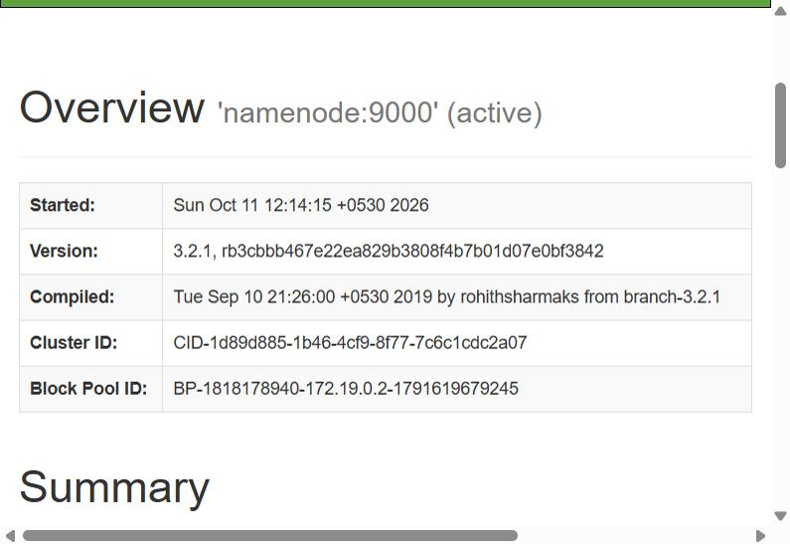
Figure 2: HDFS Overview — Cluster details table
This table shows the core identity of your HDFS cluster:

Field | What It Means
Started | When the NameNode process was last started. If this is very recent, the cluster was just restarted.
Version | Hadoop version (3.2.1 in our project) plus the git commit hash of the build. Our project uses Hadoop 3.2.1 which is bundled with the Docker image.
Compiled | When and by whom the Hadoop binary was built. This is the build info of the Docker image, not our code.
Cluster ID | A unique UUID for this HDFS cluster. Generated when the NameNode is first formatted. All DataNodes must share this same cluster ID.
Block Pool ID | Identifies the set of blocks managed by this NameNode. Contains the NameNode IP and a timestamp. Each DataNode stores blocks in a directory named after this pool ID.

2.3 Summary Section — Storage & Health
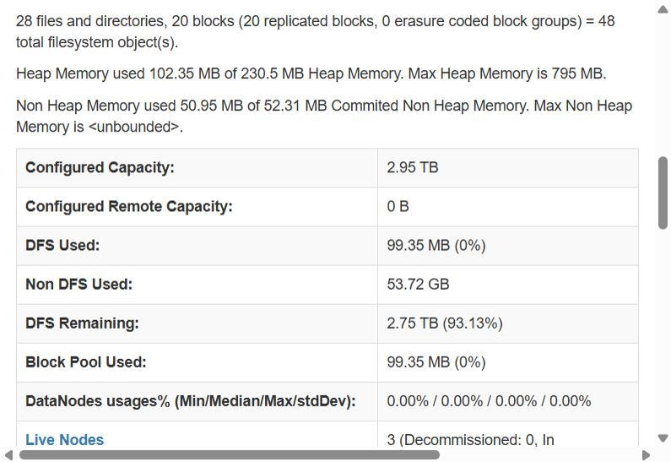
Figure 3: HDFS Summary — Capacity, memory, and node status
The Summary section is the most important part of the Overview. Here is what every field means:

Text Summary Line:
- '28 files and directories, 20 blocks' — Total filesystem objects stored in HDFS
- '20 replicated blocks, 0 erasure coded block groups' — Our replication factor is 3, so each block exists on 3 DataNodes. Erasure coding is an alternative to replication (not used here).
- '48 total filesystem objects' — files + directories + blocks combined count

Memory Section:
- Heap Memory: Java heap used by the NameNode JVM. If this approaches Max Heap Memory, the NameNode may slow down or crash.
- Non Heap Memory: JVM memory outside the heap (class metadata, compiled code). Usually stable.

Storage Table:
Field | Explanation
Configured Capacity | Total disk space across all 3 DataNodes combined. Our cluster has 2.95 TB total (from the host machine disk).
DFS Used | How much space is actually used by HDFS data (our cleaned/processed data). 99.35 MB here means the data from previous runs is stored.
Non DFS Used | Disk space used by non-HDFS files (OS, Docker, logs). This is the host disk usage that is NOT our data.
DFS Remaining | Free space available for new HDFS data. 93.13% means we have plenty of room.
Block Pool Used | Same as DFS Used but specific to this block pool (we only have one).
DataNodes usages% | Min/Median/Max/StdDev of disk usage across DataNodes. All 0% means data is evenly distributed (or very little data stored).
Live Nodes | Number of DataNodes that are alive and responding. Should be 3 for our cluster. Decommissioned = gracefully removed.
Dead Nodes | DataNodes that stopped responding. If > 0, check if a container crashed (docker ps).

2.4 Datanodes Tab
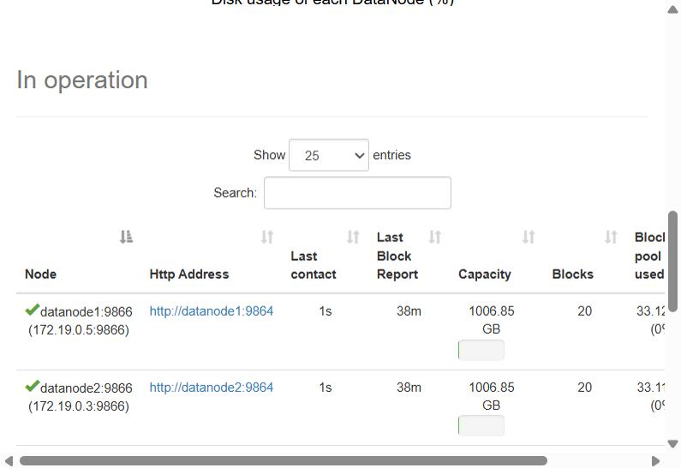
Figure 4: Datanodes tab — All 3 DataNodes with status and capacity
Click 'Datanodes' in the navigation bar to see this table. It shows every DataNode registered with the NameNode.

Column | What It Means
Node | The DataNode hostname and port. Green checkmark = healthy. Our nodes: datanode1:9866, datanode2:9866, datanode3:9866. The IP addresses are Docker internal IPs.
Http Address | Link to that DataNode's own web UI (port 9864). Click to see that DataNode's individual status page.
Last contact | How long ago the DataNode sent a heartbeat to the NameNode. Should be '0s' or '1s'. If > 10 minutes, the node is considered dead.
Last Block Report | How long ago the DataNode sent a full list of all its blocks. Happens every ~6 hours by default. The NameNode uses this to verify block locations.
Capacity | Total disk space on this DataNode. ~1006 GB each (1/3 of the 2.95 TB total, since all 3 share the host disk via Docker volumes).
Blocks | Number of HDFS blocks stored on this node. With replication=3, each block appears on all 3 nodes, so all show 20.
Block pool used | Disk space used by HDFS blocks on this node.

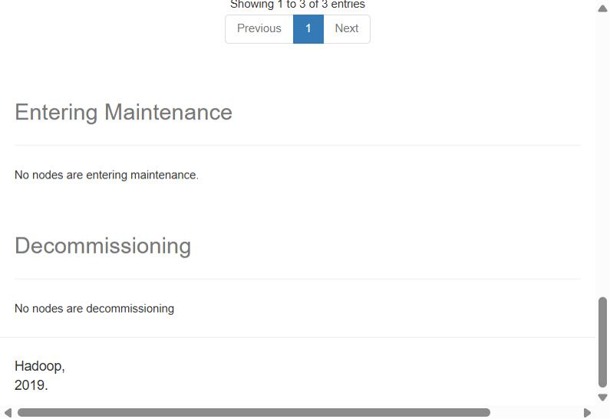
Figure 5: Datanodes tab — Maintenance and Decommissioning sections
Below the table, you see two sections:
- Entering Maintenance — Nodes temporarily taken offline for maintenance. Empty means no nodes are in maintenance.
- Decommissioning — Nodes being gracefully removed from the cluster. HDFS replicates their blocks to other nodes before fully removing them. Also empty in our case.

2.5 File Browser (Utilities > Browse the File System)
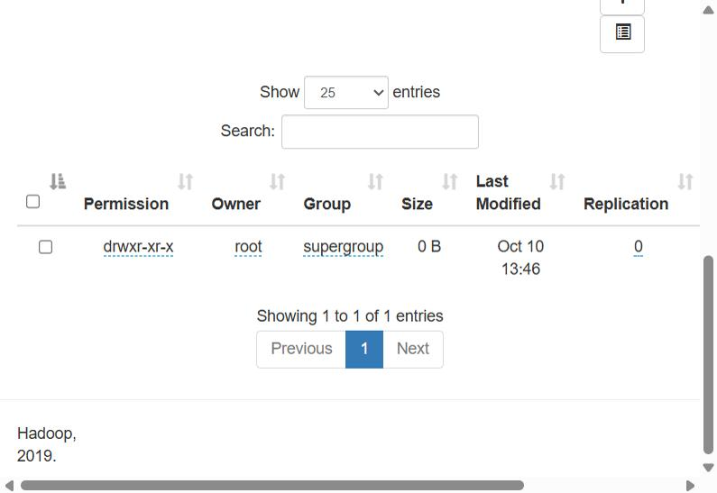
Figure 6: HDFS File Browser — Browse Directory view
Access this via the Utilities dropdown > 'Browse the File System', or directly at: http://localhost:9870/explorer.html#/

This is a web-based file explorer for HDFS (similar to Windows Explorer but for HDFS). It shows:

Column | What It Means
Permission | Unix-style permissions (drwxr-xr-x). 'd' = directory, 'r' = read, 'w' = write, 'x' = execute. HDFS uses the same permission model as Linux.
Owner | Who owns the file/directory. Usually 'root' in our Docker setup.
Group | Group ownership. 'supergroup' is the default Hadoop admin group.
Size | File size. Directories show 0 B. Files show their actual size. Click a file to download it.
Last Modified | When the file was last written or the directory was last modified.
Replication | How many copies of each block exist. 0 for directories. Our config is 3 (set in hadoop.env: HDFS_REPLICATION=3).

Key HDFS paths in our project:
- /data/neurotraffic/raw/ — Raw uploaded data (taxi, subway, bike, weather, 311, events)
- /data/neurotraffic/cleaned/ — Cleaned Parquet files from Stage 2
- /data/neurotraffic/combined_v3/ — Joined dataset (263 zones x hours, ~6.9M rows)
- /data/neurotraffic/graph_features/ — PageRank, community, degree data from GraphX
- /data/neurotraffic/predictions/ — ML model predictions
- /data/streaming/input/ — JSON micro-batches from live fetcher or simulator
- /data/streaming/output/ — latest.csv and source_status.json from streaming pipeline

2.6 Other NameNode Tabs
Datanode Volume Failures:
- Shows any disk volumes on DataNodes that have failed. If a DataNode has multiple disks and one fails, it continues serving from the healthy disks. Should be empty in our Docker setup.
Snapshot:
- HDFS supports snapshots — frozen point-in-time copies of a directory. Useful for backup before running destructive operations. We do not use snapshots in this project.
Startup Progress:
- Shows the NameNode boot sequence: Loading fsimage (the filesystem state), Replaying edit log (recent changes), Saving checkpoint, Safe mode (read-only until enough DataNodes report). After startup, this shows 100% complete.

3. Spark Master Web UI (port 8080)
Open in your browser: http://localhost:8080
This is the Spark cluster manager interface. It shows the health of the Spark cluster, its workers, and any running or completed applications.

3.1 Master Status Section
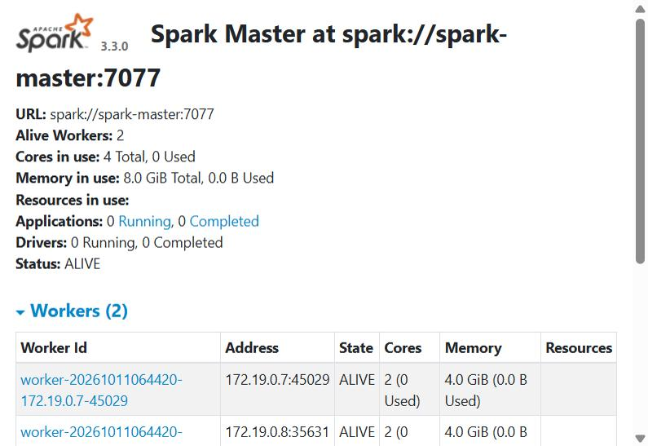
Figure 7: Spark Master UI — Cluster status and Workers table
The top section shows the Spark cluster status:

Field | What It Means
Spark Master at spark://...:7077 | The Spark Master's RPC address. Port 7077 is how workers and applications connect to the master. Workers register here when they start.
URL | The internal Spark RPC URL (spark://spark-master:7077). Applications use this to submit jobs.
Alive Workers | Number of worker nodes connected and healthy. Should be 2 for our cluster.
Cores in use | CPU cores. '4 Total' = 2 workers x 2 cores each. '0 Used' means no job is running right now.
Memory in use | RAM allocated. '8.0 GiB Total' = 2 workers x 4 GB each. '0.0 B Used' = no active jobs.
Applications | Running = currently executing Spark jobs. Completed = finished jobs. When you run spark-shell -i script.scala, it appears here as a running application.
Drivers | Spark drivers submitted in cluster mode. Our scripts use client mode (spark-shell), so this stays at 0.
Status: ALIVE | The master is healthy. Other states: STANDBY (backup master), RECOVERING (after crash).

3.2 Workers Table
The Workers section lists every Spark worker node:

Column | What It Means
Worker Id | Unique ID: worker-<timestamp>-<IP>-<port>. Click to see that worker's own UI with its executors, logs, and running tasks.
Address | The worker's Docker internal IP and RPC port. Workers communicate with the master on this address.
State | ALIVE = healthy and ready. DEAD = lost contact. DECOMMISSIONED = gracefully removed.
Cores | '2 (0 Used)' = This worker has 2 CPU cores, none currently assigned to a job. When a Spark job runs, cores are allocated to executors.
Memory | '4.0 GiB (0.0 B Used)' = 4 GB RAM available, none allocated. Each executor gets a portion when a job starts.

3.3 Running & Completed Applications
Below the Workers table, you see two more tables:

Running Applications:
- Shows applications currently executing on the cluster
- When you run: docker exec spark-master /spark/bin/spark-shell -i /project/02_cleaning/clean_taxi.scala
- An application named 'Spark shell' appears here with its allocated cores, memory, submit time, and duration
- Click the Application ID link to go to the Spark Application UI (port 4040) for that job

Completed Applications:
- After a spark-shell script finishes (System.exit(0)), the application moves here
- Shows the same columns plus the final state (FINISHED, KILLED, FAILED)
- You can click on completed apps to see their historical execution details

4. Spark Application UI (port 4040)
Open in your browser: http://localhost:4040 (only available while a Spark job is running)
This UI appears when you run a Spark job (spark-shell, spark-submit). It disappears when the job ends.

The Application UI has these tabs:

Tab | What It Shows
Jobs | List of all Spark jobs (each action like count(), write(), collect() creates a job). Shows status, stages, tasks, and duration. This is where you see the DAG (Directed Acyclic Graph) — click any job to see how Spark broke it into stages.
Stages | All stages across all jobs. A stage is a set of tasks that can run in parallel. Stages are separated by shuffle operations (groupBy, join, repartition). Shows input/output size, shuffle read/write, and task counts.
Storage | Cached/persisted RDDs and DataFrames. Shows memory usage and partitions. If you call .cache() or .persist(), the data appears here.
Environment | All Spark configuration properties (spark.executor.memory, spark.sql.shuffle.partitions, etc.), JVM info, classpath. Useful for debugging configuration issues.
Executors | Shows each executor's resource usage: memory, disk, tasks completed/failed, shuffle data. The 'driver' row is the spark-shell process itself. Other rows are executors on workers.
SQL/DataFrame | When using DataFrame/SQL operations, shows the logical and physical query plans. Click any query to see the execution plan, similar to SQL EXPLAIN. Shows the DAG of DataFrame operations.
Structured Streaming | Only appears when running Structured Streaming (our streaming_pipeline.scala). Shows active queries, input rate, processing rate, batch duration, and watermark.

Understanding the DAG Visualization:
- Click any Job number to see its DAG (Directed Acyclic Graph)
- Blue boxes = stages that completed successfully
- Green/red = currently running or failed
- Arrows between stages = shuffle boundaries (data is redistributed across nodes)
- Within each stage, you can see: how many tasks ran, their duration, and data read/written
- This is the visual representation of how Spark executes your code — each transformation becomes a node in the graph

5. DataNode Web UI (ports 9864, 9865, 9866)
Each DataNode has its own web UI:
- DataNode 1: http://localhost:9864
- DataNode 2: http://localhost:9865
- DataNode 3: http://localhost:9866

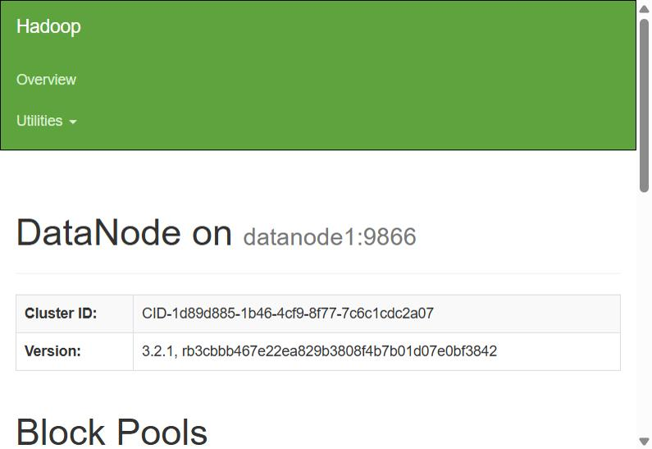
Figure 8: DataNode 1 Web UI
The DataNode UI is simpler than the NameNode UI. It shows:

Section | What It Shows
DataNode on hostname:port | Which DataNode this is and its data transfer port (9866)
Cluster ID | Must match the NameNode's Cluster ID. If different, this node cannot join the cluster.
Version | Hadoop version (should match NameNode: 3.2.1)
Block Pools | Shows the block pool(s) this DataNode serves, how many blocks it holds, and disk usage per pool. Should show 20 blocks matching the NameNode's count.

The DataNode also has a Utilities dropdown with access to logs and configuration, similar to the NameNode.

When to check DataNode UIs:
- If the NameNode shows a Dead Node — check if that DataNode's UI is reachable
- To verify block counts match across all 3 DataNodes (replication=3 means all should have the same block count)
- To check disk usage on individual nodes

6. Quick Reference — Port Map
Bookmark these URLs. They are your window into the cluster.

Port | Service | URL | When Available
9870 | HDFS NameNode Web UI | http://localhost:9870 | Always (cluster up)
9000 | HDFS RPC (not web) | hdfs://namenode:9000 | Internal only
8080 | Spark Master Web UI | http://localhost:8080 | Always (cluster up)
4040 | Spark Application UI | http://localhost:4040 | Only during a job
7077 | Spark Master RPC | spark://spark-master:7077 | Internal only
9864 | DataNode 1 | http://localhost:9864 | Always (cluster up)
9865 | DataNode 2 | http://localhost:9865 | Always (cluster up)
9866 | DataNode 3 | http://localhost:9866 | Always (cluster up)
8501 | Streamlit Dashboard | http://localhost:8501 | After streamlit run

Commands to remember:
- Start cluster: docker-compose up -d
- Stop cluster: docker-compose down
- Check containers: docker ps
- Run a Spark script: docker exec spark-master /spark/bin/spark-shell -i /project/<path>.scala
- Start dashboard: streamlit run 08_dashboard/app.py

