NeuroTraffic
Hadoop & Spark Web UIs — a guided tour of every screen and every number
NameNode · DataNodes · Spark Master · Spark Application UI · Structured Streaming
Screenshots captured from the live cluster on 15 October 2026, around 12:35 IST,
while the live streaming pipeline (live_pipeline.scala) was running.

Contents
Contents 2
1. Before you start: the cluster and its web UIs 3
1.1 Where each UI lives 3
1.2 The cluster behind the pages 3
2. HDFS NameNode UI (port 9870) 4
2.1 Overview — identity of the cluster 4
2.2 Overview — journal and storage 7
2.3 Datanodes tab 8
2.4 Datanode Volume Failures and Snapshot 9
2.5 Startup Progress 10
2.6 Utilities → Browse the file system 11
3. DataNode UIs (ports 9864, 9865, 9866) 13
3.1 Comparing the three DataNodes 14
4. Spark Master UI (port 8080) 16
4.1 Application page on the Master 17
5. Spark Application UI (port 4040) 19
5.0 Job → Stage → Task: the three levels 19
5.1 Jobs tab 19
5.2 Details for one job (Job 1771) 21
5.3 Stages tab 22
5.4 Details for one stage (Stage 3352) 23
5.5 Storage tab 24
5.6 Environment tab 25
5.7 Executors tab 27
5.8 SQL / DataFrame tab 28
5.9 Query plan for one query (Query 1582) 29
5.10 Structured Streaming tab 32
5.11 Streaming Query Statistics 33
6. How the numbers connect 35
7. Health checklist: what good and bad look like 36
8. Glossary 37

1. Before you start: the cluster and its web UIs
Every big-data service in this project publishes a small website that shows what it is doing. Learning to read these pages is how you prove the cluster works, find problems, and explain the system in a viva. This guide walks through every page and explains each number: what it means, and why it has that value on your cluster right now.

1.1 Where each UI lives
UI | Address | What it is for
HDFS NameNode | http://localhost:9870 | The "index" of the distributed file system. Health of HDFS, all DataNodes, and a file browser.
DataNode 1 / 2 / 3 | http://localhost:9864, 9865, 9866 | One page per storage server: its disk, its blocks and its link to the NameNode.
Spark Master | http://localhost:8080 | The cluster manager: which workers exist, how many cores and how much memory are free, which applications are running.
Spark Application UI | http://localhost:4040 | Exists only while a Spark program runs (here: the live pipeline). Shows jobs, stages, tasks, memory, SQL plans and streaming statistics.
Spark Worker UIs | port 8081 inside Docker | Not reachable from Windows because docker-compose.yml does not publish port 8081. Everything they show is also visible on the Master and Executors pages.

1.2 The cluster behind the pages
- 1 NameNode + 3 DataNodes (Hadoop 3.2.1) form HDFS. Replication factor is 3 and block size is 128 MB (set in hadoop.env).
- 1 Spark Master + 2 Spark Workers (Spark 3.3.0). Each worker offers 2 cores and 4 GB (set in docker-compose.yml).
- All containers share one Docker network (hadoop_net) and one virtual disk inside Docker Desktop.
- At capture time the live pipeline was running: realtime_fetcher.py wrote a JSON batch for 263 zones to HDFS every ~10 s, and live_pipeline.scala processed new batches every 15 s, writing latest.csv and live_history.csv.

Two clocks on the same screens
Hadoop pages print times in your browser's time zone (India, +0530). Spark containers run in UTC, so Spark pages show times 5 h 30 min earlier. Example: a job "Submitted 2026/10/15 07:05:17" on a Spark page is 12:35:17 IST. The task table on a Stage page is converted by the browser, so it shows 12:35:17 for the same moment.

Numbers move while you watch
Because the pipeline creates, rewrites and deletes files every few seconds, counts such as blocks, files and transaction IDs change between screenshots taken a few seconds apart. That is normal and is itself a sign that the cluster is alive.

2. HDFS NameNode UI (port 9870)
The NameNode stores the metadata of HDFS: the folder tree, file names, which blocks make up each file, and where every block replica lives. It does not store file contents; the DataNodes do. Tabs across the green bar: Overview, Datanodes, Datanode Volume Failures, Snapshot, Startup Progress and Utilities.

2.1 Overview — identity of the cluster
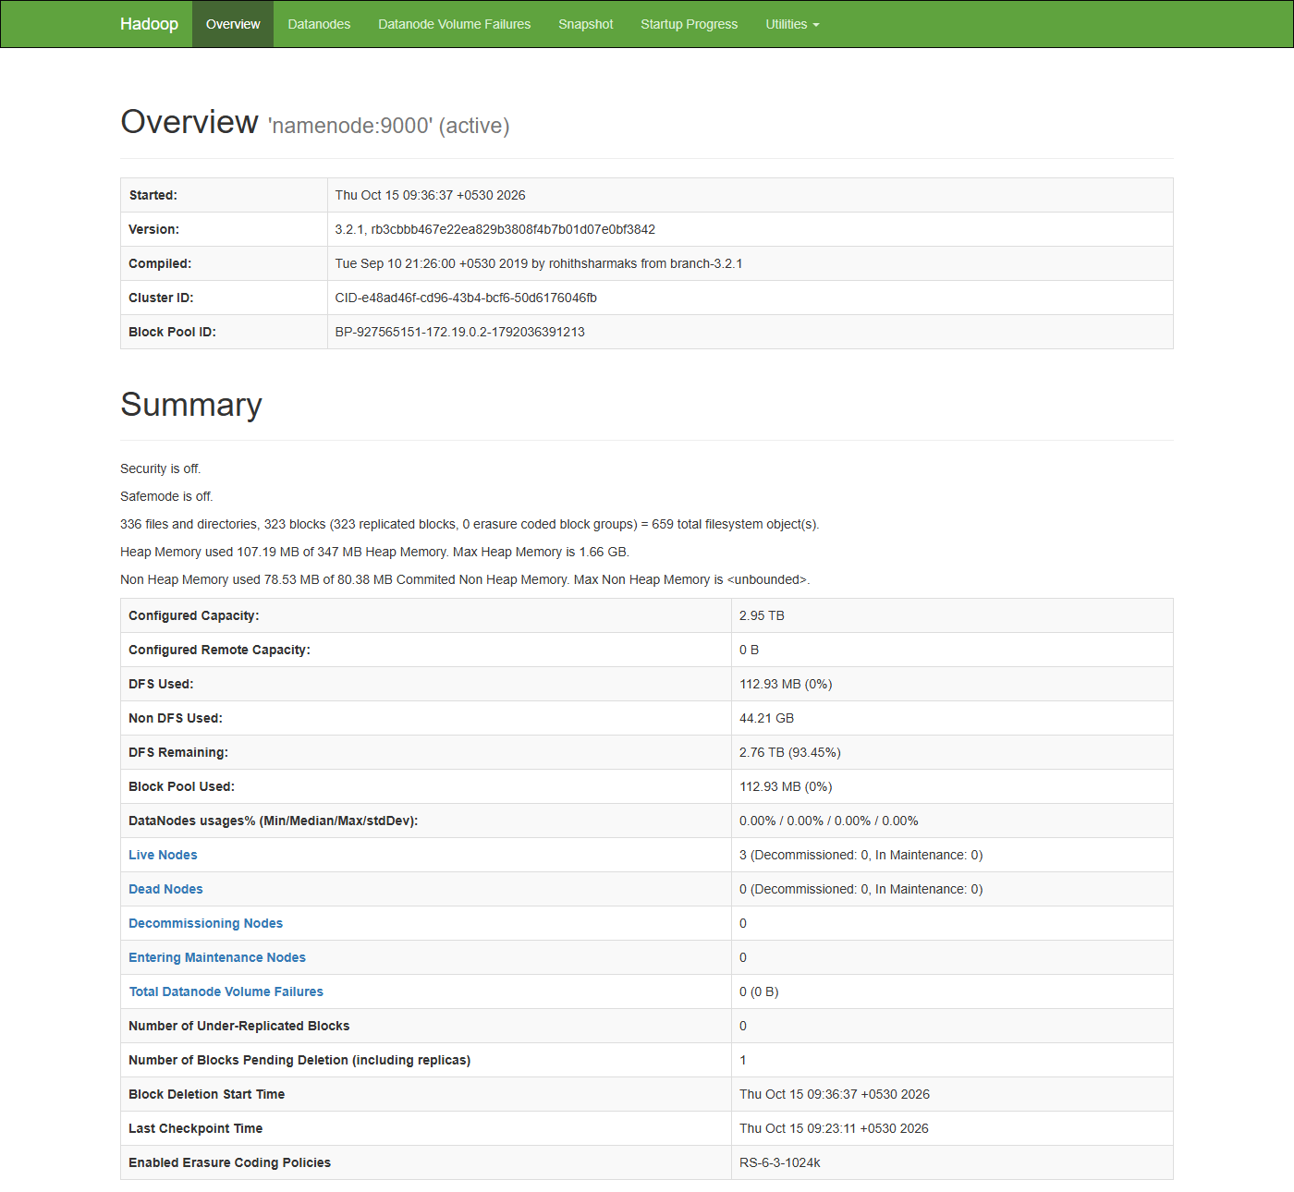
Figure 1 — NameNode Overview: identity block and Summary
What you see | Value here | What it means and why it has this value
Overview 'namenode:9000' (active) | namenode:9000 | The NameNode's RPC address. Clients (Spark, hdfs dfs) talk to it on port 9000. "active" means it is the one serving requests (there is no standby NameNode in this cluster).
Started | Thu Oct 15 09:36:37 +0530 2026 | When the NameNode process last started: the docker compose up -d after the Docker Desktop restart this morning.
Version / Compiled | 3.2.1, 2019 | Hadoop version inside the bde2020 image and when that build was made. Every DataNode must run a compatible version (theirs is also 3.2.1).
Cluster ID | CID-e48ad46f-… | Created when HDFS is formatted. DataNodes refuse to join a NameNode with a different Cluster ID. It is new today because the HDFS volumes were recreated, which is why HDFS started empty.
Block Pool ID | BP-927565151-172.19.0.2-1792036391213 | Name of this namespace's set of blocks: random number, NameNode IP (172.19.0.2) and creation time in milliseconds since 1970 (1792036391213 = 15 Oct 2026 09:23 IST, the format time).

Summary section
What you see | Value here | What it means and why it has this value
Security is off | — | No Kerberos authentication. Normal for a local project; production clusters turn it on.
Safemode is off | — | Safe mode is a read-only state right after start-up while the NameNode waits for DataNodes to report their blocks. "off" = HDFS accepts writes.
336 files and directories, 323 blocks = 659 total filesystem objects | 659 | Objects the NameNode keeps in memory: 336 files+folders plus 323 blocks (the same 323 blocks each DataNode holds on the Datanodes tab). Every small file needs at least one block, so many tiny files cost NameNode memory (the "small files problem"). Most of these are dashboard files, lookups and Spark streaming checkpoint files.
Heap Memory used 107.19 MB of 347 MB. Max 1.66 GB | 107.19 MB | Java memory used by the NameNode to hold the file tree and block map. 347 MB is what the JVM has reserved so far; 1.66 GB is the most it may grow to (a quarter of the memory Docker gives the container, the Java default).
Non Heap Memory used 78.53 MB | 78.53 MB | Memory for the JVM itself (loaded classes, compiled code). Not related to your data.
Configured Capacity | 2.95 TB | Sum of the disk capacity reported by the 3 DataNodes: 3 × 1006.85 GB. All three containers live on the same Docker Desktop virtual disk (~1 TB), so the same disk is counted three times. Real free space is about 940 GB, not 2.76 TB.
Configured Remote Capacity | 0 B | Capacity on remote/provided storage (cloud tiers). Not used.
DFS Used | 112.93 MB (0%) | Space taken by HDFS block files including all replicas: about 37.6 MB of real data × 3 copies.
Non DFS Used | 44.21 GB | Space on the same disk used by other things (Docker images, container files, logs). Calculated as Capacity − DFS Remaining − DFS Used.
DFS Remaining | 2.76 TB (93.45%) | Capacity still available for HDFS, again counting the shared disk three times.
Block Pool Used | 112.93 MB (0%) | Space used by this block pool. Same as DFS Used because there is only one namespace.
DataNodes usages% (Min/Median/Max/stdDev) | 0.00% / 0.00% / 0.00% / 0.00% | How full each DataNode is. All equal and near zero: the data is tiny and perfectly balanced, because replication 3 on 3 nodes puts a copy of every block on every node.
Live Nodes | 3 | DataNodes that sent a heartbeat recently. 3 of 3 = all healthy.
Dead Nodes | 0 | DataNodes silent for more than ~10.5 minutes. 0 is what you want.
Decommissioning / Entering Maintenance | 0 / 0 | Nodes being retired or paused by an administrator. Not used here.
Total Datanode Volume Failures | 0 (0 B) | Failed disks across DataNodes.
Number of Under-Replicated Blocks | 0 | Blocks with fewer than 3 copies. 0 means every block has its full 3 replicas. If a DataNode died this number would jump, and HDFS would copy blocks to restore 3 replicas.
Number of Blocks Pending Deletion | 1 | Block replicas the NameNode has told DataNodes to delete but that are not gone yet. The pipeline deletes processed input files and rewrites latest.csv and live_history.csv every batch, so there is always a small queue. Deletions are sent with the next heartbeats.
Block Deletion Start Time | 09:36:37 | After a restart the NameNode waits briefly before deleting anything (a safety delay); this is when deletions were allowed again.
Last Checkpoint Time | 09:23:11 | Last time the full metadata image (fsimage) was saved. Between checkpoints every change goes into the edit log. With no Secondary NameNode, checkpoints are rare; this one is from the format.
Enabled Erasure Coding Policies | RS-6-3-1024k | An alternative to 3× replication (Reed-Solomon: 6 data + 3 parity pieces). Enabled by default but unused; it would need at least 9 DataNodes.

2.2 Overview — journal and storage
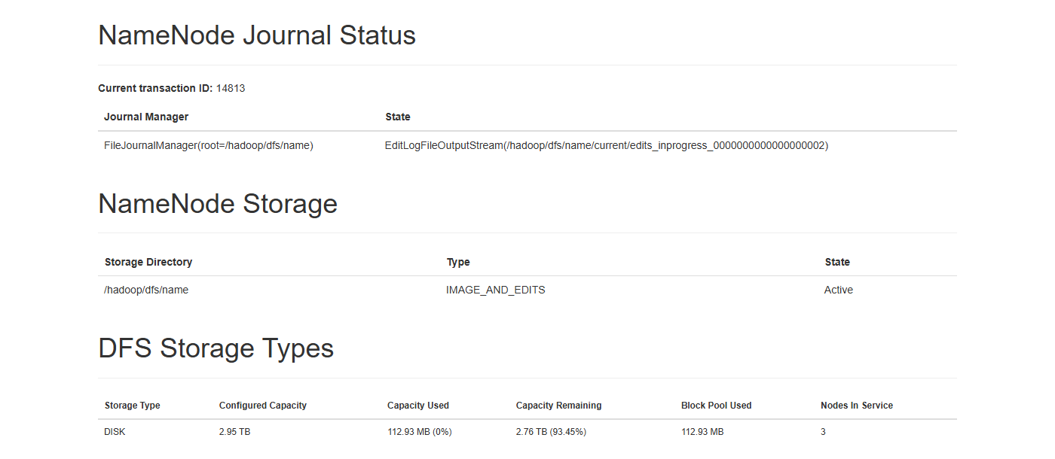
Figure 2 — NameNode Journal Status, NameNode Storage and DFS Storage Types
What you see | Value here | What it means and why it has this value
Current transaction ID | 14813 | Every change to the namespace (create, rename, delete, set permission) is a numbered transaction written to the edit log. It climbs quickly because the pipeline creates, renames and deletes files every few seconds.
Journal Manager / State | FileJournalManager(/hadoop/dfs/name) — edits_inprogress_…0002 | The edit log is a local file in the NameNode container (inside the namenode_data Docker volume). "in progress" is the file being appended to now.
NameNode Storage | /hadoop/dfs/name — IMAGE_AND_EDITS — Active | The folder holding both the fsimage (snapshot of metadata) and the edit logs. Losing this folder would lose all of HDFS, which is why it lives in a named volume.
DFS Storage Types | DISK, 2.95 TB, 112.93 MB used, 3 nodes in service | Breakdown by storage type (DISK, SSD, ARCHIVE…). Everything here is plain DISK on 3 nodes.

2.3 Datanodes tab
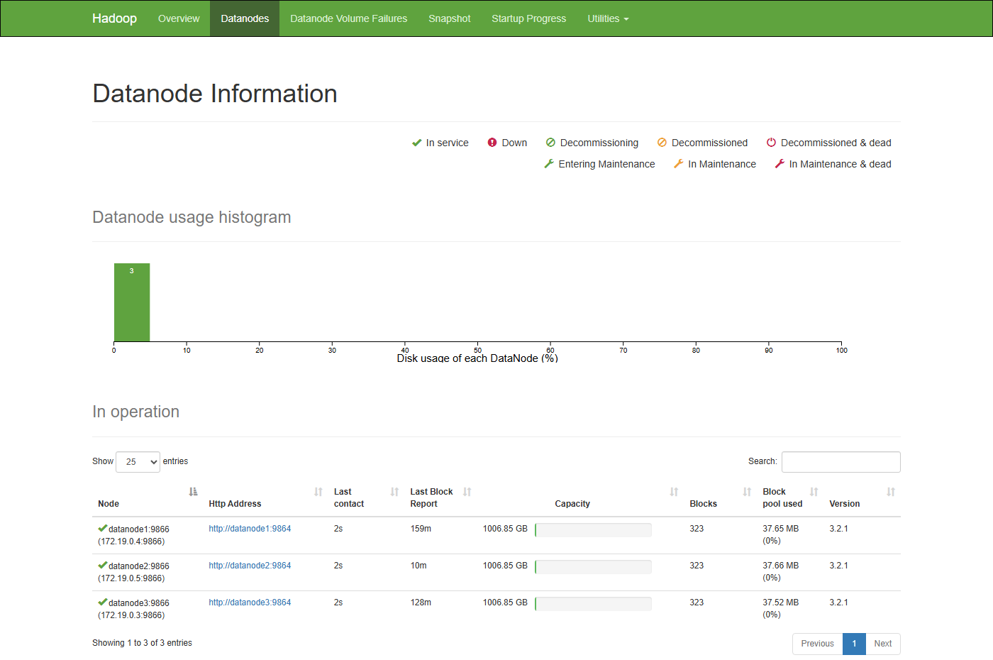
Figure 3 — Datanode Information: usage histogram and the In operation table
What you see | Value here | What it means and why it has this value
Legend icons | In service, Down, Decommissioning… | Status symbols used in the table. All three nodes show the green tick = In service.
Datanode usage histogram | one bar of 3 at 0–10% | Counts DataNodes by how full they are. A single bar means a balanced cluster. If one node were much fuller you would run the HDFS balancer.
Node | datanode1:9866 (172.19.0.4:9866) | Container name and IP on the Docker network. 9866 is the data transfer port (block reads/writes); the web UI is on 9864 inside the container.
Http Address | http://datanode1:9864 | Link to that DataNode's own page. It uses the container name, which Windows cannot resolve; open localhost:9864 / 9865 / 9866 instead (docker-compose maps them).
Last contact | 2s | Seconds since the last heartbeat. DataNodes send one every 3 seconds; after ~10.5 minutes of silence a node is marked dead.
Last Block Report | 159m / 10m / 128m | Minutes since each node sent its full list of blocks. Full reports happen every 6 hours by default; between them, small incremental reports are sent immediately when blocks are added or removed.
Capacity | 1006.85 GB each | Disk size each DataNode sees. Identical because all three share the Docker Desktop disk.
Blocks | 323 each | Block replicas on each node. Equal on all three because replication = 3 with exactly 3 nodes: every block must be on every node.
Block pool used | 37.65 / 37.66 / 37.52 MB (0%) | HDFS data stored by each node ≈ one full copy of all data. Tiny differences come from deletions still in progress.
Version | 3.2.1 | Hadoop version of each DataNode.
Entering Maintenance / Decommissioning | No nodes | No administrator operations in progress.

2.4 Datanode Volume Failures and Snapshot
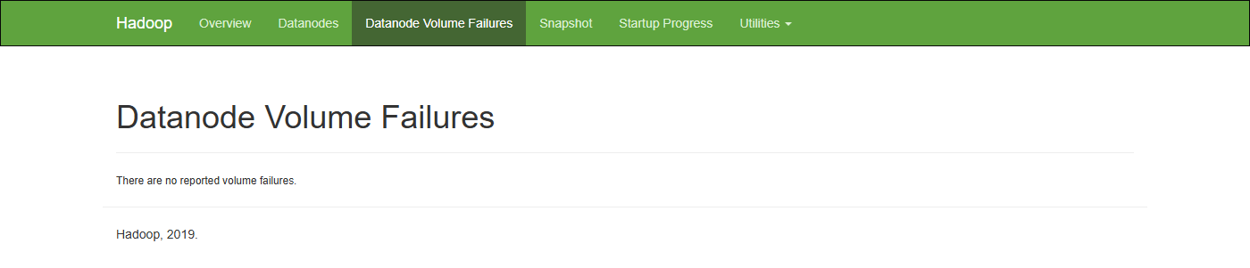
Figure 4 — No reported volume failures
Datanode Volume Failures lists broken disks per DataNode. "There are no reported volume failures" is the healthy state. Each DataNode has a single volume (/hadoop/dfs/data).
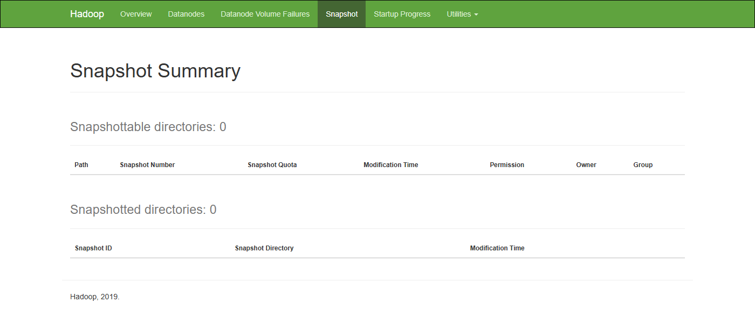
Figure 5 — Snapshot Summary
Snapshots are read-only, point-in-time copies of an HDFS folder (useful for backups or undoing mistakes). A folder must first be made "snapshottable" by an administrator (hdfs dfsadmin -allowSnapshot <path>). Snapshottable directories: 0 and Snapshotted directories: 0 mean the feature is not used in this project.

2.5 Startup Progress
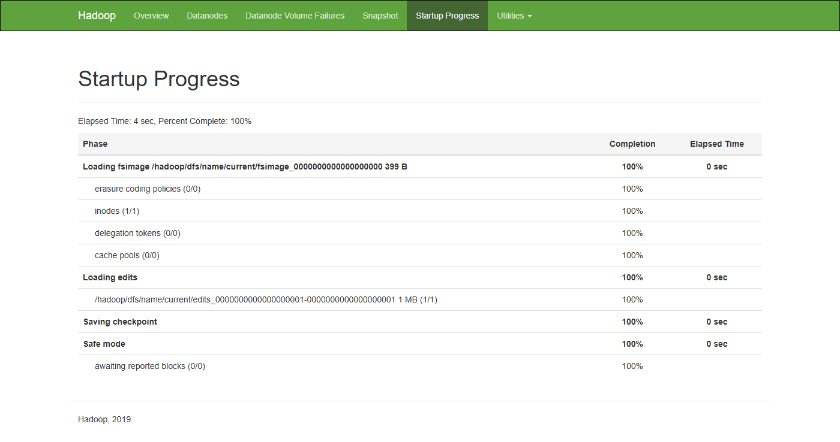
Figure 6 — What the NameNode did when it started
What you see | Value here | What it means and why it has this value
Elapsed Time / Percent Complete | 4 sec, 100% | The whole start-up took 4 seconds because HDFS was almost empty.
Loading fsimage … 399 B | 100%, 0 sec | Step 1: read the last saved metadata image. 399 bytes = essentially an empty file system (just the format).
inodes (1/1) | 1 | Number of files/folders in that image: only the root folder "/".
erasure coding policies, delegation tokens, cache pools | 0/0 | Other metadata in the image; none exist.
Loading edits … 1 MB (1/1) | 100% | Step 2: replay the edit log written since that image (all changes made after the format), rebuilding the current tree.
Saving checkpoint | 100% | Step 3: write a fresh fsimage that includes those edits.
Safe mode — awaiting reported blocks (0/0) | 100% | Step 4: wait until enough DataNodes report their blocks, then leave safe mode. This is what hdfs dfsadmin -safemode wait waited for before data was loaded.

2.6 Utilities → Browse the file system
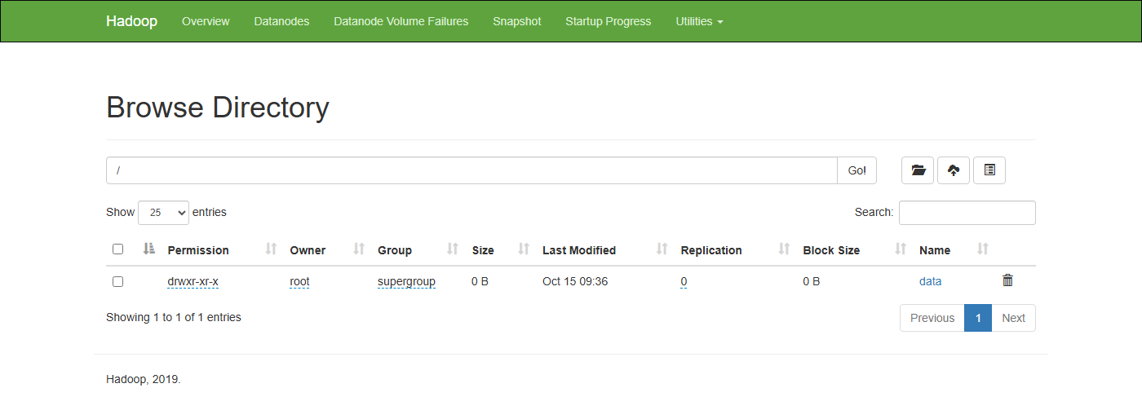
Figure 7 — The root folder of HDFS
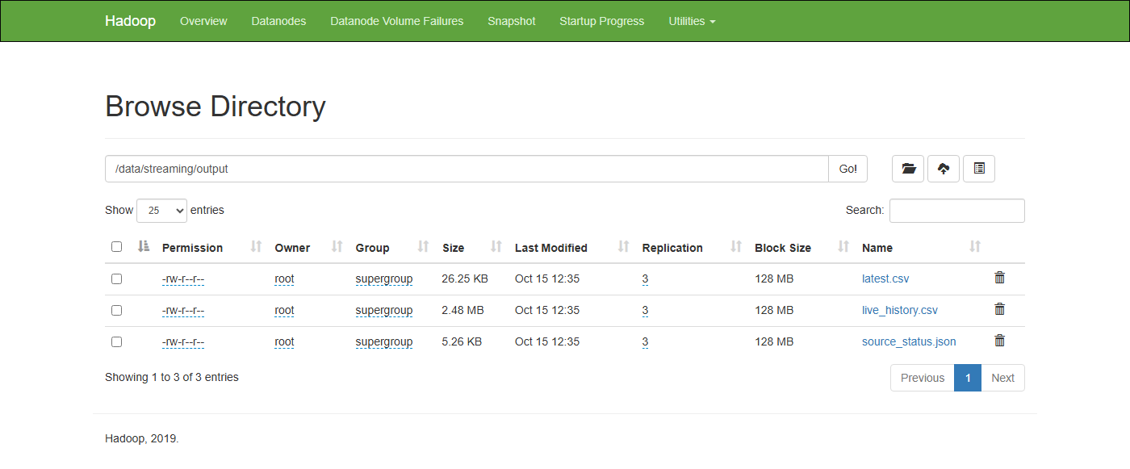
Figure 8 — /data/streaming/output, written by the live pipeline
What you see | Value here | What it means and why it has this value
Permission | drwxr-xr-x / -rw-r--r-- | Unix-style permissions. d = directory. rw- for the owner, r-- for the group and others. (Permission checks are switched off in hadoop.env, so they are informative only.)
Owner / Group | root / supergroup | Spark inside the container runs as root, so files it writes belong to root.
Size | 26.25 KB, 2.48 MB, 5.26 KB | latest.csv: one row for each of the 263 zones (~100 bytes per row). live_history.csv: one snapshot per minute for the last 24 h, so it grows during the day and stops growing after 24 h. source_status.json: freshness of each live data source, written by the fetcher.
Last Modified | Oct 15 12:35 | All three were rewritten seconds ago: proof that the fetcher and pipeline are running.
Replication | 3 (files) / 0 (folders) | Number of copies of each block. Folders have no blocks, so 0.
Block Size | 128 MB | The maximum size of one block. A 26 KB file still uses one block but only 26 KB of disk; HDFS does not pad blocks.
Name / bin icon | latest.csv … | Click a name to see its blocks and which DataNodes hold them, or to download it. The bin icon deletes.
The Utilities menu also offers Logs (NameNode log files), Log Level, Metrics (raw JMX numbers as JSON) and Configuration (the live hdfs-site and core-site values).

3. DataNode UIs (ports 9864, 9865, 9866)
Each DataNode has its own small page. Docker maps the same internal port (9864) of each container to a different Windows port, which is why you open three different ports to see the three nodes.
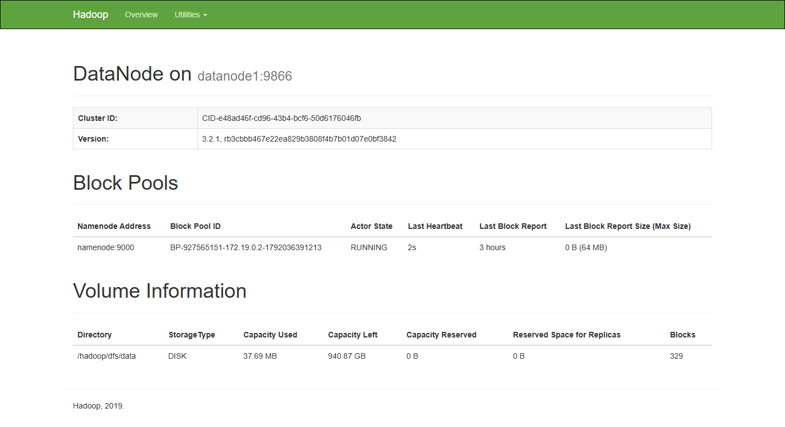
Figure 9 — DataNode 1 (http://localhost:9864)
What you see | Value here | What it means and why it has this value
DataNode on | datanode1:9866 | Container name and data-transfer port of this node.
Cluster ID | CID-e48ad46f-… | Must equal the NameNode's Cluster ID (it does). A mismatch, e.g. after formatting the NameNode but keeping old DataNode volumes, stops the node from joining.
Namenode Address | namenode:9000 | The NameNode this DataNode reports to.
Block Pool ID | BP-927565151-… | The same block pool as on the NameNode Overview page.
Actor State | RUNNING | The DataNode's connection to that NameNode is active.
Last Heartbeat | 2s | Seconds since the last heartbeat it sent (every 3 s).
Last Block Report | 3 hours | Time since its last full block report (sent at start-up, then every 6 hours).
Last Block Report Size (Max Size) | 0 B (64 MB) | Size of that full report. 0 B because when it was sent, right after start-up, HDFS held no blocks yet. 64 MB is the maximum message size the NameNode accepts.
Directory / StorageType | /hadoop/dfs/data — DISK | Where block files are stored inside the container (the datanode1_data Docker volume).
Capacity Used | 37.69 MB | Block data on this node = one full copy of all HDFS data.
Capacity Left | 940.87 GB | Free space on the shared Docker disk (1006.85 GB minus the 44 GB used by other things and the HDFS data).
Capacity Reserved / Reserved Space for Replicas | 0 B / 0 B | Space kept back for non-HDFS use / for replicas currently being written. Nothing reserved.
Blocks | 329 | Block replicas stored on this node at that second.

3.1 Comparing the three DataNodes
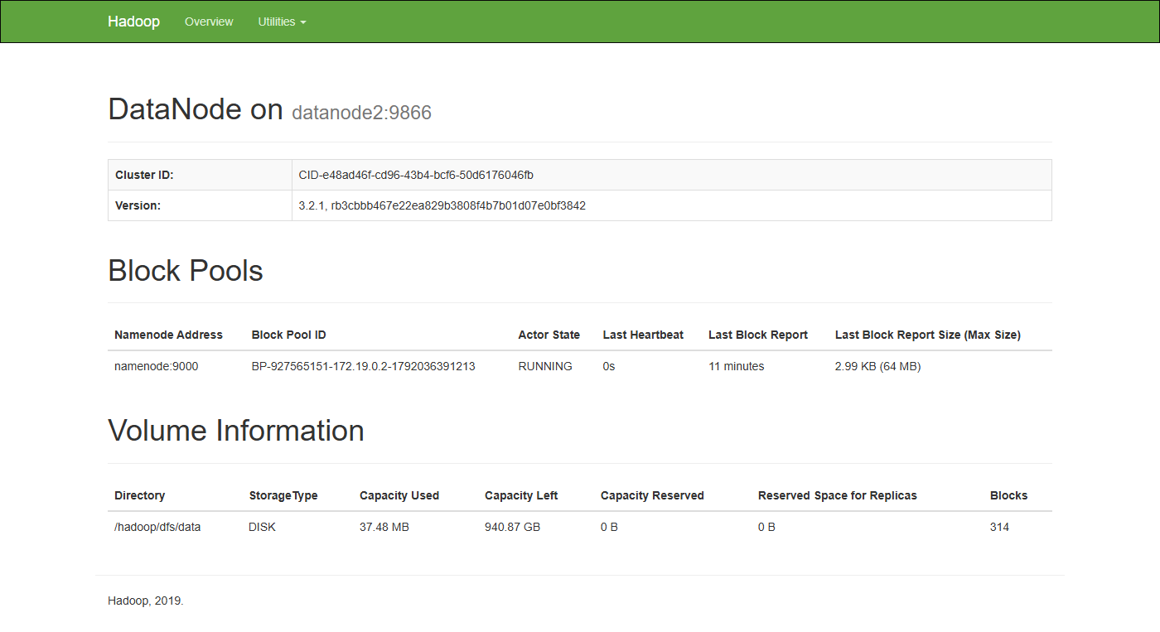
Figure 10 — DataNode 2 (http://localhost:9865)
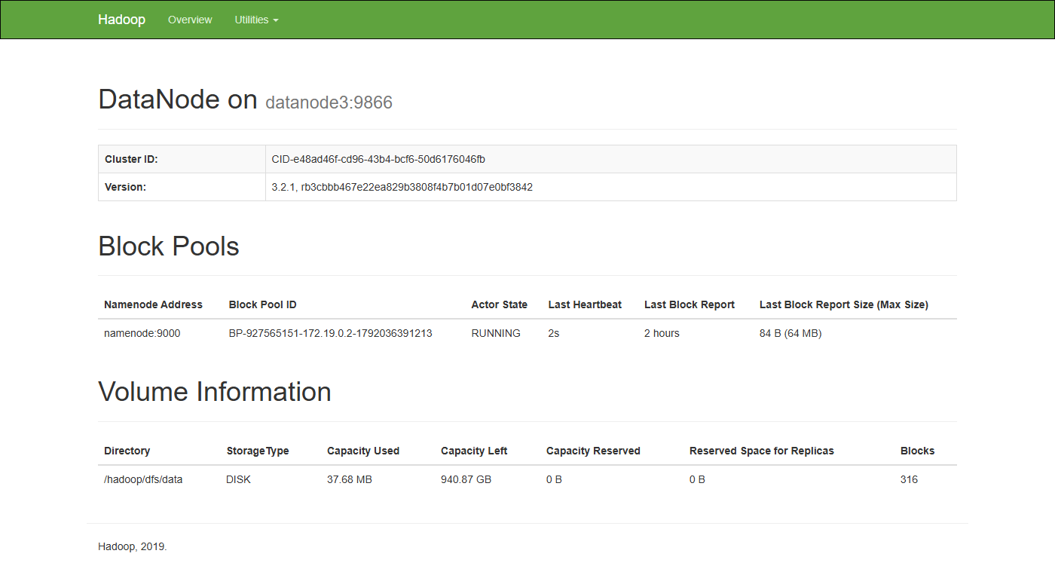
Figure 11 — DataNode 3 (http://localhost:9866)
Value | DataNode 1 | DataNode 2 | DataNode 3
Capacity Used | 37.69 MB | 37.48 MB | 37.68 MB
Blocks | 329 | 314 | 316
Last Block Report | 3 hours | 11 minutes | 2 hours
Last Block Report Size | 0 B | 2.99 KB | 84 B

Why the block counts differ (329 / 314 / 316) when replication 3 on 3 nodes should give equal numbers: each page was captured a few seconds apart, and in those seconds the pipeline created some files and deleted others. Deletions reach each node with its own heartbeat, so the counts drift and then converge. On the NameNode's Datanodes tab, captured in one go, all three showed 323. The full block report times also differ because each node's 6-hour timer started at a slightly different moment (DataNode 2 sent one 11 minutes ago, so its report size, 2.99 KB, describes today's files).

4. Spark Master UI (port 8080)
The Spark Master is the cluster manager in Spark's standalone mode. Workers register with it, and applications ask it for executors. It does not run your code; it only hands out resources.
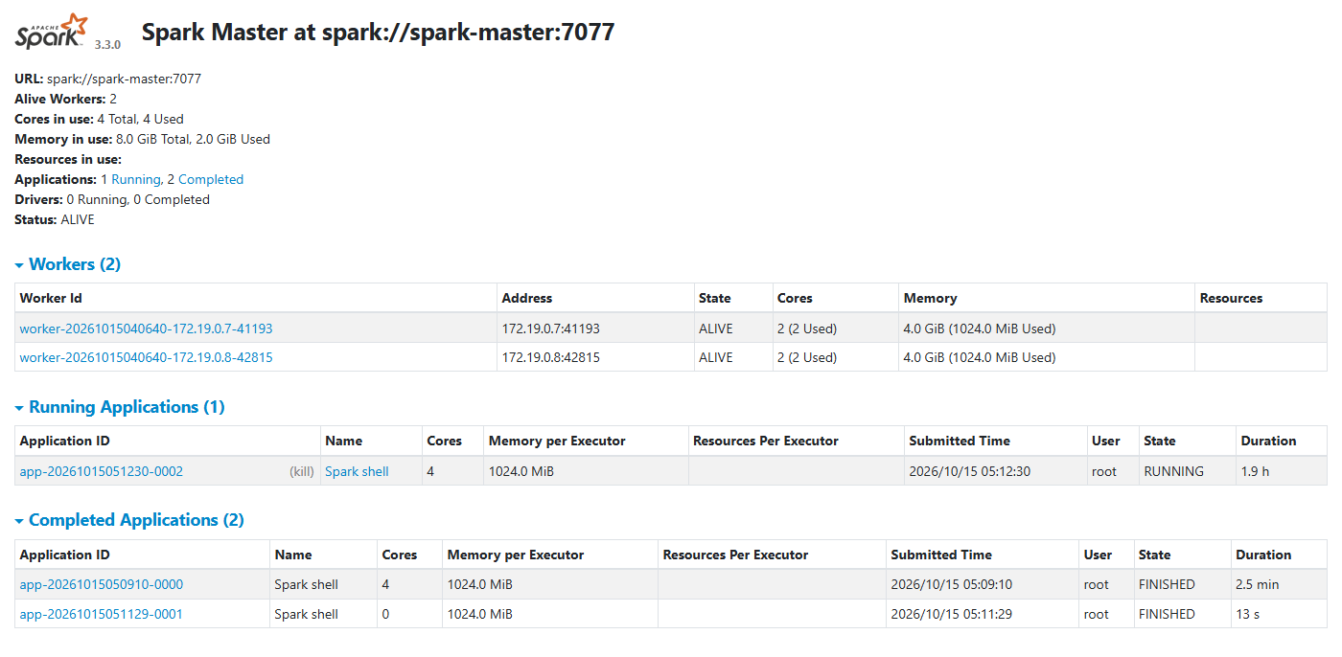
Figure 12 — Spark Master overview
What you see | Value here | What it means and why it has this value
URL | spark://spark-master:7077 | Address applications connect to (--master spark://spark-master:7077). Port 7077 is published, so it works from Windows too.
Alive Workers | 2 | spark-worker-1 and spark-worker-2 are registered and sending heartbeats.
Cores in use | 4 Total, 4 Used | Each worker offers 2 cores (SPARK_WORKER_CORES=2). The live pipeline holds all 4: an application takes every free core unless spark.cores.max is set.
Memory in use | 8.0 GiB Total, 2.0 GiB Used | Each worker offers 4 GiB (SPARK_WORKER_MEMORY=4g). Used = 2 executors × 1024 MiB, the default spark.executor.memory. 6 GiB is idle; a bigger job could ask for more.
Applications | 1 Running, 2 Completed | Running: the live pipeline. Completed: the two earlier starts of the pipeline that were stopped this morning.
Drivers | 0 Running, 0 Completed | Counts drivers launched *on* the cluster (cluster deploy mode). We use client mode: the driver runs inside the spark-shell process, so it is not counted here.
Status | ALIVE | The master is healthy.
Worker Id | worker-20261015040640-172.19.0.7-41193 | "worker" + start time in UTC (04:06:40 = 09:36:40 IST) + worker IP + port.
Workers: Cores / Memory | 2 (2 Used) / 4.0 GiB (1024.0 MiB Used) | Each worker runs one executor of the pipeline using both its cores and 1 GiB.
Running Applications | app-20261015051230-0002, Spark shell, 4 cores, 1024 MiB, 1.9 h | ID = "app" + submit time (UTC) + a counter (0002 = third app since the master started). Name is "Spark shell" because it was started with spark-shell -i. Duration 1.9 h = running since 05:12 UTC.
Completed Applications | …0000 FINISHED 2.5 min; …0001 FINISHED 13 s with 0 cores | 0000 was the first pipeline run, stopped after 2.5 minutes. 0001 got 0 cores because 0000 was still holding all 4; it waited and was stopped after 13 s. This is how core starvation looks.

4.1 Application page on the Master
Clicking an application ID opens this page: the master's view of that application's executors.
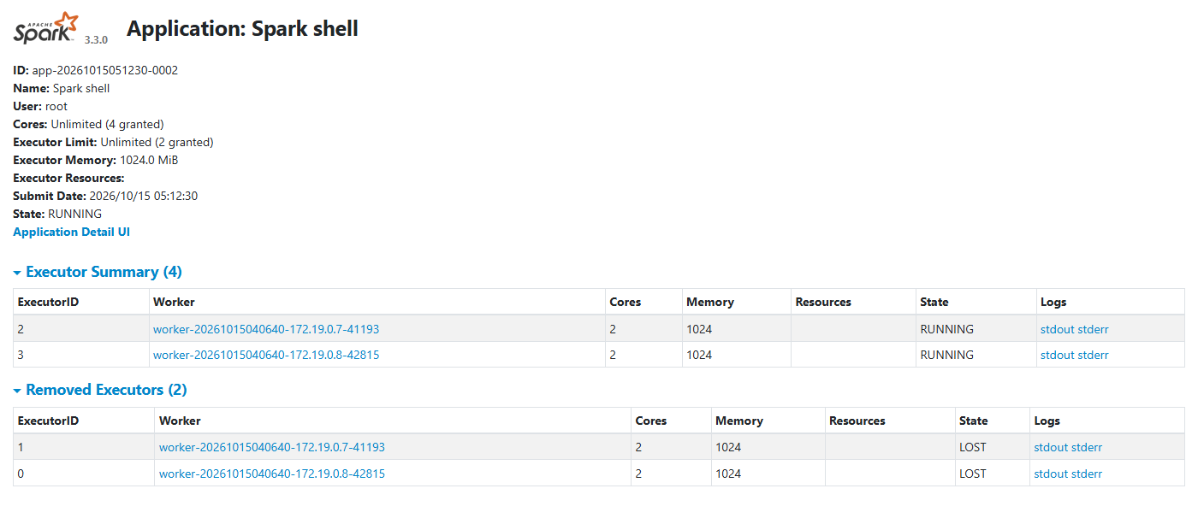
Figure 13 — The live pipeline as seen by the Spark Master
What you see | Value here | What it means and why it has this value
Cores | Unlimited (4 granted) | No cap was set, so the app received every free core: 4.
Executor Limit | Unlimited (2 granted) | One executor per worker: in standalone mode an executor takes all of a worker's free cores by default (2), so 2 workers give 2 executors.
Executor Memory | 1024.0 MiB | Heap size of each executor JVM (the default).
Submit Date / State | 2026/10/15 05:12:30 (UTC) / RUNNING | When the pipeline started; it is still running.
Application Detail UI | link | Opens the application's own UI (port 4040, chapter 5).
Executor Summary (4) | Executors 2 and 3 RUNNING | The executors working right now, one on each worker (172.19.0.7 and 172.19.0.8), each with 2 cores and 1024 MB.
Removed Executors (2) | Executors 0 and 1 — LOST | The first two executors of this app. The worker logs show they exited at 06:40 UTC (12:10 IST); the master immediately launched replacements (2 and 3) on the same workers. The streaming query kept going, which shows Spark's fault tolerance: executors are replaceable, and lost work is recomputed.
stdout / stderr | links | Each executor's console output and logs (served by the worker on port 8081, so these links do not open from Windows).

5. Spark Application UI (port 4040)
This UI belongs to one running application: the live pipeline started with spark-shell. It disappears when the application stops. Its tabs are Jobs, Stages, Storage, Environment, Executors, SQL / DataFrame and Structured Streaming.

5.0 Job → Stage → Task: the three levels
- Job: created every time your code calls an action (count(), write, collect(), isEmpty, head). One line such as latest.agg(max("anomaly_score")).head becomes one job.
- Stage: a job is cut into stages at every shuffle (when rows must move between machines, e.g. for groupBy, dropDuplicates, the final step of an aggregation).
- Task: a stage runs one task per partition of its data, in parallel on executor cores. Our pipeline sets spark.sql.shuffle.partitions = 4, so many stages have 4 tasks.

What one micro-batch of the pipeline produces
For each micro-batch, process() in live_pipeline.scala triggers several actions: batch.isEmpty, agg(max(timestamp)), writing latest.csv, agg(max(anomaly_score)), count(), and once a minute reading and rewriting live_history.csv. Plus Spark broadcasts the profile table for the join. So one micro-batch creates about 6–8 jobs, each with 1–3 stages.

5.1 Jobs tab
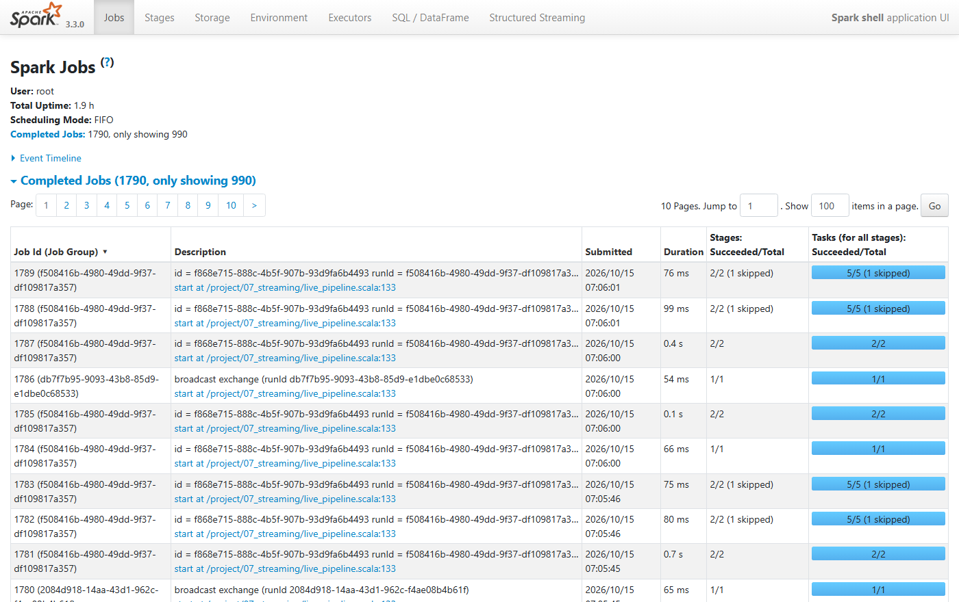
Figure 14 — Spark Jobs (top of the list)
What you see | Value here | What it means and why it has this value
User | root | OS user running the driver inside the container.
Total Uptime | 1.9 h | Time since the application started.
Scheduling Mode | FIFO | Jobs run first-in-first-out. (FAIR mode would share executors between parallel jobs.)
Completed Jobs | 1790, only showing 990 | Total jobs since start. The UI keeps only about the last 1000 (spark.ui.retainedJobs) to save driver memory; older ones are dropped from the page.
Event Timeline | collapsed | Click it for a time chart of when jobs and executors started and ended.
Job Id (Job Group) | 1789 (f508416b-…) | Job number and its group. The group is the streaming query's run ID, linking each job to the streaming query.
Description | id = f868e715… runId = f508416b… batch = 251 / broadcast exchange / start at live_pipeline.scala:133 | Which query and micro-batch caused the job. "broadcast exchange" jobs send the cached profile table (12,624 rows) to every executor for the join. Line 133 of live_pipeline.scala is .start(), where the streaming query begins.
Submitted | 2026/10/15 07:06:01 | UTC time; 12:36:01 IST.
Duration | 37 ms – 0.7 s | Tiny jobs on tiny data (263 zones). Most of the time is scheduling overhead, not computation.
Stages: Succeeded/Total | 2/2 (1 skipped) | The job had 3 stages; 2 ran and 1 was skipped because its output already existed (cached data or shuffle files from an earlier job in the same batch). Skipping is good: Spark avoids repeating work.
Tasks (for all stages): Succeeded/Total | 5/5 (1 skipped) | Total tasks of the stages that ran, e.g. 4 tasks + 1 task. The blue bar fills as tasks finish.

5.2 Details for one job (Job 1771)
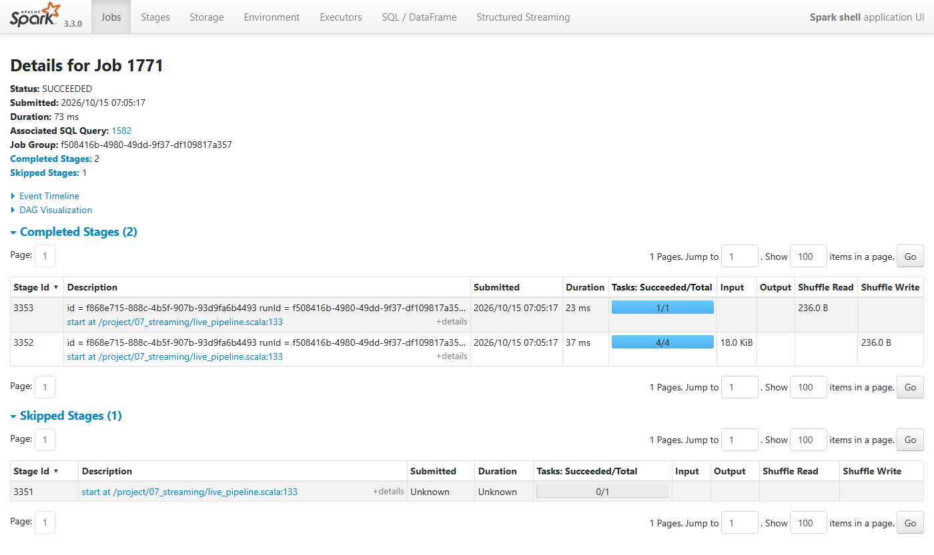
Figure 15 — Details for Job 1771
Job 1771 is the line val peak = latest.agg(max("anomaly_score")).head.getDouble(0) for micro-batch 247: find the highest anomaly score among the 263 zones.
What you see | Value here | What it means and why it has this value
Status / Duration | SUCCEEDED / 73 ms | Finished without errors in 73 milliseconds.
Associated SQL Query | 1582 | The DataFrame query that produced this job (see section 5.9).
Completed Stages | 2 | Stage 3352 (4 tasks) and stage 3353 (1 task).
Skipped Stages | 1 (stage 3351) | Building latest (filter, dedupe, join, score). It was already cached by .cache() in process(), so Spark skipped it.
Stage 3352: Input 18.0 KiB, Shuffle Write 236.0 B, 4 tasks | — | Each of the 4 cached partitions of latest is read and its own maximum is computed (a "partial aggregate"). The 4 partial results are written for the shuffle: 4 × 59 B = 236 B.
Stage 3353: Shuffle Read 236.0 B, 1 task | — | One task collects the 4 partial maxima and picks the overall maximum. Partial-then-final aggregation is how Spark computes max, sum and count without moving all rows to one place.
DAG Visualization | collapsed | Click to see these stages as a diagram.

5.3 Stages tab
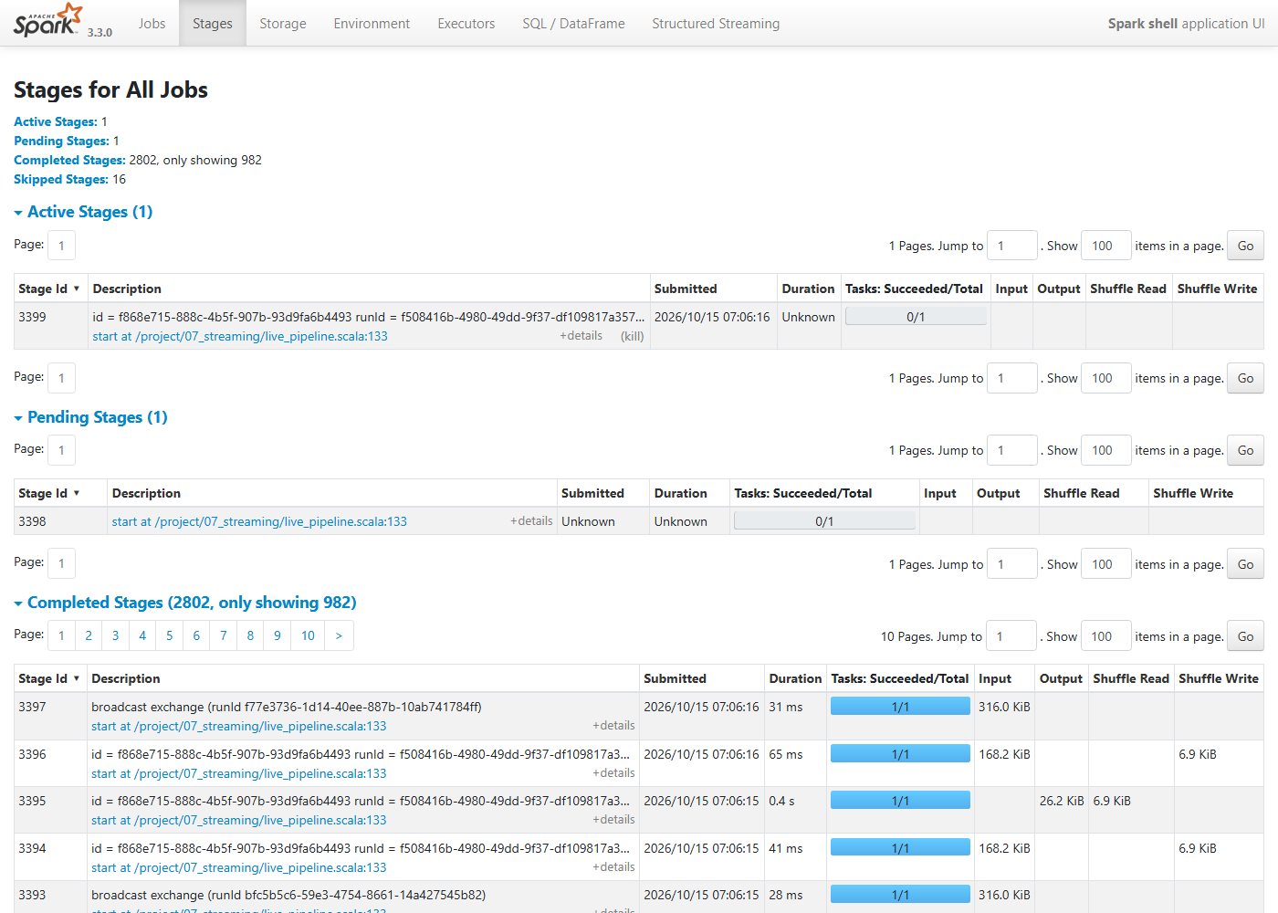
Figure 16 — Stages for All Jobs
What you see | Value here | What it means and why it has this value
Active Stages | 1 (stage 3399, 0/1 tasks) | A stage running at that instant: the next micro-batch had just started.
Pending Stages | 1 (stage 3398) | A stage waiting for the stage before it to finish.
Completed Stages | 2802, only showing 982 | All stages finished so far; the UI keeps about the last 1000.
Skipped Stages | 16 | Stages that did not need to run because their results were reused.
broadcast exchange … Input 316.0 KiB, 1/1 | stage 3397, 31 ms | Reads the cached profile (316 KiB in memory, see Storage) and broadcasts it for the join.
Input 168.2 KiB, Shuffle Write 6.9 KiB | stage 3396 / 3394 | Reads the new JSON micro-batch from HDFS (~168 KB = two fetcher files of 263 zones) and shuffles the reduced rows (6.9 KB) for dropDuplicates("zone_id").
Output 26.2 KiB, Shuffle Read 6.9 KiB | stage 3395, 0.4 s | Writes latest.csv. 26.2 KiB is exactly the size of latest.csv in the HDFS browser (Figure 8): you can trace a file from the Spark UI to HDFS.

5.4 Details for one stage (Stage 3352)
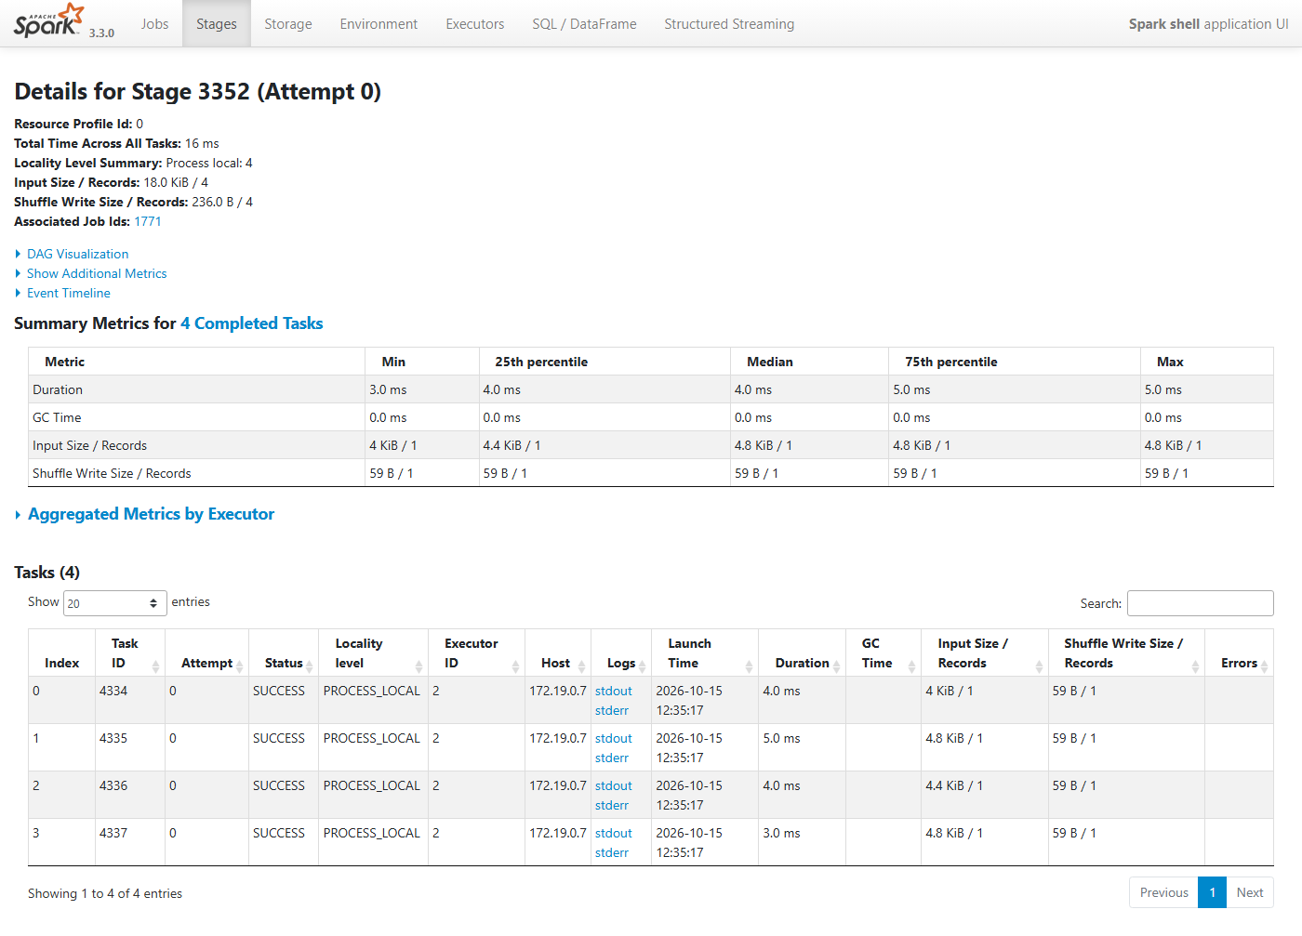
Figure 17 — Details for Stage 3352: summary metrics and the 4 tasks
What you see | Value here | What it means and why it has this value
Total Time Across All Tasks | 16 ms | Sum of the 4 task durations (3 + 4 + 4 + 5 ms). The stage took less wall-clock time because the tasks ran in parallel.
Locality Level Summary | Process local: 4 | All 4 tasks ran in the same executor process that holds their cached data, the best possible locality (no network transfer). The levels are PROCESS_LOCAL > NODE_LOCAL > RACK_LOCAL > ANY.
Input Size / Records | 18.0 KiB / 4 | 4 cached partitions. A cached DataFrame is stored as compressed column batches, and each partition is one batch, so Spark counts 1 "record" per partition, even though they hold 263 rows in total.
Shuffle Write Size / Records | 236.0 B / 4 | 4 partial maxima, 59 bytes each.
Summary Metrics: Min / 25th percentile / Median / 75th / Max | Duration 3.0 – 5.0 ms; GC 0 ms | Distribution over the tasks. The key use is spotting skew: if Max were far above the Median, one partition would hold much more data than the others. Here they are even.
GC Time | 0 ms | Java garbage collection during the tasks. High GC time means executors are short of memory.
Tasks table: Index / Task ID / Attempt | 0–3 / 4334–4337 / 0 | Index = partition number in this stage. Task ID = global counter since the app started (4,334 tasks before these). Attempt 0 = first try (a failed task is retried as attempt 1).
Status / Executor ID / Host | SUCCESS / 2 / 172.19.0.7 | All 4 ran on executor 2 on spark-worker-1, where the cached partitions live.
Launch Time | 2026-10-15 12:35:17 | Shown in IST by the browser (UTC 07:05:17).
Errors | empty | No failures.

5.5 Storage tab
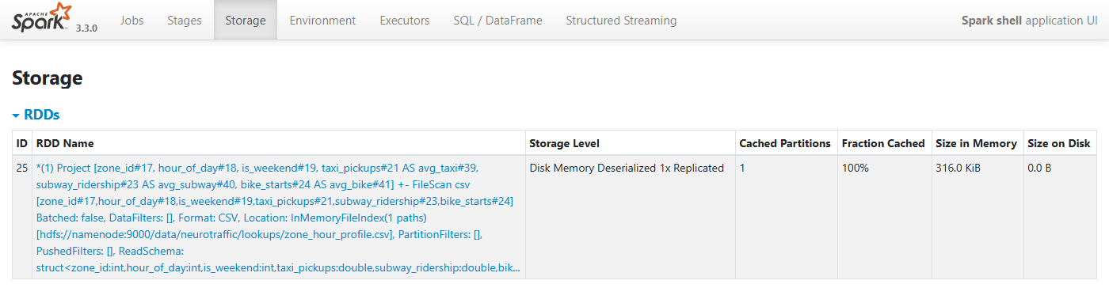
Figure 18 — Cached data
What you see | Value here | What it means and why it has this value
ID / RDD Name | 25 — Project [zone_id, hour_of_day, is_weekend, taxi_pickups AS avg_taxi …] FileScan csv … zone_hour_profile.csv | The cached profile table: the .cache() on profile in live_pipeline.scala. The name is the query plan that produced it.
Storage Level | Disk Memory Deserialized 1x Replicated | DataFrame .cache() default (MEMORY_AND_DISK): kept in memory as Java objects; spills to disk only if memory runs out; one copy.
Cached Partitions | 1 | The 759 KB CSV fits in one partition.
Fraction Cached | 100% | All of it is in memory.
Size in Memory / on Disk | 316.0 KiB / 0.0 B | Only the 6 columns we selected are kept, so it is smaller than the CSV file. Nothing spilled to disk.
The per-batch latest DataFrame is also cached, but latest.unpersist() frees it at the end of every batch, so it rarely appears here.

5.6 Environment tab
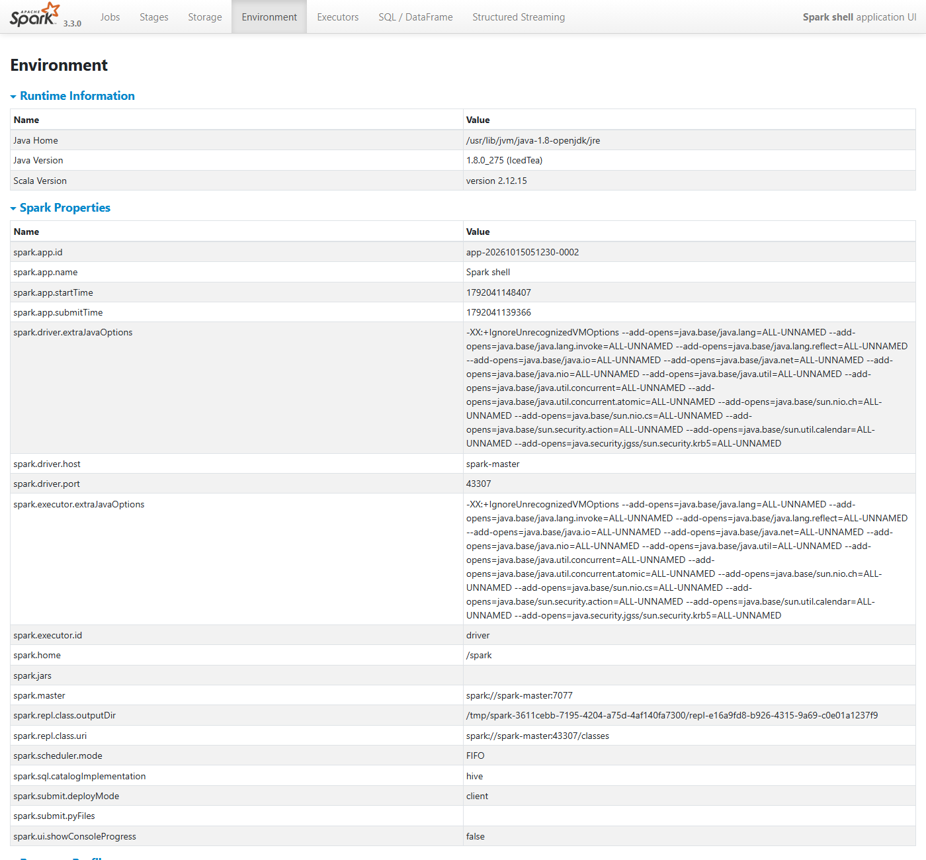
Figure 19 — Runtime information and Spark properties
What you see | Value here | What it means and why it has this value
Java Home / Java Version | /usr/lib/jvm/java-1.8-openjdk/jre / 1.8.0_275 | Java inside the container (Java 8). It is separate from Java 24 on Windows, which is why Windows Java does not matter for the pipeline.
Scala Version | 2.12.15 | Scala version Spark 3.3.0 was built with; your .scala scripts are compiled with it.
spark.app.id / spark.app.name | app-20261015051230-0002 / Spark shell | Same ID as on the Master page.
spark.app.startTime / submitTime | 1792041148407 / 1792041139366 | Milliseconds since 1970 (05:12:28 and 05:12:19 UTC). The 9 s gap is spark-shell starting up.
spark.driver.host / spark.driver.port | spark-master / 43307 | The driver runs in the spark-master container on a random port; executors connect back to it there.
spark.driver/executor.extraJavaOptions | --add-opens … | Java flags the image adds so Spark works on newer Java versions; harmless on Java 8.
spark.executor.id | driver | This page is served by the driver.
spark.home | /spark | Spark installation folder in the image.
spark.master | spark://spark-master:7077 | Cluster mode (from --master). With local[2] everything would run inside the driver.
spark.repl.class.outputDir / spark.repl.class.uri | /tmp/spark-… / spark://spark-master:43307/classes | spark-shell compiles each line of your script into classes; executors download them from the driver through this URI. That is how code typed into a REPL runs on remote executors.
spark.scheduler.mode | FIFO | Job scheduling order.
spark.sql.catalogImplementation | hive | Table catalog type (the image includes Hive support). We don't use tables, only files.
spark.submit.deployMode | client | The driver runs where you launched it (inside spark-shell), not on a worker.
spark.ui.showConsoleProgress | false | Set by our command (--conf spark.ui.showConsoleProgress=false) to hide the progress bars in the terminal.
Resource Profile 0 | Executor cores 1, memory 1024, offHeap 0; Task cpus 1.0 | Default resource request: each task needs 1 CPU. An executor with 2 cores can therefore run 2 tasks at once.
Hadoop / System Properties / Classpath Entries | collapsed | Every Hadoop setting, JVM property and JAR file in use. Useful when debugging configuration.
Note: spark.sql.shuffle.partitions = 4 does not appear in this list because the script sets it at run time with spark.conf.set(...); the list shows start-up properties.

5.7 Executors tab
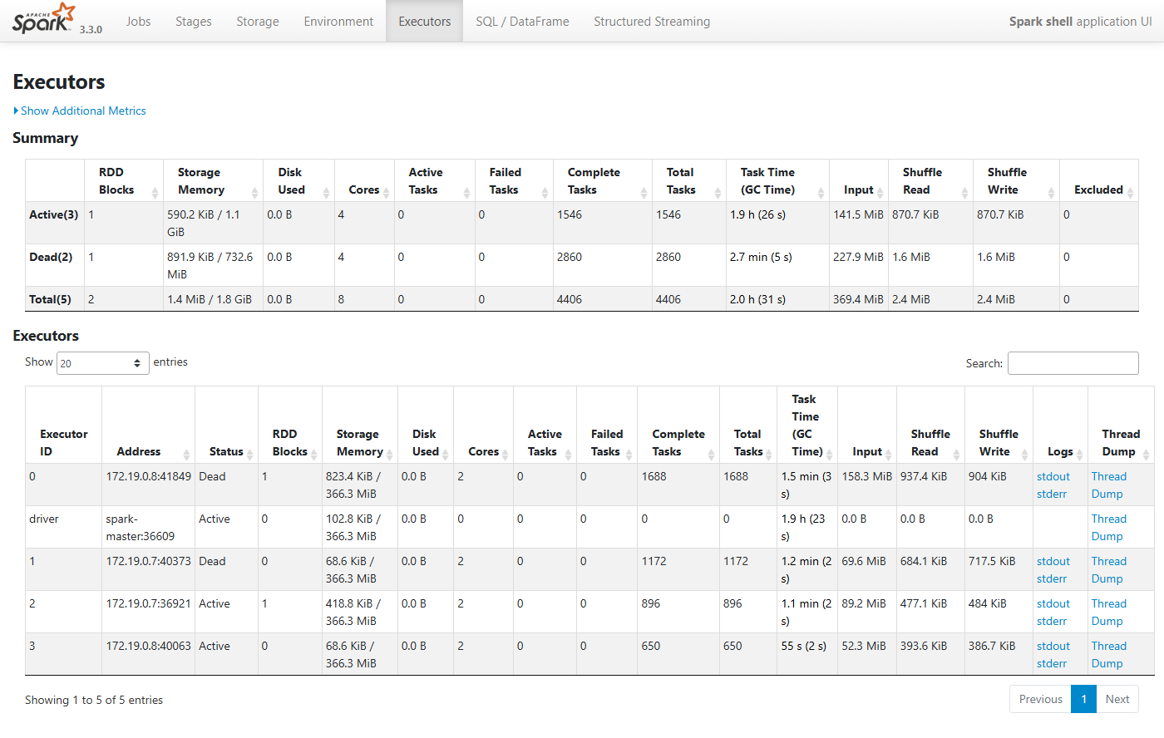
Figure 20 — Executors: the driver, two live executors and two dead ones
What you see | Value here | What it means and why it has this value
Summary: Active(3) | driver + executors 2 and 3 | The driver is counted as an executor, though it runs no tasks here.
Summary: Dead(2) | executors 0 and 1 | The executors replaced at 06:40 UTC (see 4.1). Their totals are kept for history.
RDD Blocks | 1 | Cached partitions held: the profile table (on executor 2; the dead executor 0 held it before).
Storage Memory | 590.2 KiB / 1.1 GiB (Active) | Cache memory used / available. Each JVM gets 366.3 MiB of "unified" memory for caching and computation: Java reports about 910 MiB usable out of the 1024 MiB heap, Spark keeps 300 MiB in reserve, and 60% of the rest is unified memory: (910 − 300) × 0.6 ≈ 366 MiB. 3 JVMs ≈ 1.1 GiB.
Disk Used | 0.0 B | Nothing spilled to disk.
Cores | 2 per executor, 0 for driver | Task slots.
Active / Failed / Complete / Total Tasks | 0 / 0 / 1546 / 1546 (Active) | No task has ever failed. 4,406 tasks in total across all 5 JVMs.
Task Time (GC Time) | Executor 2: 1.1 min (2 s) | Time spent running tasks, and how much of it was garbage collection (2%: healthy). The driver row shows 1.9 h (23 s) although it ran no tasks: Spark reports the driver's uptime and the driver JVM's GC time there, so it does not mean task work.
Input | 369.4 MiB total | Bytes read from sources over 2 hours: mostly the JSON micro-batches (~170 KB each) plus reading the history file every minute.
Shuffle Read / Write | 2.4 MiB total | Data moved between tasks. Very small because each batch has only 263 zones.
Excluded | 0 | Executors excluded for repeated failures (formerly called blacklisting).
Address | 172.19.0.7:36921 etc. | Executor IP (worker container) and the port its block manager uses.
Logs / Thread Dump | links | Logs are served by the worker (not reachable from Windows). Thread Dump shows what every thread is doing, which is useful if something hangs.

5.8 SQL / DataFrame tab
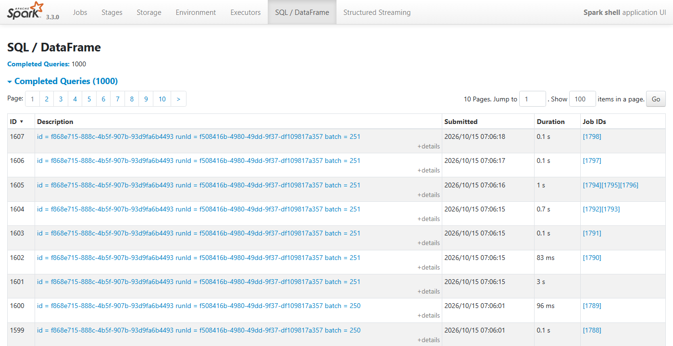
Figure 21 — Completed DataFrame queries
What you see | Value here | What it means and why it has this value
Completed Queries | 1000 | Every DataFrame action creates a "query execution". The UI keeps the last 1000 (spark.sql.ui.retainedExecutions).
Description | id = f868e715… runId = f508416b… batch = 251 | Each query belongs to a streaming micro-batch (batch 251 = the 252nd batch, counting from 0).
Rows with the same batch number | 7 queries for batch 251 | The actions inside one process() call: the micro-batch itself plus isEmpty, max(timestamp), write latest.csv, max(score), count, and the minute-by-minute history update.
Duration with no Job IDs | 1601: 3 s | The micro-batch as a whole (the foreachBatch wrapper). Its jobs are listed under the inner queries, so its own Job IDs column is empty; its duration covers all of them.
Job IDs | [1794][1795][1796] | Jobs that ran for that query; click to jump to them.

5.9 Query plan for one query (Query 1582)
This page draws the physical plan: the steps Spark actually executed, bottom to top. Query 1582 is the max(anomaly_score) of Job 1771.
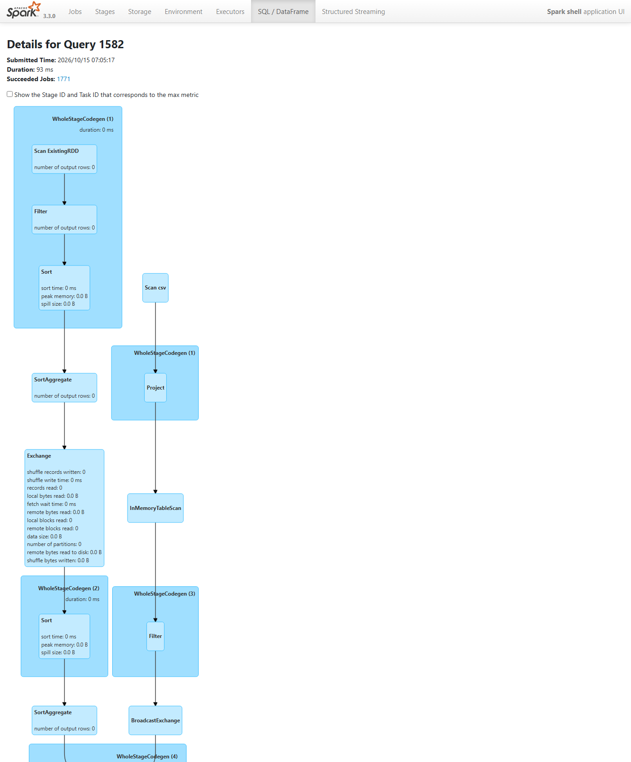
Figure 22 — Query 1582, upper part: how the cached `latest` DataFrame was built
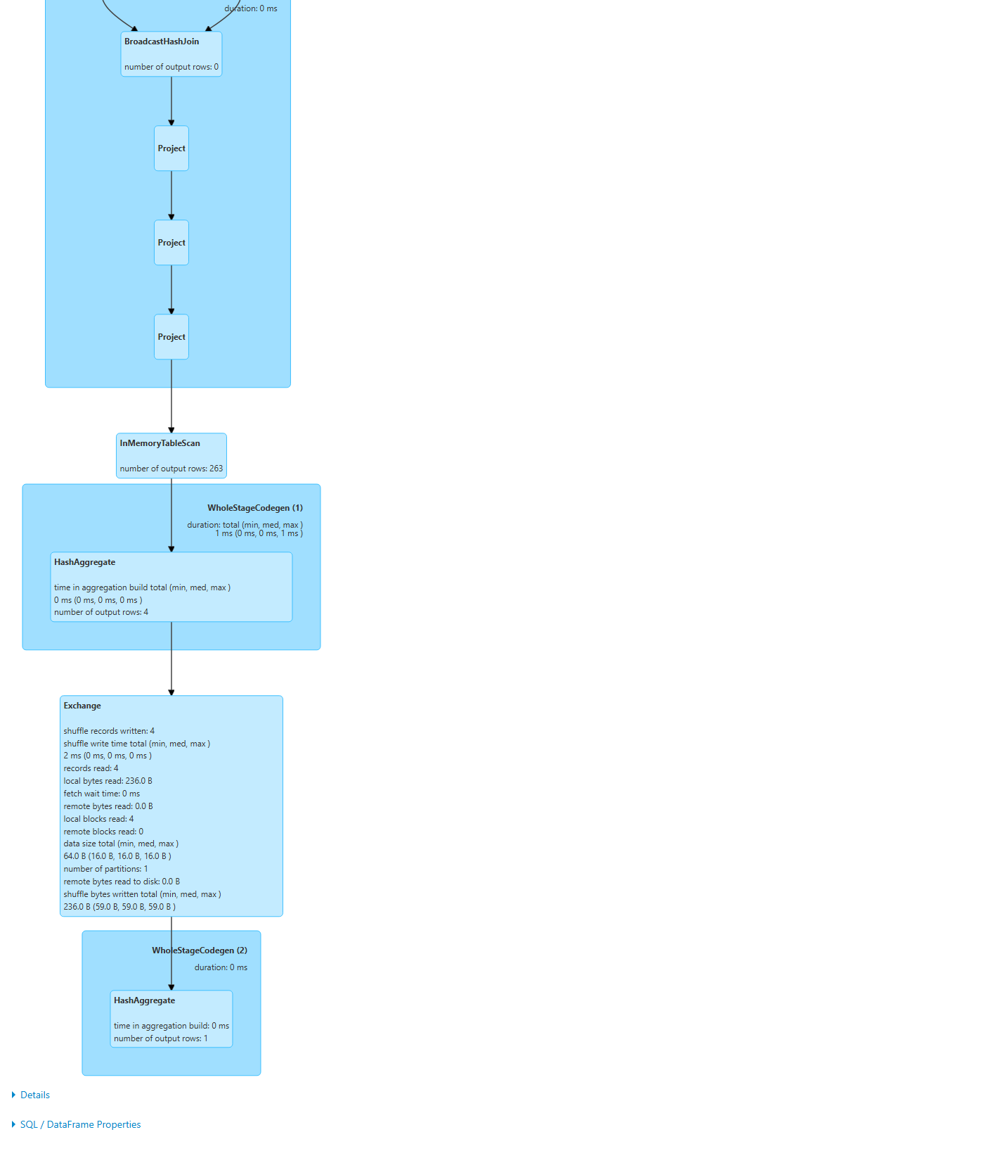
Figure 23 — Query 1582, lower part: reading the cache and computing the maximum
Upper part (Figure 22), with 0 rows on every box. These steps describe how latest was originally computed. In this query they did not run again, because latest was cached, which is why the counters are 0. Reading them from top to bottom (left branch):
- Scan ExistingRDD: the rows of the micro-batch handed to foreachBatch.
- Filter: keep only the newest timestamp (batch.filter(col("timestamp") === newest)).
- Sort → SortAggregate → Exchange → Sort → SortAggregate: dropDuplicates("zone_id"), done as a partial aggregate, a shuffle (Exchange) and a final aggregate.
- Right branch: Scan csv → Project → InMemoryTableScan → Filter → BroadcastExchange: the cached profile table, filtered and broadcast to every executor.
- BroadcastHashJoin: join each zone with its profile row without shuffling the big side; then three Project steps compute the z-scores, the anomaly score and the selected columns.
- WholeStageCodegen (n) boxes: Spark fused the steps inside each box into one generated Java function for speed.
Lower part (Figure 23), the steps that actually ran:
What you see | Value here | What it means and why it has this value
InMemoryTableScan | number of output rows: 263 | Reads the cached latest: one row per taxi zone (263).
HashAggregate (partial) | output rows: 4; duration 1 ms | Each of the 4 partitions computes its own maximum, giving 4 rows.
Exchange | shuffle records written 4; local bytes read 236.0 B; local blocks read 4; remote bytes read 0.0 B; number of partitions 1; data size 64.0 B | Moves the 4 partial results into 1 partition. All bytes were local (both tasks were on executor 2), so nothing crossed the network. 236 B = shuffle file size, 64 B = the data itself (4 × 16 B).
HashAggregate (final) | number of output rows: 1 | Combines the 4 partial maxima into the single answer, the peak score printed in the pipeline terminal.
Details / SQL / DataFrame Properties | collapsed | Text version of the plan and the SQL settings in force for this query.

5.10 Structured Streaming tab
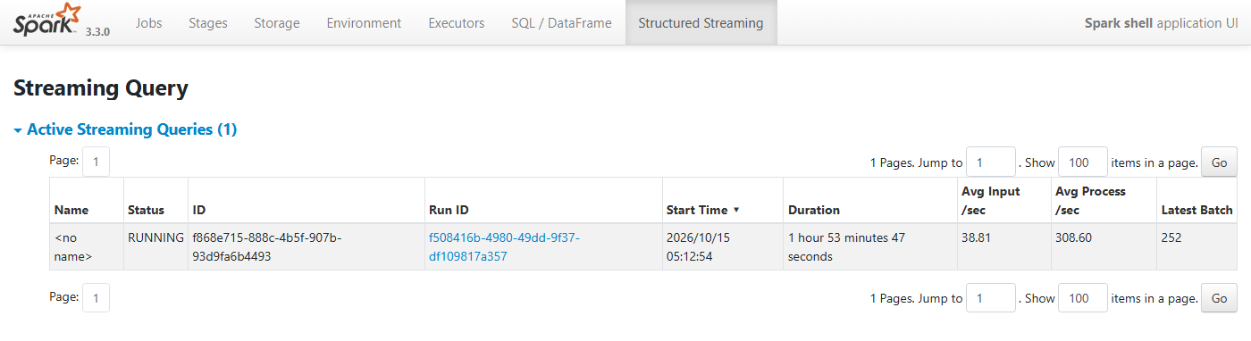
Figure 24 — Active streaming queries
What you see | Value here | What it means and why it has this value
Name | <no name> | We did not call .queryName("…") in live_pipeline.scala.
Status | RUNNING | The query is active.
ID | f868e715-… | Permanent ID of the query, stored in the checkpoint folder. It stays the same across restarts that reuse the checkpoint.
Run ID | f508416b-… | A new ID for each start of the query. The same value appears as the Job Group on the Jobs page.
Start Time / Duration | 05:12:54 (UTC) / 1 h 53 min 47 s | When this run began.
Avg Input/sec | 38.81 | Average rate at which new records arrived. The fetcher writes 263 records every ~10–15 s and a batch usually picks up 2 files (526 records) in about 13.5 s, roughly 39 records per second.
Avg Process/sec | 308.60 | Average rate at which Spark processed records while working on a batch. It is about 8 times the input rate, so the pipeline easily keeps up. If Process/sec ever fell below Input/sec, a backlog would build up.
Latest Batch | 252 | Micro-batches are numbered from 0, so 253 batches have completed.

5.11 Streaming Query Statistics
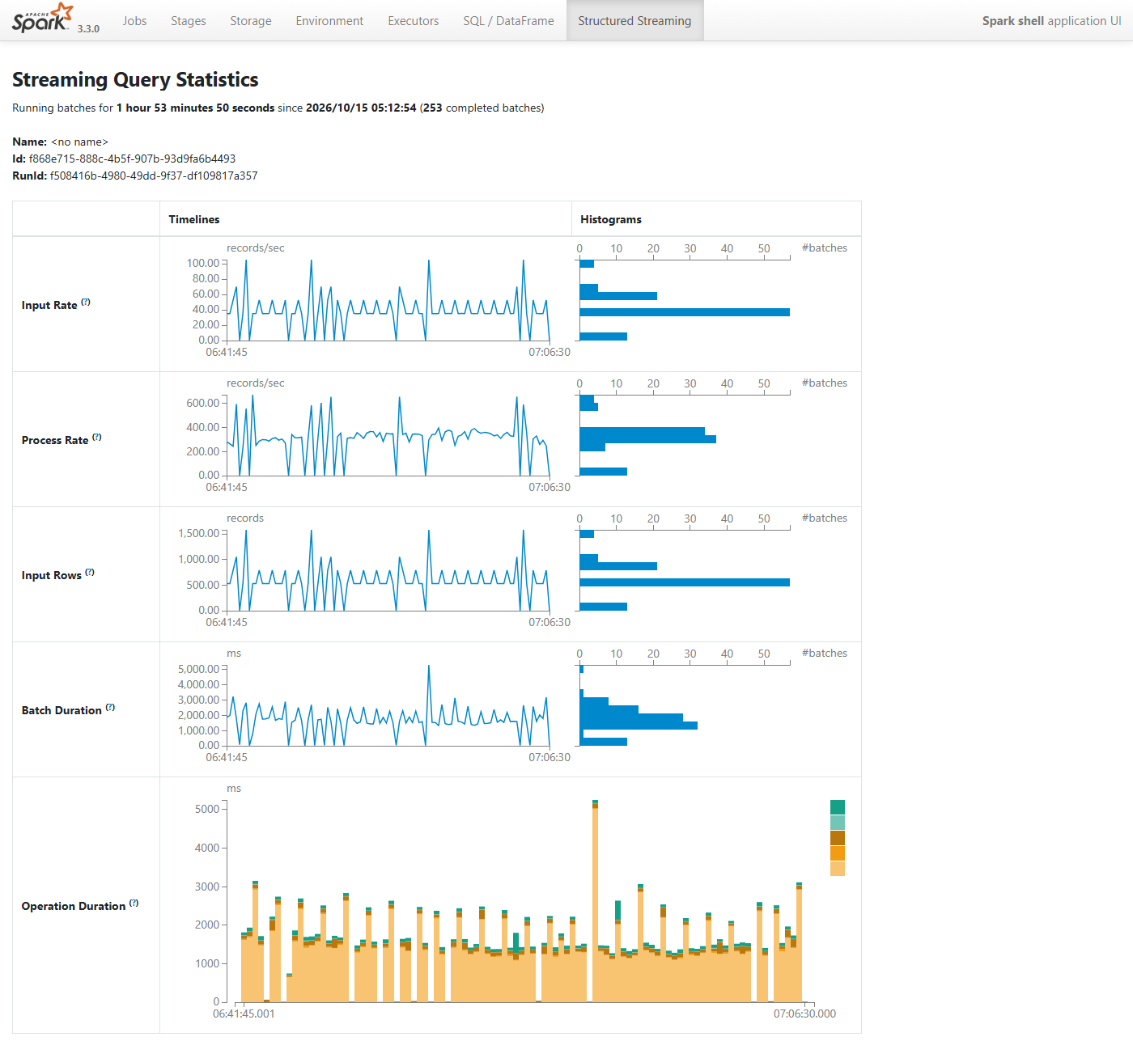
Figure 25 — Timelines and histograms of the last 100 micro-batches
The left column shows each metric over time; the right column is a histogram: how many batches had each value. The charts cover only the most recent 100 batches (06:41:45 → 07:06:30 UTC), which is how many progress reports Spark keeps.
What you see | Value here | What it means and why it has this value
Running batches for 1 h 53 min since 05:12:54 (253 completed batches) | 253 | At one trigger every 15 s, you might expect ~455 batches. A micro-batch only runs when at least one new file has arrived; triggers with no new data are skipped. The executor replacement around 06:40 also paused processing briefly.
Input Rate (records/sec) | mostly ~40, spikes to ~100, some 0 | ≈40 is the normal two-files-per-batch rhythm. Spikes happen when 3–4 files were waiting (for example after a slow batch). The histogram's longest bar is at ~40.
Process Rate (records/sec) | mostly 250–350, spikes to ~600 | Records ÷ processing time. Bigger batches give higher rates, because the fixed overhead per batch is shared by more rows.
Input Rows (records) | mostly 526, some 263, spikes ~1,300 | Rows per batch = files picked up × 263 zones: 1 file = 263, 2 files = 526, 5 files = 1,315.
Batch Duration (ms) | mostly 1,500–3,000, one ~5,000 | Total time per micro-batch. As long as it stays below the 15 s trigger interval the query never falls behind. The ~5 s outlier was a batch that also rewrote the 24-hour history file.
Operation Duration (stacked bars) | large pale-orange part + thin coloured parts | How each batch's time divides into phases: addBatch (running your foreachBatch code; the big pale-orange part), getBatch / latestOffset (finding the new files in HDFS), queryPlanning (building the plan), walCommit (recording progress in the checkpoint; the green parts). Almost all the time is your own code, which is expected.

6. How the numbers connect
The same facts show up on several pages. Following one fact across pages is the best way to check your understanding:
Fact | Where you can see it | Why
263 taxi zones | latest.csv has 263 rows; InMemoryTableScan outputs 263 rows; Input Rows are multiples of 263 (263, 526, 1,315) | Everything in the live system is one row per zone.
Replication factor 3 | Replication column = 3; DFS Used 112.93 MB ≈ 3 × 37.6 MB; 323 blocks on the NameNode and 323 on each DataNode; Under-replicated blocks 0 | Each block lives on all three DataNodes.
One shared Docker disk | Configured Capacity 2.95 TB = 3 × 1006.85 GB; Capacity Left 940.87 GB on every DataNode | Containers on one machine share one disk; HDFS cannot tell, so it adds them up.
2 workers × (2 cores, 4 GB) | Master: 4 cores, 8 GiB; App: 2 executors × 2 cores; Executors tab: 2 cores each; Stage: 2 tasks run at once per executor | The worker settings in docker-compose.yml decide how much parallel work Spark can do.
1024 MiB executor memory | Master: 1024 MiB per executor, 2.0 GiB used; Executors tab: 366.3 MiB storage memory each | Default executor heap, minus Spark's reserved and user memory.
spark.sql.shuffle.partitions = 4 | Stage 3352 has 4 tasks; Exchange writes 4 records; partial aggregate outputs 4 rows | Each shuffle creates 4 partitions instead of the default 200, which suits 263 rows.
Cached profile table | Storage: 316 KiB, 1 partition; Stages: broadcast exchange input 316 KiB; Executors: RDD Blocks 1 | Cached once, reused by every micro-batch.
latest.csv size | HDFS browser: 26.25 KB; Stages: Output 26.2 KiB | The Spark stage that writes the file and the file in HDFS match.

7. Health checklist: what good and bad look like
Page | Healthy sign | Warning sign and what to check
NameNode | Live Nodes 3, Dead Nodes 0 | Dead Nodes > 0 → a DataNode container stopped. Run docker compose ps.
NameNode | Under-replicated blocks 0 | > 0 for long → not enough live DataNodes to keep 3 copies.
NameNode | Safemode is off | On for a long time → DataNodes are not reporting; check their logs.
NameNode | Missing / corrupt blocks not shown | If shown → data loss; some file cannot be read.
DataNode | Last Heartbeat a few seconds | Minutes → network or container problem.
DataNode | Cluster ID equals the NameNode's | Different → the DataNode volume belongs to an older HDFS format.
Spark Master | Alive Workers 2, Status ALIVE | Fewer workers → a worker container stopped.
Spark Master | Running app has cores > 0 | 0 cores → another app holds all cores (as with app 0001).
Spark App | Failed Tasks 0 | Failures → open the stage, read the Errors column.
Spark App | GC time small compared with task time | Large GC → executors need more memory.
Spark App | Task durations even (Median ≈ Max) | Max ≫ Median → data skew: one partition much bigger than the rest.
Streaming | Process/sec > Input/sec; batch duration < trigger (15 s) | Otherwise the query falls behind and the dashboard lags.
Streaming | Latest Batch keeps increasing | Stuck → the fetcher stopped writing files, or the query failed.

8. Glossary
Term | Meaning
Block | A chunk of an HDFS file (max 128 MB here). The unit of storage and replication.
Block pool | All blocks belonging to one HDFS namespace.
Block report | A DataNode's list of the blocks it holds: full every 6 h, incremental immediately.
Heartbeat | "I'm alive" message: DataNode → NameNode every 3 s; also worker → master.
fsimage / edit log | Saved snapshot of HDFS metadata / list of changes since that snapshot.
Checkpoint (HDFS) | Merging the edit log into a new fsimage.
Safe mode | Read-only start-up state of the NameNode.
Replication | Number of copies of each block (3).
Driver | The process running your program (spark-shell); plans jobs and collects results.
Executor | A JVM on a worker that runs tasks and caches data.
Worker | A machine/container offering cores and memory to the Spark master.
Job / Stage / Task | Action → parts separated by shuffles → one unit of work per partition.
Partition | One slice of a DataFrame, processed by one task.
Shuffle / Exchange | Moving rows between tasks so related rows meet (for groupBy, joins, distinct).
Skipped stage | A stage whose output already existed, so it was not re-run.
Locality | How close a task runs to its data (PROCESS_LOCAL is best).
Broadcast join | Sending a small table to every executor so the big table needn't be shuffled.
WholeStageCodegen | Spark fusing several plan steps into one generated function.
Cache / persist | Keeping a DataFrame in executor memory for reuse.
Micro-batch | One small chunk of new streaming data processed at a trigger.
Trigger | How often Structured Streaming checks for new data (15 s).
Streaming checkpoint | HDFS folder where a streaming query records which files it has processed.
Client deploy mode | The driver runs where you launched it, not on a worker.
GC (garbage collection) | Java freeing unused memory; time spent in GC is time not spent working.

