Freight Rate Prediction — Modeling Report
Machine Learning Engineer Assessment

1. Data Overview
The labeled dataset (data/train_test.csv) contains 48,000 freight loads from Jan 1 – Oct 31, 2025, each with pickup/delivery city, coordinates, road distance (miles), equipment type (Dry Van / Reefer / Flatbed), weight (lbs), date, two market signals (market_index, quote_signal), and the target posted_rate ($).
Two files require predictions with no target: validation.csv (12,000 loads, Nov 1 – Dec 31, 2025, ~736 of its pickup–delivery lanes never appear in training) and december_chart_inputs.csv (31 rows, one fixed lane — Lexington→Fort Wayne, Dry Van, 360 mi, 32,000 lb — repeated once per day in December so only the date varies). Critically, december_chart_inputs.csv does NOT include coordinates, market_index, or quote_signal, so the production pipeline treats those as optional features rather than requirements.

2. Data Quality Findings & Preprocessing

Findings
- distance is a real road-distance figure, not derivable purely from coordinates: it correlates 0.9995 with great-circle (haversine) distance between the given lat/lon pairs but is systematically ~170 miles longer on average (road circuity), so both were kept as separate features.
- Missing values: weight (~0.6%) and market_index (~0.8%) have scattered gaps in train_test.csv; validation.csv has similar small gaps; december_chart_inputs.csv is missing coordinates, market_index and quote_signal entirely.
- posted_rate is right-skewed (skew ≈ 1.9). Modeling log1p(posted_rate) reduces skew to ≈ -0.49 and stabilizes variance, so all candidate models were trained on the log target and predictions were inverse-transformed (expm1) before scoring.
- Rate-per-mile decreases with distance (corr ≈ -0.33) — short hauls carry a higher $/mile due to fixed handling costs. This is normal trucking-market economics, not a data error, so no rows were dropped as 'rate-per-mile outliers'; instead log_distance was added so the (mildly nonlinear) distance/rate relationship is captured directly.
- market_index and quote_signal correlate only weakly with posted_rate in isolation (|r| < 0.04), so a simple median impute is safe and does not materially bias predictions — important because these columns are entirely absent for the December file.

Preprocessing Pipeline (src/features.py)
- Time features: month, day-of-week, weekend flag, sine/cosine encodings of day-of-week and day-of-year (captures weekly and annual seasonality without a false jump between Dec 31 and Jan 1), and a continuous days_since_anchor trend feature anchored to 2025-01-01 so it extrapolates sensibly into Nov/Dec.
- Distance features: log1p(distance); haversine distance and circuity ratio when coordinates are available.
- Missing-value handling: weight imputed by equipment-specific median (Reefer/Flatbed loads run systematically heavier/lighter than Dry Van); market_index/quote_signal imputed with the training median; explicit *_missing indicator flags added for every imputed field, including a flag set to 1 across all rows when a whole column (market_index, quote_signal) is absent, as on december_chart_inputs.csv.
- Categorical handling: pickup, delivery, equipment kept as native categorical features for tree models (avoids exploding dimensionality from ~64×64 city pairs) and one-hot encoded only for the linear/RF baselines.
- All imputation statistics (medians) are fit once on the training data and reused unchanged at inference time — never refit on validation or December inputs — to avoid leakage.

3. Train / Validation Split Strategy
A time-based (not random) split was used: rows were sorted by date and the most recent 15% of days (Sep 16 – Oct 31, 2025; 7,150 rows) were held out, with the remaining 85% (Jan 1 – Sep 15; 40,850 rows) used for training.
Rationale: the real deployment gap is large — the model must score loads in Nov–Dec 2025, one to three months beyond the end of the labeled data. A random row-level split would let the model train on days immediately adjacent to its test days, which overstates real-world accuracy because nearby dates share very similar market conditions. Holding out the latest calendar slice instead simulates the actual forecasting gap the model will face in production.
For the gradient-boosted models (XGBoost, LightGBM, CatBoost), a further internal split was carved out of the training window only (last 12% of the training dates, never touching the holdout) to select iteration counts via early stopping, so their comparison against the linear baselines is not disadvantaged by fixed, arbitrarily-chosen tree counts.
Once the best model family was selected on the untouched holdout, it was refit on 100% of train_test.csv (all 48,000 rows) before generating the final validation_predictions.csv and December predictions, so the production model uses all available signal.

4. Models Trained & Comparison
Six regression approaches were trained and evaluated on the same time-based holdout, using identical engineered features (log target, inverse-transformed to dollars for scoring):
- Linear Regression — one-hot encoded categoricals + engineered numeric features
- Ridge Regression — L2-regularized linear model, same feature set
- Random Forest — 400 trees, one-hot encoded categoricals
- XGBoost — native categorical support, tuned depth/learning rate with early stopping
- LightGBM — native categorical support, tuned depth/learning rate with early stopping
- CatBoost — native categorical support (best suited to high-cardinality city pairs), tuned depth/learning rate with early stopping

Model | MAE ($) | RMSE ($) | MAPE (%) | R²
Linear Regression (selected) | 111.61 | 605.64 | 5.06 | 0.840
Ridge Regression | 113.67 | 606.31 | 5.15 | 0.840
CatBoost | 117.55 | 607.66 | 5.31 | 0.839
XGBoost | 122.33 | 609.60 | 5.48 | 0.838
LightGBM | 126.42 | 611.20 | 5.57 | 0.837
Random Forest | 138.37 | 613.98 | 6.35 | 0.836

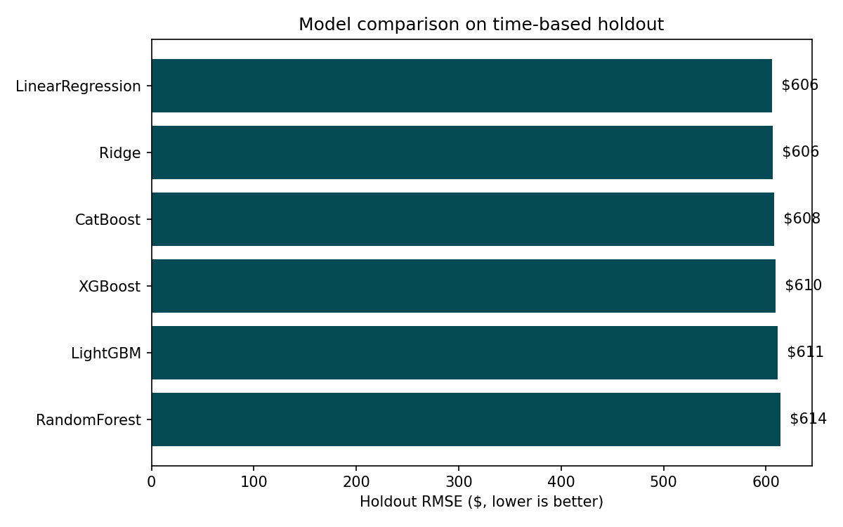
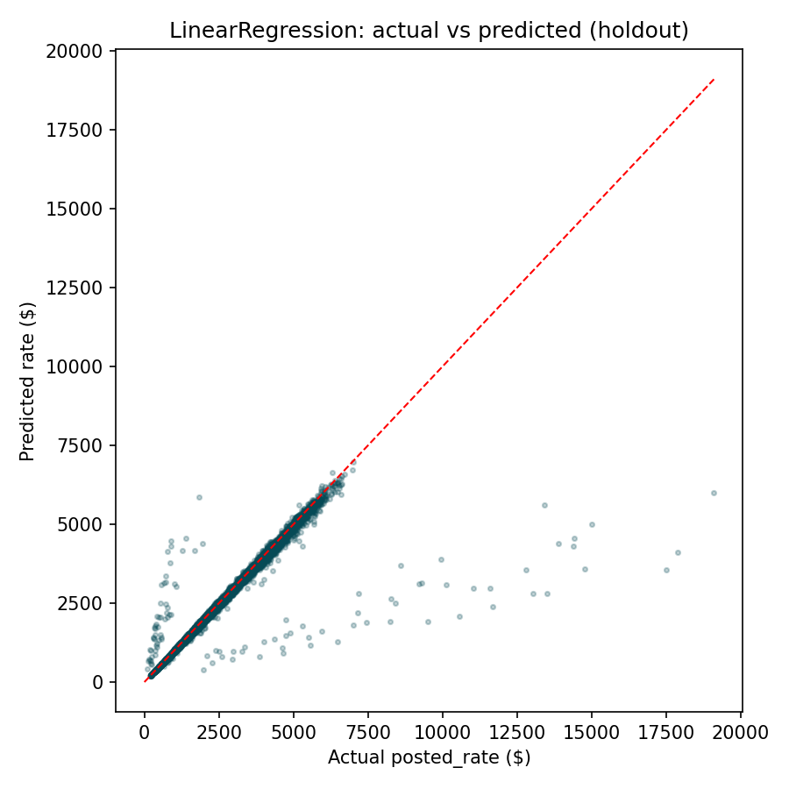

5. Model Selected & Why
Linear Regression was selected as the production model.
This was not decided a priori — all six models were tuned (including early stopping for the boosted trees to avoid disadvantaging them with arbitrary tree counts) and compared on the same untouched, time-based holdout. Linear Regression came out narrowly but consistently ahead on every metric (RMSE $605.64 vs. $607.66 for the next-best model, CatBoost; MAPE 5.06% vs. 5.31%), and it beat every tree ensemble by a wider margin on MAE.
Why a simple linear model wins here: the EDA shows posted_rate is well explained by a largely additive, log-linear structure — a base effect per city/equipment (captured by one-hot dummies), a smooth log(distance) effect, and a mild time trend/seasonality — sitting on top of moderate, fairly homoscedastic noise (log-target skew ≈ -0.49 after transformation). That is exactly the regime linear regression is built for. The more flexible tree ensembles have more capacity to fit noise in the training window, which showed up as a real (if small) generalization cost on the forward-looking holdout, despite early stopping. R² was essentially tied across all six models (0.836–0.840), meaning the *shape* of the relationship is not in serious dispute between model families — the differences come down to how much each model overfits idiosyncratic patterns in Jan–Sep that don't repeat in Sep–Oct.
Practical bonus: Linear Regression is fully interpretable (each city, equipment type, and time feature has a directly readable dollar coefficient), trains in seconds, and — unlike the tree models — degrades gracefully rather than unpredictably when a whole feature column is absent (December file), since its one-hot/median-imputed inputs are simple to reason about and audit.
CatBoost was the strongest runner-up and would be a reasonable second choice if more complex, non-additive interactions were expected to matter as more data becomes available; the gap to Linear Regression here is small (about 0.3% higher RMSE) and could plausibly close or reverse with more training data or richer categorical interactions.

6. December 2025 Prediction Chart
Produced by score.py from the completed data/december_chart_inputs.csv (fixed lane: Lexington → Fort Wayne, 360 mi, Dry Van, 32,000 lb — only the date changes across all 31 rows). The model produces a smooth, plausible trend (~$889–$911) driven entirely by its learned day-of-week/day-of-year seasonality and trend terms, since every other input is held constant — a useful sanity check that the temporal features behave reasonably under extrapolation, an important check given the model must generalize from Jan–Oct training data to a December-only test lane it never observed with market_index/quote_signal available.
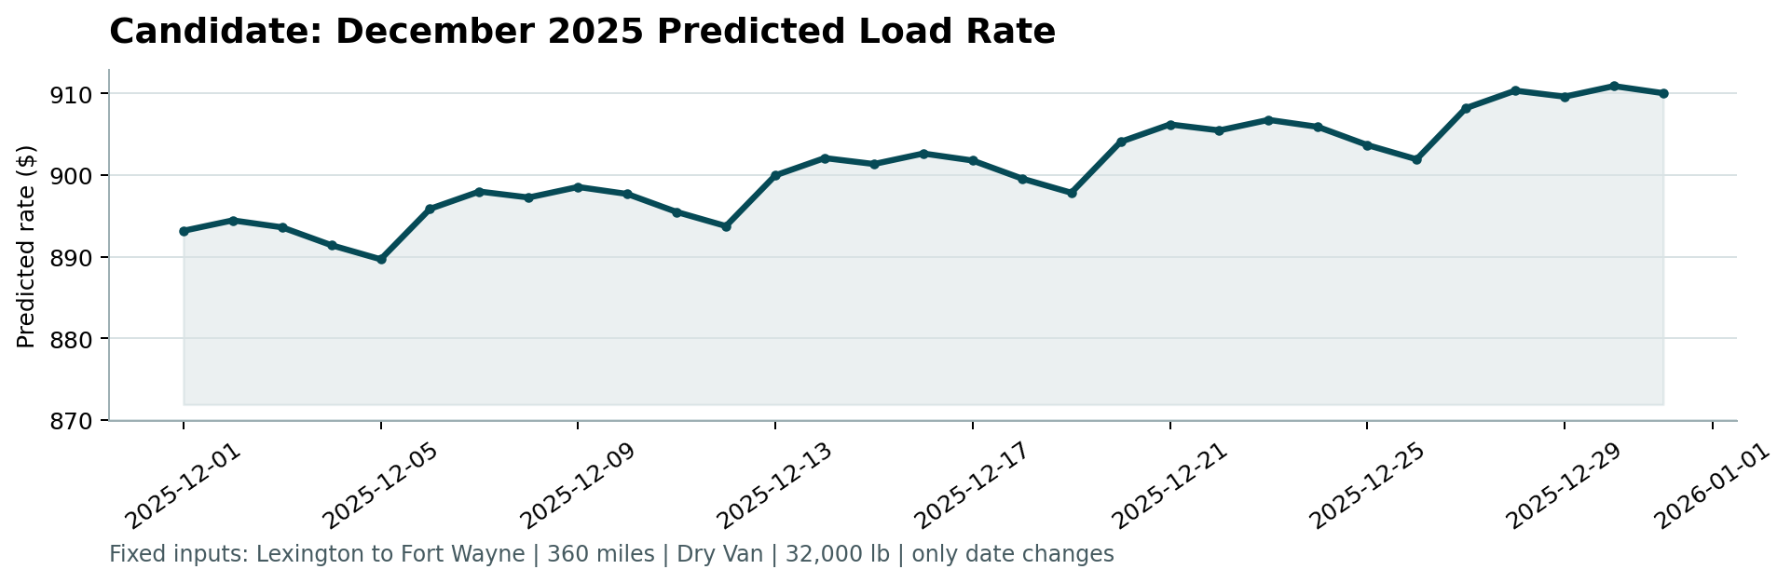

7. Reproducing These Results
See README.md for exact commands. In short:
- python -m pip install -r requirements.txt
- python src/train.py # compares all 6 models on the time-based holdout, saves the winner
- python src/predict.py # writes validation_predictions.csv and fills data/december_chart_inputs.csv
- python score.py --predictions validation_predictions.csv --december-predictions data/december_chart_inputs.csv

