Kevin Sass

9/18/19

CSC_355_401_1040 Database Systems

Assignment 1

1. 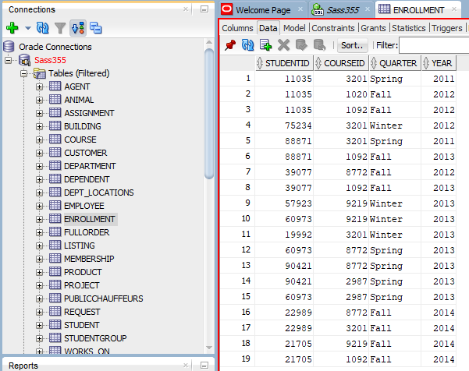
2. 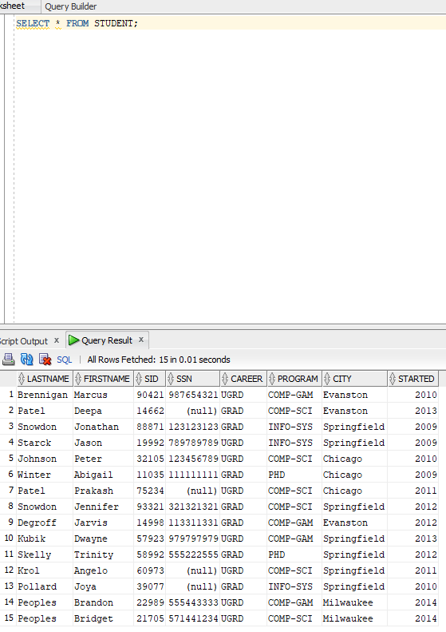
3. A. TourID, CustomerID  
   b. TID  
   c. DID  
   d. TourID, CustomerID  
   e. DestinationID  
   f. none  
   g. INSERT INTO BOOKING  
    VALUES (‘86428’, ‘0005’, ‘18-SEP-19’);  
   h. INSERT INTO BOOKING  
    VALUES (‘54321’, ‘0005’, ‘18-SEP-19’);  
   i. INSERT INTO TOUR  
    VALUES (‘54321’, ‘02’, ‘13’, ‘9000’)  
   j. INSERT INTO TOUR  
    VALUES (‘12345’, ‘02’, ‘13’, ‘9000’)  
   k. (0005, Margolis 5555150) can be removed because it is the only tuple that has a primary key that is not referenced by any foreign keys in Booking.