Kevin Sass

7/26/19

G141 Lab 3

**Spatial Data Model and Terrain Analysis**

1. 567 columns, 377 rows, 213,759 pixels
2. The pixel depth, or bit depth, determines the range of values that a particular raster file can store, which is based on the formula 2^n where n is the pixel depth. The pixel depth is 32 Bit.
3. “On-the-fly projection” means that ArcMap uses the coordinate system and projection of the first layer in a data frame to be the default for the rest of the layers added to the data frame. It can automatically project layers, ‘on-the-fly’, to the same projection as the layer that was incorporated into the data frame first. Projecting data ‘on-the-fly’ is useful because it does not actually change the original data. The data is projected in the ArcMap document, and any real changes in projections would have been made using tools found in ArcToolbox.
4. A histogram is an accurate representation of the distribution of numerical data. It is an estimate of the probability distribution of a continuous variable. Histogram equalization assigns the intensity values of pixels in the input image such that the output image contains a uniform distribution of intensities. It improves contrast and obtain a uniform histogram.
5. 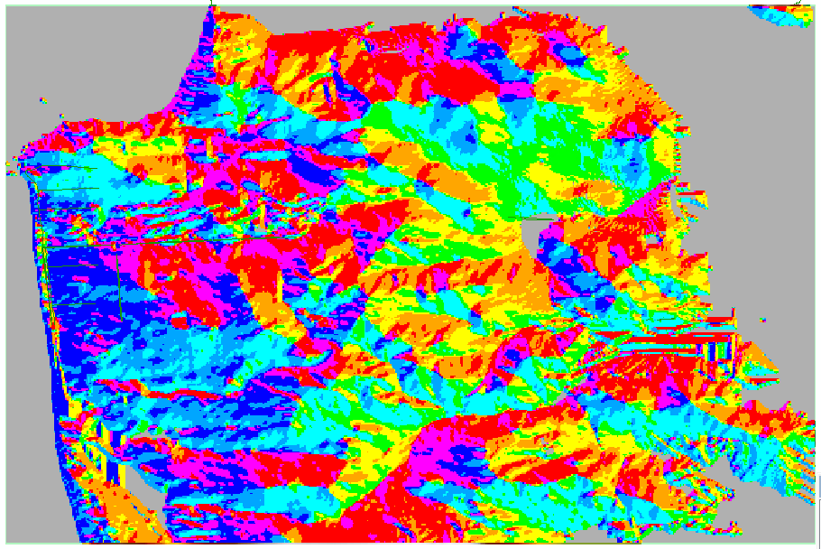

The aspect shows the compass direction each slope faces, with cyan being north, blue being east, red being south, and yellow being west.

1. 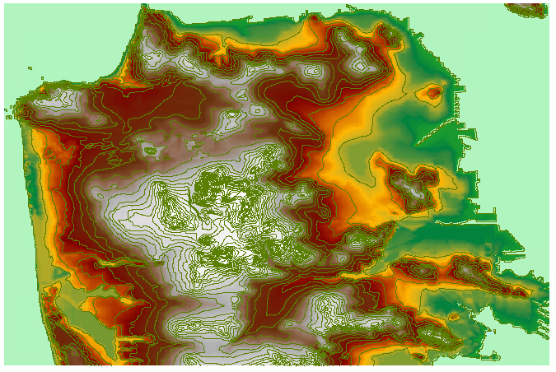  
   In the contours map, each area separated by the green lines are of same/very similar elevation, with each green line area denoting a different elevation level.
2. When the contours are close together and dense, this means this area has a steep elevation slope, usually denoting mountains. When the lines are far apart, this denotes a gradual elevation or flatland plains.
3. 10 meters is the vertical distance between 2 contours.
4. 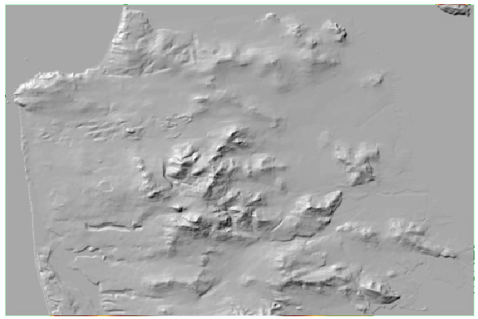  
   This hillshade map shows the hypothetical illumination of a surface according to a specified azimuth and altitude for the sun. Hillshading creates a three-dimensional effect that provides a sense of visual relief for cartography, and a relative measure of incident light for analysis.
5. 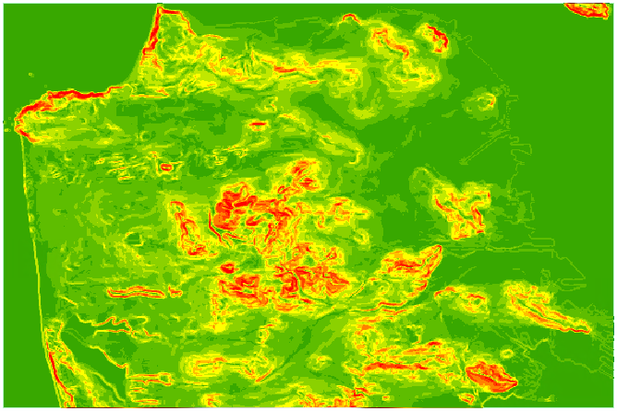  
   This slope map shows the incline, or steepness, of a surface. Steep areas are shown in hot colors and less steep areas are shown in cool colors.
6. 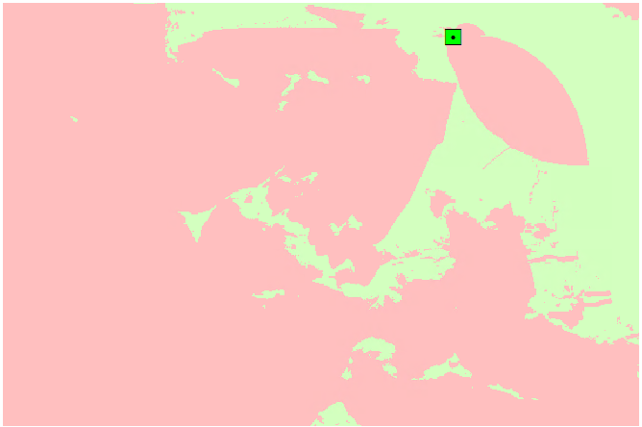  
   This viewshed map shows the locations visible from Coit Tower.
7. If we were to use a more realistic viewshade model, the map would be different as there would be buildings and trees blocking the line of sight from Coit Tower.
8. 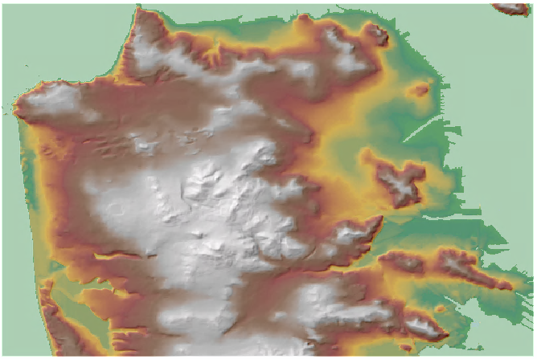  
   This is a combined map of the DEM (with 50% transparency) and hillshade, creating a cool, more realistic, and informative image.