Kevin Sass

8/9/19

G141 Lab 4

**Spatial Analysis with Vector Data**

1. The range of Class 2 wind speeds at height of 50m is 5.6 m/s to 6.4 m/s. The range for Class 3 is 6.4 m/s to 7.0 m/s.
2. 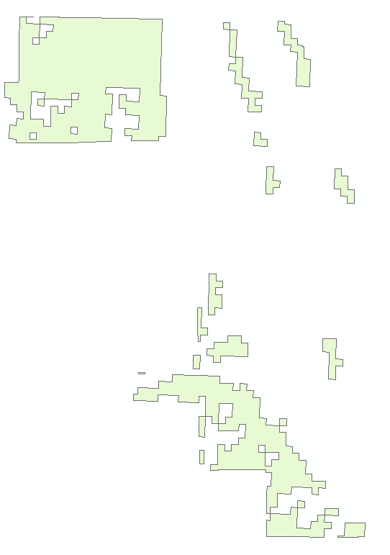  
   This represents the dissolved area of wind resource class 3, symbolized by WPC.
3. 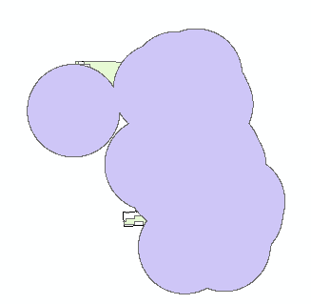  
   This shows the areas that are within 10 miles of a power plant.
4. 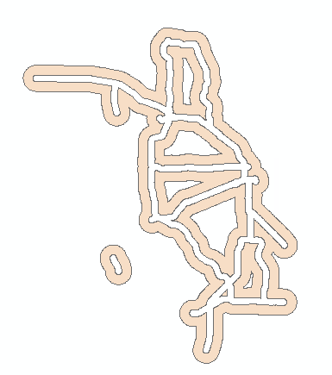  
   This shows the areas that are between 0.5mi and 2mi from major roads.
5. 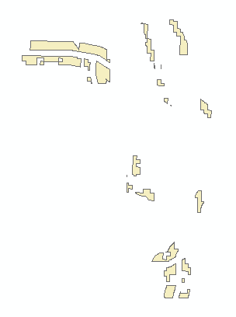  
   This shows the intersection of areas that have the desired wind strength, are within 10 meters of a powerplant, and are within 0.5mi to 2mi of a major road. This step is important because it shows the final areas that are suitable to build wind turbines.
6. This polygon overlay technique could be used to find a suitable place to build a school where there is a large population density. It can also be used to find suitable places to build a mall with large population density and near major roads.