Kevin Sass

Corey Zheng

CSC 299 Lab_Week 2 Report

4/5/2018

In this lab we learned how to properly set up an LED circuit with resistor to a breadboard. From that, we learned how electricity flows through a breadboard and what directions it goes, as well as how the resistor prevents damage to the raspberry pi. We learned python code related to outputs and inputs for the raspberry pi, and how to create a convenient GUI interface to control color, brightness, and power.

We faced one challenge. During the brightness exercise, we could not get the LED bulb to light up. We double checked the code and the wire placements and it still wouldn’t light. We resolved the issue by switching the ground and GPIO wires.

1. 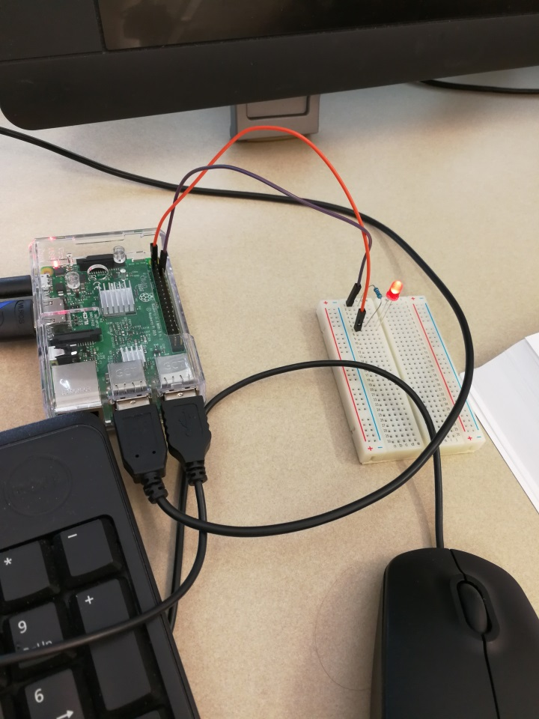

2. 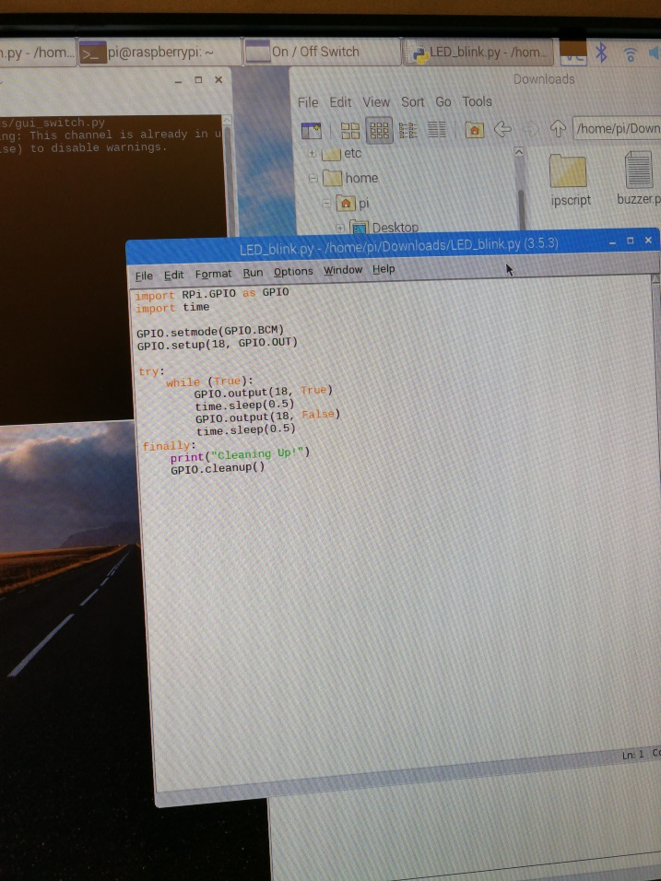

3. 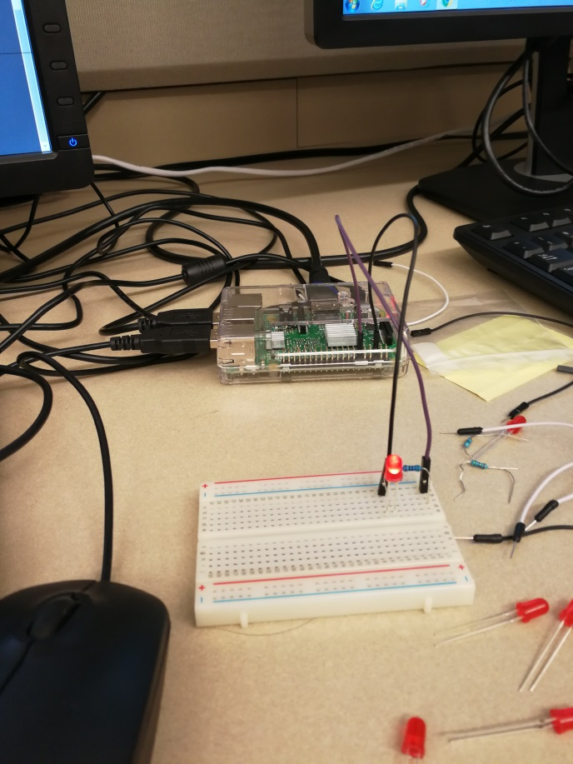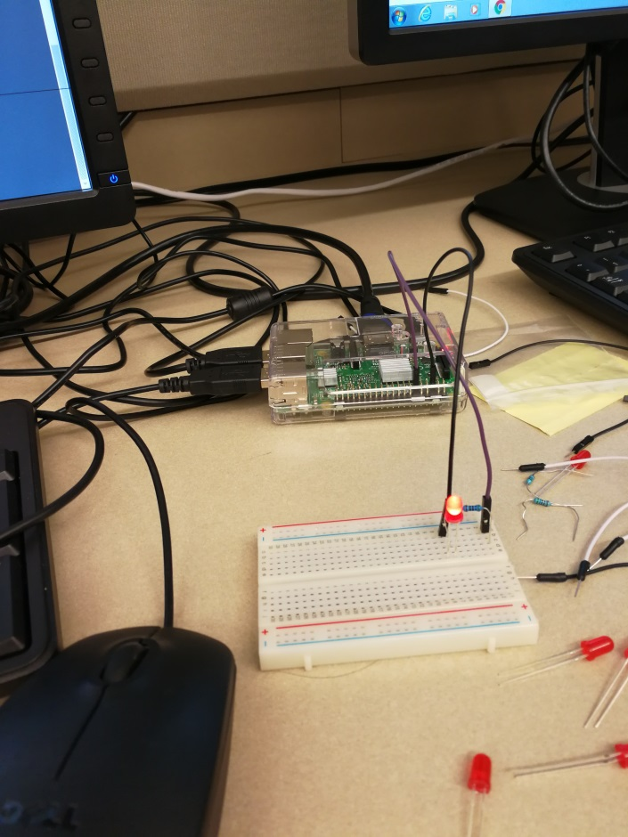

4. 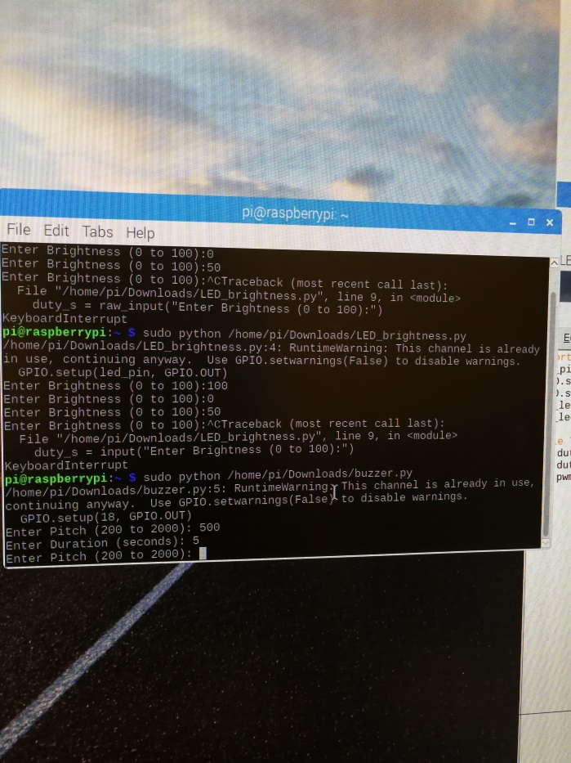

5. 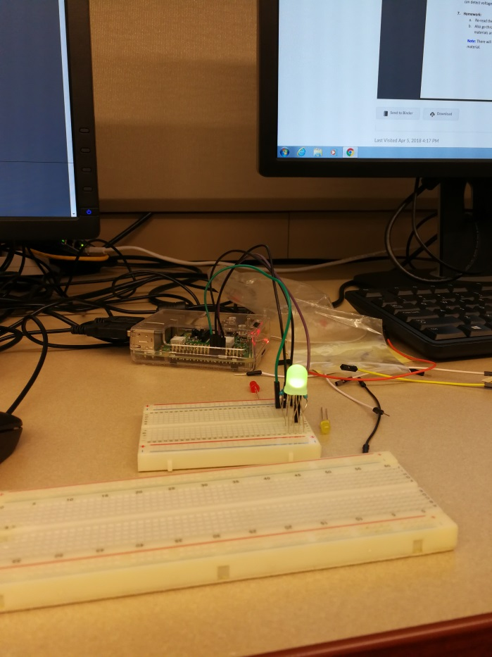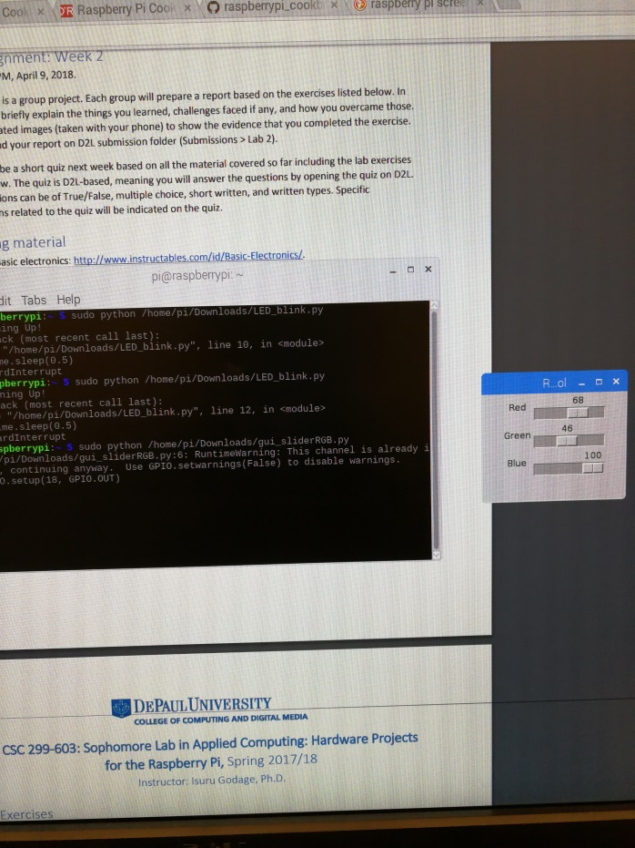

6. 