RELAY RUSH

TURRET

Sassan Nourian

Template:
Version: 1.7
Date: 08/06/2026-08/06/2026
Overview 3
Definition & Purpose 3
Aesthetics 3
Writing 4
Goals 4
Definition 4
Design 4
Goals 4
Workflow 4
Systems, contents, etc. 4
Programming 4
Goals 4
Inputs, physics etc. 4
Visual 5
Goals 5
Definition 5
Aural 5
Goals 5
Definition 5

Overview

Definition & Purpose
Turrets are enemy defensive structures that will shoot at intervals in straight lines. In small numbers it will give players basic challenges while in large numbers it can increase the challenge. There are two types of turrets, stationary and dynamic.

Aesthetics
A sense of cautious but not worrying so much about it. Low amount is good for casual and less tense situations and High amount is good for higher tensions.

Design

Goals
- Balanced projectiles speed
- Balanced projectiles damage (low)

Workflow
Stationary:
- Shoots at intervals
Dynamic:
- Moves in a range
- Shoots at intervals

Stats
Each turret has 5 stats:
Speed determines how fast the cannonballs move.
Cooldown determines the time between each shot
Damage determines how much damage the player takes upon impact.
Lifetime determines how long should the bullet travel before it gets removed
Starting timer determines the delay for the starting shot.
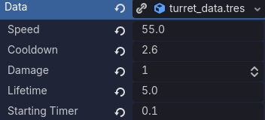

Shooting
Type | Damage | Range (px)
Stationary | 1 | 200
Dynamic | 1 | 180

Moving (dynamic)
Movement speed: varies
Movement range: varies

Programming

Goals
- Smooth collision detection for projectiles

Visual

Goals
- Easy to track the projectiles (distinguishable)

Definition
Key features:
- Sci-fi turrets
- Round projectiles
Size & shape:
- Tube shaped
Sketches:
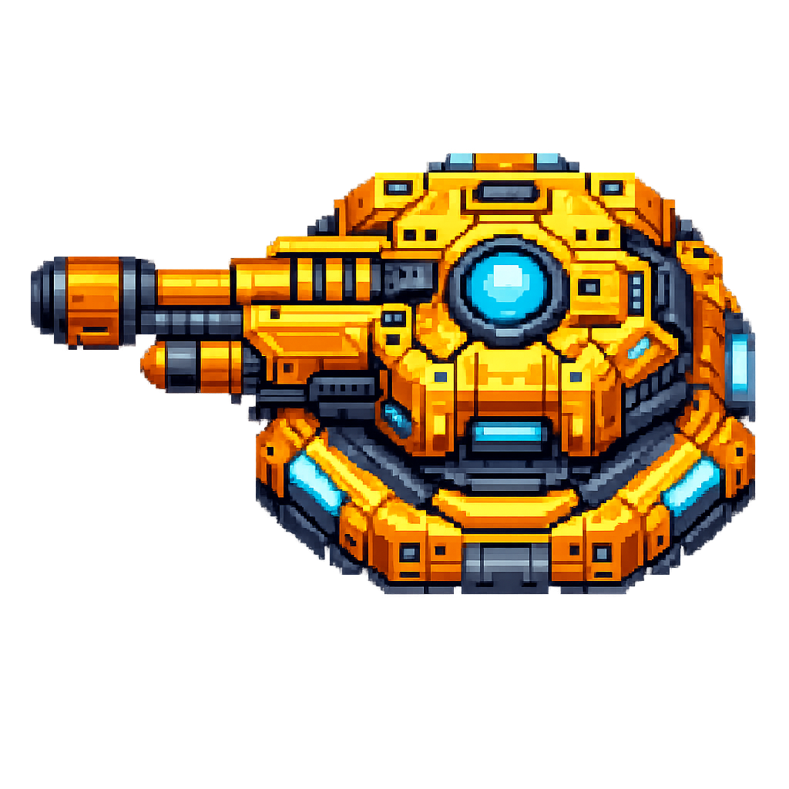
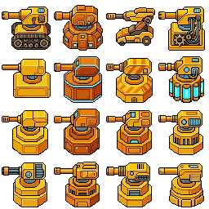
Materials:
Steel
Glass
Colored wires (optional)
Primary colors:
Yellow, orange
Secondary colors:
Light blue, light purple
Accent colors:
Dark purple, dark orange
Rough color shapes:


