**ECSE 543**

**NUMERICAL METHODS IN ELECTRICAL ENGINEERING**

Zhiyu Chen

260605624

**2) Figure 2 shows the cross-section of an electrostatic problem with translational symmetry: a rectangular coaxial cable. The inner conductor is held at 110 volts and the outer conductor is grounded. (This is similar to the system considered in Question 3, Assignment 1.)**

1. **Use the two-element mesh shown in Figure 1(b) as a “building block” to construct a finite element mesh for one-quarter of the cross-section of the coaxial cable. Specify the mesh, including boundary conditions, in an input file following the format for the SIMPLE2D program as explained in the course notes. (Hint: Your mesh should consist of 46 elements.)**

Choosing the upper-right one quarter of the cross-section, it is a 0.1m x 0.1m square, we therefore divide it into 25 meshes, each has a size of 0.02m x 0.02m. But in this case, the bottom-left two meshes, as Figure 2(a)1 shows, lie in the region where U = 110V and we do not need to solve for their potentials.

So, in total we have (25-2) *2 = 46 elements. And the I typed the input file according to the SIMPLE2D help file manually and include it in the appendix.

Notice that here I put the center point of the whole cross-section as the zero point while the actual zero point lies at the bottom-left corner of the coaxial cable.

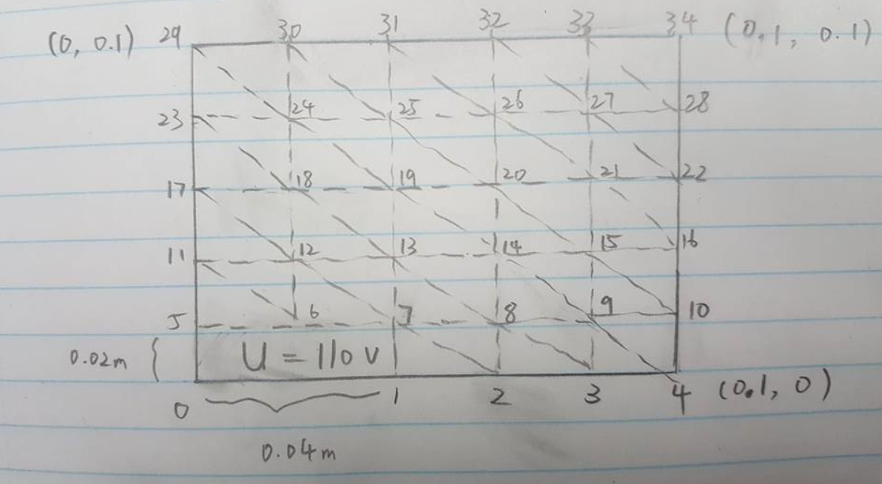

**Figure 2(a)1: two-element meshes for one-quarter of the cross-section of the coaxial cable**

1. **Use the SIMPLE2D program with the mesh from part (a) to compute the electrostatic potential solution. Determine the potential at (x, y) = (0.06, 0.04) from the data in the output file of the program.**

The input file can be find in appendix. And from the data in the output file, the potential at potential at global (x, y) = (0.06, 0.04) is **40.5265V**. (Notice that, in the input file, we define node14 as 0.06, 0.04, this is because when writing the input file, I put the center of the coaxial cable cross-section as the zero point(See figure 2a)1) for analysis. However, by symmetry, the global (x, y) = (0.06, 0.04), as defined in the problem where the left-bottom corner is the zero point, should actually equal the value on node 19)

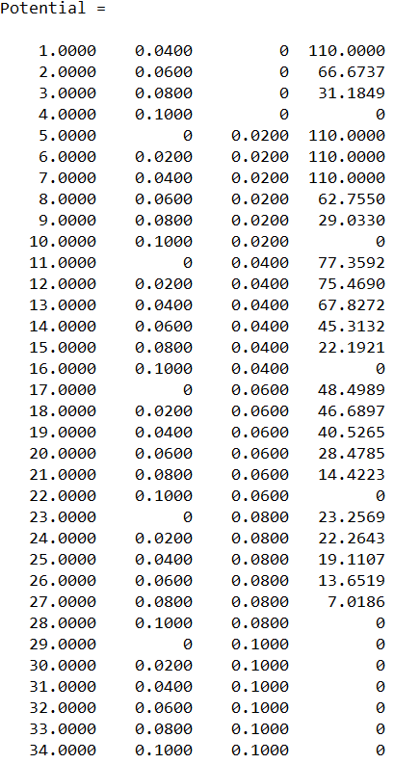

**Figure 2(b)1: output file of SIMPLE2D**

1. **Compute the capacitance per unit length of the system using the solution obtained from SIMPLE2D.**

The energy of the system is given by E = 1/2*CunitlengthV2. And we know that for one quarter of the cross section where we do the analysis, Equater = 𝜀0*W. W for each single mesh, in our case, equals 1/2*UTconSUcon, where S = CTSC. We should add up all W of the meshes, and then, E = 4*Equater

From problem 1), we can see that the S for a single mesh is

$$S= \left[\begin{matrix}1 & -0.5 & 0 & -0.5 \\ -0.5 & 1 & -0.5 & 0 \\ 0 & -0.5 & 1 & -0.5 \\ -0.5 & 0 & -0.5 & 1\end{matrix}\right]$$

And finally, Cunitlength = 2*E/V2 = 4* 𝜀0*(UTconSUcon)/ V2

From the **capacitance.m**(see appendix) file, the final capacitance we get is: **5.2136*1011F/m**

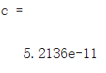

**Figure 2(c)1: output file of matlab capacitance computation**

**3) Write a program implementing the conjugate gradient method (un-preconditioned). Solve the matrix equation corresponding to a finite difference node-spacing, h = 0.02m in x and y directions for the same one-quarter cross-section of the system shown in Figure 2 that considered in Question 2 above. Use a starting solution of zero. (Hint: The program you wrote for Question 3 of Assignment 1 may be useful for generating the matrix equation.)**

First of all, we need to define the A and b matrix before using the conjugate gradient method. Both are based on the five-point difference formula.



**Figure 3(1): two-element meshes for one-quarter of the cross-section of the coaxial cable**

Take Figure3(1). There are 19 free nodes in total: 2, 3, 8, 9, 11-15, 17-21, 23-27. They are called free nodes since their voltages are to be determined. So, to characterize all these nodes, we need A to be a 19x19 square matrix, and b to be a 19x1 vector. For matrix A, row A gives the characterization of a node, while column A represents the nodes.

By five-point different method: −4φi,j +φi+1,j +φi−1,j +φi,j+1 +φi,j−1 = 0. Also, if a node is lies at the left or bottom border, of which the gradient of potential is 0, we know by symmetry its up point and bottom point are have the same value. The formula changes to: −4φi,j +2*φi+1,j +φi,j+1 +φi,j−1 = 0 for the bottom-boundary node or

−4φi,j +φi+1,j +φi−1,j +2*φi,j+1 = 0 for a left-boundary node.

So, take node 8 as an example, in the way I order the node, it should represent the third column of the A matrix, and is characterized by the third row of the A matrix. By the five-point difference formula: −4φ8 +φ7 +φ2 +φ14 +φ9 = 0. So, the third row of A should be: 1, 0, -4, 1, 0, 0, 0, 1, 0… (11 zeros). Here there rises a problem: φ7 is not a free node, it has a voltage of 110V, so it cannot be characterized by A. In this case, considering Ax = b, the result of multiplying the third row of A (which characterizing node 8) by the x potential vector should be −4φ8 +φ2 +φ14 +φ9, which should equal -φ7. This simply means, on the third row of b vector the value is -φ7 = -110V. In general, if some of the neighbors of a node is not a free node, they will be “moved” to the right-hand side of the equation and therefore be the entries of b vector. Below are the A and b generated:

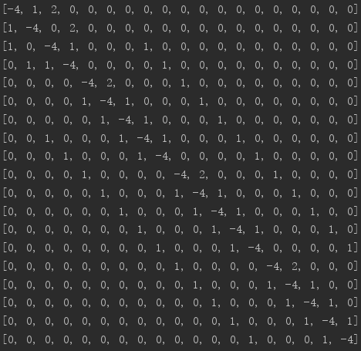

**Figure 3(2): A matrix**



**Figure 3(3): b vector**

The only thing left is to solve Ax = b with the numerical methods

1. **Test your matrix using your Choleski decomposition program that you wrote for Question 1 of Assignment 1 to ensure that it is positive definite. If it is not, suggest how you could modify the matrix equation in order to use the conjugate gradient method for this problem.**

The A matrix is not positive definite by nature. This can be shown when testing it with the Choleski function in Assignment 1, it will return an error “the matrix A is not positive definite”.

One way to resolve this issue is to multiply both A and b by AT, which gives

AT ∗A ∗x = AT ∗b.

AT ∗A creates a positive definite matrix, which can then be decomposed.

1. **Once you have modified the problem, if necessary, so that the matrix is positive definite, solve the matrix equation first using the Choleski decomposition program from Assignment 1, and then the conjugate gradient program written for this assignment.**

Solving AT∗A ∗x = AT∗b and we will get all potentials. The corresponding method should be found in **conjugateGradient.py**(see Appendix).

1. **Plot a graph of the infinity norm and the 2-norm of the residual vector versus the number of iterations for the conjugate program.**

The infinity norm is the max absolute value of all the entries in a vector, and the 2-norm is the square root of the squared sum of all the entries of a vector.

There are 19 iterations in total, and the result is as follows, where the iteration number 0 is the norms of the initial r vector:

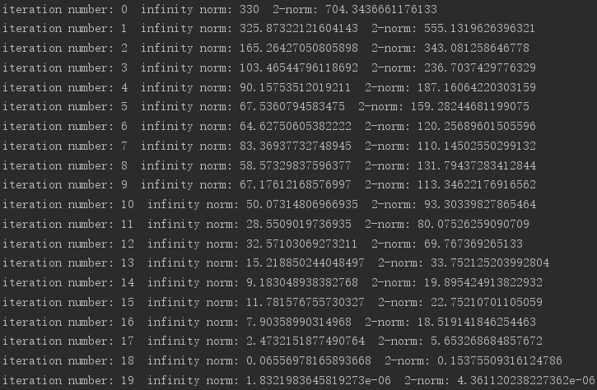

**Figure 3(c)1: infinity norm and 2-norm**

The plots are in the next page:

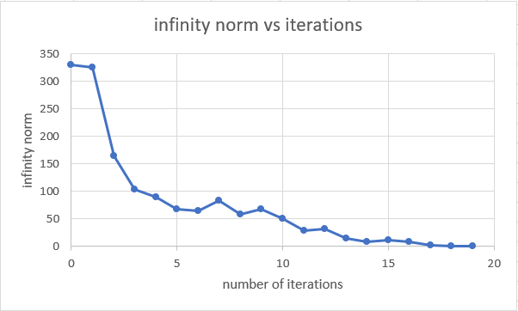

**Figure 3(c)2: infinity norm vs number of iterations**

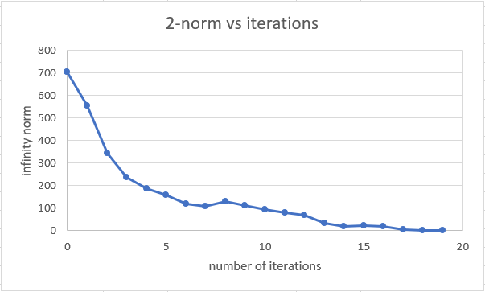

**Figure 3(c)1: 2-norm vs number of iterations**

Both infinity norm and 2-norm of the r vector decrease in general.

1. **What is the potential at (x,y) = (0.06, 0.04), using the Choleski decomposition and the conjugate gradient programs, and how do they compare with the value you computed in Question 2(b) above. How do they compare with the value at the same (x,y) location and for the same node spacing that you computed in Assignment 1 using SOR.**

For the potential at the point (0.06, 0.04):

The result from the Choleski decomposition method is: 40.5265V

The result from the conjugate gradient method is: 40.5265V

Both are consistent with the result in question 2(b)(40.5265V). The value I computed in Assignment 1 using SOR is 40.5265V as well.



**Figure 3(d)1: Result for both Choleski and Conjugate gradient method**

1. **Suggest how you could compute the capacitance per unit length of the system from the finite difference solution**.

After we compute the matrix A and b using finite difference method, we can compute the potential at each node using whether Choleski or conjugate gradient program. Once we have the voltages at each node, we can use the same method in problem 2(c), with **capacitance.m** to solve the capacitance per unit length of the system.

**Appendix：**

Question 2:

1. **capacitance.m:**

function Capacitance = capacitance(filename1,filename2,filename3)

clc;

% The total potential across the system

W = 0;

U = zeros(1,4);

V = 110 - 0;

potentials = SIMPLE2D_M(filename1,filename2,filename3);

S = [1, -0.5, 0, -0.5; -0.5, 1, -0.5, 0; 0, -0.5, 1, -0.5; -0.5, 0, -0.5, 1];

e0 = 8.854e-12;

for i = 1:length(potentials)

if potentials(i, 2) < 0.1 && potentials(i, 3) < 0.1

U(1) = potentials(i, 4);

U(2) = potentials(i + 1, 4);

U(3) = potentials(i + 7, 4);

U(4) = potentials(i + 6, 4);

W = W + 0.5*U*S*transpose(U);

end

end

Capacitance = 8*W*e0/V^2;

return

end

1. **input files:**

**1)file.dat:**1 0.04 0.0

2 0.06 0.0

3 0.08 0.0

4 0.1 0.0

5 0.0 0.02

6 0.02 0.02

7 0.04 0.02

8 0.06 0.02

9 0.08 0.02

10 0.1 0.02

11 0.0 0.04

12 0.02 0.04

13 0.04 0.04

14 0.06 0.04

15 0.08 0.04

16 0.1 0.04

17 0.0 0.06

18 0.02 0.06

19 0.04 0.06

20 0.06 0.06

21 0.08 0.06

22 0.1 0.06

23 0.0 0.08

24 0.02 0.08

25 0.04 0.08

26 0.06 0.08

27 0.08 0.08

28 0.1 0.08

29 0.0 0.1

30 0.02 0.1

31 0.04 0.1

32 0.06 0.1

33 0.08 0.1

34 0.1 0.1

**2)file1.dat:**

1 2 7 0.000

2 8 7 0.000

2 3 8 0.000

3 9 8 0.000

3 4 9 0.000

4 10 9 0.000

5 6 11 0.000

6 12 11 0.000

6 7 12 0.000

7 13 12 0.000

7 8 13 0.000

8 14 13 0.000

8 9 14 0.000

9 15 14 0.000

9 10 15 0.000

10 16 15 0.000

11 12 17 0.000

12 18 17 0.000

12 13 18 0.000

13 19 18 0.000

13 14 19 0.000

14 20 19 0.000

14 15 20 0.000

15 21 20 0.000

15 16 21 0.000

16 22 21 0.000

17 18 23 0.000

18 24 23 0.000

18 19 24 0.000

19 25 24 0.000

19 20 25 0.000

20 26 25 0.000

20 21 26 0.000

21 27 26 0.000

21 22 27 0.000

22 28 27 0.000

23 24 29 0.000

24 30 29 0.000

24 25 30 0.000

25 31 30 0.000

25 26 31 0.000

26 32 31 0.000

26 27 32 0.000

27 33 32 0.000

27 28 33 0.000

28 34 33 0.000

**3)file2.dat:**

1 110.0

5 110.0

6 110.0

7 110.0

29 0.000

30 0.000

31 0.000

32 0.000

33 0.000

34 0.000

28 0.000

22 0.000

16 0.000

10 0.000

4 0.000

Question 3:

1. **conjugateGradient.py:**

from potentialSolver import *

from methods import *

import math

def generateAandb(mesh, numNode, innerPotential, outerPotential):

A = [[-4 if a == b else 0 for a in range(numNode)] for b in range(numNode)]

b = [0 for a in range(numNode)]

k = 0

for i in range(0, len(mesh) - 1):

for j in range(0, len(mesh[0]) - 1):

if j > 1 and mesh[i][j] == 0 and mesh[i][j - 1] == innerPotential:

if i == 0:

A[k][k + 1] = 1

A[k][k + 2] = 2

b[k] = -innerPotential

elif i == 1:

A[k][k + 1] = A[k][k - 2] = A[k][k + 5] = 1

b[k] = -innerPotential

k += 1

elif j + 2 == len(mesh[0]):

if i == 0:

A[k][k - 1] = 1

A[k][k + 2] = 2

b[k] = -outerPotential

elif i == 1:

A[k][k - 1] = A[k][k + 5] = A[k][k - 2] = 1

b[k] == 0

elif i == len(mesh) - 2:

A[k][k - 1] = A[k][k - 5] = 1

b[k] = -outerPotential * 2

else:

A[k][k - 1] = A[k][k + 5] = A[k][k - 5] = 1

k += 1

elif j == 0 and i > 1:

if mesh[i - 1][j] == innerPotential:

A[k][k + 1] = 2

A[k][k + 5] = 1

b[k] = -innerPotential

elif i + 2 == len(mesh):

A[k][k + 1] = 2

A[k][k - 5] = 1

b[k] = -outerPotential

else:

A[k][k + 1] = 2

A[k][k + 5] = A[k][k - 5] = 1

b[k] = 0

k += 1

elif i == 2 and mesh[i - 1][j] == innerPotential:

A[k][k - 1] = A[k][k + 1] = A[k][k + 5] = 1

b[k] = -innerPotential

k += 1

elif i + 2 == len(mesh):

A[k][k - 1] = A[k][k + 1] = A[k][k - 5] = 1

b[k] = -outerPotential

k += 1

elif 1 < i and 1 <= j:

A[k][k - 1] = A[k][k + 1] = A[k][k - 5] = A[k][k + 5] = 1

b[k] = 0

k += 1

return A, b

def conjugateGradient(A, b, numNode):

x = numColumnCheck([0 for a in range(numNode)])

r = matrixAddOrSub(b, multiplyMatrix(A, x), 'sub')

p = [0 for a in range(len(r))]

for i in range(0, len(r)):

p[i] = r[i]

r = numColumnCheck(r)

p = numColumnCheck(p)

infNorm_ini = 0

twoNorm_ini = 0

print(r)

for l in range(numNode):

if abs(r[l][0]) > infNorm_ini:

infNorm_ini = abs(r[l][0])

twoNorm_ini += r[l][0] ** 2

twoNorm_ini = math.sqrt(twoNorm_ini)

print("iteration number: 0" + " infinity norm: " + str(infNorm_ini) + " 2-norm: " + str(twoNorm_ini))

for k in range(numNode):

alpha = multiplyMatrix(transposeMatrix(p), r)[0][0]/(multiplyMatrix(transposeMatrix(p), multiplyMatrix(A, p))[0][0])

x = matrixAddOrSub(x, scalarmultiplier(alpha, p), 'add')

r = matrixAddOrSub(b, multiplyMatrix(A, x), 'sub')

beta = -((multiplyMatrix(transposeMatrix(p), multiplyMatrix(A, r))[0][0])/(multiplyMatrix(transposeMatrix(p), multiplyMatrix(A, p))[0][0]))

p = matrixAddOrSub(r, scalarmultiplier(beta, p), 'add')

# finding the norms

infNorm = 0

twoNorm = 0

for j in range(numNode):

if abs(r[j][0]) > infNorm:

infNorm = abs(r[j][0])

twoNorm += r[j][0] ** 2

twoNorm = math.sqrt(twoNorm)

print("iteration number: " + str(k + 1) + " infinity norm: " + str(infNorm) + " 2-norm: " + str(twoNorm))

return x

h = 0.02

innerPotential = 110

outerPotential = 0

potentials = potentialMesh(h, 0)

mesh = potentials.mesh

print(mesh)

numNode = 19

(A, b) = generateAandb(mesh, numNode, innerPotential, outerPotential)

print(b)

for n in range(0, numNode):

print(A[n])

choleskiTest = choleski(A, b)

Afinal = multiplyMatrix (transposeMatrix(A), A)

bfinal = multiplyMatrix(transposeMatrix(A), b)

conjugateSolution = conjugateGradient(Afinal, bfinal, numNode)

choleskiOutput = choleski(Afinal, bfinal)

choleskiSolution = backwardElim(choleskiOutput[0], choleskiOutput[1])

print("Choleski result of the potential equals " + str(choleskiSolution[11]) + " V" )

print("Conjugate result of the potential equals " + str(conjugateSolution[11][0]) + " V" )

1. **methods.py**

import math

from scipy import random

import csv

# Function to check the number of columns of a matrix

def numColumnCheck (A):

numOfColumuns = 0

try:

numOfColumuns = len(A[0])

return A

except TypeError:

B = [[0] for a in range(len(A))]

for i in range(0, len(A)):

B[i][0] = A[i]

return B

# Function to multiply a scalar and a matrix

def scalarmultiplier(a, A):

A = numColumnCheck(A)

B = [[0 for i in range(len(A[0]))]for k in range(len(A))]

for i in range(len(A)):

for j in range(len(A[0])):

B[i][j] = a*A[i][j]

return B

# Function to multiply two matrices

def multiplyMatrix (A, B):

A = numColumnCheck(A)

B = numColumnCheck(B)

if len(A[0]) == len(B):

C = [[0 for i in range(len(B[0]))]for k in range(len(A))]

for i in range(len(A)):

for j in range(len(B[0])):

for k in range(len(A[0])):

C[i][j] += A[i][k]*B[k][j]

return C

else:

print('cannot multiply this two matrices, incorrect dimensions')

# Function to transpose a matrix

def transposeMatrix (A):

numOfRows = len(A)

numOfColumns = len(A[0])

C = [[0 for i in range(numOfRows)]for k in range(numOfColumns)]

for i in range(numOfRows):

for j in range(numOfColumns):

C[j][i] = A[i][j]

return C

# Function to create a symmetric matrix

def symmetricMatrix(size, n):

A = [[0 for i in range(size)] for k in range(size)]

# assign the lower part of A a value

for i in range(len(A)):

for j in range(0, i + 1):

A[i][j] = n * random.random() - n

B = transposeMatrix (A)

C = multiplyMatrix (A, B)

return C

# Function to use the choleski decomposition to find L and y

def choleski(A, b, halfBandwidth=None):

A = numColumnCheck(A)

b = numColumnCheck(b)

if len(b[0])!= 1:

print('invalid b input')

return

try:

numOfColumuns = len(A[0])

except TypeError:

print('A only has one column')

return

if len(A) != len(A[0]):

print('A is not a nxn matrix')

return

size = len(A)

for j in range (size):

if A[j][j] < 0:

print("the matrix A is not positive definite")

return

A[j][j] = math.sqrt(A[j][j])

b[j][0] = b[j][0]/A[j][j]

for i in range (j+1, size):

if halfBandwidth and i >= j + halfBandwidth:

break

A[i][j] = A[i][j]/A[j][j]

b[i][0] = b[i][0]-A[i][j]*b[j][0]

for k in range (j+1, i+1):

if halfBandwidth and k >= j + halfBandwidth:

break

A[i][k] = A[i][k]-A[i][j]*A[k][j]

return [b,A]

# Function to find the solution through backward elimination, notice here L should be a lower matrix

def backwardElim(y, L):

y = numColumnCheck(y)

L = numColumnCheck(L)

x = [0 for a in range(len(y))]

for i in range(len(L)-1, -1, -1):

for j in range(len(L)-1, i, -1):

y[i][0] = y[i][0] - L[j][i]*x[j]

x[i] = y[i][0] / L[i][i]

return x

def matrixAddOrSub(A, B, option):

A = numColumnCheck(A)

B = numColumnCheck(B)

if len(A)!= len(B) or len(A[0])!= len(B[0]):

print('cannot add or subtract two matrices with different sizes!')

return

C = [[0 for a in range(len(A[0]))] for b in range(len(A))]

if option == 'add':

for i in range(0, len(A)):

for j in range(0, len(A[0])):

C[i][j] = A[i][j] + B[i][j]

elif option == 'sub':

for i in range(0, len(A)):

for j in range(0, len(A[0])):

C[i][j] = A[i][j] - B[i][j]

return C

def getCircuit(r):

with open('test_circuit.csv')as circuitData:

reader = csv.reader(circuitData)

for n in reader:

if (n[0].startswith('#')):

cirNumber = int(n[0].replace('#', ''))

if cirNumber == r:

A_pre = n[1].split(';')

J_pre = n[2].split(';')

R_pre = n[3].split(';')

E_pre = n[4].split(';')

A = [0 for i in range(len(A_pre))]

for i in range(len(A)):

rowA_pre = A_pre[i].split(',')

rowA = []

for j in range(len(rowA_pre)):

rowA.append(int(rowA_pre[j]))

A[i] = rowA

J, E = [], []

y = [[0 for a in range(len(R_pre))] for b in range(len(R_pre))]

for i in range(len(J_pre)):

J.append(int(J_pre[i]))

E.append(int(E_pre[i]))

y[i][i] = 1/int(R_pre[i])

return [A, J, y, E]

def solveCircuitProblem(A,J, y, E, halfBandwidth=None):

A = numColumnCheck(A)

J = numColumnCheck(J)

y = numColumnCheck(y)

E = numColumnCheck(E)

A_final = multiplyMatrix(A, multiplyMatrix (y, transposeMatrix(A)))

b_final = multiplyMatrix(A, matrixAddOrSub(J, multiplyMatrix(y, E), 'sub'))

choleskiOutput = choleski(A_final, b_final, halfBandwidth)

voltage = backwardElim(choleskiOutput[0], choleskiOutput[1])

return voltage

1. **potentialSolver.py:**

class potentialMesh:

def __init__(self, h, residual_limit, width_index = None, height_index = None):

# define the size of the symmetry plane

self.h = h

self.residual_limit = residual_limit

self.outerLength = 0.1

self.innerHeight = 0.02

self.innerWidth = 0.04

self.outerPotential = 0

self.innerPotential = 110

self.numColumns = int(self.outerLength/h + 1)

self.numRows = int(self.outerLength/h + 1)

self.mesh = None

self.x_interest = None

self.y_interest = None

self.x_inner = None

self.y_inner = None

self.width_index = width_index

self.height_index = height_index

if width_index and height_index:

self.x_interest = width_index.index(0.06)

self.y_interest = height_index.index(0.04)

for i in range(len(width_index)):

if width_index[i] > self.innerWidth:

self.x_inner = i

break

for j in range(len(width_index)):

if height_index[j] > self.innerHeight:

self.y_inner = j

break

self.mesh = [[self.innerPotential if x < self.x_inner and y < self.y_inner

else self.outerPotential if x == self.numColumns - 1 and y == self.numRows - 1 else 0.0 for x

in range(self.numColumns)] for y in range(self.numRows)]

else:

self.mesh = [[self.innerPotential if x <= self.innerWidth / self.h and y <= self.innerHeight / self.h

else self.outerPotential if x == self.numColumns - 1 or y == self.numRows - 1 else 0.0 for x

in range(self.numColumns)] for y in range(self.numRows)]

def SOR(self, w):

# we should keep in mind that the most 'outer' node has V = 0

for y in range(self.numRows - 1):

for x in range(int(self.numColumns - 1)):

if x == 0 and y > int(self.innerHeight/ self.h):

# we can assume this formula since when x = 0 d(potential)/dx = 0, we have mesh[x - 1][y] = mesh[x+1}[y]

self.mesh[y][x] = (1 - w) * self.mesh[y][x] + (w / 4) * (2*self.mesh[y][x + 1] + self.mesh[y - 1][x] + self.mesh[y + 1][x])

elif y == 0 and x > int(self.innerWidth/ self.h):

# same argument as above

self.mesh[y][x] = (1 - w) * self.mesh[y][x] + (w / 4) * (

self.mesh[y][x - 1] + self.mesh[y][x + 1] + 2*self.mesh[y + 1][x])

elif x > int(self.innerWidth/ self.h) or y > int(self.innerHeight/ self.h):

self.mesh[y][x] = (1 - w) * self.mesh[y][x] + (w / 4) * (

self.mesh[y][x - 1] + self.mesh[y][x + 1] + self.mesh[y - 1][x] + self.mesh[y + 1][x])

return self.mesh

# Equation that computes the residue

def residual(self):

res = 0

finalRes = 0

if self.width_index and self.height_index:

for y in range(1, self.numRows - 1):

for x in range(1, self.numColumns - 1):

if x == 0 and y >= self.y_inner:

a2 = self.width_index[x + 1] - self.width_index[x]

a1 = a2

b1 = self.height_index[y] - self.height_index[y - 1]

b2 = self.height_index[y + 1] - self.height_index[y]

# we can assume this formula since when x = 0 d(potential)/dx = 0, we have mesh[x - 1][y] = mesh[x+1}[y]

res = (1 / (a1 * a2) + 1 / (b1 * b2)) * self.mesh[y][x] - (

2 * self.mesh[y][x + 1] / (a2 * (a1 + a2))

+ self.mesh[y - 1][x] / (b1 * (b1 + b2)) + self.mesh[y + 1][x] / (b2 * (b1 + b2)))

print(res)

elif y == 0 and x >= self.x_inner:

# same argument as above

a1 = self.width_index[x] - self.width_index[x - 1]

a2 = self.width_index[x + 1] - self.height_index[x]

b2 = self.height_index[y + 1] - self.height_index[y]

b1 = b2

res = (1 / (a1 * a2) + 1 / (b1 * b2)) * self.mesh[y][x] - (

self.mesh[y][x - 1] / (a1 * (a1 + a2)) + self.mesh[y][x + 1] / (a2 * (a1 + a2))

+ 2 * self.mesh[y + 1][x] / (b2 * (b1 + b2)))

print(res)

elif x >= self.x_inner or y >= self.y_inner:

a1 = self.width_index[x] - self.width_index[x - 1]

a2 = self.width_index[x + 1] - self.width_index[x]

b1 = self.height_index[y] - self.height_index[y - 1]

b2 = self.height_index[y + 1] - self.height_index[y]

res = (1 / (a1 * a2) + 1 / (b1 * b2)) * self.mesh[y][x] - (

self.mesh[y][x - 1] / (a1 * (a1 + a2)) + self.mesh[y][x + 1] / (a2 * (a1 + a2))

+ self.mesh[y - 1][x] / (b1 * (b1 + b2)) + self.mesh[y + 1][x] / (b2 * (b1 + b2)))

res = abs(res)

if res > finalRes:

# Updates variable with the biggest residue amongst the free point

finalRes = res

else:

for y in range(1, self.numRows - 1):

for x in range(1, self.numColumns - 1):

if x == 0 and y > int(self.innerHeight/ self.h):

# we can assume this formula since when x = 0 d(potential)/dx = 0, we have mesh[x - 1][y] = mesh[x+1}[y]

res = 2 * self.mesh[y][x + 1] + self.mesh[y - 1][x] + self.mesh[y + 1][x] - 4 * self.mesh[y][x]

elif y == 0 and x > int(self.innerWidth/ self.h):

res = self.mesh[y][x - 1] + self.mesh[y][x + 1] + 2*self.mesh[y + 1][x] - 4 * self.mesh[y][x]

elif x > int(self.innerWidth/ self.h) or y > int(self.innerHeight/ self.h):

res = self.mesh[y][x - 1] + self.mesh[y][x + 1] + s elf.mesh[y - 1][x] + self.mesh[y + 1][x] - 4 * self.mesh[y][x]

res = abs(res)

if res > finalRes:

# Updates variable with the biggest residue amongst the free point

finalRes = res

return finalRes

# The Equation that calculates Jacobian

def jacobi(self):

# we should keep in mind that the most 'outer' node has V = 0

for y in range(self.numRows - 1):

for x in range(int(self.numColumns - 1)):

if x == 0 and y > int(self.innerHeight / self.h):

# we can assume this formula since when x = 0 d(potential)/dx = 0, we have mesh[x - 1][y] = mesh[x+1}[y]

self.mesh[y][x] = 1/4* (2 * self.mesh[y][x + 1] + self.mesh[y - 1][x] + self.mesh[y + 1][x])

elif y == 0 and x > int(self.innerWidth / self.h):

# same argument as above

self.mesh[y][x] = 1/4 * (self.mesh[y][x - 1] + self.mesh[y][x + 1] + 2 * self.mesh[y + 1][x])

elif x > int(self.innerWidth / self.h) or y > int(self.innerHeight / self.h):

self.mesh[y][x] = 1/4 * (self.mesh[y][x - 1] + self.mesh[y][x + 1] + self.mesh[y - 1][x] + self.mesh[y + 1][x])

return self.mesh

def potentials_SOR(self, w):

iteration = 0

if self.width_index and self.height_index:

self.SOR_non_uniform(w)

while self.residual() >= self.residual_limit:

self.SOR_non_uniform(w)

iteration = iteration + 1

print('total iteration is: ' + str(iteration))

else:

self.SOR(w)

while self.residual() >= self.residual_limit:

self.SOR(w)

iteration = iteration + 1

print('total iteration is: ' + str(iteration))

return self.mesh

def potentials_jacobi(self):

iteration = 0

self.jacobi()

while self.residual() >= self.residual_limit:

self.jacobi()

iteration = iteration + 1

print('total iteration is: ' + str(iteration))

return self.mesh

def SOR_non_uniform(self, w):

# we should keep in mind that the most 'outer' node has V = 0

for y in range(self.numRows - 1):

for x in range(int(self.numColumns - 1)):

if x == 0 and y >= self.y_inner:

a2 = self.width_index[x + 1] - self.width_index[x]

a1 = a2

b1 = self.height_index[y] - self.height_index[y - 1]

b2 = self.height_index[y + 1] - self.height_index[y]

# we can assume this formula since when x = 0 d(potential)/dx = 0, we have mesh[x - 1][y] = mesh[x+1}[y]

self.mesh[y][x] = (1 - w) * self.mesh[y][x] + w * (2 * self.mesh[y][x + 1] / (a2 * (a1 + a2))

+ self.mesh[y - 1][x] / (b1 * (b1 + b2)) + self.mesh[y + 1][x] / (b2 * (b1 + b2)))/(1 / (a1 * a2) + 1 / (b1 * b2))

elif y == 0 and x >= self.x_inner:

# same argument as above

a1 = self.width_index[x] - self.width_index[x - 1]

a2 = self.width_index[x + 1] - self.width_index[x]

b2 = self.height_index[y + 1] - self.height_index[y]

b1 = b2

self.mesh[y][x] = (1 - w) * self.mesh[y][x] + w * (self.mesh[y][x - 1] / (a1 * (a1 + a2)) + self.mesh[y][x + 1] / (a2 * (a1 + a2)) + 2 * self.mesh[y + 1][x] / (b2 * (b1 + b2)))/(1 / (a1 * a2) + 1 / (b1 * b2))

elif x >= self.x_inner or y >= self.y_inner:

a1 = self.width_index[x] - self.width_index[x - 1]

a2 = self.width_index[x + 1] - self.width_index[x]

b1 = self.height_index[y] - self.height_index[y - 1]

b2 = self.height_index[y + 1] - self.height_index[y]

self.mesh[y][x] = (1 - w) * self.mesh[y][x] + w * (self.mesh[y][x - 1]/(a1*(a1 + a2)) + self.mesh[y][x + 1]/(a2*(a1 + a2)) + self.mesh[y - 1][x]/(b1*(b1 + b2)) + self.mesh[y + 1][x]/(b2*(b1 + b2)))/(1 / (a1 * a2) + 1 / (b1 * b2))

return self.mesh