**MPI PROGRAM**

#include <stdio.h>

#include <mpi.h>

int main(int argc, char** argv) {

int rank, size;

MPI_Init(&argc, &argv);

MPI_Comm_rank(MPI_COMM_WORLD, &rank);

MPI_Comm_size(MPI_COMM_WORLD, &size);

printf("Hello, World! from MPI Process %d of %d\n", rank, size);

MPI_Finalize();

return 0;

}

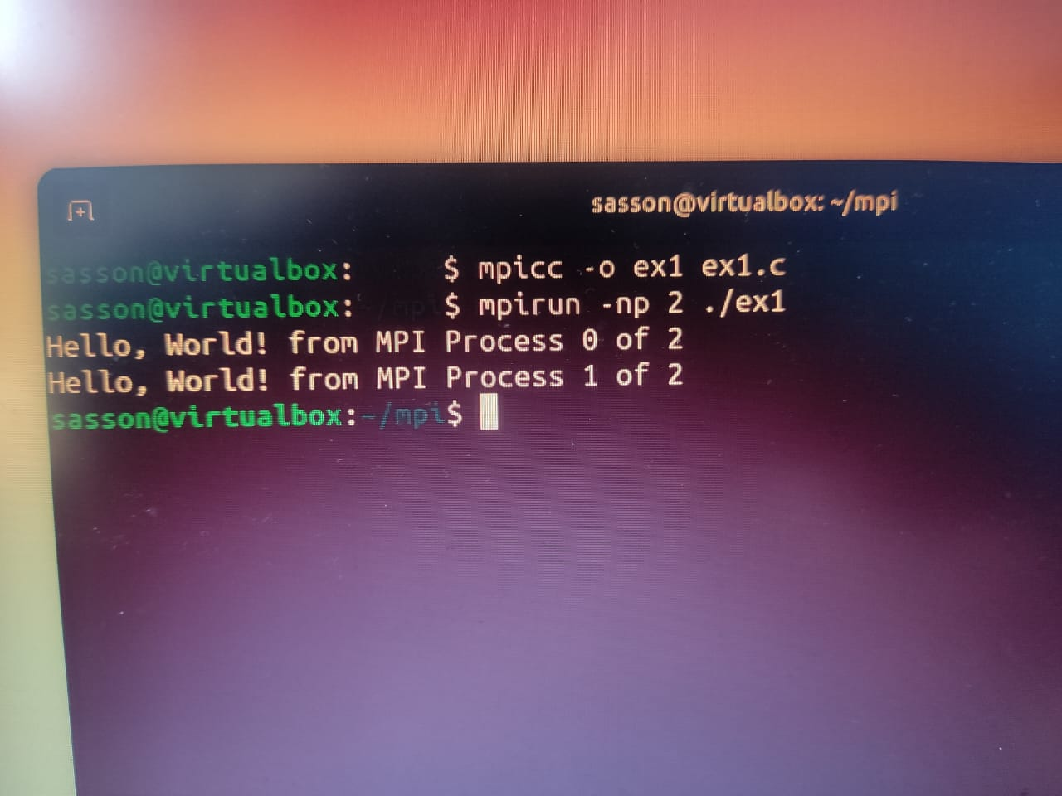

**MPI Program to find smallest between 2 nos and implement bcast constraint in the program**

Program :

#include <stdio.h>

#include <mpi.h>

int main(int argc, char *argv[]) {

MPI_Init(&argc, &argv);

int rank, size;

MPI_Comm_rank(MPI_COMM_WORLD, &rank);

MPI_Comm_size(MPI_COMM_WORLD, &size);

double start_time, end_time;

if (rank == 0) {

int num1 = 15;

int num2 = 8;

start_time = MPI_Wtime();

MPI_Bcast(&num1, 1, MPI_INT, 0, MPI_COMM_WORLD);

MPI_Bcast(&num2, 1, MPI_INT, 0, MPI_COMM_WORLD);

printf("Process %d broadcasting numbers: %d and %d\n", rank, num1, num2);

} else {

int my_num1, my_num2;

MPI_Bcast(&my_num1, 1, MPI_INT, 0, MPI_COMM_WORLD);

MPI_Bcast(&my_num2, 1, MPI_INT, 0, MPI_COMM_WORLD);

printf("Process %d received numbers: %d and %d\n", rank, my_num1, my_num2);

int smallest = (my_num1 < my_num2) ? my_num1 : my_num2;

MPI_Reduce(&smallest, NULL, 1, MPI_INT, MPI_MIN, 0, MPI_COMM_WORLD);

}

if (rank == 0) {

end_time = MPI_Wtime();

printf("Elapsed time: %f seconds\n", end_time - start_time);

}

MPI_Finalize();

return 0;

}

**Output**

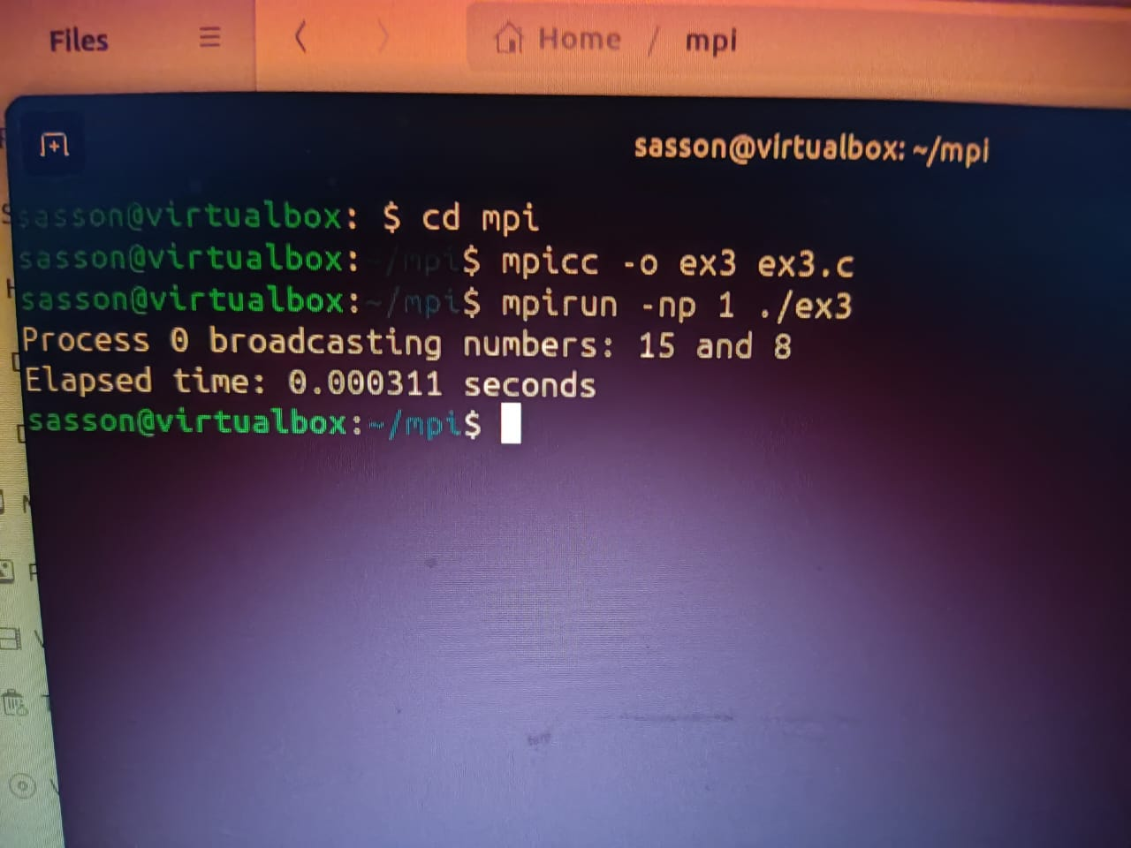

**OPENMP PROGRAM**

**PROGRAM :**

#include <stdio.h>

#include <omp.h>

int main(){

{

int thread_id = omp_get_thread_num();

printf("Hello, World! (Thread %d)\n", thread_id);}

return 0;

