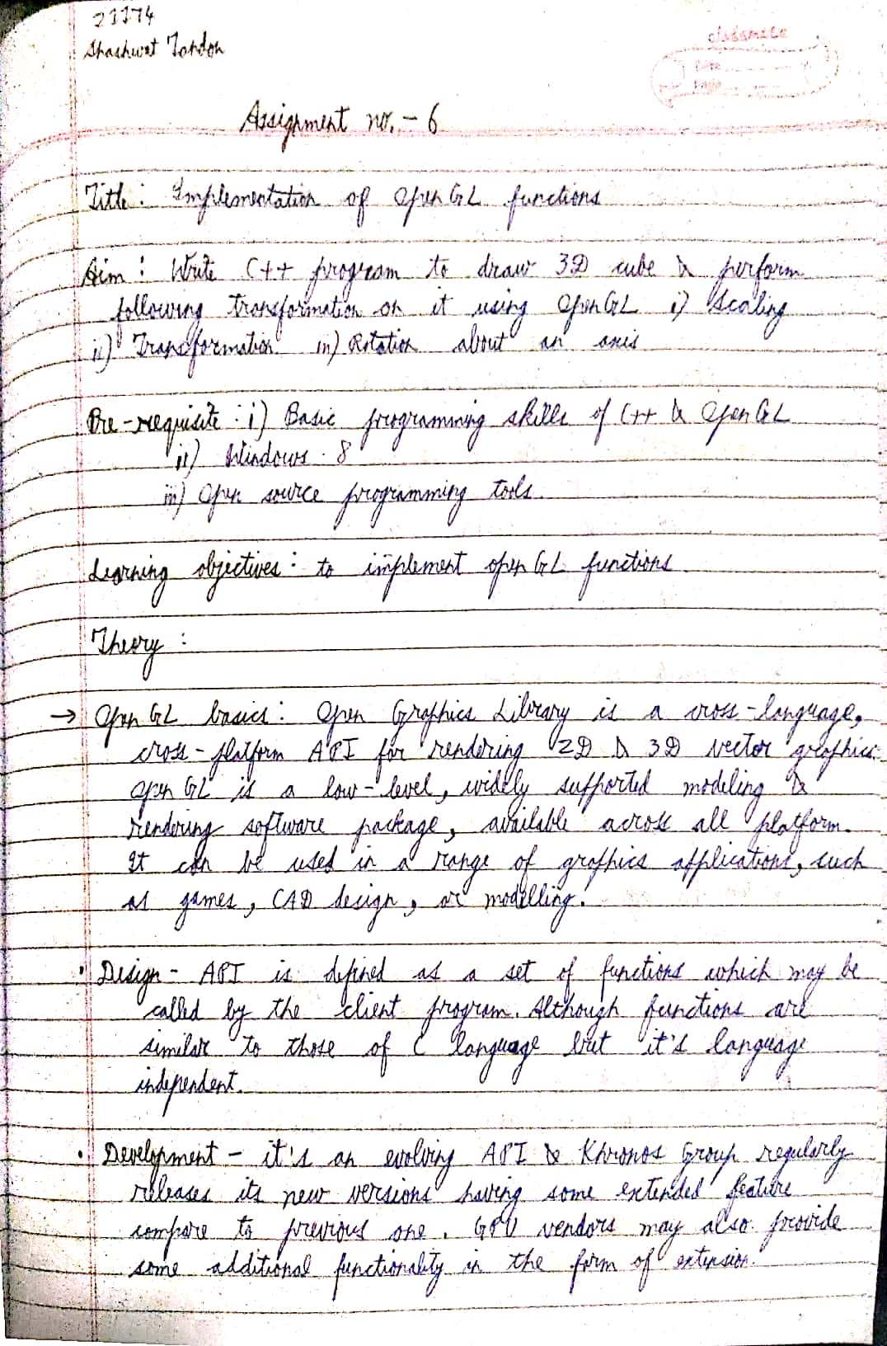

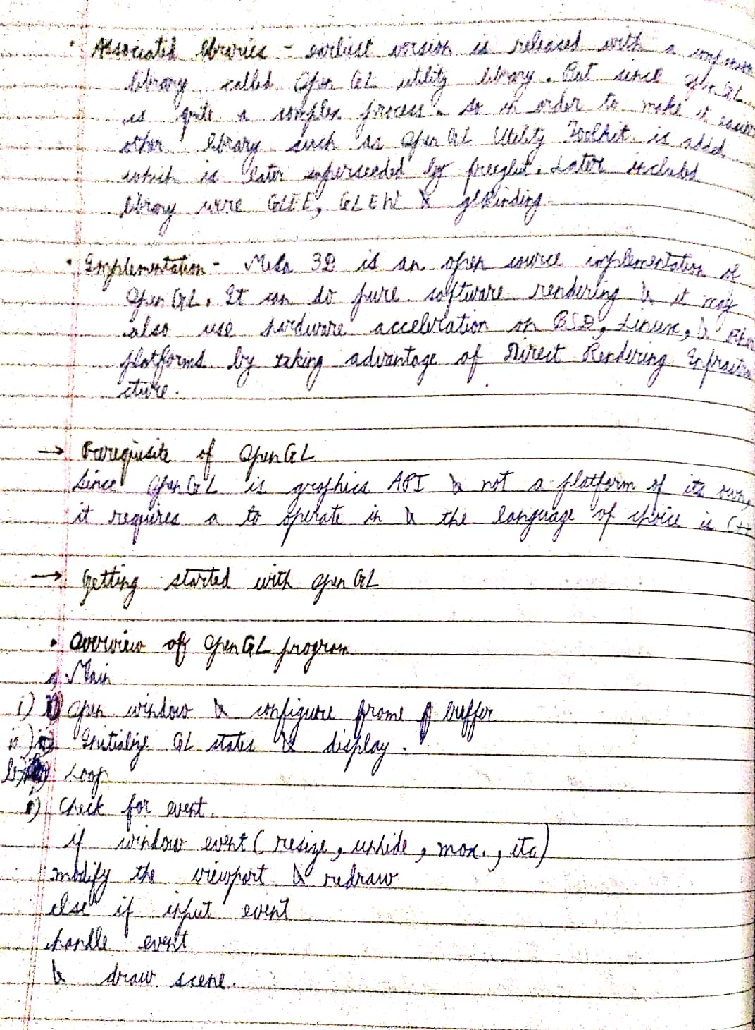

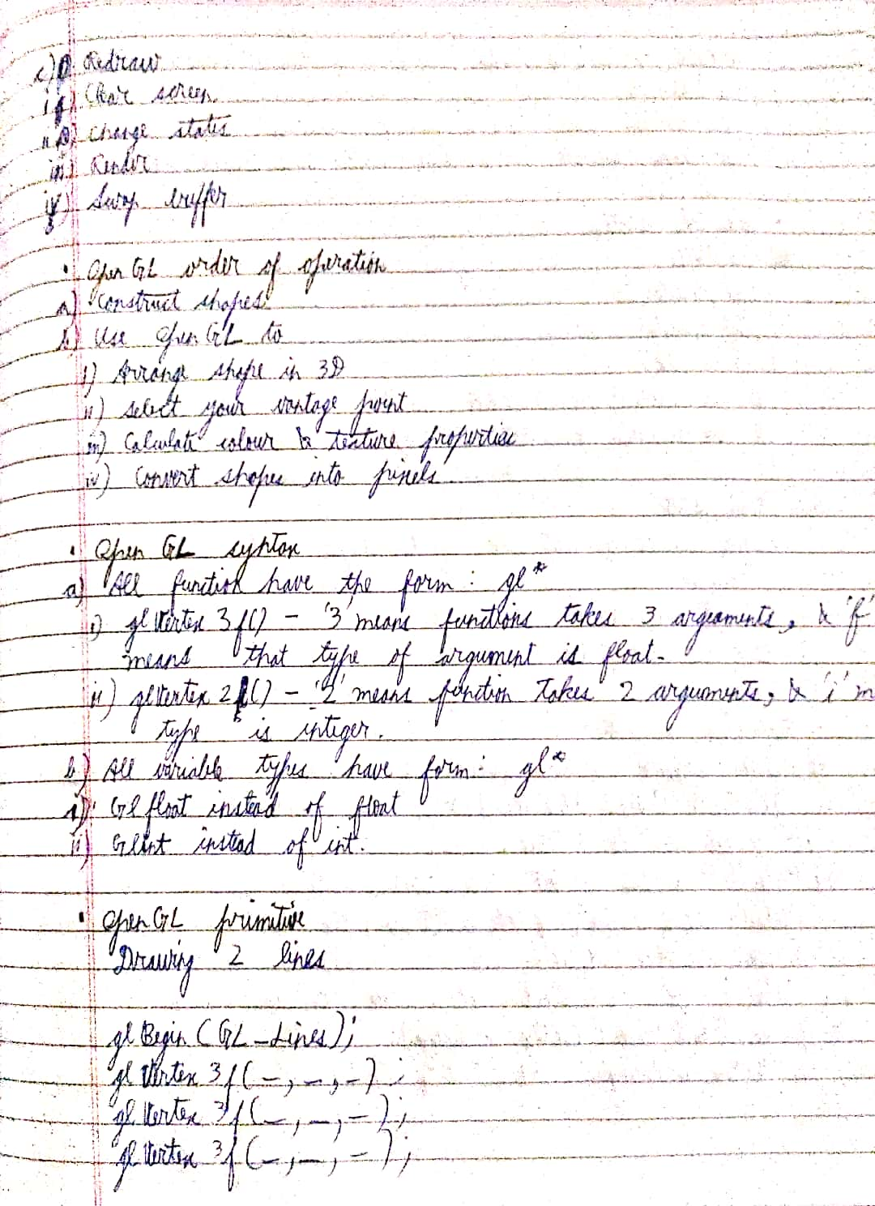

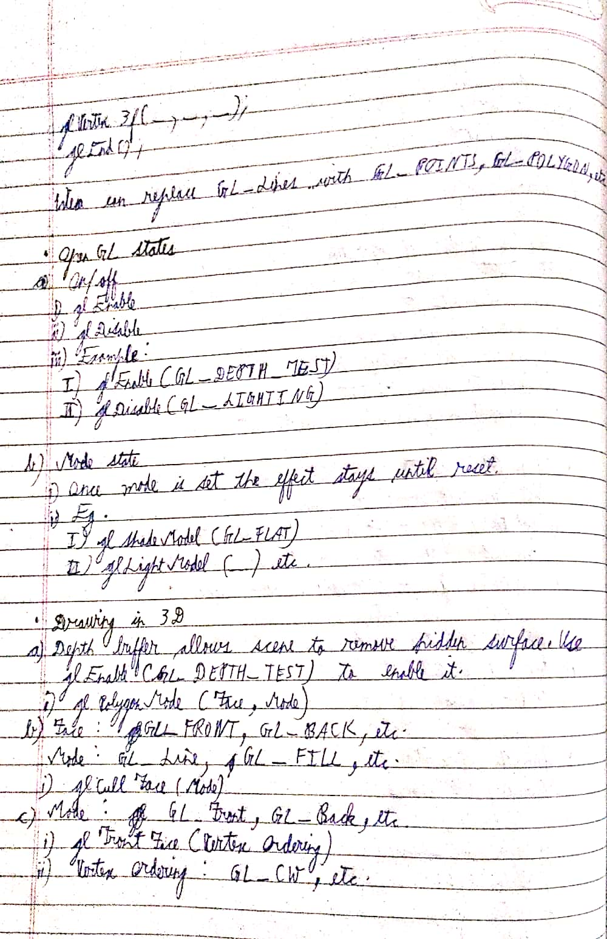

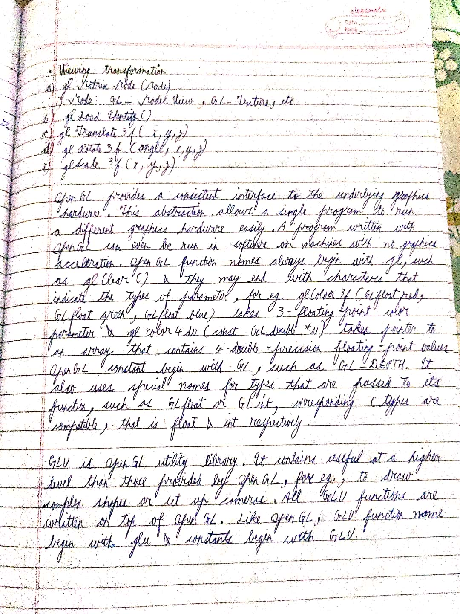

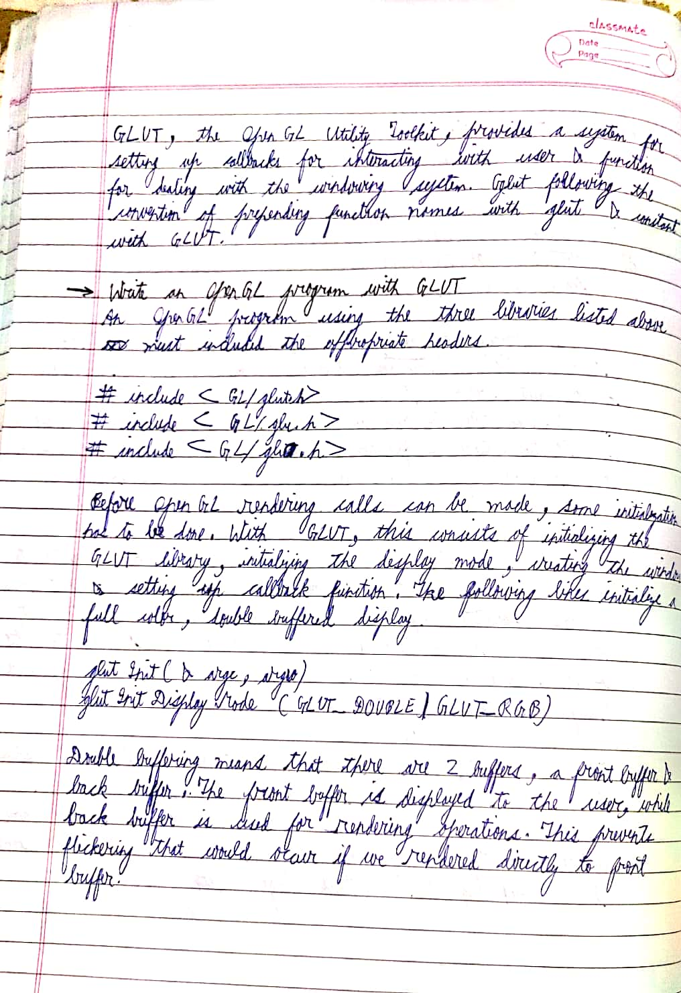

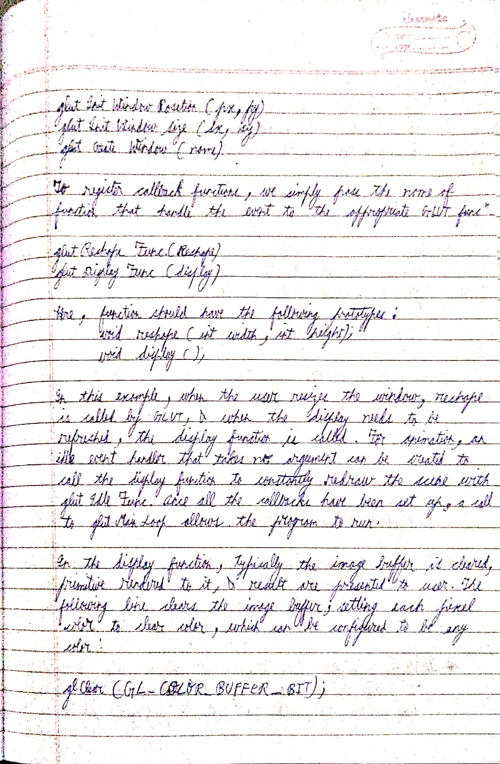

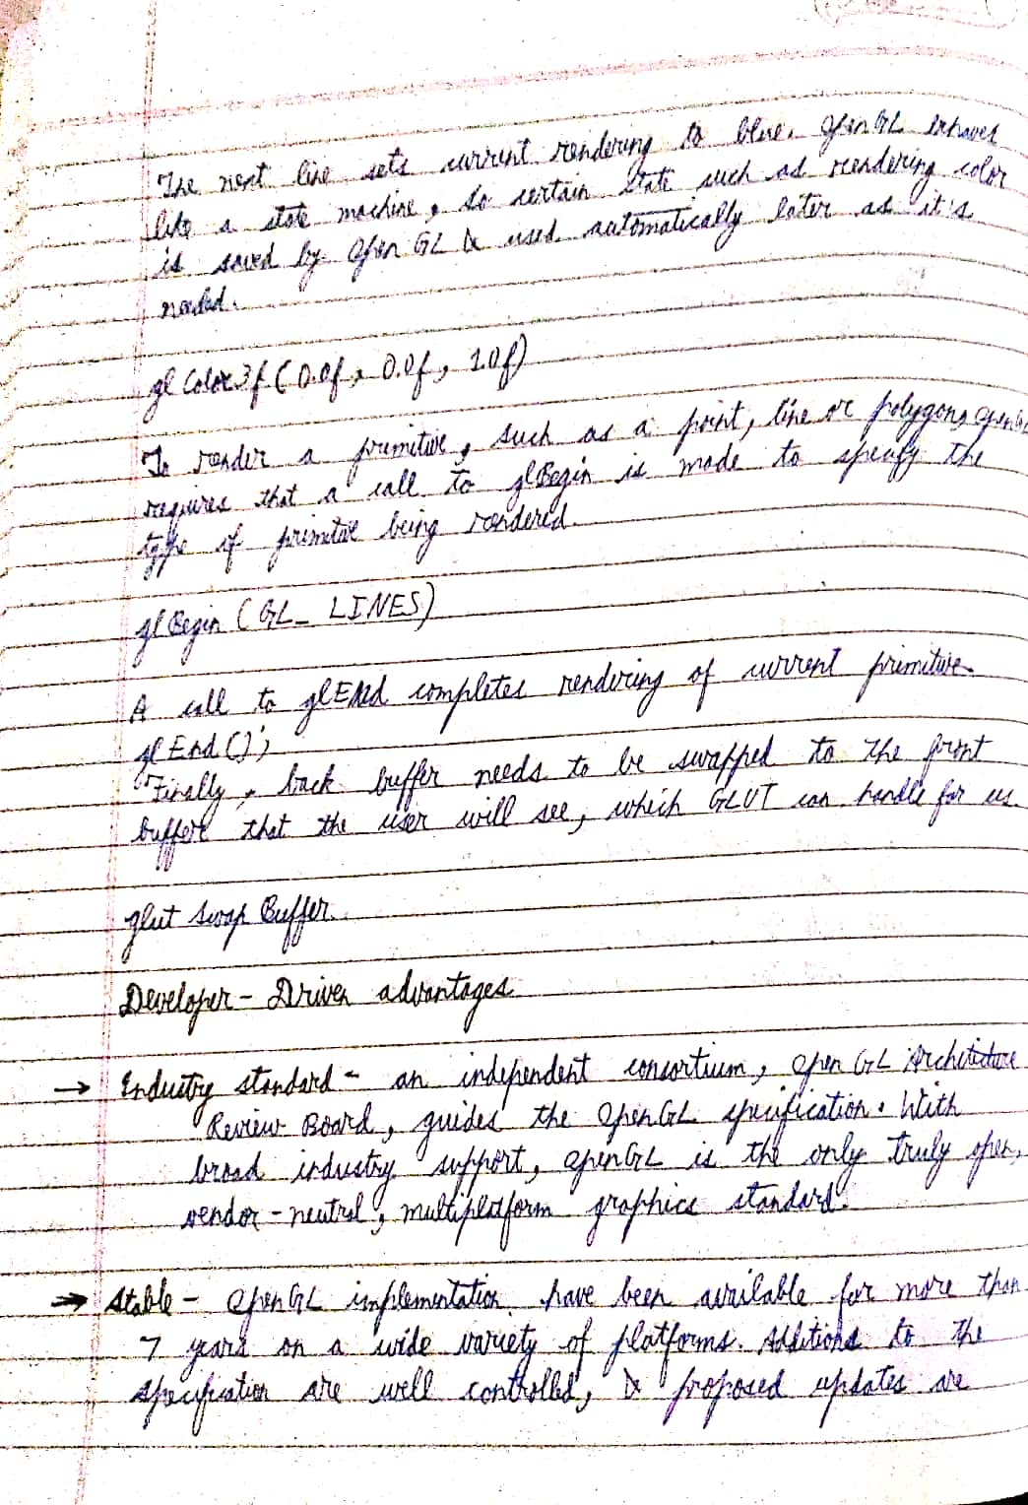

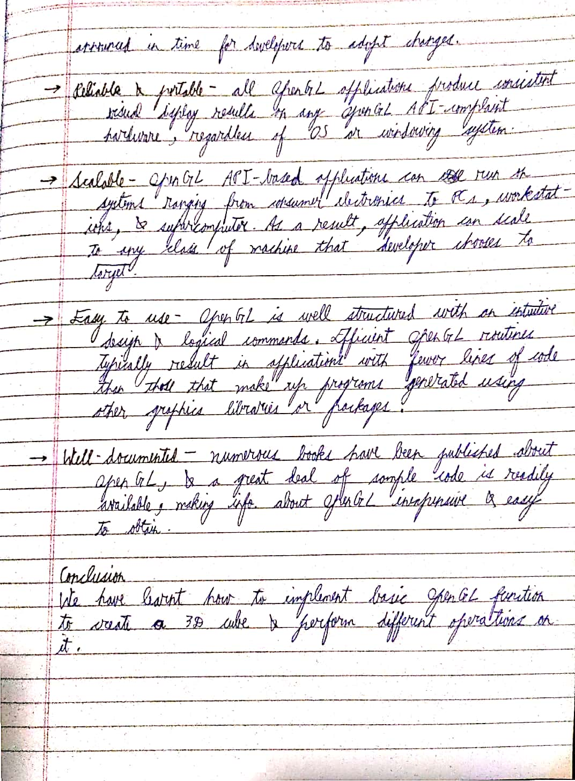

CODE

//Sassy_Don30

#include<GL\glut.h>

#include<iostream>

#include<math.h>

using namespace std;

GLfloat xRotation, yRotation, zRotation;

void Init(void){

glClearColor(0, 0, 0, 0); // RGB- alpha set kiya black ko

}

void DrawCube(void){

//view mode select kiya

glMatrixMode(GL_MODELVIEW);

// clear the drawing buffer.

glClear(GL_COLOR_BUFFER_BIT);

glLoadIdentity();

// move and rotate the cube using inbuilt function

glTranslatef(0.0, 0.0, -10.5);

glRotatef(xRotation, 1.0, 0.0, 0.0);

// rotation about Y axis

glRotatef(yRotation, 0.0, 1.0, 0.0);

// rotation about Z axis

glRotatef(zRotation, 0.0, 0.0, 1.0);

//yaha pe cube ko actually set karenge

glBegin(GL_QUADS);

//color wala toh color dega uska seedha

glColor3f(0.0f, 1.0f, 0.0f);

//vertex matlab uske actual coordinates

glVertex3f(1.0f, 1.0f, -1.0f);

glVertex3f(-1.0f, 1.0f, -1.0f);

glVertex3f(-1.0f, 1.0f, 1.0f);

glVertex3f(1.0f, 1.0f, 1.0f);

glColor3f(1.0f, 0.5f, 0.0f);

glVertex3f(1.0f, -1.0f, 1.0f);

glVertex3f(-1.0f, -1.0f, 1.0f);

glVertex3f(-1.0f, -1.0f, -1.0f);

glVertex3f(1.0f, -1.0f, -1.0f);

glColor3f(1.0f, 0.0f, 0.0f);

glVertex3f(1.0f, 1.0f, 1.0f);

glVertex3f(-1.0f, 1.0f, 1.0f);

glVertex3f(-1.0f, -1.0f, 1.0f);

glVertex3f(1.0f, -1.0f, 1.0f);

glColor3f(1.0f, 1.0f, 0.0f);

glVertex3f(1.0f, -1.0f, -1.0f);

glVertex3f(-1.0f, -1.0f, -1.0f);

glVertex3f(-1.0f, 1.0f, -1.0f);

glVertex3f(1.0f, 1.0f, -1.0f);

glColor3f(0.0f, 0.0f, 1.0f);

glVertex3f(-1.0f, 1.0f, 1.0f);

glVertex3f(-1.0f, 1.0f, -1.0f);

glVertex3f(-1.0f, -1.0f, -1.0f);

glVertex3f(-1.0f, -1.0f, 1.0f);

glColor3f(1.0f, 0.0f, 1.0f);

glVertex3f(1.0f, 1.0f, -1.0f);

glVertex3f(1.0f, 1.0f, 1.0f);

glVertex3f(1.0f, -1.0f, 1.0f);

glVertex3f(1.0f, -1.0f, -1.0f);

glEnd();

//end me sab kuch flush kar diya

glFlush();

}

// uska rotation yaha change hoga haar second

// taaki jo actually humne draw cube me kiya voh sahi se ho

void Animation(void){

yRotation += 0.01; //haar baar increase hoga itne se x aur y

xRotation += 0.02;

DrawCube(); // lagatar draw honge cubes because

//animation is bohot saari images moving jaldi jaldi

}

void Reshape(int x, int y){

if (y == 0 || x == 0)

return;

glMatrixMode(GL_PROJECTION);

glLoadIdentity();

//kaise dikhega voh hai ye

gluPerspective(40.0, (GLdouble)x / (GLdouble)y, 0.5, 20.0);

glMatrixMode(GL_MODELVIEW);

glViewport(0, 0, x, y);

}

int main(int argc, char** argv){

glutInit(&argc, argv);

// display mode select kiya aur window position lagai

glutInitDisplayMode(GLUT_SINGLE | GLUT_RGB);

glutInitWindowPosition(200, 200);

//kuch nahi dala isleye argv[0] kar rahe

glutCreateWindow("3D cube");

// yaha pe sab function call kiye

Init();

glutDisplayFunc(DrawCube); // cube draw hoga lagatar

glutReshapeFunc(Reshape); //uska shape kaisa rahega voh

glutIdleFunc(Animation); // lagatar frames jo aayenge voh

glutMainLoop();

return 0;

}

OUTPUT

