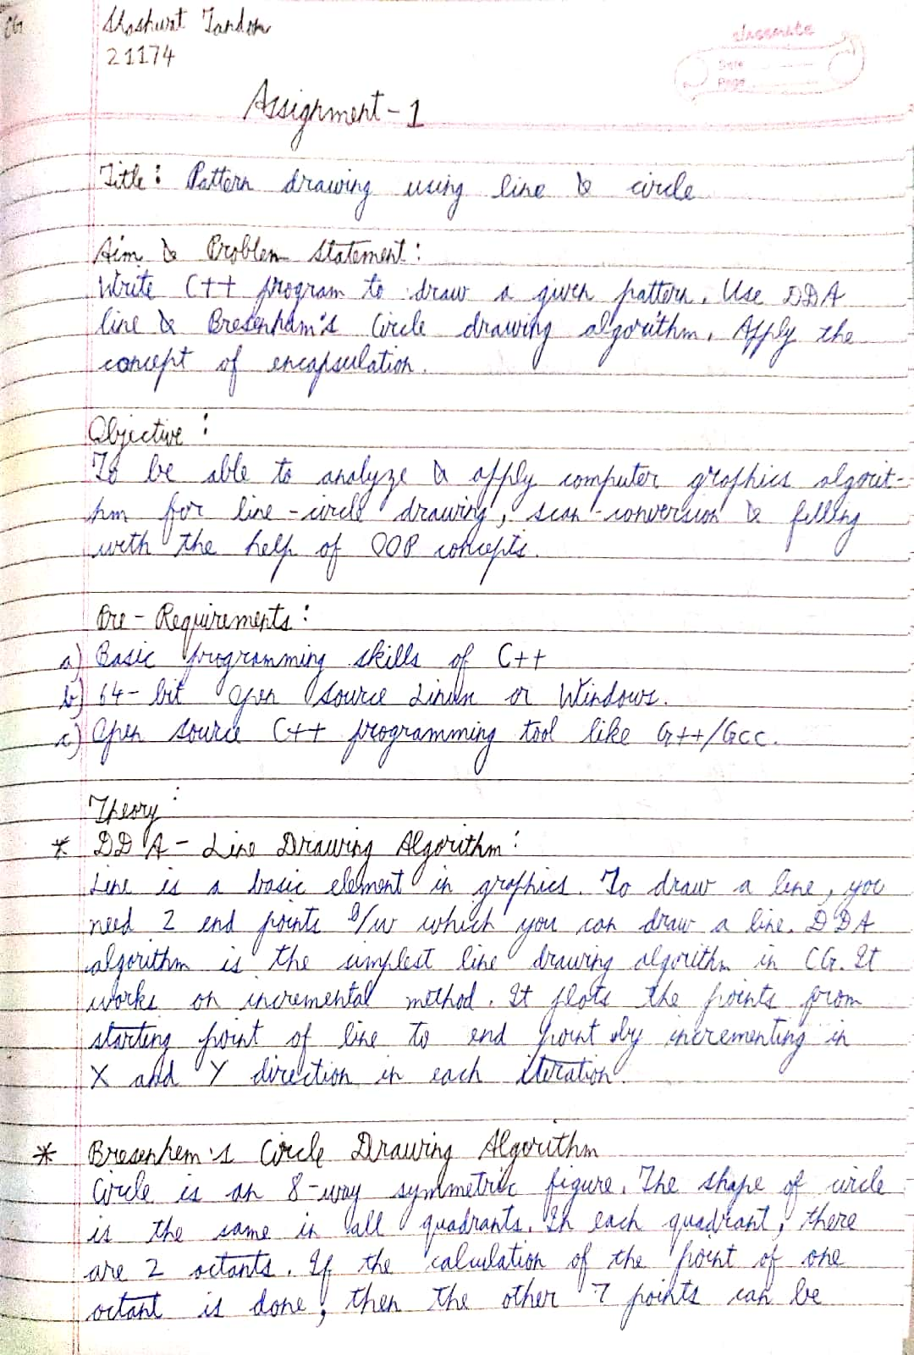

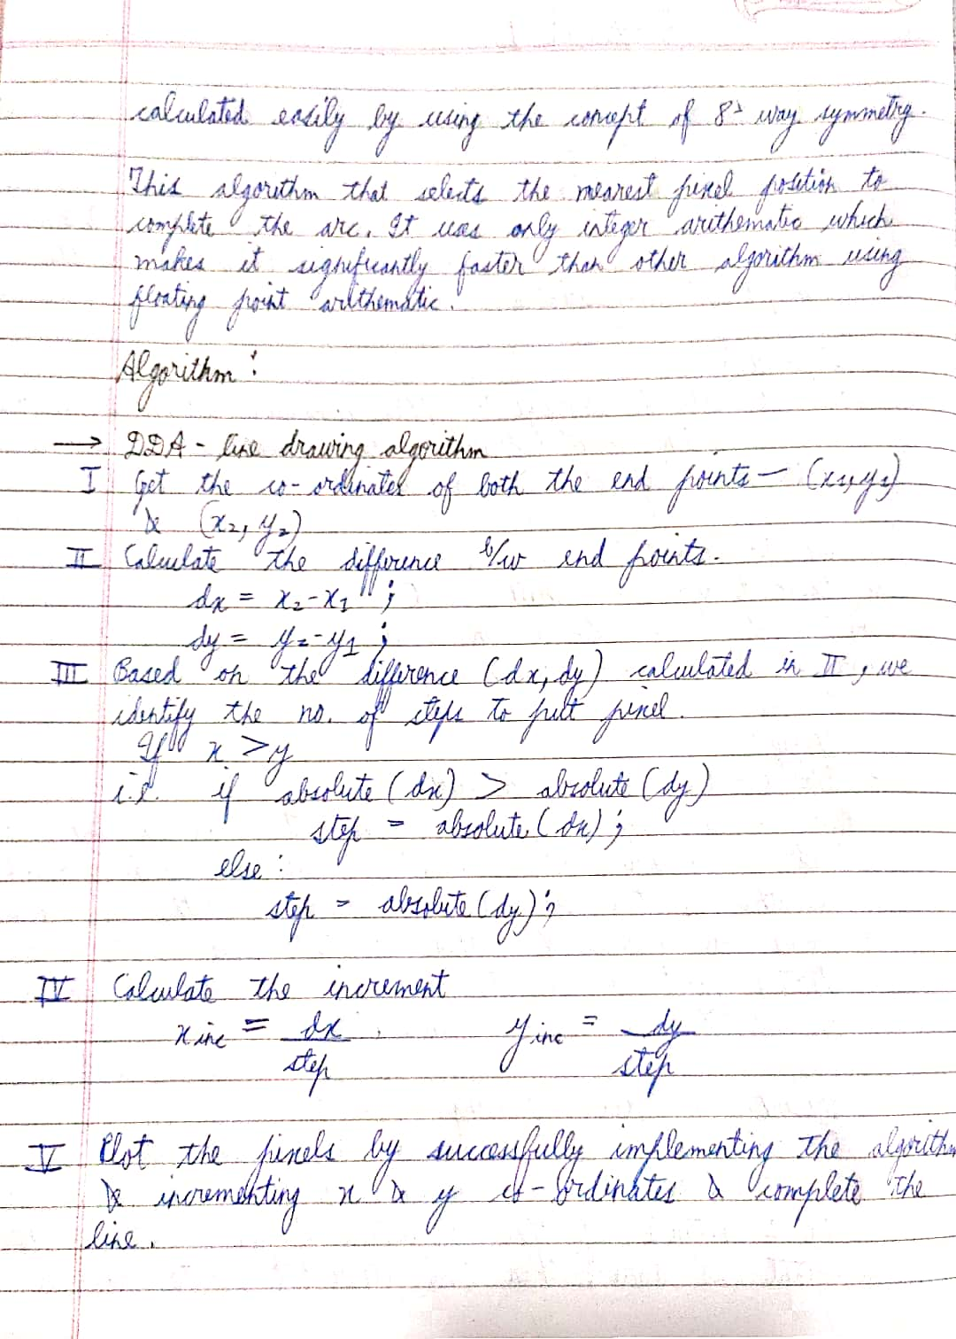

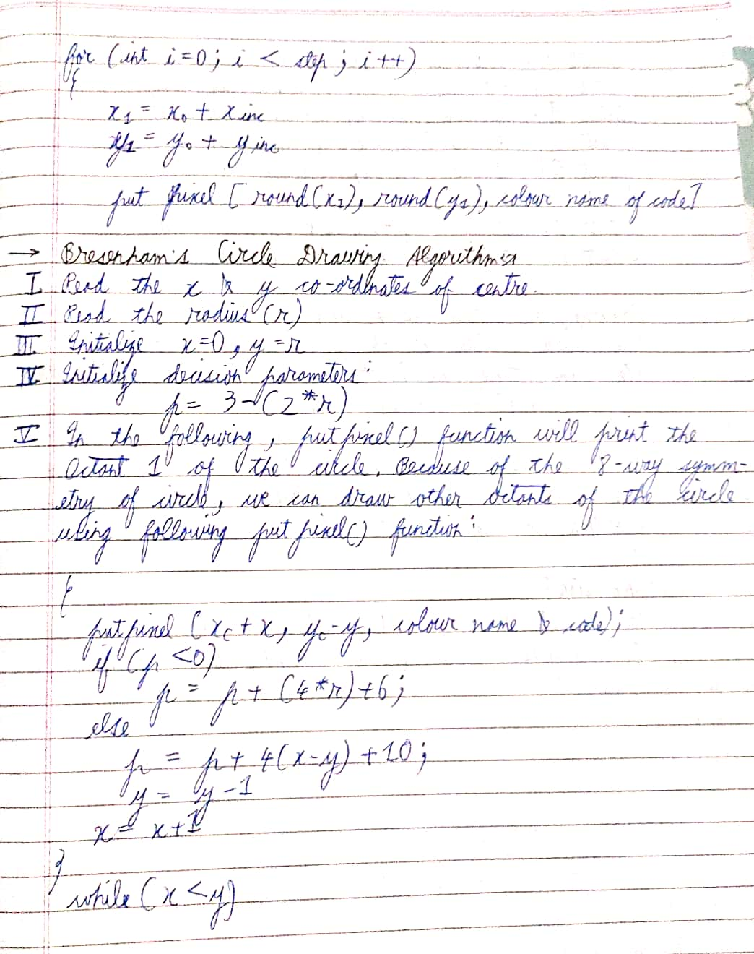

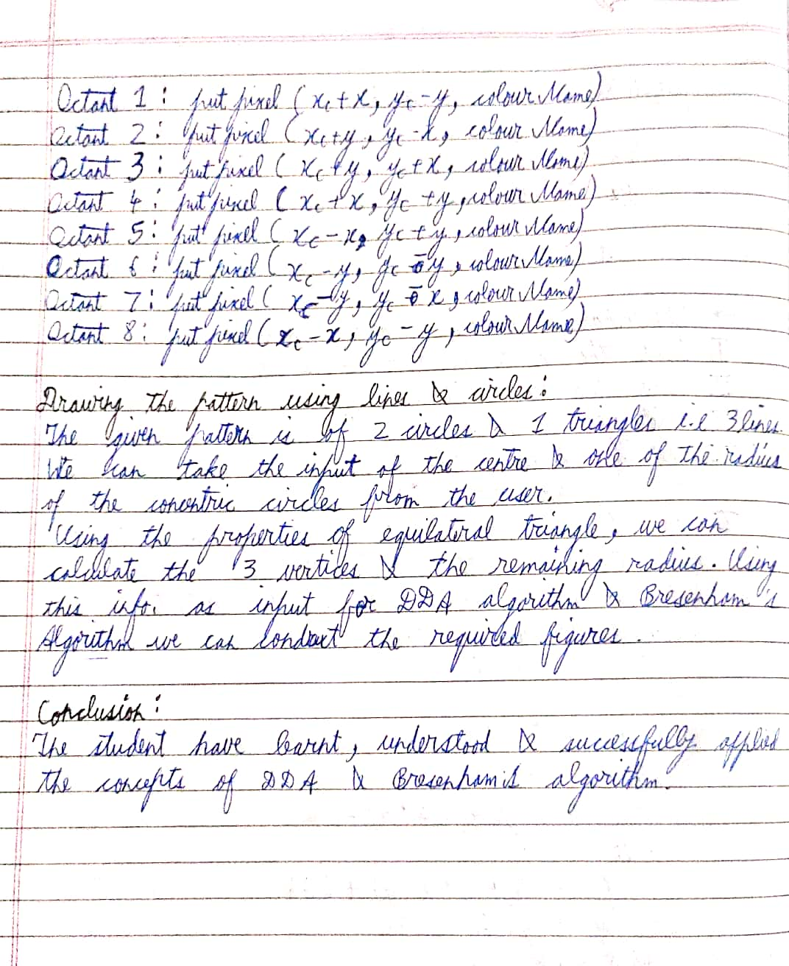

Code

mainwindow.cpp

#include "mainwindow.h"

#include "ui_mainwindow.h"

QImage img(500,500,QImage::Format_RGB888);

MainWindow::**MainWindow**(QWidget *parent)

: QMainWindow(parent)

, ui(new Ui::MainWindow)

{

ui->setupUi(this);

}

MainWindow::~***MainWindow***()

{

delete ui;

}

void MainWindow::**on_pushButton_clicked**()

{

int x1,y1,x2,y2;

x1 = ui->textEdit->toPlainText().toInt();

y1 = ui->textEdit_2->toPlainText().toInt();

x2 = ui->textEdit_3->toPlainText().toInt();

y2 = ui -> textEdit_4->toPlainText().toInt();

DDA(x1,y1,x2,y2);

ui->label->setPixmap(QPixmap::fromImage(img));

}

void MainWindow::**on_pushButton_2_clicked**()

{

int cx,cy,r;

cx = ui->textEdit_5->toPlainText().toInt();

cy = ui->textEdit_6->toPlainText().toInt();

r = ui-> textEdit_7->toPlainText().toInt();

Bresenham(cx,cy,r);

ui -> label->setPixmap(QPixmap::fromImage(img));

}

void MainWindow::**on_pushButton_3_clicked**()

{

DDA(100,100,400,100);

DDA(100,100,100,300);

DDA(400,300,100,300);

DDA(400,300,400,100);

DDA(250,100,400,200);

DDA(250,100,100,200);

DDA(250,300,100,200);

DDA(250,300,400,200);

Bresenham(250,200,83);

ui->label->setPixmap(QPixmap::fromImage(img));

}

void MainWindow::**DDA**(int x1, int y1, int x2, int y2)

{

float dx,dy,xinc,yinc,step;

dx = x2-x1;

dy = y2-y1;

step = abs(dx)>abs(dy) ? abs(dx) : abs(dy);

xinc = dx/step;

yinc = dy/step;

float x=x1;

float y=y1;

for (int i=0;i<=step;i++)

{

img.setPixel(x,y,qRgb(0,255,0));

x += xinc;

y += yinc;

}

}

void MainWindow::**Bresenham**(int cx, int cy, int r)

{

int p = 3-(2*r);

int x=0,y=r;

while (x<=y)

{

img.setPixel(cx+y,cy+x,qRgb(0,0,255));

img.setPixel(cx+x,cy+y,qRgb(0,0,255));

img.setPixel(cx-x,cy+y,qRgb(0,0,255));

img.setPixel(cx-y,cy+x,qRgb(0,0,255));

img.setPixel(cx-y,cy-x,qRgb(0,0,255));

img.setPixel(cx-x,cy-y,qRgb(0,0,255));

img.setPixel(cx+x,cy-y,qRgb(0,0,255));

img.setPixel(cx+y,cy-x,qRgb(0,0,255));

x +=1;

if(p<0)

p = p + 4*x + 6;

else {

p = p + 4*(x-y) + 10;

y--;

}

}

}

mainwindow.h

#ifndef MAINWINDOW_H

#define MAINWINDOW_H

#include <QMainWindow>

QT_BEGIN_NAMESPACE

namespace **Ui** { class **MainWindow**; }

QT_END_NAMESPACE

class **MainWindow** : public QMainWindow

{

Q_OBJECT

public:

**MainWindow**(QWidget *parent = nullptr);

~***MainWindow***();

private slots:

void **on_pushButton_clicked**();

void **DDA**(int x1,int y1,int x2,int y2);

void **Bresenham**(int cx,int cy,int r);

void **on_pushButton_2_clicked**();

void **on_pushButton_3_clicked**();

private:

Ui::MainWindow *ui;

};

#endif // MAINWINDOW_H

main.cpp

#include "mainwindow.h"

#include <QApplication>

int main(int argc, char *argv[])

{

QApplication a(*argc*, argv);

MainWindow w;

w.show();

return a.exec();

}

