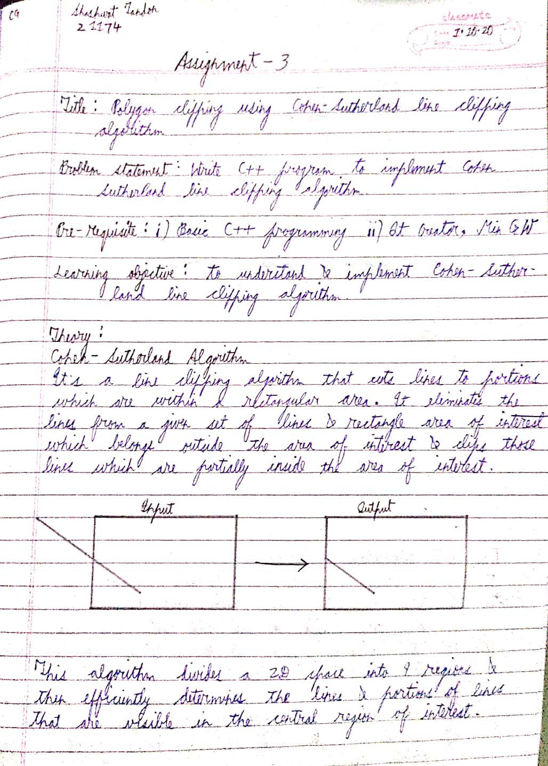

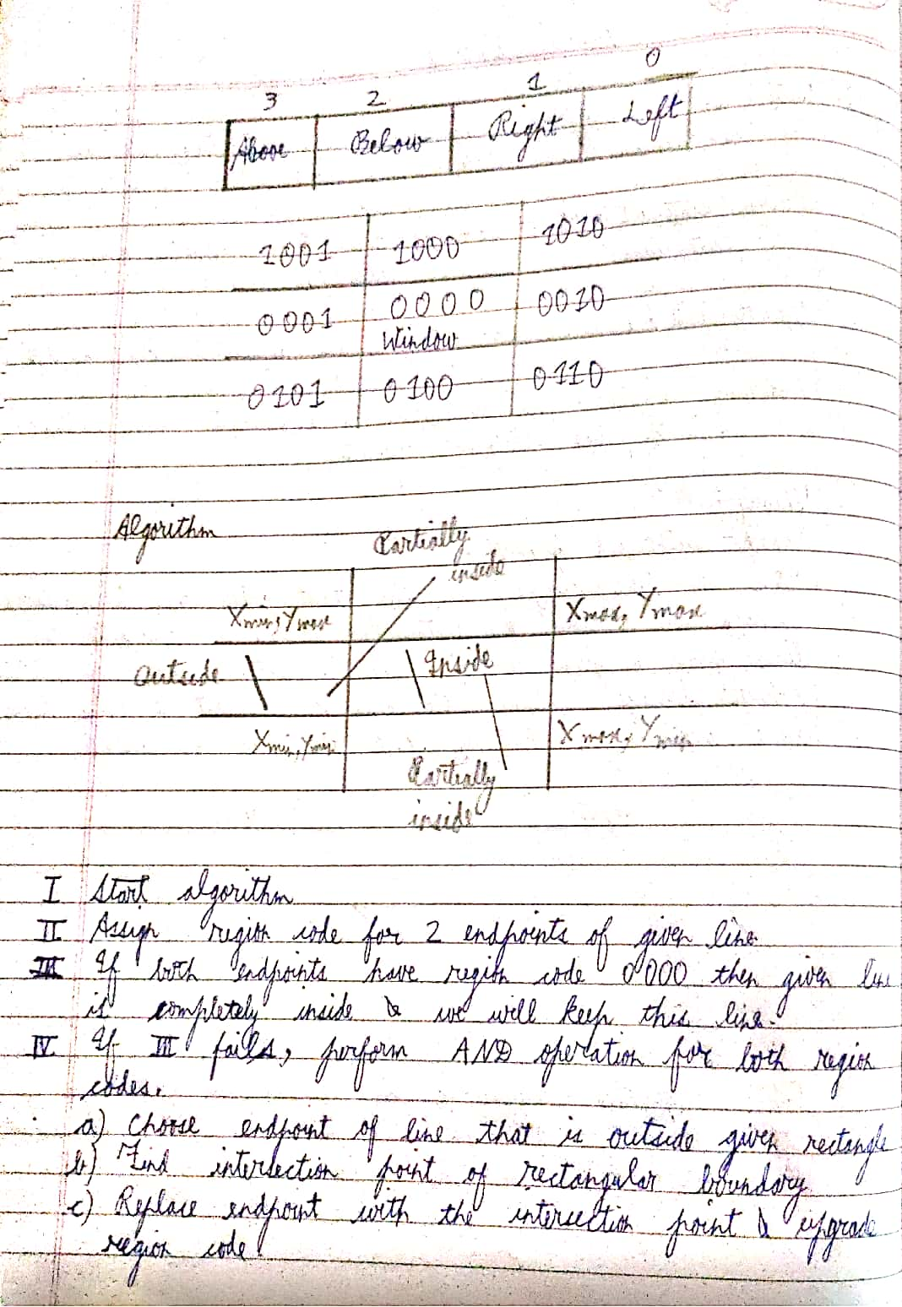

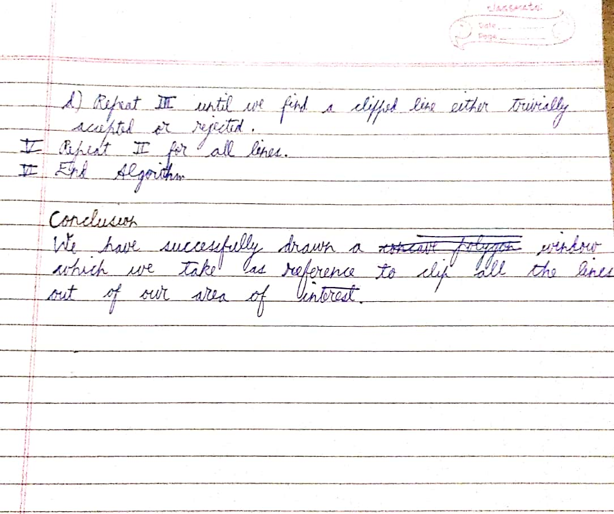

CODE

**mainwindow.cpp**

#include "mainwindow.h"

#include "ui_mainwindow.h"

#include <QMouseEvent>

using namespace std;

#include<QColorDialog>

QColor c;

static QImage img(500,500,QImage::*Format_RGB888*);

MainWindow::**MainWindow**(QWidget *parent)

: QMainWindow(parent)

, ui(new Ui::MainWindow)

{

ui->setupUi(this);

start = true;

accept = false;

ver = 0;

cnt = 0;

}

MainWindow::~***MainWindow***()

{

delete ui;

}

void MainWindow::**DDA**(int x1, int y1, int x2, int y2)

{

float dx, dy, step;

dx = x2 - x1;

dy = y2 - y1;

if(abs(dx) > abs(dy))

step = abs(dx);

else

step = abs(dy);

float x =x1,y = y1;

float xincr = dx / step, yincr = dy / step;

for(int i = 0;i<step;++i)

{

img.setPixel(x,y,qRgb(0,255,0));

x += xincr;

y += yincr;

}

ui->label->setPixmap(QPixmap::fromImage(img));

}

void MainWindow::***mousePressEvent***(QMouseEvent *ev)

{

if(start)

{

cnt++;

int p = ev->pos().x();

int q = ev->pos().y();

a[ver] = p;

b[ver] = q;

if(ev->button() == Qt::*RightButton*)

{

start = false;

}

if(cnt == 2)

{

if(ver > 0)

{

DDA(a[ver],b[ver],a[ver-1],b[ver-1]);

}

cnt = 0;

}

ver++;

}

}

int MainWindow::**coder**(int x, int y)

{

reg = 0;

if(y > 350)

reg += 8;

if(y < 150)

reg += 4;

if(x > 450)

reg += 2;

if(x < 50)

reg += 1;

return reg;

}

void MainWindow::**Eraser**(int x1, int y1, int x2, int y2)

{

float dx, dy, step;

dx = x2 - x1;

dy = y2 - y1;

if(abs(dx) > abs(dy))

step = abs(dx);

else

step = abs(dy);

float x =x1,y = y1;

float xincr = dx / step, yincr = dy / step;

for(int i = 0;i<step;++i)

{

img.setPixel(x,y,qRgb(0,0,0));

x += xincr;

y += yincr;

}

ui->label->setPixmap(QPixmap::fromImage(img));

}

void MainWindow::**clipper**(int x1, int y1, int x2, int y2)

{

fcode = coder(x1,y1);

scode = coder(x2,y2);

accept = false;

Eraser(x1,y1,x2,y2);

dy = y2 - y1;

dx = x2 - x1;

if(dy == 0.0f) slope = 1.0;

if(dx == 0.0f) slope = 0.0;

if((dy != 0.0f)&&(dx != 0.0f))

{

slope = dy/dx;

}

while (true)

{

if((fcode == 0) && (scode == 0))

{

accept = true;

break;

}

else if(fcode & scode)

{

break;

}

else

{

if(fcode != 0)

temp = fcode;

else

temp = scode;

if(temp & 8)

{

tx = x1 + (350-y1)/slope;

ty = 350;

}

else if(temp & 4)

{

tx = x1 +(150-y1)/slope;

ty = 150;

}

if( temp & 2)

{

ty = y1 + slope*(450-x1);

tx = 450;

}

else if( temp & 1 )

{

ty = y1 + slope*(50-x1);

tx = 50;

}

if(temp == fcode)

{

x1 = tx;

y1 = ty;

fcode = coder(x1,y1);

}

else

{

x2 = tx;

y2 = ty;

scode = coder(x2,y2);

}

}

}

if(accept)

{

DDA(x1,y1,x2,y2);

img.setPixel(x1,y1,qRgb(0,255,0));

img.setPixel(x2,y2,qRgb(0,255,0));

}

}

void MainWindow::**on_pushButton_clicked**()

{

DDA(50,150,450,150);

DDA(50,150,50,350);

DDA(50,350,450,350);

DDA(450,150,450,350);

}

void MainWindow::**on_pushButton_2_clicked**()

{

for(i = 0;i < ver;i+=2)

{

clipper(a[i],b[i],a[i+1],b[i+1]);

}

}

**mainwindow.h**

#ifndef MAINWINDOW_H

#define MAINWINDOW_H

#include <QMainWindow>

QT_BEGIN_NAMESPACE

namespace **Ui** { class **MainWindow**; }

QT_END_NAMESPACE

class **MainWindow** : public QMainWindow

{

Q_OBJECT

public:

**MainWindow**(QWidget *parent = nullptr);

~***MainWindow***();

void **DDA**(int x1, int y1, int x2, int y2);

void ***mousePressEvent***(QMouseEvent *ev);

int **coder**(int,int);

void **Eraser**(int x1, int y1, int x2, int y2);

void **clipper**(int x1, int y1, int x2, int y2);

private slots:

void **on_pushButton_clicked**();

void **on_pushButton_2_clicked**();

void **on_pushButton_3_clicked**();

private:

Ui::MainWindow *ui;

int ver, a[20],b[20],cnt,i,reg,fcode,scode,tx,ty,temp;

//short int tcode[20],bcode[20],rcode[20],lcode[20];

bool start,accept;

float slope,dx,dy;

};

#endif // MAINWINDOW_H

**main.cpp**

#include "mainwindow.h"

#include <QApplication>

int main(int argc, char *argv[])

{

QApplication a(*argc*, argv);

MainWindow w;

w.show();

return a.exec();

}

OUTPUT

